
University of Wales Trinity Saint David

Master of Business Administration

LCMB7024: Marketing Management

Marketing Environment Analysis: BHP Group Limited and the Transition to Lower-Carbon Products
Assessment Component 1
Lecturer:
Taonga Kaonga Sobere-Snithers

Student Name: Rana Naga Modhavadiya
Student ID Number: 2532684
Submission Date: 22/10/2026
Word Count: 2,544 words

Table of Contents
Table of Contents 2
1. Task 1: Marketing Environment Analysis 3
1.1 Introduction to the Environmental Analysis 3
1.2 The Environmental Actor: Climate Change, Emissions, and Resource Constraints 4
1.3 The Political/Legal Actor: Carbon Pricing, CBAM, and Regulatory Divergence 7
1.4 The Social/Cultural Actor: Stakeholder Pressure and Social License 10
Task 2: Strategic Growth and Competitive Positioning 11
2.1 Introduction to the Ansoff Analysis 11
2.2 Product Development: Lower-Carbon Steel Inputs and Value Chain Collaboration 12
2.3 Market Development: Repositioning for Carbon-Conscious Customers 13
2.4 Diversification: Potash, Copper, and Battery Metals 14
2.5 Market Penetration 15
2.6 Competitive Advantage: Differentiation Through Carbon Credentials 15
Task 3: Managerial and Professional Reflection 16
3.1 Reflection on Key Decisions 16
3.2 Reflection on Limitations of the Analysis 17
References 18

1. Task 1: Marketing Environment Analysis

1.1 Introduction to the Environmental Analysis
The report includes three factors of the PESTLE framework for analysing the external marketing environment shaping Broken Hill Proprietary Company Limited’s transition towards low-carbon products (Islami et al., 2025).
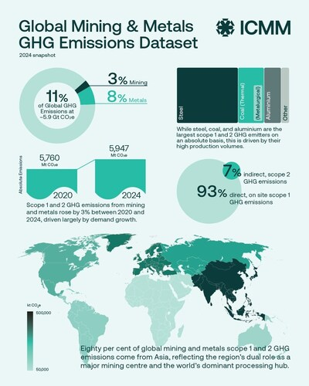
Figure 01: Global Mining & Metal GHG Emissions
Source: (PR Newswire, 2026)
Global mining and metal greenhouse gas accounts for 11% of the total, with 5.9 GTCO2e as Scope 1 and 2 emissions from mining (3%) and metal processing (8%) in 2024 (PR Newswire, 2026). BHP Group is one of the largest mining companies in the world, with a market capitalisation of $209 billion and headquarters in Australia (Huayu Parts, 2026). BHP operates across iron ore, copper, coal and potash. The analysis includes the environmental actor as the primary analytical focus because it is the root driver of the strategic imperative. The political actor is also incorporated as the second key actor because it translates environmental expectations into enforceable financial consequences. The social actor is included as the third because stakeholder pressure and community expectations shape the social license to operate for BHP.

1.2 The Environmental Actor: Climate Change, Emissions, and Resource Constraints
The environmental actor is the dominant force reshaping the strategic agenda of BHP. Mining operations contribute to climate change through the emissions released during drilling, blasting, loading, hauling, and beneficiation (Islami et al., 2025). Effective integration of green mining technology can be the reason for the reduction in greenhouse gas emissions, lower carbon emissions, and improved waste management compared to the traditional method. BHP must pursue a technology path, but the actual emissions trajectory of the company shows the gap between potential and performance.
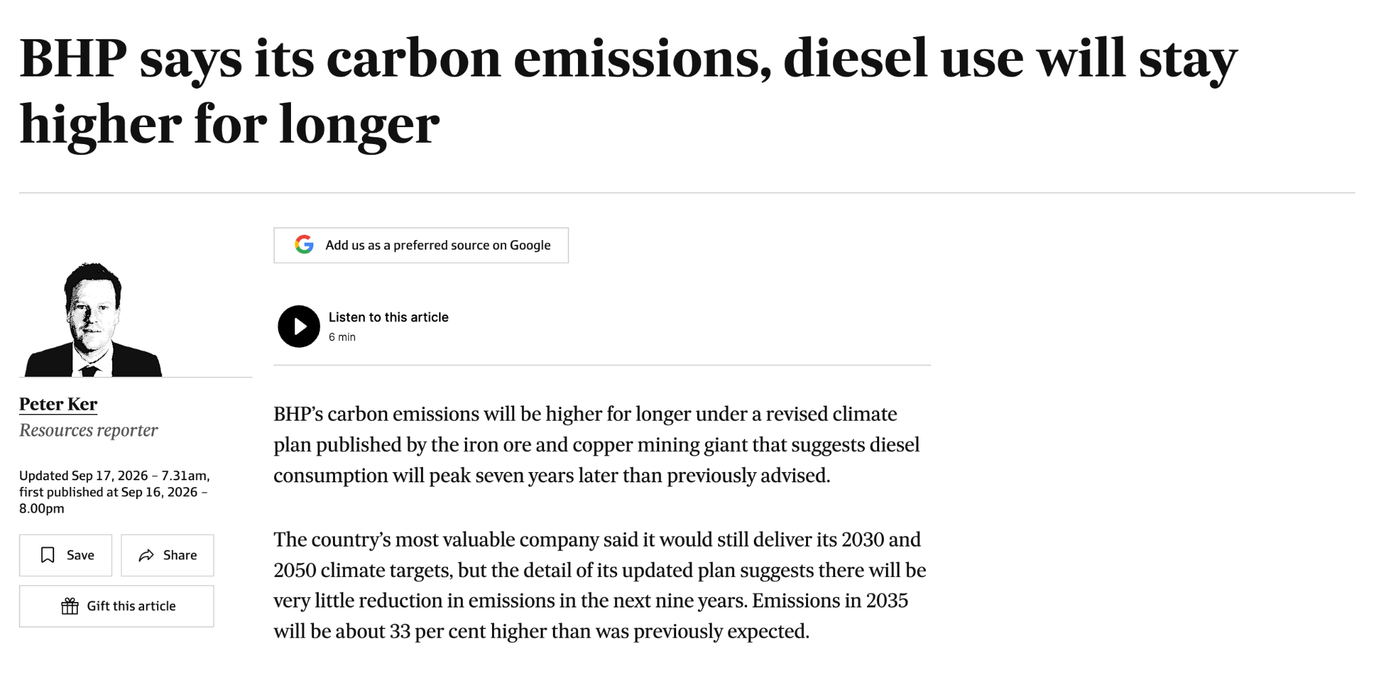
Figure 02: Carbon emissions and diesel use will stay higher for longer for BHP
Source: (Financial Review, 2026)
BHP aims to reduce its 15.9 million tons of greenhouse gases emitted in 2020 by 30% through 2030 to reach net zero emissions by 2050 (Financial Review, 2026). It has already achieved its goal of cutting emissions by 30% in half the time period, after registering 8.7 million tons of emissions in 2025. BHP’s emissions grew by 8% in the year ended June this year and are set to rise further in the next two years (Financial Review, 2026).
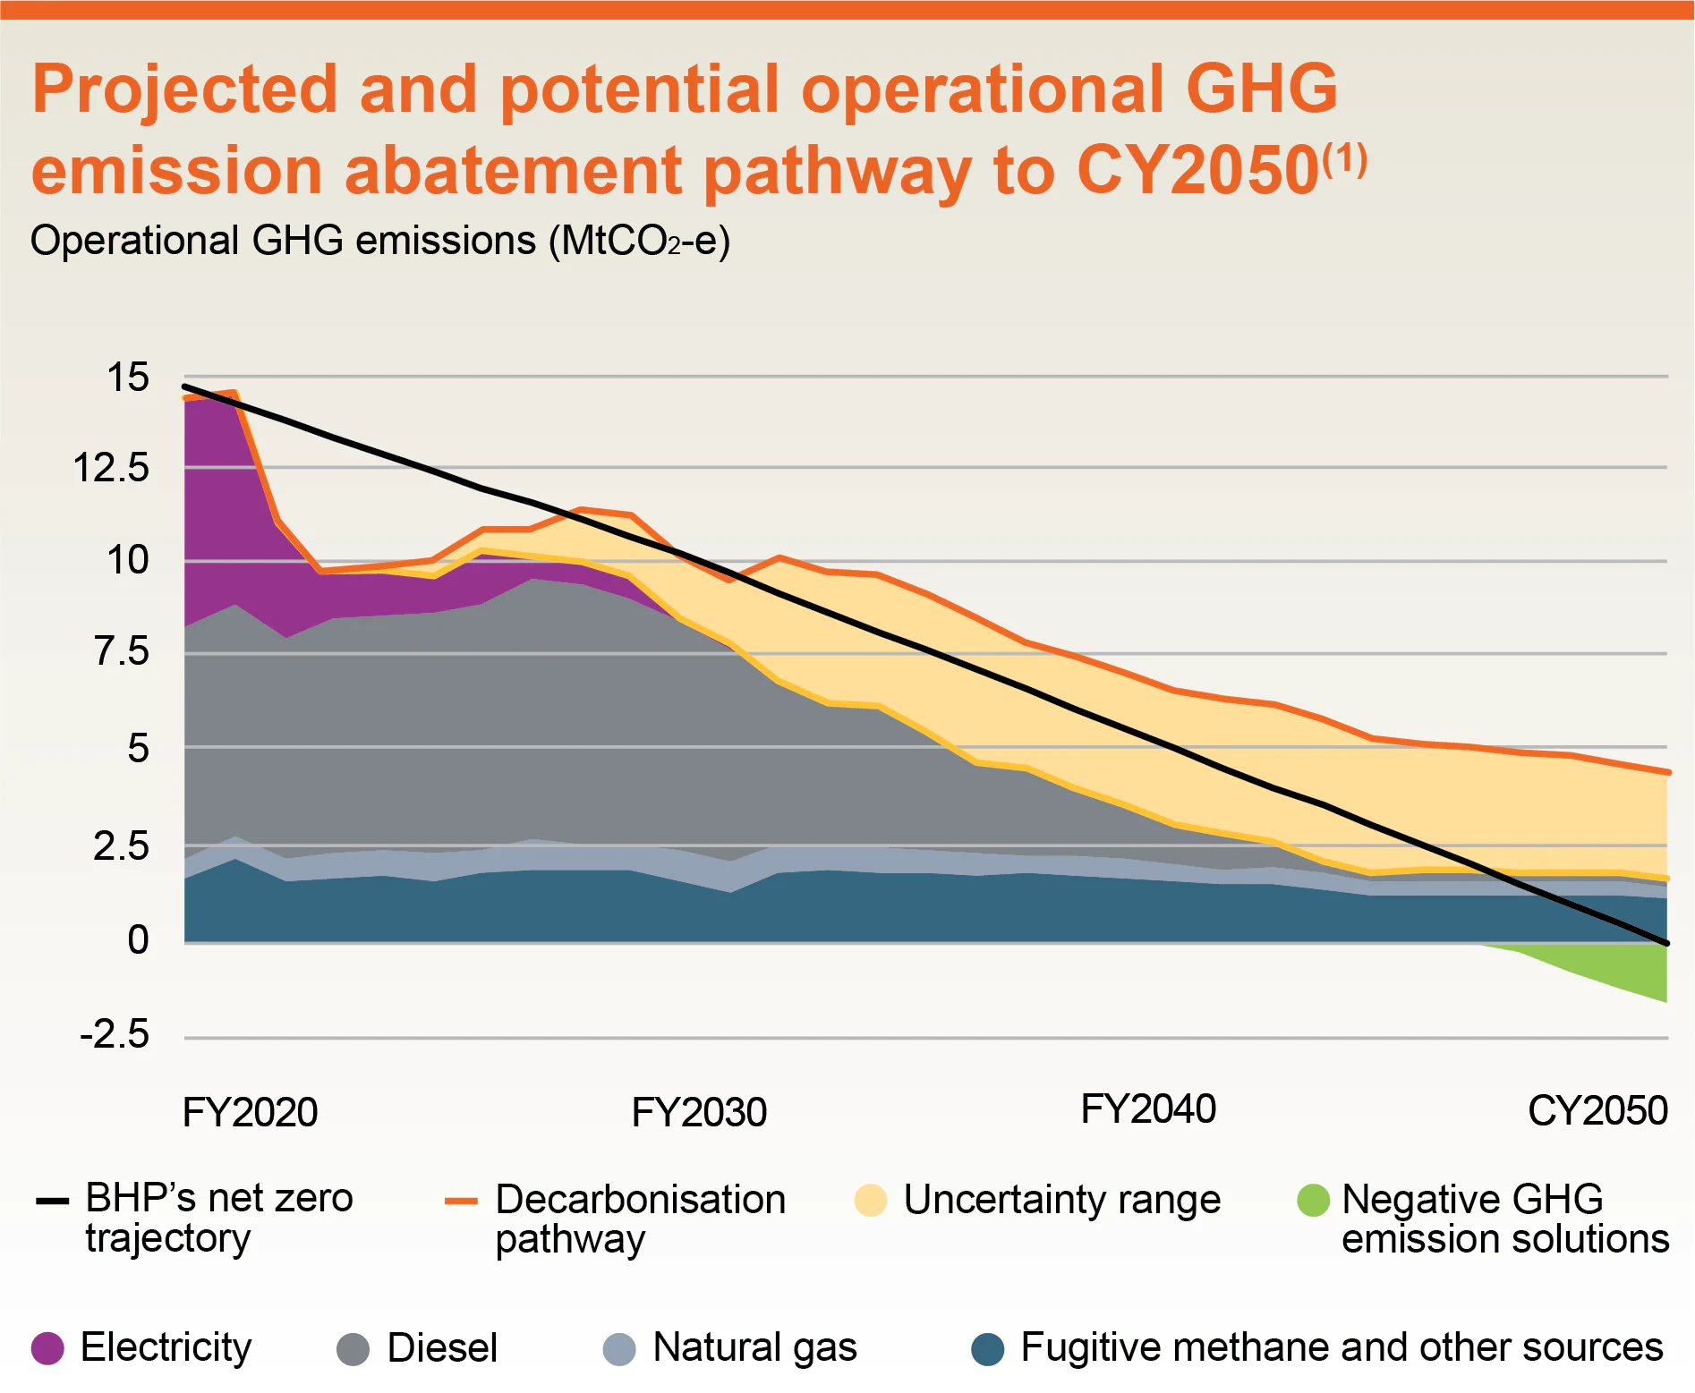
Figure 03: BHP's emission reduction path
Source: (BHP, 2023)
BHP's present target is to reduce operational GHG emissions (Scope 1 and Scope 2) by at least 30% from FY2020 levels by FY2030 with a long-term objective of net zero operational GHG emissions by 2050 (BHP, 2023). However, BHP emitted 387 MtCO₂e equivalent to greenhouse gases in FY 2024 (Statista, 2024). BHP's Scope 3 emissions across its value chain are expected to amount to 377.6 MtCO₂e, in contrast to merely more than eight MtCO₂e of direct emissions (Scope 1) from its operations in 2024 (Statista, 2024). Thus, over 97% of emissions generated by BHP are indirect and primarily stem from the conversion of iron ore into crude steel (Statista, 2024).
Although BHP reduced Scope 1 and 2 emissions, Scope 3 emissions are roughly 41 times larger than operating emissions (Statista, 2024). BHP successfully reduces emissions from its own operations, but the emissions generated by the use of the product by the customers are continuously rising. Transitions towards low-carbon operations create new environmental pressures, particularly around water use and land disturbance.
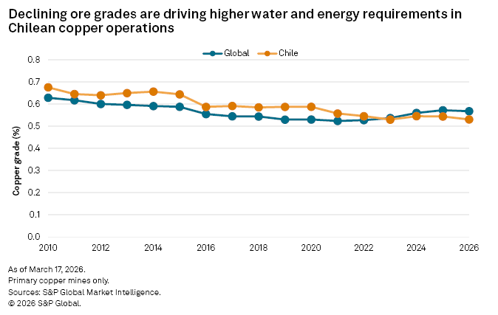
Figure 04: High energy and water requirement in Chilean copper operations
Source: (S&P Global, 2026)
The restrictions on legal groundwater to protect the wetlands reduce the output of the Cerro Colorado facility of BHP (S&P Global, 2026).
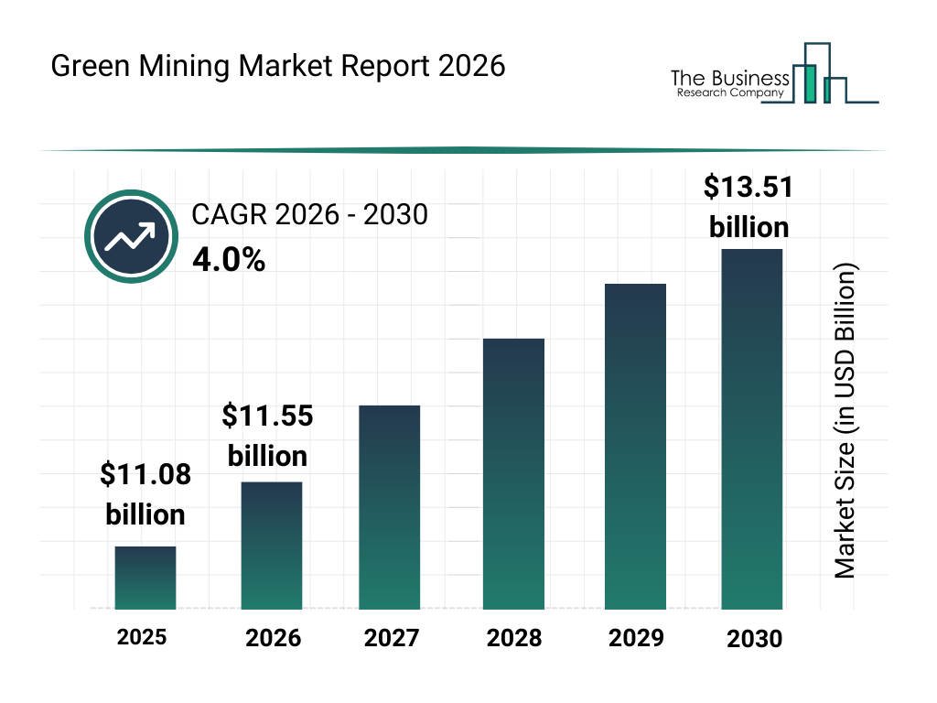
Figure 05: Green Mining Market Report
Source: (The Business Research Company, 2026)
At a CAGR of 4.3%, the green mining market expanded from $11.08 billion in 2025 to $11.55 billion in 2026 (The Business Research Company, 2026). There is commercial opportunity, but BHP's position is not guaranteed as the market is growing at a moderate pace.

1.3 The Political/Legal Actor: Carbon Pricing, CBAM, and Regulatory Divergence
The political and legal actor translates environmental expectations into enforceable financial consequences (Yan et al., 2026). The most significant regulatory development is the European Union's Carbon Border Adjustment Mechanism (CBAM), which entered its definitive phase on 1 January 2026.
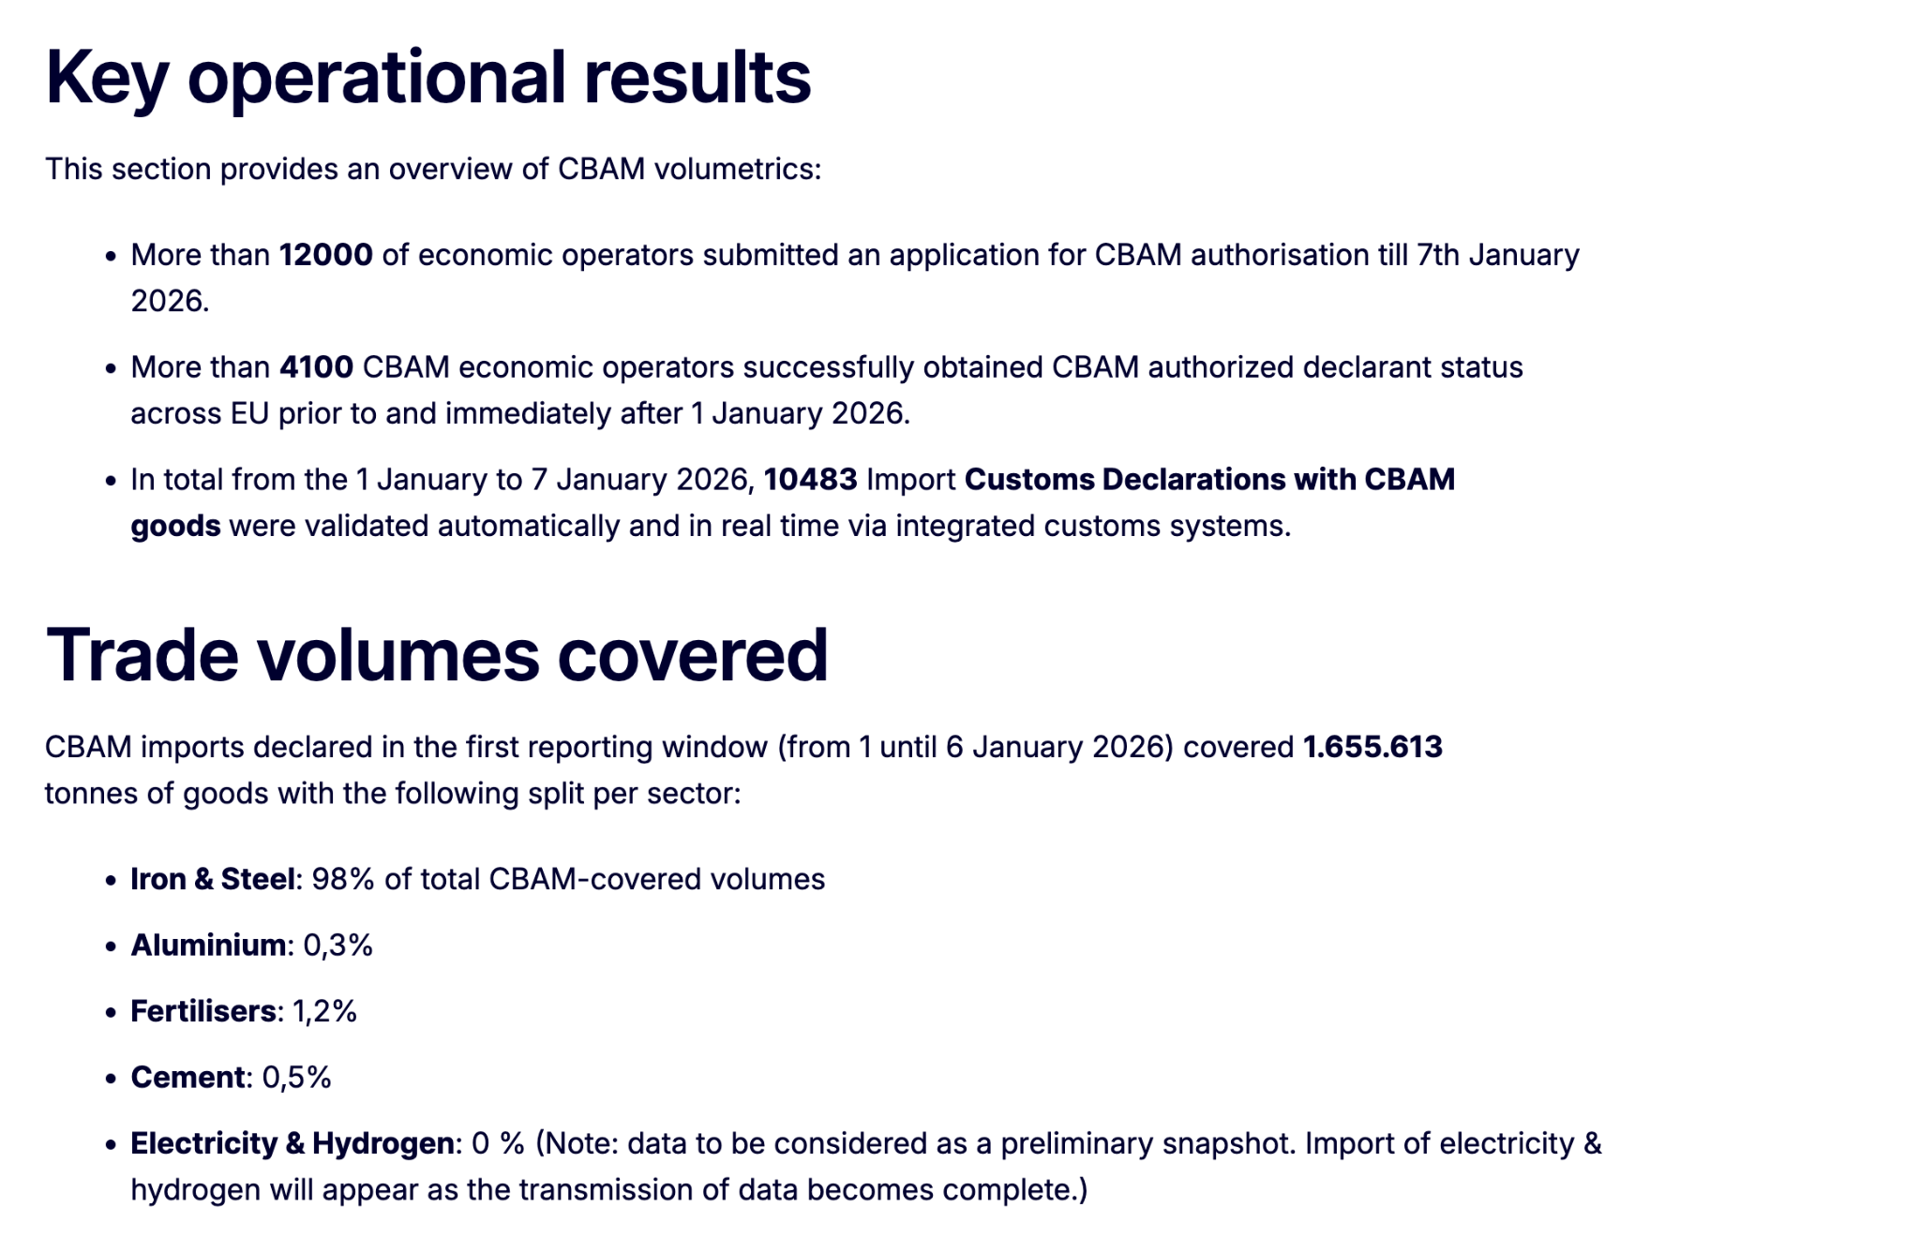
Figure 06: Operational Result and Trade Volume of CBAM
Source: (Union, 2026)
1,655,613 tonnes of products were imported under CBAM during the first reporting window, which ran from January 1 to January 6, 2026 (Union, 2026). On April 7, 2026, the initial quarterly CBAM certificate price was established at €75.36 per ton of CO2 equivalent (Union, 2026). The €75.36/ton CBAM certificate price erodes BHP’s margin, making certified low-carbon ore a competitive necessity. The steel import in the European Union and CBAM cost provide the difference in cost based on the origin and production route. CBAM places the carbon cost on the impacted emissions in BHP’s product destined for the steelmakers of the EU. Iron and steel comprise nearly 98% of the CBAM-covered importers, which indicates that the mechanism is overwhelmingly focused on the core product category of BHP (Union, 2026).
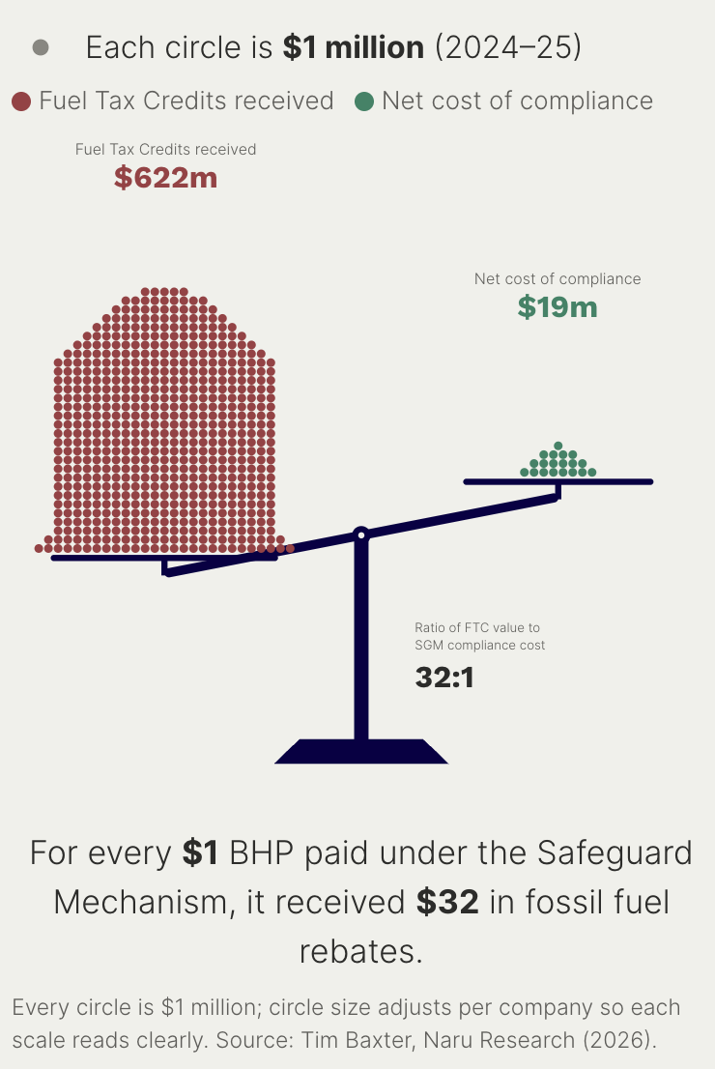
Figure 07: Diesel rebates to big polluters
Source: (Climate Integrity, 2026)
For every dollar they spent adhering to the federal government's emissions reduction target last year, Australia's largest industrial polluters got around $22 in Fuel Tax Credit reimbursements. The ratio of $622 million to $19.2 million that BHP got was 32 to 1 (The Point, 2026).
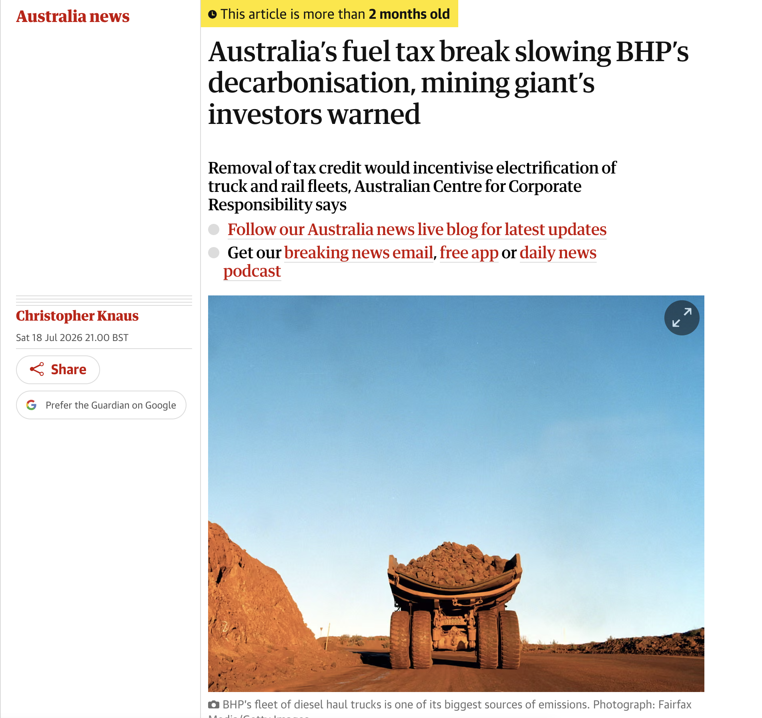
Figure 08: Australia’s fuel tax break slowing BHP’s decarbonisation
Source: (The Guardian, 2026)
BHP investors were also cautioned by the ACCR report that the company will incur higher carbon expenses if decarbonisation is delayed. The company's original decarbonisation strategy, which was presented to shareholders in a paper in 2024, would cost it between $11.2 billion and $19.3 billion in mandatory and voluntary carbon credit purchases by 2050. These expenses would rise by 48% to US$16.6 billion to $28.5 billion if its plans were delayed by ten years (The Guardian, 2026). The domestic regulatory environment of BHP actively undermines the business case for decarbonization (Campbell, 2024). There is an opportunity for sustainable mining through solar photovoltaic and wind energy installation in Australia.

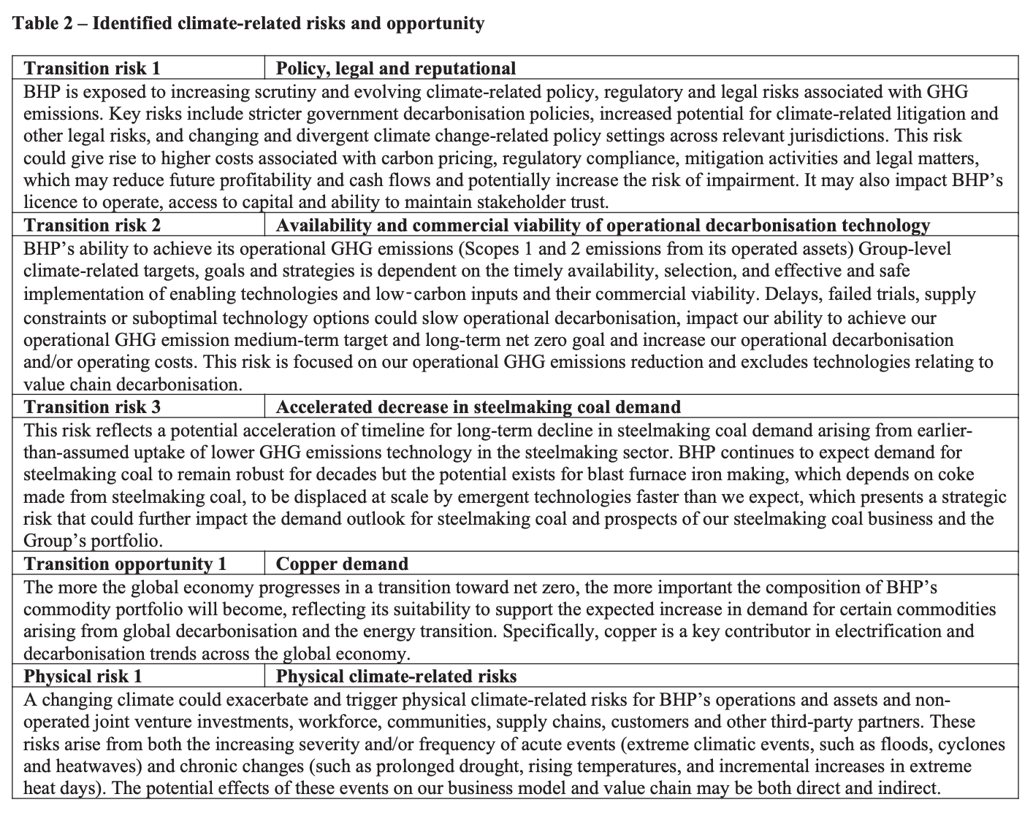
Figure 09: Key Risk of BHP
Source: (BHP, 2026)
Stricter government decarbonisation measures, a greater likelihood of climate-related litigation and other legal concerns, and shifting and disparate climate change-related policy settings across pertinent countries are some of the main hazards (BHP, 2026). Higher expenses for carbon pricing, regulatory compliance, mitigation efforts, and legal issues might result from this risk. This could lower future profitability and cash flows and perhaps raise the risk of impairment. BHP cannot be dependent on a coherent policy to guide investment.

1.4 The Social/Cultural Actor: Stakeholder Pressure and Social License
The social and cultural factors shape the transition of BHP through community expectations, investor activism and public scrutiny of the corporate climate commitment (Deonandan et al., 2024). In the recent Annual General Meeting, 92% of the shareholders voted in favour of the company's climate transition plan, which reflects the approach towards the pace of change (BHP, 2024). At the same time, 61% of the people in Australia agree that mining has negative environmental impacts (CSIRO, 2024). It creates the direction for the social license of BHP to operate, particularly in the Pilbara region where iron ore operations are concentrated. BHP could face a reputation crisis which is directly linked to its climate performance. The gap between public commitments and actual investment decisions is amplified by media scrutiny and investor activism.

Task 2: Strategic Growth and Competitive Positioning

2.1 Introduction to the Ansoff Analysis
Ansoff Matrix provides four growth paths based on the interaction of existing and new products with existing and new markets (Zugay, 2023). The transition of BHP to the low-carbon business model is not a strategic move but a portfolio of responses across the quadrants. Product development includes creating the low-carbon steel input for the existing steelmaker customers. Market development requires the repositioning of those products for the carbon-conscious buyers in Europe and Asia. Diversification includes the long-horizon bets on potash and copper as demand shifts from steel and coal.
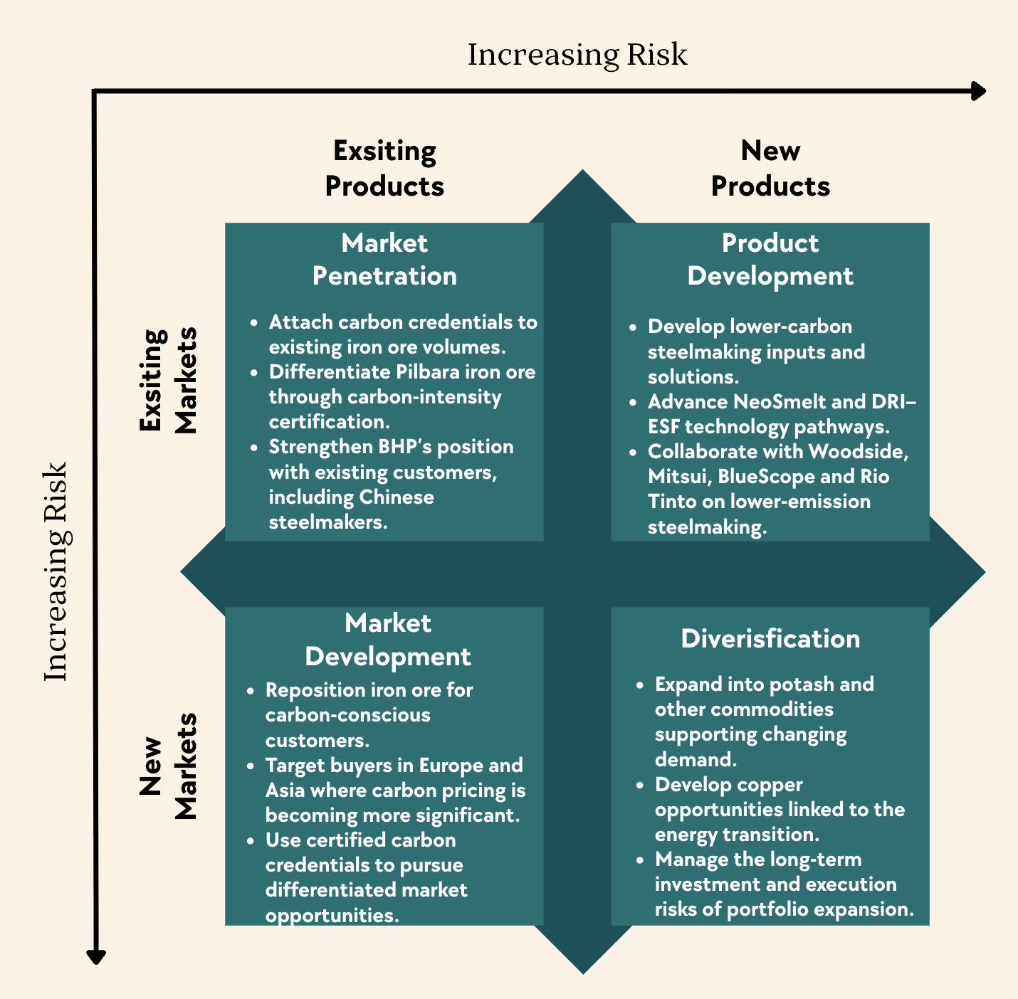
Figure 10: Ansoff Matrix
Source: (Self-designed)

Ansoff strategy | Role in BHP’s transition | Priority
Product development | Lower-carbon steelmaking solutions, including NeoSmelt and DRI–ESF collaboration | Primary
Market development | Reach carbon-conscious steelmakers and markets | Primary, complementary
Market penetration | Strengthen existing iron ore sales through carbon credentials | Supporting
Diversification | Develop copper and potash opportunities | Longer-term
Table I: Rationale for choosing factors of Ansoff Matrix

2.2 Product Development: Lower-Carbon Steel Inputs and Value Chain Collaboration
Product development is the most direct response to decarbonisation by BHP. The company is looking for multiple technology paths to allow low-emission steelmaking.
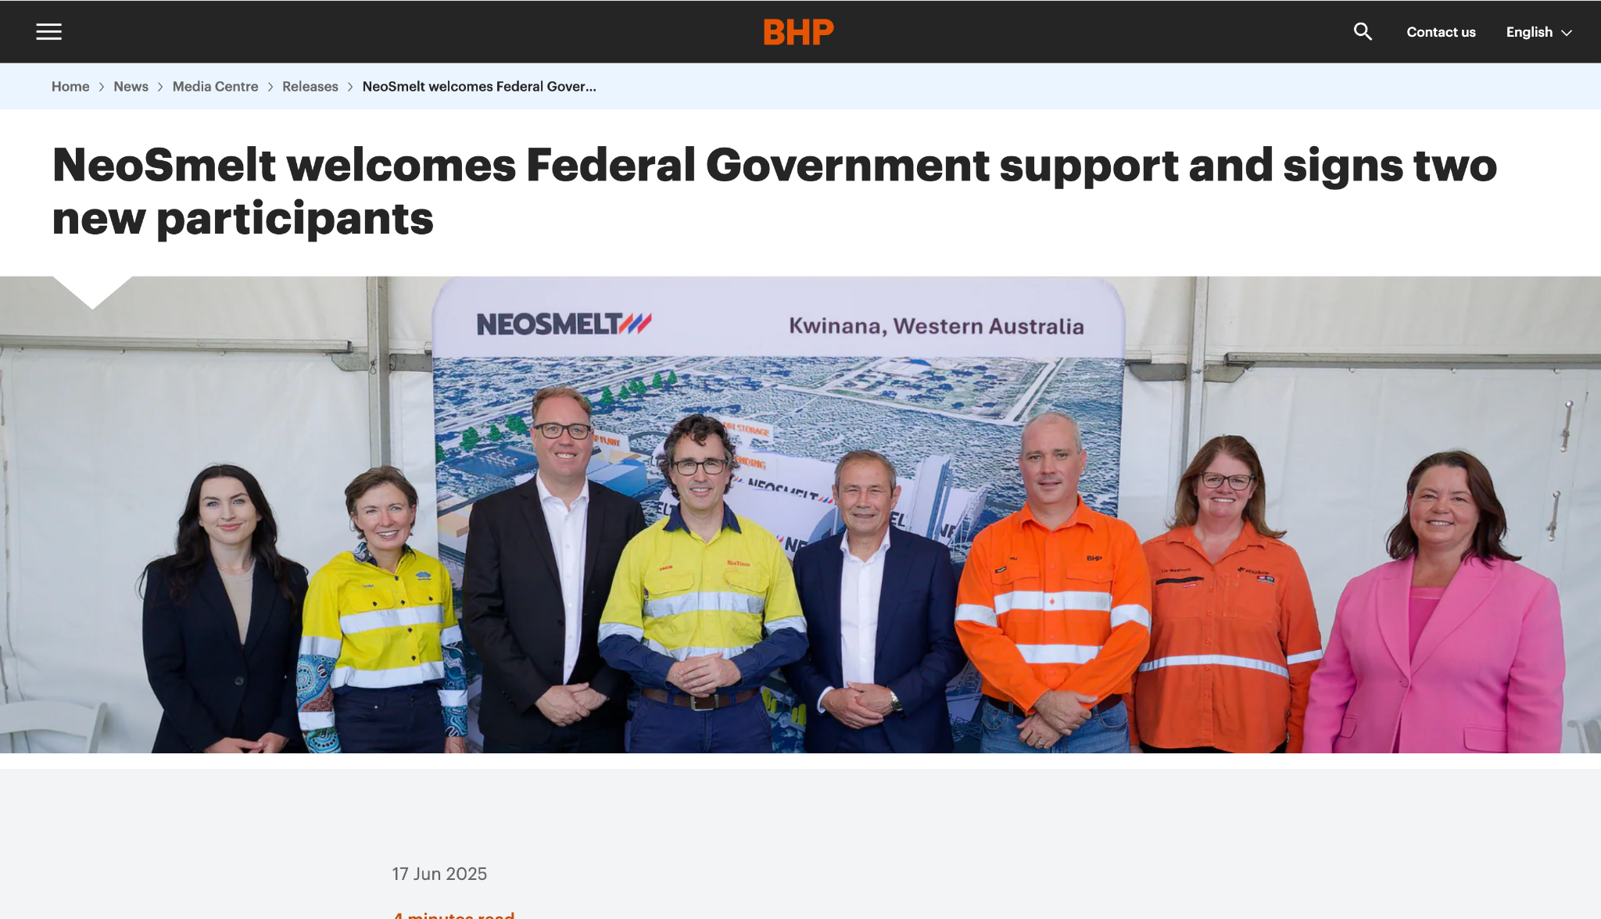
Figure 11: NeoSmelt welcomes Federal Government support
Source: (BHP, 2025)
Woodside Energy and Mitsui Iron Ore Development are new equity members in the NeoSmelt joint venture, which was established by BlueScope, BHP, and Rio Tinto (BHP, 2025). These collaborations create cutting-edge technology with the government and business community. This lays the groundwork for a lower-carbon Australian iron export sector with the global steel industry. Importantly, future DRI deployment will be supported by increasing the use of Pilbara iron ore fines, and coupled DRI-ESF routes have the potential to significantly reduce CO2 emissions intensity by over 80% when compared to traditional blast furnace steelmaking (BHP, 2026). This illustrates that BHP is investing in product development, but the commercial viability is still uncertain.

2.3 Market Development: Repositioning for Carbon-Conscious Customers
Market development includes taking BHP's iron ore product to a new customer segment which can value the carbon credentials. BHP has 50 partners, including 11 steelmakers, 16 research institutes, and 12 technology businesses. The eleven steelmakers together account for around 22% of the reported global steel production (BHP, 2024). These partners are primarily located in the markets where carbon pricing is becoming material. Certified products facilitate the brand premium, indicating the company is looking for commercial opportunities in differentiated low-carbon iron ore (Recabarrem et al., 2024). With a 65% iron grade, Simandou's ore caters to the premium market for green steel that uses less carbon (Reuters, 2025). High-grade ore is the most suitable for DRI-based steelmaking, the leading route for emission reduction. BHP’s product portfolio is not aligned with customer demand as the market for low-grade ore contracts, and clean steel-making input grows.

2.4 Diversification: Potash, Copper, and Battery Metals
Diversification includes the long-horizon bet of BHP on the commodity which can benefit from the energy transition but is not directly exposed to the steel decarbonization risk.
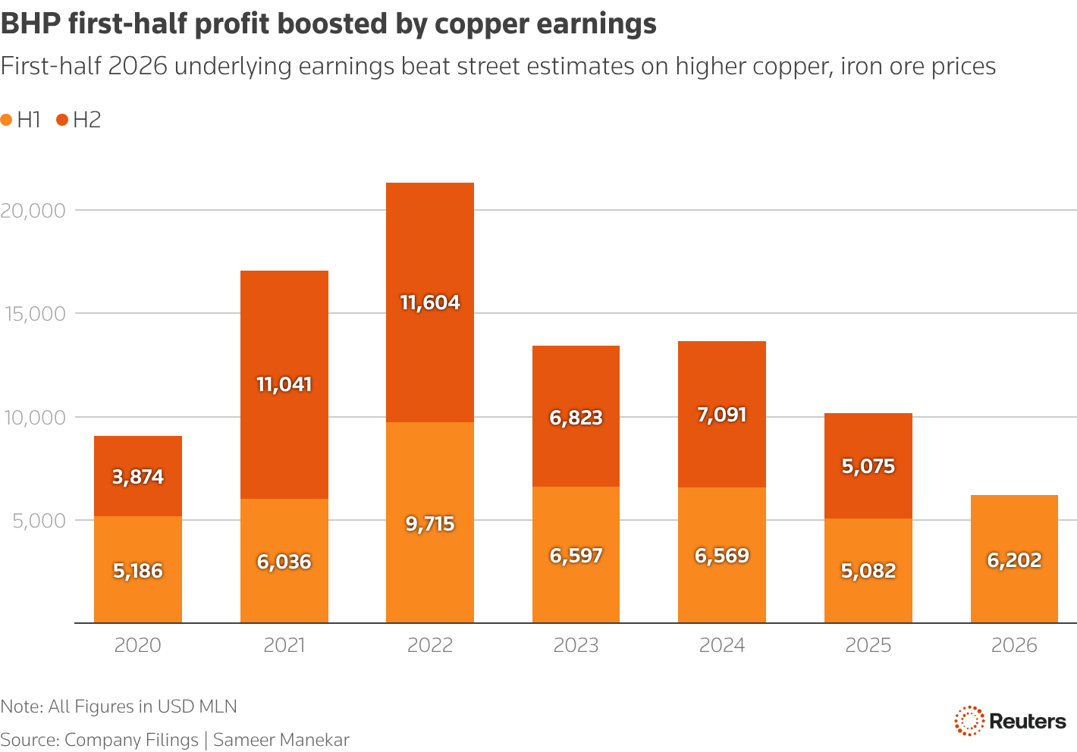
Figure 12: BHP first-half earnings
Source: (Reuters, 2026)
Copper accounts for 51% of operational earnings, surpassing iron ore in the top global miner's profitability (Reuters, 2026). Copper output reached a record 2,017 kt, an 8% annual increase (Yahoo Finance, 2025). Notably, BHP still anticipates that Jansen Stage 2 will produce about 4.36 million tons annually (Mtpa) (BHP, 2026). However, the investment cost estimate has been revised from the US$5.7 billion initial estimate for Jansen Stage 1 when the project was approved in August 2021 to the previously estimated range of US$7.0 billion to US$7.4 billion (including contingencies) announced in July 2025 (BHP, 2026). The cost overrun and impairment demonstrate that moving into the new commodity is not a hedge against steel decarbonization. The fertilizer demand, rather than steel or wiring, can provide the genuine different demand cycle. However, the financial return will not be realized for several years, and the new term transition story remains in iron ore and copper.

2.5 Market Penetration
Market penetration focuses on increasing the position of BHP in the existing market with the existing product. BHP's annual contract discussions with China Mineral Resources Group, which accounts for about 80% of Chinese steel mills, involved concessions on increasing the usage of yuan (Financial Review, 2026). BHP’s Western Australia iron ore operation delivered 199 Mt in 9 months (Steel Orbis, 2026). The strategic opportunity is identified in attaching the carbon credentials to the existing iron ore volumes. Certifying the carbon intensity of the Pilbara ore can differentiate their market share while meeting the customer's determination requirements

2.6 Competitive Advantage: Differentiation Through Carbon Credentials
BHP should use differentiation rather than cost leadership, as the competitive advantage is identified in the certified low-carbon input for the steelmaker facing the carbon price. Unlike its competitors, BHP does not produce high-quality iron ore for low-carbon steel, a grade in demand (IEEFA, 2024). This gap represents both a risk and an opportunity; BHP should accelerate the NeoSmelt DRI-ESF collaboration. Processing might reduce CO2 emission intensity by up to 80%. Iron ore from the Pilbara via a DRI-ESF route (Rio Tinto, 2025). Differentiation is only suitable and sustainable if the carbon cost becomes material for the customers.

Task 3: Managerial and Professional Reflection

3.1 Reflection on Key Decisions
Why BHP?
I selected BHP because it is the largest mining company in the world in terms of market capitalisation and is responsible for GHG emissions. BHP is at the center of the discussion between resource extraction and recognition as the major producer of iron ore, copper, coal and potash (Mugebe, 2024). BHP recently made a public commitment to net zero by 2050, which is not yet matched by the capital allocation decisions. There is a gap between BHP's climate rhetoric and the actual investment behaviour, which provides evidence of the credibility gap that senior leadership has to address.

Why the Environmental actor as the primary lens?
I selected an environmental actor as the root driver for the strategic imperative of BHP. Climate change emissions, water scarcity and biodiversity loss can affect the social license of BHP, access to capital and the ability to sell the product to carbon-conscious customers. I incorporated the political factor because it translated environmental expectations into enforceable financial consequences. CBAM demonstrates that the policy is a proximate mechanism through which environmental pressure can become material. Social factors are also included because investor activism, community opposition and media scrutiny can amplify the gap between BHP's commitment and action.

Why the Ansoff Matrix?
I selected the Ansoff Matrix because it clearly articulates whether growth is about the new product, new market or both. The transition of BHP is the single strategic move, as it is the portfolio response. Product development, market development and diversification address the dimensions of the transition. Matrix simplicity is the primary strength, but the limitation is that it does not capture the execution risk.

3.2 Reflection on Limitations of the Analysis
Information gaps
The analysis is heavily dependent on the publicly available data, internal documents and third-party reports. It provides valuable understanding but does not offer the complete picture of internal decision-making at BHP. The real consultant would look to assess the marginal abatement cost curve of BHP, investment committee criteria for the green project approval and customer willingness to pay for the low-carbon iron ore.
What additional information would a consultant seek?
I think consultants would look for scenario-based financial modelling to compare the return on capital employed for the green project with the conventional project under a different carbon price scenario for BHP. Secondly, direct interviews with the customers as to what the premium European and Asian still makers are willing to pay for the certified low-carbon ore. Jurisdiction-by-jurisdiction policy discussion assessment, as it also means how Australia will safeguard mechanisms, CBAM expansion and how the US regulatory environment will evolve.
Reflection on the consultant's role
As a consultant, the value is not in providing the definitive answers but in framing the right questions and quantifying the trade-offs. I identify the central issue as the public commitment of BHP against the investment decision. The strategic question arise here for the senior leader is whether they can credibly differentiate through the carbon credentials when its own capital allocation suggests a difference from maintaining the status quo.

References
BHP, (2024). BHP's Climate Transition Action Plan (CTAP) 2024. Available at: https://www.bhp.com/ctap2024
BHP, (2024). Decarbonisation: Why our emissions reduction pathway is not a smooth nor straight line. Available at: https://www.bhp.com/news/articles/2023/10/decarbonisation-why-our-emissions-reduction-pathway-is-not-a-smooth-nor-straight-line
BHP, (2024). Pathways towards steelmaking decarbonisation. Available at: https://www.bhp.com/news/bhp-insights/2024/10/pathways-towards-steelmaking-decarbonisation
BHP, (2025). NeoSmelt welcomes Federal Government support and signs two new participants. Available at: https://www.bhp.com/news/media-centre/releases/2025/06/neosmelt-welcomes-federal-government-support-and-signs-two-new-participants
BHP, (2026). BHP Exchange release. Available at: https://www.londonstockexchange.com/news-article/BHP/jansen-project-update/17646343
BHP, (2026). BHP Group Limited Exchange release. Available at: https://company-announcements.afr.com/asx/bhp/28e9294d-9b4f-11f1-8469-d2c92360b8b4.pdf
BHP, (2026). Progressing multiple technology pathways to achieve our steelmaking decarbonisation 2030 goal. Available at: https://www.bhp.com/news/case-studies/2026/08/progressing-multiple-technology-pathways
BHP, (2026). Update - Jansen Stage 1 Potash Project. Available at: https://www.bhp.com/news/media-centre/releases/2026/01/jansen-update
Campbell, R., (2024). Australia's Fuel Tax Credits Scheme: A Fossil Fuel Subsidy Debate. Available at: https://australiainstitute.org.au/report/australias-fuel-tax-credits-and-the-debate-over-fossil-fuel-subsidies/
Climate Integrity, (2026). Conflicting Signals: How diesel rebates to big polluters are undermining the Safeguard Mechanism. Available at: https://climateintegrity.org.au/latest/conflicting-signals-how-diesel-rebates-to-big-polluters-are-undermining-the-safeguard-mechanism
CSRIO, (2024). CSIRO report: Aussies support mining for energy transition minerals, want rigorous governance. Available at: https://www.csiro.au/en/news/All/News/2024/October/CSIRO-report-reveals-Australians-attitudes-toward-mining-in-2024
Deonandan, K., Schoenfeld, J., Salim, A. and Bourassa, M., (2024). Social License to Operate (SLO): private governance and barriers to community engagement. The Extractive Industries and Society, 17, p.101404. Available at: https://www.sciencedirect.com/science/article/pii/S2214790X24000029
Financial Review, (2026). BHP says its carbon emissions, diesel use will stay higher for longer. Available at: https://www.afr.com/companies/energy/bhp-says-its-carbon-emissions-diesel-use-will-stay-higher-for-longer-20260916-p60xvq
Financial Review, (2026). BHP, Fortescue warn China’s influence over iron ore will only grow. Available at: https://www.afr.com/companies/mining/bhp-fortescue-warn-china-s-influence-over-iron-ore-will-only-grow-20260527-p601bv
Huyau Parts, (2026). Top 10 Mining Companies in the World in 2026. Available at: https://www.huayuparts.com/top-10-mining-companies/
IEEFA, (2024). BHP is lagging its peers on Scope 3 and steel technology transition. Available at: https://ieefa.org/sites/default/files/2024-10/BN_BHP%20is%20lagging%20its%20peers%20on%20Scope%203%20and%20steel%20technology%20transition_Oct24.pdf#2#1
Islami, M.S., Urmee, T., Lund, C., Bahri, P.A. and Anisuzzaman, M., (2025). Decarbonisation strategies for critical mineral supply chain: State-of-Art in mining and refining industries. Renewable and Sustainable Energy Reviews, 218, p.115811. Available at: https://www.sciencedirect.com/science/article/pii/S1364032125004848
Mugebe, P., (2024). Impact of mining technological innovations on iron ore share prices. Available at: https://espace.library.uq.edu.au/view/UQ:e27e9ef
PR Newswire, (2026). Mining for key energy-transition minerals is not a major source of global greenhouse gas emissions, ICMM research finds. Available at: https://www.prnewswire.com/in/news-releases/mining-for-key-energy-transition-minerals-is-not-a-major-source-of-global-greenhouse-gas-emissions-icmm-research-finds-302709285.html
Recabarren, J.I., Castillo, E., García, A. and Cantallopts, J., 2024. Product differentiation in mineral commodities based on sustainability indicators: The case of copper mining. Journal of Cleaner Production, 476, p.143786. Available at: https://www.sciencedirect.com/science/article/pii/S0959652624032359
Reuters, (2025). Guinea aims for global high-grade iron ore leverage with Simandou launch. Available at: https://www.reuters.com/world/africa/guinea-aims-global-high-grade-iron-ore-leverage-with-simandou-launch-2025-11-12/
Reuters, (2026). BHP profit beats forecasts as copper tops iron ore earnings on AI-driven demand. Available at: https://www.reuters.com/business/bhp-group-reports-22-growth-first-half-profit-2026-02-16/
Rio Tinto, (2025). NeoSmelt welcomes Federal Government support and signs two new participants for groundbreaking steel decarbonisation project. Available at: https://www.riotinto.com/en/news/releases/2025/neosmelt-welcomes-federal-government-support-and-signs-two-new-participants-for-groundbreaking-steel-decarbonisation-project
S&P Global, (2026). Water, energy pressures are driving up Chile's mining costs. Available at: https://www.spglobal.com/market-intelligence/en/news-insights/research/2026/04/water-energy-pressures-are-driving-up-chiles-mining-costs
Statista, (2024). BHP's operational greenhouse gas emissions from FY 2020 to FY 2024. Available at: https://www.statista.com/statistics/1407581/bhp-operational-emissions-of-greenhouse-gases/?srsltid=AU7gw4Wodaal0DLHrLrpX9-eKlU8n0VMEUV5nyS6tviHvTjzDjmZ0PA6
Statista, (2024). BHP's total greenhouse gas emissions from FY 2021 to FY 2024, by scope. Available at: https://www.statista.com/statistics/1409009/bhp-emissions-of-greenhouse-gases-by-scope/?srsltid=AU7gw4WylgdJknbgCnuPGpufckJMr1Ja7T1AvGq6AsyCjYZJ1Igd0067
Steel Orbis, (2026). BHP secures iron ore supply deal with China Mineral Resources Group. Available at: https://www.steelorbis.com/steel-news/latest-news/bhp-secures-iron-ore-supply-deal-with-china-mineral-resources-group-1449591.htm
The Business Research Company, (2026). Green Mining Market Report 2026. Available at: https://www.thebusinessresearchcompany.com/report/green-mining-global-market-report
The Guardian, (2026). Australia’s fuel tax break slowing BHP’s decarbonisation, mining giant’s investors warned. Available at: https://www.theguardian.com/australia-news/2026/jul/18/australias-fuel-tax-break-slowing-bhps-decarbonisation-mining-giants-investors-warned
The Point, (2026). Australia’s biggest industrial emitters are being paid to pollute, new analysis finds. Available at: https://thepoint.com.au/new/260731-australias-biggest-industrial-emitters-are-being-paid-to-pollute-new-analysis-finds
Union, (2026). Price of CBAM certificates. Available at: ​https://taxation-customs.ec.europa.eu/carbon-border-adjustment-mechanism/price-cbam-certificates_en
Union, D.-G. for T. and C. (2026) 'CBAM successfully entered into force on 1 January 2026,' Taxation and Customs Union, 14 January. Available at: https://taxation-customs.ec.europa.eu/news/cbam-successfully-entered-force-1-january-2026-2026-01-14_en.
Yahoo Finance, (2025). BHP Group FY25 Earnings & Revenues Decline Y/Y on Lower Prices. Available at: https://finance.yahoo.com/news/bhp-group-fy25-earnings-revenues-161300386.html
Yan, L., Weng, K., Zhou, H., Zhu, D., Zhu, X., Zhou, Y., Gao, S. and Du, Z., (2025). The Long-Term Impact of Carbon Border Adjustment Mechanism on China’s Power Supply and Demand and Environmental Benefits: An Analysis Based on the Computable General Equilibrium Model. Energies, 18(18), p.4943. Available at: https://www.mdpi.com/1996-1073/18/18/4943
Zugay, B., (2023). Ansoff matrix. SAGE Publications, Inc.. Available at: https://sk.sagepub.com/foundations/ansoff-matrix

