MODULE CODE: BMSW4003

MODULE: DIGITAL SKILLS AND RESEARCH METHODS
  - TOPIC: The impact of Virtual Learning Environment (VLE) – Moodle on students’ learning experience in the University of Wales Trinity Saint David London Campus.

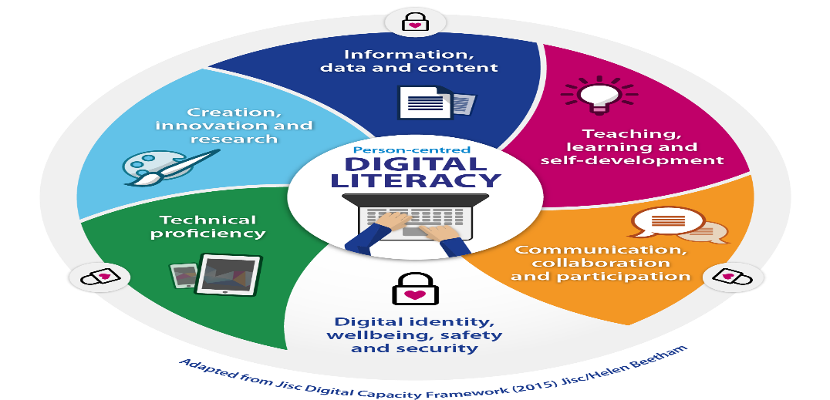

  - Student Number: 1909062
  - Student Name: Sabina Bocsenean
  - Tutor Name: Balendran Kandasamy

Date: 08/05/2020

Contents

1. Abstract 3
2. Background 3
3. Purpose 7
4. Methodology 7
5. Result 8
6. Conclusion 8
Appendix 9
Reference List: 10

The impact of Virtual Learning Environment (VLE) – Moodle on students’ learning experience in the University of Wales Trinity Saint David London Campus.

1. Abstract

In the UK in Higher Education, the online learning platforms, with other words virtual learning environments play vital role as it is an essential resource for the students that enable them to get engaged with each other, with the professors, faculty and access variety of learning materials. It not only delivers instructional materials to the users but also facilitates communication, too. (Secker, 2004) In regard to how strong the engagement with the students via VLE is very limited and not many studies have been made. Therefore, this research study was written with the aim of analysing the impact of VLE on my and my classmates learning experience who are studying towards for a Certificate of Higher Education in Skills for the Workplace. To write this short research study, qualitative and quantitative approach, primary and secondary data were taken to identify and access the impact of VLE on the learners as well their engagement level. The finding chapter summarizes the result of the distributed surveys to my classmates (21) which was made of 3 research questions to investigate the impact of VLE on the learning and motivation of the students. The findings explain that the VLE and Moodle increased the motivation of the students to learn.

2. Background

This chapter will outline the background of virtual learning environments to support students’ learning. In 1996 Scardamalia and Bereiter wrote a study about a collaboration tool that aimed to enable the learners and lecturers to communicate with each other online and develop their analytical skills. According to the study, virtual learning environments have both negative and positive impacts, too. The research indicated that VLEs positively impacted on the students. Whoever used VLEs, performed better compared to those ones who did not use VLEs, from different aspects that are as follows:
- Vocabulary and language
- Standardised tests in reading
- Independent thoughts
The progressive thought of the students is encouraged, and the reflection of the students are maximized too by VLEs. Addition to that, Schacter (1999) explained that those students who have access to integrated learning systems, programming technologies and simulation software are positively impacted and can achieve greater results on national, constructed and standardised tests. In the context of Higher Education, Wernet et al (2000) survey result indicated that technology-based instruction had negative impact and is disadvantageous for women and for those mature students who are non-traditional. The graduate and undergraduate students show more enthusiasm about the technology in terms of learning. While VLE accommodates the non-traditional and mature students’ needs who study social work, the purely satisfaction of the students of VLE depends on access, utility and usefulness of the tools.
Moreover, in 2001, Cameron and Diochon carried out a research and conducted a survey within business undergraduate students, who only had access to their learning and training materials by VLE. The study findings indicated that the students’ enthusiasm, confidence and capacity all got increased as VLE helped students to create their knowledge and developed their core competencies and employability skills, too.
Furthermore, the UK Government evaluated the VLE’s development, too. In 2005 Ofsted visited colleges, primary and secondary schools, too. 25 years ago, the inspectors found that Colleges made the most use of VLEs. By that time the VLE’s concept was still relatively new. (Ofsted, 2009) The VLE provides students with the opportunity to catch up on what they missed in school. By that time Ofsted found that the interactive tools, e.g.: chat rooms and forums were not equally used by the institutions. Even though, wherever it was used, the students were enthusiastic to use the technology. The report also indicated that those classes that have online learning elements managed to achieve higher learning outcomes than those classes that had only face to face teaching. The 2 major positive impacts were readiness for learning and the flexible accessibility of the resources for the learners that got integrated into the process of education.
Indeed, Jewitt et al (2011) reported 3 top benefits of VLE, that are the enhanced support for learning from home, improved facilitated communication across the school, and increased opportunities for the students to study independently. In summary, it can be stated that from various context, virtual learning environments provide positive impacts for both learners and educational institutes and teachers, too. Moodle, Blackboard, VLEs, etc, promote the student reflection, variety of the students’ needs are accommodated, significantly increase the readiness to learn, highly improving the students’ confidence and enthusiasm, and the assessment/assignment/exam performance is also improved by VLEs.
However, from the other side, negative impacts of the VLEs were also identified by different researchers. Crook (2000) explained that virtual learning environments and web-based instructions do not allow the students’ social and emotional interaction. While the traditional classroom based teaching does allow the students to interact with each other from social and emotional aspects. However, no significant diversifications were found between the environments from learning performance point of view. Crook (2000) also stated that the students who are only provided with learning environment opportunities and no classroom-based teaching activity have no opportunity and cannot benefit from the structured dialogue that can be created by the community in the classroom.
Additionally, the LXP (2006) study that was focusing on 4 academic subjects: medicine, Economics, IT and Languages focused on how the study habits of the learners are changing by the use of VLEs. Both quantitative and qualitative methodologies were used for the study and over 400 learners were questioned. LXP study concluded that the students study style is often passive that active within those, who use the technology.
Moreover, Open University UK conducted researches too. The study concluded six main reasons why students can be motivated by using VLEs. The reasons are as follows:
- The students are provided with control over their learning. They may choose and define activities and tasks that they prefer to get engage with, which makes them to take responsibility for their own learning.
- The access to the technologies is increased, which gives students ownership and significantly encourages the participation. The students find it highly motivating that they have opportunity to learn informally when and wherever it suits them better.
- Students have opportunity to share content with each other. Indeed, they may access those resources and information that they feel is the most relevant context.
- Between the contexts there is continuity as the virtual learning environments offer students more opportunities to get feedback for their formative assessment ant they can achieve better.
- Virtual learning environments can be fun. Most of the questioned students mentioned the phrase of fun when talking about VLEs.
- VLEs provide a platform to chat and communicate as well learn collaboratively with other students, which is motivating.

3. Purpose

The web-based software system, with other words it also called as virtual learning environment is designed for both learners and educators to facilitate the teaching activity with variety of tools. In the UK, the students in higher education are required and asked to use VLE. It is a task that needs to be completed with a purpose of developing their own learning. Due to the increasing popularity of the VLEs, there are questions arising, that are essential to be answered. Is there any impact that VLEs can have on the achievement of the students? Are the students motivation for independent learning encouraged by the web-based software systems? This study was written with a purpose of gaining deeper understanding of the impact of VLEs on the learner experience, answering 3 main questions that will be revealed in the following chapter as well giving recommendations to the educators.
The reviewed literature answered the research questions already, as evidences suggest that virtual learning environments transformed the way of learning and has both positive and negative impacts on the achievements of the students. However, to answer the fully the research questions, quantitative survey was also conducted with the aim of gathering data.

4. Methodology

To write this research study, a questionnaire was distributed to 21 students with the help of Google Form. In addition to that, articles and previous study results were analysed, too. My classmates were invited to answer questions with the aim of answering the 3 main research questions in their spare time. Only 10 completed survey were sent back. The research questions are as follows:
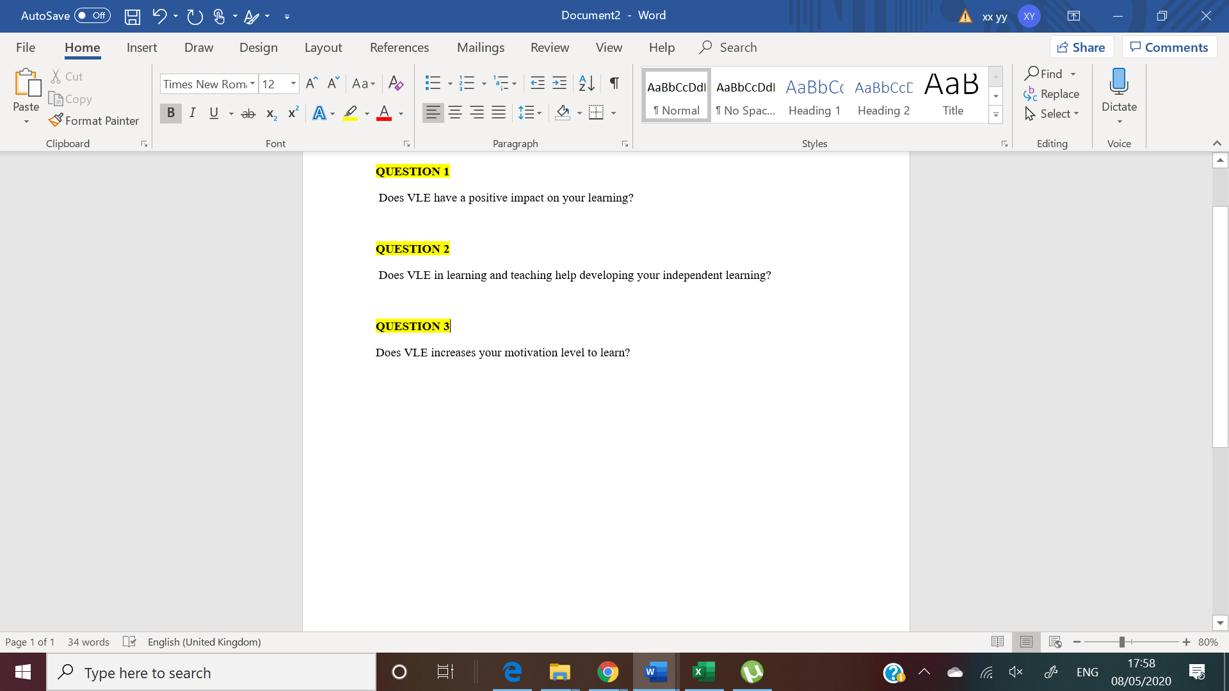
The 10 respondents are studying for their Higher Educational Certificate and they are first year students. In the questionnaire there were 2 sections and 8 questions in total. The scale to respond was as follows:
- Strongly Disagree – 1
- Disagree – 2
- Nor disagree neither agree – 3
- Agree – 4
- Strongly agree – 5
The questionnaires were anonymous and nobody was forced to respond. The respondents were volunteers. The survey was open for 7 days for the invited volunteers to answer the questions.

.

5. Results

Within one week, from distributing the surveys until the deadline, 10 questionnaires were completed. 8 questions were asked, see it in Appendix. The respondents are first year students.
The answers for the questionnaires were in line with the revealed literature review in the second chapter.
7 female and 3 male. 80% of the respondents accessed virtual learning environment without any issues, while 20% had some problems accessing it. None of the respondents answered that they have never tried to access VLE. As part of student learning, VLE/Moodle is required from students who study at University of Wales – Trinity Saint David. 100% of the respondents use VLE/Moodle. Nobody answered that they would not use moodle at all. It is important to mention, that all of the coursework have to be uploaded via VLE so the answer of the respondents is not surprising at all.
The below table and graph shows the answers for the 8th questions. 50% of the respondents believe that VLE has positive impact on their learning and on their achievement.
Question 8: VLE has a positive impact on your achievement
Strongly Disagree | Disagree | Neither Agree or Disagree | Agree | Strongly Agree
1 | 1 | 3 | 3 | 2
10% | 10% | 30% | 30% | 20%


The overall result indicated that the VLE use helps the students to develop their independent learning. 70% of the respondents agreed or strongly agreed on VLE encourages their independent learning. However, only 30% of the respondents agreed on the VLE would encourage their interaction and communication with their professors or with other students. 80% of the respondents agreed that the resources that can be found on VLE are mainly for information purposes. 100% of the respondents are asked at least once a week by their teachers to use VLE.

6. Conclusion

The background and literature review chapter answered the research questions what were further justified with the results of the survey. The virtual learning environments usage motivates the learners and encourages them to learn independently as it gives an opportunity to the student to learn informally whenever and wherever it suits them best. It does no only provides the students with flexibility in this fast paced and busy environment but it also enables them to catch up on what they missed, gather feedback on their formative work. The literature review highlighted that there is evidence of how VLE can increase the motivation of the students to learn as it promotes direct feedbacks, communication and collaborative learning which is already motivating itself. While there are numerous positive impacts of the VLEs on the students motivation and learning, the reviewed literature review and survey feedbacks both indicated that it also has negative impact, too. For the 8th question 50% of the respondents answered “either agree” on VLE has positive impact on their learning which makes us think that 50% does not strongly agree.
For the second research question, we can clearly state that virtual learning environments do help the students’ independent learning. The survey results show that more that half of the respondents agree and strongly agree of their independent learning is being developed by VLEs/moodle.
For the 3rd main research question, the answer was already given by the previously revealed studies, such as VLEs increasing the motivation of the students to learn.

Recommendations

From the result of the research, the conclusion and own student experiences, it felt essential to make some recommendations in regards to the virtual learning environments use. These are as follows:
- Provide both academic staff and students with training on how to use the virtual learning environmental platforms. Personally, I felt it challenging to start using the platform at the beginning of my studies. Indeed, some of my professors do not make all the learning materials available to download.
- Minimum requirements may be considered in regards to the use of VLEs by the learners and students.
- Regardless the technology is booming and the internet accessibility has been significantly increased in the last decade, not all the students have access to VLE from their home. For these cases students should be provided with opportunities, e.g.: laptop, tablet etc to access VLE not only from the school.
- With wider range of communication tools on VLEs, students should be encouraged to use VLE in a non-directed way.
- Provide students with an opportunity to be able to control their use of VLE. E.g.: statistics of how many hours have been spent online.
- VLE use should not be restricted to information repository.

Appendix

  - Questionnaire



Reference List:

Barker, J., Gossman, P. (2013). ‘The learning impact of a virtual learning environment: students’ views ‘ Tean Journal 5 (2)
Jewitt, C., Hadjithoma-Garstka, C., Clark. W, Banaji, S. and Selwyn, N. (2011). School use of Learning Platforms and associated technologies. London Knowledge Lab: Institute of Education.
Cowan, J., (2003) Assessment for Learning, giving timely and effective feedback. Exchange, Issue 4, 21−22.
Knowledge Anywhere. 2020. Knowledge Anywhere :: The Advantages And Disadvantages Of A Virtual Learning Environment. [online] Available at: <https://www.knowledgeanywhere.com/resources/article-detail/the-advantages-and-disadvantages-of-a-virtual-learning-environment> [Accessed 1 May 2020].
Ofsted (2009). Harnessing technology – transforming learning and children’s services (1296-2005DOC-EN), DfES 2005.
Ofsted (2009). Virtual learning environments: an evaluation of their development in a sample of educational settings [online]. Available at: http://dera.ioe.ac.uk/325/1/VLE%20an%20evaluation%20of%20their%20development.pdf
Read, D., Coles, S., Frey, J., and Littlefield, B. (2013). Investigating the use of Virtual Learning Environments by teachers in schools and colleges.
Secker, J. ( 2004). Electronic Resources In The Virtual Learning Environment. Oxford: Chandos Publishing.
Simon K. Haslett & Caroline B. Usei (2016). Wales Journal of Learning and Teaching in Higher Education. Volume 1, Number 1, 60-65 pp ISSN 2396-7285 (online)
TheFreeDictionary.com. 2020. VLE. [online] Available at: <https://acronyms.thefreedictionary.com/VLE> [Accessed 2 May 2020].
Wernet, S. P., Olliges, R. H., & Delicath, T. A. (2000). Post course evaluations of WebC T (Web Course Tools) classes by social work students. Research on Social Work Practice, 10(4), 487-505
Meer, S., 2020. The Learning Impact Of A Virtual Learning Environment: Students’ Views - Insight. [online] Insight.cumbria.ac.uk. Available at: <http://insight.cumbria.ac.uk/id/eprint/1455/> [Accessed 2 May 2020].

