

Assessment 1 – Reading Task Template
PART 1: Upload your photo of your A3 in-class notes here:
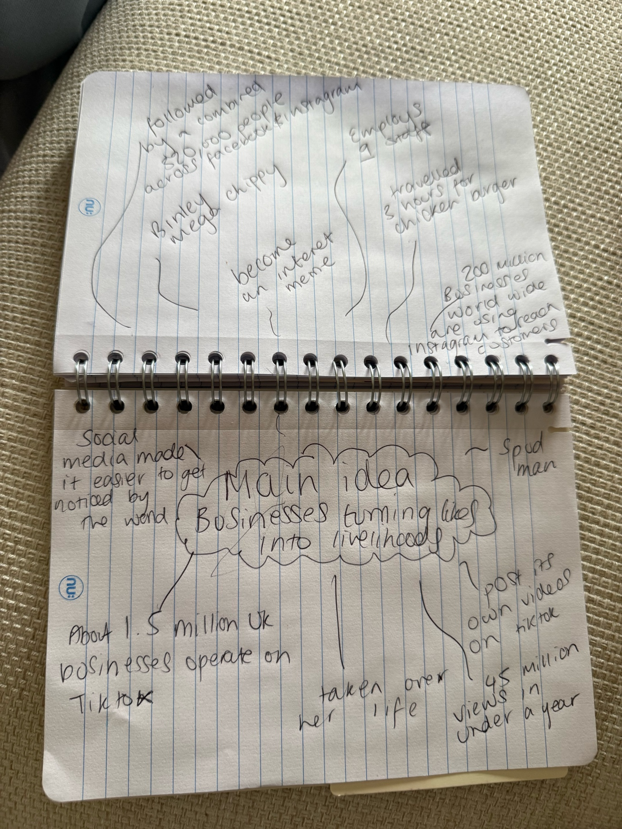

PART 2:
- Answer every question below in 1-3 full sentences.
- Use your own words. Do not use generative AI to answer these questions.
- Include a specific detail from the text when asked.
REMINDER
- The main idea is the overall message of the whole text.
- A key point helps to explain the main idea.
- A specific detail or example from the text shows that the key point is true.

- What is the main idea of the whole text?
The main idea is that social media can help small businesses go viral, drawing in customers from far away and increasing their sales.
- What is one key point that supports the main idea, and which specific example from the text shows this?
Key point: social media can help bring a large number of new customers to small businesses
Specific examples: The Honywood sandwich shop became very popular after the shop was posted online by customers and people travelled up to three hours just to try their burger.

- What is a different key point that supports the main idea, and which specific example from the text shows this?
Key point: social media that goes viral can help greatly increase a businesses sale.
Specific example: The Binley mega chippy saw that its trade increase because of videos that was posted on social media.

- Which part of the text do you think is most important, and why?
I think the most important part is where it says customers travelled three hours for our chicken burger because it shows social media can turn small businesses successful because the burger become popular online so people travelled long distances just to try it making the business gain more customers.
Reflection:
- What did you find difficult in this task (including in-class components), and why was it difficult?
Finding so many different points because its talking about the same sort of thing

- What helped you with this difficulty, and how did it help you?

