Michael Oldham (2235684)
[Email address]
Data Mining

Contents
The Purpose and use of Data Mining 2
Dataset Description 3
Exploration and visualisation 4
Pre-processing & Post-processing 6
Sample Runs & Results 9
M5P Regression tree 9
Random Forests 10
K-NN (K-Nearest Neighbor) 11
K-Means Clustering 12
Business Recommendations 14
Refection 14
References 15
Appendix 16

The Purpose and use of Data Mining
Data mining is the process of examining large datasets to find useful patterns, trends, and relationships. Its main purpose is to turn raw data into meaningful information that can support better decision making. In todays digital world, businesses can collect huge amounts of data from sales, customers and websites. Data mining helps make sense of this information.[1]

The practice of data mining involves several steps. First, data is collected and cleaned to remove errors or duplicates. Then, its organised and analysed using tools and techniques such as sorting, grouping and statistical methods. More advanced methods may include machine learning, where systems can identify patterns automatically. The final step is interpreting the results so they can be used in a practical way.[2]

In business, data mining is widely used to improve performance and gain possible competitive advantages. For example, businesses can analyse customer buying habits to understand what products are popular, linked products and when people are most likely to buy them. This can help with stock control and targeted marketing. Other businesses can use data mining to detect fraud, improve customer service and predict trends.

Overall, data mining allows organisations to make informed decisions based on evidence rather than guessing and estimates. By using the data effectively, businesses can reduce costs, increase profits and better meet customer needs. [3]

Dataset Description
The dataset used in this study focuses on student achievement in secondary education from two Portuguese schools. It consists of two related datasets covering Mathematics and Portuguese language subjects, which can be merged due to overlapping student records. The data was collected from school reports and questionnaires, providing a mix of academic, demographic and social information.

The datasets contain 33 attributes describing each student. These attributes include a combination of numerical and categorical data. Numerical attributes include age, study time, number of past failures, absences, and grades (G1, G2, G3), while categorical attributes include gender, school, parental job, and access to internet. The target variable is G3 which represents the final grade. It is important to note that G3 is strongly correlated with G1 and G2 as these are earlier assessment results.

There are no missing values in the dataset, which improves the data quality and reduces the need for data cleaning. However, there are duplicate records across the two datasets, which require preprocessing.

The below R Script has been used to merge the datasets together for accurate analysis.
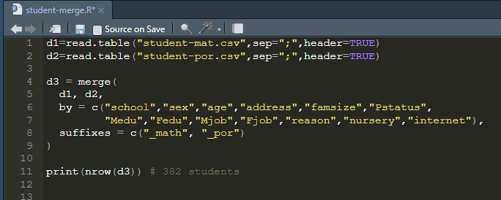

D1 and D2 put each dataset into data frames and d3 creates a new data frame by merging d1 + d2 by the specified columns. I’ve also added suffixes to label the other columns to identify the Math and Portuguese data.

With some research I found a package for R in order for me to save my new d3 dataset as an ARFF file ready to use in Weka, and also exported it as a csv for me to use in excel.

R Script showing install package and code to save the d3 data frame in different formats.
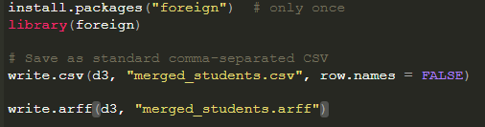

Exploration and visualisation
After merging the data and exploring this in excel, I have come across some of the following insights.
Within the Mathematics data, the average G3 score was 10, with the Minimum score recorded as 0 and Maximum score as 20.
In the Portuguese class, the average G3 score was 13, with a Minimum score recorded as 0 and Maximum of 19. This information has been generated using statistical formulas. I have also used a count to show that there are 382 students, and pivot tables to show the split of Males / Female and the split of students by school.

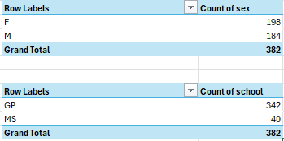

Using the study time categories shown below, I was also able to check for any correlation in the number of hours studying against the average G3 scores in Maths and Portuguese
Weekly Study Time Categories | Corresponding Hours
1 | < 2 Hours
2 | 2-5 Hours
3 | 5-10 Hours
4 | >10 Hours

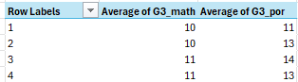
As shown in the image above, the average scores do not change greatly in relation to the weekly hours spent studying.

Below are two graphs showing the absences against the G3 scores in each subject to also check if anything stood out here. The trendline shows a slight decrease in average scores depending on the number of absences, but nothing major.

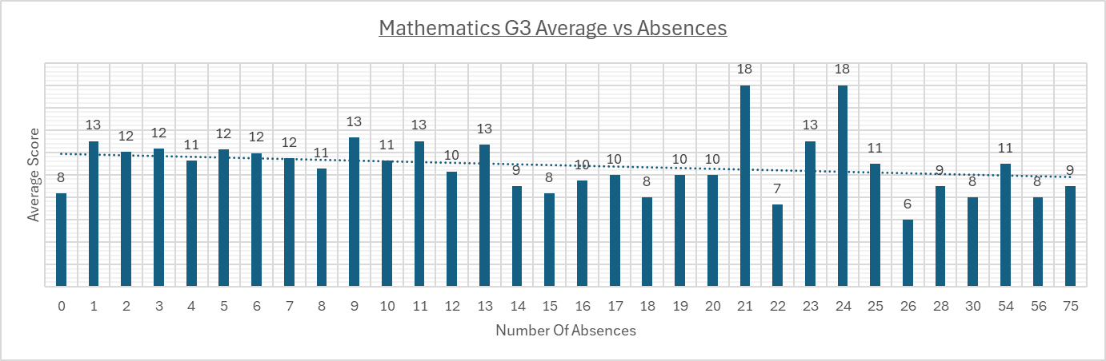
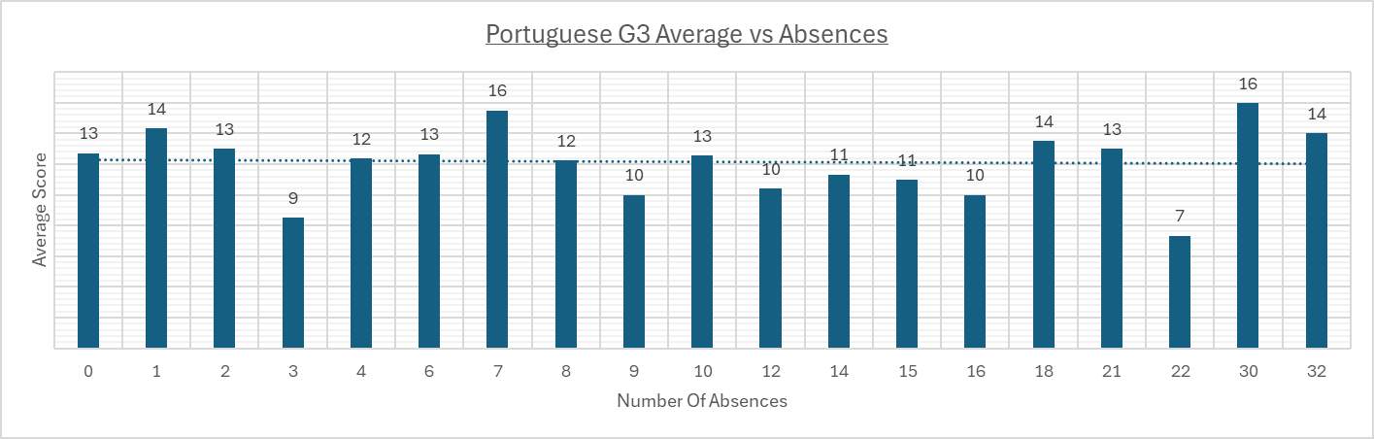

Pre-processing & Post-processing

Pre-processing is a crucial stage in any data analysis or data mining project, as it ensures that the data is clean, consistent, and structured in a way that allows algorithms to perform effectively. without careful pre-processing, models may produce inaccurate or misleading results[4]. In this study, the aim of pre-processing was to prepare the merged dataset of student information from two Portuguese schools so that the final grade outcomes could be predicted reliably. The dataset contains a combination of numeric, binary and categorical attributes, including student grades from different periods, demographic characteristics, school and family information.

Primary pre-processing focused on the basic cleaning and structuring of the dataset. The first step involved checking the types of all the attributes within Weka. Numeric attributes, such as age, previous grades G1/G2, weekly study time, absences were all correctly identified and did not require changes; however, several attributes such as sex, school, reason for choosing the school, and guardian were initially recognised as strings. These were converted to nominal attributes using Weka’s StringToNominal filter. This conversion allows algorithms such as decision trees and random forests to process these features correctly, as nominal attributes are treated as categories rather than free text. It was also confirmed that there were no missing values in the dataset, so this did not require addressing.

Once the primary cleaning was complete, secondary pre-processing involved creating additional features that could enhance the predictability of the models. Two key features were created for each subject using WEKA’s AddExpression filter. The first was ‘math_average_G1_G2’, which calculates the average of the first and second period grades (G1,G2) providing a measure of overall prior performance. The second ‘por_average_G1_G2’ doing the same as the first but for the Portuguese language scores. The third, ‘math_improvement’, measures the differences between the second and first period scores, to capture whether the student performance has improved of declined over time in Mathematics and finally ‘por_improvement’ doing the same again for Portuguese language. These features help the model understand patterns in student performance that might not be apparent from the individual grades alone. Other potential features, such as study effort in relation to absences could also be created and explored if needed, but for this analysis, the focus remained on the grade data.
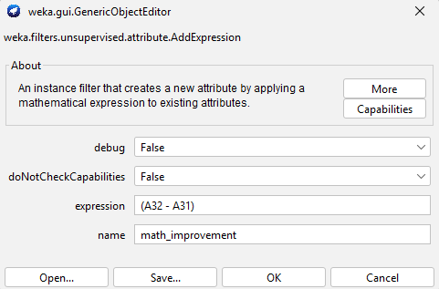
Example of the math improvement expression created to see the difference between G2 and G1.
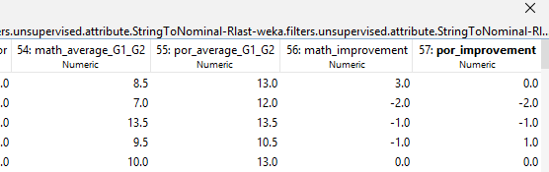
I also manually checked these newly derived features in WEKA to ensure that the expressions were operating correctly.

At this stage the target variable G3 was treated as numeric, showing the final grade on a scale from 0 to 20. While classification methods could later be applied by grouping these grades into categories such as fail, pass and exceeded (or similar), at this stage it was preferable to keep G3 numeric to allow regression methods to predict precise values. Normalisation or scaling of the numeric attributes was not applied at this point because the first algorithms explored (decision trees and random forests), can handle numeric attributes without this being applied. This step can be explored later if distance-based algorithms, such as K-NN (K-Nearest Neighbor) or clustering are used as these methods are sensitive to attribute scales.

Post-processing preparation involved saving the pre-processed dataset to ensure that all conversions and derived features were kept for modelling. The dataset was saved as an ARFF file, which retains both numeric and nominal attribute types and allows it to be reopened in WEKA without the need for repeating previous pre-processing steps. This ensures consistency in all future analyses and provides a foundation for the predictive modelling in the next stage. After modelling, post-processing will also include using the predicted values and comparing them with actual grades, and analysing the features to understand which attributes most influence the final grade outcomes (G3).

In summary, these steps have structured the dataset to be ready for regression modelling, with all categorical variables correctly categorised, numeric values verified, derived features created and the target variable properly defined. These steps reduce errors, improve model performance, and provide a clear workflow for future analysis. The preparation of the dataset ensures that the predictive models applied later can deliver reliable insights into student performance patterns, which is essential for both accuracy and meaningful interpretation of the results.

Sample Runs & Results

M5P Regression tree
The M5P regression tree was used as an initial method to predict student final grades (G3), as it is suitable for problems where the target variable is numeric. M5P works by splitting the data into groups based on important attributes and then applying a linear regression model within each group. This allows it to model both simple and more complex relationships in the data.
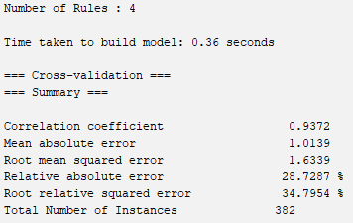

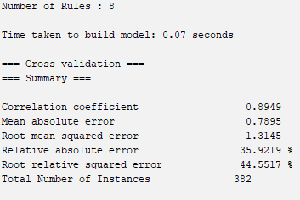
Here are the initial outputs for math_g3 followed by por_g3 using M5P.
The model was run in WEKA using 10-fold cross-validation, which helps to ensure that the results are reliable and reduces the chance of overfitting. The results showed strong performance for both Mathematics and Portuguese, with high correlation values and relatively low error measures.
A Key finding was that the second period grade G2 was the most important variable in predicting the final grades. This shows that previous academic performance has a strong influence on outcomes.

Random Forests
Random Forest was chosen because it is a method that combines multiple decision trees to improve predictive accuracy and reduce the risk of overfitting[5]. It is useful when there are many input variables and complex relationships between them. This was applied to Math_G3 and Por_G3 which provided good results; however, when compared to the previous M5P model, Random Forest performed slightly worse in terms of correlation and error. This is likely because the prior grades G2 dominate the prediction. Random Forest considers additional factors such as absences, family support and social habits, giving a wider view of influences on student performance.

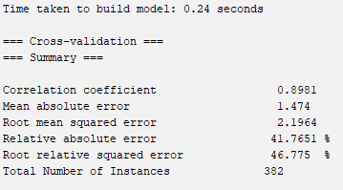

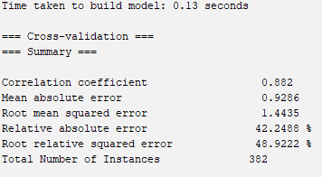

Results shown for Random Forest for Math and Por G3.

K-NN (K-Nearest Neighbor)
Before starting the K-NN analysis, pre-processing is required to standardise numeric data. This was done using ‘normalize’ in WEKA’s Preprocess tab.

The K-NN analysis was applied as an alternative distance-based method to explore local patterns in the data and examine how students’ characteristics relate to their final grades. [6]

KNN Math K-3
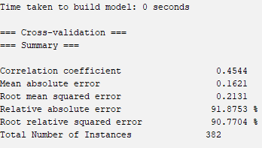
KNN Math K-5
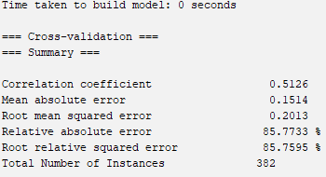

KNN POR K-3
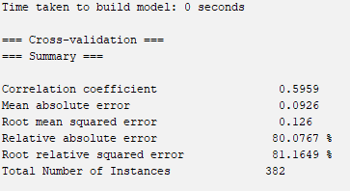

KNN POR K-5
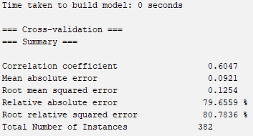

The KNN Outputs show that predictions for Portuguese G3 K-5 are slightly more accurate than Mathematics K-5. Both subjects demonstrate moderate predictive outcomes, with high relative errors, showing KNN limitations when strong predictors like G2 dominate the final outcomes. Increasing from K-3 to K-5 improved the results for both subjects. While KNN can capture local patterns influenced by multiple factors, tree-based and linear models such as M5P and Random Forest outperform it for precise grade prediction in this dataset.

K-Means Clustering
K-Means was used to identify groups of students with similar characteristics and outcomes allowing patterns in study habits, grades, and social factors to be explored which can help highlight student profiles.

K3 findings
Cluster | Size | Key Patterns | Academic Performance | Study / Support Traits
0 | 132 (35%) | Mostly male, MS school | Slightly below average G3 in Math & Portuguese | Moderate family support, some extra-curricular activities
1 | 81 (21%) | Mostly female, GP school | Slightly higher G3 in Portuguese than Math | Lower study time, fewer failures, mixed family support
2 | 169 (44%) | Mostly female | Highest G3 scores in both subjects | Higher study time, strong family support, attends activities

K5 Findings
Cluster | Size | Key Patterns | Academic Performance | Study / Support Traits
0 | 113 (30%) | Mostly male, MS school | Slightly above average G3 in Math & Portuguese | Moderate study time, some family support, attends activities
1 | 30 (8%) | Mostly female, GP school | Lower G3 in Math & Portuguese | Higher study time, mixed family support
2 | 75 (20%) | Mostly female, MS school | Moderate G3 in both subjects | High study time, strong family support, some extra-curricular activities
3 | 121 (32%) | Mostly female, GP school | Slightly above average G3 | Moderate study time, family support present
4 | 43 (11%) | Mostly male, GP school | Mixed performance, slightly lower Math | Moderate study time, some family support

The K-means clustering revealed patterns in the dataset showing that students can be grouped by school type, gender and study/family support traits. Clusters highlighted differences in academic performances and background demographics.

Business Recommendations
Based on the analyses, several recommendations can be made to improve student outcomes. Firstly, predictive models such as M5P and Random Forests identified that prior performance (G1 and G2 scores) and study habits are the strongest indicators of final grades. Schools could use this information to identify students at risk early and provide targeted support, such as tutoring, mentoring, or additional study resources.

Secondly, clustering results highlighted distinct student groups with different learning needs and behaviours. For example, some clusters included students with high family support and consistent study routines, who tended to achieve higher grades. Interventions could be designed for students in clusters with lower performance ensuring support is personalised rather than generic. Schools could also implement structured study groups or activity-based learning to enhance student engagement.

Refection
The analysis methods worked reasonably well, with Random Forest and M5P producing high correlation coefficients and relatively low errors for predicting G3 scores. KNN and clustering were less precise for exact predictions but offered valuable insights into patterns and groupings within the data. Overall, the models were efficient and fast to run on a medium-sized dataset.

The main advantage of using multiple methods was that it combined predictive accuracy with interpretability. For instance, M5P and Random Forests highlighted key predictors, while K-means revealed underlying student groupings that may not be obvious from single-variable analysis. However, one limitation is that some methods, such as KNN, were sensitive to scaling and required careful preprocessing. Clustering can also be difficult to interpret without domain knowledge, and the choice of k affects results.

If this analysis were repeated, I would explore normalising all numeric attributes from the start, test additional algorithms along with further refinements, and consider separate models for Math and Portuguese to improve predictions. Gathering more data from the students could also improve both predictive and clustering performance.

References
References
[1] Anonymous (-10-07). Data Mining Definition & Explanation. Available: https://www.kaspersky.co.uk/resource-center/definitions/data-mining.
[2] S. Polamuri, "Exploring the Essential Five Stages of Data Mining," 2023. Available: https://dataaspirant.com/data-mining-stages/.
[3] D. Antonenko, "What is Data Mining, and How is it used by Businesses?" 2022. Available: https://www.businesstechweekly.com/operational-efficiency/data-management/data-mining/.
[4] Anonymous (-03-12). Data Preprocessing in Data Mining. Available: https://www.geeksforgeeks.org/data-science/data-preprocessing-in-data-mining/.
[5] Anonymous (-02-22). Random Forest Algorithm in Machine Learning. Available: https://www.geeksforgeeks.org/machine-learning/random-forest-algorithm-in-machine-learning/.
[6] Anonymous . What is k-Nearest Neighbor (kNN)? | A Comprehensive k-Nearest Neighbor Guide. Available: https://www.elastic.co/what-is/knn.

Appendix
WEKA Outputs
M5P Math G3

Test mode: 10-fold cross-validation

=== Classifier model (full training set) ===

M5 pruned model tree:
(using smoothed linear models)

G2_math <= 10.5 :
| absences_math <= 1 :
| | G2_math <= 6.5 : LM1 (24/0%)
| | G2_math > 6.5 : LM2 (38/65.668%)
| absences_math > 1 : LM3 (126/16.412%)
G2_math > 10.5 : LM4 (194/14.865%)

LM num: 1
G3_math =
-0.4302 * age
- 0.1822 * Fjob=services,health,teacher
- 0.395 * reason=home,other,reputation
- 0.0254 * activities_math=yes
+ 0.1569 * romantic_math=no
+ 0.5722 * famrel_math
+ 0.0799 * Walc_math
+ 0.024 * absences_math
- 0.0034 * G1_math
+ 0.409 * G2_math
- 0.0209 * absences_por
+ 0.0052 * G2_por
+ 0.0761 * math_average_G1_G2
+ 4.1112

LM num: 2
G3_math =
-1.41 * age
- 0.1822 * Fjob=services,health,teacher
- 0.2906 * reason=home,other,reputation
- 0.0254 * activities_math=yes
+ 0.1569 * romantic_math=no
+ 1.6139 * famrel_math
+ 0.0799 * Walc_math
+ 0.4318 * health_math
+ 0.024 * absences_math
- 0.0034 * G1_math
+ 1.3212 * G2_math
- 0.0209 * absences_por
+ 0.0052 * G2_por
+ 0.0761 * math_average_G1_G2
+ 9.3813

LM num: 3
G3_math =
0.0736 * age
- 0.1306 * Fedu
- 0.1108 * Fjob=services,health,teacher
- 0.0254 * activities_math=yes
+ 0.0965 * romantic_math=no
+ 0.2588 * famrel_math
- 0.1479 * goout_math
+ 0.1681 * Walc_math
- 0.0002 * absences_math
- 0.0034 * G1_math
+ 0.6544 * G2_math
- 0.0132 * absences_por
+ 0.0052 * G2_por
+ 0.0749 * G3_por
+ 0.3156 * math_average_G1_G2
- 2.3364

LM num: 4
G3_math =
-0.0178 * age
- 0.0243 * Fjob=services,health,teacher
- 0.1764 * traveltime_math
- 0.0246 * activities_math=yes
+ 0.0231 * romantic_math=no
+ 0.1217 * famrel_math
- 0.0564 * Walc_math
+ 0.0047 * absences_math
- 0.0033 * G1_math
+ 0.8611 * G2_math
- 0.0039 * absences_por
+ 0.0553 * G2_por
+ 0.1754 * math_average_G1_G2
- 0.9126

Number of Rules : 4

Time taken to build model: 0.36 seconds

=== Cross-validation ===
=== Summary ===

Correlation coefficient 0.9372
Mean absolute error 1.0139
Root mean squared error 1.6339
Relative absolute error 28.7287 %
Root relative squared error 34.7954 %
Total Number of Instances 382

MP5 Por G3

Test mode: 10-fold cross-validation

=== Classifier model (full training set) ===

M5 pruned model tree:
(using smoothed linear models)

G2_por <= 13.5 :
| G2_por <= 10.5 :
| | G2_por <= 8.5 :
| | | por_average_G1_G2 <= 7.25 : LM1 (4/0%)
| | | por_average_G1_G2 > 7.25 : LM2 (15/26.952%)
| | G2_por > 8.5 :
| | | goout_por <= 4.5 : LM3 (54/19.244%)
| | | goout_por > 4.5 :
| | | | absences_por <= 1 :
| | | | | failures_math <= 0.5 : LM4 (3/80.128%)
| | | | | failures_math > 0.5 : LM5 (2/16.998%)
| | | | absences_por > 1 : LM6 (13/17.908%)
| G2_por > 10.5 : LM7 (186/24.53%)
G2_por > 13.5 : LM8 (105/22.602%)

LM num: 1
G3_por =
0.5091 * school=GP
+ 0.0557 * sex=F
- 0.0182 * Medu
+ 0.3899 * Fedu
+ 0.0216 * Mjob=at_home,services,teacher,health
+ 0.0727 * Mjob=services,teacher,health
+ 0.1412 * reason=course,home,reputation
- 0.0156 * traveltime_math
- 0.0507 * failures_math
+ 0.0504 * schoolsup_math=no
+ 0.0401 * famsup_math=yes
- 0.0398 * paid_math=yes
+ 0.023 * Walc_math
+ 0.0365 * health_math
+ 0.0083 * G1_math
+ 0.2238 * traveltime_por
- 0.0278 * Walc_por
- 0.0534 * health_por
+ 0.0243 * absences_por
+ 0.6102 * G2_por
+ 2.197 * por_average_G1_G2
+ 0.0298 * por_improvement
- 17.1186

LM num: 2
G3_por =
0.5091 * school=GP
+ 0.0557 * sex=F
- 0.5039 * address=U
- 0.0182 * Medu
+ 0.247 * Fedu
+ 0.0216 * Mjob=at_home,services,teacher,health
+ 0.0727 * Mjob=services,teacher,health
+ 0.1412 * reason=course,home,reputation
- 0.0156 * traveltime_math
- 0.0507 * failures_math
+ 0.0504 * schoolsup_math=no
+ 0.0401 * famsup_math=yes
- 0.0398 * paid_math=yes
+ 0.023 * Walc_math
+ 0.0365 * health_math
+ 0.0083 * G1_math
+ 0.2238 * traveltime_por
- 0.0278 * Walc_por
- 0.0534 * health_por
+ 0.0243 * absences_por
+ 0.6102 * G2_por
+ 1.4823 * por_average_G1_G2
+ 0.0298 * por_improvement
- 10.2952

LM num: 3
G3_por =
0.3152 * school=GP
+ 0.0557 * sex=F
+ 0.083 * age
- 0.0182 * Medu
- 0.1467 * Fedu
+ 0.0216 * Mjob=at_home,services,teacher,health
+ 0.0727 * Mjob=services,teacher,health
+ 0.1412 * reason=course,home,reputation
- 0.0156 * traveltime_math
- 0.12 * failures_math
+ 0.0504 * schoolsup_math=no
+ 0.0401 * famsup_math=yes
- 0.0398 * paid_math=yes
+ 0.023 * Walc_math
- 0.02 * health_math
+ 0.0083 * G1_math
+ 0.1204 * traveltime_por
- 0.0278 * Walc_por
- 0.0534 * health_por
- 0.0125 * absences_por
+ 0.2993 * G2_por
+ 0.4509 * por_average_G1_G2
+ 0.0298 * por_improvement
+ 1.4011

LM num: 4
G3_por =
0.3152 * school=GP
+ 0.0557 * sex=F
- 0.0182 * Medu
- 0.1133 * Fedu
+ 0.0216 * Mjob=at_home,services,teacher,health
+ 0.0727 * Mjob=services,teacher,health
+ 0.1412 * reason=course,home,reputation
- 0.0156 * traveltime_math
- 0.9199 * failures_math
+ 0.0504 * schoolsup_math=no
+ 0.0401 * famsup_math=yes
- 0.0398 * paid_math=yes
+ 0.023 * Walc_math
+ 0.0365 * health_math
+ 0.0083 * G1_math
+ 0.1204 * traveltime_por
- 0.0278 * Walc_por
- 0.0534 * health_por
+ 0.0102 * absences_por
+ 0.2993 * G2_por
+ 0.1505 * por_average_G1_G2
+ 0.0298 * por_improvement
+ 5.5125

LM num: 5
G3_por =
0.3152 * school=GP
+ 0.0557 * sex=F
- 0.0182 * Medu
- 0.1133 * Fedu
+ 0.0216 * Mjob=at_home,services,teacher,health
+ 0.0727 * Mjob=services,teacher,health
+ 0.1412 * reason=course,home,reputation
- 0.0156 * traveltime_math
- 0.94 * failures_math
+ 0.0504 * schoolsup_math=no
+ 0.0401 * famsup_math=yes
- 0.0398 * paid_math=yes
+ 0.023 * Walc_math
+ 0.0365 * health_math
+ 0.0083 * G1_math
+ 0.1204 * traveltime_por
- 0.0278 * Walc_por
- 0.0534 * health_por
+ 0.0102 * absences_por
+ 0.2993 * G2_por
+ 0.1505 * por_average_G1_G2
+ 0.0298 * por_improvement
+ 5.3751

LM num: 6
G3_por =
0.3152 * school=GP
+ 0.0557 * sex=F
- 0.0182 * Medu
- 0.1133 * Fedu
+ 0.0216 * Mjob=at_home,services,teacher,health
- 0.1677 * Mjob=services,teacher,health
+ 0.1412 * reason=course,home,reputation
- 0.0156 * traveltime_math
- 0.47 * failures_math
+ 0.0504 * schoolsup_math=no
+ 0.0401 * famsup_math=yes
- 0.0398 * paid_math=yes
+ 0.023 * Walc_math
+ 0.0365 * health_math
+ 0.0083 * G1_math
+ 0.0131 * G2_math
+ 0.1204 * traveltime_por
- 0.0278 * Walc_por
- 0.0534 * health_por
+ 0.0102 * absences_por
+ 0.2993 * G2_por
+ 0.1505 * por_average_G1_G2
+ 0.0298 * por_improvement
+ 5.33

LM num: 7
G3_por =
0.1169 * school=GP
+ 0.0294 * sex=F
+ 0.1254 * age
+ 0.3801 * address=U
- 0.326 * famsize=LE3
- 0.0096 * Medu
+ 0.0216 * Mjob=at_home,services,teacher,health
+ 0.0384 * Mjob=services,teacher,health
+ 0.0922 * reason=course,home,reputation
- 0.0156 * traveltime_math
- 0.0341 * failures_math
+ 0.3099 * schoolsup_math=no
+ 0.0211 * famsup_math=yes
- 0.021 * paid_math=yes
- 0.1657 * romantic_math=no
+ 0.2093 * Walc_math
+ 0.0248 * health_math
+ 0.0697 * G1_math
+ 0.0397 * traveltime_por
- 0.2078 * Walc_por
- 0.0349 * health_por
+ 0.0012 * absences_por
+ 0.8072 * G2_por
+ 0.0589 * por_average_G1_G2
+ 0.0186 * por_improvement
- 1.3735

LM num: 8
G3_por =
0.0835 * school=GP
- 0.1163 * Fedu
+ 0.0524 * Mjob=at_home,services,teacher,health
+ 0.0912 * reason=course,home,reputation
- 0.038 * traveltime_math
- 0.0378 * failures_math
+ 0.261 * paid_math=yes
+ 0.0183 * Walc_math
+ 0.0287 * health_math
+ 0.0576 * traveltime_por
- 0.1255 * goout_por
- 0.0266 * Walc_por
- 0.0348 * health_por
+ 0.0509 * absences_por
+ 0.2345 * G2_por
+ 0.5925 * por_average_G1_G2
+ 0.0146 * por_improvement
+ 3.4228

Number of Rules : 8

Time taken to build model: 0.07 seconds

=== Cross-validation ===
=== Summary ===

Correlation coefficient 0.8949
Mean absolute error 0.7895
Root mean squared error 1.3145
Relative absolute error 35.9219 %
Root relative squared error 44.5517 %
Total Number of Instances 382

Random Forest Math G3

Test mode: 10-fold cross-validation

=== Classifier model (full training set) ===

RandomForest

Bagging with 100 iterations and base learner

weka.classifiers.trees.RandomTree -K 0 -M 1.0 -V 0.001 -S 1 -do-not-check-capabilities

Time taken to build model: 0.24 seconds

=== Cross-validation ===
=== Summary ===

Correlation coefficient 0.8981
Mean absolute error 1.474
Root mean squared error 2.1964
Relative absolute error 41.7651 %
Root relative squared error 46.775 %
Total Number of Instances 382

Random Forest Por G3

Test mode: 10-fold cross-validation

=== Classifier model (full training set) ===

RandomForest

Bagging with 100 iterations and base learner

weka.classifiers.trees.RandomTree -K 0 -M 1.0 -V 0.001 -S 1 -do-not-check-capabilities

Time taken to build model: 0.13 seconds

=== Cross-validation ===
=== Summary ===

Correlation coefficient 0.882
Mean absolute error 0.9286
Root mean squared error 1.4435
Relative absolute error 42.2488 %
Root relative squared error 48.9222 %
Total Number of Instances 382

KNN Math K3

Test mode: 10-fold cross-validation

=== Classifier model (full training set) ===

IB1 instance-based classifier
using 3 nearest neighbour(s) for classification

Time taken to build model: 0 seconds

=== Cross-validation ===
=== Summary ===

Correlation coefficient 0.4544
Mean absolute error 0.1621
Root mean squared error 0.2131
Relative absolute error 91.8753 %
Root relative squared error 90.7704 %
Total Number of Instances 382

KNN Math K5

Test mode: 10-fold cross-validation

=== Classifier model (full training set) ===

IB1 instance-based classifier
using 5 nearest neighbour(s) for classification

Time taken to build model: 0 seconds

=== Cross-validation ===
=== Summary ===

Correlation coefficient 0.5126
Mean absolute error 0.1514
Root mean squared error 0.2013
Relative absolute error 85.7733 %
Root relative squared error 85.7595 %
Total Number of Instances 382

KNN Por K3

Test mode: 10-fold cross-validation

=== Classifier model (full training set) ===

IB1 instance-based classifier
using 3 nearest neighbour(s) for classification

Time taken to build model: 0 seconds

=== Cross-validation ===
=== Summary ===

Correlation coefficient 0.5959
Mean absolute error 0.0926
Root mean squared error 0.126
Relative absolute error 80.0767 %
Root relative squared error 81.1649 %
Total Number of Instances 382

KNN Por K5

Test mode: 10-fold cross-validation

=== Classifier model (full training set) ===

IB1 instance-based classifier
using 5 nearest neighbour(s) for classification

Time taken to build model: 0 seconds

=== Cross-validation ===
=== Summary ===

Correlation coefficient 0.6047
Mean absolute error 0.0921
Root mean squared error 0.1254
Relative absolute error 79.6559 %
Root relative squared error 80.7836 %
Total Number of Instances 382

K Means K3

Final cluster centroids:
Cluster#
Attribute Full Data 0 1 2
(382.0) (132.0) (81.0) (169.0)
================================================================
school GP GP GP GP
sex F M F F
age 0.2266 0.2608 0.2205 0.2029
address U U U U
famsize GT3 GT3 GT3 GT3
Pstatus T T T T
Medu 0.7016 0.6345 0.6574 0.7751
Fedu 0.6414 0.5663 0.6481 0.6967
Mjob other other other services
Fjob other other other other
reason course course reputation course
nursery yes yes yes yes
internet yes yes yes yes
guardian_math mother mother father mother
traveltime_math 0.1475 0.1692 0.1481 0.1302
studytime_math 0.3447 0.2449 0.3704 0.4103
failures_math 0.0969 0.1414 0.107 0.0572
schoolsup_math no no no no
famsup_math yes no yes yes
paid_math no no no yes
activities_math yes no no yes
higher_math yes yes yes yes
romantic_math no no no no
famrel_math 0.7349 0.7348 0.6975 0.753
freetime_math 0.5556 0.5682 0.5247 0.5607
goout_math 0.5281 0.5436 0.4784 0.5399
Dalc_math 0.1185 0.1515 0.0772 0.1124
Walc_math 0.32 0.3712 0.2593 0.3092
health_math 0.6446 0.6648 0.5679 0.6657
absences_math 0.0709 0.0696 0.0576 0.0783
G1_math 0.4913 0.4901 0.436 0.5189
G2_math 0.5638 0.553 0.5198 0.5933
G3_math 0.5194 0.5091 0.4654 0.5533
guardian_por mother mother father mother
traveltime_por 0.1483 0.1742 0.1481 0.1282
studytime_por 0.3464 0.2449 0.3704 0.4142
failures_por 0.0471 0.0758 0.0412 0.0276
schoolsup_por no no no no
famsup_por yes no yes yes
paid_por no no no no
activities_por yes no no yes
higher_por yes yes yes yes
romantic_por no no no no
famrel_por 0.7356 0.7348 0.6975 0.7544
freetime_por 0.5576 0.5739 0.5247 0.5607
goout_por 0.5295 0.553 0.4784 0.5355
Dalc_por 0.1191 0.1515 0.0772 0.1139
Walc_por 0.3226 0.3788 0.2593 0.3092
health_por 0.644 0.6629 0.5679 0.6657
absences_por 0.1148 0.1257 0.0984 0.1141
G1_por 0.6375 0.6005 0.6478 0.6615
G2_por 0.517 0.4708 0.5273 0.5482
G3_por 0.6587 0.6136 0.6595 0.6936
math_average_G1_G2 0.5169 0.5102 0.4662 0.5463
por_average_G1_G2 0.5135 0.4615 0.5266 0.5478
math_improvement 0.7407 0.7292 0.7438 0.7482
por_improvement 0.1257 0.1818 0.0741 0.1065

Time taken to build model (full training data) : 0.05 seconds

=== Model and evaluation on training set ===

Clustered Instances

0 132 ( 35%)
1 81 ( 21%)
2 169 ( 44%)

K Means K5

Final cluster centroids:
Cluster#
Attribute Full Data 0 1 2 3 4
(382.0) (113.0) (30.0) (75.0) (121.0) (43.0)
======================================================================================
school GP GP GP GP GP GP
sex F M F F F M
age 0.2266 0.2554 0.119 0.24 0.2125 0.2425
address U U U U U U
famsize GT3 GT3 GT3 GT3 GT3 GT3
Pstatus T T T T T T
Medu 0.7016 0.6571 0.6417 0.8167 0.6694 0.75
Fedu 0.6414 0.5796 0.5667 0.7033 0.6446 0.7384
Mjob other other other teacher other other
Fjob other other other other other other
reason course course course reputation course course
nursery yes yes yes yes yes yes
internet yes yes yes yes yes yes
guardian_math mother mother father mother mother father
traveltime_math 0.1475 0.1829 0.1222 0.1022 0.1405 0.1705
studytime_math 0.3447 0.2419 0.4444 0.4267 0.3747 0.3178
failures_math 0.0969 0.1062 0.1222 0.0533 0.1102 0.093
schoolsup_math no no yes no no no
famsup_math yes no yes yes yes yes
paid_math no no no yes no yes
activities_math yes no no yes yes no
higher_math yes yes yes yes yes yes
romantic_math no no no yes no yes
famrel_math 0.7349 0.7367 0.7333 0.6933 0.7603 0.7326
freetime_math 0.5556 0.5642 0.5083 0.5767 0.5434 0.564
goout_math 0.5281 0.5332 0.5 0.5367 0.5186 0.5465
Dalc_math 0.1185 0.1704 0.1 0.11 0.0682 0.1512
Walc_math 0.32 0.4181 0.2 0.31 0.25 0.3605
health_math 0.6446 0.6549 0.6333 0.4967 0.6798 0.7849
absences_math 0.0709 0.0683 0.0529 0.0901 0.0701 0.0592
G1_math 0.4913 0.5343 0.35 0.5042 0.4809 0.484
G2_math 0.5638 0.599 0.4912 0.5614 0.5598 0.5373
G3_math 0.5194 0.5673 0.45 0.4967 0.5145 0.4953
guardian_por mother mother father mother mother father
traveltime_por 0.1483 0.1829 0.1222 0.0978 0.146 0.1705
studytime_por 0.3464 0.2419 0.4444 0.4311 0.3774 0.3178
failures_por 0.0471 0.0708 0.0556 0.0178 0.0551 0.0078
schoolsup_por no no yes no no no
famsup_por yes no yes yes yes yes
paid_por no no no no no no
activities_por yes no no yes yes no
higher_por yes yes yes yes yes yes
romantic_por no no no yes no yes
famrel_por 0.7356 0.7367 0.7333 0.7 0.7583 0.7326
freetime_por 0.5576 0.5642 0.5083 0.58 0.5475 0.564
goout_por 0.5295 0.5332 0.5 0.5233 0.531 0.5465
Dalc_por 0.1191 0.1704 0.1 0.1133 0.0682 0.1512
Walc_por 0.3226 0.4181 0.2 0.3033 0.2624 0.3605
health_por 0.644 0.6549 0.6333 0.5033 0.6736 0.7849
absences_por 0.1148 0.1103 0.0813 0.1138 0.1206 0.1352
G1_por 0.6375 0.612 0.6053 0.654 0.6633 0.6255
G2_por 0.517 0.493 0.4881 0.54 0.546 0.4784
G3_por 0.6587 0.6306 0.6298 0.6912 0.6851 0.6218
math_average_G1_G2 0.5169 0.5567 0.4098 0.5216 0.5097 0.4986
por_average_G1_G2 0.5135 0.482 0.4744 0.5379 0.548 0.4839
math_improvement 0.7407 0.7395 0.7958 0.725 0.7464 0.7166
por_improvement 0.1257 0.2743 0.3333 0.1333 0.0413 -0.186

Time taken to build model (full training data) : 0.02 seconds

=== Model and evaluation on training set ===

Clustered Instances

0 113 ( 30%)
1 30 ( 8%)
2 75 ( 20%)
3 121 ( 32%)
4 43 ( 11%)

