

University of Wales Trinity Saint David
Master of Business Administration in International Business (MBA IN IB)

Name: Rushangkumar Malani

SID: 2430699

Module Title: International Marketing: Principles and Practices

Module Code: LCMB7026

Assignment Title: Comparative Analysis of Starbucks’ International Marketing Strategies in the United States and China

Lecturer: Taonga Kaonga Sobere-Snithers
Submission Date: 14th November 2025

Word Count:- 5442

Table Of Contents

1. Introduction 3
2. Brand Overview 5
3. PESTLE and Socio-Cultural Comparison 8
4. STP Strategies 15
5. Marketing Mix (7Ps) Comparison 19
6. Evaluation of Marketing Strategy Performance 24
7. Evaluation of Ethical Practices 26
8. Recommendations & Conclusion 27
9. References 28

1. Introduction
In a more globalised economy, international marketing is crucial in facilitating a firm to attain sustainable competitive advantage through balancing international brand image with the local consumer anticipation (Kotabe and Helsen, 2022). Multinational enterprises have to use various marketing strategies to suit different socio-cultural, political, and economic settings without changing the brand (Czinkota and Ronkainen, 2013). This report is a critical report on the international marketing strategies of Starbucks Corporation with its operations in the United States and China being two of its most important and contrasting markets. This is aimed at assessing how Starbucks has managed cultural disparities, macro environment and ethical concerns to strengthen its world brand equity and market performance (Hollensen, 2020).
Starbucks, which began in 1971 in Seattle, Washington, is no longer a local coffee retailer, but rather the largest chain of specialty Coffeehouses in the world, now operating in more than 80 countries (Starbucks Corporation, 2024). The United States is the official country of Starbucks and its success here is based on the high quality of goods, convenience and the establishment of a third place in between home and work (Paryani, 2011). On the contrary, China has turned out to be the largest international growth market of Starbucks, due to the increased disposable income, changing the urban lifestyle, and the growing use of the coffee culture by younger consumers (Liu and Mattila, 2019; Euromonitor International, 2024).

The cultural and economic differences between these markets serve as a perfect starting point in the analysis of how Starbucks balances between the concepts of standardisation and adaptation, two primary themes in the international marketing theory (Levitt, 1983; Cavusgil et al., 2017).
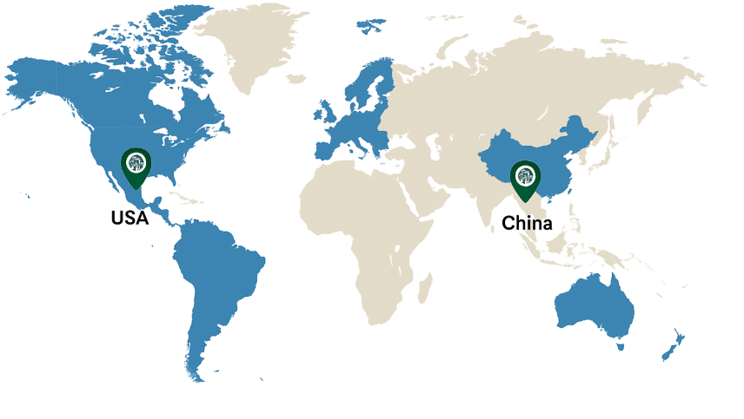
Figure 1: Global Presence of Starbucks
This report is organized in such a way that it gives us in depth comparative analysis of the marketing strategies employed by Starbucks in the two markets. It begins by giving a concise overview of the brand, then a discussion of macro environmental environment using a PESTLE framework. It subsequently analyses the Segmentation, Targeting and Positioning (STP) strategies of Starbucks and compares its Marketing Mix (7Ps) in the United States and China with support of scholarly works and market data. Starting with the assessment of the effectiveness of these strategies, the further parts measure the effectiveness of these strategies based on key performance indicators like market share, revenue growth, and customer engagement. The report also critically evaluates the ethical practices that apply to sustainability, fair sourcing, and cultural sensitivity and then offers strategic suggestions on the international marketing direction that Starbucks needs to take in the future. By this examination, this report will seek to show how Starbucks has managed to combine its global brand congruency with local responsiveness in two culturally different markets (Yip, 2017).

2. Brand Overview
Starbucks Corporation is a multinational coffeehouse chain that has made its mark in the coffeehouse sector as a pioneer of the specialty coffeehouse area, which changes the consumption of coffee in to a way of life. The company was incepted in 1971 in Seattle, Washington, as a coffee beans selling enterprise and then developed into brewed drinks and developed a unique cafeteria atmosphere that stresses community and coziness. Starbucks has been able to grow and develop over 38,000 stores globally and operate in more than 80 markets throughout over five decades, becoming a multinational corporation. It is founded on its customer-focused and socially responsible business philosophy based on its corporate vision, which is to inspire and nurture the human spirit, one person, one cup, and one neighborhood at a time (Starbucks Corporation, 2024).
The success of the brand is mainly due to its continuous provision of high quality, robust brand identity, and experience marketing strategy. Starbucks has positioned itself as not only a beverage company but also as a third place between home and work environment, where people can socialize and relax (Paryani, 2011). This has been the main concept of global expansion as the company is able to attract middle and high-income consumers who associate Starbucks with status, sophistication, and comfort. Starbucks differentiation the world over has been based on premium pricing, ethical sourcing of its coffee under its Coffee and Farmer Equity (C.A.F.E.) practices and focus on sustainability which strengthens its brand equity and corporate reputation (Hollensen, 2020).
Starbucks is a potentially classic American brand that is embedded in the everyday life of the United States. Being its native country, the U.S. provides the biggest portion of Starbucks overall revenue as there are more than 16,000 stores in the country (Euromonitor International, 2024). Convenience and digital innovation are the core of the U.S. operations, with mobile ordering and loyalty programs, delivery partnerships, becoming the primary distinguishing features in a saturated market (Kotabe and Helsen, 2022). The marketing approach of the brand in the U.S. is focused on personalization, community-building and seasonal product development, including the Pumpkin Spice Latte, which has become cult-like. There is a profound appreciation of American consumer values, including individuality, choice and expression of lifestyle through these strategies. The success of Starbucks in its local market indicates that its brand consistency is paired with the changing consumer demands in an extremely competitive environment that is filled with competitors like Dunkin’ and McCafé (Hitt et al., 2020).
China, in its turn, is the most strategically relevant international market of Starbucks. The company opened its first store in Beijing in 1999 and by 2024, was able to grow to more than 6,800 stores distributed in 250 cities (Starbucks Corporation, 2024). The introduction of Starbucks in China ushered the onset of a change of culture because the consumption of coffee had been overshadowed by tea in the country. Starbucks has managed to spread coffee culture with a careful localisation and adaptation, integrating Western cafe experience, social standards and aesthetics of the Chinese (Liu and Mattila, 2019). The brand has positioned itself as a high-end lifestyle icon targeting wealthy urban consumers and young professional people that want to be modern and identify themselves with the global image and world (Yip, 2017). Chinese stores tend to be designed with the use of local architecture, have beverages of local interest like red bean Frappuccino and green tea latte, and larger seats that can serve a group of people- which is an aspect of the Chinese culture as it is collectivist in orientation (Hofstede Insights, 2024).
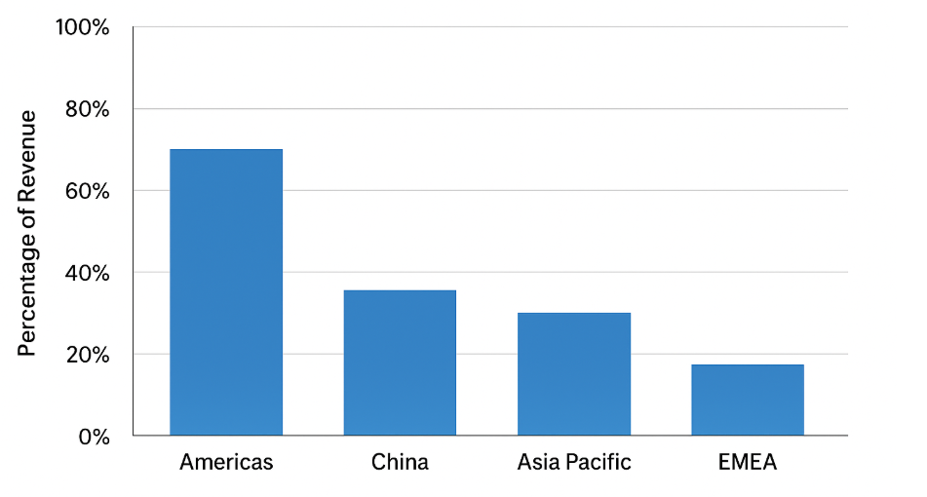
Figure 2: Starbucks Global Revenue Breakdown by Region
Furthermore, Starbucks has pumped resources in digital innovation and joint ventures with the Chinese to improve customer interactions. Its partnership with Alibaba incorporates mobile ordering, delivery, and digital payments via applications such as Alipay, and is a demonstration of how Starbucks customizes its approach to the sophisticated digital ecosystem of China (Chen et al., 2021). The company also focuses on its sustainability and social responsibility such as farmer support programs in Yunnan and recyclable packaging initiatives. Such localized approaches have made Starbucks a Western aspirational brand and culturally attuned local player, which allows it to remain a market leader of the high-end coffee market in China (Euromonitor International, 2024).
Altogether, the brand strength of Starbucks is based on its capacity to combine world and local adaptation. It is all about convenience, innovation and familiarity in the United States, it is all about aspiration, social status and modernity of Chinese culture. Such duality is why Starbucks has mastered the international marketing strategy - its mastery of international brand identity, and its constant adjustment to the values and market conditions of consumers all over the world.

3. PESTLE and Socio-Cultural Comparison
The macro-environment is what would be very significant in formulation of effective international marketing strategies. The PESTLE framework that examines Political, Economic, Social, Technological, Legal and Environmental environments assists in assessing the way in which external influences influence the operations of Starbucks in its two largest markets, the United States, its domestic market, and China, the most dynamic foreign market. These aspects do not only affect the performance of the company, but also define the level of accommodations that would be necessary to attain local market fit.

Political Factors
Starbucks in the United States is in a stable, business friendly political environment that promotes international trade and business. Corporate values of Starbucks are in line with government policies that promote small businesses and sustainable sourcing (Kotabe and Helsen, 2022). Good trade legislation and clear regulatory framework give an advantage to the company. Nevertheless, there are issues like changing taxation policies, unionisation of labor, and differences in labour laws by the states which remain a constant threat (Starbucks Corporation, 2024). The recent unionisation trends in some stores in the U.S. are a pointer to the rising political debate on the rights of workers, which has necessitated the revision of its human resource and consumer relations approaches at Starbucks (BBC News, 2023).
On the other hand, there are the opportunities and threats within the political environment of China. Starbucks has expanded rapidly due to the economic reforms, urbanisation strategies and domestic consumption emphasis by the Chinese government (Euromonitor International, 2024). Nevertheless, the high regulatory controls and government regulations of overseas business activities make it imperative to enter into local collaborations and adhere to the government policies (Liu and Mattila, 2019). The partnership of Starbucks with Alibaba can be viewed as the example of a politically savvy approach, as it allows the company to work within the Chinese digital and logistical ecosystem and stay aligned with the government (Chen et al., 2021). Although the relationship between the two countries occasionally experiences some geopolitical tension between the U.S. and China, Starbucks has able to maintain its brand neutrality and build a good relationship with the government by conducting local sourcing and community participation activities.
Economic Factors
The US market with high disposable income, consumerism and a strong service industry serves Starbucks with a stable base to grow. Starbucks has leveraged the willingness of consumers to spend high prices to obtain high quality and convenience and get a steady increase in revenue (Hollensen, 2020). There are however slight changes in the profit margins brought about by inflationary pressures and increasing wage costs in recent years (Starbucks Corporation, 2024). These have been alleviated by the fact that the company has been keen on digital efficiency and product innovation, which includes ready to drink beverages.
On the contrary, China has one of the largest economies in the world and the second largest in the world and it can provide Starbucks with extensive opportunities of growth. Aspirational brands have been driven by the emergence of the middle class and more urbanisation (Liu & Mattila, 2019). Starbucks positions itself as a luxury experience and not a need and, in fact, it aims at increasing purchasing power consumers. However, economic shocks and the appearance of local rivals such as Luckin Coffee are the major risks (Yip, 2017). Starbucks has reacted by moving to the lower-level cities and launching cheaper options thus reflecting its flexibility in pricing. In addition, the shift in China to a digital and cashless economy coincides with the technology-based payment systems at Starbucks, which is another factor that promotes market penetration.

Social and Cultural Factors
In both markets, social and cultural forces are critical towards influencing the brand positioning of Starbucks. Coffee is a deep rooted aspect in the lives of the people of United States, as a symbol of productivity, identity, and socializing. The idea of the third place applied by Starbucks makes sense to these cultural values, providing a warm and intimate atmosphere between home and work (Paryani, 2011). American consumers appreciate customisation and expediency which the mobile ordering and drive-thru services at Starbucks show. Health consciousness, ethical consumption, and other social trends have also given Starbucks the opportunity to launch plant-based alternatives and promote fair-trade coffee (Kotler & Keller, 2022).
Maximum consumption of coffee has not been realized in China as the country has a culture of tea drinking. Nonetheless, Starbucks has managed to reinvent coffee as a part of the contemporary way of life and social status (Liu and Mattila, 2019). The localisation strategy by the company entails incorporation of the Chinese social norms, such as collectivism and relationship-building (guanxi). The stores are not arranged as places to have a takeaway meal and instead are designed to encourage social interactions, a feature that collectivists like (Hofstede Insights, 2024). The marketing campaigns in China by Starbucks focus more on the emotional bonding and belonging to a bigger community than on the personal indulgence, which strengthens its aspirational and high end image. The fact that the company celebrates local festivals like lunar new year where limited-edition products are offered and packaging has a cultural theme further reinforces its cultural resonance.
Based on the dimensions of the culture by Hofstede, there are major differences. The U.S. has a high score on individualism (91), which means autonomy and personal accomplishment, which is very low in China (20), which means collective identity (Hofstede Insights, 2024). This is why Starbucks is interested in customisation and personal choice in the U.S. in comparison to community and shared experience in China. Furthermore, increased power distance and long-term orientation contribute to China affect the hierarchical management style and emphasis on the brand tradition instead of immediate promotion at Starbucks. These cultural differences can be used to show how Starbucks customizes its service design and communication tone to conform to local values.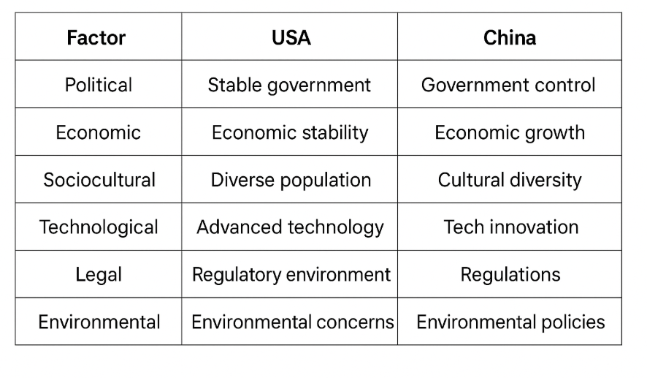 Figure 3: PESTLE Comparison Table – USA vs. China

Technological Factors
The technological innovation is a very important facilitator of the global competitiveness of Starbucks. The brand has been an early adopter of digital transformation in the United States, with Starbucks Rewards loyalty app, mobile ordering, and personalisation, powered by AI, enabling the brand to make more than 55% of the U.S. sales on the digital platform (Starbucks Corporation, 2024). The digital technology encompasses the integration that improves customer convenience, engagement and data-based marketing.
The use of technology in China is also at a higher level as mobile payments take a huge percentage as the customer spending. The collaboration with Alibaba and Ele.me hub of Deliveries and WeChat Mini Programs lets Starbucks provide a smooth online-to-offline experience (Chen et al., 2021). These partnerships indicate Starbucks flexibility to the local digital ecosystems and customer behaviour. Data analytics also helps the company to forecast the market, product innovation, and customer relationship management.
Legal Factors
Starbucks has to conform to strict labour laws, health and environmental legislation in the U.S. The problem of employee unionisation and wage minimum has become topical recently (BBC News, 2023). Digital marketing activities are also affected by the compliance with the data privacy laws and consumer protection regulations.
The legal issues that are linked to China include intellectual protection and the complexity of regulations. Starbucks has been experiencing counterfeit brand and has to find a way around advertising rules and food safety regulations (Liu and Mattila, 2019). Starbucks spends a lot of money on legal expertise in the country in order to stay on track and closely cooperates with government organizations.
Environmental Factors
Sustainability is a core part of the corporate strategy of Starbucks in both markets. Starbucks in the U.S. has been encouraging environmental friendly programs, like recyclable cups, reusable packaging, and carbon neutral goals (Starbucks Corporation, 2024). Growing concern about environmental matters by consumers has placed pressure on Starbucks to minimize its environmental footprint.
The environmental issues in China have also increased as a result of the government policies on sustainability and minimising wastes. In China, Starbucks has launched Greener Stores, which are aimed at minimising waste and energy use, which is in line with national sustainability objectives (Euromonitor International, 2024). In addition, the fact that Starbucks interacts with local farmers in Yunnan shows that the company believes in ethical sourcing and long term environmental care.
Comparative Summary
In general, the external environment of Starbucks in the USA can be characterized as market maturity, technological leadership, and consumer sophistication, whereas in China it was rapid growth, cultural transformation, and digital integration. The company’s capability to adapt to such different macroenvironmental and socio-cultural contexts reflects its strategic agility. Starbucks not only keeps its brand relevant but also strengthens its global position by synchronizing its activities with local political, economic and cultural dynamics. This comparative PESTLE analysis indicates that the international success of Starbucks is not only about leveraging its global identity but also about continually adapting to the changing external powers that shape each market.

4. STP Strategies
Segmentation, Targeting, and Positioning (STP) model is a guiding principle of international marketing that allows companies to target and serve specific segments of consumers in the most efficient way possible (Kotler and Keller, 2022). In the case of Starbucks, as an international company with business operations in various markets, the STP approach is the solution to the need to balance standardisation and localisation in marketing strategies. The company also plans its segmentation, targeting, and positioning to be suitable in the United States and China in terms of cultural, economic and behavioural differences.
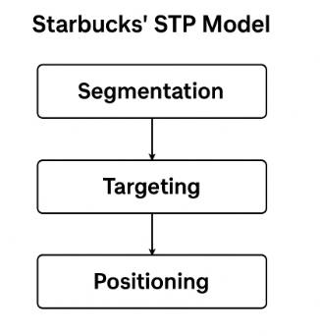

Segmentation
Starbucks works through a multi-segregated marketing approach that is on the basis of demographic, psychographic, behavioural, and geographic variables (Hollensen, 2020).
In the United States, segmentation is very psychographic and behavioural. Starbucks is aimed at busy people, students and urban residents who appreciate convenience, personalisation and high quality. The brand targets the customers with a higher level of disposable income and lifestyle ambitions, as the brand is associated with their preference towards quick and customisable beverages (Kotabe and Helsen, 2022). Digital engagement also divides the American consumer base, using Starbucks Rewards information to customize promotions and seasonal product offerings.
On the contrary, the segmentation of Starbucks in China is based on the combination of the demographic and socio-cultural variables. The firm focuses mainly on younger professionals, the new middle-income, and high-income urban elites who view the use of coffee as a form of modern and aspirational lifestyle (Liu and Mattila, 2019). The other segmentation method Starbucks uses is geographic segmentation whereby it has targeted Tier 1 and Tier 2 cities, then proceeded to target smaller urban cities as the coffee culture is diffusing (Euromonitor International, 2024). The segmentation demonstrates the cultural peculiarities, in contrast to American customers who want to find their individuality and efficiency, Chinese customers attach importance to community, prestige, and social cohesion.

Targeting
Starbucks uses differentiated targeting approach in the two markets. The brand targets a large audience in the U.S. including working adults, millennials, and Gen Z customers that seek premium experiences and social identity in consumption (Yip, 2017). The brand focuses on tech-savvy consumers who are convenience-focused and sustainability-centric through the use of broad digital platforms, including mobile ordering, loyalty programs, and social media.
The targeting in China focuses on aspirational and status oriented customers as Starbucks targets consumers that associate western brands with sophistication and international identity (Liu & Mattila, 2019). Starbucks also aims its consumers who perceive Starbucks outlets as a social place to meet or study or even have leisure, and not only as a transactional coffee places. The marketing activities are very localised, e.g. digital activities on WeChat and Weibo are designed to appeal to the Chinese cultural values, like harmony and togetherness (Chen et al., 2021). This strategy can be used to show how Starbucks can modify its targeting strategy to accommodate the collectivist culture of the Chinese population, unlike the individualist culture of its American clients (Hofstede Insights, 2024).
Positioning
One of the main areas that Starbucks has relied on in its brand identity and success lies in positioning. Starbucks presents itself as a luxury coffeehouse that provides an outstanding customer experience, a mix of high-quality products, atmosphere, and ethical principles globally (Hollensen, 2020). In America, Starbucks has been positioning itself based on convenience, personalisation, and community. The concept of the third place between work and home is strengthened by the use of a consistent store design, customer service, and brand communication (Paryani, 2011). The fact that the brand also focuses on ethical sourcing and sustainability is also another appeal that attracts socially mindful American consumers (Starbucks Corporation, 2024).
Starbucks' positioning strategy in China is more of a dream and an experience. It markets itself as modern lifestyle and social prestige, thus attracting consumers who want to show their cosmopolitanism and social status via brand association (Liu & Mattila, 2019). Simply, Starbucks does this with ambient store architectures that are influenced by local trends, not-so-cheap pricing, and culturally selective product introduction like tea-flavored drinks. The company's Shanghai Roastery flagship store is the ideal case in point of positioning as luxury lifestyle brand and experiential venue rather than mere coffee shop (Euromonitor International, 2024).

Comparative Analysis
Starbucks STP strategies overall reveal a strategic equilibrium between global consistency and local adaptation. While the core brand values—premium quality, community, and ethical responsibility—stay the same in every country, the way of execution differs a lot from one market to another. The U.S. strategy highlights making the product available and convenient to use in a saturated market while the Chinese strategy centers on cultural relevance, exclusivity, and brand aspiration within a growing coffee market. Starbucks, by adapting its segmentation, targeting, and positioning to be in line with local consumer values and behaviours, enhances its global competitiveness and also guarantees brand resonance through the different socio-cultural landscapes.

5. Marketing Mix (7Ps) Comparison
Marketing Mix (7Ps) framework offers an organized approach that will help analyze how Starbucks creates and produces customer value in the global markets (Kotler and Keller, 2022). The domestic and international experiences of Starbucks in the United States and China exemplify the ability to strike a balance between the global brand and the local market, which is necessary to continue to have competitive advantage in culturally diverse markets.
- Product
Starbucks in the United States has a wide selection of upscale coffee drinks, tea, and snacks and specialises in customisation, conveniences and lifestyle integration (Paryani, 2011). American consumers are passionate about customisation- in terms of individual combinations of drinks and seasonally- with such a drink as the Pumpkin Spice Latte. Innovations in the recent past have been the introduction of plant-based and ready-to-drink items, which have conformed to the trends of health and sustainability (Hollensen, 2020).
Starbucks localizes the product mix in China. Coffee is not yet consolidated and, thus, the brand offers tea-themed drinks like matcha lattes and oolong tea frappuccinos, as well as local dishes such as mooncakes (Liu and Mattila, 2019). Festive one-time pieces like Lunar New Year boost the cultural appeal. The localisation approach will guarantee that the brand is accepted in a society dominated by tea.

- Price
Starbucks uses a high-end pricing approach in both markets, as it is associated with a high-end image. In the U.S. the high pricing carries with it the quality and experience, which is reinforced by a loyalty program to create a sense of value, despite the cost (Kotabe and Helsen, 2022).
Starbucks is a luxury lifestyle brand in China, and it has been selling to middle- and upper-class consumers who equate Western brands with sophistication (Yip, 2017). Nevertheless, the prices are slightly differentiated in the case of Tier 2 and Tier 3 cities to appeal to new coffee drinkers (Euromonitor International, 2024). In such way, the premium strategy can underpin the world brand equity whereas the local differences indicate the purchasing power and the competition.
- Place (Distribution)
The distribution model of Starbucks is based on digitalization and accessibility. The brand has employed the convenience of the omnichannel in the U.S. in the form of company-owned stores, drive-thrus, and agreements with retailers. The fast-paced market of this company revolves around mobile ordering and curbside pickup (Kotler and Keller, 2022).
Starbucks in China is a combination of both physical and digital collaboration. The brand has more than 6,800 stores in 250 cities, and most are in high-end urban locations (Starbucks Corporation, 2024). It works with Ele.me and WeChat Mini Programs of Alibaba by combining online ordering and loyalty, which conform to the mobile-first Chinese culture (Chen et al., 2021). Such localisation allows accessibility and reinforces online interaction.
- Promotion
The promotional strategies convey the cultural and media environment of any country. Starbucks in the U.S. uses integrated marketing communication (IMC) in the form of social media and loyalty apps, as well as in the form of experience campaigns. Such campaigns as “Meet Me at Starbucks encourage inclusivity and emotional attachment (Hollensen, 2020). Messaging is concentrated on individuality, sustainability, ethical sourcing-the values that are aligned with the culture of individualism of America (Hofstede Insights, 2024).
Digital promotion is the leading one in China. Starbucks uses WeChat, Weibo, and Douyin (Tik Tok) in order to implement interactive activities and e-gifting promotions that focus on community and togetherness (Chen et al., 2021). Local resonance is enhanced through collaboration with local artists and advertising with culturally oriented advertising which exhibits a high cultural dexterity.
- People
Starbucks is a company that has employees at the heart of their brand promise. Baristas are trained as a brand ambassador in the United States where efficient and personalised service is provided. The programs of employee benefits, inclusiveness, and development increase engagement and brand loyalty (Kotabe and Helsen, 2022).
Starbucks in China is very sensitive to culture and relationship building. Employees are trained on hospitality and etiquette, which is in line with collectivist values (Liu and Mattila, 2019). Starbucks is also a company that promotes family-friendly welfare initiatives, which fosters trust and improves the company image as a friendly employer (Starbucks Corporation, 2024). This is a people-based approach, which enhances brand reputation within a relationship society.
- Process
Starbucks has very standardised procedures in the U.S. through mobile payment, drive-thru service efficiency, and uniform service flow to satisfy the speed and convenience requirement of the consumers (Paryani, 2011).
The service process in china is based on experience and interaction. Store experiences are socialising and leisure based, and transactions are easily integrated with WeChat Pay and Alipay (Chen et al., 2021). This brings an experience and digitally empowered customer experience that would fit the new retail culture in China.
- Physical Evidence
The physical environment supports the global image of Starbucks and it changes to local preferences. The store designs in the U.S. are based on the philosophy of the third place- comfort, familiarity and efficiency. Green materials like environmental-friendly packaging and simplicity in exterior add to brand authenticity (Kotler and Keller, 2022).
Starbucks has placed an investment in architectural and aesthetic uniqueness in China. A good example is the Shanghai Reserve Roastery where the luxury design is combined with local craftsmanship, which represents cultural fusion (Euromonitor International, 2024). Most of the stores are bigger to facilitate social events, which uphold collectivist social regulations (Hofstede Insights, 2024).
Comparative Analysis
Starbucks is masterful in its approach to globalisation the core brand elements are standardised, but the operational details are tailored to the cultural specifics. In the US, it has been found that efficiency, personalisation and digital convenience are important strategies that are taken to satisfy a mature coffee market. The brand uses aspirational marketing, localised products and digital ecosystems in China to create social and emotional ties.
This balance allows Starbucks to sustain global coherence and local resonance, which helps its sustainable development in both developed and emerging markets.
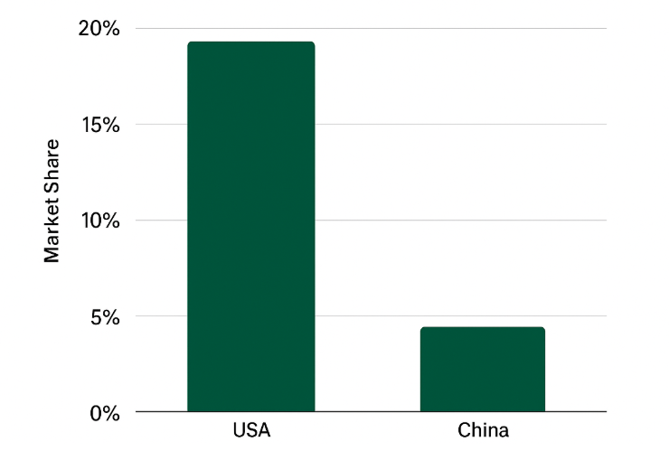
Figure 5: Comparison of Starbucks’ 7Ps in USA vs. China

6. Evaluation of Marketing Strategy Performance
An examination of the performance of Starbucks in creating its marketing strategy in the United States and China shows how well its global-local balance is functioning to achieve growth, market share, and customer interaction.
Starbucks is a company that dominates the market in the United States because it controls more than 40 percent of the coffeehouse market in the United States (Statista, 2024). The convenience, digitalisation and customer loyalty strategic emphasis of the brand has enhanced retentions and profitability greatly. Starbucks Rewards Program enrolls a total of 34 million participants in the program, which provides the company with almost 60% of the sales in the U.S. as a result of individualised promotions and mobile payment (Starbucks Corporation, 2024). Several mobile ordering, drive-thrus, and digital payment strategies have improved the efficiency of the operational and customer satisfaction, which proves the effectiveness of the service differentiation strategy implemented by Starbucks (Kotler and Keller, 2022). Its focus on sustainability and ethical sourcing also reinforces the brand image of the company in the minds of socially mindful consumers (Hollensen, 2020).
The performance of Starbucks in China is full of outstanding growth and cultural adjustment. The company has grown to more than 6,800 stores in 250 cities since its entry in 1999 making China its second-largest market in the world (Euromonitor International, 2024). Starbucks has a high brand equity although the local chains are increasingly competing with it such as Luckin Coffee courtesy of its premium positioning and digital partnerships. The partnership with Alibaba and connection with WeChat have made the process of ordering online and interacting with the social media seamless and have helped the company achieve a two-digit yearly sales growth rate in major cities (Chen et al., 2021). The products and stores that Starbucks offer culturally and its commitment to the community also increase customer loyalty.
Altogether, marketing activities of Starbucks are characterized by its capability to convert worldwide brand values into the achievements at the local level. The American approach ensures effectiveness and devotion in an experienced economy, whereas the Chinese one implies inspirational attraction and online tolerance, which strengthens the competitive advantage of Starbucks and its long-term sustainable development pattern.

7. Evaluation of Ethical Practices
Starbucks has made ethical marketing part of its strategy worldwide and strengthens its position in the world as a socially responsible and sustainable brand (Starbucks Corporation, 2024). The enterprise incorporates sustainability, fair trade, and community impact in its marketing and operations in both U.S and China though context-specifically prioritizing them.
Starbucks supports ethical sourcing in the United States by its C.A.F.E. Practices, which have been used to support fair wages and responsible farming (Kotler & Keller, 2022). Its sustainability is indicated by the environmental campaigns like Greener Stores and carbon neutrality targets (Hollensen, 2020). The firm also promotes inclusiveness and diversity, which is consistent with the American social values. Nevertheless, it has been criticized on putting waste in the package and the high cost of its ethically focused products (Yip, 2017).
Starbucks aligns its ethics with the local expectations in China by emphasizing on employee welfare, development of the community and responsibility to the environment. The foundation of the Starbucks China finances education and social programs, and health benefits to employees and families establish industry standards (Liu and Mattila, 2019). Local sustainability marketing, e.g., the promotion of reusable cups, also leads to an increase in ethical credibility.
On the whole, Starbucks has a solid ethical identity characterised in the combination of global sustainability objectives and the locally specific CSR activities, which strengthen the consumer confidence and brand loyalty within the various markets.

8. Recommendations & Conclusion
The secret behind the success of Starbucks in its international operation lies in the fact that the company has been able to retain a fixed global image and adapt to the local consumer tastes. Its operations in the United States and China can be considered as evidence of successful adjustment of marketing mix and STP strategies, although the competitive, sustainability, and digital presence can be improved.
Recommendations
- Enhance Localisation of Emerging Cities (China):
Starbucks needs to go beyond the Tier 1 and Tier 2 cities to harness the growth in the developing nations. Youthful and cost-effective product lines and local alliances may be useful to target younger and more cost-sensitive consumers without losing brand equity (Euromonitor International, 2024).
- Improve Digital Integration Globally:
The brand is to follow the example of China with regard to digital innovation, including the use of WeChat, in the U.S. market. Loyalty can also be enhanced by making AI-based personalisation and mobile ordering even stronger (Chen et al., 2021).
- Rapidly Implement Sustainability measures:
To achieve global sustainability, Starbucks needs to pursue the following strategies: investing in biodegradable packaging and increasing its capacity to expand its Greener Stores initiative in markets. Clarity in sustainability reporting can strengthen the trust of the environmentally conscious consumer group (Hollensen, 2020).
- Cultural Sensitivity and Worker Well-being:
Further commitment to employee development, diversity and local cultural awareness will ensure service quality and ethical reputation across the world (Liu and Mattila, 2019).
Conclusion
Overall, Starbucks is a vivid example of glocalisation- the ability to combine the global uniformity and local sensitivity. Convenience, digitalisation, and ethical branding drive the brand to prosperity in the U.S., whereas aspirational appeal, digital innovation, and cultural relevance drive the brand to prosperity in China. In order to maintain growth in the long-term, Starbucks should keep innovating and incorporate more cultural intelligence and sustainability leadership in its global marketing plan. Such steps will make Starbucks a model of ethical, customer-focused, and flexible global marketing.

9. References
Chen, X., Huang, J. & Zhou, L. (2021) Digital marketing adaptation in China: A case study of Starbucks and local consumer engagement. Journal of International Consumer Marketing, 33(5), pp. 442–458.
Euromonitor International. (2024) Starbucks Corporation in Consumer Foodservice – Global Company Profile. Available at: https://www.euromonitor.com
Hofstede Insights. (2024) National Culture Comparison: USA vs China. Available at: https://www.hofstede-insights.com
Hollensen, S. (2020) Global Marketing. 8th edn. Harlow: Pearson Education.
Kotabe, M. & Helsen, K. (2022) Global Marketing Management. 9th edn. Hoboken, NJ: John Wiley & Sons.
Kotler, P. & Keller, K. L. (2022) Marketing Management. 16th edn. Harlow: Pearson Education Limited.
Liu, S. & Mattila, A. S. (2019) ‘Cultural influences on consumers’ evaluation of service failure and recovery: The role of face concern in China’, Journal of Services Marketing, 33(1), pp. 81–91.
Paryani, K. (2011) ‘Product quality, service reliability and management of operations at Starbucks’, International Journal of Engineering, Science and Technology, 3(7), pp. 1–14.
Starbucks Corporation. (2024) Global Environmental and Social Impact Report 2023/24. Seattle: Starbucks Coffee Company. Available at: https://www.starbucks.com/responsibility
Statista. (2024) Market share of leading coffee chains in the United States. Available at: https://www.statista.com
Yip, G. S. (2017) Total Global Strategy: Managing for Worldwide Competitive Advantage. 3rd edn. New York: Routledge.

