BA BUSINESS MANAGEMENT
Student: Raluca Manda (2127848)
Module: Project Management
Code: LCBB5005
Lecturer: Dr. Olu Adegbite
Assignment 1: Essay- Project plan
Submission deadline: 16th of June, before 3 pm

Table of Contents:
- Introduction of the project chosen
- Aims and vision of the project.
- Main Body
- Conclusion
- References list

- Introduction
The company I have chosen for this task is 'The Boots Company,' a company with a rich and prestigious history in the United Kingdom. I have a personal connection to this organization as I recently became a team member in the customer assistant role, and I am genuinely pleased with my decision. This personal connection has sparked my interest in exploring the company's project management principles.
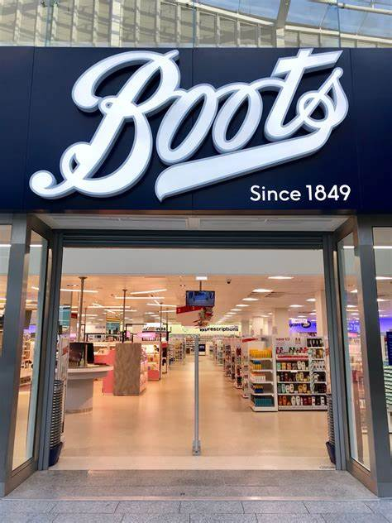
As documented by Heritage Boots (2024), John Boot founded Nottingham's inaugural herbalist business in 1849. The shop offered an affordable alternative to traditional medical therapies. John, who held strong religious beliefs, found the US-based Thomsonian healthcare system appealing due to its practical approach, which enabled even the most economically disadvantaged individuals to care for their well-being. This historical significance of 'The Boots Company' is a key aspect of my project plan.
During research that I have done about the company to understand better the importance, influence, and economic impact it has made this company during the years.
John Boot's journey began in 1849 when he opened an herbalist store in Nottingham, offering affordable alternatives to traditional medicines. The business expanded significantly in the 1870s under Jesse's leadership, venturing into over-the-counter medicines. Florence Boot's entry in 1886 marked the establishment of Boots as a high-street beauty destination. The company continued to grow, reaching a significant milestone in 1933 with the opening of its 1000th store and the introduction of the five-day working week. In 2021, Boots demonstrated its adaptability and commitment to public health by opening the first COVID-19 vaccination hub.

At the heart of Walgreens Boots Alliance's mission is the aspiration to create a better world through health and wellness. Their brand purpose, vision, and core values, including courage, connectedness, commitment, and curiosity, guide their every action. They are committed to being the leading partner in reimagining local healthcare and wellbeing, challenging the status quo, and driving informed risk-taking.

2.The main body
As we continue with this assignment, this section will examine the chosen organisation and its present impact, define stakeholders, and illustrate them.

“A) What Is a Stakeholder Analysis?
Stakeholder analysis is performed at the outset of a project to understand each stakeholder's needs and significant requirements comprehensively. A stakeholder encompasses individuals or groups affected by the project, such as investors, advisors, sponsors, team members, and existing or potential customers.

B) Purpose of a Stakeholder Analysis
A stakeholder analysis identifies the primary stakeholders and their respective requirements at the beginning of the project. A comprehensive comprehension of each stakeholder and their respective expectations is crucial, mainly due to potential conflicts between stakeholders' wants and expectations and the project's fundamental requirements.

C) How To Do a Stakeholder Analysis?
As Chris Mattmann, the Chief Technology and Innovation Officer (CTIO) at NASA Jet Propulsion Laboratory, states, initiating a stakeholder analysis involves acquiring sufficient data to comprehend each stakeholder's individual requirements. Normally, the team's designers would interview each stakeholder to understand their procedures, requirements, constraints, and concerns.

For example, Mattmann described a theoretical endeavour to quantify and generate a geographical representation of the water resources in the western region of the United States. This would require the coordination of several systems and teams, including personnel, to carry out field experiments and equipment such as aircraft, towers, and satellites. The design team will interview each stakeholder to perform the stakeholder analysis, including sponsors, data sources, the IT team, and project developers.

Upon gathering the unprocessed data from interviews, the team would analyse and analyse the information obtained from these discussions. During this phase, the team may arrange several adhesive notes on the wall and categorise them based on requirements. Alternatively, they might utilise a software tool to organise the raw data. The main objective is to recognise patterns and potential areas of disagreement among the material provided by each participant during the interview. The reference is cited as Hoory L (2004).

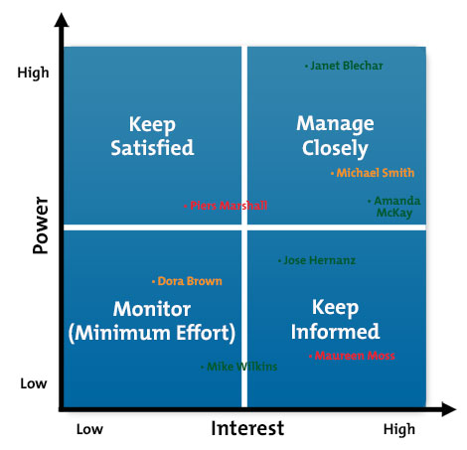(Bing,2024)

During research, a document from the most recent year, 2020, was found online while conducting research. It contains the data required to analyse Boots Company.
“During the period of operation ending on August 31, 2020, the Directors carefully evaluated and discussed the factors outlined in Section 172(1) (a-f) when making decisions. They acted in a manner they believed, in good faith, would best advance the company's success for the benefit of its members. The Directors consider the perspectives of the Company's stakeholders, such as employees, suppliers, customers, and others, as elaborated below, when making decisions. The Directors appreciate comments and will consistently evaluate how the company and its executive committee can enhance communication and involvement with employees and other stakeholders. Here are some examples of how the Directors have interacted with different stakeholders and met their obligations under this provision. Staff members: The Directors actively implement a strategy to foster diversity and inclusivity among the workforce. The Company, directly or through its associate companies, employs a range of official and informal procedures to involve its personnel actively. These methods encompass staff performance evaluations, communication via email, intranet, bulletin boards, and 'town hall' gatherings. The Directors utilise these methods and engagements to comprehend employees' perspectives and duly consider them in decision-making. For instance, employee engagement surveys encompass most of the employees, and the findings are submitted to the Board. The survey results are disseminated throughout the organisation, actions are determined through discussion with the broader employee teams, and the ensuing actions are conveyed to colleagues. Regular executive briefings and 'town hall' meetings are conducted to keep employees informed about the Company's performance and strategy. Employee participation is fostered through the use of 'Q&A forums before and during these events, allowing employees to submit questions and/or feedback to the leadership teams. Responses are given either during or after the event. Employee questionnaires are commonly employed after such occurrences to enable employees to offer comments. Furthermore, to maintain interaction with colleagues and prioritise their health, safety, and well-being amidst the COVID-19 epidemic, the Annual Strategy meeting for the 2021 Financial Year was conducted electronically. This allowed colleagues to participate from a remote location over a span of two days. The Company oversees several aspects linked to employees, such as engagement activities, survey outcomes, staff retention rates, diversity, whistleblower activity, learning and development programmes, pay and reward systems (including gender pay gap), and other similar endeavours. Key messages are disseminated to all colleagues throughout the company regularly throughout the year. Patrons The Directors firmly uphold the principles of equitable treatment towards customers and strive to deliver items that are both secure and of high quality. The Company and its affiliated firms within the Group have implemented several methods to contact customers, such as in-person and online encounters, surveys, and tailored customer messages through the Company's Advantage Card rewards programme. The Group employs these procedures to comprehend the perspectives of its consumers, evaluate the consequences of their choices on customers' interests, and enhance its ability to meet the demands of its customers. Customer interests are taken into account when making important decisions, such as modifying the store portfolio, choosing product lines and brands, considering environmental sustainability and ethics, selecting and monitoring suppliers, and developing the online platform. For instance, in response to changes in customer demands due to COVID-19, the Company and its affiliate companies promptly invested in and increased the capacity of Boots.com during the lockdown period. This allowed for more online shopping options and additional home delivery services for customers. Other measures implemented involved expanding the capability of the complimentary online repeat prescription delivery, and the implementation of novel online pharmacy and beauty services, such as virtual consultations. Providers The Directors strive to ensure that the Company operates in a manner that is equitable, transparent, and characterised by honesty in its dealings with suppliers. The Company and its associates interact with its suppliers through many channels, including formal and informal means. These interactions allow the Directors and the broader teams to gain a comprehensive and varied comprehension of the suppliers and their priorities. This enables the Company to take into account the suppliers' interests when making choices. The Company actively collaborates with and oversees crucial suppliers for ethical, environmental, and sustainability concerns. Any modifications to these standards are promptly reported to the suppliers. The Board aims to cultivate robust supplier partnerships with strategic suppliers, while also prioritising cost-effectiveness and ensuring optimal service levels for consumers. Communities Boots holds a distinctive position in the affections of the communities it caters to throughout the United Kingdom. Over the course of 170 years, the Company has utilised its extensive knowledge and assistance in the field of pharmacy to enhance the health and wellness of nearby communities. The Company consistently exhibits a steadfast dedication to operating as a socially responsible enterprise and acknowledges the proactive role it may have in contributing to the development of more contented and healthier communities. The Directors prioritise fostering transparent communication with the communities in which the firm operates. This enables the Directors to gain insight into the perspectives of these communities regarding the business and their evolving requirements. Additionally, it allows the Directors to consider the influence of their decisions on these communities. The Company, either directly or through its affiliated enterprises, interacts with the broader community through numerous channels such as social media, charitable events, and involvement with other associations, among other methods.
To enhance my understanding of the company's concept, stakeholder assessments, and the various theories explored in this research, I have devised a plan to condense and synthesise all the relevant materials I have come across.
1. Customer Influence: Significant Interest: Significant Engagement: The clients of Boots are crucial to the success of the business. Their expectations include top-notch products, exceptional customer service, and easily available healthcare treatments. The company's emphasis on customer happiness and loyalty programmes, such as the Boots Advantage Card, underscores the significance of this demographic (Boots UK, 2024).2. Employees Level of Influence: High Level of Interest: High Level of Engagement: Employees have a crucial role in implementing the company's strategy and upholding its values. Boots prioritises staff training, professional advancement, and well-being. Ensuring employee satisfaction and efficiency is essential for achieving operational success and delivering excellent customer service at Boots UK.

3. Suppliers and Partners
Impact: Medium Area of interest: Suppliers are responsible for providing the products that Boots offers, resulting in a high level of engagement. The company collaborates closely with suppliers to guarantee quality and dependability, fostering robust connections to establish a consistent supply chain and cutting-edge products. (Boots UK, 2024)

4. Investors and Shareholders Impact: Interest: Significant Engagement: Investors and shareholders are primarily focused on the company's financial performance and strategic direction. Boots consistently shares information about its financial status, strategies for growth, and position in the market with this group through reports and meetings (Boots UK, Walgreens Boots Alliance, 2024).

5. Government and Regulators Impact: Elevated level of curiosity or attention: Medium Compliance with rules in healthcare, employment, and environmental standards is vital. Boots actively collaborates with government entities to guarantee compliance with legal regulations and to champion matters relevant to the industry (Boots UK, 2024).

6. Communities Impact: Medium Interest: High Engagement: Boots substantially influences local communities by offering healthcare services and generating employment opportunities. The company's corporate social responsibility (CSR) initiatives, including community health programmes and environmental sustainability efforts, demonstrate its dedication to the welfare of society. (Boots UK, 2024)

- Conclusion
In conclusion, it is worth noting that the company I recently joined has a rich and enduring legacy in the United Kingdom. Furthermore, it has expanded its operations globally, implementing extensive benefits programmes and assuming significant responsibility in the fields of pharmacy and optometry. Customers have provided excellent feedback regarding beauty products from prestigious brands such as NO7, Clinique, and Huda.
As both a customer and an employee, I must acknowledge the alignment of business principles and the expectations from both parties.

Reference list
- https://www.boots-uk.com/media/5171/the-boots-company-plc-s172-statement.pdf
- https://www.boots-uk.com/about-boots-uk/company-information/walgreens-boots-alliance/vision-purpose-and-values/
- https://www.boots-uk.com/about-boots-uk/company-information/boots-heritage/
- https://www.boots-uk.com/environmental-social-governance/what-we-do/caring-for-healthier-communities/
- https://www.bing.com/images/search
- https://asana.com/resources/project-stakeholder
- https://www.bing.com/images/search
- https://www.forbes.com/advisor/business/what-is-stakeholder-analysis/

