Network Programmability:

Creating a python application that consume a restful web service.

Joseph Evans

University of Wales Trinity St David, Swansea, Wales

2216851@student.uwtsd.ac.uk

Ergast API
After considering ideas for this project and browsing through various APIs, I settled on the idea of creating a python application that retrieves and displays Formula One statistics based on user inputs. I chose this in part due to the variety of information and statistics available to work with in Formula One and the many years of historical data, as well as due to my own personal interest in the sport. In order for the application to display F1 information it performs GET requests to the Ergast Developer API (https://ergast.com/mrd/) and manipulates JSON data structures. Before integrating the API into code and building a program around it, I used Postman to review the data and gain an understanding of what information was available to be used in the application, as well as how the data is structured. The below screenshot from Postman depicts the data available at the /driverStandings endpoint of the API, upon reviewing the fields here I concluded that this data could be used in an application that retrieves Drivers Championship statistics from a user inputted year.
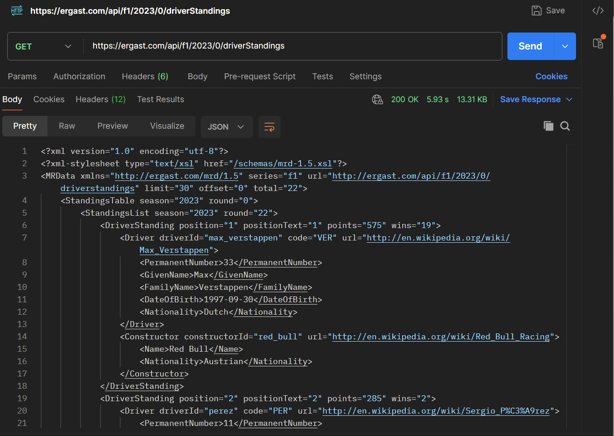

Python application
As a starting point I created a simple python program that performed a GET request to the API endpoint for the 2023 Driver Championship standings and printed the data to the terminal unformatted:
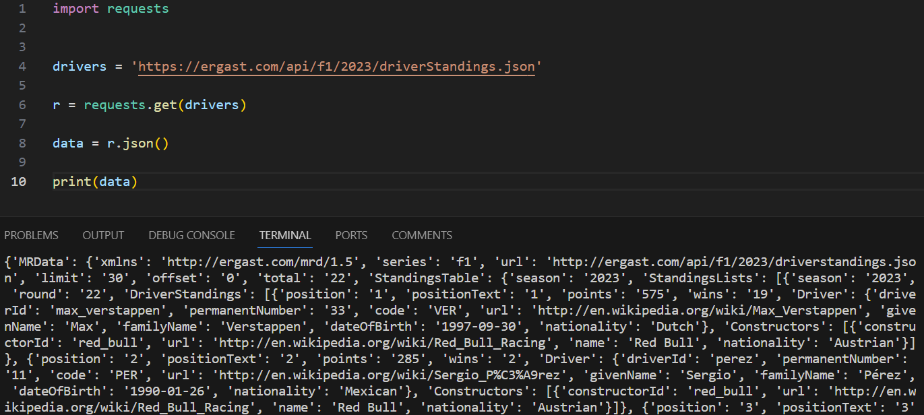
Once I knew that the GET request worked and the application was able to print the data, next I could look at adding additional functionality, and tiding the output up at a later point. I added the ability for the application to retrieve information relevant to a year inputted by the user. I did this by storing the user input as a variable and embedding it into the GET request using an f-string. Every time I added a new feature, I performed a GIT commit in order to track progress and have various levels to fall back on should I need to revert the code.
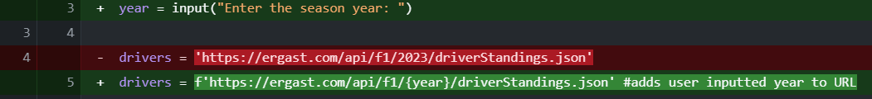
Next, I added an IF statement to check the HTTP status code of the request to the API. If the code was 200 (OK) then the application would print the data, else it would print an error message displaying the returned error code, again using an f-string:
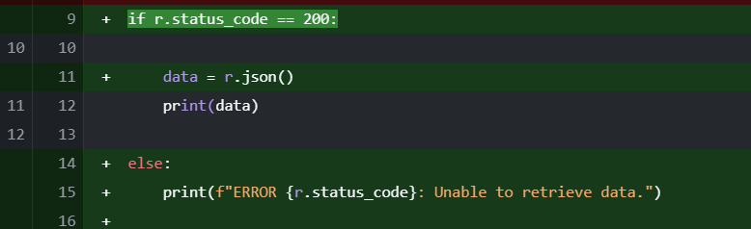
After this I began to work on tidying up the output, at this stage the program prints the entire dataset to the terminal. I wanted the output to display each set of information clearly and in order, with each driver separate by an empty line. To achieve this, I decided to use a for-loop. I first extracted data to the dStandings variable, reviewing the data outputted previously and Postman to gain an understanding of which elements of the data structure I would need. Then I used the loop to extract data for each field and print it to the terminal using f-strings:
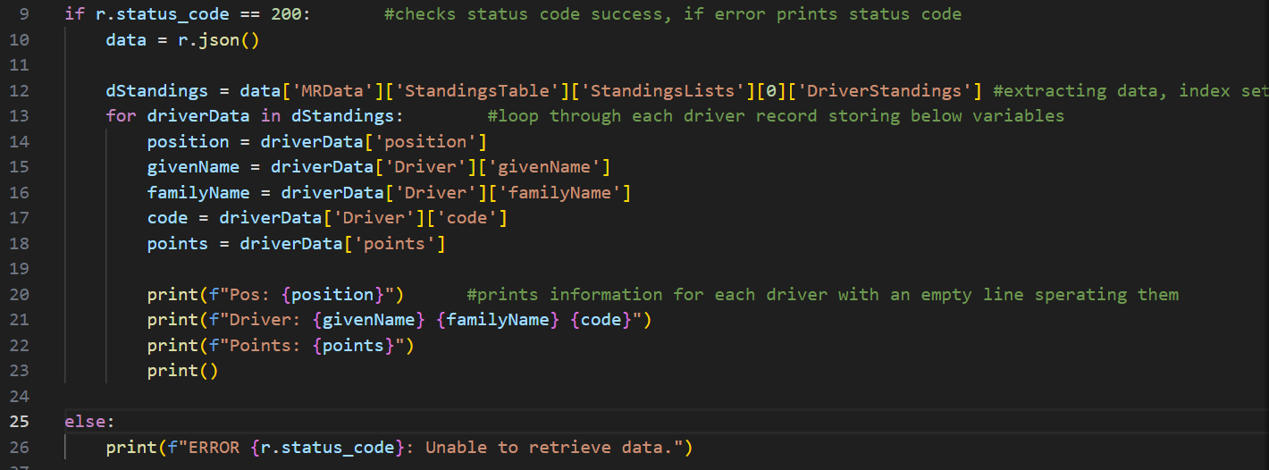
Output:
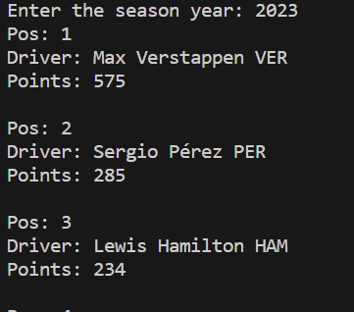
I next added the team = driverData[‘Constructors’][0][‘name] line to access the Constructors list, and selected index 0 to list the first team in the list associated with the driver. I also ammened the layout of the printed output:
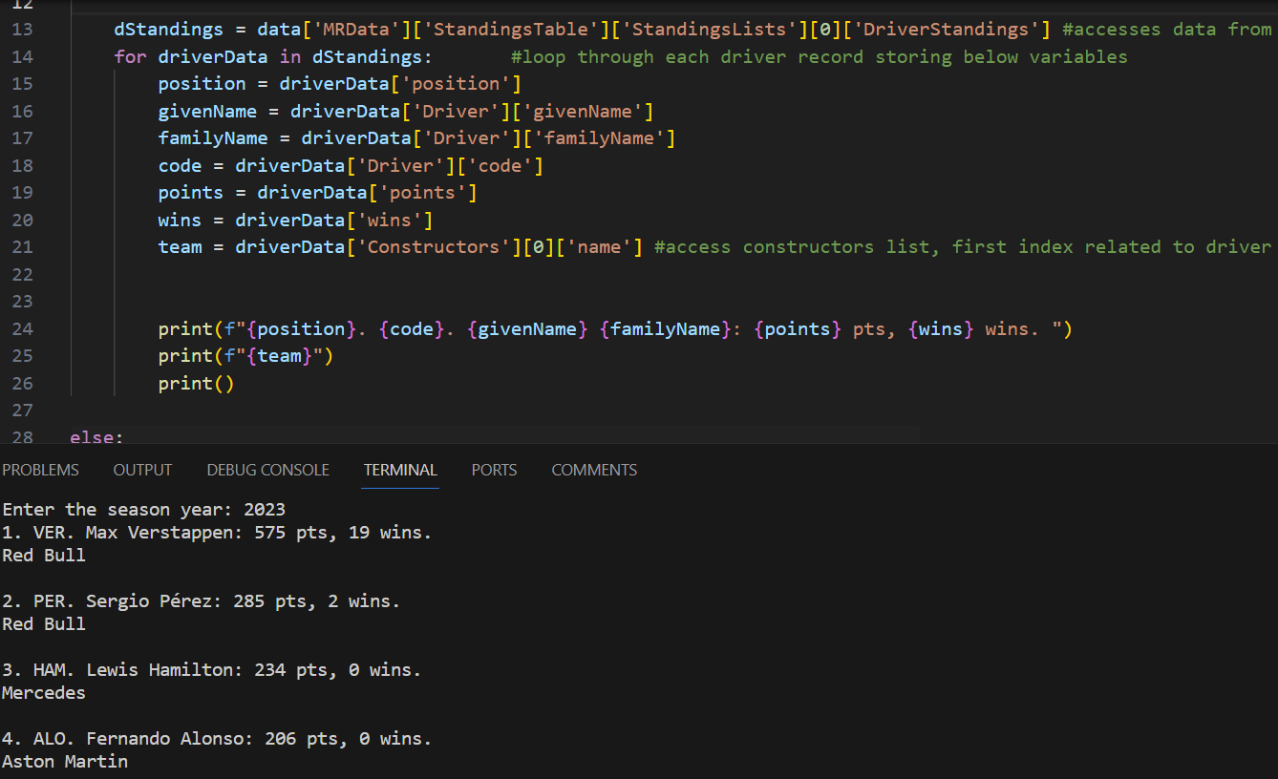
The next section of code that I added was to access Constructor Championship data as well as Drivers Championship. To add this, I used the same code structure as Drivers, with different datapoints being collected and printed in a different way. I also added an IF statement to control the flow of the program, allowing the user to chose between accessing driver or constructor data. I set the ‘championship’ variable at the start so that the while loop is triggered:
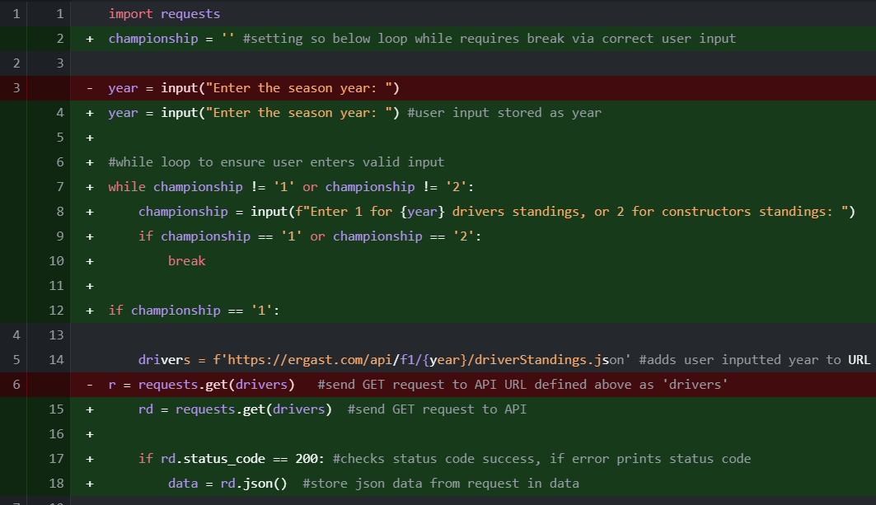
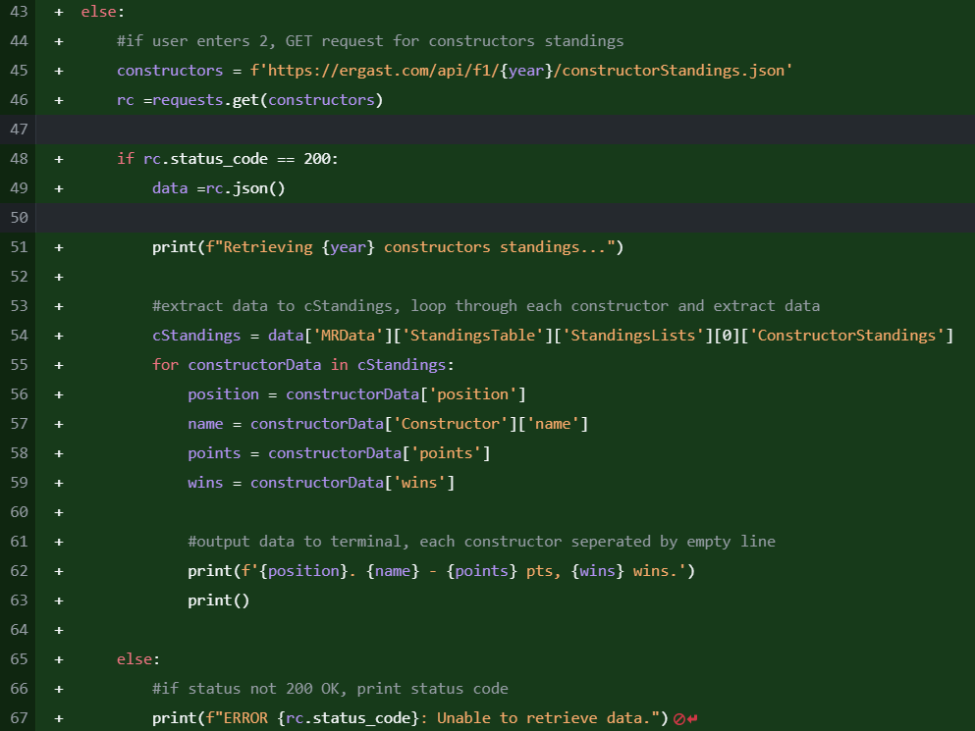
With most of the code in place I began testing the program, entering various years and making sure that it could retrieve the data. I realised that the application did not give the user an option to exit at the terminal, so I added an if statement that took the string value inputted by the user for ‘year’, if they entered ‘exit’ it breaks, exiting the program. I used if year.lower() to convert any string to lowercase, meaning that if the user entered ‘Exit’ it would still close the application:
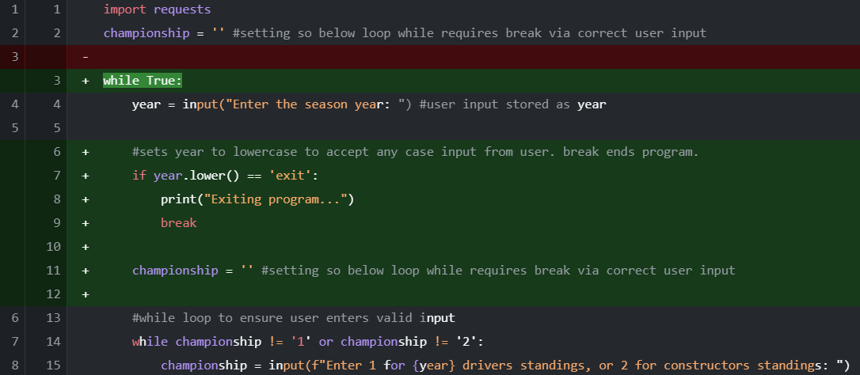

A problem I encountered during testing was that when I entered some older years for Drivers Championship, the program crashed trying to retrieve the driver code, the below image shows what happens when I request driver data from 2004:
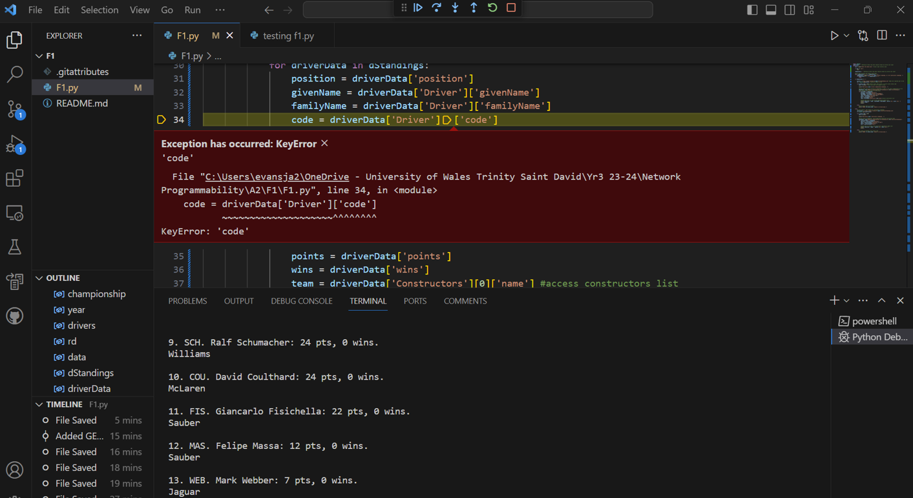
The code crashed retrieving driver 14, so I checked the data structure in Postman and discovered that driver 14 in the 2004 standings did not have a driver code, and many drivers in years prior also did not:
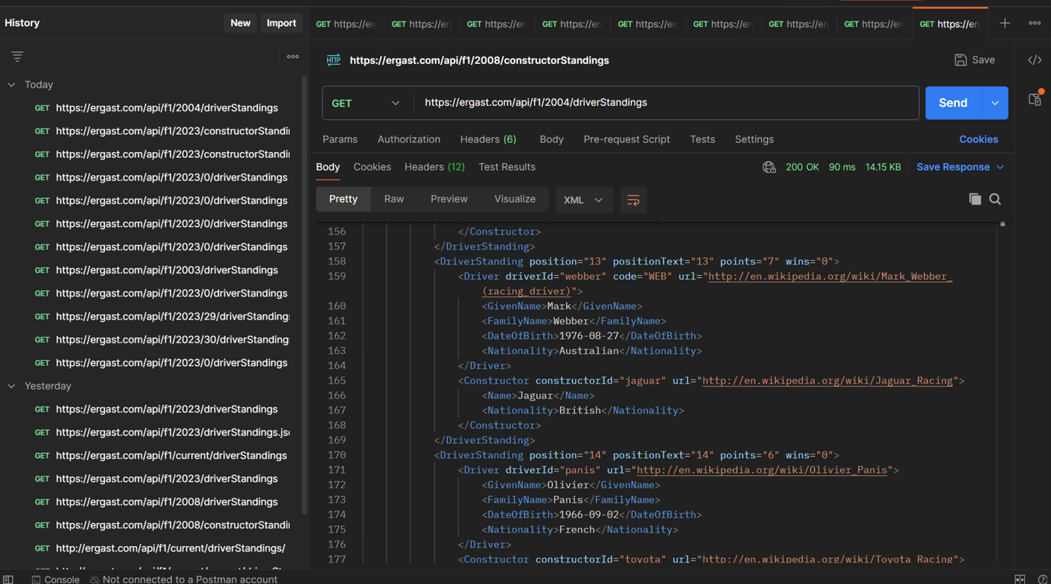

I did not want to remove the driver code field, so to rectify this issue I added a default value to the variable in order to prevent the program crashing if it could not find data:
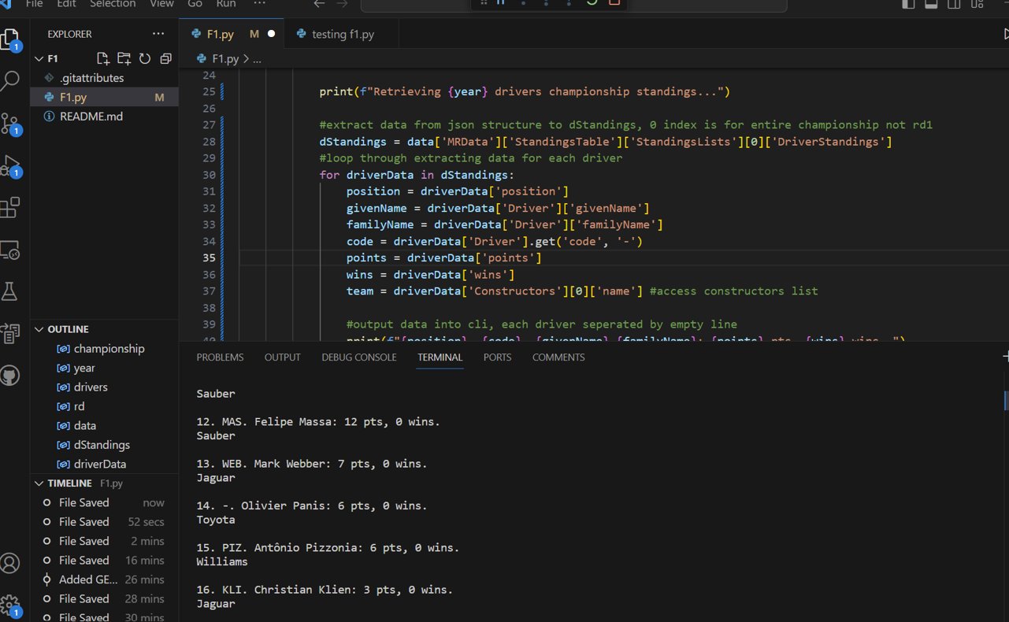
This displays a ‘-‘ in place of a driver code where data is not available, allowing the application to run through smoothly.
Another issue I discovered was that the user could cause the application to crash by entering a year where no data is available, to prevent this I added an IF statement to check that the year is in range, and if not returns the user to input a year:
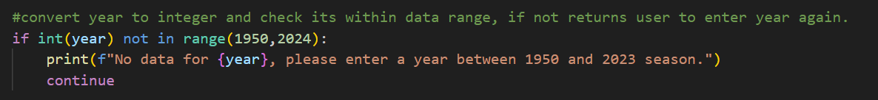
I implemented the same principle to prevent requests for Constructor Championship data before it was started in 1958:
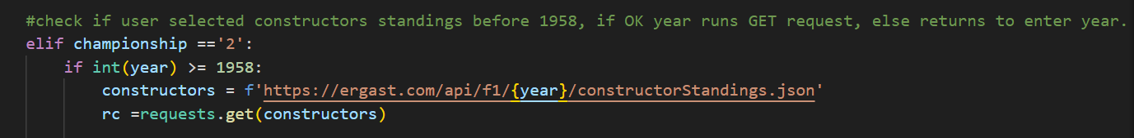

I also added a welcome message to explain to context of the application to the user:
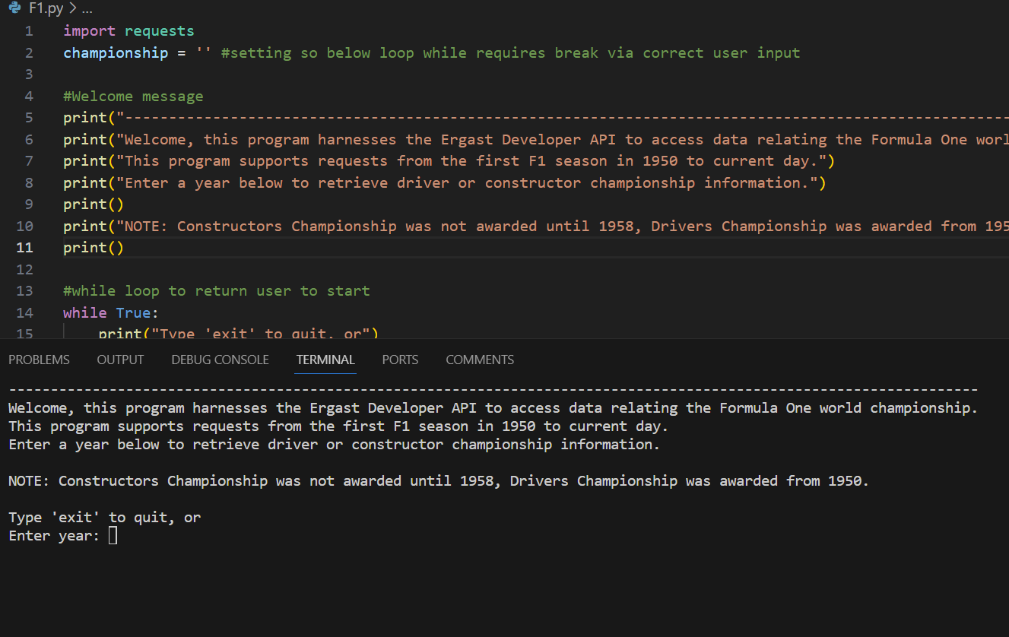
At this point I was satisfied that the code is robust and serves it purpose of displaying Formula One standings data well without having vulnerabilities to crashing, and taking precautions to ensure that even if data is missing from the API the program can still return an output.

Github link: https://github.com/2216851/F1/blob/main/F1.py

