

Investigating the relationship between support services for ex-offender and re-offending.

School: UWTSD Swansea

Degree: Professional Policing

Due Date: 4th July 2022

Word Count:10,884

Acknowledgements

I would like to thank my team in Morriston for reminding me on a daily basis what teamwork is and having my back in dangerous situation. I would also like to thank my Mother-In-Law for her time, support and encouragement. I am fully aware this is not an easy job! I would like to thank my Wife, who has sat with me patiently to help me understand what to do for each essay and put up with my frustration. I promise I will never do another university degree again.

Declaration
This work has not previously been accepted in substance for any degree and is not being concurrently submitted in candidature for any degree.
Signed: Sam Bellingham
Date: 24.06.22
STATEMENT 1
This dissertation is being submitted in partial fulfilment of the requirements for the degree of BA.
Signed: Sam Bellingham
Date: 24.06.22
STATEMENT 2
This dissertation is the result of my own independent work/investigation, except where otherwise stated.
Other sources are acknowledged by footnotes giving explicit references. A bibliography is appended.
Signed: Sam Bellingham
Date: 24.06.22
STATEMENT 3
I hereby give consent for my dissertation, if accepted, to be available for photocopying and for interlibrary loan, and for the title and summary to be made available to outside organisations.
Signed: Sam Bellingham
Date: 24.06.22
STATEMENT 4
I hereby give consent for my dissertation, if accepted, to be available on the university’s IT system to those who have consent to use the system.
Signed: Sam Bellingham
Date: 24.06.22

Abstract
The aim of this dissertation is to investigate and establish why reoffending occurs amongst prisoners and whether current support services are sufficient with the UK. The researcher carried out critical analysis of relevant and existing academic literature on this.
Education, employment, drug and alcohol misuse, mental and physical health, attitudes and self-control, institutionalisation and life skills, housing, financial support and debt and family networks are just some of the reasons why offenders often find themselves reoffending; this results in the UK spending over £18 Billion to find solutions and provision to prevent reoffending (Ministry of Justice, 2019). Over the last 28 years the population within prisons has quadrupled with costings per prisoner at approximately £30,312 (House of Commons Library, 2021) It has been identified that approximately 30% of prisoners re-offend within a year and it is evident that despite two prime ministers over the last 7 years claiming that they will reform and change the entire prison system this ‘biggest shake up in the way our prisons are run since Victorian times’ has not happened (Prisons: re-offending, costs and conditions, 2016).
It is evident that awareness from police officers is lacking in relation to what services they can offer to reduce re-offending and a view from (unlock N.D?) explores an ex-offender who believes they have reformed but still experiences a negative stigma and a lack of support or help from the local police force, “don’t think the police believe in rehabilitation.”

List of Abbreviations

Abbreviations | Definitions
ACEs | Adverse Childhood experiences
BIC | Belief in change
BBR | Building better relationships
CSTR | Community sentence treatment requirements
IOM | Integrated offender management
IOMA | Integrated offender management approach
RWC | Residential women’s centre
RJ | Restorative Justice
SOR | Sex offenders register
UWTSD | University of Wales Trinity Saint David’s

Table of Contents Page
Chapter 1: Introduction …page 10
1.1 Introduction
1.2 Background and Rationale…
1.3 Aim
1.4 Objectives
1.5 Research Structure
1.6 Research Rationale
1.7 Conclusion
2 Chapter two: Literature review… page 25
2.1 Introduction
2.2 To review, research and specify the re-offending rates and crimes amongst prisoners in the UK
2.3 To analyse why re-offending occurs amongst prisoners
2.4 To examine what provisions are in place to prevent re-offending and if enough support is provided to prisoners for rehabilitation
2.5 Conclusion
3. Chapter Three: Research Method…page31
3.1 Introduction
3.2 Research Onion and Philosophy
3.2.1 Time Horizon
3.2.2 Procedure
3.2.3 Choice
3.3 Techniques: Data Collection and Analysis
3.3.1 Data Collection
3.3.2 Pilot Study
3.4 Sample
3.5 Reliability and Validity
3.6 Limitations
3.7 Ethical Considerations
3.8 Conclusion
4. Chapter Four: Results…page41
4.1 Introduction
4.2 Data Analysis
4.3 Demographics and Descriptive Statistics
4.4 Questionnaire Findings
4.4.1 Age
4.4.2 length of service
4.4.3 Knowing what services are available for ex-offenders and could confidentially offer theses services to encourage rehabilitation.
4.4.4 What type of support do you think the government should provide to prevent re-offending.
4.4.5 Opinion on the prison system
4.4.6 Total estimated economic and social cost of re-offending in the UK in Billions per year?
4.4.7 Percentage of all prisoners who re-offend within England and Wales
4.4.8 If you could suggest something to prevent re-offending, what ideas or recommendations would you offer.
4.4.9 Do you agree or disagree with these statements.
4.5 Conclusion

5. Chapter Five: Conclusions and Recommendations…page49

5.1 Introduction

5.2 Main Findings

5.3 Recommendations

5.4 Limitations

5.5 Further Research

5.6 The Achievements of Objectives

5.7 Self Reflection

5.8 Conclusion
6. Bibliography…page55
7. Appendices…page63
7.1.1 Appendix 1
7.1.2 Appendix 2
7.1.3 Appendix 3
7.1.4 Appendix 4
7.1.5 Appendix 5
7.1.6 Appendix 6

7.2 Appendix 7 – Research Onion by Saunders

7.3 Appendix 8 – Copy of Questionnaire

7.4 Appendix 9 - Ethics Form

7.5 Appendix 10 – Question and Literature Review Mix

7.6 Appendix 11 – Questionnaire Answers

7.7 Appendix 12 – Responses to Question 6

7.8 Appendix 13 – Responses to Question 9

Chapter 1: Introduction
1.1 Introduction
The purpose of this research paper is to establish the relationship between services for the ex-offender and re-offending.
This topic is of particular interest as it is clearly shown through data and statistics within government publications, articles and newspapers that offending rates are rising and the cost of re-offending has risen dramatically over the past 10 years and more work is required to prevent further re-offending. It appears that many prisoners have had complex and complicated lives lacking proper support or education which are common factors in reoffending.
The term ex-offender will be used throughout the research; this term is described by the National Association for Reformed Offenders as someone who has previous criminal convictions, although it does not particularly distinguish between ex-offenders who will continue to offend and those that have changed (Aresti, Eatough & Brooks-Gordon, 2010). The term ‘prison’ will also be used consistently throughout this research paper; it is described by Coyle (n.d. para. 1) as “ an institution for the confinement of persons who have been remanded (held) in custody by a judicial authority or who have been deprived of their liberty following conviction for a crime.”

1.2 Background and Rationale
The UK is known to have a profound problem within imprisonment compared to western Europe (Prison Reform Trust, 2021). The UK is particularly poor at reducing reoffending; 47% of adults who were released from prison were reconvicted within one year ( Lyon, 2010) and adults who were released from custodial sentences of less than 1 year had a proven reoffending rate at 59.7% in 2019 (Ministry of justice, 2019)
It was stated that in 2016 the cycle of reoffending costs approximately £13 Billion a year (Ministry of Justice, 2016) and it is clearly a problem as in 2019 it is estimated that the UK spends £18.1 Billion per year for reoffending (Ministry of Justice, 2019).
Over 62% of offenders who enter prison are classed as having a reading age of 11 or lower unlike the general adult population which is less than 15% (Department for Business Innovation and Skills, 2022). Moreover, there is clear context stating that an offender’s welfare and mental health is not at the forefront, as over 70% of inmates who have died from self-inflicted means whilst in prison, had already been identified with experiencing mental health issues, although less than half of these people had their mental health problems flagged only on entry to the prison and had no support afterwards (Prison and Probation Ombudsman, 2017).
There are many factors that can influence an offender to reoffend; this often relates to, but is not limited to, a lack of employment opportunities, accommodation and mental health services. (Prison and Probation Ombudsman, 2017).
One in seven people who left prison in the year 2018 were homeless. Ex-offenders often resort to sleeping rough, as over a third lose their house while in prison and two-thirds lose their job, this often results in a vicious cycle with ex-offenders feeling that they have no alternative but to re-offend as a means to have a roof over their head. It is clear therefore, that the systems are unable to cope with the demand for housing and provisions for ex-offenders (Smythe, 2017).
Extended research in this area over the last few decades is a widely recognised issue within modern society. It is clear that previous efforts to reduce reoffending within the UK have been attempted, however there is clearly more work to do due to the complex and severe deprivation ex-offenders face once released from prison. The research paper was initially going to explore opinions and perception of ex-offenders however due to difficulties in finding any willing participants who had a history of offending and due to the ethical restrictions this was not pursued but to meet the set objectives below the research was conducted with South Wales Police employees.

1.3 Aim
The aim of this research investigation is to establish why reoffending occurs amongst prisoners and whether current support services are sufficient within the UK.

1.4 Objectives
1.To review, research and specify the re-offending rates and crimes amongst prisoners in the UK
2. To analyse why prisoners re-offend.
3. To examine what provisions are in place to prevent re-offending and if enough support is provided to prisoners for rehabilitation
4. To collect data and analyse it to see police officers’ perception of prisoners and whether they believe enough support exists and is provided.

_{1.5 Research Structure}
To meet the objections of this piece of work, this research paper will contain five chapters.
Chapter one will show the research through a clear background outlining the reasoning for the conducted research, the aim and objectives. The research paper will consist of primary and secondary data in the form of a questionnaire and a literature review.

Chapter two will show the literature review with the aim and objectives set in chapter one. This literature review will aim to provide an understanding of the relationship between a lack of support services for prisoners and re-offending.
Chapter three will demonstrate the method and methodology which will identify suitable primary research techniques and questions for this research; this aims to assist in the research gaps and the data can then be analysed.
Chapter four will show the analysis of primary data which has been collected through the methods discussed in chapter three; statistical analysis will be used to present the findings.
Chapter five will calculate and view the aim and objects of this research paper, it will finalise with a discussion of the main findings, recommendations and limitations it has faced.

1.6 Research Rationale
For reflection of the aims and objections for this dissertation, there are large amounts of research available online and articles found on google scholar and within the University library. There have been numerous studies to investigate if prisons are capable of reforming offenders and preventing them from reoffending; one such study by the Ministry of Justice clearly shows a large list of programmes which have been created to help prevent reoffending and offer support (Ministry of Justice, n.d.).
A further study from the ‘Ministry of Justice 2013- Transforming rehabilitations’ which is aimed at reducing reoffending, explained there are eight common factors which are associated to reoffending; these are drug misuse, alcohol misuse, impulsivity or low self-control, attitudes that support crimes, social networks, lack of family and intimate relationships, lack of employment and suitable accommodation (Ministry of Justice, 2013).
Another study from the Ministry of Justice – ‘The factors associated with proven re-offending following release from prison explores in depth reasons why reoffending happens and looks at patterns of behaviour. The study finds that a child who rarely attended school or truanted was more likely to reoffend on release than those who attended regularly. The study also identified that those children with adverse childhood events such as witnessing violence, abuse, sexual acts, having parents who have separated or being taken into care are more likely to commence a criminal career and, without further preventative measures, could continue to reoffend in the future. Within this study it shows that out of the sample studied 91% of reoffenders in the stated time period were white males with an average sentence of one month to six months (Ministry of Justice, 2013).

1.7 Conclusion
Chapter one introduced the research, identified the aim and objectives and shaped why this research is key within established reasons to why reoffending happens and what preventive measures are lacking. This research should enable recommendations for improvement to be made by the end of this study. The next chapter will present a literature review exploring in more depth the key issues raised in chapter one.

2 Chapter two: Literature review

2.1 Introduction
The reason of this chapter is to review current academic literature which will specify the re-offending rates and crimes amongst prisoners within the UK, to analyse why re-offending occurs amongst prisoners and particularly on what provisions and services are available to prevent re-offending.
The literature review below will contain a wide range of sources which have been obtained from Google Scholar, online documents and the University of Wales Trinity Saint David’s (UWTSD) online library. These sources consist of academic journals and Government publications and existing primary research in the research area of ex-offenders and re-offending. The literature within this chapter may enhance the reader in the creation of primary research and the methodology for data collection.
It has long been recognised in the research literature that continuity of case management is
critical to the successful resettlement and rehabilitation of prisoners, but that unless
determined efforts are made to counteract them, offenders are likely to experience major
discontinuities in their contact with rehabilitative services as they move into and out of prison (Petersilia 2003; Taxman 2004; Maguire and Raynor 2006).
More often than not, ex-prisoners have been handed over from whatever sources of assistance are available in prison to different and usually inadequately connected arrangements at the point of release; this is immediately followed, for many, by the period of greatest risk of involvement in new offences.
Staff within prisons tend to focus primarily on the custodial sentence itself rather than on preparing offenders for release (Maguire & Raynor 2016). In a study of Pentonville published over fifty years ago, Morris and Morris (1963, p. 309) remarked that, ‘The prison staff are concerned not with what a man will do after he goes out of the gate, but with feeding, clothing, and housing him while he is inside, not with whether he will turn again to crime, but whether he will be up to mischief in the prison. Because the dominating concerns of the prison are not for tomorrow . . . contemporary notions of . . .after-care find great difficulty in taking root”

2.2 To review, research and specify the re-offending rates and crimes amongst prisoners in the UK.
Within the UK over 87,550 people were in prison as of June 2021; of that 78,756 are within England and Wales, 7,417 in Scotland and 1,377 in Northern Ireland and between 1990 and 2018 the prison population has quadrupled from 17,400 in 1990 to 80,000 in 2021. In June 2021 it announced that 44% of all prisons were classified as “overcrowded” and on average the cost per prisoner was approximately £30,312 (House of commons Library, 2021).

Figure 1.1 showcases Prison Population with England and Wales since 1900-2020 (House of commons Library, 2021).

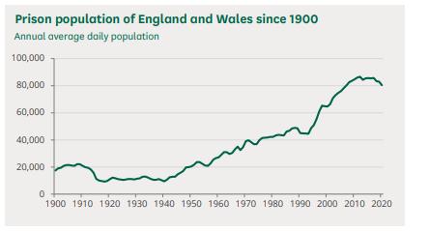

Firstly, to clarify the term reoffending, “A reoffence is when someone commits another offence within 12 months of being released from custody (or receiving a caution, fine or court order) which then leads to a conviction, caution, reprimand or warning in the same 12-month period (or up to 18 months to allow for court proceedings).” (Ministry of Justice, 2021).
David Cameron held a prison review in 2016 while he was Prime Minister; this was the first review of the entire prison system for more than 2 decades outlining the plans for 6 new reform prisons and a “wholesale reform”. It is clear that David Cameron was fully aware of impacting issues re-offending had on the UK; he stated within this speech in 2016 “46% of all prisoners will re-offend within a year of release. 60% of short-sentenced prisoners will reoffend within the same period.” It was identified in 2016 that the cycle of reoffending cost approximately £13 Billion a year (Ministry of Justice, 2016) and (Prisons: re-offending, costs and conditions, 2016) and (Open access Government, 2022). The most up to date research shows that reoffending is estimated at £18.1 Billion per year (Ministry of Justice, 2019).
Re-offending rates as a whole have been broadly stable since 2007 with approximately between 28% and 32% being the proportion of offenders who have reoffended.

Figure 1.2 (Ministry of justice, 2020)
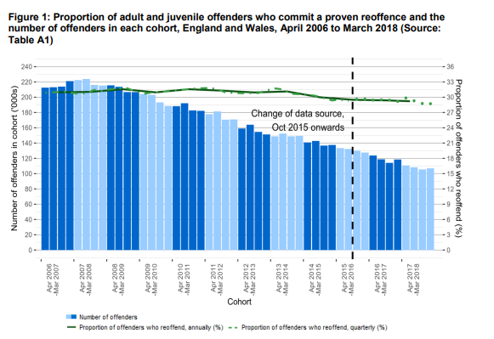

This diagram shows only minor fluctuations statistically between 2006 and 2018 however the increased frequency rate along with the decreasing rate of proven reoffending in theory shows that a higher number of reoffending is often being committed by a smaller number of individuals.
When looking at ethnicity and gender in terms of reoffending, black offenders have the highest reoffending rate of 32.7% in 2018 whilst white offenders stood at 30.6% and mixed ethnic groups accounted for 20.9% for reoffending. However, in all ethnic groups young offenders had the highest reoffending rate and white offenders committed more reoffences per person averagely 4.17. Regarding gender, male offenders often reoffended at a high rate of 30.0% compared to females at 23.1% however these rates fluctuated between 25.7% and 33.8% for males and 19.4% to 24.4% for females (Proven reoffending statistics quarterly bulletin, England and Wales, January 2018 to March 2018, 2020) and (Ministry of justice, 2020) (Ministry of justice, 2013-2016.)

Figure 1.3 (Ministry of justice, 2020) Explains the proportion of adult and juvenile offenders in England and Wales who commit a proven reoffence and the number of offenders in each cohort, April 2015 to June 2020
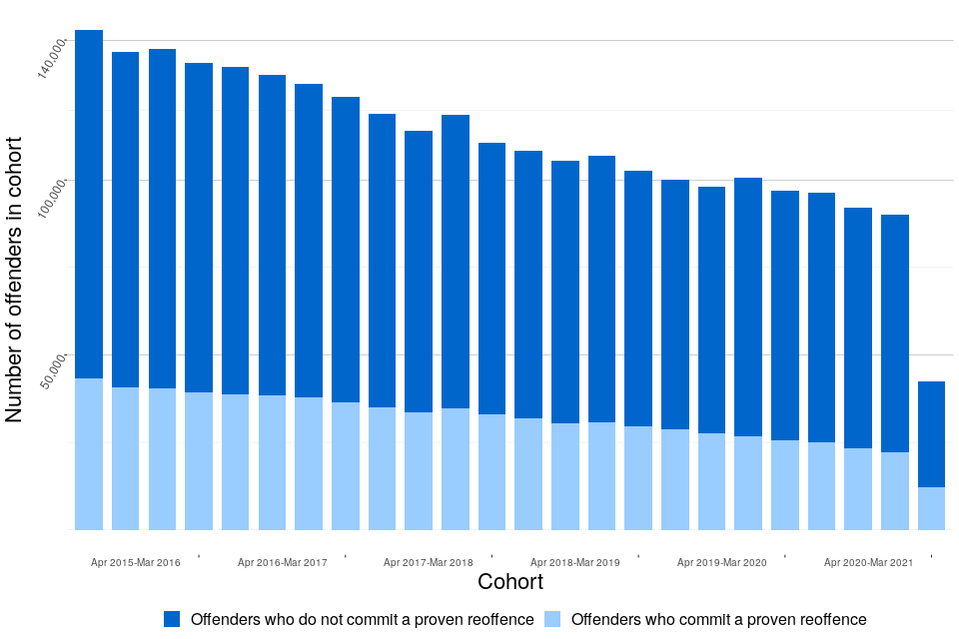
This diagram clearly shows a reduction in the number of offenders being reduced slowly over the past 5 years from 140,000 offenders in April 2015 to approximately 100,000 offenders in May 2020. The pattern of reoffending is on a decline, however, only a very gradual one, which still highlights a clear issue within reoffending. A study shows that between April 2020 and June 2020 offenders who have a previous large number of offences have a lot higher rate of proven reoffending than those who had fewer previous offences. Between this period adults who had 11 or more previous offences were 45.3% more likely to reoffend and represented 72% of all adult reoffenders who committed 81% of all adult proven re-offenders (Ministry of justice, 2020).

Figure 1.4 (Ministry of justice, 2020) Proportion of adult and juvenile offenders in England and Wales who commit a proven reoffence, by age, April to June 2020 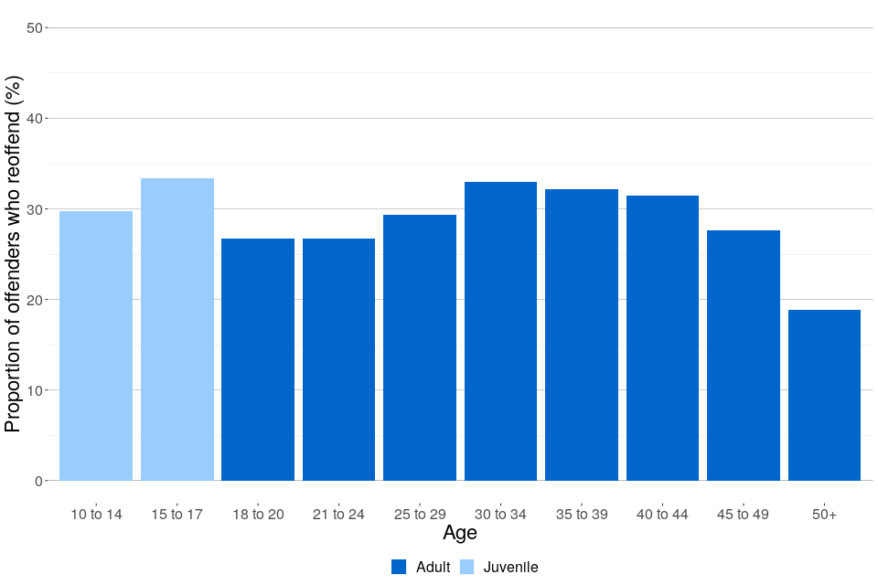
This diagram clearly shows the age of those individuals who reoffend where the highest reoffending age group is 15–17 year-olds followed by the 30–34 year-old offenders (Ministry of justice, 2020).
Figure 1.5(Ministry of justice, 2020) Proportion of adult and juvenile offenders in England and Wales who commit a proven reoffence (April to June 2020)
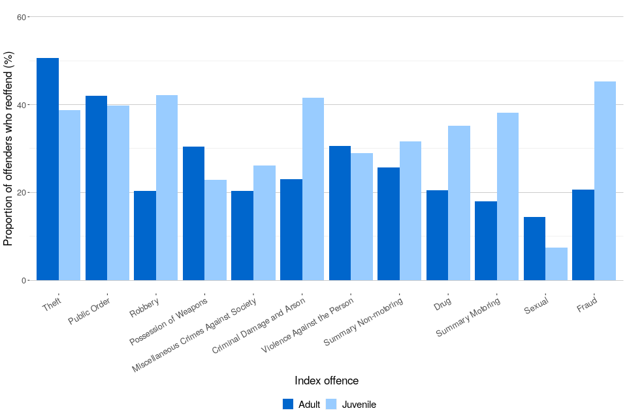

This diagram shows the levels of percentage of reoffences committed by adults and juveniles on different types of crime between April to June 2020. It is clear that the lowest rate of reoffending within the adults was amongst those with a sexual offence with a rate of 14.4%; this could be argued as due to the Sexual Offence Act which ensures all convicted offenders must register on the sex offenders register (SOR) within a certain timeframe and have conditions upon being released. It is also evident that offences of theft have the highest number of reoffenders over 50% (Ministry of justice, 2020).

Figure 1.6 (Ministry of justice, 2020) Proportion of proven reoffences for adult and juveniles committed in the one-year follow-up period, by month of reoffence, April to June 2020
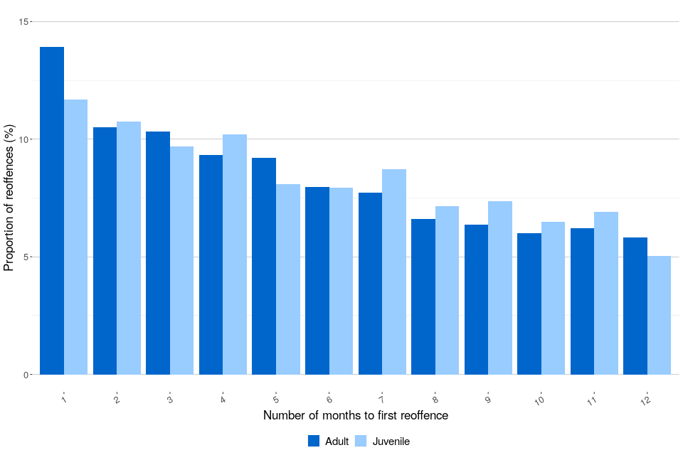
This diagram shows the reoffences for adults and juveniles committed in a one year period. For both adults and juvenile offenders, over 34% of all reoffences happened in the first three months after release from either custody or non-custodial conviction. This figure increased when within 6 months of release where over 60% of all reoffences occurred (Ministry of justice, 2020).

2.3 To analyse why re-offending occurs amongst prisoners.
There are many reasons as to why prisoners may re-offend however it is clear that adverse childhood experiences and mental and physical health plays a major part in understanding why re-offending occurs. It is established that there is not a clear path for each and every offender as some individuals may re-offend while others who have faced similar experiences, do not.
A report by the social exclusion unit written for the Prime Minster in 2003 explores the factors which influence reoffending and they have been identified as nine key factors;
education, employment, drug and alcohol misuse, mental and physical health, attitudes and self-control, institutionalisation and life skills, housing, financial support and debt and family networks. Compared with the general population, prisoners are ten times more likely to have been a regular truant, two and a half times more likely to have had a family member convicted of a criminal offence, six times more likely to have been a young father, and fifteen times more likely to be HIV positive”.
Another key finding regarding prisoners within the report is that “a third lose their house while in prison, two-thirds lose their job, over a fifth face increased financial problems and over two-fifths lose contact with their family. There are also real dangers of mental and physical health deteriorating further, of life and thinking skills being eroded, and of prisoners being introduced to drugs. By aggravating the factors associated with re-offending, prison sentences can prove counterproductive as a contribution to crime reduction and public safety.” Ministry of Justice, 2013.
Offenders are often labelled during their time in prison, however once they are released, they can experience negative stigma as they are referred to as “criminals” which can produce negative psychological and behavioural consequences causing members of the public to be biased and believe a stereotype; this, in turn, may prevent them from gaining suitable housing provision, employment or join communities upon release (Moore, Milam, Folk and Tangney, 2018).
If prisoners experience negative social interactions and are still referred to as criminals upon release they often find themselves returning to prison (Recidivism, 2022).

Prisoners within England and Wales are often sentenced to short periods of incarceration which fails to prevent reoffending because of a lack of awareness and availability of community-based sentencing. Courts have options rather than placing someone in jail such as fining an individual, offering a Community Sentence Treatment Requirement (CSTR), which can be for mental health problems, or alcohol, or drug dependency. It is believed that short periods of incarceration are being handed out by default according to John Bache, a former national chair of the Magistrates Association. He has stated that this has failed to achieve any type of objectives where sentencing and impacting the offender’s families and lives and potentially allowing children to follow in their parents’ footsteps (Siddique, 2021).
John Bache stated, “The bulk of these people, who commit multiple crimes, they’ve got an underlying problem, which is mental health or alcohol or drugs or a combination of any two or three of those. The treatment for that is not to shove them in prison, because if they haven’t got a drug problem when they go into prison, they’re likely to have one when they come out. The solution is to attempt to treat alcoholism or their drug requirements.” (Bache, 2021) and (Siddique, 2021).
Bache stated that it would be more beneficial and cheaper to treat criminals within the community rather than sending them to custody and explained that often Community Treatments are a postcode lottery.
Allison and Grierson 2021 establish that between 2009 and 2019 over 60% of rehabilitative courses, which were aimed at preventing reducing general offending, ceased but that the use of prisons has increased in popularity.
However, Angela Charles argues that prison is the answer and that it is an effective deterrent as it takes away freedom, support networks and removes any type of identify which is sufficient for members of the public to not even think about committing a criminal offence. She also suggests that putting criminals in prison protects the public ensuring they cannot commit any further offences and it also gives a sense of justice to any victims affected (Charles, n.d.).
The report states that all these factors are interlinked and will often cause a prisoner to reoffend. However, there is an opportunity for reforming if offenders have a chance to maintain relationships and support especially if they are from non-offending members of the public. The report states that steady employment will reduce the risk of reoffending especially if it offers a reward or achievement. Other factors in preventing offending are having something to give to others and being able to contribute to society, not seeing themselves as having a criminal identity but being seen as a good person who has made a mistake in the past. Another factor is age; street level crimes such as theft, drugs and assaults tend to peak in late teens and early 20s on average; when someone gets older they often have to give more attention to family and loved ones and cannot spend time and energy committing offences so reoffending after custody tends to reduce with age.
Reasons for re-offending are often varied, however 75,000 of the 156,000 offenders within the probation service in 2021 were struggling with drug abuse but only 3,000 of them were referred by probation to specialist drug services. The reason given for this was that most probation officers have heavy workloads and often manage 70 cases each which in turn results in re-offending to feed drug habits (Grierson, 2021) .
Further reason as to why re-offending happens is shown within prison; offenders who are less likely to follow prison rules are more like to re-offend once they have completed their sentences. Offenders who express worry or feel anxiety about prison sentences were less likely to re-offend once released. (Ministry of Justice, 2013).
Evidence suggests that short sentences not only offer no opportunity for rehabilitation but for an offender’s children “their whole life is turned upside down through no fault of their own” so it is not surprising, “if their behaviour becomes unacceptable and if they themselves begin to demonstrate criminal tendencies” (Berman and Grimwood, 2012 and Siddique, 2021).
Thompson (2016) discusses that prior to offenders entering prison over two thirds have no former qualifications and most have the reading age of a 10-year-old; in theory these prisoners are already unemployable prior to going to prison however due to the lack of educational programmes they often find themselves no more employable when they are released. While prison populations have increased over the last five to ten years, staff have been cut by 30% which has resulted in major overcrowding conditions and now 20% of prisoners spend more than 22 hours a day in a cell. Understandably, suicide is at its highest point in 25 years. If you view the measure of success in rehabilitation and prevention of re-offending and compare it to GCSE’s context then re-offending rate within a year for juveniles is 37% and for adults is 25%, if you compare this to 25% of pupils achieving no GCSE’s (Ministry of Justice, 2021).
David Cameron outlined plans in 2016 to conduct an entire reform of the prison system and Boris Johnson in 2019 outlined plans for an additional £2.5 billion to deliver an additional 10,000 prison places within England and Wales. Boris Johnson stated he was going to create a bold plan for the justice system to cut crime and protect law-abiding people which would in turn prevent re-offending in the future (Prisons: re-offending, costs and conditions, 2016).
However, in 2016 David Cameron and Michael Gove set out plans for a ‘once in a generation’ investment to modernise the prisons and deliver 10,000 more prison places by 2020, claiming it to be ‘biggest shake up in the way our prisons are run since Victorian times’. However, none of these plans have been completed as the Ministry of Justice has seen a budget cut in 2010/2011 of £9.3 billion to an estimated £5.6 billion in 20019/2020, approximately 40% cut in under a decade (Prisons: re-offending, costs and conditions, 2016).

2.4 To examine what provisions are in place to prevent re-offending and if enough support is provided to prisoners for rehabilitation
Over the past thirty years the UK has attempted many different ideas in trying to reduce re-offending from having high intensity training boot camps in the 1990s to introducing and applying the Restorative Justice (RJ) model when focusing on property crimes and increasing the use of electronic tagging. Treatment for mental health problems in reducing criminal re-offending and parole re-entry schemes have been attempted and prevention and engagement officers for drug misuse (Ministry of Justice, 2021) and (The National Offender Management Service, 2015).
There were two high intensity training boot camps in place in the 1990s across the UK which aimed at trying to break the cycle of offending, especially in young offenders, by offering them a physically demanding 16-hour regimen which also included life skills (Travis, 1999).
Police officers are expected to assist and support offenders to prevent re-offending and one of the aims is to encourage rehabilitation. A study from (Unlock N.D) shows that an ex offender who believes they have reformed and moved on with rehabilitation is still experiencing a negative stigma and a lack of support or help from the local police force and a view of, “ don’t think the police believe in rehabilitation.”
Training and guidance within police forces has changed over the last few years and since the Integrated Offender Management Approach (IOMA) was introduced, officers were warned to deviate from an ethos of “catch and convict” and from the IOM’s latest inspection it was noted, “We are clear that police officers working in this environment should have some knowledge of the theories and practices associated with assisting an offender to achieve desistance, but their principal role should be gathering and disseminating intelligence and enforcement”.
The report on a Chief Constable’s recommendations stated that it is key to promote the benefits of the IOM to all officers within the force particularly those on the front line, making sure that the processes are in place. To ensure that police officers are to receive sufficient training to fulfil their duties to aim to reduce crime and re-offending (HMIP & HMIC, 2014, p.8-18).
In 2010 drug and alcohol recovery pilot programmes were offered to offenders to encourage them from prolific drug misuse which also offered a payment incentive to programme providers to reduce harm and allow recovery; this resulted in a reduction of drug misuse across 8 areas of the UK such as Oxfordshire and Kent as well as improved housing, ceased injecting and prevention of reoffending over a 12-month period (Drug and Alcohol Recovery Pilots, 2022).
Within the prison system there are many programmes set up and designed to reduce and prevent re-offending with the UK such as ‘Building Better Relationships (BBR)’ designed for male perpetrators of abuse and violence within relationships and it has increased understanding and relationship skills to prevent further domestic violence. Another scheme is ‘Belief In Change (BIC)’ which explores ‘prolific career criminals’ who have accelerated since childhood through the prison system with increasing levels of offending. A further programme created to deliver a reduction is prison partnership therapeutic community, which aims to reduce prisoners’ drug dependence a known high risk group for reoffending. It is an intense programme 24 hours a day, 7 days a week, lasting 10/12 months which uses a cognitive behaviour approach to try and alter mindsets and allows participants to learn and develop new skills and values to eventually become drug and crime free (Ministry of Justice, n.d.).
Another suggestion is that as prisons within the UK are reaching full capacity, alternative community sentencing options in the UK would save money both for public sector and for society. By diverting adult offenders from standard prison sentences to interventions would save between £19,000 and £88,000 per offender which is suggesting that standard prison sentences are not an economically efficient means for reducing re-offending (Marsh and Fox, 2008).
The Ministry of Justice implemented in 2021 many suggestions and options for intervention in reducing re-offending such as a home, a job and access for support and treatment for substance misuse. They have decided to deliver a female offending strategy allowing the first residential women’s centre (RWC) within Wales, which will support women offenders to address any underlying issues causing re-offending and look to alter their behaviour and thought process. The aim is to target further departments to reduce levels of re-offending within young people to try and prevent them from offending in the first place. Focus is also on prison officers to enable them to perform their duties correctly and be able to implement rehabilitation programmes to prevent future crime. The Ministry of Justice has increased supervision of offenders once outside of prison to allow the courts more confidence in ensuring that monitoring and community sentences are more effective, to implement a transitional accommodation for prison leavers to reduce the level of homelessness within probation regions to overall prevent the re-offending. They are delivering services and treatment for vulnerable offenders with mental health, alcohol and substance abuse. Further provisions are to ensure education to staff to increase the level of electronic monitoring and alcohol abstinence tagging and expand the use of Global Position System tagging (Ministry of Justice, 2021).
Also, in 2021 the government invested a further £80 million to expand community drug treatment services within the UK which will allow thousands of offenders to get the correct help and restart their lives preventing reoffending and assisting with a reduced prison population and ultimately to protect the public (Grierson, 2021) and (Bullock and Bunce, 2018)
The HM Chief Inspector of Prisons stated, “Far too many of our jails have been plagued by drugs, violence, appalling living conditions and a lack of access to meaningful rehabilitative activity” (Howard league for Penal Reform, 2019) and (GUINEY, 2019)
Another reason why reoffending occurs is due to the level of danger within prisons. Her Majesty’s inspectorate of prisons require four basic measures in all prisons, these are safety, respect, purposeful rehabilitation and release planning. Within prisons it is clear self-harming and self-inflicted deaths have nearly doubled between 2009 and 2018 but prison staff budget cuts were made at 20% between 2010-2015 and front line officers fell by 26% between 2010-2015 resulting in 10% fewer in 2018 than 2010. Violence with prisons has also risen by nearly triple from 2009 to 2019. Drug misuse amongst prisoners causes addictions and in 2018 it was at its highest point since 2004/5 and contraband within prions for alcohol, drugs and weapons has nearly doubled between 2017 and 2019 causing major concerns resulting in overcrowding and over six prisons have been issued with urgent notifications related to this issue (Portal, 2019).

2.5 Conclusion
This chapter achieved the objectives:
To review, research and specify the re-offending rates and crimes amongst prisoners in the UK.
To analyse why re-offending occurs amongst prisoners
To examine what provisions are in place to prevent re-offending and if there is enough support provided to prisoners for rehabilitation.
In conclusion, from this literature review it is evident that there is a substantial amount of research that the Government, independent teams and newspapers have developed and studied regarding the levels of re-offending, why it occurs and what provisions are in place.
It is clear that the literature review has outlined that there are certain gaps in the research surrounding the topic of provisions in place as it is a fact that re-offending is still occurring and therefore needs to be addressed even further.
The next chapter will identify the appropriate research method and methodology to address the issues highlighted in this chapter.

3. Chapter Three: Research Method
3.1 Introduction
Research is not merely gathering or searching for information; it needs to show real life problems and have clear objectives with specific plans to conduct data collection to try and identify the problem. (LeedyP, OrmrodJ (2011, as cited in Bruwer, 2016).
(Collis, J. & Hussey, R. 2013 as cited in Collis and Hussey, 2013) define research as organised processes that are being investigated of a specific subject to advance current research and knowledge and to ensure the research is of interest. It is also the opinion of Collis and Hussey 2009 that research can be broken down into four categories, purpose, process, logic and outcome of research (Collis, & Hussey. 2009)
The term research philosophy is referred to as a system of beliefs and assumptions about that developing knowledge. During the stages of research, it is assumed there are a number of assumptions such as the encounters you have in your research and having your own values which will eventually shape the understanding and findings. (Burrell and Morgan 1979, as cited in Saunders, Mark & Lewis, P. & Thornhill, A.. 2009).
According to Earl Robert Babbie, research is, “systematic inquiry to describe, explain, predict and control the observed phenomenon.” (What is Research - Definition, Types, Methods & Examples, n.d.)
Primary research is often explained by using the research onion which was created by Saunders et Al (2016) and will offer guidance throughout the processes of research and assist with identification and explanation of the chosen strategy for this research paper (Saunders research onion for effective research methodology, 2019) and Sahay, Arunaditya. (2016).

3.2 Research Onion and Philosophy
The research onion was created by Saunders Et Al which has given an insight into the chosen research methods to establish and provide a clear understanding and the different decisions you need to make when developing a methodology; it is often described as a thinking holistically approach to methodology (Saunders et al, 2009).
Saunders’ research onion is made up of 6 different layers to try and represent the development, these include Research Philosophy, Research Approach, Research Strategy, Choices, Time Horizon and techniques and procedures. From reviewing the Research Onion within the first layer, Interpretivism explores the social and cultural factors that can be on anyone and focus on people’s thoughts and ideas. This study includes Interpretivism which has a range of answers that may be subjective and does require the opinion and thoughts from police officers to discuss if they are aware of and believe there is enough support in place (Bhattacherjee, 2012). “Interpretivism, thus, is a socially constructed phenomenon and differs from positivism and critical theories in that this approach does not believe in making broad conclusions but offers deeper understanding of a particular situation.” Sabharwal, Meghna. (2007).
Within the second layer, deductive is viewed as an approach in which one begins with a theory and builds on it through methods such as research. By using quantitative types of research this is often reflected via the deductive method as it uses numerical data. The third layer of the research onion explores the options available to conduct and approach the study, depending on its aims. The fourth layer of the research onion focuses on amounts of data types such as qualitative or quantitative being used. This research paper will explore and use varied methods by the use of a survey to collect data and analyse the results statistically. The final layer of the research onion is time horizon which is understood by the number of points in time you are aiming to collect your data. This research paper will be using a cross-sectional time horizon which is where data is collected all at once and viewing it as a snapshot Saunders, Mark & Lewis, Philip & Thornhill, Adrian & Bristow, Alex. (2019) & (Phair and Warren, 2021).

Figure 1.1 showcases the researcher’s chosen process (Melnikova A. (2018). ‘Towards an Explicit Research Methodology)


3.2.1 Time Horizon

Deciding to conduct the study with a cross-sectional approach ensures data is reviewed from one given point in time to another (Levin, 2006). The reason cross-sectional research is the most appropriate for this type of study and subject is because it is relatively inexpensive and completed quickly; it is however over a short period of time and results only show a snapshot of the situation and other research studies at different times may therefore produce different results. (Levin, 2006).

3.2.2 Procedure
The research will be conducted through questionnaires which will be created through “Survey Monkey” which results in a large range of anonymous answers.
The procedures for this questionnaire was completed on a draft document before implementing then onto an online website called Survey Monkey which offers free online survey feedback. The questions were all aimed at trying to enhance and achieve the objectives given previously, to try and identify if there was any patterns between different ages and levels of service with the police force. Once the questionnaires were completed they were sent out to a large number of employees of South Wales Police force and the time frame given was 48hours to have as many completed as possible. The information researched within the literature review was the grounding and reasoning as to why certain questions were asked on the questionnaire please see Appendix 10 question and literature mix 7.5 for further details.
Questionnaires are the most appropriate choice throughout this research as the results can be analysed and compared allowing a view or insight on quantitative and qualitative data quickly and easily.
Survey research is used, “to answer questions that have been raised, to solve problems that have been posed or observed, to assess needs and set goals, to determine whether or not specific objectives have been met, to establish baselines against which future comparisons can be made, to analyse trends across time, and generally, to describe what exists, in what amount, and in what context.” (Isaac & Michael, 1997, p. 136 , as cited in (Glasow, 2005).
Within Questionnaires there is weakness which Bell (1996, p.68 as cited in (Glasow, 2005)) notes in that biases may occur either in the lack of responses or from the nature and accuracy of the responds received.

3.2.3 Choice
This Research paper will explore and use the mixed methods option to ensure the data is collected and analysed by using both quantitative and qualitative data throughout the survey (Adamson, 2004).
Creswell (2014) states that by using a mixed method approach it offers a pragmatic and transformative approach by using both open and closed questions which results in developing a rationing decision as it resides in the middle of both. Creswell (2014) also states that a mixed method researcher, pragmatism allows to open the door into multiple methods, different worldviews and many different assumptions which enables different forms of data collected. Crotty (1998) has identified that qualitative researchers tend to only use open ended questions therefore allowing the participants to share their views.
Babones (2015) discusses the interpretive approach which is usually linked to quantitative and quantitative data. Within interpretive quantitative research, it explores the analysis data by multiple perspectives and allowing it to become a holistic process and promotes the option to have a more meaningful and understandable view rather than other research methodology options such as positivist.

3.3 Techniques: Data Collection and Analysis
3.3.1 Data Collection

Questionnaires are often used as a favoured tool to gather and record information as agreed by Gilliham (2008); they are seen as very convenient and time-saving methods to collect a large data however it is conceded that participants may misinterpret the statements and questions resulting in incomplete responses and there is also the potential of having a low turnout of participants response (Biggerstaff, 2012).
This questionnaire contains 10 questions with varied, open and closed questions aiming to gather a large range of different information and data from individuals from remote locations aiming to have a good cross section of population (Gillham, B. 2007 as cited in Designing and Using Research Questionnaires, n.d.).
Open questions are viewed as an invite to the respondents to provide data or offer short comments. Closed questions are viewed as allowing the respondent a number of options on what to select and are seen as more difficult to design (Sudman, Bradburn, Schwarzs and Bass, 2010).
Closed questions are seen as quicker for the respondent to answer which may in turn increase the response rate and are easier to analyse and understand if the aim is to collect large data. Open questions allow the respondents to answer in more depth and to share their views on that particular topic, however because they would take longer to analyse the response rate may be less (Designing and Using Research Questionnaires, n.d.).
.
3.3.2 Pilot Study
A Pilot study is a main stage of any research project to ensure all requirements are met and if any potential problems arise so that changes can be implemented prior to any larger study. An ethical approach was met to ensure that all research is appropriate and valid and if the research is feasible and effective (Abu Hassan, Schattner and Mazza, 2006).

3.4 Sample

Salkind (2010) describes sampling as it “occurs when researchers examine a portion or sample of a larger group of potential participants and use the results to make statements that apply to this broader group or population. The extent to which the research findings can be generalized or applied to the larger group or population is an indication of the external validity of the research design.”.
The aim for this research project was to have 30-50 respondents from the entire South Wales Police force population. This aim will offer a chance to view and understand Police officers’ perceptions on whether there is enough support provided to prisoners for rehabilitation. Pearson and Mundform (2010) suggests that the minimum requirement for a sample of any statistical analysis is 100 responses however Kline (1994) suggests a sample size should only be more than 50 respondents (Pearson and Mundform, 2010) & (ELWELL, 1995).
There is a number of different types of sampling which forms an integral part of any research design. Different sampling types are simple random, cluster, systematic and stratified and all are described collectively as probability sampling methodologies (Sample: Definition, Methodologies, Types, formula, and Examples | QuestionPro, n.d.).

3.5 Reliability and Validity

Both reliability and validity are methods of demonstrating and communicating the research processes and findings Roberts, P. and Priest, H. (2006)
“Reliability and validity are concepts used to evaluate the quality of research. They indicate how well a method, technique or test measures something. Reliability is about the consistency of a measure, and validity is about the accuracy of a measure.” (Middleton, 2022).
Both validity and reliability are important factors; it is necessary to research the literature and have a clear suggestion and to ensure its credibility data prior to the designing of the questionnaire. A questionnaire which is both valid and reliable collects the data which measures the interest, and it will ensure its consistency. One concept of both valid and reliable information is to produce a questionnaire which offers a target market and aims to capture a larger audience (Saunders and Akinic, 2015).
Studies have explored and shown that asking people to answer questionnaires completely anonymously increases the honesty but does not show more accurate information. By being anonymous, it might decrease the respondent’s motivation and may compromise measurement accuracy instead of improving it (Marx, Judd and Park, 2011).

3.6 Limitations
There are two categories of limitations within research studies described by Price and Murnan (n.d), these are threats to internal validity and threats to external validity. A main threat of internal validity of any study is that the respondents do not answer truthfully or in a socially desirable way. The study has taken actions to try and prevent this from happening by emphasising anonymity and confidentially. Another limitation may be that the respondent does not fully understand the question which may impact responses as they may be guessing what the question means. Another limitation is focusing on closed questions throughout the questionnaire; however, this has been prevented by offering the respondent spaces after questions within the questionnaire to they can add additional text (Price and Murman, 2004).
A further limitation within this research study is the time frame allowed; as this research is for an undergraduate dissertation, there are only a few months for the questionnaire to be circulated and answered.

3.7 Ethical Considerations
Saunders et al (2007) describe research ethics as “how to formulate and clarify our research topic, design our research and gain access, collect data, process and store our data (Saunders, Lewis and Thornhill, 2009).
The consideration for an ethical approach has always been relevant and key to this research study ensuring that all questions asked are morally sound and by keeping to procedures to prevent any excessive harm or upset to any respondents. There are many types of ethical issues within a research paper such as having voluntary participations, informed consent, anonymity, confidentially and the potential for any harm.
The questionnaires used within this study were based on voluntary participation allowing the respondents to withdraw at any point without obligation. During the study the respondents were asked if they were willing to give consent, informing them that all the information is kept confidential and that answers will not be able to be linked to any individual respondents. This research study was completed online; respondents were sent links to a survey website which initially explained the study and reasoning as to why it is being conducted; prior to starting the study all respondents were asked to give consent.
The respondents for this study were all volunteers and over the age of eighteen and the data collated from them was password protected online to prevent any potential misuse. This research study, therefore, foresaw no opportunities or chances of any potential psychological harm to the respondents (Bhandari, 2022).
3.8 Conclusion

This chapter has developed, reviewed and completed the fourth objective and described the research methodology and the reasons to why a mixed method approach has been used.

4. Chapter Four: Results
4.1 Introduction
Chapter 3 has identified the methods and methodology and reasoning behind the research. This chapter is aimed at achieving the final two objectives:
To investigate if enough support is provided to prisoners for rehabilitation.
To collect data and analyse it to understand the perception of police officers regarding prisoners and whether they believe enough support exists to prevent reoffending.
This chapter will explore the data collected that was obtained through the researcher’s primary research.
Initially this research paper was to explore ex-offenders and their opinions and perception however, there were difficulties in finding any willing participants with a history of offending and there were also ethical restrictions. To avoid “singling out” individuals, the research questionnaire was targeted at participants who are employed only by South Wales Police; this was the best compromise as they have the most experience of dealing with local offenders and would be able to give a more in depth perception than members of the public.
An online survey was created via Survey Monkey which gathered 56 respondents’ views on the perception of prisoners and whether they believe enough support exists for those offenders. Throughout this chapter, refence will be made to all questions that have been answered by South Wales Police Officers.

4.2 Data Analysis
There have been many studies trying to explore and understand the importance and reasoning of why data analysis is undertaken. It is portrayed as “a must” within any research study because it makes studying the data much easier and more accurate to view and interpret and aims to try and uncover any minor patterns within the transformed data (E.Amadebai, N.D)
Data is described as a “ Factual information used as a basis for reasoning, discussion, or calculation” (Gleason, 2022).
Analysis is described as, “ a detailed examination of anything complex in order to understand its nature or to determine its essential features, a thorough study” (Analysis, 2022).
The data was collected and analysed through Survey Monkey; using this tool allowed many advantages for data analysis such as the ability to collect data quickly and within an easy format to easily understand and view.
Over the past three decades, it is accepted that online surveys have changed and become the predominant method of gaining participants for any type of academic research due to its quick responses, low cost and ease (Nayak and K A, 2019) and (Saleh and Bista, 2017).
Both Saleh and Bista 2017 believe that survey platforms such as Qualtrics and Survey Monkey ensure the researcher an easy transfer of any type of data to statistical analysis programmes (Saleh and Bista, 2017).

A blank copy of the questionnaire proforma can be found in 7.3 Appendix 8 – Copy of Questionnaire and the answered questionnaire by all 56 respondents can be found in 7.6 Appendix 11 – Questionnaire Answers

4.3 Demographics and Descriptive Statistics
Respondents were categorised by gender, age and the amount of years’ service in the Police Force to try and identify any significant difference in respondents’ views. This survey was completed by 56 respondents who were all aged 18 years and older, who were all employed by South Wales Police and participated voluntarily. This survey was shared amongst work colleagues via social media and “WhatsApp” to try and enhance the respond rate and range.
Of the 56 respondents, 34 or 69.71% were male and 21 or 37.5% were female and 1 or 1.79% were other.
Previous research outlined that male participants were more likely to complete any type of survey if they had received a reminder and if the questions were short and concise. Further studies show that the older the participant the higher the response rate if a reward was promised. (Couper, Conrad, & Tourangeau, 2007; Yan & Fan, 2010) and (Saleh and Bista, 2017).
Another study suggests that 88% of participants would take part if they were interested in that particular topic. (Petrovčič et al., 2016) and (Saleh and Bista, 2017).
All respondents had to give permission to take part and gave consent from the subheading and information provided for their answers provided to be used within the research paper.

4.4 Questionnaire Findings

4.4.1 Age
When analysing the 56 responses, it was clear that the majority (46.43%) of participants who answered were between 25 and 34 years. 5.36% were aged between 18 and 24 years old, leaving 30.36% who were aged 35 and 44 years old, 14.29% were aged between 45 and 54 years old, 3.57% were aged between 55 and 64 years old.
From the responses it was clear there were patterns within the data suggesting that the participants aged between 35 and 44 years old were unable to offer knowledge of services to encourage rehabilitation but that participants aged between 18-24 and 25-34 years old were more likely to have a view for the same question.
These patterns also show the participants aged between 35-65 believe that the prison system is either not at all effective; comments included, ‘no deterrent’ and “sentences are weak” and “the system is soft” and the younger participants aged 18-34 on average believed the prison system to be either very effective, somewhat effective or not so effective.

4.4.2 Length of service
The data found that 35.71% had been with the police for between 5 and 10 years and 23.21% had been in the police over 10 years; 28.57% had been in service between 2 and 5 years leaving 12.5% who had only been serving for less than two years. From reviewing the data there seems to be a pattern of not being aware of what services to offer ex-offenders with officers between 2-5 years of service. Over 70% of participants who had been in between 2-5 years of service answered either disagree or strongly disagree to the relevant question; this may suggest a lack of training or experience for officers with this length of service and more research may be useful to try and identify similar patterns.

4.4.3 Knowing what services are available for ex-offenders and could confidentially offer these services to encourage rehabilitation.
When analysing the 56 responses, the police officer responses were wide ranging around if they knew what services were available to ex-offenders and how they felt in offering these services to encourage rehabilitation. The highest response received was 37.5% of respondents saying they somewhat agree, followed by 16.07% who disagreed in knowing what services were available. This data sourced is clearly concerning as a lack of knowledge from trained and qualified police officers who are not confident and over 25% disagree or strongly disagree in knowing the available options to ex-offenders. If police officers are not aware of these services then this generates “a knock on effect” that offenders are less likely to be aware and more likely to re-offend without clear or concise support and eventually would turn back to going to prison; this often results in a vicious cycle, with ex-offenders feeling that they have no alternative, but to re-offend, (Smythe, 2017).

4.4.4 What type of support do you think the government should provide to prevent re-offending.
When analysing the 56 responses where respondents had an option of, offering relationship guidance, drug and alcohol abuse, mental health issues, housing options and apprenticeship schemes and finding work, the highest response was 89.29% of the 56 responses who believed that drug and alcohol abuse support should be the key to prevent re-offending and the government should provide this. This is highlighted within the reports of Grierson 2021 and Bullock and Bunce 2018 regarding the additional £80 million being provided to support drug treatment services. This was closely followed by offering apprenticeship schemes and finding work options thereby avoiding the need to turn to crime again for financial gain.

4.4.5 Opinion on the prison system

When analysing the 56 responses it was evident that either the respondents felt the prison system was not so effective or not at all effective resulting in over 64% thinking this.
From this question there was over 10 additional comments from the respondents expressing opinions such as “the whole point of prison, initially was to stop wanting people to go back” or “it isn’t a deterrent for reoffending”. The perception from the Police Officers questioned is that Prisons are not effective, however data from the findings published by Angela Charles indicate that prisons are an effective deterrent. This is also highlighted within the House of Commons Library Report from 2021 stating that prisons were classed as overcrowded and how the prison population had quadrupled.

4.4.6 Total estimated economic and social cost of re-offending in the UK in Billions per year?
When analysing the 56 responses it is noted that over 46% of police officers believe the cost of reoffending per year is between £2 and £5 billion with only 25% of officers believing it was over £15 billion; from reviewing the data from Ministry of Justice 2019, the estimated cost in 2019 was actually £18.1 billion.

4.4.7 Percentage of all prisoners who re-offend within England and Wales

When analysing the 56 responses the overall outcome was that 37.5% of police officers questioned believed over 50% of prisoners will re-offend within England and Wales; this is a much high perception than the actual data sourced from within the literature review. From analysing the data more closely those in service aged over 60% of the 45-64 year age group believe re-offending rates are over 50%; in comparison in the 18-24 year olds group the believed re-offending rate is between 20 and 30%.

4.4.8 If you could suggest something to prevent re-offending, what ideas or recommendations would you offer.
Of the 56 responses there were 44 which contained comments and suggestions around preventing re-offending; 12 respondents failed to make any additional comments.
Comments to address the issue of reoffending included similar statements to, “Stronger punishment”, “stricter, harsher sentencing as a deterrent”, and “tougher prisons.” Additional suggestions made included, “ to offer jobs, better education, support prisoners with mental health issues and give financial support”.

4.4.9 Do you agree or disagree with these statements.

The following statements were made.
Adverse childhood events such as witnessing violence, abuse and children who are removed from their home environment can increase the chances of involvement in crime.
Far too many of our prisons have been plagued by drugs, violence ,appalling living conditions and a lack of access to meaningful rehabilitative activity.
Nearly 84% of the 56 responses agreed with the first statement believing that adverse effects on children have a correlation to chances of being involved in crime however only 17% of the 56 responders agreed with the second statement despite data collected within the Literature review which stated by Portal in 2019 that violence, drugs and overcrowding are all factors and are on the rise.

4.5 Conclusion
This chapter achieved the final objectives:
To collect data and analyse to see individual police officers’ perception of prisoners and whether they believe enough support exists and is provided.
In conclusion, the data collected by Police Officers demonstrates that they are not fully confident in offering the appropriate services to encourage rehabilitation. They believe drug and alcohol support is paramount in preventing re-offending and agree that prisons are not a deterrent and need to be more stringent and stern in towards repeat offenders.
It is evident that there are patterns found within the data from the participants and that the research viewed has found a relationship between services and support; it shows that there is not enough support for ex-offenders who are released from prison to prevent them from re-offending; even though a large amount of money is being spent on supporting drug and alcohol misuse initiatives. There is a limitation to the data sourced because over 40% of the 56 respondents who answered had less than 5 years of service and on average were under 34 years old; this lack of experience may impact the data and not give a true reflection of prison officers views and experiences.
The police officers’ opinions have positively and negatively differed from the research which was found in the literature review and the suggestion is that more work is needed to prevent re-offending through further support and development within the prison systems. This chapter has successfully analysed the data gathered from the police officers. The closing chapter of this research paper will provide recommendations and conclude the study.

5. Chapter Five: Conclusions and Recommendations

5.1 Introduction

Previous chapters of this dissertation have explained, explored and guided the research study through the process of introductory, research, methods, planning and analysing the results.
This chapter will discuss and offer a conclusion around the research question of investigating the relationship between support services for ex-offenders and re-offending and will highlight any limitations from this study and offer potential recommendations for future research in this field. Finally, this chapter will offer a self-reflection using the Gibbs model approach to fully recognise and reflect on practice.

5.2 Main Findings

During this research study a number of findings have been explored throughout the chapters of this study.
There are clear gaps within research on what type of provisions are in place to support ex-offenders, and how the UK seeks to prevent re-offending. It has been identified that the UK government has attempted, over last 20 years, to prevent re-offending by offering varied programmes and funding opportunities to probation and put services in place, however, from the evidence within the literature review it is clear that these changes have not been fulfilled such as David Cameron’s 2016 plans for reform and Boris Johnson’s similar claims in 2019 (Prisons: re-offending, costs and conditions, 2016).

5.3 Recommendations

Throughout this study a variety of recommendations could be made to offer further support to offenders and on how prevent further re-offending in the future.
Firstly, there is a need to train and educate police officers to ensure they have an awareness and knowledge of the reasons why individuals commit crime and to identify which offenders need further support to avoid repeating this behaviour.
A second recommendation focuses on clear, concise and streamlined support networks that are UK-wide and available to those prisoners who are most in need; these programmes would need to ensure the service is shared equally and not dependent on an individual’s location.
Thirdly, it would be beneficial to have a partnership with local councils and businesses connecting these with probation teams to offer apprenticeships and housing options to those who have been released from prison to prevent then being homeless and not earning money which is a trigger for re-offending.
Finally, a large percentage of re-offenders come from children, therefore education, parenting skill workshops and social services need to be offered to any children who has experienced ACEs in an attempt to prevent the next generation of offenders.

5.4 Limitations

The main limitation within this research study is the size of the study, due to it being a undergraduate level with a limited word count and restrictions on time it has not been possible to gather all available secondary research on the subject of which there is much still to explore.
Secondly, due to the ethical restrictions on the primary research of completing a survey on ex-offenders it has not been possible to hear their opinions and suggestions which arguably would have offered a better insight into the subject. Also, the ability to explore different police forces among the UK would perhaps have offered a more reliable and diverse data.

5.5 Further Research

Due to the timeframe of this research study only a small number of research studies and limited primary research took place as described in the time horizon project. Should further studies occur then they should possibly look to research around offenders who have achieved rehabilitation from prison or community service and why this has been successful.

5.6 The Achievements of Objectives
This research study has accomplished the set objectives.
1.To review, research and specify the re-offending rates and crimes amongst prisoners in the UK .
This objective was explored throughout the literature review which reviewed all previous research set and discovered the re-offending rates among all different ethical groups, ages and gender and if particular crimes caused more re-offending that others. It is a fact that the population within prisons quadrupled to 80,000 in 2021 costing on average £30,000 per prisoner (House of Commons Library, 2021) and the cost of re-offending is approximately £18 billion per year (Ministry of Justice, 2019). Re-offending rates have been found to be stable over the last 15 years however with the rise in prison population, in theory, this is still rising with average rates for re-offending between 32% and 28%. Young males within ethnic minorities have the highest re-offending rate especially those aged between 15 and 17 years old (Ministry of justice, 2020)
2. To analyse why re-offending occurs amongst prisoners
This objective was again explored throughout the literature review and discovered there were many aspects as to why re-offending occurs including lack of education, employment, drug and alcohol misuse, mental and physical health, and the level of stigma prisoners gain after they leave prison (Ministry of Justice, 2013) as well as the lack of housing options or job success.
A study from John Bache 2021 explored that most offenders have underlying problems either with mental health, alcohol or drug misuse and stated that if they do not have one of these issues prior to going into prison then they will by the time they are released indicating the need for programmes to be put in place to attempt to treat alcoholism or drug misuse.
3. To examine what provisions are in place to prevent re-offending and if enough support is provided to prisoners for rehabilitation.
This objective was completed throughout the literature review showing a lot of different programmes and options the probation service and the Government have in attempts to reduce the number of re-offenders every year. It is clear from this research that a number of factors hinder the provisions such as staffing and budget cuts. The questionnaire looked at professional departments such as the police to see if they are aware of the provisions they should provide and if they assist in reducing re-offending
4. To collect data and analysis to see the police officers’ perceptions regarding prisoners and whether they believe enough support exists and is provided.
This objective was achieved by using the research onion and developing a questionnaire which was given to a large number of police officers to try and establish their perception and knowledge around offenders. The police perception on reoffending and lack of provisions was evident from the questionnaire which contradicts recent statistics from government publications by the (HMIP & HMIC, 2014, p.8-18) stating that all police forces should have awareness and knowledge to assist offenders and have sufficient training to reduce re-offending.

5.7 Self Reflection

Throughout this dissertation the researcher has developed their independent learning skills and learnt to discover and analyse key topics and journals. The researcher has learnt new skills such as identifying a key area, critical analysis information, creating a questionnaire and analysing the results. The researcher has learnt time management and organisational skills throughout this study to be able to complete the work in time. The reason for the choice of topic was due to the researcher’s personal interaction with offenders in their formal job as a police officer and an interest in understanding more about the reasons why offending happens and why individuals continue to offend even after a prison term.

5.8 Conclusion
This research study has highlighted key issues and given more awareness to the previous research within the literature review.
A number of gaps were identified during this study and could be further explored further such as the provision of better support networks to eventually reduce the re-offending rate overall.
This research study has attempted to increase the awareness of this topic and the political, social and economic factors around it and whether more work can and should be done.

6. Reference List

2016. Prisons: re-offending, costs and conditions. Prisons: re-offending, costs and conditions - Full Fact
2020. Proven reoffending statistics quarterly bulletin, England and Wales, January 2018 to March 2018. (ebook) Ministry of justice, pp.1-16. Available at: <https://assets.publishing.service.gov.uk/government/uploads/system/uploads/attachment_data/file/872390/bulletin_Jan_to_Mar_2018.pdf> (Accessed 1 June 2022).
2021. Prison: the facts. 1st ed. (ebook) London: Prison reform trust, pp.1-16. Available at: <http://www.prisonreformtrust.org.uk/Portals/0/Documents/Bromley%20Briefings/Summer%202021%20briefing%20web%20FINAL.pdf> (Accessed 30 May 2022).
Abu Hassan, Z., Schattner, P. and Mazza, D., 2006. Doing A Pilot Study: Why Is It Essential?. (online) pp.1-10. Available at: <https://www.ncbi.nlm.nih.gov/pmc/articles/PMC4453116/> (Accessed 17 June 2022).
Adamson, J., (2004). Handbook of Mixed Methods in Social and Behavioural Research. Tashakkori A, Teddlie C (eds). Thousand Oaks: Sage, 2003, pp.768, 77.00 ISBN: 0-7619-2073-0. International Journal of Epidemiology, 33(6), pp.1414-1415.
Adamson, J., 2004. Handbook of Mixed Methods in Social and Behavioural Research. Tashakkori A, Teddlie C (eds). Thousand Oaks: Sage, 2003, pp.768, 77.00 ISBN: 0-7619-2073-0. International Journal of Epidemiology, (online) 33(6), pp.1414-1415. Available at: <https://academic.oup.com/ije/article/33/6/1414/866483> (Accessed 17 June 2022).
Adamson, J., 2004. Handbook of Mixed Methods in Social and Behavioural -Research. Tashakkori A, Teddlie C (eds). Thousand Oaks: Sage, 2003, pp.768, 77.00 ISBN: 0-7619-2073-0. International Journal of Epidemiology, 33(6), pp.1414-1415.
Adamson, J., 2004. Handbook of Mixed Methods in Social and Behavioural Research. Tashakkori A, Teddlie C (eds). Thousand Oaks: Sage, 2003, pp.768, 77.00 ISBN: 0-7619-2073-0. International Journal of Epidemiology, (online) 33(6), pp.1414-1415. Available at: <https://academic.oup.com/ije/article/33/6/1414/866483> (Accessed 17 June 2022).
Allassignmenthelp.co.uk. 2019. Saunders research onion for effective research methodoloy. (online) Available at: <https://www.allassignmenthelp.co.uk/blog/saunders-research-onion/> (Accessed 17 June 2022).
Allison, E. and Grierson, J., 2021. England and Wales prisoners taking fewer rehabilitation courses. The Guardian, (online) Available at: <https://www.theguardian.com/society/2021/may/17/england-and-wales-prisoners-taking-fewer-rehabilitation-courses> (Accessed 28 June 2022).
Amadebai, E., n.d. The Importance of Data Analysis in Research – Analytics for Decisions. (online) Analyticsfordecisions.com. Available at: <https://www.analyticsfordecisions.com/importance-of-data-analysis-in-research/#:~:text=Data%20analysis%20is%20important%20in,them%20derive%20insights%20from%20it.> (Accessed 28 June 2022).
Andreas Aresti, Virginia Eatough & Belinda Brooks-Gordon (2010) Doing time after time: an Interpretative Phenomenological Analysis of reformed ex-prisoners' experiences of self-change, identity and career opportunities, Psychology, Crime & Law, 16:3, 169-190, DOI: 10.1080/10683160802516273
Assets.publishing.service.gov.uk. 2022. Drug and Alcohol Recovery Pilots. (online) Available at: <https://assets.publishing.service.gov.uk/government/uploads/system/uploads/attachment_data/file/118036/pbr-lessons-learnt.pdf> (Accessed 15 June 2022).
Babones, S., 2015. Interpretive Quantitative Methods for the Social Sciences. Sociology, 50(3), pp.453-469.
Babones, S., 2015. Interpretive Quantitative Methods for the Social Sciences. Sociology, (online) 50(3), pp.453-469. Available at: <https://journals.sagepub.com/doi/abs/10.1177/0038038515583637> (Accessed 17 June 2022).
Bache, J., 2021. Senior magistrate says prison is overused. (online) Inside time reports, p.1. Available at: <https://insidetime.org/senior-magistrate-says-prison-is-overused/> (Accessed 15 June 2022).
Berman, G. and Grimwood, G., 2012. REDUCING REOFFENDING: THE “WHAT WORKS” DEBATE. Research Paper 12/71. https://www.files.ethz.ch/isn/157081/RP12-71.pdf.
Bhandari, P., 2022. Ethical Considerations in Research | Types & Examples. (online) Scribbr. Available at: <https://www.scribbr.co.uk/research-methods/ethical-considerations/> (Accessed 17 June 2022).
Bhattacherjee, A., 2012. Social Science Research: Principles, Methods, and Practices. 3rd ed. (ebook) pp.1-159. Available at: <https://digitalcommons.usf.edu/cgi/viewcontent.cgi?article=1002&context=oa_textbooks> (Accessed 17 June 2022).
Biggerstaff, D., 2012. Psychology - Selected Papers. Qualitative Research Methods in Psychology, (online) Available at: <https://www.researchgate.net/publication/236158419_Qualitative_Research_Methods_in_Psychology> (Accessed 17 June 2022).
Bruwer, J., 2016. An introduction to Research Methodology. (ebook) pp.1-23. Available at: <http://(PDF) An introduction to Research Methodology | Juan-Pierré Bruwer - Academia.edu> (Accessed 17 June 2022).
Bullock, K. and Bunce, A., 2018. ‘The prison don’t talk to you about getting out of prison’: On why prisons in England and Wales fail to rehabilitate prisoners. Criminology &amp; Criminal Justice, (online) 20(1), pp.111-127. Available at: <https://journals.sagepub.com/doi/full/10.1177/1748895818800743>.
Burrell, G., & Morgan, G. (1979). Sociological Paradigms and Organizational Analysis. Aldershot, UK: Gower.
Charles, A., n.d. Diversity and Inclusion at ULaw: Read more here. (Blog) Is prison an effective form of punishment?, Available at: <https://www.law.ac.uk/resources/blog/is-prison-effective/> (Accessed 15 June 2022).
Collis and Hussey, 2013. Key concept 1 Introduction to Research. (online) Available at: <https://www.studocu.com/en-gb/document/university-of-liverpool/research-methods/key-concept-1-introduction-to-research/12377120> (Accessed 17 June 2022).
Collis, J. & Hussey, R. (2013) Business Research: A Practical Guide for Undergraduate and
Collis, J. and Hussey, R. (2009) Business Research: A Practical Guide for Undergraduate and Postgraduate Students. 3rd Edition, Palgrave Macmillan, Basingstoke
Coyle, A., n.d. prison | Definition, History, & Facts. (online) Encyclopedia Britannica. Available at: <https://www.britannica.com/topic/prison> (Accessed 30 May 2022).
Cresswell, J. W. (2007), Qualitative Inquiry and Research Design: Choosing among Five Traditions, 2nd ed., Sage, Thousand Oaks, Calif.
Creswell, J., 2014. Research Design, Qualitative, Quantitative, and Mixed Methods Approaches. 4th ed. (ebook) California: SAGE, pp.1-250. Available at: <https://books.google.co.uk/books?id=PViMtOnJ1LcC&pg=PA18&source=gbs_selected_pages&cad=2#v=onepage&q&f=true> (Accessed 17 June 2022).
Crotty, M., 1998. The Foundations of Social Research. (online) SAGE Publications Ltd. Available at: <https://uk.sagepub.com/en-gb/eur/the-foundations-of-social-research/book207972#preview> (Accessed 17 June 2022).
Dearden, L., 2020. Homeless convicts committing more crime to get back into prison, watchdog saysIn. Independent, (online) p.1. Available at: <http://Homeless convicts committing more crime to get back into prison, watchdog says> (Accessed 30 May 2022).
Department for business innovation and skills, 2022. The 2011 Skills for Life Survey: A Survey of Literacy, Numeracy and ICT Levels in England. London: BIS RESEARCH PAPER NUMBER 81, pp.1-425.
ELWELL, R., 1995. A review of: “<i>An Easy Guide to Factor Analysis</i>”, by PAUL KLINE, Routledge, London (1994), pp. viii + 194, paperback ISBN 0-415-09490-9; hardback ISBN 0-415-09489-5. Ergonomics, (online) 38(4), pp.849-849. Available at: <https://www.tandfonline.com/doi/citedby/10.1080/00140139508945330?scroll=top&needAccess=true> (Accessed 17 June 2022).
Encyclopedia of Research Design, 2010. Sampling. (online) Available at: <https://methods.sagepub.com/reference/encyc-of-research-design/n398.xml> (Accessed 17 June 2022).
E-space.mmu.ac.uk. n.d. Designing and Using Research Questionnaires. (online) Available at: <https://e-space.mmu.ac.uk/579515/1/Designing%20and%20using%20Research%20QuestionnairesREV18042013.pdf> (Accessed 17 June 2022).
E-space.mmu.ac.uk. n.d. Designing and Using Research Questionnaires. (online) Available at: https://e-space.mmu.ac.uk/579515/1/Designing%20and%20using%20Research%20QuestionnairesREV18042013.pdf . Page 4 - 9. (Accessed 17 June 2022).
Gillham, B. (2007), Developing a Questionnaire, 2nd ed., Continum, London
Gillham, B., 2008. https://www.researchgate.net/publication/271524663_Developing_a_Questionaire_Real_World_Research. (online) 2(ISBN: 9780826496317), pp.1-25. Available at: <https://www.researchgate.net/publication/271524663_Developing_a_Questionaire_Real_World_Research> (Accessed 17 June 2022).
Glasow, P., 2005. Fundamentals of survey research methodolgy. (online) Uky.edu. Available at: <http://www.uky.edu/~kdbrad2/EPE619/Handouts/SurveyResearchReading.pdf> (Accessed 17 June 2022).
Gleason, H., 2022. Data. In: Merriam webster. (online) Merriam Webster. Available at: <https://www.merriam-webster.com/dictionary/data> (Accessed 28 June 2022).
Grierson, J., 2021. Support for drug users on probation in England and Wales ‘not good enough’. The Guardian, (online) Available at: <https://www.theguardian.com/society/2021/aug/18/support-for-drug-users-on-probation-in-england-and-wales-not-good-enough> (Accessed 15 June 2022).
Growing pains? Penal reform and the challenge of prison building programmes, 2019. Howard league for Penal Reform. Available at: <https://howardleague.org/blog/growing-pains-penal-reform-and-the-challenge-of-prison-building-programmes/> (Accessed 15 June 2022).
GUINEY, T., 2019. Solid Foundations? Towards a Historical Sociology of Prison Building Programmes in England and Wales, 1959–2015. The Howard Journal of Crime and Justice, 58(4), pp.459-476.
Hassan, Z., Schattner, P. and Mazza, D., (2006). ‘Doing A Pilot Study: Why Is It Essential?’. (online) pp.1-10. Available at: <https://www.ncbi.nlm.nih.gov/pmc/articles/PMC4453116/> (Accessed 17 June 2022)
HM Inspectorate of Probation & HM Inspectorate of Constabulary. (2014). A Joint Inspection of the Integrated Offender Management Approach. London: Criminal Justice Joint Inspection
House of commons Libary, 2021. UK Prison Population Statistics 04334. london: commons libary, pp.1-33.
In: Marriam Webster. 2022. Analysis. (online) Available at: <https://www.merriam-webster.com/dictionary/analysis> (Accessed 28 June 2022).
Juliet Lyon, 2010. MORE PRISONS ARE NOT THE ANSWER. (online) Available at: <http://www.prisonreformtrust.org.uk/presspolicy/comment/moreprisonsarenottheanswer> (Accessed 30 May 2022).
LeedyP, OrmrodJ (2010). Practical Research – Planning andDesign. New York: Pearson
Levin, K., 2006. Study design III: Cross-sectional studies. Evidence-Based Dentistry, (online) 7(1), pp.24-25. Available at: <https://www.nature.com/articles/6400375#citeas> (Accessed 17 June 2022).
Maguire, Mike & Raynor, Peter. (2016). Offender management in and after prison: The end of ‘end to end’?. Criminology and Criminal Justice. 17. 10.1177/1748895816665435.
Marsh, K. and Fox, C., 2008. The benefit and cost of prison in the UK. The results of a model of lifetime re-offending. Journal of Experimental Criminology, 4(4), pp.403-423.
Marx, D., Judd, C. and Park, B., 2011. Complete Anonymity Compromises the Accuracy of Self-Reports. (online) p.2. Available at: <https://pprg.stanford.edu/wp-content/uploads/Anonymity-JESP-FINAL-June-2012.pdf> (Accessed 17 June 2022).
Melnikovas, A. (2018). ‘Towards an Explicit Research Methodology: Adapting Research Onion Model for Futures Studies’, Journal of Futures Studies, 23(2), pp. 29–44. DOI: :10.6531/JFS.201812_23(2).0003
Middleton, F., 2022. Reliability vs. validity: What's the difference?. (online) Scribbr. Available at: <https://www.scribbr.com/methodology/reliability-vs-validity/#:~:text=Reliability%20and%20validity%20are%20concepts%20used%20to%20evaluate,validity%20is%20about%20the%20accuracy%20of%20a%20measure.> (Accessed 17 June 2022).
Mininstry of Justice, 2016. Prime Minister outlines plan for reform of prisons. London: Ministry Of Justice, p.1.
Ministry of Justice (2020). Proven reoffending statistics: January to March 2018. Available at: https://www.gov.uk/government/statistics/proven-reoffending-statistics-january-to-march-2018 (Accessed: 17 June 2022)
Ministry of Justice, 2013. The factors associated with proven re-offending following release from prison: findings from Waves 1 to 3 of SPCR. London: Crown, pp.1-41.
Ministry of Justice, 2013. The factors associated with proven re-offending following release from prison: findings from Waves 1 to 3 of SPCR. London: Crown, pp.1-41.
Ministry of Justice, 2013. Transforming Rehabilitation A Strategy for Reform. London: TSO, pp.1-52.
Ministry of Justice, 2013. Transforming Rehabilitation A Strategy for Reform. London: The Stationery office limited, pp.4-52.
Ministry of Justice, 2016. Story of the Prison Population: 1993 – 2016 England and Wales. London, pp.1-18.
Ministry of justice, 2020. Proven reoffending statistics: April to June 2020. London: Ministry of justice, pp.1-25 Proven reoffending statistics: April to June 2020 - GOV.UK (www.gov.uk)
Ministry of Justice, 2021. Ministry of Justice Outcome Delivery Plan: 2021-22. https://www.gov.uk/government/publications/ministry-of-justice-outcome-delivery-plan/ministry-of-justice-outcome-delivery-plan-2021-22.
Ministry of Justice, 2021. Reoffending. London: Ministry of Jusice, p.1.
Ministry of Justice, n.d. Glossary of Programmes Probation. pp.1-11.
Ministry of Justice, n.d. Glossary of Programmes. https://assets.publishing.service.gov.uk/government/uploads/system/uploads/attachment_data/file/449290/glossary-of-programmes.pdf, pp.1-11.
Moore, K., Milam, K., Folk, J. and Tangney, J., 2018. Self-stigma among criminal offenders: Risk and protective factors. Stigma and Health, (online) 3(3), pp.241-252. Available at: <https://www.ncbi.nlm.nih.gov/pmc/articles/PMC6157751/> (Accessed 28 June 2022).
Moran, D. and Dixon, l., 2016. Breaking the Cycle? Prison Visitation and Recidivism in the UK. (online) https://gtr.ukri.org/projects?ref=ES/K002023/1#/tabOverview. Available at: <https://gtr.ukri.org/projects?ref=ES/K002023/1#/tabOverview> (Accessed 30 May 2022).
MORRIS, T., BARER, B. and Morris, P., 1963. Pentonville. A sociological study of an English prison. By T. Morris and P. Morris, assisted by Barbara Barer. Pl. 16. Routledge & Kegan Paul: London, p.309.
n.d. UNLOCK. (online) Available at: <https://unlock.org.uk/personal_story/do-the-police-believe-in-rehabilitation/> (Accessed 21 June 2022).
National Institute of Justice. 2022. Recidivism. (online) Available at: <https://nij.ojp.gov/topics/corrections/recidivism> (Accessed 28 June 2022).
Nayak, M. and K A, N., 2019. Strengths and Weakness of Online Surveys. Journal of Humanities and Social Sciences, (online) 24(5), pp.31-38. Available at: <https://www.researchgate.net/publication/333207786_Strengths_and_Weakness_of_Online_Surveys> (Accessed 28 June 2022).
O’Leary, J. (2016) ‘Prisons: re-offending, costs and conditions’, Full Fact, 8 February. Available at: https://fullfact.org/crime/state-prisons-England-Wales/ (Accessed: 17 June 2022)
Open Access Government (2022). ‘Breaking the reoffending cycle: Reforms to employment support’, Open Access Government, March 11. Available at: https://www.openaccessgovernment.org/reoffending-cycle-employment-support/131367/#:~:text=In%20December%2C%20the%20UK%20Government%20released%20a%20Prisons,%C2%A318.1%20billion%20per%20year%20%28Ministry%20of%20Justice%2C%202019%29. (Accessed: 17 June 2022)
Open access Government, 2022. Breaking the reoffending cycle: Reforms to employment support. (online) p.1. Available at: <https://www.openaccessgovernment.org/reoffending-cycle-employment-support/131367/#:~:text=In%20December%2C%20the%20UK%20Government%20released%20a%20Prisons,%C2%A318.1%20billion%20per%20year%20%28Ministry%20of%20Justice%2C%202019%29.> (Accessed 15 June 2022).
Pearson, R. and Mundform, D., 2010. Recommended Sample Size for Conducting Exploratory Factor Analysis on Dichotomous Data. Journal of Modern Applied Statistical Methods, (online) 9(2), p.359. Available at: <https://digitalcommons.wayne.edu/cgi/viewcontent.cgi?article=1390&context=jmasm> (Accessed 17 June 2022).
Phair, D. and Warren, K., 2021. Saunders' Research Onion: Explained Simply (+ Examples) - Grad Coach. (online) Grad Coach. Available at: <https://gradcoach.com/saunders-research-onion/> (Accessed 17 June 2022).
Portal, G., 2019. How dangerous are prisons in England and Wales?. BBC, (online) Available at: <https://www.bbc.co.uk/news/uk-49324718> (Accessed 23 May 2022).
Postgraduate Students. 4th ed. London: Palgrave-MacMillan. Business Research: A Practical Guide for Undergraduate and Postgraduate Students - Jill Collis, Roger Hussey - Google Books
Price, J. and Murman, J., 2004. Research Limitations and the Necessity of Reporting Them. Scholarly, (online) 35(2), pp.66-67. Available at: <https://www.proquest.com/openview/b6991f124333fca111dfbc6ef96d080c/1?pq-origsite=gscholar&cbl=44607> (Accessed 17 June 2022).
Prison and Probation Ombudsman Independent investigations, 2017. Prisons & Probation Ombudsman Annual Report 2016–17. London: OGL, pp.4-140.
Prison Reform (2021). Prison: the facts. Available at: https://prisonreformtrust.org.uk/wp-content/uploads/2022/01/Prison_the_facts_2021.pdf (Accessed: 30 May 2022)
Proven reoffending statistics: July to September 2019 - GOV.UK (www.gov.uk)
QuestionPro. n.d. Sample: Definition, Methodologies, Types, formula, and Examples | QuestionPro. (online) Available at: <https://www.questionpro.com/blog/sample/> (Accessed 17 June 2022).
QuestionPro. n.d. What is Research - Definition, Types, Methods & Examples. (online) Available at: <https://www.questionpro.com/blog/what-is-research/> (Accessed 17 June 2022).
Roberts, P. and Priest, H. (2006) 'Reliability and validity in research', Nursing Standard, 20(44), 41+, available: https://link.gale.com/apps/doc/A149022548/HRCA?u=anon~ba1d9fec&sid=googleScholar&xid=1f25e8c5 (accessed 17 Jun 2022).
Sabharwal, Meghna. (2007). Foundations of Qualitative Research: Interpretive and Critical Approaches, Jerry W. Willis Sage Publications Inc., Thousand Oaks, CA (2007), 367 pages. Social Science Journal - SOC SCI J. 44. 582-584. 10.1016/j.soscij.2007.07.007.
Sahay, Arunaditya. (2016). Peeling Saunder's Research Onion. Shodh Gyan. ISSN 2395-0617.
Saleh, A. and Bista, K., 2017. Examining Factors Impacting Online Survey Response Ratesin Educational Research: Perceptions of Graduate Students. Journal of MultiDisciplinary Evaluation, (online) 13(29), pp.64-71. Available at: <https://journals.sfu.ca/jmde/index.php/jmde_1/article/view/487/439> (Accessed 28 June 2022).
Saunders, M. and Akinic, C., 2015. Using Questionnaire Surveys for Within-Organisation HRD Research. (ebook) p.357. Available at: <https://www.researchgate.net/publication/283329027_Using_Questionnaire_Surveys_for_Within-Organisation_HRD_Research> (Accessed 17 June 2022).
Saunders, M., Lewis, P. and Thornhill, A., 2009. Research methods for business students. 5th ed. pp.183-188.
Saunders, Mark & Lewis, P. & Thornhill, A.. (2009). Understanding research philosophies and approaches. Research Methods for Business Students. 4. 106-135. (PDF) Understanding research philosophies and approaches (researchgate.net).
Saunders, Mark & Lewis, Philip & Thornhill, Adrian & Bristow, Alex. (2019). "Research Methods for Business Students" Chapter 4: Understanding research philosophy and approaches to theory development (PDF) "Research Methods for Business Students" Chapter 4: Understanding research philosophy and approaches to theory development (researchgate.net).
Siddique, H., 2021. Short jail terms fail to prevent reoffending, says former England and Wales magistrate. The Guardian, (online) p.1. Available at: <https://www.theguardian.com/society/2021/oct/05/short-jail-terms-fail-to-prevent-reoffending-says-former-england-and-wales-magistrate> (Accessed 15 June 2022).
Smythe, A., 2017. I asked to go to jail, rather than stay homeless'. BBC News, (online) p.1. Available at: <https://www.bbc.co.uk/news/uk-42057173> (Accessed 30 May 2022).
Sudman, S., Bradburn, N., Schwarzs, N. and Bass, J., 2010. 2010 AAPOR BOOK AWARD: Presented toSeymour Sudman, Norman M. Bradburn and Norbert SchwarzforThinking About Answers: The Application of Cognitive Processes to Survey Methodology (Jossey-Bass, San Francisco, CA, 1996). Public Opinion Quarterly, (online) 74(3), pp.601-601. Available at: <https://www.academia.edu/48482145/Thinking_about_Answers_The_Application_of_Cognitive_Processes_to_Survey_Methodology>.
The National Offender Management Service, 2015. What works in reducing reoffending in young adults? A Rapid Evidence Assessment. https://assets.publishing.service.gov.uk/government/uploads/system/uploads/attachment_data/file/449347/reducing-reoffending-in-adults.pdf, pp.1-5.
Thompson, K., 2016. Does Prison Work?. (online) ReviseSociology. Available at: <https://revisesociology.com/2016/09/16/does-prison-work/> (Accessed 15 June 2022).
Travis, A., 1999. Boot camp' is a hit with jails chief. The Guardian, (online) Available at: <https://www.theguardian.com/uk/1999/jan/12/alantravis> (Accessed 15 June 2022).

7. Appendices

7.1.1 Appendix 1
Figure 1.1 showcases Prison Population with England and Wales since 1900-2020 (House of commons Library, 2021).
7.1.2 Appendix 2
Figure 1.2 (Ministry of justice, 2020)
7.1.3 Appendix 3
Figure 1.3 (Ministry of justice, 2020)

7.1.4 Appendix 4
Figure 1.4 (Ministry of justice, 2020)

*

7.1.5 Appendix 5
Figure 1.5 (Ministry of justice, 2020)

7.1.6 Appendix 6
Figure 1.6 (Ministry of justice, 2020)

7.2 Appendix 7 – Research Onion by Saunders
Figure 2.1 showcases the researcher’s chosen process Figure 1.1 showcases the researcher’s chosen process (Melnikova A. (2018). ‘Towards an Explicit Research Methodology)

7.3 Appendix 8 – Copy of Questionnaire

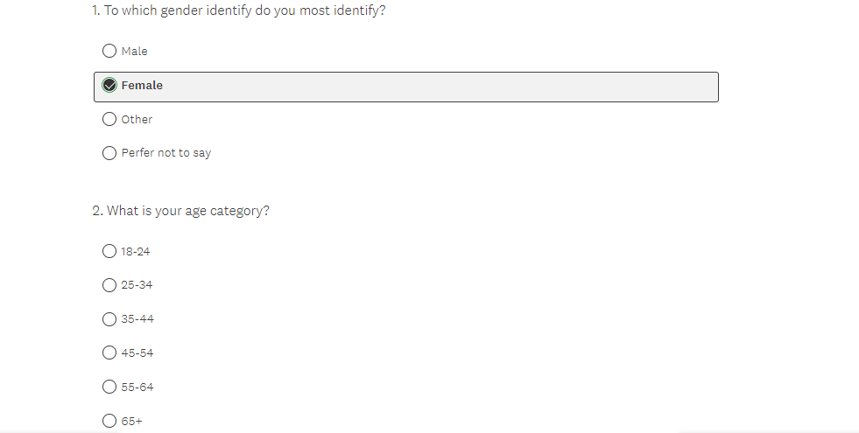
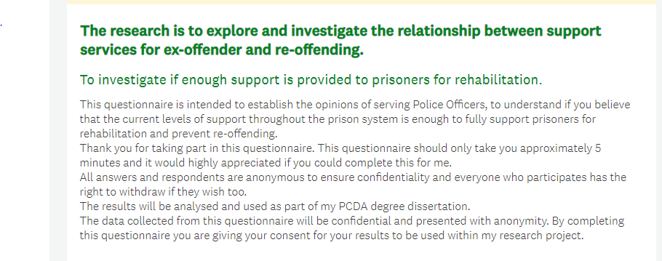

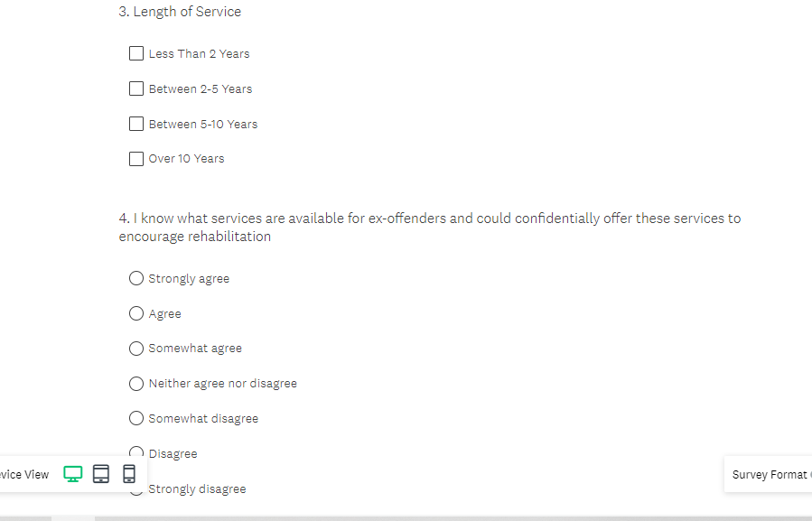
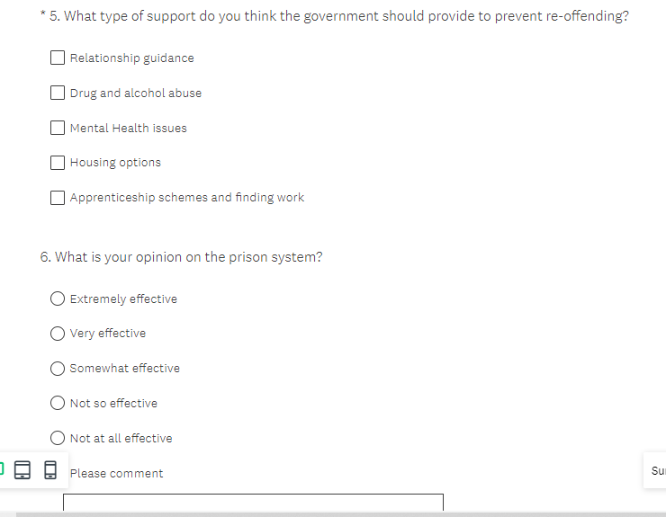
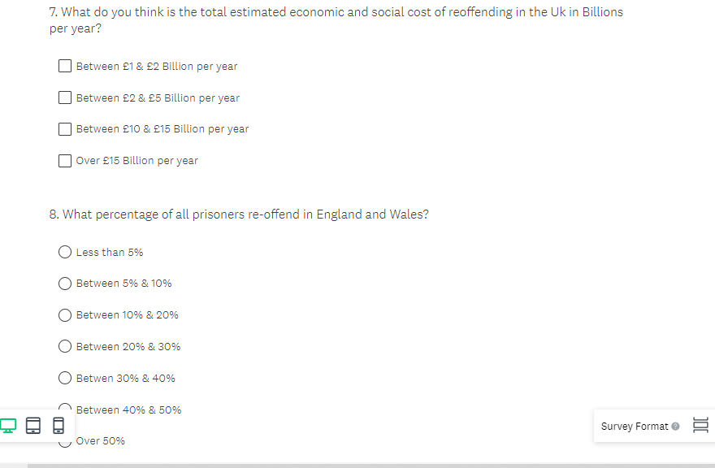

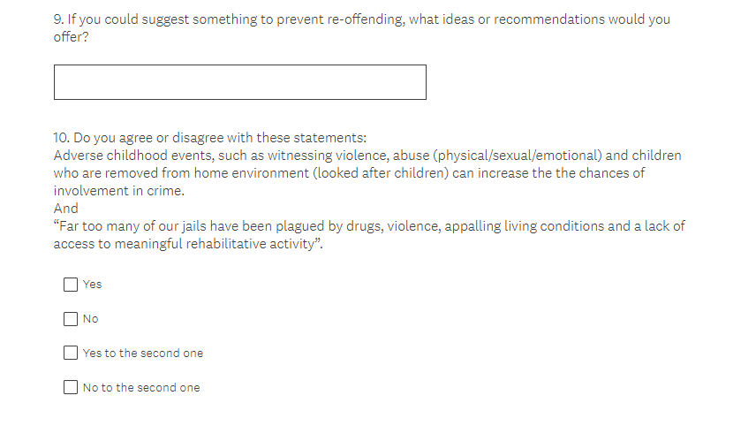

7.4 Appendix 9 - Ethics Form

APPLICATION FOR ETHICAL APPROVAL

In order for research to result in benefit and minimise risk of harm, it must be conducted ethically. A researcher may not be covered by the University’s insurance if ethical approval has not been obtained prior to commencement.

The University follows the OECD Frascati manual definition of research activity: “creative work undertaken on a systematic basis in order to increase the stock of knowledge, including knowledge of man, culture and society, and the use of this stock of knowledge to devise new applications”. As such this covers activities undertaken by members of staff, postgraduate research students, and both taught postgraduate and undergraduate students working on dissertations/projects.

The individual undertaking the research activity is known as the “principal researcher”.

Ethical approval is not required for routine audits, performance reviews, quality assurance studies, testing within normal educational requirements, and literary or artistic criticism.

Please read the notes for guidance before completing ALL sections of the form.

This form must be completed and approved prior to undertaking any research activity. Please see Checklist for details of process for different categories of application.

Delete the Guidance Notes at the end of the form BEFORE submitting your application

SECTION A: About You (Principal Researcher)
Full Name: |  | Sam Bellingham
Tick all boxes which apply: |  | Member of staff: | ☐ | Honorary research fellow: | ☐
Undergraduate Student | ☒ | Taught Postgraduate Student | ☐ | Postgraduate Research Student | ☐

Institute/Academic Discipline/Centre: | Policing School
Campus: | Swansea
E-mail address: | 1910715@student.uwtsd.ac.uk
Contact Telephone Number: | 07833371324
For students:
Student Number: | 1910715
Programme of Study: | Professional Policing
Director of Studies/Supervisor: | Jane Thomas

SECTION B: Approval for Research Activity
Has the research activity received approval in principle?  (please check the Guidance Notes as to the appropriate approval process for different levels of research by different categories of individual) |  | YES | ☒ | NO | ☐
 |  |  |  | Date
If Yes, please indicate source of approval (and date where known): Approval in principle must be obtained from the relevant source prior to seeking ethical approval | Research Degrees Committee |  | ☐
 | Institute Research Committee |  | ☐
 | Other (write in) |  | ☒ | Supervisor

SECTION C: Internal and External Ethical Guidance Materials
Please list the core ethical guidance documents that have been referred to during the completion of this form (including any discipline-specific codes of research ethics, and also any specific ethical guidance relating to the proposed methodology). Please tick to confirm that your research proposal adheres to these codes and guidelines.
UWTSD Research Ethics & Integrity Code of Practice | ☒
UWTSD Research Data Management Policy | ☒
 | ☐

SECTION D: External Collaborative Research Activity
Does the research activity involve collaborators outside of the University? | YES | ☐ | NO | ☒
If Yes, please provide the name of the external organisation and name and contact details for the main contact person and confirmation this person has consented to their personal data being shared.as part of this collaboration.

SECTION E: Details of Research Activity
Indicative title: | Investigating the relationship between support services for ex-offender and re-offending.
Proposed start date: | October 2021 | Proposed end date: | July 2022
Introduction to the Research (maximum 300 words)
Ensure that you write for a Non-Specialist Audience when outlining your response to the three points below:
- Purpose of Research Activity
- Proposed Research Question
- Aims of Research Activity
- Objectives of Research Activity
Demonstrate, briefly, how Existing Research has informed the proposed activity and explain
- What the research activity will add to the body of knowledge
- How it addresses an area of importance.
Purpose of Research Activity
This research addresses the case of, Investigating the relationship between support services for ex-offender and re-offending.
.

Aims of Research Activity
The aim of this research investigation is to establish why reoffending occurs amongst prisoners and whether current support services are sufficient.

Objectives of Research Activity
The aim of this research investigation is to establish why reoffending occurs amongst prisoners and whether current support services are sufficient within the UK.

1.4 Objectives
1.To review, research and specify the re-offending rates and crimes amongst prisoners in the UK
2. To analyse why prisoners re-offend.
3. To examine what provisions are in place to prevent re-offending and if enough support is provided to prisoners for rehabilitation
4. To collect data and analyse it to see police officers’ perception of prisoners and whether they believe enough support exists and is provided.

Proposed methods (maximum 600 words)
Provide a brief summary of all the methods that may be used in the research activity, making it clear what specific techniques may be used. If methods other than those listed in this section are deemed appropriate later, additional ethical approval for those methods will be needed.
In this research, the method that will be used are questionnaires. However, due to confidentiality and anonymous they will be conducted via a website , the questionnaire will be the main research method used and focused on.

Location of research activity
Identify all locations where research activity will take place.
Within South Wales
Research activity outside of the UK
If research activity will take place overseas, you are responsible for ensuring that local ethical considerations are complied with and that the relevant permissions are sought. Specify any local guidelines (e.g. from local professional associations/learned societies/universities) that exist and whether these involve any ethical stipulations beyond those usual in the UK (provide details of any licenses or permissions required). Also specify whether there are any specific ethical issues raised by the local context in which the research activity is taking place, for example, particular cultural and/or legal sensitivities or vulnerabilities of participants.
N/A

SECTION F: Scope of Research Activity
Will the research activity include: | YES | NO
Use of a questionnaire or similar research instrument? | ☒ | ☐
Use of interviews? | ☒ | ☐
Use of diaries? | ☐ | ☒
Participant observation with their knowledge? | ☐ | ☒
Participant observation without their knowledge? | ☐ | ☒
Use of video or audio recording? | ☐ | ☒
Access to personal or confidential information without the participants’ specific consent? | ☐ | ☒
Administration of any questions, test stimuli, presentation that may be experienced as physically, mentally or emotionally harmful / offensive? | ☐ | ☒
Performance of any acts which may cause embarrassment or affect self-esteem? | ☐ | ☒
Investigation of participants involved in illegal activities? | ☐ | ☒
Use of procedures that involve deception? | ☐ | ☒
Administration of any substance, agent or placebo? | ☐ | ☒
Working with live vertebrate animals? | ☐ | ☒
Other primary data collection methods, please explain in this box  For example, ‘focus groups’. Please indicate the type of data collection method(s) in this box and tick the accompany box. | ☐ | ☒
Details of any other primary data collection method:  (this box should expand as you type) | ☐ | ☒
If NO to every question, then the research activity is (ethically) low risk and may be exempt from some of the following sections (please refer to Guidance Notes).

If YES to any question, then no research activity should be undertaken until full ethical approval has been obtained.
SECTION G: Intended Participants
Who are the intended participants: | YES | NO
Students or staff at the University? | ☐ | ☒
Adults (over the age of 18 and competent to give consent)? | ☒ | ☐
Vulnerable adults? | ☐ | ☒
Children and Young People under the age of 18? (Consent from Parent, Carer or Guardian will be required) | ☐ | ☒
Prisoners? | ☐ | ☒
Young offenders? | ☐ | ☒
Those who could be considered to have a particularly dependent relationship with the investigator or a gatekeeper? | ☐ | ☒
People engaged in illegal activities? | ☐ | ☒
Others (please identify specifically any group who may be unable to give consent) please indicate here and tick the appropriate box. | ☒ | ☐
Other – please indicate here:  Intended Participants will be Employed by South Wales Police and will be Police Officers.  (this box should expand as you type) | ☒ | ☐

Participant numbers and source
Provide an estimate of the expected number of participants. How will you identify participants and how will they be recruited?
How many participants are expected? | 50 respondents for the questionnaire
Who will the participants be? | The questionnaire participants will be all from South Wales Police, however varied and anonymous due to the anonymity of a questionnaire.
How will you identify the participants? | Via social media platforms where the link will be shared amongst colleagues and employees from South Wales Police.

Information for participants: | YES | NO | N/A
Will you describe the main research procedures to participants in advance, so that they are informed about what to expect? | ☒ | ☐ | ☐
Will you tell participants that their participation is voluntary? | ☒ | ☐ | ☐
Will you obtain written consent for participation? | ☒ | ☐ | ☐
Will you explain to participants that refusal to participate in the research will not affect their treatment or education (if relevant)? | ☐ | ☐ | ☒
If the research is observational, will you ask participants for their consent to being observed? | ☐ | ☐ | ☒
Will you tell participants that they may withdraw from the research at any time and for any reason? | ☒ | ☐ | ☐
With questionnaires, will you give participants the option of omitting questions they do not want to answer? | ☐ | ☒ | ☐
Will you tell participants that their data will be treated with full confidentiality and that, if published, it will not be identifiable as theirs? | ☒ | ☐ | ☐
Will you debrief participants at the end of their participation, in a way appropriate to the type of research undertaken? | ☒ | ☐ | ☐
If NO to any of above questions, please give an explanation
Because my research method is going to use questionnaires, each question will require a answer prior to moving onto the next question and is also required to increase research in this area of choice.
.

(this box should expand as you type)

Information for participants: | YES | NO | N/A
Will participants be paid? | ☐ | ☒ | ☐
Is specialist electrical or other equipment to be used with participants? | ☐ | ☒ | ☐
Are there any financial or other interests to the investigator or University arising from this study? | ☐ | ☒ | ☐
Will the research activity involve deliberately misleading participants in any way, or the partial or full concealment of the specific study aims? | ☐ | ☒ | ☐
If YES to any question, please provide full details
(this box should expand as you type)

SECTION H: Anticipated Risks
Outline any anticipated risks that may adversely affect any of the participants, the researchers and/or the University, and the steps that will be taken to address them.

If you have completed a full risk assessment (for example as required by a laboratory, or external research collaborator) you may append that to this form.
Full risk assessment completed and appended? |  | Yes | ☐
 |  | No | ☒
Risks to participants
For example: emotional distress, financial disclosure, physical harm, transfer of personal data, sensitive organisational information
Risk to Participant:  Stage 1: The Questionnaires input make the participants have concerns about the questions related to sensitive organisational information.  Stage 2: Once the questionnaires have been completed the participants maybe concerned about confidentiality and anonymity of personal data and how it is shared. | How will you mitigate the Risk to Participant  1. Using a online questionnaire on a recognised website to try and protect all confidential data collected and removed the option of keeping IP addresses from the participants once questionnaires are completed.  2. By not asking any personal questions such names or addresses and prior to starting the questionnaire asking for the participants consent.  3. By ensuring all sensitive and confidential data is kept on the secure and recognised website and only downloaded onto the laptop if necessary.  4. By ensuring the questionnaire is completed via the internet through a link instead of offering participants paper questionnaires which would result in having hard copies and storage problems.
If research activity may include sensitive, embarrassing or upsetting topics (e.g. sexual activity, drug use) or issues likely to disclose information requiring further action (e.g. criminal activity), give details of the procedures to deal with these issues, including any support/advice (e.g. helpline numbers) to be offered to participants. Note that where applicable, consent procedures should make it clear that if something potentially or actually illegal is discovered in the course of a project, it may need to be disclosed to the proper authorities
(this box should expand as you type)
Risks to investigator
For example: personal safety, physical harm, emotional distress, risk of accusation of harm/impropriety, conflict of interest
Risk to Investigator:  1. Participants may decide to not fully complete the questionnaire resulting in not having enough participants within the limited amount of time given. | How will you mitigate the Risk to Investigator:  1. By fully understanding the expectations prior to the participants starting the questionnaire and reaching out to as many people as possible to ensure I reach the target.
University/institutional risks
For example: adverse publicity, financial loss, data protection
Risk to University:  A negative impact on the university as its connected and mentioned within the questionnaire.  (this box should expand as you type) | How will you mitigate the Risk to University:  The good standing and reputation of the university will be kept by ensuring confidentially is at its highest.  (this box should expand as you type)

Disclosure and Barring Service
If the research activity involves children or vulnerable adults, a Disclosure and Barring Service (DBS) certificate must be obtained before any contact with such participants. | YES | NO | N/A
Does your research require you to hold a current DBS Certificate? | ☐ | ☒ | ☐

SECTION I: Feedback, Consent and Confidentiality
Feedback
What de-briefing and feedback will be provided to participants, how will this be done and when?
Once completion of the dissertation it will be available to any organisation or individual of whom request a copy.
Informed consent
Describe the arrangements to inform potential participants, before providing consent, of what is involved in participating. Describe the arrangements for participants to provide full consent before data collection begins. If gaining consent in this way is inappropriate, explain how consent will be obtained and recorded in accordance with prevailing data protection legislation.
To ensure that the consent process is clear and concise and approved by the ethic committee. The participants who will take part in the questionnaire will be given the required and set information which will offer a option to continue and give consent in a clear and concise method prior to then doing the questionnaire allowing the research to take place.

Confidentiality / Anonymity
Set out how anonymity of participants and confidentiality will be ensured in any outputs. If anonymity is not being offered, explain why this is the case.
Anonymity and confidentiality is guaranteed by the researcher as no names or addresses will be used throughout the dissertation.

SECTION J: Data Protection and Storage
In completing this section refer to the University’s Research Data Management Policy and the extensive resources on the University’s Research Data Management web pages (http://uwtsd.ac.uk/library/research-data-management/).
Does the research activity involve personal data (as defined by the General Data Protection Regulation 2016 “GDPR” and the Data Protection Act 2018 “DPA”)? | YES | NO
“Personal data” means any information relating to an identified or identifiable natural person (‘data subject’). An identifiable natural person is one who can be identified, directly or indirectly, in particular by reference to an identifier such as a name, an identification number, location data, an online identifier or to one or more factors specific to the physical, physiological, genetic, mental, economic, cultural or social identity of that natural person. |  | x
If YES, provide a description of the data and explain why this data needs to be collected:
Does it involve special category data (as defined by the GDPR)? | YES | NO
“Special category data” means sensitive personal data consisting of information as to the data subjects’ –  (a) racial or ethnic origin,  (b) political opinions,  (c ) religious beliefs or other beliefs of a similar nature,  (d) membership of a trade union (within the meaning of the Trade Union and Labour Relations (Consolidation) Act 1992),  (e) physical or mental health or condition,  (f) sexual life,  (g) genetics,  (h) biometric data (as used for ID purposes), | ☐ | ☒
If YES, provide a description of the special category data and explain why this data needs to be collected:
(this box should expand as you type)
Will the research activity involve storing personal data and/or special category data on one of the following: | YES | NO
Manual files (i.e. in paper form)? | ☐ | ☒
University computers? | ☐ | ☒
Private company computers? | ☐ | ☒
Home or other personal computers? | ☐ | ☒
Laptop computers/ CDs/ Portable disk-drives/ memory sticks? | ☒ | ☐
“Cloud” storage or websites? | ☒ | ☐
Other – specify: | ☐ | ☒
For all stored data, explain the measures in place to ensure the security of the data collected, data confidentiality, including details of password protection, encryption, anonymisation and pseudonymisation:
The data will remain anonymous. Computers will be fully encrypted and access to the website is password protected.

All Data Storage
Will the research activity involve any of the following activities: | YES | NO
Electronic transfer of data in any form? | ☐ | ☒
Sharing of data with others at the University? | ☐ | ☒
Sharing of data with other organisations? | ☐ | ☒
Export of data outside the European Union or importing of data from outside the UK? | ☐ | ☒
Use of personal addresses, postcodes, faxes, emails or telephone numbers? | ☐ | ☒
Publication of data that might allow identification of individuals? | ☐ | ☒
Use of data management system? | ☐ | ☒
Data archiving? | ☐ | ☒
If YES to any question, please provide full details, explaining how this will be conducted in accordance with the GDPR and DPA (and/or any international equivalent):
List all who will have access to the data generated by the research activity:
Myself.

List who will have control of, and act as custodian(s) for, data generated by the research activity:
Only myself

Give details of data storage arrangements, including security measures in place to protect the data, where data will be stored, how long for, and in what form. Will data be archived – if so how and if not why not.
The research data will be stored and managed in a protected environment to prevent data loss and unauthorised access or modification which complies with legal, regulatory and other obligations for the length it needs to be stored for. Unauthorised access is prevent by having password protected software and once the research study is completed and given advice the data will then be deleted.

Please indicate if your data will be stored in the UWTSD Research Data Repository (see https://researchdata.uwtsd.ac.uk/ ). If so please explain. (Most relevant to academic staff)
(this box should expand as you type)
Confirm that you have read the UWTSD guidance on data management (see https://www.uwtsd.ac.uk/library/research-data-management/) | YES | ☒
 | NO | ☐
Confirm that you are aware that you need to keep all data until after your research has completed or the end of your funding | YES | ☒
 | NO | ☐
SECTION K: Declaration
The information which I have provided is correct and complete to the best of my knowledge. I have attempted to identify any risks and issues related to the research activity and acknowledge my obligations and the rights of the participants.

In submitting this application I hereby confirm that I undertake to ensure that the above named research activity will meet the University’s Research Ethics and Integrity Code of Practice which is published on the website: https://www.uwtsd.ac.uk/research/research-ethics/
Signature of applicant: | Sam Bellingham | Date: 6th June 2022.

For students:
Director of Studies/Supervisor: | Jane Thomas
Signature:
Date:

For staff:
Head of School/Assistant Dean:
Signature:
Date:

7.5 Appendix 10 – Question and Literature Review Mix

Questions | References relating to questions drawn from previous chapters
Q.1 – To which gender identity do you most identify?  Q.2 - What is your age category? | Questions 1 and 2 were used to gather the participant’s gender and age.
Q3 – Length of service? | There is a lack of literature on the topic whether if the length of service changes the opinion of police officers.
Q4. I know what services are available for ex-offenders and could confidentially offer these services to encourage rehabilitation? | (Unlock N.D) suggestions that an ex offender who believes they have reformed stated “ don’t think the police believe in rehabilitation.”  Police officers are expected to assist and support offenders to prevent re-offending and one of there aims is to encourage rehabilitation.  Within police forces training and guidance has changed over the last few years and since the Integrated offender Management approach was introduced (IOMA) “We are clear that police officers working in this environment should have some knowledge of the theories and practices associated with assisting an offender to achieve desistance, but their principal role should be gathering and disseminating intelligence and enforcement”.  From this report on a chief constable recommendations stated that its key to promote the benefits of the IOM to all officers within the force particularly those on the front line, making sure that the processes are In place. To ensure that police officers are to received sufficient training to fulfil their duties to aim to reduce crime and re-offending (HMIP & HMIC, 2014, p.8-18).
Q5. What type of support do you think the government should provide to prevent re-offending? | There are delivering services and treatment for vulnerable offenders with mental health, alcohol and substance abuse. Further provisions are to ensure education to staff to increase the level of electronic monitoring and alcohol abstinence tagging and expand the use of Global position system tagging (Ministry of Justice, 2021).
Q6. What is your opinion on the prison system? | John Brace stated “The bulk of these people, who commit multiple crimes, they’ve got an underlying problem, which is mental health or alcohol or drugs or a combination of any two or three of those. The treatment for that is not to shove them in prison, because if they haven’t got a drug problem when they go into prison, they’re likely to have one when they come out. The solution is to attempt to treat alcoholism or their drug requirements.” (Bache, 2021) and (Siddique, 2021).
Q7. What do you think is the total estimated economic and social cost of re-offending in the UK in Billions per year? | The most up to date research shows that’s reoffending is estimated at £18.1 Billion per year (Ministry of Justice, 2019).
Q8. What percentage of all prisoners re-offend in England and Wales? | Re-offending rates on a whole have been broadly stable since 2007 approximately between 32% and 28% is the proportion of offenders who have reoffended.  That David Cameron was fully aware of impacting issues re-offending had to the UK, he stated within this speech in 2016 “46% of all prisoners will re-offend within a year of release. 60% of short-sentenced prisoners will reoffend within the same period.” (Mininstry of Justice, 2016)
Q9. If you could suggest something to prevent re-offending, what ideas or recommendations would you offer? | The Ministry of Justice have implemented in 2021 many suggestions and options for intervention in reducing re-offending where they use options which work, such as a home, a job and access for support and treatment for substance misuse. They have decided to delivery a female offending strategy allowing the first residential women’s centre
Q10. Do you agree with these statements?  Adverse childhood events, such as witnessing violence, abuse (physical/sexual emotional) and children who are removed from home environment (looked after children) can increase the chances of involvement in crime?  &  Far too many of our jails have been plagued by drugs, violence, appalling living conditions and a lack of access to meaningful rehabilitative activity? | The HM Chief inspector of Prisons stated, “Far too many of our jails have been plagued by drugs, violence, appalling living conditions and a lack of access to meaningful rehabilitative activity” (Howard league for Penal Reform, 2019) and (GUINEY, 2019)  A report written by social exclusion unit written for the prime minster in 2003 explores the factors which influence reoffending and it’s been identified as nine factors.  Ministry of Justice, 2013.

7.6 Appendix 11 – Questionnaire Answers

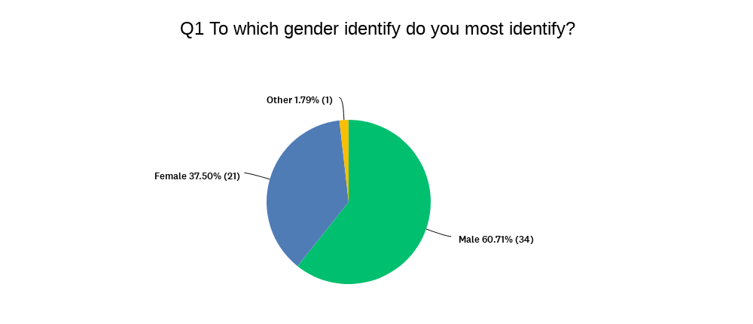

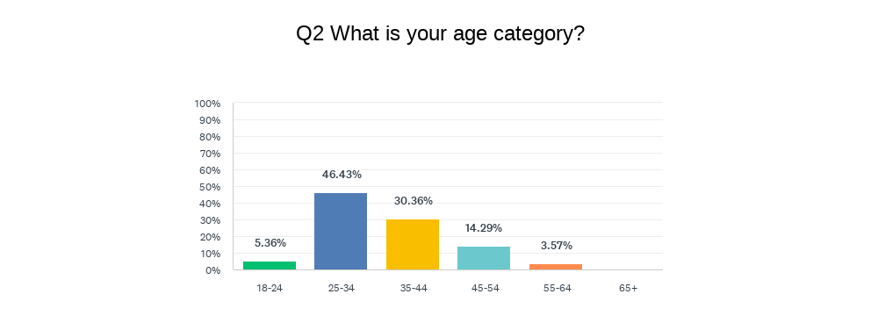

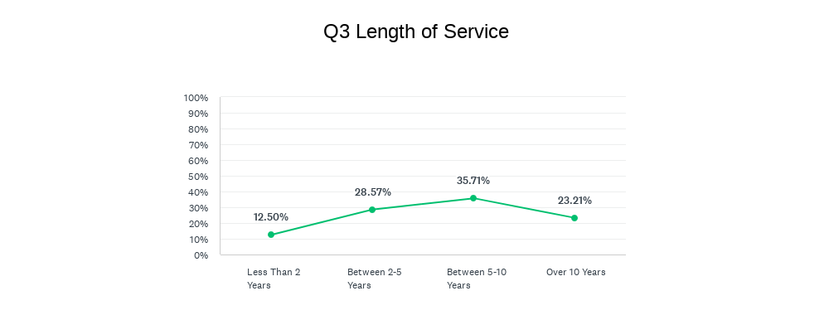

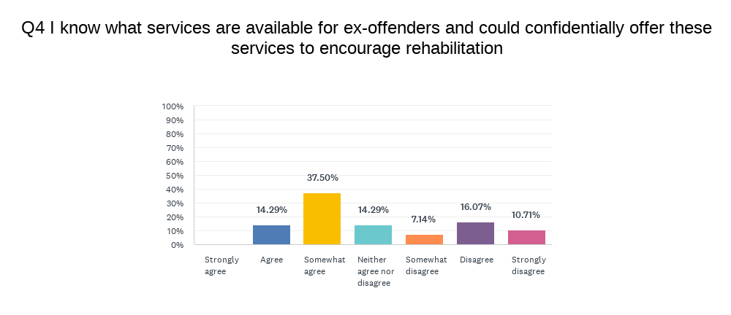

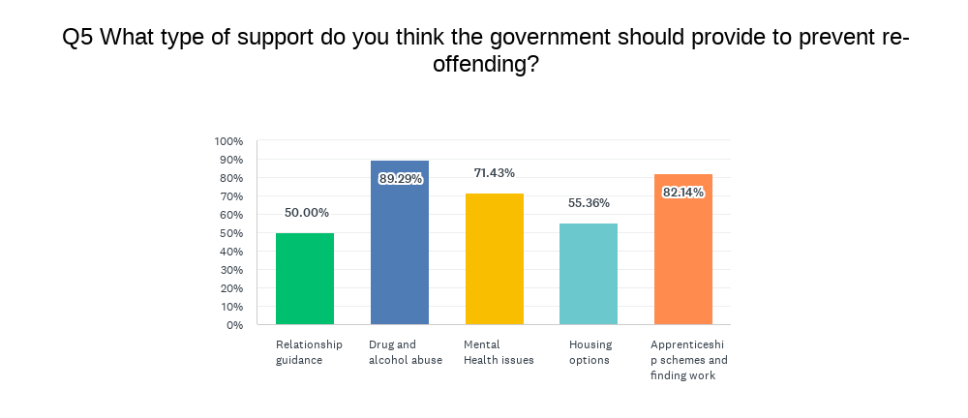

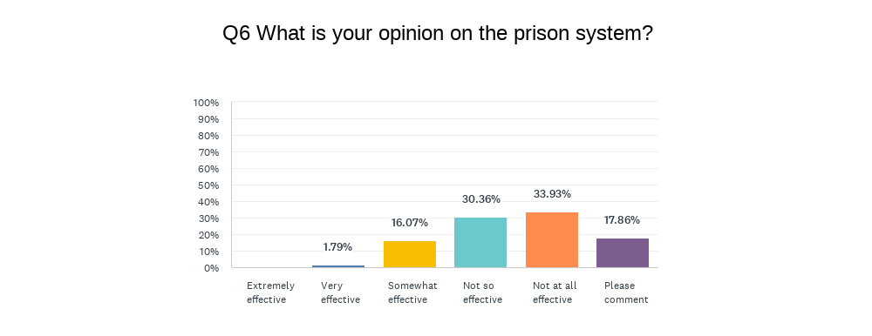

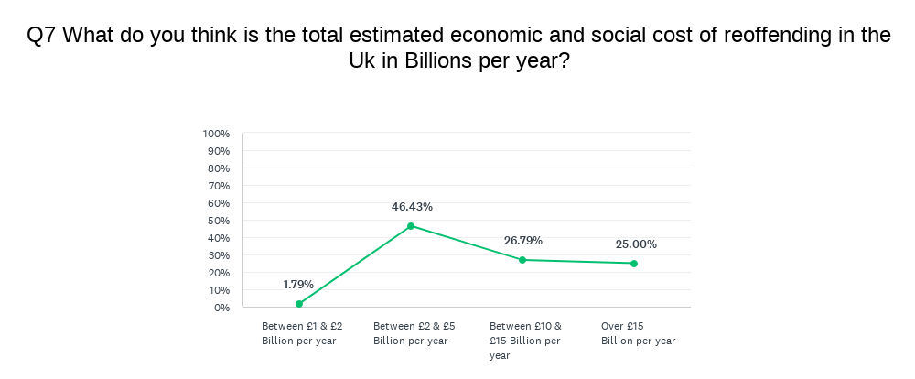
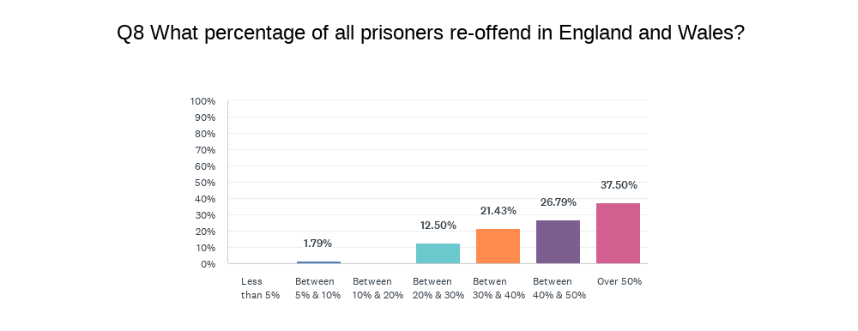
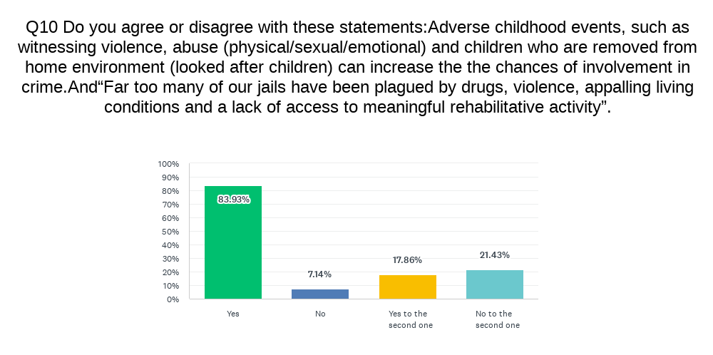

7.7 Appendix 12 – Responses to Question 6

Responsive #
1 Treated too well, like a hotel, offenders regularly tell me they commit crimes just to go back to prison as it is a better life than the outside world
2 I have had no input on the prison system from SWP and have no knowledge of it

3 Privately run prisons are seen by many inmates as a walk in the Parc (as opposed to a HMP). Standards are not as high
4 Nothing in place for them before they leave

5 It doesn't work. The prison itself is no longer seen as 'hard time'. We should follow other countries and make it a not so nice place to live for weeks/months/years. The whole point of prison, initially, was to stop wanting people to go back there. This isn't the case nowadays.

6 Repeat offenders are simply not bothered by the prison

7 No deterrent

8 Due to rates of reoffending

9 Sentences are weak and prison as it is not a deterrent for reoffending.
10 I genuinely feel that the system is to soft with many offenders stating that they find life easier inside

7.8 Appendix 13 – Responses to Question 9
Q9 If you could suggest something to prevent re-offending, what ideas or recommendations would you offer?
Answered: 44 Skipped: 12
# RESPONSES
1 Not as many luxuries in prison only basic human rights, I.e. food, bed to sleep on, warmth etc
2 Community engagement
3 Multi agency early intervention approach.
4 Longer sentences
5 Harsher sentencing
6 Stronger prison sentences as a deterrent
7 Longer licences
8 Stricter sentencing
9 Intense Mentoring when prisoners leave prison.
10 More severe punishments/ prison terms
11 Multi disciplinary teams to ensure all aspects of the individuals life are addressed eg mental health service plus suitable accommodation
12 Stronger punishments including lengthy sentences
13 Higher sentences to start with. Complete full sentences not %. Use a prison sentence as more of a deterrent.
14 Harsher sentences, no access to luxuries in prisons such as tv, games consoles. I believe this would deter more people from being happy to spend time inside
15 Stronger sentences, services as mentioned above upon them leaving prison to make outside life more appealing
16 Tougher sentences and tougher prisons
17 Learning and scholarships for short term offender's that will continue when let go
18 Death penalty. Life means life in prison. Mandatory minimum sentances which are substantial.
19 Longer sentences with out parole
20 Longer prison terms with less benefits whilst inside
21 Harsher sentences
22 Make prison a tougher place to live.
23 Harsher sentences.Prisons should be horrible places to go not TV, playstation and gym hotels.
24 Longer sentences
25 Offers if jobs - they require a steady income.
26 More lengthy prison sentences which actually put people off offending
27 Stricter rules in prisons and compulsory service
28 Stop benefits for drug users and alcoholics. Help them get into work and provide effective rehab
29 Longer sentences
30 Tough prison sentences.
31 Harsher prison sentences
32 Harsher sentences
33 There needs to be immediate support when people are released from prison - with things like housing , addiction and work. Otherwise it’s unsurprising that many reoffend.
34 More support upon release as to help stop reopening. More help in getting work and with finances. Possibly education around finances and budgeting
35 Harsher punishments, tougher licensing conditions
36 Stricter prison sentences
37 Stricter sentencing
38 To impose tougher sentences and to make the prison more disciplined
39 Stricter sentences
40 Better support, treating the causes of issues in young people- more links with schools.
41 Tougher sentencing and make prison a place where people don’t want to go back to. If prison was less comfy (game consoles tvs etc) maybe people would see it as too awful to risk going back. Some people are in and out of prison doors more than their own homes and are unfazed. That’s provided they actually get a custodial sentence and not a slap on the wrist for the millionth time. The criminal justice system is not rehabilitating offenders just inconveniencing them between offences
42 Therapies...to better understand why they do what they do.
43 Serving full custodial terms
44 Better education within prisons , better support for prisoners.

