Question 4:
Outline a current environmental, political, or social issue that requires redesign. Explain how you will solve this issue over the duration of your future design career. Underline the tools and approaches you will use and discuss how and why.
Name: Jordan Higham
Student Number: 2003738
Module Course: Research in context ADAD5003
Course: Product and furniture design
Word Count: 2736
Lecturer: Julia Lockheart

Table of Contents
Table of Figures 2
Introduction 3
Eco-design 4
Design Certification 6
What Can Be Done In The Future To Resolve This Environmental Issue 7
Conclusion 8
References 9

Table of Figures
Figure 1: Image showing sea turtle surrounded by plastic waste (Young, 2021) 3
Figure 2: An example of biodegradable bioplastic (Joshi, 2021) 5
Figure 3: Representation of a sustainable future (Onal 2019) 8

Introduction
When looking at designing a product, many focus on aesthetics rather than properties. Delving too deep into the appearance and function of a product instead of the materials can become a problem. Unfortunately, there are still many companies that do not take into consideration the environmental impact of the materials that they are using within their products. This can be in the form of using unsustainable materials or using materials that are hazardous to the environment. One example of this is the high use of plastic within many products currently on the market. As a result of this, is, this essay will investigate the environmental impact of plastic and the use of raw materials and how eco-design is something that needs to be implemented more. This is a very significant issue that the world faces, creating many different adverse effects that can be mitigated.
As stated by National Geographic (n.d.), our Earth is 4.543 million years old and is our home. Globally, we have become addicted to single-use plastic and plastic in general. We also produce so many products using raw materials and our consumption of these has doubled over the last 30 years. As mentioned by Unep.org “We produce about 300 million tonnes of plastic waste every year” (UN Environment Programme, n.d.). This is an absolutely staggering amount and this is also backed up by Griggs (2017) in the book ‘Coasts in crisis’. According to Griggs (2017) “The largest single source is China, with an estimated 2.4 million tons per year, followed by Indonesia (975,000 tons), the Philippines (525,000 tons), Vietnam (500,000 tons), and Sri Lanka (425,000 tons) (Griggs, 2017, p144). There is only a limited amount of raw materials, and the planet is paying the price for our selfishness and greediness for our consumption of these at a highly unsustainable rate. This is further discussed by Chapman (2005), where they also state that “one-third of all the planet’s resources have been consumed within the past four decades”. Consequentially, if we carry on as we are without taking into account the exponential increase that will occur due to the increase in population, all of the planet’s resources will be entirely consumed within the next 80 years.
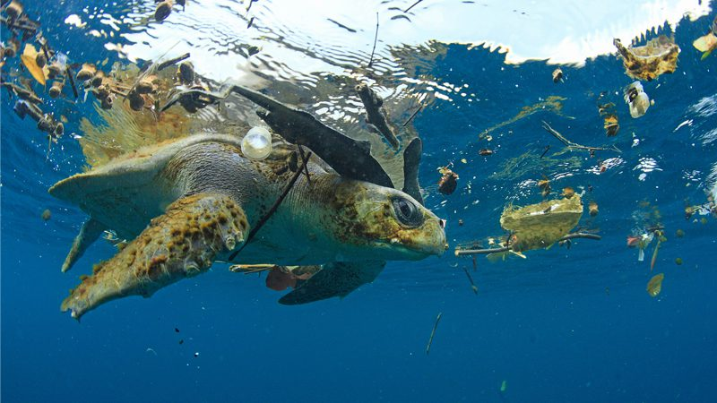
Figure 1: Image showing sea turtle surrounded by plastic waste (Young, 2021)
There are so many ways we can stop this, but we seem so addicted to it that a small minority of us care. Animals are also highly affected by this such as sea life. The ocean is filling up day by day with plastic. Sea creatures are consuming the plastic waste, dying from it and or swimming into plastic parts and strangling themselves. An example of this can be shown previously in figure 1 (Young, 2021). This is discussed at length in the article written by Wilcox et al, which discusses the inherent dangers of plastic waste to seabirds, the concern for plastic pollution and the statistics of how many birds are ingesting all this plastic (Wilcox et al., 2015). When looking into materials and the impact we should all be considering the impact on the world, animals, plants, even the people.

Eco-design
One concept that is used to help mitigate these issues is Eco-design. Eco-design looks at a product’s life cycle and tries to get the lowest possible environmental impact it can. As discussed by Fournier (2019), the main criteria that are assessed within the process of eco-design are the consumption of raw materials, any pollution that arises, the impact on the climate, and any impacts on biodiversity and wildlife in general.
Using these criteria, we can learn how we can achieve the optimal use of resources and energy and sustainable infrastructure that mitigate the risk to the climate and wildlife. Eco-design is more sustainable for industries as it is more innovative than most things these days. It looks good on the company as there is a small amount who already do this but for the ones who didn’t use this method before, it makes them stand out from competitors. Also, if a customer is happy with a product and or company and they go eco-friendly and use eco-design methods it makes for happier customers and makes them feel good as they are now helping the environment as well as you. Some companies have implemented eco-design, but not enough to stand out.
It allows for market differentiation and adds value to products in comparison to other competitors. Sustainability sells and as mentioned in (Rainforest Alliance, 2019) sustainability has made an increase in sales and marketing for companies and has improved their overall profitability. A company should want to feel good selling a good product that is helping save the world and people also like to show off that they are helping as well. One other thing that customers enjoy is a reduced retail price. The reduction in retail price will potentially entice more consumers to buy the product, consequentially increasing the profitability of the company. This is another major factor of why people would love and buy it.
Additionally, from the research that has been conducted if companies start to use eco-design and become more eco-friendly, it allows for more efficient production. This will save on the usage of energy and money for the company. By using eco-design methods, it looks at the life cycle and impact of the product. This means that fewer emissions are produced slowing down greenhouse gases. It also helps towards the endangerment of animals and plant species. It also gives the product a better life. They are forever in use in a waste-free circuit. As they are so easy to recycle, they also become easy to disassemble which means less energy is used to do this.
There is also the need to take into consideration the use of raw materials, C02, and energy used to make products. If we follow the methods outlined within eco-design, then it slows down the use of precious or non-renewable resources. This is shown in an online article “the European Commission says that “nearly 80% of a product’s environmental impact can be improved through eco-design.” (Usbek & Rica, 2017). This provides evidence that shows that we are using them and not taking into consideration the fact that the materials we are using are ultimately unsustainable.
These materials will not last forever and can be used for other important things that we do not necessarily use. The fact that other materials are recyclable and sometimes more durable and are not being used is baffling. Why create a product that is harming the earth at the end of its use and during the manufacturing process, when there are better options. Although there are certain advantages from a business standpoint from using plastic, such as reducing the cost of manufacturing products, using sustainable and less harmful materials also creates significant positive effects. One such positive effect is the advertisement advantage that arises from selling eco-friendly products using sustainable materials.
Not just the products themselves but the packaging plays an important part in looking after the environment. If eco-design methods are used, then it means we can have optimum packaging. This means it still has great storage, hygiene, and protection. Plastic, cardboard and paper can be used. Even the invoice which is made from paper has an effect. Although it is biodegradable the ink that is used is not. ‘…it produces dioxins, some of the most dangerous cancer-causing material ever created by humans’ (Braungart, 2009, p29). To mitigate the use of paper within receipts and invoices, some companies have started to go paperless or have reduced their use of paper significantly. An example of this is emailing consumers their receipt and invoice. However, it can be understandable for consumers to be slightly hesitant to provide their email address so every effort should be made to ensure that the consumer is made aware of the changes, why the changes have been made and how it will benefit them.
One material used for packaging is cardboard. Although it is not a material made for lifelong products it can be amazing for packaging. When we look at re-designing for packaging, we should consider using cardboard more. We use these airbags made from plastic to hold our products safe during transit but why not use cardboard. Cardboard can be manipulated to whatever shape you want. We could use shredded cardboard, they are decomposable, they can be used as a space saver or product holder and can be much better than plastic.
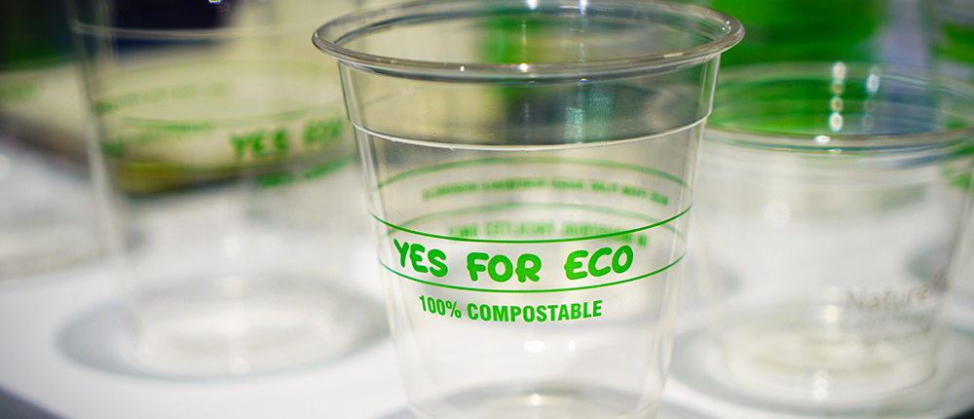
Figure 2: An example of biodegradeable bioplastic (Joshi, 2021)
Although plastic has previously been mentioned in the case of products and packaging, there are many products themselves that are plastic for example straws. ‘Five hundred million straws are used each day in the US’ (AZA, 2021). They are one of the biggest things to be advertised as bad as they are the most popular single-use plastic thing we use once then throw away. As mentioned by (Cao, 2018) McDonald’s and KFC have already implemented paper straws as they are trying to be more eco-friendly. Although these may not exactly be popular or liked that much, they are reducing the amount of single-use plastic. When considering redesigning, there must be a better alternative as they can be used for about 5 minutes before they become too wet and unusable. Some people carry metal straws with them. Edible, bamboo, bioplastic, and sip cups have been made and be used as a replacement. Although people could carry their own straws to places like McDonald’s, they need better solutions so they can still help with the impact but keep customers happy. Any place that does take away drinks should start using the ‘sip cup’ method. Most of these cups would have lids anyway so use more materials when a hole can be created in something that is already made. There will be cases where a straw is used but rules can be made that you must purchase bamboo or metal straws from the place of purchase making people either carry one or consider the reason why this is being implemented.
One of the methods that are used to incorporate eco-design is bioplastic. Bioplastic is made from renewable biomass sources such as vegetable oil, straw, and sawdust. As discussed by Joshi (2019), these bioplastics are completely made from natural polymers which are fully biodegradable. It uses significantly fewer fossil fuels in transit, less energy, and less waste than normal plastic. Bioplastic can also be broken down or biodegraded by using water, carbon dioxide, and microorganisms when composted. This is highly beneficial as they can be easily disposed of when they come to the end of the product life cycle. Another advantage of biodegradable materials is that they are longer-lasting, this is something that can be promoted from the company to customers as this will entice them more to buy it. Although bioplastic is not perfect it still is a massive improvement.
One question that is posed is why companies do not already want to be green? It is killing the world, plants, and animals every day. Just taking into consideration the world saves you money and allows you to say you have a green company. The fact that just changing material and how they are produced can make such an impact on the world, why can we not do this more? Also, in universities on product design courses, you do learn about the impact on the world and what is bad but they do not push for it. It would be greatly beneficial if this was pushed more as the future generation of designers would go into their new roles already knowledgeable of this and how to implement it into their work. If the future generation of designers is not made more aware of the circumstances, then their work will be the same as today and the world will not get any better and the impact will increase.

Design Certification
As mentioned by (Fournier, 2019) there are 3 design certifications companies should adhere to or it should be made compulsory to follow for the reduction of the environmental impact caused by the use of plastic. If they do produce eco products it means they have to adhere to the rules which are as follows:
- Cradle to Cradle
- ISO 14062
- ISO 14001
The first certification makes the company follow 5 critical performance categories. These include:
- Material health
- Material Reutilisation
- Renewable Energy and Carbon Management
- Water Stewardship
- Social Fairness
This certification is great as it looks after the product from start to finish. It takes into consideration the health and reusability of the product. It also watches how much it uses water looking after a raw material. This is a great certification to look after the product’s life cycle and the usage of raw materials. The second certification is international. It monitors the use of environmental aspects within the design of products and their development. This takes into consideration the impact on the environment and how it can be reduced and or monitored. This means that we can consider all this when making new products. This allows us to make products we want but also watch how we are going to be impacting our home. The third is a commitment that they make towards the environment. This commitment is to watch out for the ecological hazards within their products. Companies who use these will have no excuse but to be eco-friendly. These are certifications that could easily be integrated into companies if they put the work in. If more companies followed these the level of raw materials would increase, and waste would decrease, and this is what we need desperately.

What Can Be Done In The Future To Resolve This Environmental Issue
Outlined below is a step-by-step plan that can be used when designing in the future. Using this step-by-step plan alongside the concept of eco-design will help take into consideration the types of materials and the impact that they create.
- Sketch ideas
- Research in the products already made
- Crowdsourcing
- User profiles and day in the life
- My ideas
- Development pack
- Prototypes
- Research into materials
- Consider the 3 certifications
- Look into the impact the product could be creating
- Final designs
- Final materials
This list will act as a starter to help assess the impact and to always allow consideration of the environmental impact. Companies should use something similar to this which will allow them to consider the same things. Even if eco-friendly material has not been used previously due to the type of product, then at least the consideration and every effort will have been made to make the step towards being green and help in any way you can.
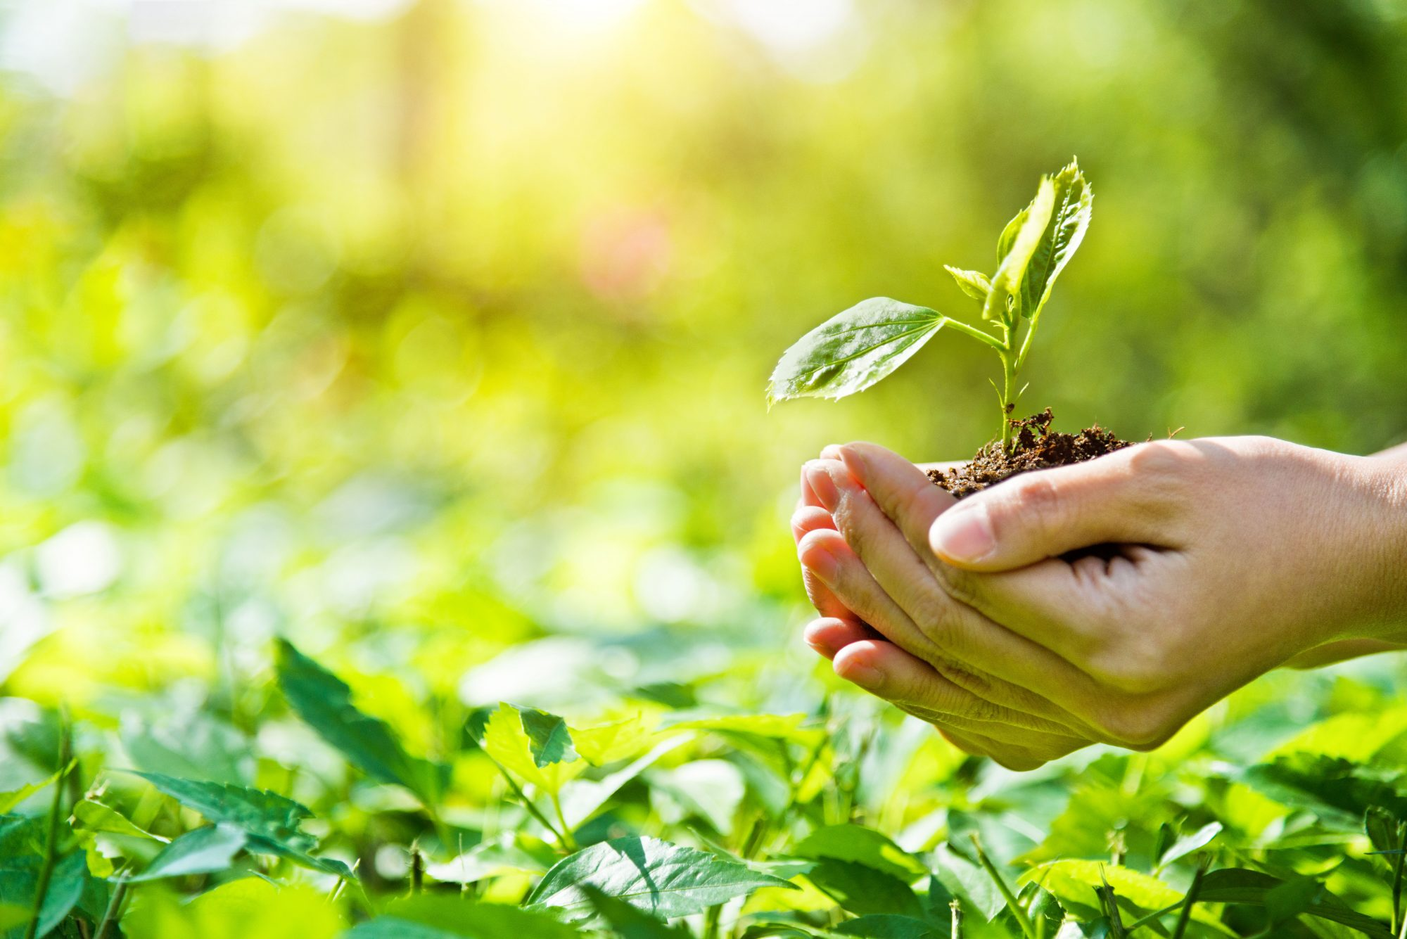
Figure 3: Representation of a sustainable future (Onal, 2019)

Conclusion
In conclusion to this investigation, when taking into consideration the environmental impact there are many things already being done as mentioned previously. However, the process of redesigning products should be done in tandem with creating new products to fulfil the objective of the unsustainable product. Of course, we are always going to be looking into more things that can be made in replacement, but we should be utilizing the things that are already made now. When it comes to designing products in the future, the design process should be heavily influenced by eco-design and the aforementioned certifications to know the impact those future designs could be creating. In the future, the certifications will be used when looking into materials and their durability. Tests will be conducted using more recyclable materials to ensure that a high-quality product is still being made using these sustainable materials. Being more ethical when it comes to the use of materials means that there is potential to stand out from others and attract a different customer than normal. Sometimes using recyclable materials can be stronger or look aesthetically pleasing compared to others. All in all, companies are losing out by not becoming eco-friendly or at least more eco-friendly. There is a massive margin in the production and design of products that are being missed. It would be beneficial to always look for a more sustainable way to do things and always think of the impact that would have on the world.

References
Braungart, M., 2009. Cradle to cradle. s.l.:Vintage Digital.
Cao, S., 2018. Why KFC and McDonald’s Are Ditching Plastic Straws Everywhere Except the US. [Online]
Available at: https://observer.com/2018/06/why-kfc-and-mcdonalds-are-ditching-plastic-straws-everywhere-except-the-us/
[Accessed 5 February 2022].
Chapman, J., 2012. Emotionally Durable Design: Objects, Experiences and Empathy. s.l.:Taylor and Francis Group.
Fournier, C., 2019. Eco design; definition examples , principles. [Online]
Available at: https://youmatter.world/en/definition/definition-eco-design-examples-definition/
[Accessed 14 February 2022].
Griggs, G., 2017. Coasts in crisis. s.l.:The university of California press.
Joshi, S., 2021. Bioplastics - A sustainable solution to our plastic waste problem. [Online]
Available at: https://www.teriin.org/article/bioplastics-sustainable-solution-our-plastic-waste-problem
[Accessed 4 March 2022].
Onal, E., 2019. A more sustainable future. [Online]
Available at: https://www.theconsumergoodsforum.com/blog/2019/10/14/a-more-sustainable-future/
[Accessed 01 March 2022].
Rainforest Alliance, 2019. What is the buisness value of sustainability?. [Online]
Available at: https://www.rainforest-alliance.org/business/marketing-sustainability/what-is-the-business-value-of-sustainability/#:~:text=Sustainability%20sells&text=98%20percent%20of%20businesses%20who,increased%20production%20(30%20percent).
[Accessed 4 February 2022].
Staff, A., 2019. Straw or no straw: How our choices impact aquatic wildlife one straw at a time. [Online]
Available at: https://www.aza.org/connect-stories/stories/how-do-straws-hurt-the-environment?locale=en
[Accessed 21 November 2021].
UN Environment Programme, n.d. Our planet is drowning in plastic pollution - it's time for a change. [Online]
Available at: https://www.unep.org/interactive/beat-plastic-pollution/?fbclid=IwAR02OyxnD5Vvn7ICDqjVYls6ZpnSVWBaVYeoDMr5ZXka5iNXb-DxLYKxFis
[Accessed 11 November 2021].
Usbek & Rica, 2017. Designing the products to meet environmental challenges is possible and needed. [Online]
Available at: https://medium.com/@Danone/designing-the-products-to-meet-environmental-challenges-is-possible-and-needed-3f251d912420
[Accessed 15 November 2021].
Wilcox, C., Sebille, E. V. & Hardesty, B. D., 2015. Threat of plastic pollution to sea birds is global, pervasive, and increasing. Proceedings of the national academy of sciences of the United States of America, 112(38), pp. 11899-11904.
Young, R., 2021. Five animals impacted by plastic pollution and how you can help protect them. [Online]
Available at: https://oceana.ca/en/blog/five-animals-impacted-plastic-pollution-and-how-you-can-help-protect-them/
[Accessed 1 March 2022].

