University of Wales Trinity Saint David
Wales Institute of Science and Art


Performance assessment and optimisation

Race engineering and simulation
ACHA 7026

Word count: 2211
Ewan Evans
2200899
Date submitted: 3/5/2026

Contents
1. Introduction 1
2. Literature review 1
3. Test plan development and testing methods 3
4. Execution of test plans 6
a. Push factor test 6
b. Consistency test 9
c. ARB, Toe and Camber full factorial test 11
d. Ride height and wing test 13
5. Combined test 15
6. Conclusion 15
7. References 16
8. Appendix 17

Introduction
The focus of this investigation is the test plan procedure of a Driver-in-the-Loop (DIL) simulator, where both driver and vehicle performance is analysed. The DIL simulations are taken place on the university’s simulation over three, two-hour slots. This requires strategic planning needing to extract the maximum amount of data within the time constraint.
With the focus being both driver and vehicle assessment, a balance between the two must be considered. Furthermore, the use of driver assessments allows for the reliability in vehicle performance. These tests involve various testing methods with an iterative process as they need to be completed for other tests to be conducted, whilst others use full factorial methods to save simulation time.

Literature review
There are various approaches that can be taken to critically analyse the DIL simulation, however, this case uses vehicle characteristic setup changes in a systematic method. With this, various DOE testing methods are applicable, consisting of space filling designs, factorial designs and RSM designs (M.Sadowski, 2023).
Space filling designs work by distributing simulations, within a range, where maximising the space/ distance covered is the priority of the test (Victor G 2025). There are various sub-categories within these (uniform design, maximin design, Latin hypercube design and fast flexible design), with the intent to find trends in unknown models across a large dataset. Due to the random nature, it can produce unreliability in the data but can also identify spikes in data that may not be clear with other methods (IsalosAnalyticalPlatform, 2026).

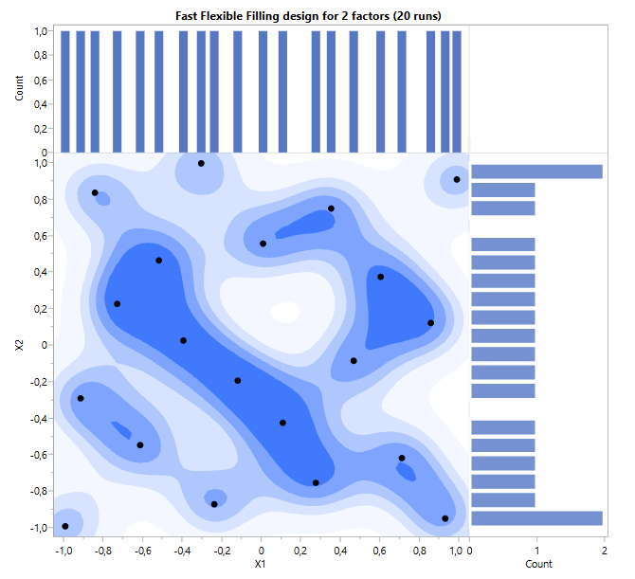
Figure 1 - Fast flexible filling design for 2 changes over 20 runs (Victor G 2025).

Factorial designs come under two brackets, full factorial or fractional factorial, which both aim to investigate the interaction between different factors (Minitab, date unknown). A full factorial design records data at all points, building a complete image of the data. Meanwhile, fractional factorial designs use selective points to reduce the number of simulations runs whilst still building a complete image. (figure 2) With this, the number of runs used in the fractional factorial has an influence on the reliability of the data, however, if there are a sufficient number of data points, then the test can be deemed valid.

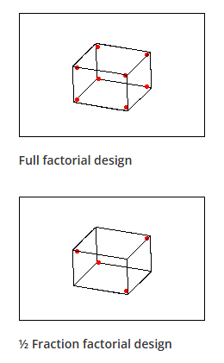
Figure 2 – Full factorial (left) and fractional factorial (right) design diagram (minitab, date unknown).

Box-Benken is commonly used due to it requiring fewer runs in relation to the central composite design (CCD), due to CCD looking at the limits in contrast to the Box-Benken, which uses the mid points. With this, the CCD then gives an improved level of accuracy in contrast, however it takes longer due to the additional runs needed (minitab, date unknown).

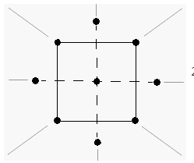  Figure 3 - Central composite design method (minitab, date unknown) | 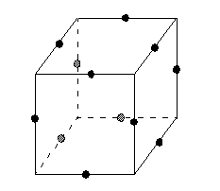  Figure 4 - Box-Benkhen model (minitab, date unknown).

Test plan development and testing methods

To get the balance between the reliability and the driver performance analysis, the first 1-hour session was used to prove reliability in results, using push factor tests and a consistency test. Before and after these sessions, a push lap was done to show the deviance between the start and end of the sessions.
The pace of the vehicle was increased in 10% increments from 50% to 100% to show how the lap times change and deviate in relation to how the driver is pushing the vehicle. Furthermore, these tests were conducted over 3 laps to gain an initial comparison, whilst not taking up a significant amount of time. The consistency test aims to not only look at how the drivers lap time changes, but also to investigate the characteristics of the vehicle to control the reliability of the results. The number of laps needed for future tests was to be analysed and potentially altered after the consistency test. With the consistency test, a push factor was to be gauged off the previous test, which would then be carried onto future tests. These two tests gave foundations for the validity of the future tests, which focus on tuning the setup to improve driver performance. For the consistency test, the plan was to run between 10 to 20 laps depending upon the consistency of the driver and the tyre characteristics, with the final number of laps being 13.

Table 1 - Lap number and the push % in comparison for the push percentage run plan
Lap number | 1,2,3 | 4,5,6 | 7,8,9 | 10,11,12 | 13,14,15 | 16,17,18
Push % | 50 | 60 | 70 | 80 | 90 | 100

The first test multi variable test was the combination of Anti roll bar, toe and camber, using the full factorial method. Due to the time constraints involved with the test, the use of the fractional factorial method would be implemented. This allows for the interpolation of the data collected to produce a response plot for a desired output. It must be noted that the middle point in the camber values are not directly a middle ground between the upper and lower limits, this is due to camber limits middle point not being directly in the middle of the upper and lower limits of the simulation.

Table 2 - ARB, Toe and Camber test numbers completed using fractional factorial model
Test number | ARB Front | ARB Rear | Toe | Camber
1 | 30 | 15 | 1 | -2
2 | 15 | 7 | 1 | -3
3 | 45 | 23 | 2 | -2
4 | 45 | 23 | 2 | -2
5 | 45 | 23 | 1 | -1.5
6 | 45 | 23 | 0 | -2
7 | 15 | 7 | 0 | -1.5
8 | 30 | 15 | 1 | -3
9 | 45 | 23 | 0 | -3
10 | 30 | 15 | 1 | -1.5
11 | 15 | 7 | 0 | -2
12 | 15 | 7 | 2 | -2

The second test conducted follows a similar process as the previous using a fractional factorial test when comparing different front and rear ride heights, as well as different rear wing factors. The simulator uses a numerical scale for rear wing angle, with 5 being high angle of attack. The process follows the same trend with 12 tests conducted over multiple laps to give consolidation to the test results, within a certain time frame.

Table 3 -Front ride height, Rear ride height, Rear wing angle test plan using fractional factorial method
Test number | Front ride height | Rear ride height | Rear wing
1 | 41 | 65 | 4
2 | 38 | 57 | 4
3 | 48 | 77 | 5
4 | 48 | 77 | 4
5 | 38 | 65 | 4
6 | 38 | .65 | 3
7 | 38 | 65 | 5
8 | 38 | 57 | 3
9 | 41 | 65 | 5
10 | 48 | 57 | 5
11 | 41 | 65 | 3
12 | 48 | 65 | 5

To conclude the tests, the best setup of the fractional factorial tests will be combined to investigate the improvement of these set ups on the driver performance.
All tests are completed on the Pembrey circuit due to the shorter track distance allowing for more data collection for varying set ups. In addition, the vehicle in use is the university’s sports 2000 race vehicle and with track data being available, the simulation results can be compared to the track data, which is key for track testing as simulators are frequently used for preparation of track testing.

Execution of test plans
When analysing results, vehicle characteristics and the influence of driver and vehicle set up is investigated. In addition, the use of driver feedback on how setups feel can also help to dial in setup for driver preference.

Push factor test
A comment made from driver feedback is the difficulty to dictate pace between 50% to 70%, which can be shown through the large deviation in lap times. This suggest that for future investigations, focusing the runs between 70% to 100% pace is more beneficial. Once the driver reaches a pace above 70% the consistency in the data drastically improves with no larger than a 0.2% difference from this point forwards. Indicating that no less than 80% should be used for the future test.

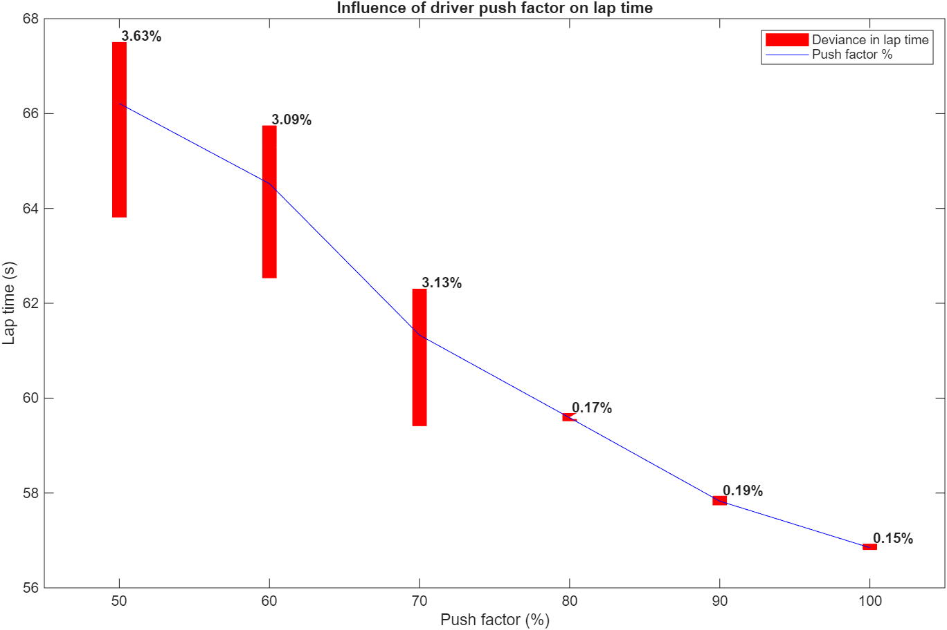
Figure 5 - Influence of push factor on lap time and the deviance of lap time

When deciding what push factor to select, several aspects were investigated, one of which being the ability to push flat out for longer periods of time. To keep qualifying pace for long periods of time is unsustainable and so slowing down of the pace is integrated. A strong example of this is the pace difference between qualifying and the fastest lap of the race set by Kimi Antonelli in Suzuka 2026, which showed a 4.12% drop off in pace (F1, 2026). There are other factors that influence the comparability between race pace and qualifying, such as the tyre life and fuel loads.

When comparing the impact of push percentages on tyre loads, there is a proportional increase in the extremities of the vertical tyre loads between the push percentages. Therefore, reinforcing the validity of the test. Using figure 7 the 80% push factor deviates away from the other push percentages, leading to the exclusion of this data set. Due to lap times not being completed at 100% pace for race application, the decision was made to proceed with 90% push percentage for testing.

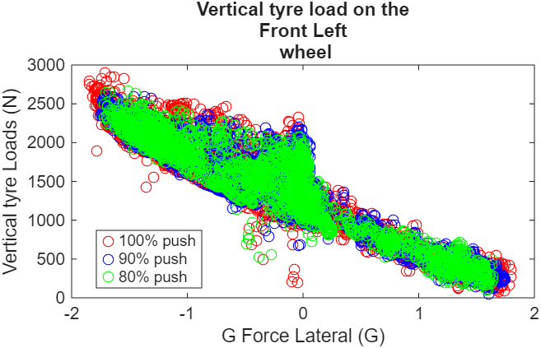
Figure 6 – Vertical tyre loads in relation to G Force lateral on the front left wheel

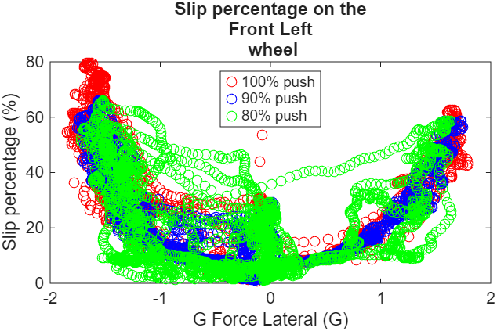
Figure 7 - Slip percentage against G Force lateral

Consistency test
To gauge the number of laps needed to retrieve consistent data, a consistency test was implemented. By running repetitive laps, it investigates not only at the consistency of the driver, but also the change of vehicle characteristics (such as tyre temperatures). The data shows that lap times decreased after around the first half of the tests, however, this drop is by a maximum of 0.1475 seconds, showing strong consistency in all the laps completed. Due to the drivers previous experience with the vehicle, simulator and track, the need for the number of runs is not justified and fewer laps could have been completed.

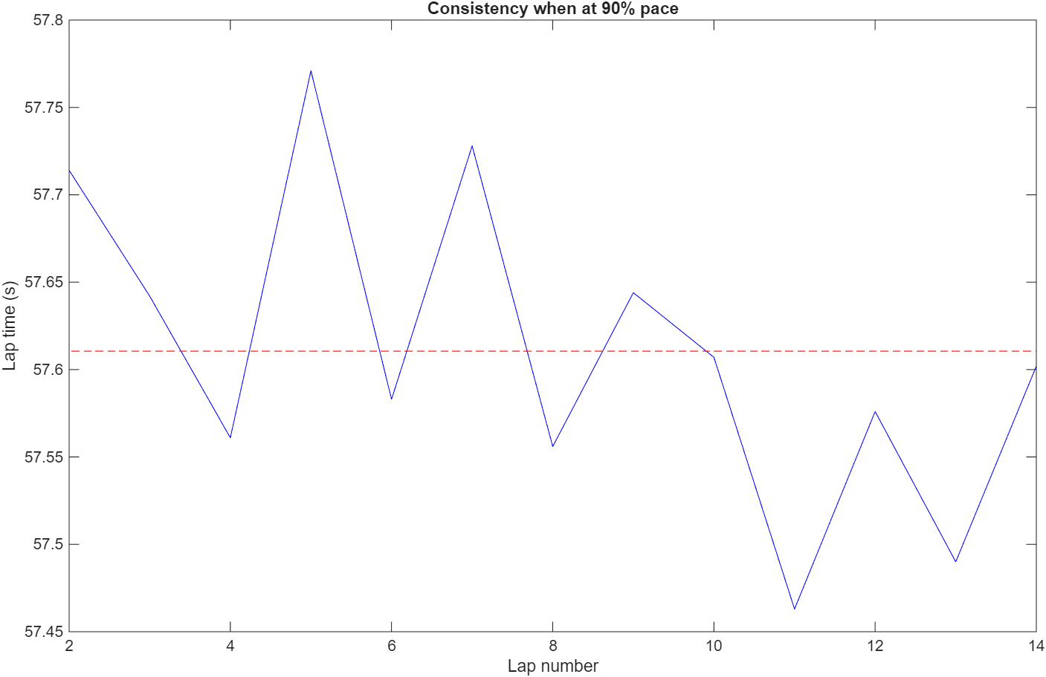
Figure 8 - Lap number against time (s) during consistency test at 90% push factor

The consistency test is not only an investigation into the consistency of the driver, but also looks at the change in vehicle performance. When comparing the performance of the vehicle, there is a common trend with all tyre data, where the tyres take a few laps to build up temperature and pressure within the tyre. Due to there being approximately a 12KPa and 15K difference between the upper and lower limits of the system, the first lap data is invalid. With this, the data was then analysed after the first lap and then 1 to 2 further laps were taken depending upon time constraints, as well as the unnecessary need for further laps.

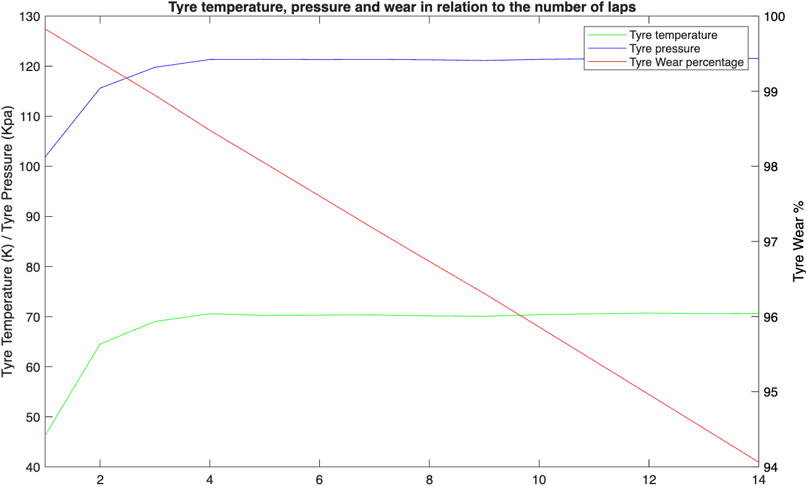
Figure 9 - Tyre temperature, pressure and wear for the number of laps

ARB, Toe and Camber full factorial test
Due to the relationship between these three areas, it was a key area of investigation, with them being commonly used for driver preference refinement. Numerical data, as well as the use of verbal driver feedback, can help to tune in on driver set up. This combination shows what performance is optimal for the driver to achieve a better lap time, whilst having a controllable vehicle platform.
When investigating the influence of various settings on lap time, there is a clear trend where having a vehicle that has toe positioned in a neutral direction, lap time decreases. A similar response for the driver was found, where a setup of more neutral camber, resulted in the vehicle ‘feeling more like the vehicle should respond’, instead of the vehicle feeling ‘unresponsive’. Therefore, indicating a more neutral toe position benefits the vehicles performance. Furthermore, the anti-roll bars seem to have a minimal impact on the vehicle characteristics. This shows that the ARBs can be used predominantly for driver feel, rather than for a reduction in lap time. Using driver feedback, it would suggest the use of stiffer ARB’s as the ‘vehicle was getting more rotation’, yet with a soft ARB set up, it was unpredictable, lazy and susceptible to understeer.
An increase in camber also seems to improve the lap times. It is likely that the vehicle rolls to high angles and therefore, the higher camber angle gives the outside wheel a better contact patch, resulting in more grip in relation to the road. This follows the same response of the driver as at higher camber angles he could ‘feel the load transfer’, with a comment also suggesting that the higher camber angle gives better front end in comparison to the rear.

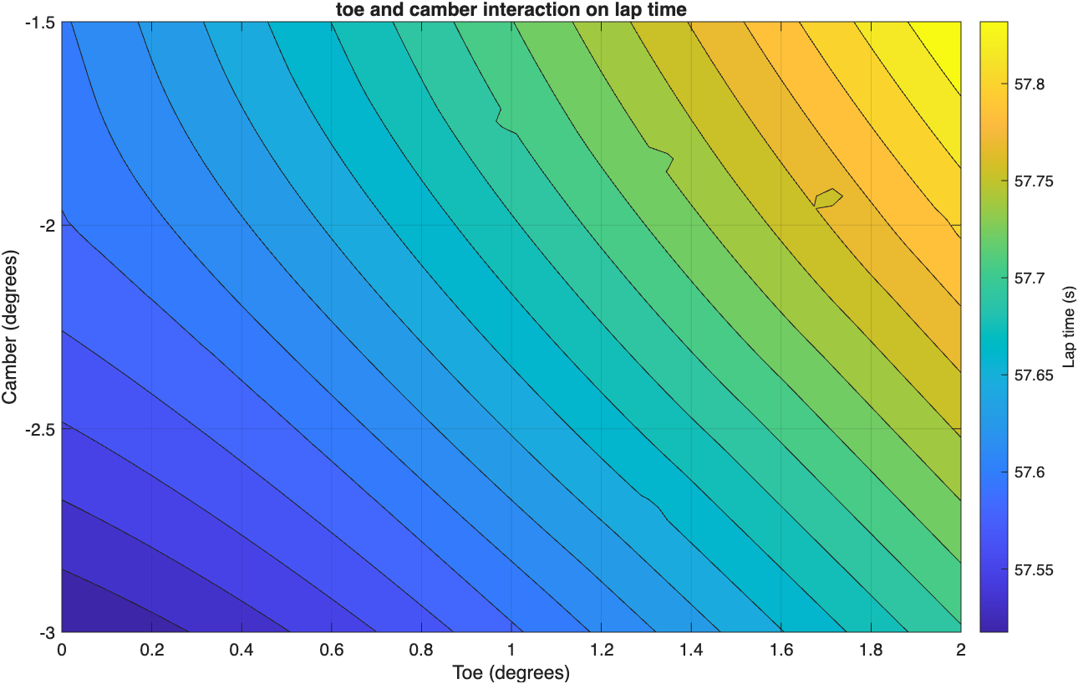
Figure 10 - Toe and camber influence on lap time

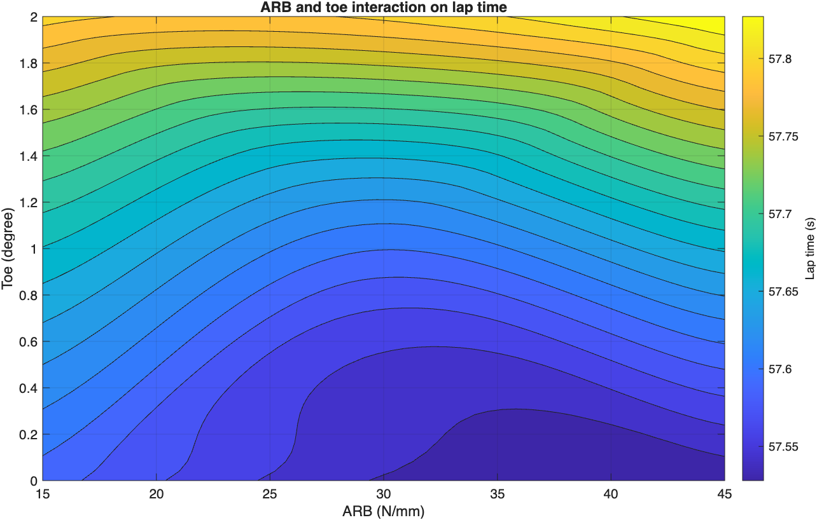
Figure 11 - ARB and toe interaction

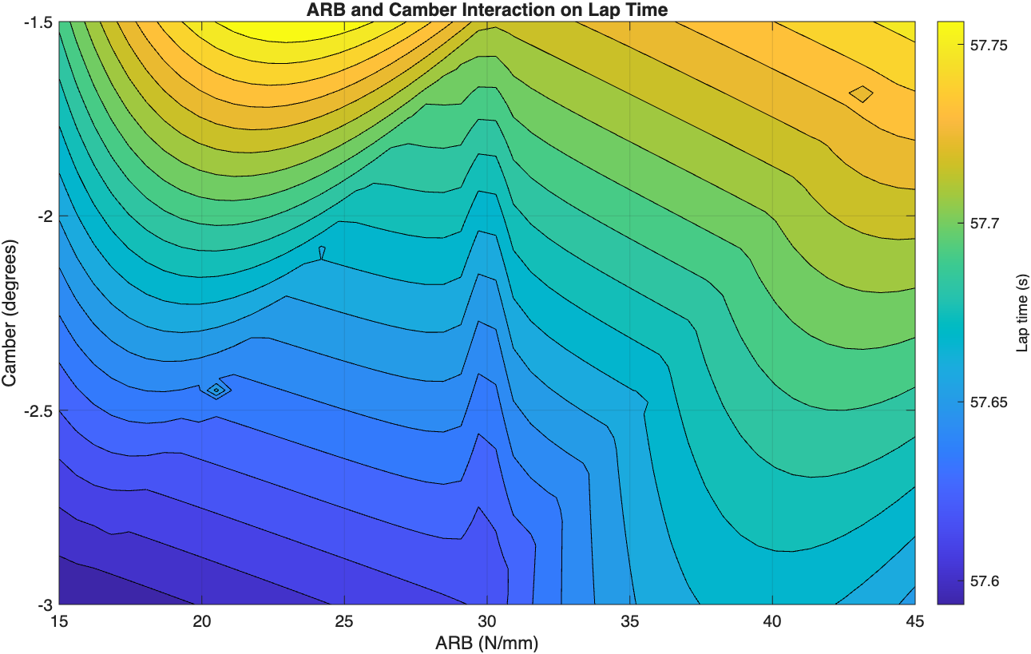
Figure 12 – ARB and camber influence with lap time

Ride height and wing test

The impact that front and rear ride heights have on the feel of a vehicle for a driver is significant due to the change in aero loads, but also the slight change to vehicle kinematics. With this understanding, how the vehicle feels along with the change in lap time is key.
There is a clear trend between the front and rear ride height influence on the lap time. This follows trends that are expected, as having a highly raked vehicle gives an increase in downforce helping to turn the vehicle into the corner. This follows a feedback comment suggesting that the ‘vehicle can be driven quicker, but not nice to driver’ when at higher rake angles.
Figure 14 shows an uneven trend with the rear wing angle, where it finds peak performance at position 4 and at a high rear ride height. The high rear ride height comes from the increase in rake angle, like previously. However, the ideal rear wing position would suggest that the rear wing stalls after position 5, however this is not the case and likely an outlier in the data, due to figure 14, showing consistent trends with the rear wing position. Furthermore, with figure 15, the rear wing angle does not have a significant influence on the vehicle performance in terms of lap times, when at low front ride heights. Interestingly, the driver feedback would suggest these trends, as when at lower ride heights, with both high and low rear wing positions, the feedback remained consistent (‘nice front end’/’rear end slightly unstable’).

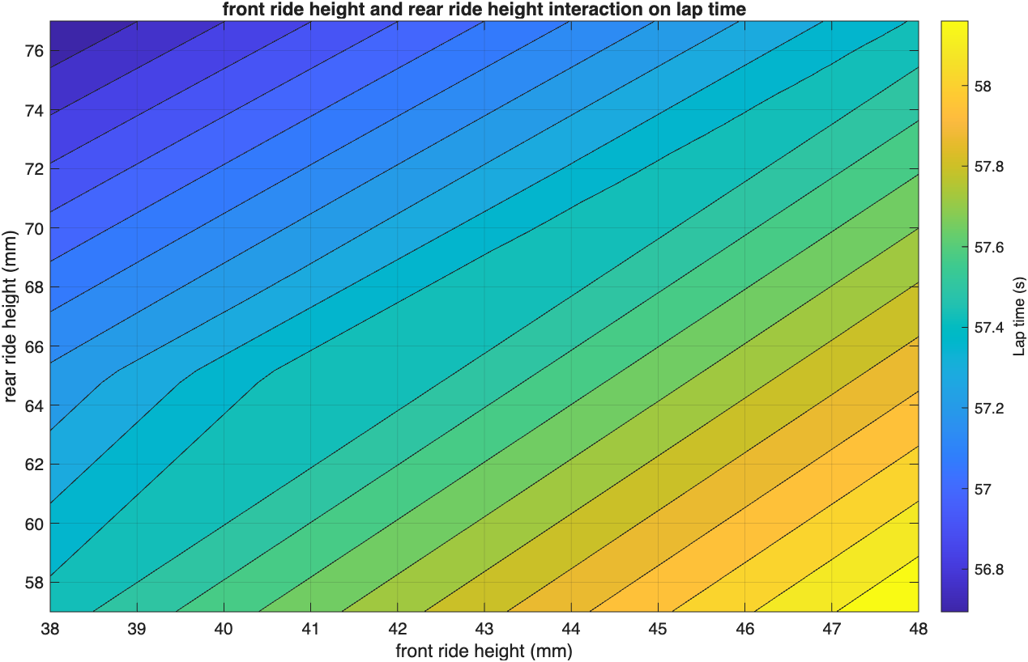
Figure 13 - front and rear ride height influence on lap time

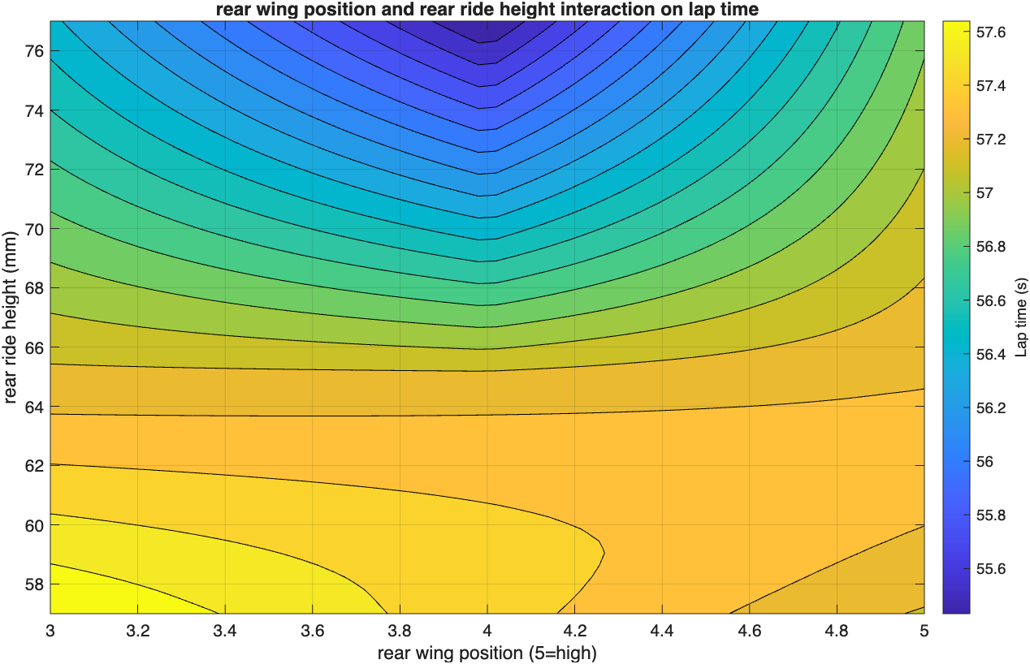
Figure 14 - rear wing position and rear ride height influence on lap times

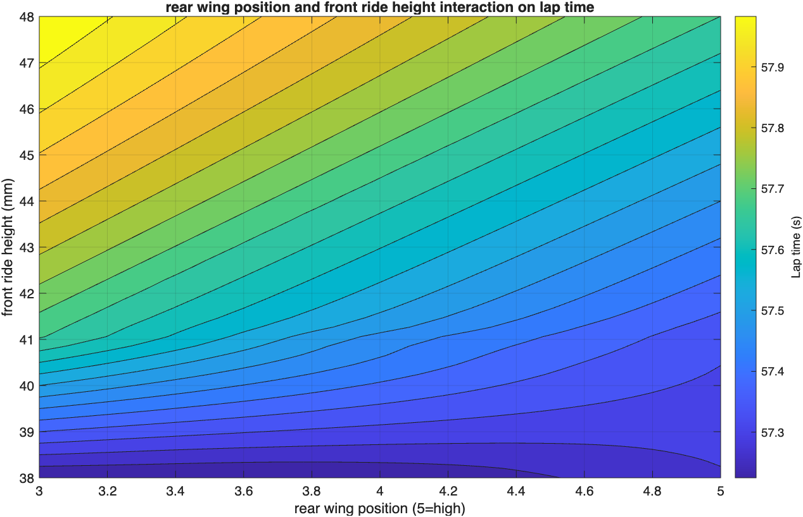
Figure 15 - Rear wing position and front ride height influence on lap times

Combined test
Towards the end of the third session a combined test took place, the preferred set up from both the ARB, toe and camber tests with the rear wing, front and rear ride height test was investigated. The lap times improved by up to 0.2 to 0.6 seconds, whilst setting the fastest lap time of the entire 3 sessions (56.163). However, the vehicle was in a position where it was difficult to drive, with it feeling ‘not as nice to drive as the aerodynamic changes’. It would therefore suggest using the set up from the aerodynamic test rather than the combination of designs.

Conclusion
A balance between driver comfortability and speed must be made as a vehicle that is quick may not be able to sustain the better pace for the race due to the difficulties involved in driving the vehicle. Furthermore, with this, the influence of combining various combinations would need tuning in an iteration approach, due to them dictating a significant change. With this, as well the combinations that showed the strongest results was ARB Front =45, ARB rear = 30, Toe = 0, camber = 2, with the other test suggesting a 41mm front ride height, 65mm rear ride height and a position 3 rear wing. The testing could have been improved further through the use of the Box-Behnken method, due to time limitations as well as it being a better alternative in this scenario, in comparison to fractional factorial method. Furthermore with the addition of push laps in between different test to get comparison was inconsistent and therefore can suggest inconsistency in the data.

References

- F1, 2026. FORMULA 1 ARAMCO JAPANESE GRAND PRIX 2026 - QUALIFYING. (Date retrieved 2026)
- ISALOSANALYTICALPLATFORM, 2026. Space filling. (Date retrieved 2026)
- M.SADOWSKI, 2023. 3 main types of Design of Experiments (DOE) designs. (Date retrieved 2026)
- MINITAB, Factorial and fractional factorial designs. (Date retrieved 2026)
- MINITAB, What are response surface designs, central composite designs, and Box-Behnken designs? . (Date retrieved 2026)
- VICTOR G, 2025. Exploring space filling designs part 1: Introduction to common types of space filling designs. (Date retrieved 2026)

Appendix

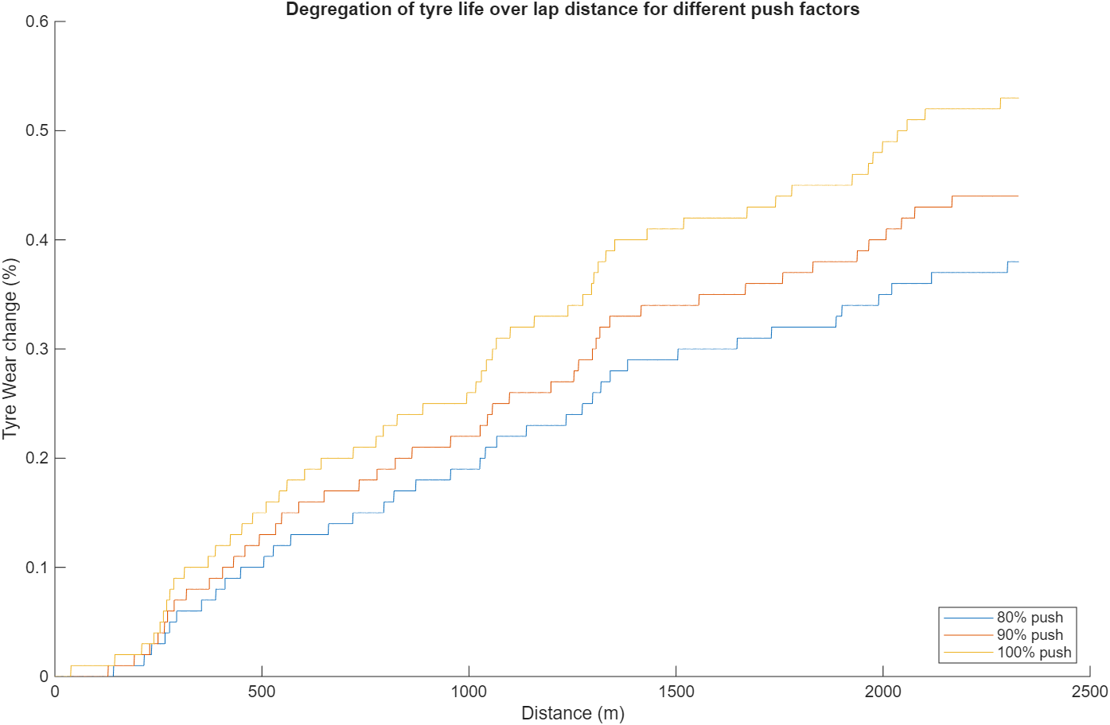
Figure 16 – Influence of varying push % on tyre wear

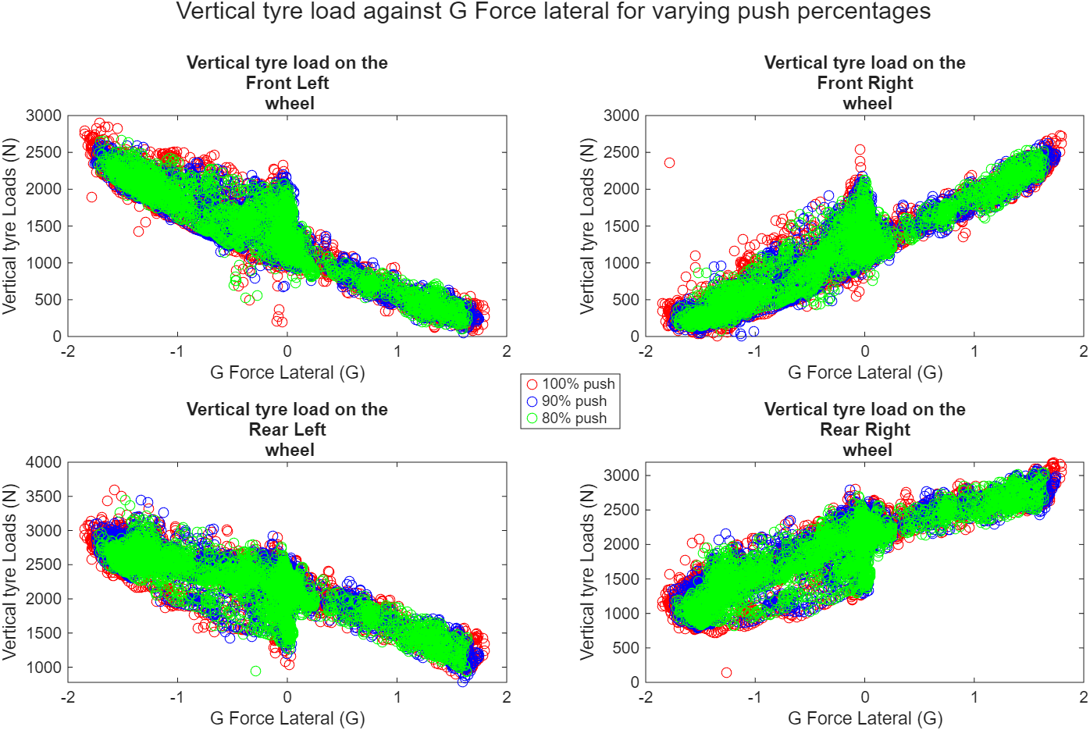
Figure 17 - G Force Lateral against the vertical tyre loads for varying push percentages

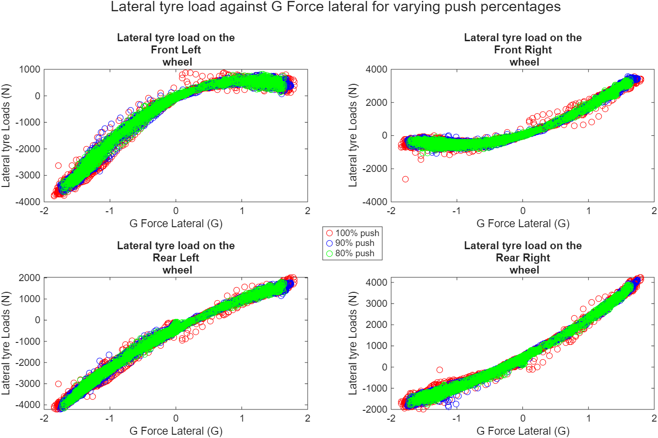
Figure 18 - G Force against lateral tyre loads for varying push percentages

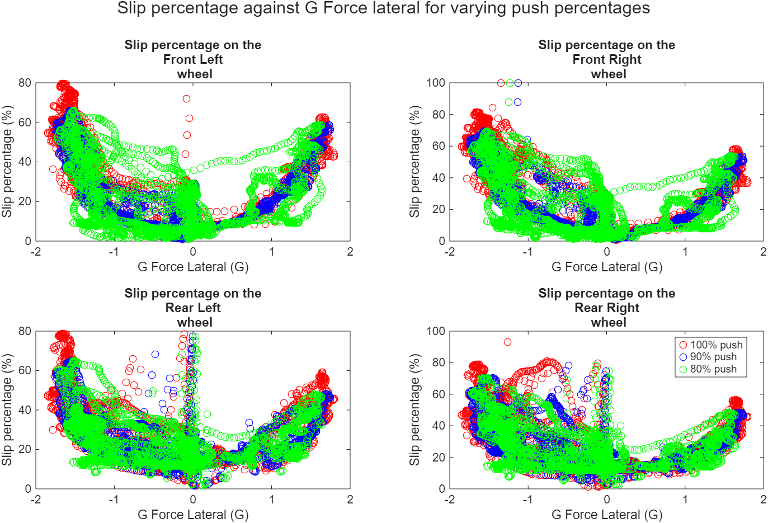
Figure 19 - Slip percentage against lateral tyre loads for varying push percentages

