
Student Name: | Astha Chabhadiya | Student ID: | 2529402
Programme: | Master of Business Administration
Module: | Human Capital Management
Module Code: | LCMB7023
Assignment Title: | Assessment component 1: Individual report – HR strategy
Lecturer Name: | Gladius Kulothungan Ejike Udeogu
Word Count: | 2560(Excluding Titles, Refernces, Tables, Appendix) | Submission Date: | 20th March, 2026

Table of Contents
Part 1: Re-Engineering Performance and Job Design at Aether Innovations 1
1. Introduction 1
2. Analytic Review of the Current Performance Practices in Technology companies 1
2.1 Collapsing of the Traditional Logic of Appraisal 1
2.2 Modern substitutes: Is it enough with OKRs? 2
3. Proposed Performance Architecture: Strategic OKRs and Developmental 360° Feedback. 2
3.1 Repackaging Performance as Ongoing Strategic Conversation. 2
3.2 Multi-Level OKR Design 2
3.3 Onboarding 360° Degree Feedback as Behavioural Governance. 3
4. Job Redesign Executive- Job Characteristics Model. 3
5. Systemic Integration and Cultural Reinforcement 4
6. Strategic mitigation and Risk 4
7. Conclusion 4
Part 2: Reflective Analysis – Developing as a Strategic Human Capital Leader 5
1.1 Description 5
1.2 Feelings 5
1.3 Evaluation 5
1.4 Analysis 6
1.5 Conclusion 6
1.6 Action Plan 7
2. Remaining Future Relevant in the Age of Artificial Intelligence 7

EXECUTIVE SUMMARY
Aether innovation is facing stagnant growth, rising voluntary turnover, and decreasing customer satisfaction, which is a symptom of systemic mismatch of strategy and human capital systems. This report suggests a complete re-engineering of the performance management and executive job design to re-establish the innovation and organisational impetus. Based on the current theory of High-Performance Work System (HPWS) and the AMO framework as well as the new studies in agile performance management, the report suggests substituting yearly appraisal with the quarterly model of strategic dialogue on the basis of OKR and incorporating it with the developmental 360-degree feedback.
The modern concept of job design combined with organisational models based on skills is applied in the redesign of executive roles that help increase autonomy, cross-functional cooperation, and intrinsic motivation. It is proposed that the performance architecture focuses on psychological safety, strategic alignment, and workforce analytics to achieve sustainable competitive advantage.
A combination of performance transparency and behavioural responsibility and structural dynamism will enable Aether to look beyond discontinuous HR practices and adopt a consistent innovation system, which will enhance the level of involvement, leadership potential, and long-term organisational productivity.

Part 1: Re-Engineering Performance and Job Design at Aether Innovations

1. Introduction
The lack of growth, rising voluntary turnover, and deteriorating customer satisfaction of Aether Innovations are not individual operational issues, but signs of systemic organisational ill-fit. The company needs to come up with an integrated human capital blueprint instead of trying to make disjointed HR processes incremental as it is the case in the assessment scenario. These difficulties are indicative of what Becker and Huselid (2006) refer to as HR architecture misalignment where people management systems do not support strategic priorities and thus weaken organisational performance.Strategic misalignment between HR architecture and organisational goals weakens performance and innovation capability (Becker & Huselid, 2006).
Competitive advantage in knowledge based technology companies does not arise primarily due to tangible asset or cost efficiency. Rather, it is the result of dynamic capabilities, i.e., the capacity of the firm to integrate, reconfigure, and refresh competencies in changing the environment (Teece, 2018). Performance management and job design in such contexts cannot be administrative tools to monitor output. They have to be strategic drivers that develop innovation, flexibility, and teamwork ability.
This report thus postulates that the change in Aether needs to develop mutually reinforcing High-Performance Work System (HPWS). Instead of presenting performance appraisal and job design as two distinct interventions, they should act as mutually relying parts of a unified performance structure. This should be a blend of goal clarity (OKR) and behavioural accountability (developmental 360°-degree feedback), intrinsic motivation (Job Characteristics Model (JCM)) and organisational agility (skills-based design). Such systemic integration is the only way that Aether could reinvent its innovation capacity and performance momentum.Strategic misalignment between HR architecture and organisational goals weakens performance and innovation capability (Becker & Huselid, 2006).

2. Analytic Review of the Current Performance Practices in Technology companies

2.1 Collapsing of the Traditional Logic of Appraisal
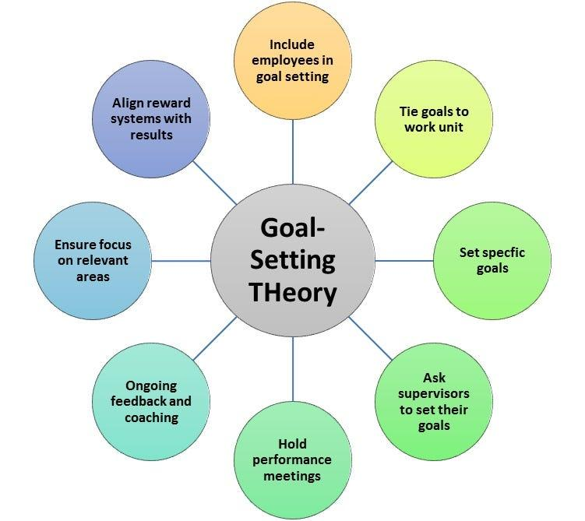
The conventional annual appraisal systems were created in fairly stable production environments with predictable planning. Nevertheless, technology companies work in iterative development systems where product lifecycles are fast and priorities change constantly. Annual reviews in this regard cause a time discrepancy between performance and reality.
Pulakos et al. (2019) show that delayed feedback lowers the perceived fairness and undermines intrinsic motivation. When performance evaluation is done on employees many months after the behaviours, developmental impact is reduced. Furthermore, forced ranking systems, which have been used in companies like Microsoft, have been condemned to destroy collaboration and psychological safety. Knowledge intensive organisations rely on cross functional collaboration, but competitive ranking systems encourage individualistic behaviour.Traditional appraisal systems are increasingly ineffective in dynamic environments due to their retrospective nature and lack of agility (CIPD, 2023; Gartner, 2024).Delayed feedback reduces motivation, perceived fairness and developmental impact (Pulakos et al., 2019).
The further constraint of the old appraisal is its philosophical orientation. Managing models based on control presuppose that employees need control and remedial assessment. Innovation ecosystems, however, rely on management based on commitment, which stresses on trust, autonomy, and purpose (Walton, 1985). The fact that Aether has high turnover rates implies that its existing performance system could be seen as evaluative and not developmental, thus demotivating discretionary effort and psychological ownership.

2.2 Modern substitutes: Is it enough with OKRs?
At the top technology companies, Objectives and Key Results (OKRs) have become popular because of their ability to match strategic ambition to tangible results. Based on the Goal-Setting Theory (Locke and Latham), OKRs highlight time-bound, specific and challenging goals. When applied in the right way, they can boost concentration and strategic clarity.While OKRs improve goal clarity, their effectiveness depends on supportive organisational culture and developmental orientation (Deloitte, 2023).
But the use of OKRs has in many cases been shallow. Studies have shown that the failure of OKRs is associated with overloading and overambitious goals, punitiveness in metrics, and the lack of cultural underpinnings to support open goal-setting. The Self-Determination Theory (Deci and Ryan) warns against too much outside control as it kills intrinsic motivation. When used as stiff performance contracts, instead of strategic dialogue instruments, OKRs can become the same constraint as conventional appraisal systems.
Thus, OKRs are not enough. They should work in a psychologically healthy and constructive development based structure that encourages learning as opposed to punishment.

3. Proposed Performance Architecture: Strategic OKRs and Developmental 360° Feedback

3.1 Repackaging Performance as Ongoing Strategic Conversation.
To overcome these limitations, Aether needs to shift the yearly appraisal to a quarterly model of strategic performance dialogue. This model would include an annual planning of strategic direction, quarterly OKR cycles, monthly coaching sessions, and real-time online performance dashboards. This will maintain a balance between agility and accountability and make sure that performance discussions are not retrospective.
The regular coaching interactions built into the organisation result in a shift in focus away from judgment to growth. This agrees with the modern-day evidence indicating that recurring developmental dialogues increase interaction and understandability.Continuous performance management systems enhance engagement, adaptability and organisational learning (Gartner, 2024; CIPD, 2023).

3.2 Multi-Level OKR Design
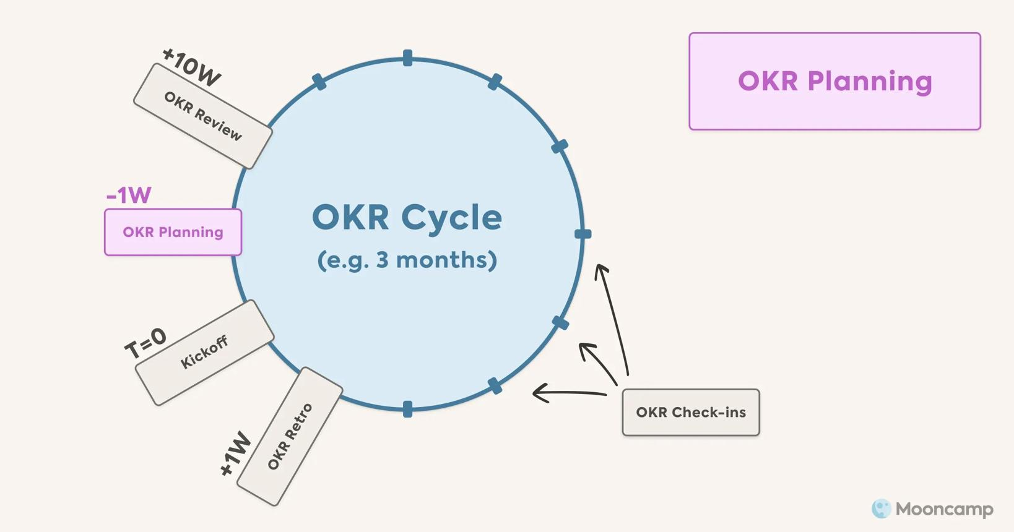
The company-wide goal of Aether must be to rebrand itself as an innovation-driven growth organisation. Strategic key outcomes can be 15% growth in revenue annually, voluntary turnover decreasing to less than 12 percent instead of 22 percent, and Net Promoter Score a 85. Notably, these metrics combine financial, employee, and customer indicators, as per the Balanced Scorecard principles and supporting the whole performance.
The strategic alignment of departmental and individual OKRs should be done vertically to eliminate silos and horizontally across teams. This cross-functionality comes especially in the scaling of technology companies when fragmentation tends to arise as structure becomes more intricate.

3.3 Onboarding 360° Degree Feedback as Behavioural Governance
Whereas the OKRs explain what needs to be accomplished, the 360°-degree feedback explains the how of performance. Behaviourally toxic individuals are high performers who may negatively affect the collaboration and innovation culture. A developmental-only 360° 0 feedback system opens up peer and subordinate views, making behaviour more accountable.Multi-source feedback improves leadership effectiveness and strengthens behavioural accountability (SHRM, 2024).
Importantly, this system must be distinctly apart compensation decisions. According to Bracken and Church (2013), the direct connection of 360°° results with pay increases defensiveness and decreases authenticity. With the developmental intent Aether can enhance the leadership capacity without causing performance anxiety.
The combination of OKRs and 360° feedback makes AMO work. OKRs increase the clarity of ability, autonomy reinforces motivation, and feedback systems provide room to develop behaviour.

4.Job Redesign Executive- Job Characteristics Model
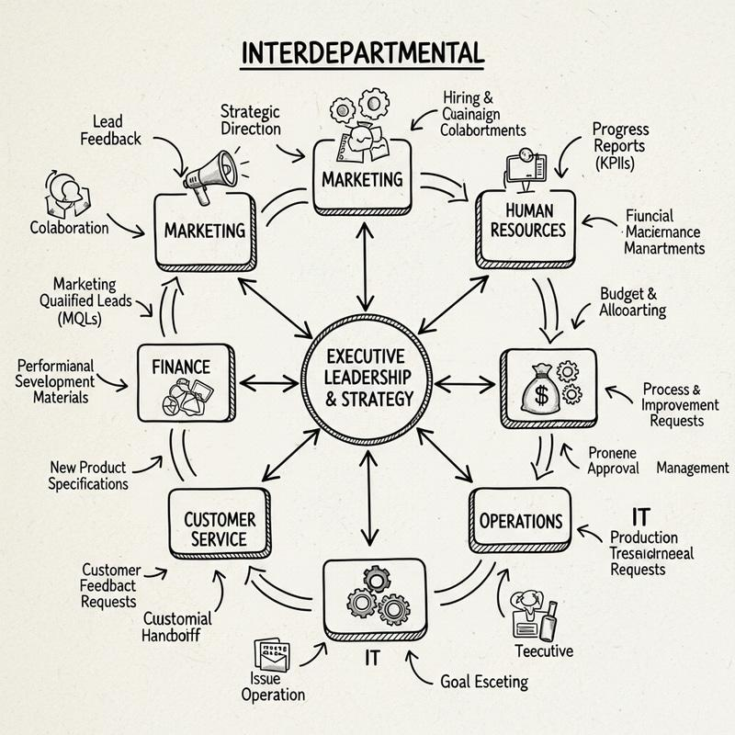
The Job Characteristics Model of Hackman and Oldham presents 5 fundamental dimensions that drive intrinsic motivation and they consist of skill variety, task identity, task significance, autonomy and feedback. In high growth companies, the executive positions can be eroded by administration and responsive decision making at the expense of strategic influence.
Aether executive redesign should therefore focus on autonomy, cross-functionalism and ownership of innovation.Job design significantly influences motivation, engagement and innovation outcomes (Parker et al., 2022).Skills-based organisational models enhance flexibility and cross-functional collaboration in dynamic environments (Tata Consultancy Services, 2023).
The CEO ought to move beyond operation overseer to dynamic capabilities orchestrator. The CEO improves task identity and strategic focus by delegating operational decisions and forming an Innovation Governance Council. A dedicated experimentation budget also institutionalises innovation instead of entrusting it to informal projects.
The CFO should not be limited to cost control but should move toward strategic capital allocation. The addition of innovation portfolio management and the real options theory used in R&D investment decisions enhances skill variety and strengthens the task importance. Money becomes a growth enabler, and not a growth constraint.
In the same vein, scalable architecture, technical debt management, and cross-functional sprint integration should all be emphasized by the CTO. The level of autonomy in architectural choices increases the responsiveness and lessens the bottle necks.
The Chief Innovation Officer has to play a structural and not a symbolic role. This position operationalizes skills-based flexibility through spearheading intrapreneurship incubators and external startup alliances. Innovation is built into the organisational design and not sporadic.
The transformation of the HR Director into a workforce analytics strategist will make people metrics and strategy aligned through engagement data, leadership capability mapping, and OKR governance.
Lastly, the Head of R&D must move into cross-functional innovation pods of customer co-creation and quick prototyping that are not siloed research. These promote the skill variety as well as task relevance, which reinforces intrinsic motivation among research teams.

5.Systemic Integration and Cultural Reinforcement
The suggested design conveys the High-Performance Work System theory that argues that synergistic results occur in mutually reinforcing HR practices. OKRs are strategic alignment drivers, behavioural standards are strengthened by 360°° feedback, JCM-based job design is a driver of intrinsic motivation, and skills-based structuring improves organisational agility.High-performance work systems generate sustainable performance when HR practices are internally consistent and strategically aligned (Kwon & Kim, 2022).
Nevertheless, these mechanisms cannot be effective without psychological safety. According to research by Edmondson, innovation can succeed when employees feel safe enough to experiment and fail. Psychological safety is a critical enabler of innovation and learning in organisations (Edmondson & Mortensen, 2023).Performance systems, without trust, are bound to produce fear and not engagement. Consequently, coaching, inclusive communication, and active listening leadership development is not auxiliary but possesses a foundation.

6.Strategic mitigation and Risk
There are risks associated with implementation. When the objectives multiply, OKR fatigue can occur. Executive resistance can also take place when the shift in autonomy is a threat to the status quo. Cultural inertia may retard behavioural change. Moreover, excessive focus on metrics can dwarf the results of qualitative innovation.
To avert such risks, the disciplined objective limitation, implementation by pilots, open communication, and a system of measurements with quantitative and qualitative indicators are essential.

7.Conclusion
The issues of Aether Innovations are structural and not ability based. The company can rebuild a sustainable innovation ecosystem by combining agile OKRs, developmental 360°° feedback, and motivation-promoting executive job redesign into a skills-based organisational structure.
This plan goes beyond reforms in processes to radical change. Performance management gets performance architecture - a consistent, theory-based system based on HPWS, AMO, dynamic capabilities, and intrinsic motivation theory. Long term organisational success can be mutually reinforced through such integration, autonomy, accountability, collaboration and innovation.

Part 2: Reflective Analysis – Developing as a Strategic Human Capital Leader

1.1 Description
The Human Capital Management module has radically redefined my concept of HR as an administrative support role to a strategic organisational performance driver. My understanding of HR at the start of the module was mostly operational, i.e. recruitment, training, performance appraisals, and compliance. Nevertheless, by working with frameworks like High-Performance Work Systems (HPWS), the AMO framework, the Job Characteristics Model and modern discussions of strategic alignment, I have started to see HR as an architecture of interdependent systems that determine culture, capability and competitive advantage.
The example of Aether Innovations was especially helpful to make me think outside of the box of isolated interventions. It is not just about improving appraisals or redesigning jobs, but comes to thinking of how performance management, leadership behaviour, autonomy, and innovation are structure-linked.

1.2 Feelings
The first thing that I experienced was that the idea of strategic HRM struck me as overwhelming intellectually. Theoretical models like dynamic capabilities and AMO were considered to be abstract and hard to operationalise. I could comfortably analyse superficial problems, but was less so putting together various models in a comprehensive solution.
But as the module continued, I started to realise that this complexity is a reflection of the reality in organisations. The contemporary organisations are working in a vagueness and dynamic environment. Thus, standardized HR solutions are not enough. This understanding further boosted my ability to confront ambiguity and make well-structured decisions even when information is unavailable to me, which is one of the critical Level 7 expectations.

1.3 Evaluation
One of the most important things I learnt during my learning experience was that I gained the critical awareness of the way in which the HR practices may sabotage the organisational goals unintentionally. Indicatively, I used to believe that performance appraisals are innately enhancing accountability. By reading modern criticisms, I realised that bad appraisal systems may both decrease teamwork and intrinsic drive.
The other learning outcome of great importance was that of differentiating between the vertical and horizontal alignment. Vertical alignment is to be used in order to assure that the HR systems are aligned with strategy, whereas horizontal alignment is to be used to assure internal consistency between the HR practices. I have now realised that individual best practices alone would hardly make performances sustained, the manner in which they are combined is what counts.
Nonetheless, a weakness of my development has been that I tend to pay much attention to structural design and underrate the emotional and political aspects of the organisational change. The cultural resistance, ego of leadership and the power dynamics contribute significantly to the HR transformation. This is one of the gaps that I have realised, and it has been a significant aspect of my development.

1.4 Analysis
The module has reinforced my conceptual knowledge in three areas of critical concern:
1. HR being a Strategic Asset (Resource-Based View)
Resource-Based View (RBV) holds to the argument that the sources of sustainable competitive advantage are valuable, rare, inimitable and non-substitutable. I now perceive human capital, when integrated in congruent systems, as fulfilling these conditions. Talent in itself is not a factor of competitive advantage, coordinated talent systems are.
2. Motivation as Systemically Engineered (AMO Framework).
AMO model made it clear that performance is dependent on Ability, Motivation and Opportunity. Earlier on, I perceived performance challenges to be mainly ability gaps. I now understand that motivation and opportunity structure which are determined by leadership and job structure are also powerful factors.
3. Job Motivation and Design (JCM)
The knowledge of the Job Characteristics Model changed my perspective of thinking in control oriented management to autonomy oriented leadership. This has not only changed the perspectives I have towards the organisations, but also my work liking perspective. The model predicts that I will be better when I have autonomy, the importance of the task, and feedback, which is what happens to me.
This analytic speculation shows the way theory can cast light upon personal experience. Theories do not exist in the abstract world of academia; they offer explanatory frames to behaviour in the real world.

1.5 Conclusion
On the whole, this module has changed my identity to not considering myself as a future HR practitioner, but as a future strategic human capital architect. I have learned that HR leadership needs to be effective, and this involves:
- Systems thinking
- Decision-making that is evidence-based.
- Ethical and inclusive leadership.
- Comfort with uncertainty
The primary development area that I am planning to work on in the future is enhancing my ability to work in the field of workforce analytics and strategic decision modelling. I need to exercise both qualitative insight and quantitative fluency to be able to work at senior level.

1.6 Action Plan
To foster an attitude of growth and innovation enabling in me, I will:
- Acquisition of high-order HR analytics (Power BI, interpretation of workforce metrics).
- Read the current HR literature through the use of journals like the Human Resource Management Journal.
- Identify team based academic or professional projects where one can exercise influence and negotiating skills.
- Develop coaching competency, because contemporary HR leaders need to facilitate and not to control.
Through the lifelong learning orientation, I will become a role model of the same growth mindset that I would champion in the organisations.

2. Remaining Future Relevant in the Age of Artificial Intelligence
The fast-moving innovation of artificial intelligence poses a threat as well as an opportunity to the HR professionals. Now, AI systems can be used to automatize recruitment screening, predictive analytics, performance tracking and even employee engagement analysis. Most of the traditional HR functions in administration are becoming algorithms.
Nevertheless, the amplification of analytical and transactional capabilities is the main role of AI; it cannot be compared to the situation of human-level contextual judgment, moral reasoning, relationship intelligence, and cultural sensitivity. Hence, my strategic placement needs a change to become an operationally-based program rather than the value-added advisory program.
I will also use AI as a cognitive enhancement tool and not as a competitor. For example:
- Turnover trends using AI-based analytics.
- Using generative AI to synthesize research.
- Using predictive models on workforce planning situations.
Nevertheless, the interpretive layer, which can determine what to do, deal with the stakeholder emotions, work around ethical trade-offs, is human-based.
In order not to be replaced, I need to develop the distinctly human abilities:
- Strategic thinking
- Complex problem framing
- Ethical judgment
- Change leadership
- Inter-functional teamwork.
AI can produce data, yet people cannot lose trust, resolve conflict, or moral responsibility, which are inherent in people management decisions.
Thus, instead of being afraid of AI displacement, I see technological development as a chance to transform the HR profession into an administrative processing into a strategic component. The HR leader of tomorrow will not be the one competing with AI, he will make it a wise orchestration.

REFERNCES
CIPD (2023) Performance management: an evidence review. London: Chartered Institute of Personnel and Development.
Deloitte (2023) 2023 Global Human Capital Trends: New fundamentals for a boundaryless world. London: Deloitte Insights.
Edmondson, A.C. and Mortensen, M. (2023) ‘What psychological safety looks like in a hybrid workplace’, Harvard Business Review, 101(3), pp. 56–65.
Gartner (2024) Reinventing performance management for the digital workforce. Stamford, CT: Gartner Research.
Harvard Business Review Analytic Services (2023) Redesigning work for innovation and growth. Boston: Harvard Business Review Press.
Kwon, K. and Kim, T. (2022) ‘High-performance work systems and organizational innovation: A meta-analytic review’, Human Resource Management Review, 32(4), 100895.
McKinsey & Company (2023) Performance through people: Transforming talent for competitive advantage. New York: McKinsey Global Institute.
Parker, S.K., Morgeson, F.P. and Johns, G. (2022) ‘One hundred years of work design research: Looking back and looking forward’, Journal of Applied Psychology, 107(2), pp. 201–222.
SHRM (2024) The state of performance management in 2024. Alexandria, VA: Society for Human Resource Management.
Tata Consultancy Services (2023) The skills-based organization: Building future-ready workforces. Mumbai: TCS Thought Leadership Institute.
World Economic Forum (2023) The future of jobs report 2023. Geneva: WEF.
Zhang, Y., Lepak, D.P., Smith, K.G. and Taylor, M.S. (2022) ‘Human capital systems and strategic agility: A multilevel perspective’, Academy of Management Journal, 65(6), pp. 1873–1902.

