
Data Handling and business intelligence
Assignment 2
LCBB5000

Lecturer name: Anupam Mazumdar
Student name: Sandrina Rangelova
Student number: 1917133

Table of Contents
Introduction 3
Evaluation of using Excel 3
Pivot tables 3
Power function 5
Average function 5
Part 2 6
SPSS 9
Clustering 9
Two Step Analysis 10
Data mining and text mining 12
Data mining methods 12
Text mining methods: 12
References 15

Part 1

Introduction
Data visualization is the process of transforming data into a graphical format. This allows people to see patterns, trends, and relationships in data. Data visualization can be used to make both small and large data sets easier to understand. There are many benefits to data visualization, including the ability to understand complex data sets, communicate information clearly and effectively. This helps to make data more accessible and understandable and help people to see the big picture Additionally, data visualization can also help you find errors in your data set. Data visualization is a very important tool for any researcher or analyst. In this report, I will analyse visualized data presented in tables and charts.

Evaluation of using Excel
Excel is a spreadsheet program that allows you to store, organize, and analyse data. I have used Excel to create charts and graphs and calculate formulas. Excel is a powerful tool for pre-processing, analysing and visualizing data. It can be used to clean up data and identify patterns and trends. Excel is also useful for creating models and simulations, which can help decision-makers understand complex problems and make better decisions. This is an essential tool for businesses and individuals who need to make sense of their data.

Pivot tables
Pivot tables are one of the most powerful features in Excel. They allow you to quickly summarize large amounts of data in a way that is easy to understand and interpret.
A pivot table is essentially a summary of your data. It can be used to calculate things like sums, averages, and counts. You can also use it to filter and sort your data in various ways.
One of the most common uses for pivot tables is to calculate percentages or ratios. For example, you could use a pivot table to calculate the percentage of total sales that each salesperson makes.
Pivot tables are also very useful for exploring data sets. For example, you can use a pivot table to quickly identify trends and patterns if you have a large data set with many different variables. One may utilize the pivot table to create various totals and numbers based on one's needs utilizing pivot tables (Clark, 2020). The data retrieved from the superstore included the sales amount for each transaction, as well as order date, order ID, and so on. The years of the orders were extracted using Year and Right functions based on the order date. The year function has been used as follows: - =Year (C1). And the Right function has been used as follows: - =Right (C1, 4). After extracting the years of the order date, a pivot table has been created using year and sum of sales. The outcome of the table was as follows
Pivot line chart
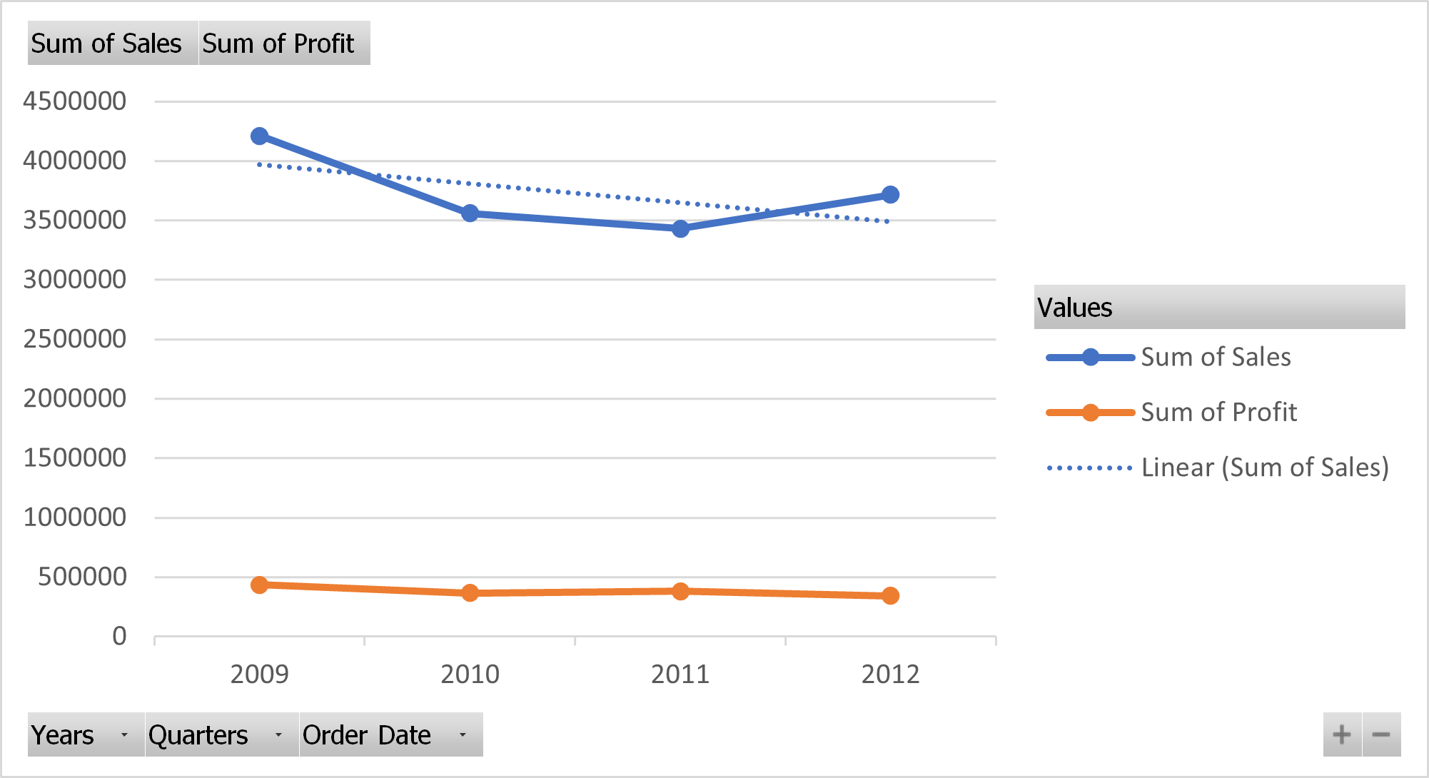
Chart 1 (author)

Table 1: Yearly total sales and profit in Pivot table
Author

As shown by the data from the table and graph on the previous page, the company's sales have been slowly decreasing over recent years, with a sharp decline in 2012. The total sales in the year of 2009 were 4209896.846 whereas it was 3715671.953 in the year of 2012. A similar trend can be seen in the profit amounts over the years: a decline over 4 years except for an increase in 2011. The total profit in the year of 2009 amounted to 434096.02 whereas it amounted to 342444.13 in the year of 2012 and a sudden increase resulted the profit to be 380310.5. This shows that the company's management of expenses has been inefficient in previous years, as sales growth did not always lead to profit proportionate increase.
Power function
Power function is used to raise a variable to a power of a number
In the table below the following formula - =POWER(B5/B4,1/(A5-A4))-1 was to find the Annual change in sales, to find the annual change in profits – was used =(C5-C4)/C4

Table 2

Average function
The Excel AVERAGE function generates a numerical value that represents a typical value from a range, distribution, or list of numbers. It's done by adding all the values in the list and dividing the total by the number of items in the list.
In the table above the average function is used – “=AVERAGE (J4:J6)”, to find the average decline per year which is -7.22% for the period 2009-2012.
This function returns the arithmetic mean of a set of numbers.
Arguments can be provided either as separate numbers or as reference cells that indicate pegs containing numerical values. The average function measures central tendency, which is the location of the centre of a group of numbers in a statistical distribution. The three most common measures of central tendency are average, median and mode.

Part 2

We have used SPSS’s Descriptive statistics frequencies to find the number of students preferring the Vanilla flavour, represented by 1 in the data set. From the table and the chart below, we can see that there are 95 people -47,5% liking the vanilla flavour, compared with 47 and 58 people preferring chocolate and strawberry respectively
From Analyse tab – Descriptive Statistics -> Frequencies and selected the ice-cream column from the data set. This would show the number of students liking Vanilla, Chocolate and Strawberry ice cream. We can see that the students preferring Vanilla are 95, Chocolate – 47, and Strawberry – 58, percentage – 47.5%, 23,5% and 29% respectively.

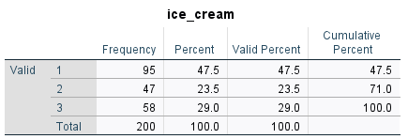
Table 3 (Author)
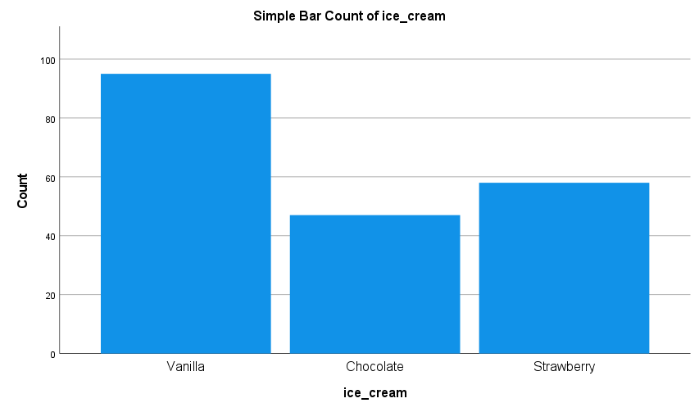
Chart 2 (Author)
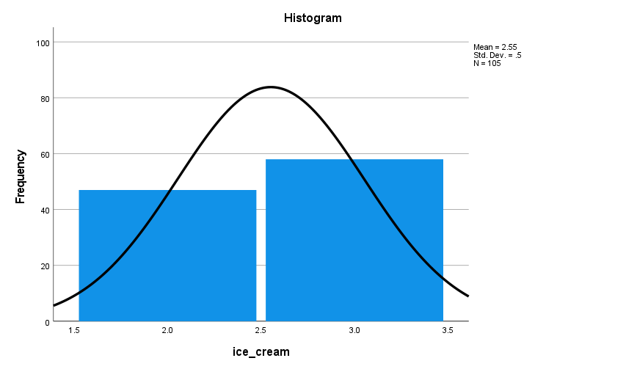
Chart 3
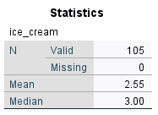Table 4
Mean is calculated by dividing the sum of all variables by total number of variables whereas median is the middle value of the data set when it is organized in ascending or descending order. The average (or mean) and the median are statistical terms that play a similar function in terms of assessing the middle point of a group of statistical scores. While an average has long been used as a popular way to measure a midway point in a sample, it has the disadvantage of being influenced by any single value being too large or small compared to the rest of the sample. Therefore, the median is sometimes regarded as a better indicator than the mean.
Descriptive statistics were used can see that the median and mean of students who likes only Chocolate and Strawberry is 3.00 and 2.55. This can be seen on Table 4 and chart 3 above.
For the mean and median for all participants eating ice-cream the results are below in table 5 and chart 4
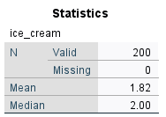
Table 5
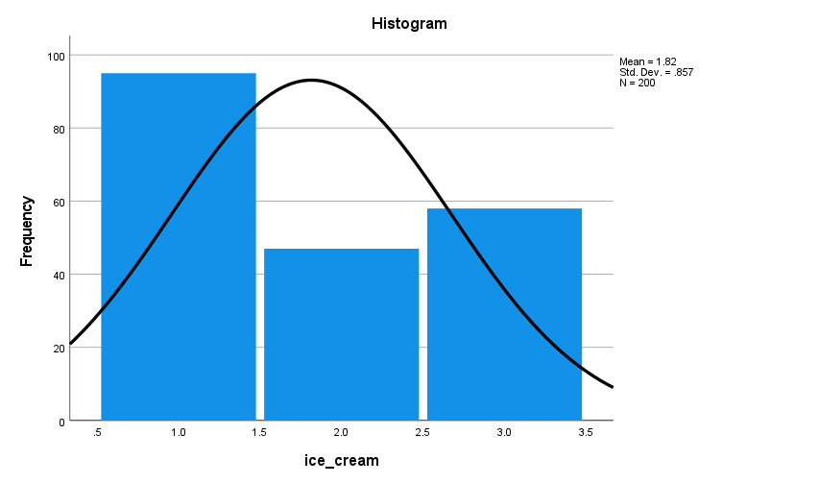
Chart 4

SPSS
SPSS is a statistical analysis software that can be used for various purposes such as data mining, text analytics, and business intelligence. It can also be used for predictive analytics and market research. Additionally, SPSS can help users understand complex relationships between different variables and calculate statistics. Some of the key features of SPSS software include:
- Data import and export: SPSS can import data from various sources such as Excel, CSV, and text files. It can also export data to popular formats such as HTML, XML, and PDF.

- Data manipulation: SPSS provides various tools for data manipulation, such as recoding, sorting, and filtering.

- Data analysis: SPSS provides a wide range of statistical analysis techniques such as regression, correlation, and factor analysis.

- Reporting: SPSS can generate professional reports in popular formats such as HTML, XML, and PDF.

- Customization: SPSS allows users to customize various aspects of the software, such as such as the interface, output, and statistics.

- Platform independence: SPSS can be installed on Windows, Mac, and Linux platforms.

Clustering
Clustering is a method of data analysis that involves the grouping of data points based on similarities between them. Clusters are groups of similar data points that are close together in terms of some measure of similarity, such as Euclidean distance. Data points that are not close to any other data point in terms of the chosen similarity measure are in their own cluster. It can also be used for dimensionality reduction by creating new features from clusters of data points. Clustering is an important tool for data mining and machine learning. Clustering can be used to find patterns in data, to reduce the dimensionality of data, or to group together similar items for further analysis. Clustering is an unsupervised learning technique, which means that it does not require labels or target values. This makes it an ideal method for exploring and understanding data. There are many different clustering algorithms, each with its own strengths and weaknesses.

Two Step Analysis
Is an alternative to K-mean cluster method of analysis which can help find natural groupings The Two Step Cluster Analysis procedure is an exploratory tool designed to reveal natural groupings (or clusters) within a data set that would otherwise not be apparent. The algorithm employed by this procedure has several desirable features that differentiate it from traditional clustering techniques:
- The ability to create clusters based on both categorical and continuous variables.
- Automatic selection of the number of clusters.
- The ability to analyse large data files efficiently.
From the given dataset Gender and Ice Cream preference were used as a Categorical variable in SPSS and Video and Puzzle as continuous variables to classify the students in different clusters. The Schwarz Criterion is an index to help quantify and choose the least complex probability model among multiple options(deepai.com) From table A we can see that the Two Step analysis found 6 clusters. From the chart below we can see the Cluster Distribution. The silhouette cohesion is how close and related are the objects in each cluster. The analysis shown on Table B shows that with 4 inputs there are 6 clusters which are Fairly, almost good in terms of cluster quality.

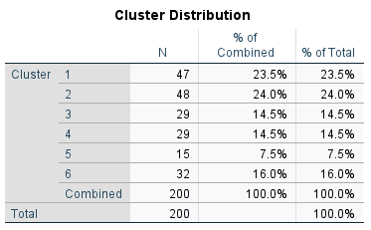
Table A

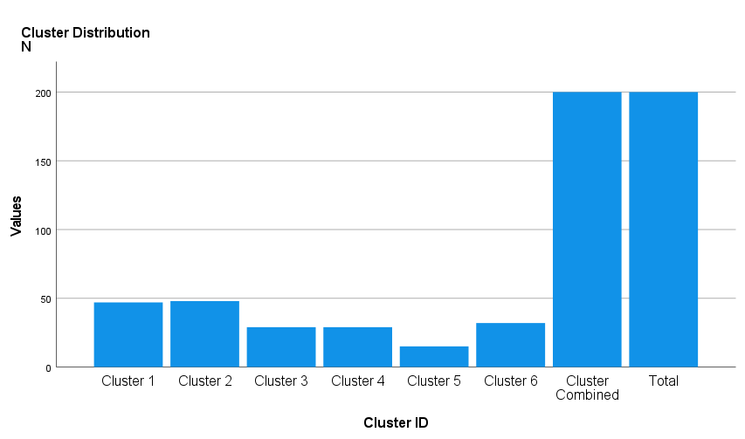
Chart A
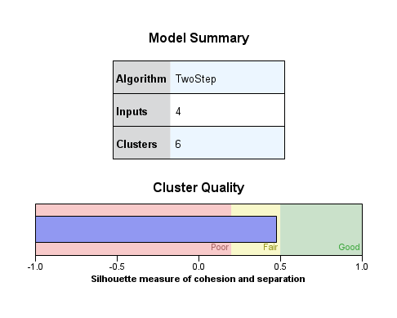

Data mining and text mining

Data mining and text mining are two of the most common methods used in business today. Data mining is the process of extracting valuable information from large data sets, while text mining is the process of extracting meaning from text data. Both methods can be used to uncover trends, patterns, and insights that would otherwise be hidden.

Data mining methods

Data mining is a process of extracting valuable information from large data sets. It involves using sophisticated algorithms to discover patterns and relationships hidden in the data. Data mining can be used to find trends in customer behaviour, predict future events, and optimize business processes
The techniques can be divided into two categories: they may either describe the target data or forecast outcomes using machine learning algorithms. These methods are used to organize and filter data, revealing the most important information possible, including fraud detection, user behaviours, bottlenecks, and even security breaches.

- Association rule mining: This is a method of finding associations between items in a data set. For example, association rule mining can be used to discover relationships between products in a store.
- Clustering: This is a method of grouping data points that are like each other. Clustering can be used to group customers by their purchasing behaviour. For example, business organizations cannot always meet the demand of all types of potential consumers by offering a single feature. They can do cluster analysis to group their consumer in different ways and customize their offerings accordingly.
- Classification: This is a method of predicting the class of an object based on its attributes. For example, classification can be used to predict whether a customer will default on a loan.
- Regression: This is a method of predicting a numeric value based on other numeric values. For example, a regression can be used to predict the selling price of a house based on its location, size, and number of bedrooms.
- Anomaly detection: This is a method of finding unusual data points. Anomaly detection can be used to detect fraud or to find errors in data sets.
- Sequence mining: This is a method of finding associations between events that occur over time. For example, sequence mining can be used to discover patterns in customer behaviour.

Text mining methods:

- Information Extraction: This is the process of extracting information from text. Information extraction can be used to extract information such as contact information or product prices from web pages.

- Named Entity Recognition: This is a method of identifying named entities in text. Named entity recognition can be used to identify people, places, and organizations in text.

- Information Retrieval: This is the process of retrieving information from text. Information retrieval can be used to search for documents, find related documents, or recommend documents to users

- Text Classification: This is a method of assigning labels to text data. Text classification can be used to categorize documents, filter spam email, or identify customer sentiment.

- Topic modelling: This method identifies the topics that are present in a text data set. Topic modelling can be used to understand what customers are talking about, identify the main themes in a document, or group together similar documents.

- Sentiment analysis: This method analyses the emotional tone of a text data set. Sentiment analysis can be used to understand how customers feel about a product, identify which employees are most likely to be satisfied with their jobs, or track the overall sentiment of a company over time.

- Text classification: This method predicts which category a text belongs to. Text classification can be used to predict whether an email is spam or not, whether a review is positive or negative, or which group of employees is most likely to be successful in a new role.

- Text visualisation: This is the process of creating visual representations of text data. Text visualization can be used to understand the structure of a text document, find essential keywords, or spot trends in customer behaviour.

- Natural language processing: This is a method of analysing and manipulating text data using artificial intelligence algorithms. Natural language processing can be used for tasks such as sentiment analysis, topic modelling, and text classification.
Both data mining and text mining are potent tools that can be used to uncover hidden insights in business data. By understanding and using these methods, businesses can make better decisions, improve their products and services, and create a competitive advantage.

Excel- Advantages  - Excel is spreadsheet software that is used to store, organize, and analyse data.  - It is easy to use and has a user-friendly interface.  - It can be used to analyse small data sets. Excel doesn’t function properly with a very large data size whereas in SPSS, there is no limitation on the size of the data.  - It can be used to create charts and graphs.  Disadvantages:  - Excel is not suitable for large data sets.  - It is not suitable for data that is not numerical.  - It is not suitable for complex statistical analysis.  When you must enter data manually, it can take up a lot of time, especially if there is a lot of data. | SPSS- Advantages  - It is a very powerful tool that can help you analyse your data in many ways. For example, you can use SPSS to create charts, graphs, and tables.  - Using SPSS, a lot of data visualization and statistical analyses can be done which cannot be conducted in MS Excel  - SPSS can help you identify trends and patterns in your data  - SPSS offers a variety of data mining features that can be accessed at the default level.  - SPSS is built with business intelligence software. As a result, SPSS allows for more BI operations.  Disadvantages:  - SPSS is not always available on all computers.  - SPSS can be expensive if you need to purchase the software and the data sets

References

Azevedo & M.F. Santos (eds.) (2015) Integration of data mining in business intelligence systems . Hershey :, Business Science Reference.Vlereader.com. (2022). - VleReader. [online] Available at: https://r1.vlereader.com/Reader?ean=9780203642597 [Accessed 12 Sep. 2022].
Connolly, T. (2015) Database systems: a practical approach to design, implementation, and management . Sixth edition, Global edition. Boston :, Pearson.
DeepAI (2019). The Schwarz Criterion. [online] DeepAI. Available at: https://deepai.org/machine-learning-glossary-and-terms/schwarz-criterion [Accessed 12 Sep. 2022].
Eloquens. (2018). Eloquens. [online] Available at: https://www.eloquens.com/tool/5ZJTqR/engineering/data-mining-techniques/two-step-cluster-analysis-in-spss [Accessed 12 Sep. 2022].
Microsoft.com. (2021). Formulas and functions. [online] Available at: https://support.microsoft.com/en-us/office/Formulas-and-functions-294d9486-b332-48ed-b489-abe7d0f9eda9#ID0EAABAAA=Functions [Accessed 12 Sep. 2022].
Small Business - Chron.com. (2017). How to Calculate the Decline in Sales by Percent for the Number of Years in Excel. [online] Available at: https://smallbusiness.chron.com/calculate-decline-sales-percent-number-years-excel-30536.html [Accessed 12 Sep. 2022].
Spss-tutorials.com. (2022). SPSS tutorials | The Ultimate Guide to SPSS. [online] Available at: https://www.spss-tutorials.com/ [Accessed 12 Sep. 2022].
Witten, I.H. (2011) Data mining [electronic resource] : practical machine learning tools and techniques . 3rd ed. Amsterdam :, Elsevier/Morgan Kaufmann.

‌
‌

‌

‌

