BMSP6008
November 2021 Embracing Rurality and Business Opportunity
Apply the ten-minute town principle to Carmarthen town, create a report that outlines how the principle could be applied to the town.

CONTENTS PAGE
- Executive Summary
- Introduction
- Principles of the “10-minute town”
- Methodology and Data collection
  - Figure 1
  - Current Demographic of Carmarthen Town
Figure 2
  - Method of travel to work
  - Vehicles in household
Figure 3
- Application of Principles to Carmarthen
  - Current Cycle Paths /routes
  - Opportunities
- Constraints
- Conclusion
- References & Bibliography
- Appendices
Appendix 1 – Carmarthen Town demographics Census 2011
Appendix 2 – Carmarthen town cycle routes 2014

- Executive Summary
Carlos Moreno is currently recognised as one of the leading theorists in the concept of the “ten-minute town” (Guilford Society, 2021). Moreno`s theory is based on four pillars: proximity, diversity, density and ubiquity and the belief that residents should be able to find everything that they need within a 10-minute walk or cycle from their home.

Carlos stresses that the infrastructure of the ten-minute town should follow the needs of people and not the convenience of cars, a theory that was also discussed when planning the infrastructure for Litchfield Park in the USA in 1966 and one which seems to have been accelerated by the Global covid 19 pandemic.

The “trend” is gathering momentum motivated by environmental benefits, reducing the numbers of vehicles on the road, seemingly the answer to targeting social isolation and loneliness and improving the mental health and physical wellbeing of nations. Melbourne, Paris, Ipswich, Guilford are all working towards becoming / achieving the status of a “ten-minute town”, so the purpose of this report is to apply the principles to Carmarthen Town. (Smith, 2021).

Carmarthen Town, based in Rural West Wales steeped in history and myths and magic, the oldest town in Wales? The birthplace of Merlin? Does that meet the criteria of ubiquity? Proximity and density? questions for cities and busy urban areas maybe? Or Could Carmarthen Town benefit from the “ten-minute town transformation”?

The report applies the principles and analyses the factual quantitative data and presents the findings and possible qualitative pro`s and con`s of the theory in practice, with the author influenced by the uniqueness and heritage of rural Wales.

- INTRODUCTION
Globally, people are facing a mass of critical, interlinked issues, including how to reduce carbon emissions, how to encourage people to become more active to improve their health and wellbeing, how to reduce loneliness and social isolation, and how to regenerate deteriorating high streets and neighbourhoods. Leading theorist Carlos Moreno believes that towns and cities will not return to how they were pre Covid 19 pandemic and talks about Paris being the 15-minute city, “In Melbourne, it’s the 20-minute neighbourhood” (Yeung, 2021). In the UK they are talking about the “ten-minute town” (Southern Regional Asembly, 2020). It seems that, the narrative, or the number of minutes, doesn’t really matter: the idea is, the same. “The “10 Minute Town” concept is about creating connected communities” (Southern Regional Asembly, 2020).
Carmarthen is the county town of Carmarthenshire, situated alongside the River Towy. The population was 14,185 in 2011, down from 15,854 in 2001, (Carmarthenshire County Council, 2011). It is reported that Carmarthen is one of the oldest towns in Wales “and legend has it that Carmarthen is the birthplace of Merlin, the wizard of Arthurian folklore” (Carmarthenshire County Council).
The key objective is to map and identify infrastructural requirements to support ‘10 minute’ towns within the region. The “10 Minute Town” concept is about creating connected communities – understanding how our neighbourhoods work and to map out how a more compact and penetrate able town can provide high quality and safe links to public transport, shops, services, green spaces and to other neighbourhoods, which will reduce the need to travel and therefore reduce carbon emissions.
- PRINCIPLES OF THE “10 min town”
Leading theorist Carlos Moreno summarises the concept of the ten-minute town as “……. requires minimal travel among housing, offices, restaurants, parks, hospitals, and cultural venues. Each neighbourhood should fulfil six social functions: living, working, supplying, caring, learning, and enjoying” (Yeung, 2021).
Whilst a seemingly contemporary concept, in 1966, Cartson wrote about the “ten-minute town designed around pathway system” (Cartson, 1966). The concept in 1966 held the same principles as today with aims to reduce the dependence of individuals on vehicles with “A major design consideration has been provision for other conveyances such as bicycles or elec- tric carts, or for pedestrians” (Cartson, 1966). Cartson went on to say that “The usefulness of the pathway system will depend heavily on its convenient access to various community facilities. Conse- quently, schools, recreation centers, and community centers have been located to be served by the pathways” (Cartson, 1966).
The Guilford Society suggests that the “15-minute Neighbourhood” is a principle that is being adopted Worldwide and focuses on 4 principles proposed by Moreno in COP21 2015:

Proximity: Things must be close.
Diversity: Land uses must be mixed to provide a wide variety of urban amenities nearby.
Density: There must be enough people to support a diversity of businesses in a compact land area.
Ubiquity: These neighbourhoods must be so common that they are available and affordable to anyone who wants to live in one. (Guilford Society, 2021)
- METHODOLOGY & DATA COLLECTION
To undertake the analysis, the locations of amenities and services was collected, through town field visit and desk top research using maps and internet resources, adopting and applying the principles and model in figure 1 (below) of the appendices as applied in the 2020 Irish Accessibility Framework report, (Southern Regional Asembly, 2020)to understand the existing distribution of community facilities in Carmarthen town.
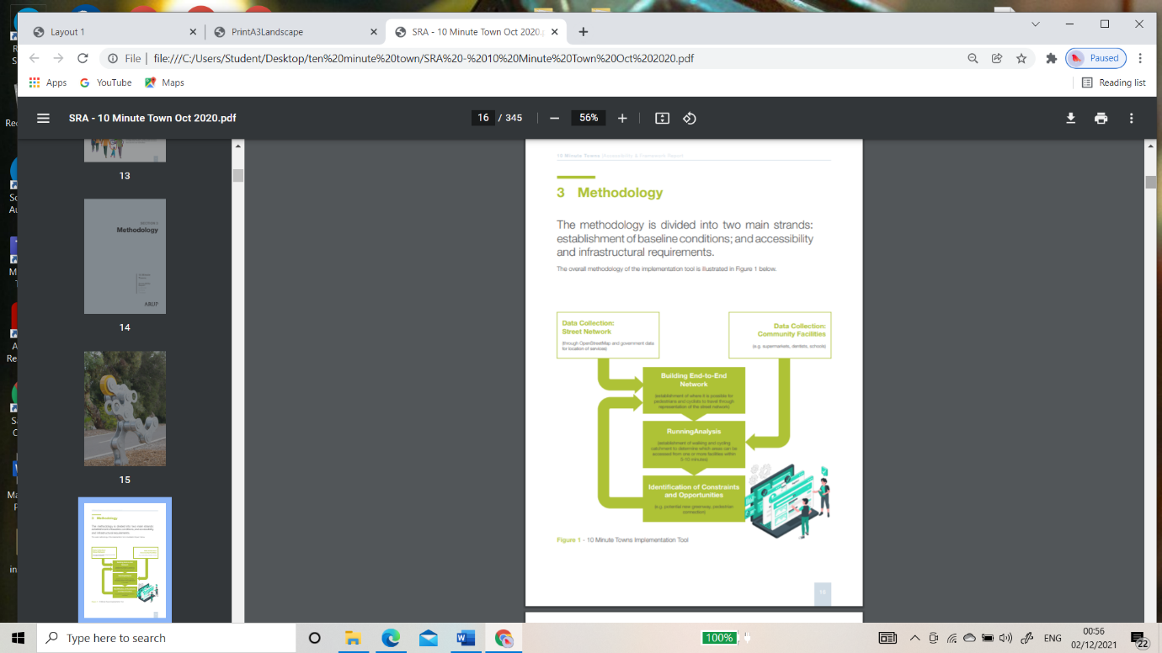
  - (Figure 1) (Southern Regional Asembly, 2020).

4.2 CURRENT ECONOMIC DEMOGRAPHIC DATA OF CARMARTHEN TOWN
2011 census indicates that there were 10,132 economically active people working in Carmarthen town. There were a further 3,184 people working across other industries recorded (see appendix 1) some of which would be based within a ten-minute walking/cycling distance of town although this would require further desk top research beyond the scope of this report. There were 383 recorded as unemployed, 32.6% (3,304) economically inactive people and 590 long term sick or disabled. (Carmarthenshire County Council, 2011).

Figure 2 Graph of Carmarthen Town employment (Carmarthenshire County Council, 2011).

4.3 Method of travel to work
4.9% work from home, 2.1% public transport, 42.6% car, 5.8% walk, 0.5% cycle
183,777 was population for Carmarthenshire (Not just Carmarthen town) in 2011 (Carmarthenshire County Council, 2011).

4.4 Vehicles in Household
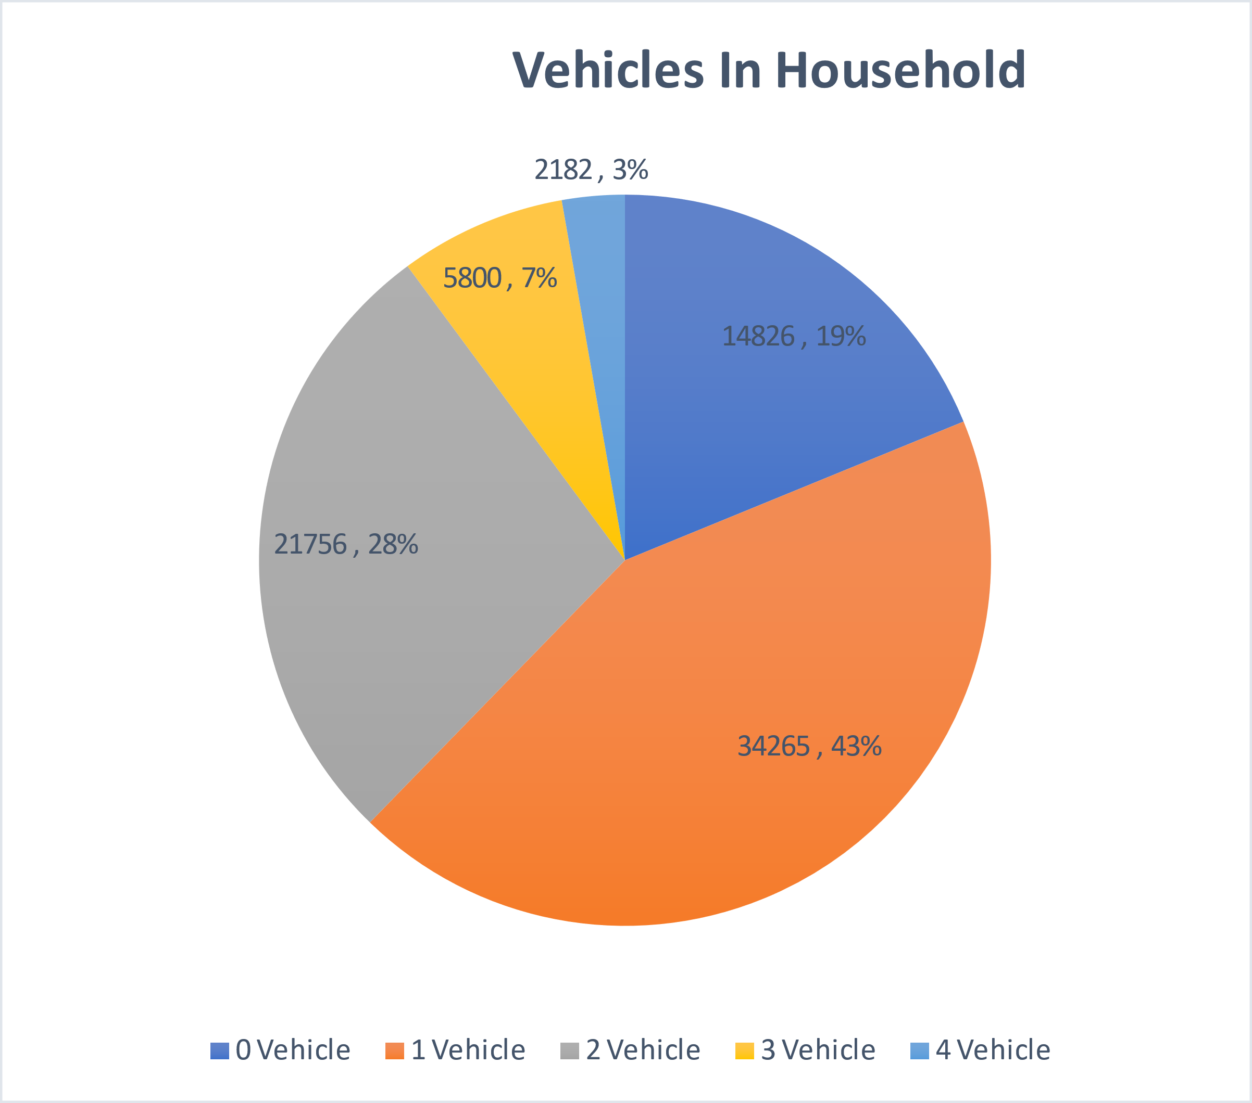
Figure 3
(Carmarthenshire County Council, 2011)note figures above based on Carmarthenshire and not just Carmarthen town but is proportionate.

- Application of the Ten-Minute Town Principles to Carmarthen
Retail
Supermarkets
High street chain stores
Independent shops
Indoor market independent traders
Farmers outdoor market weekly
Independent florists
Independent butchers
Independent jewellers
Charity Shops and discount shops
Bakeries

Health
Dentists
General Hospital
GP surgeries
Community sexual health sex
Community and inpatient mental health services,
third sector mental health and wellbeing services
Independent clinics and services
Pharmacies
Opticians
Auditory services

Education
Primary education
Secondary with SEN Unit
HE Facilities
Further Education Facilities
Adult Education classes
Independent educational classes

The location of services and amenities appear to meet 3 of the 4 of Moreno`s principles
Proximity
Diversity
Density
The writer would suggest that Carmarthen would not meet Ubiquity based on its unique heritage and history
(Southern Regional Asembly, 2020)
Leisure
Cinema complex
Third sector youth club
Eateries
Bars
Galleries
Library
Theatre
Antique Centres
Bowling Green
Velodrome
Open Park with band stand
Skate Park
Night life entertainment
Arcade
Overhang climbing centre
Escape room activity
Rugby and Football pitches

Transport
Bus (Local)
National Express / Mega Bus
Train
Private Taxi Firms
Dolen Teifi – third sector electric car service
WRVS hospital car services volunteer led and facilitated

Constraints Identified
- Local government spending cuts in terms of public transport
- Bus services are generally limited (e.g., infrequent and does not cover parts of the towns) and tend to only cover specific corridors within the towns.
- Cost of rail travel and no rail travel within Carmarthenshire or connecting to Ceredigion impacting on access of public transport by rail to Northern parts of Wales.
- Resistance to change from groups, organisations, and others.
- Changes in the way people use the high street and large retail names such as Debenhams leaving the town limiting how people may shop in the future
- There are residential properties in Carmarthen which are not within 10-minute walking distance of the town
- Separation between residential estates (e.g., cul-de-sacs and fences).
- Low cycle usage from census data.
- Poor infrastructure, particularly for cycling within the town area with most routes shared with vehicles exposing cyclists to carbon emissions and physical risks on the road as identified in appendix 2 (Active Travel website, 2014)
- Lack of services, particularly on the outskirts of the town

Opportunities identified
  - Significant amount of currently wasted space which could be better utilised (empty buildings, boarded buildings local authorities should use compulsory purchase order powers or hold owners to account)
  - Changes in the way people use the high street and large retail names such as Debenhams leaving the town limiting how people may shop in the future - giving rise to accessible “hot desking” and opportunities to those involved in incubating business, micro businesses and focussing the town as an experience and not only a retail trip.
  - Opportunities to create more green space more shared spaces for families and diverse groups to meet and share time and experiences, opportunities to create shared green space / outdoor space for different groups in society – examples Guildhall square, Notts Square, the car park at St Peters then promoting use of park and ride facility. Research as well as WAG policy recognises the links between positive physical and mental health and wellbeing and access and opportunity to spend time in natural environments. (Welsh Assembly Government , 2010).
  - Opportunities to create homelessness pods for those in need within empty shops such as Bon Marche. Improving access to basic facilities and improving the mental and physical health and wellbeing and social isolation which can be associated with homelessness.
  - Currently wasted open spaces that could be landscaped to create outdoor gardens, sensory gardens and capture the heritage and history of Carmarthen to explore opportunities of heritage tourism – old Lidl site – “Merlin’s mazes and storytelling band stand”, such initiatives would also work with the Welsh Assembly Government agenda to promote urban tree planting. “To support the creation of therapeutic landscapes, and to mitigate the impacts of climate change and traffic-related ill health, we will need to work with others” (Welsh Assembly Government , 2010) whilst also give opportunity to children who live in urban areas to explore and learn through play and development with nature. (Welsh Assembly Government , 2010).
  - Pedestrianisation of King Street, coracle way and Lammas Street improving accessibility due to issues with current pavements and traffic and parking.
CONCLUSION
Whilst not a new idea, it is another example of a “vogue” that has been augmented by the pandemic, cities across the world “reacting” or “future proofing”? Having applied the principles of the “ten-minute town” to Carmarthen and having viewed many potential positives and opportunities does this mean that a one size fits all? Despite it not being a new concept and some data available from 1966, the recent research, theory and survey outcomes appear to have been carried out in cities alone and the write has found no research relating to rural towns to date.
A survey carried out by Malcolm Smith asked “Residents of London, Paris, Madrid, Berlin and Milan were asked how far they had to travel to green space, a shop that sells groceries, a medical facility, a school, a restaurant or café, and a leisure centre or gym” (Smith, 2021). Surprisingly or not surprisingly? London “had by far the largest number of people (59%) who considered leaving and the highest (41%) that moved out temporarily” (Smith, 2021).
The writer did search for “ten minute town” examples in Wales but instead came across very different future goals which are to Increase “the percentage of people in Wales using the Welsh natural environment for outdoor activities from 36% to 60% (by 2025) Ensuring that (by 2025) 95% of people in Wales have a footpath or cycle-path within a ten minute walk, and no-one lives more than a six-minute walk from their nearest natural space” (Welsh Assembly Government , 2010). Throwing a very different focus on the agenda in Wales by comparison to Melbourne, Milan, Paris, and Ipswich. With, other findings suggesting “that greater quality of life, improved mental and physical health, and higher property values generally correlate with a higher level of “walkability” and more mixed-use development in a range of areas throughout the UK”. (Harley, 2021).
In conclusion whilst applying the principles of the ten-minute town to Carmarthen, the writer would be interested in potentially adding two further principles to the concept; choice and values.

REFERENCES

Works Cited
Active Travel website. (2014). Carmarthen ERM. Cardiff, Wales: Welsh Government.
Carmarthenshire County Council. (2011). 2011 Census for Carmarthenshire . Carmarthen: Carmarthenshire County Council.
Carmarthenshire County Council. (n.d.). Carmarthen Town. Retrieved from Carmarthsnhire County Council : www.discovercarmarthenshire.com
Cartson, E. M. (1966, October). "Ten Minute Town" Designed Around Pathway System. : Landscape Architecture Magazine , OCTOBER, 1966, Vol. 57, No. 1 (OCTOBER,, p. 1. Retrieved from https:about.jstor.org/
Guilford Society. (2021, 09 27). Guilford Society . Retrieved from Guilford Society : https://www.guildfordsociety.org.uk/15mintown2.html
Harley, F. (2021, March 01). The Intelligence Lab. Retrieved from FrankKnight.com: https://www.knightfrank.com/research/article/2021-03-01-the-rise-of-the-15minute-city
Smith, M. (2021). The fifteen minute vision: future proofing our cities. ARUP.
Southern Regional Asembly. (2020). Accessibility and Framework report. Ireland .
Welsh Assembly Government . (2010). Health and well-being benefits from Welsh woodlands and trees. Cardiff: Welsh Assembly Government.
Welsh Assembly Government . (2010). Health and wellbeing benefits from woodlands and trees. Cardiff: Forestry commission Wales.
Yeung, P. (2021, 01 04). A new urban planning model will change the French capital – and could provide a template for how to create stronger local communities and make residents happier. London, UK.

APPENDICIES
Appendix 1
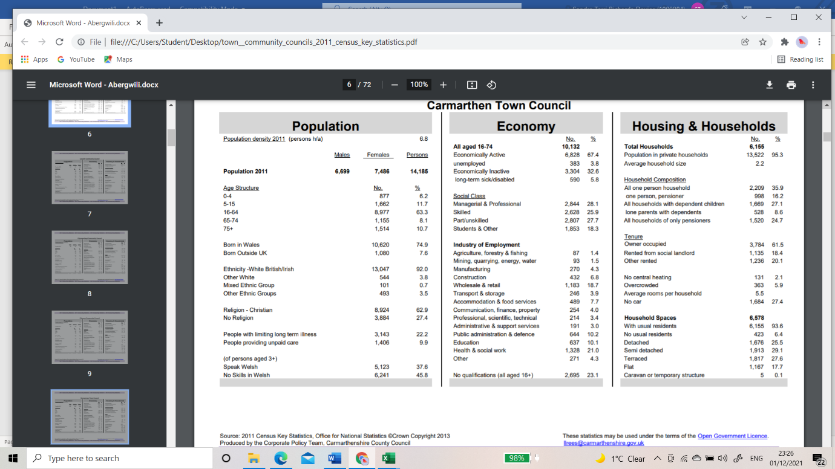

APPENDIX 2
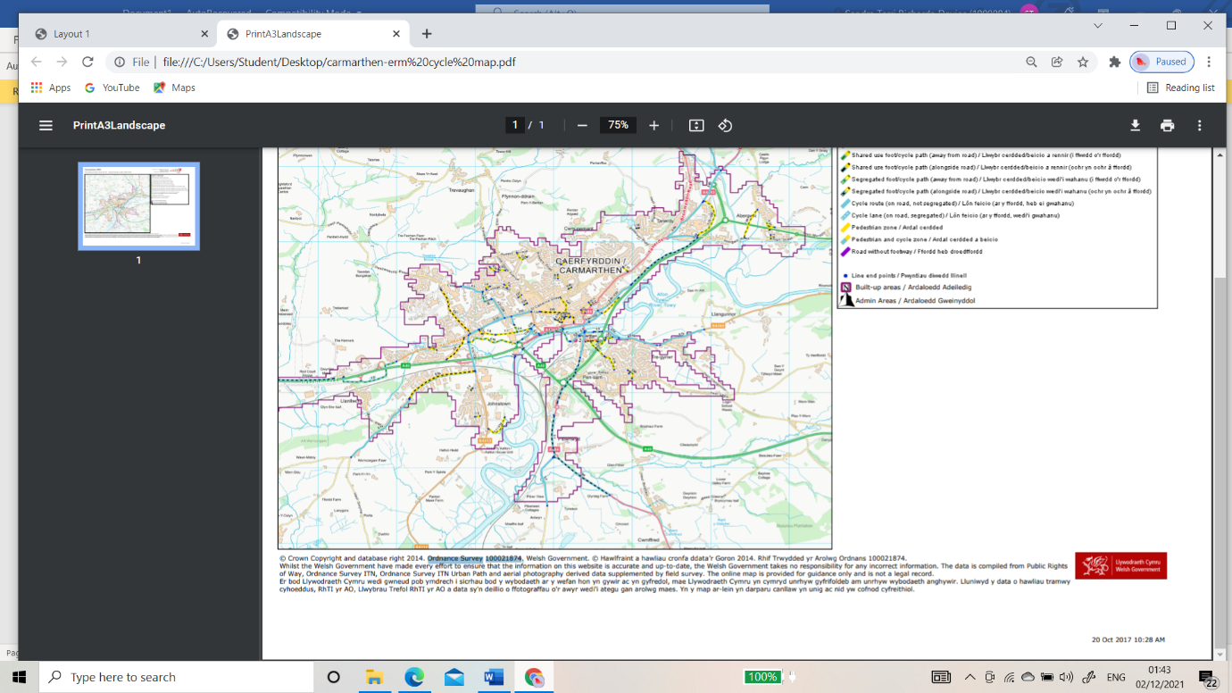

NO Further Work
01/12/2021

