Joseph Luke Harris
HTML & CSS web Development
ACCA4023

Table of Contents
Abstract 2
Requirements 2
Implementation 3
Home Page 3
RP Calculator Page 3
Contact Us Page 3
Implementation 4
Errors for HTML 4
Errors for CSS 5
Website usability 6
Website Accessibility 6
Search engine optimisation 6
Evaluation 7
Home Page 7
RP Calculator Page 8
Contact Page 9
Improvements 9
SEO 10
Website Testing 11
Index Page 11
Contact Page 12
HTML CODE for Index 13
HTML code for RP calculator 15
HTML Code for contact us 27
CSS for Style 41
CSS for boxes 43
CSS for text 44
CSS for header 44
HTML for inline 45
HTML for external 45
References 46

Abstract
Within this document I have demonstrated and explained my process of creating a website in HTML & CSS using variety of code and skills. I will outline any difficulties I have found and how I resolved them during this project. Furthermore, I will attach a ZIP folder containing my website which can be open on any browser.

Requirements

I am required to create a website based on any topic or interest which I have using raw HTML & CSS code. Once complete I will need to add evidence of my code and explain how I overcome any difficulties during this project.

Implementation

Home Page
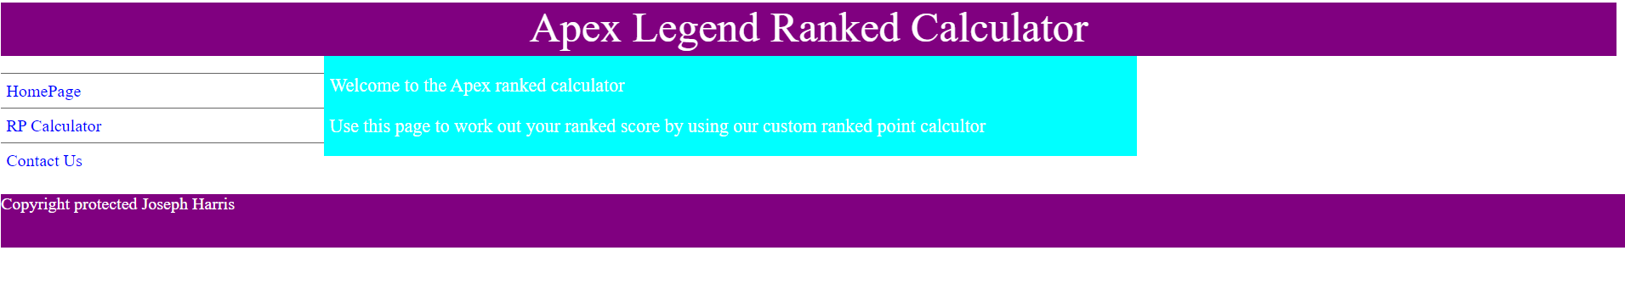

RP Calculator Page
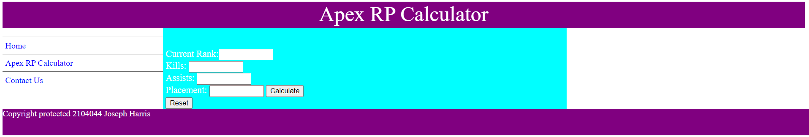

Contact Us Page
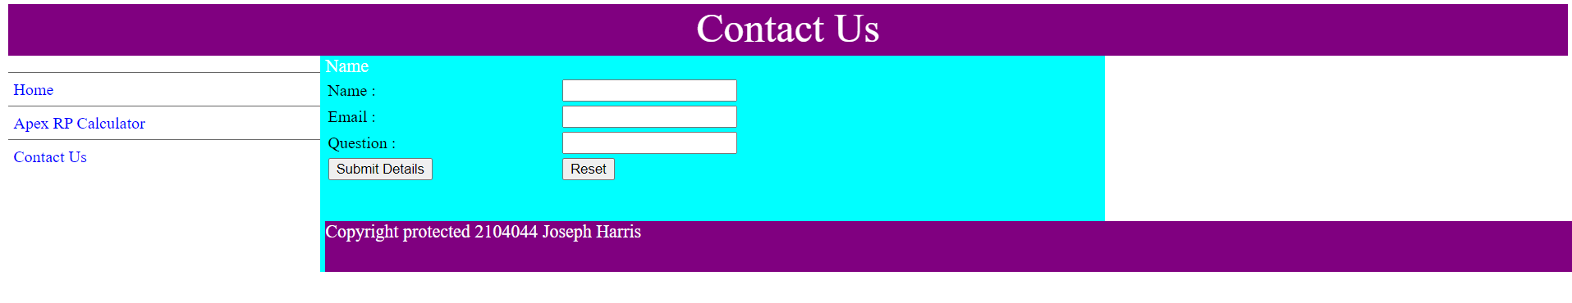

Implementation

Errors for HTML
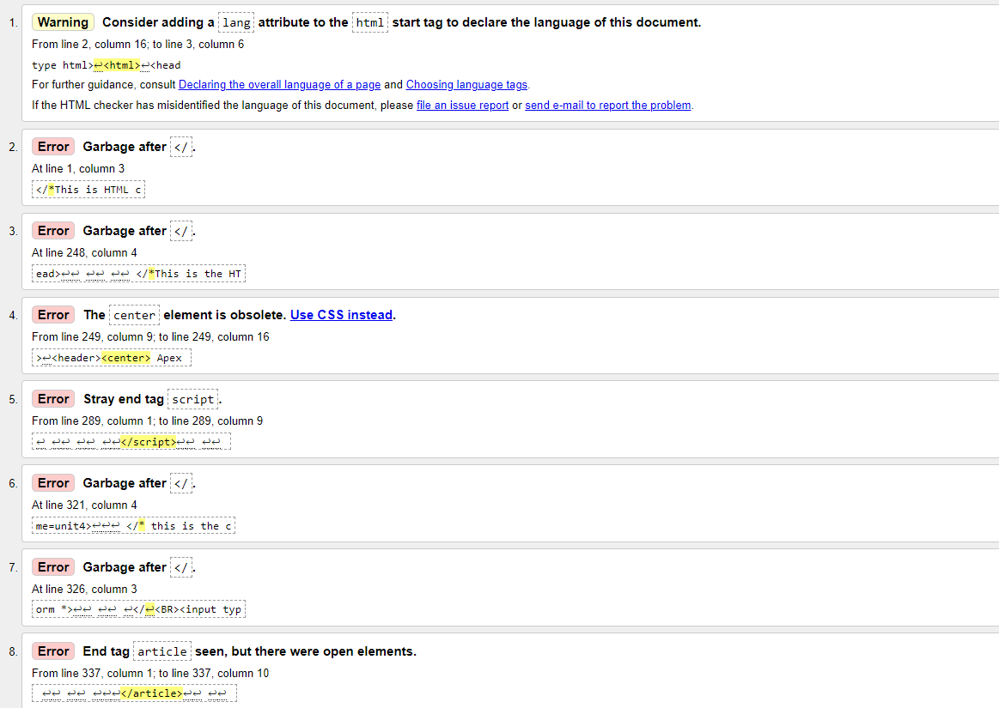

After using (http://validator.w3.org/) for my HTML raw code I have identified some issues. To not I have attempted scripts within the HTML code for my calculator page however, this is not a requirement for this project I still attempted the scripts. Due to this some mistakes listen refer to the scripts so I will not identify these and will focus on main issues.

Throughout the errors I have noticed minor mistakes such as missing a “<” or “/” which can cause slight unnoticed errors in my code. To rectify this I have gone through my raw code and identified the issues and have added the missing code. There are no major errors within my code so I will not repeat each error which is a miss of one symbol within my code.

Errors for CSS
After using (http://jigsaw.w3.org/css-validator/) for my main CSS code within this project I have found no errors within my CSS code therefore needing no evaluation for this section.
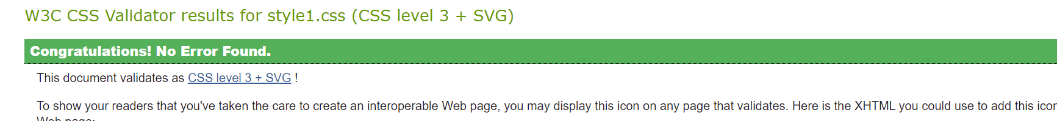

Website usability
Website usability is referred to as broad goals with good layout. To have usability the choices are needed to be made in a concise way. For example, we would need to have a clear layout and purpose using a concise choice which is fit for all applications including desktop and mobile browsers [1]. By having a key usability it will allow a user to view the web page on any device with no limitations. A good example of website usability is Amazon.

Website Accessibility
There are many examples of how accessibility to a website is important. For example, each user may have different disabilities such as colour blind, death, blind and many more. To confront these we need to adapt and by doing so we must build websites based off these needs. A website may have several accessibility options such as TTS system, colour suited for user and speak to type [2]. These all allows users to have options to use the website with no disadvantage based on their disability. Sky sports is an example of a website which features all of these accessibility options.

Search engine optimisation
Search engine optimisation is based on the list of where your website stands. As search is one of the main ways a website can be discovered the web browsers uses different tools to rank your website [3] and list it on the web. For example, having navigation system on your website will rank your website better. You can also pay to have your website at the top of the search engine of your choice.

Evaluation

Home Page
When creating this website I had to meet several requirements in order to produce a working and functional website for a customer’s needs. On the home screen I needed to have it friendly and welcoming for a user by having a clear layout allowing them to navigate at ease. I included a section dedicated to explaining what the website is for. To further remind the customer I included a bold title which states APEX RP Calculator. I have understood and taken into consideration whilst creating this page about user’s disabilities such as blind. When choosing a colour scheme for the home page I have consider these disabilities and choose a colour which is clear to be viewed by all users including any with underlying conditions. The Text was kept to a standard universal size except the title. I did this as it allows a user to not become confused with what they are reading by having this feature included It makes this website user friendly and covers a controversial section of the user requirements. Further to this I picked a purple background for the Header and footer and chosen a white text, this makes the website seem more professional and friendly whilst allowing everyone to view the site clear. I have created a working navigation section on the website for users to be able to navigate the website simply with ease of access. I have included a fully functional navigation section on this website which will take a user to all 3 pages quick and simple with no technical issues.
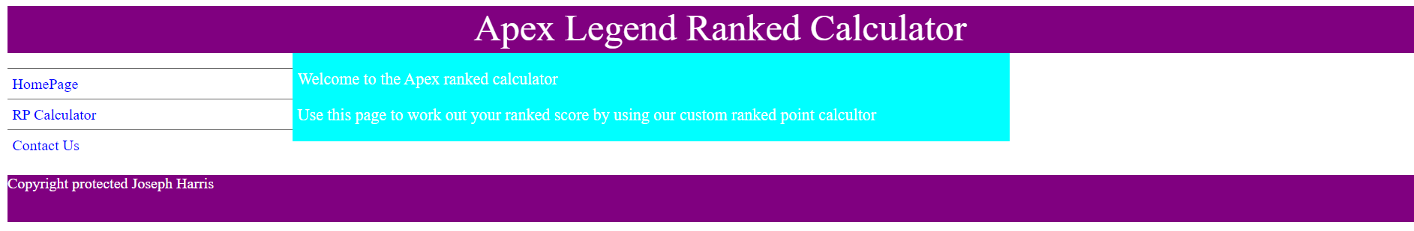

RP Calculator Page
When creating this website I wanted to create an overall ranked system for gamers who play apex legends ranked. Firstly I set up a system where users can enter their kills, assists and placement to calculate an overall rank for their game. . I have added 2 buttons one being reset and one being calculate this will allow a user to calculate their rank and then clear the page allowing then to start again. This was a main requirement for this website for me which I have met and now allows this website to be fit for purpose. In regards to the colour scheme I have understood and taken into consideration whilst creating this page about user’s disabilities such as blind. When choosing a colour scheme for the home page I have consider these disabilities and choose a colour which is clear to be viewed by all users including any with underlying conditions. The Text was kept to a standard universal size except the title. I did this as it allows a user to not become confused with what they are reading by having this feature included It makes this website user friendly and covers a controversial section of the user requirements. Further to this I picked a purple background for the Header and footer and chosen a white text, this makes the website seem more professional and friendly whilst allowing everyone to view the site clear. I have kept the navigation section which can allow a user to access other sections of the website.
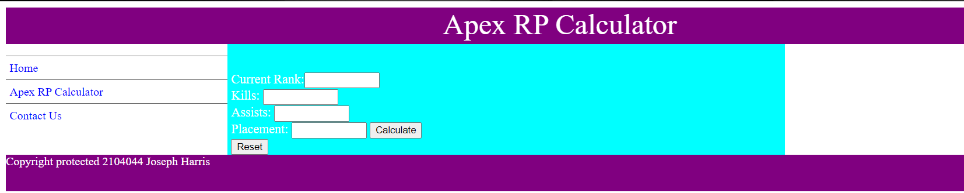

Contact Page
On my final page I have created a contact page where I tested scripts out and created a brief system where a user can input their contact details and submit it into the system, this would allow a me to see the request and then follow up on this. The requirement required me to have 3 boxes one for Name, email and any comments. On this page I created this system where all 3 boxes are included along with their purposes, this now fits the user’s requirements as the main purpose for this page is for a user to contact the company. I have kept the colour scheme the same throughout so it remains user friendly whilst meeting the users’ needs at the same time. I have kept the navigation section on this page. I have also added an error message to appear if the user submitted blank details. I have added this feature which pops up with an alert if the user does this which says you need to fill in the box to submit details.
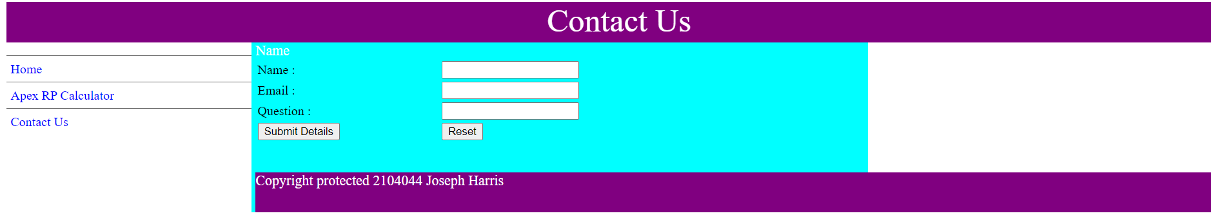

Improvements
To improve this website I would add a logo for each individual page, the reason I would add this is to make the website more professional instead of looking plain. I would also include a system where text can be converted to speech/ sub titles for anyone with disabilities which might struggle accessing the website, by doing this the website would become more user friendly for everyone. I would also introduce music to this website to make it more enjoyable to use however, there would be an option to turn this off if a user wishes to navigate the website without sound. A further improvement would be including a drop down box for users on the calculator page. The reason why this would be included is to allow users to select their ranks and possible kills instead of typing them out individually. I would also improve the calculator page by allowing users to save their results and look back on their progress over the ranked season this will help gamers become more motivated by seeing how well they are performing within the game.

SEO
I have created a website which works on all search browser with no limitations to each other. The website runs fast and smoothly and I found no errors at all. I used a Scripting language to improve the layout and navigation of the website which further improves the user’s experience. On my website I have included a fully function navigation section where users can be taken to different sections of the website in a click of a button. . By doing this I will have improved my web analytics which simply collects and stress any data imputed into the website. A further benefit is Validations. Validations can be used to improve the integrity of data that has been filled out into the forms on my webpage. For example, a user is alerted if any mistakes are caused when filling out the contact form on my webpage. The validation was used on my contact form to ensure clients fill in the correct information.
If I didn’t use JavaScript the main functions of my website would not be available. Using JavaScript as part of my scripting language allows me to create a website with many features. Java script enabled me to create a system where if a user clicked a submit button without providing any data then a warning would appear. Some functions within my script contain JavaScript code this means the code only works when the formula is called for. There is no limit for how many times the code can run. Scripting language has improved my webpage making it more user friendly and professional.

Website Testing

Index Page

Page | Page Object | Test | Result Chrome | Result Explored | Comments
Index.HTML | Heading | Heading Is displayed correct with the correct text font and colour. | Pass | Pass | N/A
Index.HTML | Navigation Button | Testing it works when clicking it | Pass | Pass | N/A
Index.HTML | Navigation Button | Testing it works when clicking it | Fail | Fail | N/A
Index.HTML | Navigation Button | Testing it works when clicking it | Pass | Pass | N/A
Index.HTML | Article | Article displayed correctly with correct text and colour | Pass | Pass | N/A
Index.HTML | Footer | Footer displayed correctly with correct | Pass | Pass | N/A

Contact Page

Page | Page Object | Test | Result Chrome | Result Explored | Comments
Contact.html | Article | Article displayed with the correct text font and colour | Pass | Pass | N/A
Contact.html | Footer | Footer Displayed with the correct text colour and font. | Pass | Pass | N/A
Contact.html | Aside | Aside displayed with the correct text colour and font | Pass | Pass | N/A

HTML CODE for Index
</*This is my HTML code for my website to display the titles and heading/>
<!doctype html>
<html>
<head>

<meta charset="UTF-8">

<title>HomePage</title>

<link rel="stylesheet" href="style_columns.css">

</head>

<header><center>Apex Legend Ranked Calculator </center>
</header>

<nav>

<ul>
<li><a title="Link: Home" href="index.html">HomePage</a></li>
<li><a title="Link: Apex RP Calculator" href="calculator.html">RP Calculator</a></li>
<li><a title="Link: Contact" href="contact.html">Contact Us</a></li>
</ul>

</nav>

<article>
<p>Welcome to the Apex ranked calculator

<p>Use this page to work out your ranked score by using our custom ranked point calcultor

</article>

<aside>

</aside>

<footer>
Copyright protected
Joseph Harris

</footer>

</body>
</html>

HTML code for RP calculator

</*This is HTML code where the titles are displayed for my webpage/>
<!doctype html>
<html>
<head>

<meta charset="UTF-8">

<title>Apex RP Calculator</title>

<link rel="stylesheet" href="style_columns.css">

<SCRIPT>
function submit_form()
{
columns1 = new Array(18);
columns2 = new Array(18);

var x=0;
var y=0;

columns1[0]=document.grade.unit1.value;
columns1[1]=document.grade.unit2.value;
columns1[2]=document.grade.unit3.value;
columns1[3]=document.grade.unit4.value;

</*This is the JavaScript code to display the 18 units for the form along side a value for each one*>

</* This is the javascript code used to check if the information has been entered to then proivde a result*>
for (x=0;x<=17;x++)

{
if (columns1[x]=="D")

{
columns2[x]=48;
}
else

{
if (columns1[x]=="M")

{
columns2[x]=60;
}
else

{
if (columns1[x]=="P")

{
columns2[x]=36;
}
else

{
if (columns1[x]=="G")

{
columns2[x]=26;
}
else

if (columns1[x]=="6")
{
columns2[x]=80;
}
else

if (columns1[x]=="5")
{
columns2[x]=70;
}
else

{
if (columns1[x]=="4")

{
columns2[x]=60;
}
else

{
if (columns1[x]=="3")

{
columns2[x]=40;
}
else

{
if (columns1[x]=="2")

{
columns2[x]=30;
}
else

{
if (columns1[x]=="1")

{
columns2[x]=20;
}
else

columns2[x]=0;
}

finalgrade = columns2[0] + columns2[1]
</* This code shows the requirements for each grade so it can be used to calculate the points that a user recivies

if (finalgrade > 160)
mark= "+202RP"+;

document.getElementById("final").innerHTML = "Total Points is " +finalgrade

}
</SCRIPT>

</head>

<header><center> Apex RP Calculator </center>
</header>

<nav>

<ul>
<li><a title="Link: Home" href="index.html">Home</a></li>
<li><a title="Link: ?????" href="???????.html">Apex RP Calculator</a></li>

<li><a title="Link: Contact" href="contact.html">Contact Us</a></li>
</ul>

</script>

</nav>

<article>
<p>
<p id="grade"></p>
<p id="kills"></p>
<p id="Point"></p>
<p id="assist"></p>
<p id="final"></p>
<p id="grade1"></p>
<FORM name=grade >
<BR>Current Rank:<INPUT size=10 name=unit1>
<BR>Kills: <INPUT size=10 name=unit2>
<BR>Assists: <INPUT size=10 name=unit3>
<BR>Placement: <INPUT size=10 name=unit4>

</
<BR><input type="button" value="Calculate" onclick="submit_form()">
<br><input type="reset" value="Reset">

</article>

<aside>

</aside>

<footer>
Copyright protected
2104044 Joseph Harris

</footer>

</body>
</html>

HTML Code for contact us

<html>
<head>

<meta charset="UTF-8">

<title>Apex RP Calculator </title>

<link rel="stylesheet" href="style_columns.css">

<script>

function validate_form()

{

valid = true;

if ( document.form.name.value == "" )

{

alert ( "Please fill in the 'Name' box." );

valid = false;

}

if ( document.form.email.value == "" )

{

alert ( "Please fill in the 'E-mail' box." );

valid = false;

}

if ( document.form.comment.value == "" )

{

alert ( "Please fill in the ‘Comment’ box." );

valid = false;

}

return valid;

}

</script>

</head>

<body>

<header><center> Contact Us </center>
</header>

<nav>

<ul>
<li><a title="Link: Home" href="index.html">Home</a></li>
<li><a title="Link: ?????" href="???????.html">Apex RP Calculator</a></li>

<li><a title="Link: Contact" href="contact.html">Contact Us</a></li>
</ul>

</nav>

<article> Name

<form name="form" action="" onsubmit="return validate_form()" method="post" enctype="text/plain">

<table width="80%" border="0">

<tr>

<td>Name :</td>

<td><input type="text" name="name"></td>

</tr>

<tr>

<td>Email :</td>

<td><input type="text" name="email"></td>

</tr>

<tr>

<td>Question :</td>

<td><input type="text" name="comment"></td>

</tr>

<tr>

<td><input type="submit" value="Submit Details" name="submit"></td>

<td><input type="reset" value="Reset"></td>

</tr>

</table>

</form>

<article>
<p>

</article>

<aside>

</aside>

<footer>
Copyright protected
2104044 Joseph Harris

</footer>

</body>
</html>

CSS for Style
header
{
height: 50px;
width:100%;
background-color:purple;
color:#ffffff;
font-size:250%;
}

footer
{
height: 50px;
width:100%;
clear:both;
background-color:purple;
color:#ffffff;
}

nav
{
width:20%;
float:left;
}

nav ul {padding-left: 0px}

nav li {list-style-type: none;
margin: 0px;
border-top: 1px solid #666;
line-height: 200%;}

nav li a { color:#0000ff;
display:block;
padding-left:5px;
text-decoration:none;}

nav li a:hover {
color: #fff;
background-color: #ff0000;
}

article
{
padding-left:5px;
width:50%;
float:left;
font-size:110%;
background-color:cyan;
color: #fff;
}

aside
{
width:29%;
float:right;
background-color:orange;
font-size:110%;
background-color:cyan;
color: #fff;
}

CSS for boxes
DIV.body
{
BORDER: #808080 2px solid;
PADDING-RIGHT: 2px;
PADDING-LEFT: 2px;
WIDTH: 300PX;
LEFT: 400px;
TOP: 40%;
PADDING-BOTTOM: 2px;
MARGIN: 10px;
PADDING-TOP: 2px;
POSITION: absolute;
HEIGHT: 200px;
BACKGROUND-COLOR: #456785;
TEXT-DECORATION: none;

HTML>
<HEAD>
<TITLE>DIV and SPAN</TITLE>
<LINK REL="stylesheet" type="text/css" HREF="boxesdiv.css">
</HEAD>
<BODY>
<div class="body">
Some normal text
</div>
</BODY>
</HTML>

CSS for text
h1 {
background-color:purple;
color:black;
font-family:Times New Roman
}

CSS for header
<html>
<head>

<style>
h1 {
background-color:purple;
color:black;
font-family:Times New Roman;
}
</style>

</head>
<body>

<h1> Joseph Harris </h1>

</body>
</html>

HTML for inline
<html>
<head>
</head>
<body>

<p style="background: purple; color: black; font-family: Times New Roman;"> Joseph Harris</p>

</body>
</html>

HTML for external
<html>
<head>

<LINK REL="stylesheet" type="text/css" HREF="style1.css">
</head>

<body>

<h1> Joseph Harris </h1>

</body>
</html>

References

[1] Letizia Zappa https://www.userreport.com/blog/usability/ date N/A
[2]W3C https://www.w3.org/WAI/fundamentals/accessibility-intro/ date N/A
[3] Optimizely https://www.optimizely.com/optimization-glossary/search-engine-optimization/ date N/A

