

Assessment 1 – Reading Task Template
PART 1: Upload your photo of your A3 in-class notes here:
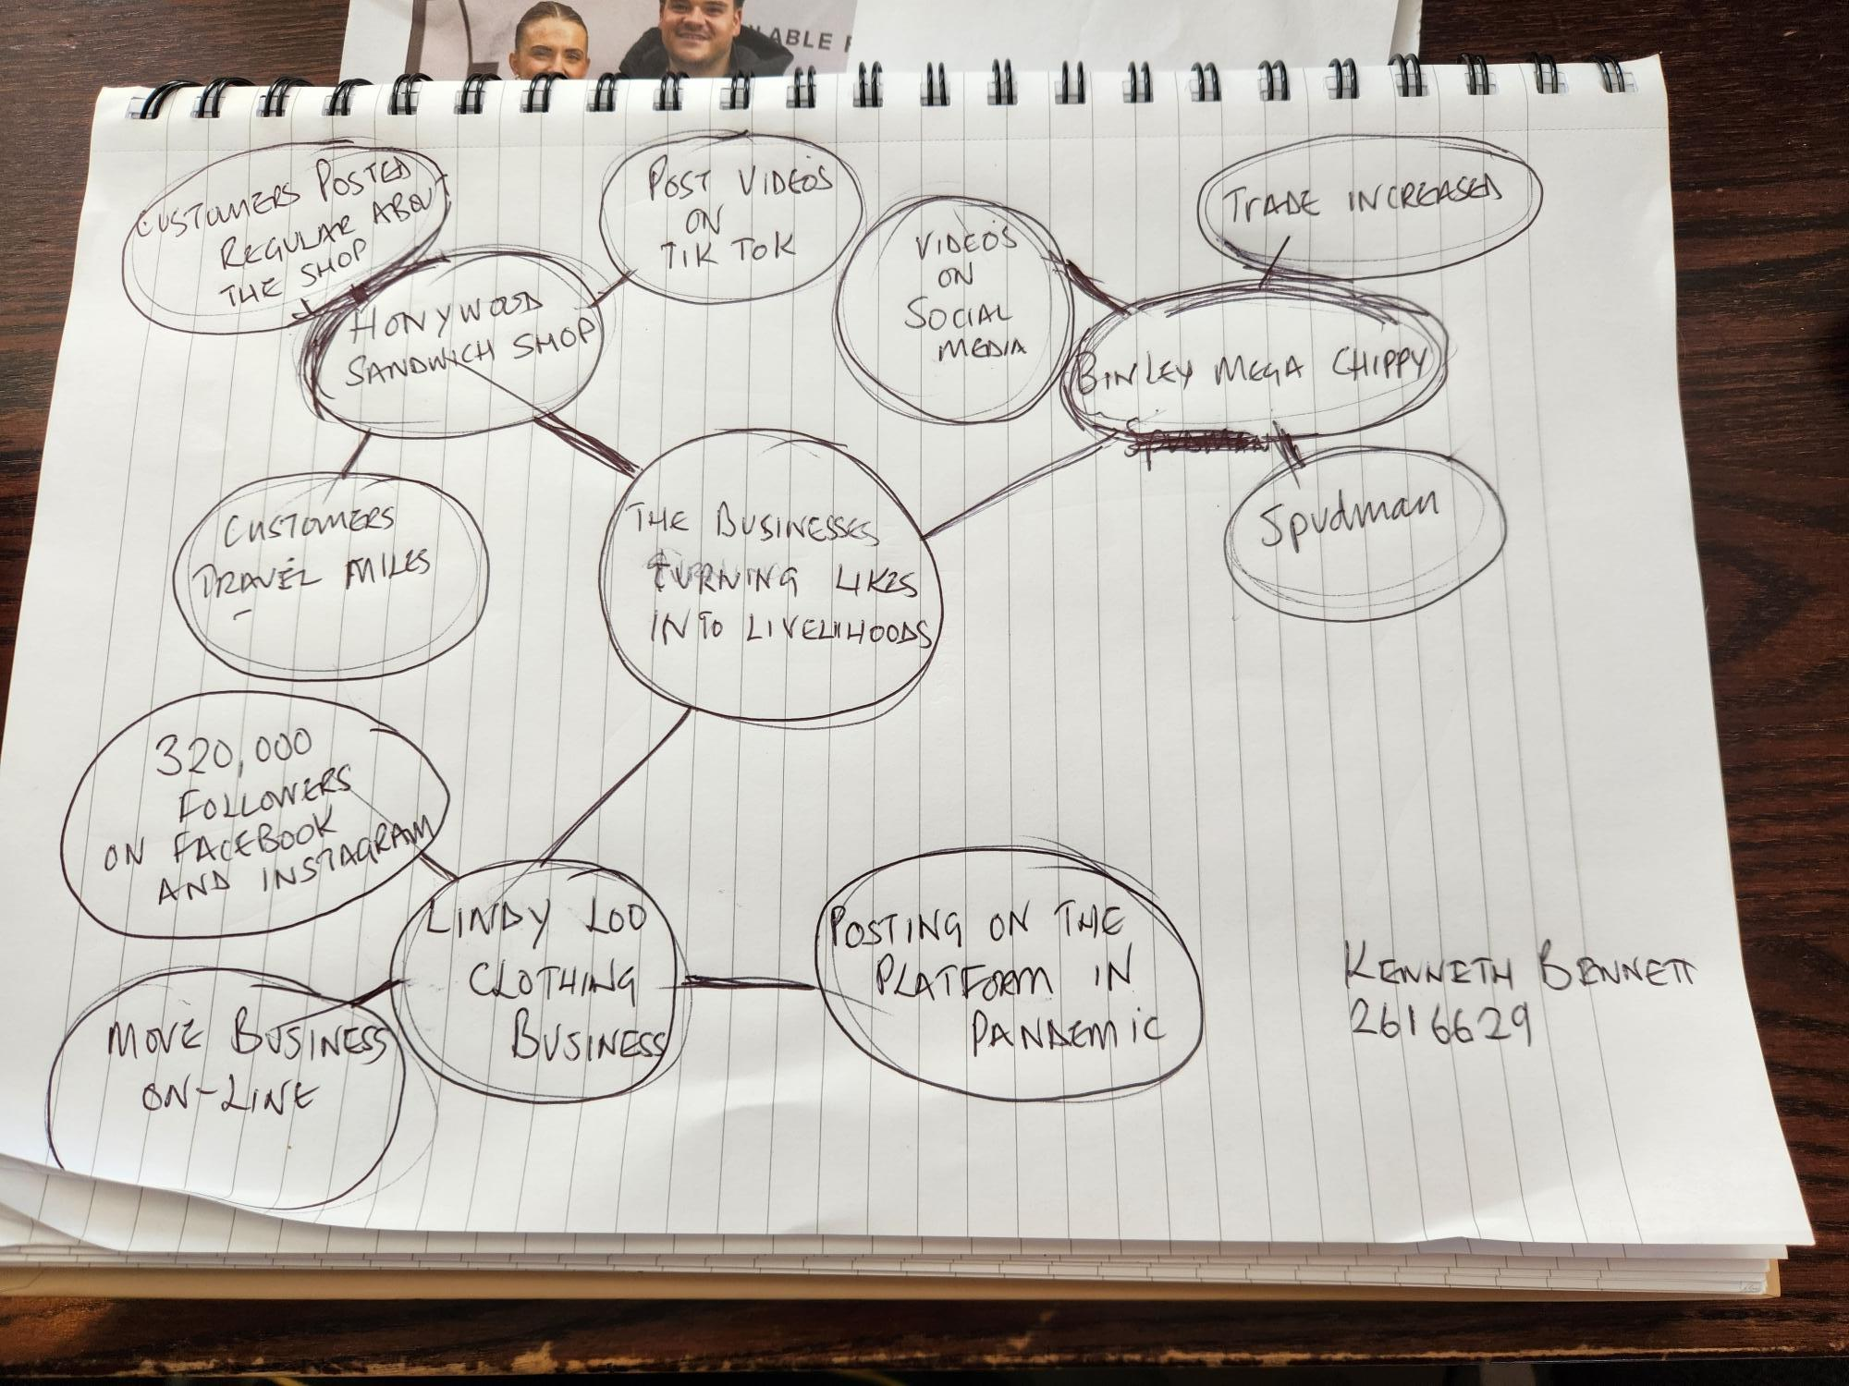

PART 2:
- Answer every question below in 1-3 full sentences.
- Use your own words. Do not use generative AI to answer these questions.
- Include a specific detail frogm the text when asked.
REMINDER
- The main idea is the overall message of the whole text.
- A key point helps to explain the main idea.
- A specific detail or example from the text shows that the key point is true.

- What is the main idea of the whole text?

- The main idea is that small businesses are growing and becoming more successful by using the internet

- What is one key point that supports the main idea, and which specific example from the text shows this?
-one key point is that social media videos can help a business become more popular for example, chip shop diva destiny harold became an internet star after appearing in on line videos.

- What is a different key point that supports the main idea, and which specific example from the text shows this?
Another key point is that businesses can use the internet to reach customers in different places for example linda loo moved her business on line and now ships outfits from the uk to Australia.-

- Which part of the text do you think is most important, and why?
-I think the opening paragraph is most important because it introduces the main idea that small businesses are using the internet to grow and reach more customers

Reflection:
- What did you find difficult in this task (including in-class components), and why was it difficult?
-I found it difficult to find the main idea and important details because there was a lot of information in the text.

- What helped you with this difficulty, and how did it help you?
Making the mind map helped me organise the main information and find the main ideas and important details.-

