
E-PORTFOLIO
BMHP5014
LECURER: DR AZURA HURD
OMENEKE YUSUF (2009232) | CREATIVITY AND CHANGE MAKERS

CONTENTS
INTRODUCTION 2
MIND MAP FOR FOLLOW UP CARE FOR PEOPLE FROM ETHNIC MINORITY WHICH COULD RESULT IN POOR HEALTH OUTCOME 3
BLOG 4
CREATING MENTAL HEALTH AWARENESS TO THE COMMUNITY 4
Statistics of mental health 4
Statistics: 4
RECOMMENDATIONS FOLLOW UP CARE 5
Networking for people 5
AVAILABLE HELP and Organizations 6

INTRODUCTION
This portfolio is created to focus on the mental health outcome of people of black, Asia and minority Ethnicity (BAME) from the perceptive of advocating support of an existing society called BAATN (The blacks, African and Asian therapy network), Mind and rethink mental illness. Lack of proper follow up has resulted in poor Mental health outcomes. The artefact used in this E-portfolio will be creating a mind map and a blog that will explain to the ethnic minority about the issues surrounding mental health and the available organisations at hand to help. Also, on how the organisations can make the help accessible to the target populations.

MIND MAP

MENTAL HEALTH CARE FOR PEOPLE FROM ETHNIC MINORITY WHICH COULD RESULT IN POOR HEALTH OUTCOME

fig.1

MIND MAP
MENTAL HEALTH: According the world health organisation, mental health related complains is the fourth common reason for people to call sick after heart disease and musculoskeletal complaints. People with mental health disorders frequently face significant human rights breaches, discrimination, and stigma notwithstanding advances in some nations. (WHO (2022). The factors contributing to the increase rate of mental health issues among the black and ethnic minorities listed in this mind map are explained below.
Statistics of mental health
The number of people suffering mental issues at certain time has increased; It is believed that 1:4 people have or will suffer mental health issues at certain point in their life. Making the people aware that mental health is an important aspect as health is an important aspect to be handled by the group. Health as stated by the world health organisation “is a complete state of physical, mental and social wellbeing of an individual and not merely the absence of infirmities”. (WHO 2001, p.1)

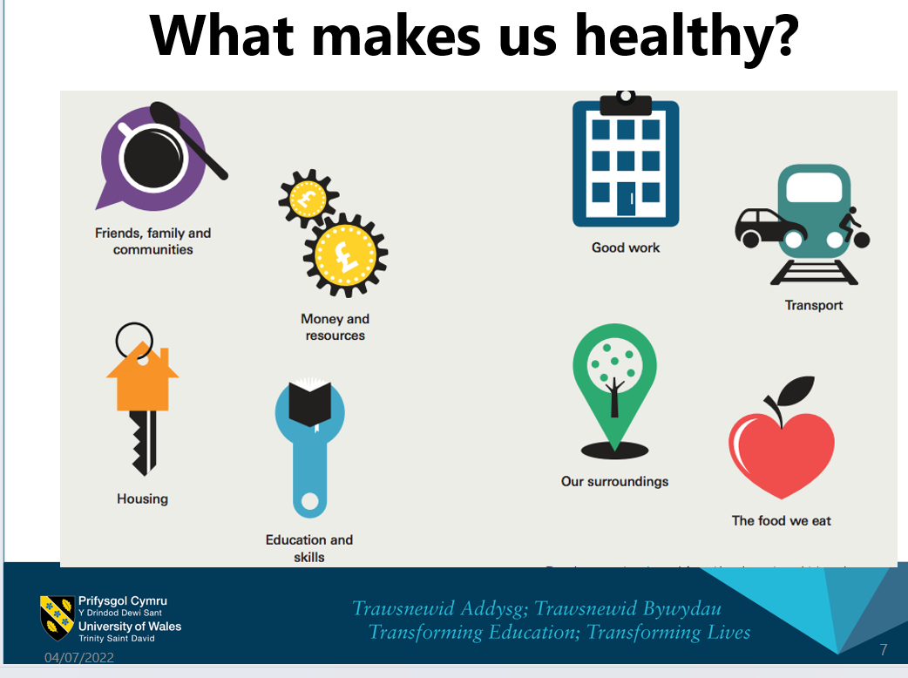 fig.3(uwtsd,2022)
MENTAL HEALTH AWARENESS: – Awareness about mental health is part of the factors affecting the ethnic minorities ‘s mental health. Perception of the BAME communities about what makes them healthy or unhealthy is different from the general health views
Minority ethnicities have very little control about what makes them healthy and thus accessing health care is not a priority. Most cultures believe in accessing traditional healers than medical science. Religion is another aspect that affect people’s awareness of the type of care available and willing to access.
AVAILABLE RESOURCES – The availability of resources is one of the factors affecting the mental health of the BAME Communities living in the UK. Disparities in housing, living conditions. In a related manner, studies have demonstrated that non-health-related regulations, such as those governing housing, schooling, and childcare, can have an impact on an individual's mental health, (Giorgi et al, 2015) ​
People have no access to resources and living in unfavourable condition might make them short of resources available to other communities thereby making them prone mental health illnesses.
JOB OPPRTUNITIES and POVERTY
Poverty and stigma associated with mental illness affects the outcome the BAME people’s mental health. It is generally observed that people from ethnic minorities tends to do less paid job and thereby remaining in poverty. This might be as a result of being educated abroad or being told they lack the necessary skills and expertise.
The ethnic minorities are equally prone to poverty and lack of fund (Holden et al., 2014).
THE MICROSYSTEM
The microsystem is comprised of the things with which an individual has immediate interaction. Family, friends, co-workers, and neighbours are all examples of common microsystem elements that might influence an individual's health. According to Reblin & Uchino, (2008), Support network, marriage, and parenting have major implications on health, according to studies of both adults and children.
It is notices especially among women who are not expected to complain but continue to endure maltreatment, lack of resources, poverty and even domestic abuse.

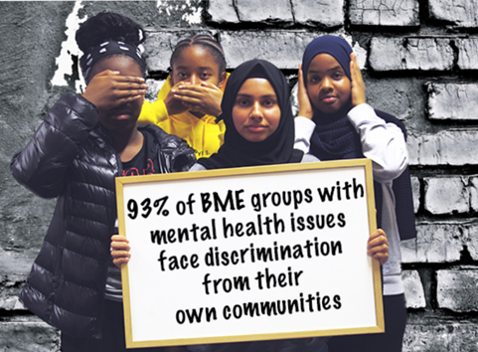 fig 2. (Crest 2020)

BLOG

CREATING MENTAL HEALTH AWARENESS TO THE COMMUNITY
By establishing supportive network of care workers who will teach family and patients on how to recognise early signs of mental health issues and equally picking up early signs of relapse. Lack of follow up care among people of minority has negative health outcome and thereby reducing their quality of life.
The supporting group is to make sure people are aware of the available help they can get and how to access them.

PREDISPOSING FACTORS TO BAME POOR MENTAL HEALTH ISSUES.
The fact that the ethnic minorities are underrepresented in the decision-making process has reduce the access they have to care.
When examining the involvement of BAME people in bandings of 8a and higher, this percentage falls drastically below 10 percent; hence, there is more work to be done. (NHS,
Culture and tradition and the stigma associated with the issues of mental health is also a big factor associated with relapse of mental health issues. The stigma associated with the issues of mental illnesses

SUSCEPTIBILITY AND PREVALENCE
Culture and stigma around mental illness: When compared to persons from white origins, those from Black, Asian, or Minority Ethnic (BAME) backgrounds experience mental health disorders more frequently and at greater percentages. However, it has been discovered that BAME groups are less likely to seek help or treatment from healthcare experts, leaving them more prone to continue suffering.
Ethnic minorities are recognised as a group that is particularly susceptible to mental health inequalities and faces difficulties when it comes to receiving mental health care. (Holden et al., 2014).
Some of the explanations for the disparities in mental disease rates among persons of colour include Disparities in wealth and living conditions, bias, prejudice, and racial prejudice and taboos about mental illness.

Fig:4 supporting groups available
The mission is to improve the quality of life for people of African, Asian, and Middle Eastern descent by increasing their access to the resources, encouraging community participation and organising social outings and how to access the available resources. People are asked to make note of whatever they feel of their experience on daily basis. Reminder for medication intake is encouraged and thought. The Care group will have opportunity to help the patients to adapt to their new environment and the community. Like every other ailment, help is available to every.
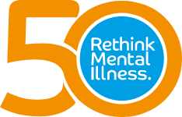

RECOMMENDATIONS
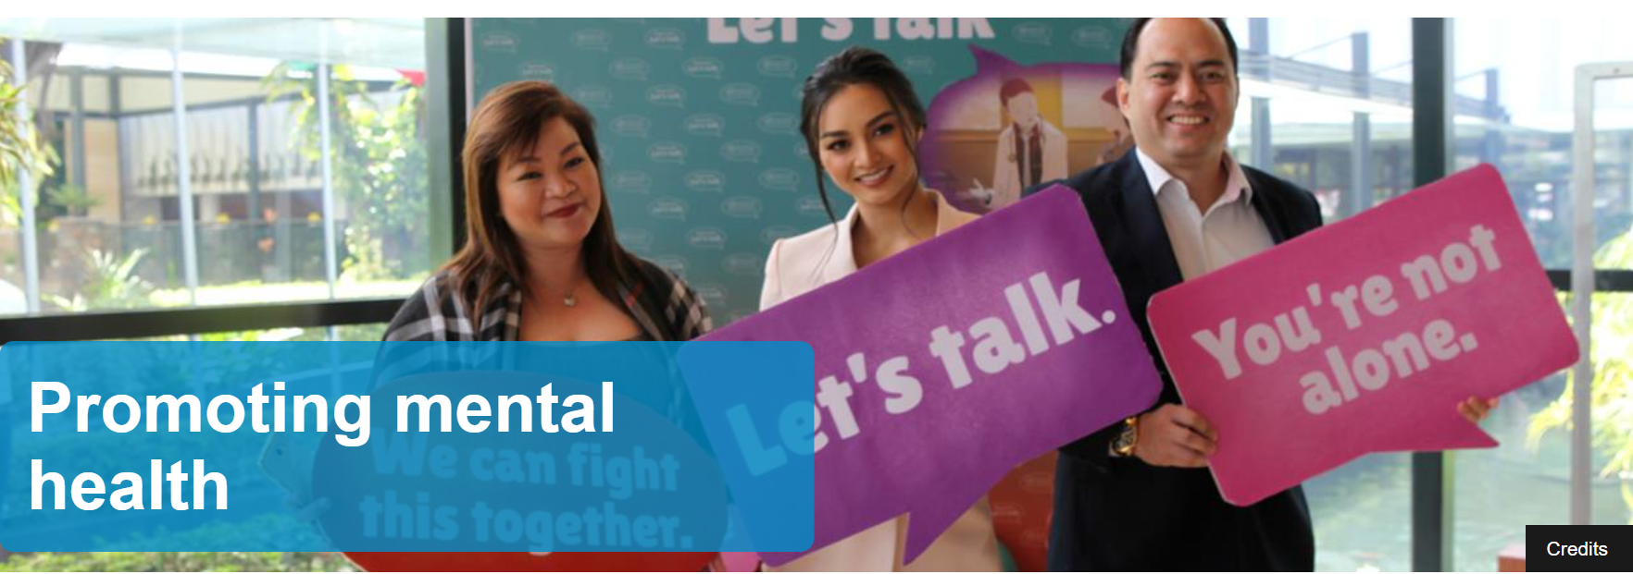Fig.5 (WHO website,2022)
Raising awareness for people who had mental health issues and the help available for people to know that they are not alone in their sufferings.

NETWORKING FOR PEOPLE
Support group comprising of multidisciplinary team to be on hand for assistance when needed. The organisation should support people with mental illness and family to access all the help made available to them. Knowing that one is not alone will help in coping and able to talk freely as they have opportunity to meet people have suffered the same conditions as them.
Early diagnosis is encouraged through a symptom awareness campaign that includes bus advertisement and Sunrise Radio Network advertising. Mind (20…) reports that 50 percent of BAME individuals avoid talking their about mental health because they would not want to disturb people.

AVAILABLE ORGANISATIONS AND CONTACT DETAILS
- BAATN (The blacks, African and Asian therapy network);
Email: administrator@baatn.org.uk baatn.org.uk
- CREST - Mental Health for BAME Communities (crest.uk.com)
- MIND - http://www.mind.uk ,
- RETHINK MENTAL ILLNESS. Phone: 08088002073 (open 4pm to 7pm Monday to Wednesday,12pm to 3pm Tuesday to Thursday).
Email is advice@rethink.org. http://.www.rethink.org

References
BAATN (2020) The blacks, African and Asian therapy network https://www.baatn.org.uk/ online access on 29/06/2022
Brown, C.M. and Ling, W. (2012). Ethnic-Racial Socialization Has an Indirect Effect on Self-Esteem for Asian American Emerging Adults. Psychology, 03(01), pp.78–81. doi:10.4236/psych.2012.31013.
CREST (2021) Mental health for BAME Communities, online access on 26/06/2022
EDGE, D., Ph.D., (2010). Falling through the net — Black and minority ethnic women and perinatal mental healthcare: health professionals' views. General hospital psychiatry; Gen Hosp Psychiatry, 32(1), pp. 17-25.
Health Education England (2020) Our need to increase representation of BAME senior leaders at HEE is clear in our workforce profiling. https://www.hee.nhs.uk/
online accessed on 09/07/2022
Holden, K., McGregor, B., Thandi, P., Fresh, E., Sheats, K., Belton, A., Mattox, G. and Satcher, D. (2014). Toward culturally centered integrative care for addressing mental health disparities among ethnic minorities. Psychological Services, [online] 11(4), pp.357–368. doi:10.1037/a0038122.
Reblin, M., & Uchino, B. N. (2008). Social and emotional support and its implication for health. Current Opinion in Psychiatry, 21, 201–205. https://doi.org/10.1097/yco.0b013e3282f3ad8.
Rethink Mental Illness (2022) BAME mental Health
https://www.rethink.org/ ,online , website accesses on 29/06/2022
Saxena, S., Ommeren, M. van and Saraceno, B. (2006). Mental health assistance to populations affected by disasters: World Health Organization’s role. International Review of Psychiatry, 18(3), pp.199–204. doi:10.1080/09540260600655755.
SAXENA, S., SHARAN, P., GARRIDO, M. and SARACENO, B., (2006). World Health Organization's Mental Health Atlas 2005: implications
for policy development. World Psychiatry, 5(3), pp. 179-184.accessed on 12/07/2022
WHO (1998). WHO Programme on Mental Health. Fact. [Online]
Available at: http://www.who.int; WHO. Mental Health. Accessed 11/07/2022
Mind (2022) mental health of BAME- https://www.mind.org.uk/ ,accessed on 01/07/2022
UWTSD (2022), week 7 Health Inequalities and wider determinants of health, Principles of Health and social care. University of Wales trinity saint David, https://moodle.uwtsd.ac.uk/course accessed on 04/07/2022

