
Skills for the Workplace
Module Assignment Submission
Student Name: | Garry Wayne Byrne
Student Number: | 2012881
Module No: | BMSK4007
Module Title: | Digital Skills and Personal Branding

Statement of Confirmation of Authenticity
By the act of making this submission, the student declares that this is the work of the student named above. The work has not, in whole or in part, been knowingly presented elsewhere for assessment, or where assessment has been built on a previous assessment, this has been identified. Where materials have been used from other sources it has been properly acknowledged. If this statement is untrue, the student acknowledges that an assessment offence has been committed.
Attention is drawn to the plagiarism and unfair practice policies of both the University and of ILM.
Permission for ILM to use this script
ILM uses learners’ submissions – on an anonymous basis – for assessment standardisation. By submitting, both the centre and the learner agree that ILM may use this script on condition that identifying information is removed. However, if you are unwilling to allow ILM use this script, please refuse by ticking the box: □

Table of Contents
What has been the impact of 21st Century Technologies on the modern workplace? 3
Evaluate the appropriate use of modern technologies and social media in the workplace generally 3
Explore the use of modern technologies and social media in own workplace 3
How can Personal branding help YOU? 4
Your LinkedIn Profile to promote your Personal Brand 4
Evaluate the value of other social media platforms to enhance networking and career prospects 4
Examine the impact of Personal Branding on your own employability 4
Discuss personal and professional security and safety online. 4
References 6
Appendix 1 7
Appendix 2 8

What has been the impact of 21st Century Technologies on the modern workplace?

Evaluate the appropriate use of modern technologies and social media in the workplace generally

I work in a sales office, so communication is a key element and we need to speak to customers to promote our products. Everyone in the office has a computer which is a PC (desktop computer), which is hard wired and runs on a Microsoft program throughout the office to each PC. To be able to communicate with other computers, my workplace uses what's called a cloud and this is used to store all the data that are sent to each computer on a Microsoft program. In the past, floppy discs and compact discs (rewriteable), were used to transfer data, photos, videos etc. from one computer to another. How the cloud works is that data is stored on very large servers worldwide with almost unlimited capacity and is accessed via the Internet. A potential downfall could be security breaches, allowing others to access your information.
One of the main programs we use to call our customers is called a dialer system. This is where all the customers details are stored and automatically comes up on our screen as it dials the number and this saves time and money for the company making it a lot more productive.
Using a head set we can talk to the customer and promote and sell our products just like a telephone. There are pros and cons to using this, the pros being it’s a lot quicker and you are able to put notes on the customer to state the outcome of the call and productivity is a lot higher, however there is no back up system for this which means if the internet goes down productivity stops, whereas in the past we had a page of data and a landline phone to dial leads manually and the phone line never went down.

Everybody has got a mobile phone in the office although they are not allowed on the office floor for distraction reasons and data protection. The new data protection law (GDPR, 2018) was introduced in 2018 which protects all customers' data from being leaked to other sources and being used inappropriately. Companies can be fined or prosecuted for breaching data protection laws.
The mobile phone is the way we all talk to each other and it also has a number of messaging apps such as Whats App, Facebook and Teams. Our manager can send us updates on sales and reports as and when they come in on a daily basis. We also have meetings on our mobile phones which we use even more so now we are all working from home.
There is a very large printer in the office which we all share to print out spread sheets, training modules etc. It also has a Scanner on it as well so we can scan and send anything.

Explore the use of modern technologies and social media in own workplace

The Internet has blossomed over the past four years. More and more people have taken to the Internet.

It is proven that businesses grow with the Internet as it's a fantastic marketing tool and reaches people globally which creates a larger audience which in turn creates larger profit margins. So businesses have to move with the times unlike the owner of a very large retail business was said to be ignorant to the Internet and as a result lost his business to a lack of sales as online sales rocketed globally

The Internet offers a wide range of apps now and a lot of social media sites which have come in very handy over the past year with the COVID pandemic. A lot more elderly people are taking to the Internet to communicate with family and loved ones as it's the only way to see them. COVID Pandemic lock down has resulted in Internet services rocketing from 40% of usage to a staggering 100% compared to pre lock down.

Social media sites make up a large part of the increase and which more and more people are using them to interact with family and friends. The most popular is Facebook which in the 3rd quarter of 2019 had 2,499,000,000 active users, (Wain, 2019).

Then you also have TicToc and Instagram which are more and more popular every week as more younger people tend to be using these sites

The biggest Messenger site is WhatsApp it's a quickest Messenger app which you can talk, send texts, videos and pictures very easily. There have been recent headlines about WhatsApp because it breached the new GDPR laws which it broke by publishing peoples phone numbers and received a very hefty fine (Cuthbertson, 2021) Edex Live, 2021).

The GDPR (2018) laws were brought in to protect people and keep their personal details safe and not get in the hands of scammers which unfortunately the internet is very renowned for.

How can Personal branding help YOU?

Your LinkedIn Profile to promote your Personal Brand

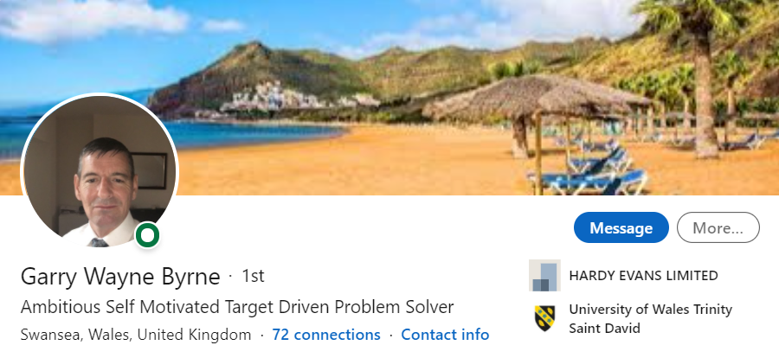

Evaluate the value of other social media platforms to enhance networking and career prospects

Most business use Social Media nowadays. It can be an effective marketing tool as well as being used for communication. My company doesn't use it to a large extent, as we just offer a service to a marketing company which has their own web site and promote their own products and services. Putting your product or services on the internet or even your own brand WILL increase your business and productivity as it can reach such a wide audience.
It's not just useful for the company but also for the consumer.
Google Review is what a lot of people use now to check the credibility of the shop or item they are looking for. People can leave a review for other people to read, both good and bad, about their experience.
More and more people have begun to use the internet over the past 20 years. According to Wain (2019), in 2000, only 25% of households had an internet connection and this had accelerated to 95% by the end of 2019.

Examine the impact of Personal Branding on your own employability

Personal Branding is very important to market who you are and what you have done, your experience and your credibility. Employers look for your personal branding all over the internet and the most popular form of personal branding is an app called LinkedIn. I have inserted a capture of my LinkedIn profile above. This helps both employers and employees who are looking for the right position or person for the job. It highlights the person's honesty, competence, inspirational skills and their forward looking ways, which will give a clearer vision of the persons capabilities and credibility in a more professional manner.
Some people and companies use Facebook for this, but I personally think Facebook is more of a personal site than a professional site like LinkedIn. Facebook is a more social site for people to message and post photos and videos of themselves and some even put what they had for tea!!
I'm not too keen on Facebook myself, because I think it’s a conversation killer. In the past, when you came into company you used to have more of a conversation, whereas nowadays people automatically look at their phone every few seconds to see if they have missed anything that other people have posted. On the flip side though, it has its benefits like Marketplace where you can buy and sell your items, anything from a car to a house.

Discuss personal and professional security and safety online.

The new GDPR laws that came in 2018 are really great for your personal details being kept safe from other companies but you are still at risk every time you switch your computer/phone on from criminals trying to steal peoples data and personal information.
Here are some tips on how to protect yourself on line by onlinesecuritytips.png.
Firstly make sure you have a good security system on your device, most new devices have some sort, but you can also buy them to suit.

If you're not sure about an uninvited email that you have received then DON'T open it delete it. Keep your personal data and information safe and don’t share it with anyone. If you shop on line be vary careful about using your bank details on line, there are some safe platforms you can use which are very safe and secure like PayPal.
And most importantly avoid potential consequences of inappropriate or unlawful on line activities and stay safe.

References

Cuthbertson, A. (2021) WHATSAPP FORCES USERS TO AGREE TO SHARE PRIVATE DATA INCLUDING PHONE NUMBER WITH FACEBOOK [online] available at: https://www.independent.co.uk/life-style/gadgets-and-tech/whatsapp-update-new-privacy-policy-b1783880.html Accessed on 25.01.21
EdEX Live (2021) In a major data breach, numbers of WhatsApp web users found on Google search [online] available at: https://m.edexlive.com/news/2021/jan/15/in-a-major-data-breach-numbers-of-whatsapp-web-users-found-on-google-search-17312.amp Accessed on 25.01.21
ICO (2018) Guide to Data Protection [online] available at: https://ico.org.uk/for-organisations/guide-to-data-protection/ Accessed on 25.01.21
Wain, S (2019) How Technology Has Changed In The Last 20 Years [online] available at:
https://www.mymemory.co.uk/blog/how-technology-has-changed-in-the-last-20-years/ Accessed on 25.01.21
Int J Inf Manage. 2020 Dec; 55: 102171.
Published online 2020 Jun 9. doi: 10.1016/j.ijinfomgt.2020.102171
https://youtu.be/QmMcSBQvQLQ Barry Posner

