LINK TO BLOG - https://ellienicholls3danimation.blogspot.com/

The aim of this assignment was to create a walk cycle that would help to improve the animation quality of my work in the Major Project. I decided to focus on and develop a walk cycle to ensure that it would convey the character’s personality, whilst allowing me to improve this particular part of my animation skillset. I wanted the walk cycle to then transition into a run cycle once the character sees something and gets scared. I believe that this will give me a range of emotions and actions to fully develop and evolve, whilst improving my skillset and understanding of the principles of animation needed to produce a successful walk cycle.
Before carrying out research on this aspect of the animation, I first began to look for an online rig that would be similar to the rig that I plan to create for the major project. This would allow me to familiarise myself with this type of rig and any possible problems that could come with it. I also watched some videos online that explained how to use the rig fully which meant that I felt more confident using the rig. After watching these videos I then spent a lot of time experimenting with the rig to ensure that I fully understood its restrictions.
LINK TO RIG - https://www.cgtarian.com/maya-character-rigs/download-free-3d-character-ray.html
Vimeo. (2018). CGTarian - Ray rig introduction. [online] Available at: https://vimeo.com/117548169
YouTube. (2018). Ray Maya Rig Explanation. [online] Available at: https://www.youtube.com/watch?v=zScHNK_QHqY&t=2s
As my character will be quite nervous and scared, I began researching scenes in films that featured panicked and distressed movements and walk cycles, found on YouTube, that had characters with similar personalities to my own character. These were especially usefully in helping me determining the style of walk I wanted for the character and how I would have to express their personality. I also observed people walking in the streets to provide me with a better understanding of how unique each person’s walk is and just how many different elements can affect it. I think that I will need to spend more time researching and studying these movements in order to produce believable and authentic animations. I also watched the film Inside Out (2015). This film was very useful in helping me determine how my character’s personality and emotions should affect his walk cycle. For example, in the film the character Sadness will walk with her back hunched, moving very slowly and often keeping her head down. On the other hand, the character Fear will move very quickly using short steps whilst often keeping his arms held up in a very defensive position. Using a consistent walk cycle could help to very quickly establish the character’s personality and quirks.

YouTube. (2018). Tangled Chase Scene. [online] Available at: https://www.youtube.com/watch?v=j8AbzVgyxVk.
YouTube. (2018). The scared and lonely walk cycle. [online] Available at: https://www.youtube.com/watch?v=_n3W-repfoo.
YouTube. (2018). 100 Ways to Walk. [online] Available at: https://www.youtube.com/watch?v=HEoUhlesN9E&t=319s
YouTube. (2018). Scared walk start to run transition animation reference. [online] Available at: https://www.youtube.com/watch?v=jD9Qyx-wyEc
YouTube. (2018). Reference Video- Scared in the woods. [online] Available at: https://www.youtube.com/watch?v=MHEdtD5mC0Y
YouTube. (2018). scared reference. [online] Available at: https://www.youtube.com/watch?v=J4J58har_Ys
YouTube. (2018). Slow Motion Study of Running At Different Speeds. [online] Available at: https://www.youtube.com/watch?v=Zb_SizNRUPg
YouTube. (2018). Animation Reference - Athletic Male Standard Walk. [online] Available at: https://www.youtube.com/watch?v=vq9A5FD8G5w
YouTube. (2018). Animation Reference - Athletic Male Walk Dazed - Slow Motion. [online] Available at: https://www.youtube.com/watch?v=Xjg1GijjazE

I drew over some of the movements in the tangled chase scene to gain a better understanding of the movement and how the character’s momentum and gravity affected his actions. It also showed me how simple movements could be exaggerated to develop and show more of the character’s personality. Through exaggeration the action become more interesting and can prevent it form appearing static and dull. I will try and use this later in my animation to make the character’s actions appear more extreme and dynamic. It also helped me understand the pacing better and see how it can give meaning to the movement. The speed of the character’s movement also helped to convey his emotional state. This could be used in my animation by having the character move very quickly to suggest that they are hurried or on instead very slowly to show that they are hesitant or uncertain.
To try and study the character’s form and position I created a breakdown of some of the actions that would be in the animation. Here I wanted to focus on the individual frames instead of allowing Maya to animate it for me. This also meant that I paid attention to the character’s pose and position in each frame and that I was aware that in each frame the character’s actions and emotions could be seen in one glance. I wanted each pose to lead from one to another and that it would convey the story without any in-betweens being necessary. This greatly improved my animation and was a great technique in ensuring that the movement remained dynamic and interesting. When working on the Major Project it would be beneficial to me if I continue to breakdown the animation especially if I do a more detailed breakdown of the walk cycle and its key poses. This will allow me to more fully understand the timing and spacing and will make it easier for me to exaggerate elements or poses that will dramatically alter the character’s personality.
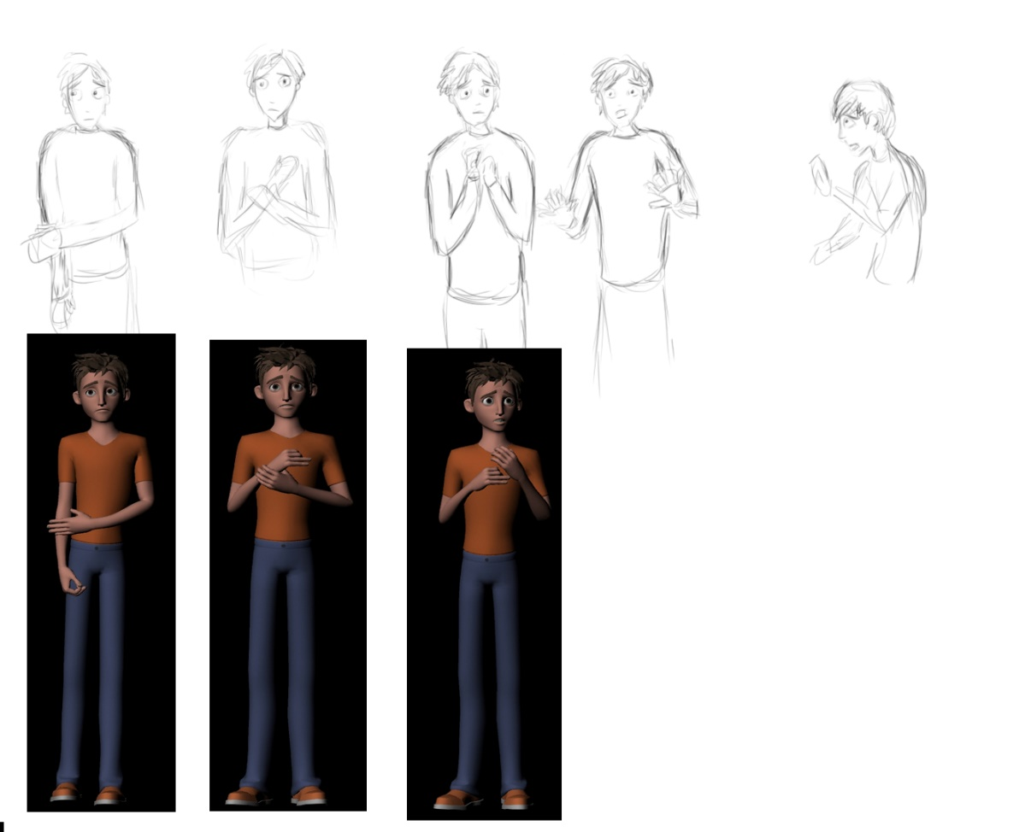

I also wanted to heavily focus on the character’s facial expressions as the Major Project will feature a lot of close ups of the character in the animation. The expressions will also be important in connecting and engaging with the audience as they will be able to relate more to the character. In this walk cycle the character is constantly looking around the environment, appearing very uneasy. I believe that I successfully conveyed the character’s emotions through their facial expressions however I need to work more on the body language to fully reinforce the emotions the character is experiencing and displaying. . I spent a lot of time prior to animating, experimenting with the facial rig to ensure that I was aware of how the different joints would affect the character’s expressions. Animation principles such as exaggeration or anticipation also helped to make the expressions seem more lifelike. To ensure that the animations were effective it was essential that the character’s expressions were clear to see as well as believable. However, in order to improve the timing of some of the expressions I need to spend more time studying and determining what point the character must react to the stimuli and the blocking them out, keeping the expressions simple, so that I can focus more on the timing. I also need to spend more time determining the character’s eye direction and perhaps try to include more eye darts to denote the character’s nervousness. To ensure that the character appears to remain focused I need to leave a long enough hold in between the darts. I think that I will need to spend more time experimenting and familiarising myself with the facial rig to improve on the quality of the facial animation.
Initially I considered transitioning the walk cycle into a run cycle. I wanted the character to be running away from something after getting scared. However, as I started animating, I decided to instead focus more on a walk cycle as I was finding it difficult to get the knee joints to move fluidly. As I wasn’t confident with altering or fixing the rig, I instead spent more time animation the character’s legs to prevent the knee from ‘popping out’. This resulted in the leg’s movement to ‘jerk’ and prevented some of the animation from appearing smooth. In the beginning of the animation I wanted the character to appear very timid and uncertain of the environment. To show this I ensured that the movements were quite slow and small. Taking the character’s body into account, quite tall and thin, I tried to make the character lighter on his feet, whilst remaining slightly hunched over as if he’s aware that he’s quite tall. In a lot of the reference videos I had gathered, the people who were anxious or scared would often fidget and move their hands and arms restlessly. This visually conveyed their anxiety really well and I wanted to incorporate it into my animation. Throughout my animation the character is constantly moving his arms and when startled raises them up slightly in a protective manner. I wanted this to express how panicked and anxious the character is in this environment. In the later half of the animation the arm’s movement grow a bit static and lose some of their fluidity. When working on the major project I will have to pay attention to the consistency of the actions throughout the entire animation. I also spent more time animating the character’s upper body and as I often worked on the two halves of the body separately some of the animation does feel disjointed. I will need to spend more time and pay more attention to the lower body and the overall body so that all the movements feel as though they have some weight behind them. This will make all of the movements seem much more life like and believable.
I found timing to be very difficult when animating this walk cycle. At first, I had the character move very slowly to show that they were uncertain of their environment and situation however I often found that this resulted in the animation being too boring and slow paced. When working on the major project I will spend more time working on the timing of the animation to prevent this. I also need to spend more time and carry out thorough research into gravity, weight and balance and how this would in turn affect the character. I spend a lot of time trying to prevent the movements from appearing too ‘floaty’ however I would then over exaggerate the character’s weight and balance in the action. To overcome this, I then made all of the movements more subdued however this resulted in it being slightly dull and even lifeless at time. This is clear in the middle of the animation when the character looks behind himself and all movement except for the turn of the hips and the head is too minimal and is too big a contrast to the rest of the animation. This is an area that I will definitely need to pay more attention to in the future. I will need to study and experiment with the principles of animation more like Overlap and Follow Through to ensure that motion remains natural and using these principles on the character’s joints will prevent it from looking robotic. I also need to focus more on the 4 key poses of the walk cycle and the character’s overall body language.
I also should have created a schedule early on for this module so that I could keep on track of the work. As I didn’t have a definite schedule, I didn’t leave myself as much time to animate as I would have liked and instead spent more time studying different walks. Organising my time better will definitely benefit my work and will help me ensure that all of my animations are of the highest quality possible. Having schedules for smaller tasks would help me to break down the workload and allow me to determine what tasks requires the most time spent on it.
To give the animation some context and to help me visualise the scene better I created a basic environment using Maya’s brush tools to create a backdrop of a forest behind the character. I also animated the camera to move with the character and to slightly rotate when the foot impacts with the ground to add more weight to the action. I think that this worked well however more time could have been spent on improving it slightly so that the camera movements were smoother and not as jumpy as it ended up being. Despite this the camera animation helped to make the overall animation more visually interesting and helped to combat some of the issues I had encountered with the timing and pacing of the character’s animation. This helped to make the later part of the animation seem more evenly paced with the first half of the animation and helped to make the character’s movements seem more hurried.
Overall, I believe that the work and study that was carried out here will elevate and improve my animation in the Major Project. This provided me with a better understanding of creating a walk cycle with personality and character. It also helped me to see the parts of the animation, in particular the timing, that I will need to pay more attention to ensure that the character’s walk and movement is believable. Using an online rig in this project has also made me more familiar with the type of rig that could be suitable for my character in the Major Project and allowed me to focus more of my time in improving my animation skillset. Analysing and studying different walk cycles has meant that I am now more familiar with the key movements needed to create a believable walk cycle and I believe that this research will greatly improve my work on the Major Project and will improve the overall quality of the animation. However, I do believe that I will need to carry out more in-depth research to be able to successfully produce a walk cycle with personality and emotions that is interactive with the environment.

