

University of Wales Trinity Saint David

School of Computing
Internet Technology and Security
(ACCA4018) (Kemi)
Rizwan Chishti 1806547

Table of Contents
Requirements 3
Implementation 3
Validation 12
Evaluation 13
Usefulness (usability and utility) 14
Search Engine Optimization (SEO) 14
Accessibility 16
Conclusion 17
References 18

Specification report

Requirements
The website is designed for helping people to Handle their mortgage as well as for any new commitments that they are about to make in regards of the mortgage. The website is properly designed to help in storing the data and several important details that are required to understand the basic rules applied on the mortgage as well as it will also help in the demonstrating the process of how to handle as well as overcome the issues while managing or starting a mortgage deal. The website is based on multiple web-pages which are including the details about the mortgage as well as are helping the user to interact with numerous levels of details regarding profiling. The targeted audience would be the people who are interested in the mortgage as well as the investors that are focusing on capturing the market of mortgage. The legal aspects are properly as well as precisely being managed. It is important to know that the mortgage with the involvement of legal aspects is a highly complicated process and it is required to be managed effectively as well as precisely. The main of this report is to enhance the understanding of the purpose of the report as well as to elaborate its development as well as designing complications.

Implementation
This section is entirely based on the screenshots of the 16 pages on which the website is being comprised. Every page is relatively very important for the process management, mortgage requirements collection from user, and getting profile data from the user. The account building as well as getting logged into the website are also some of the most important functions that are also dealt on separate pages.

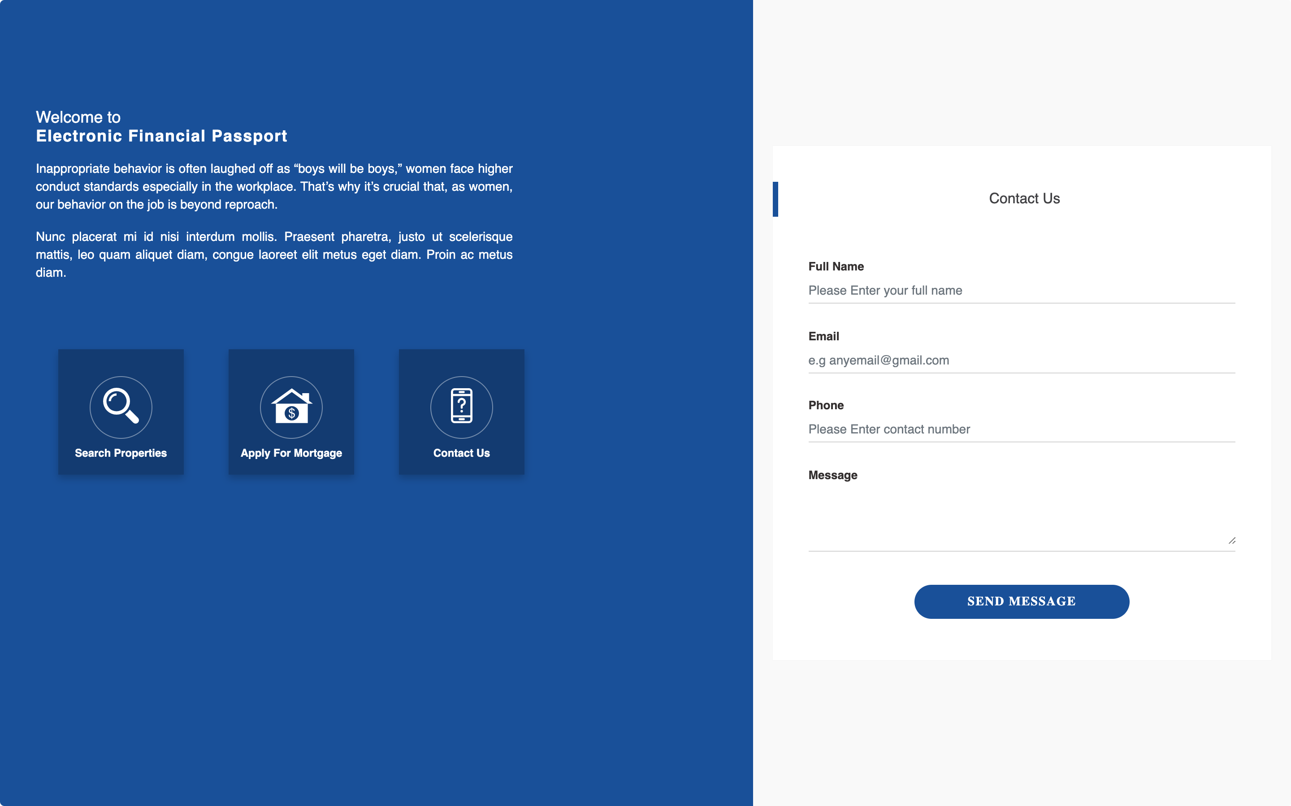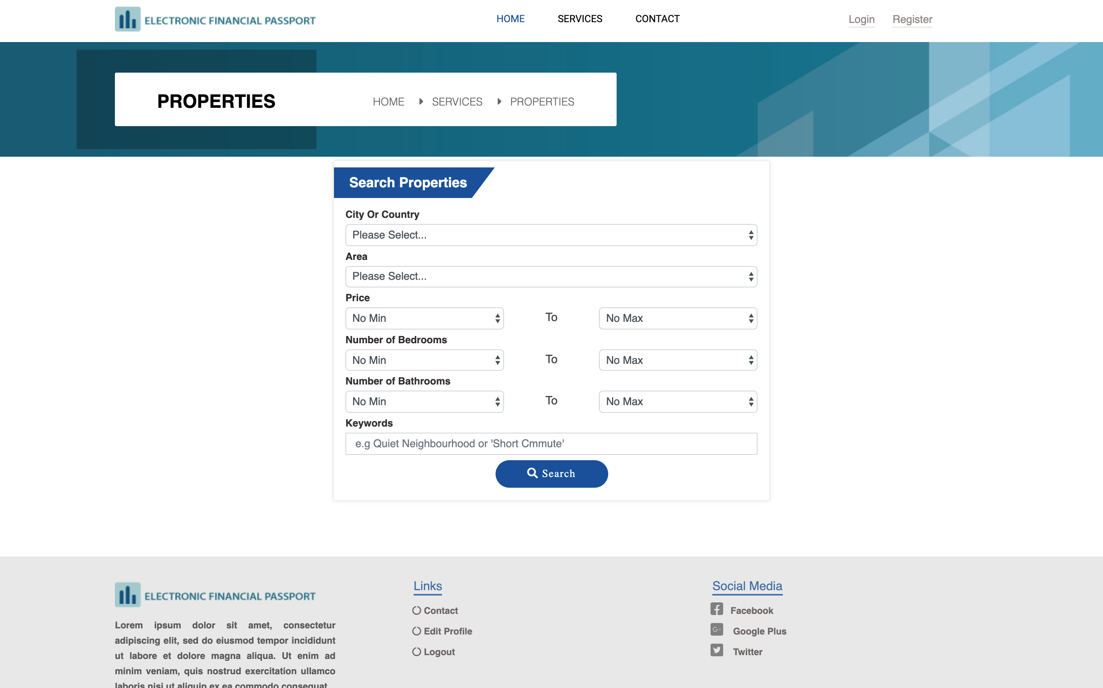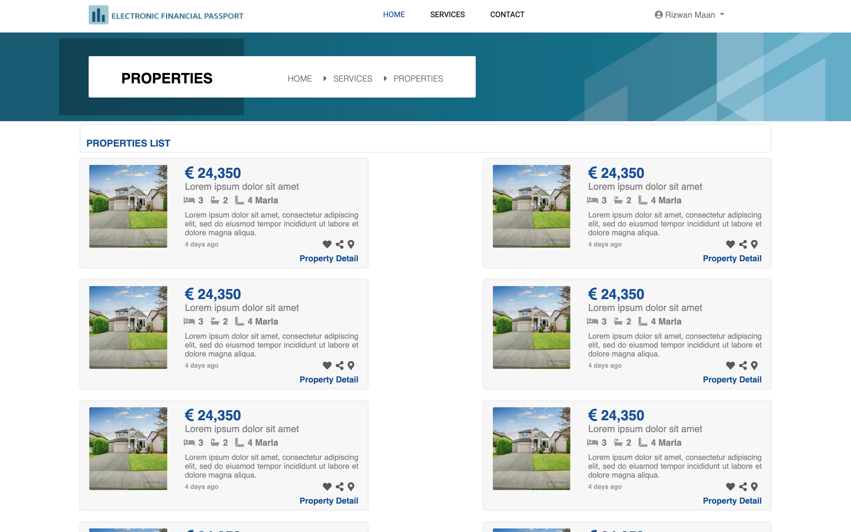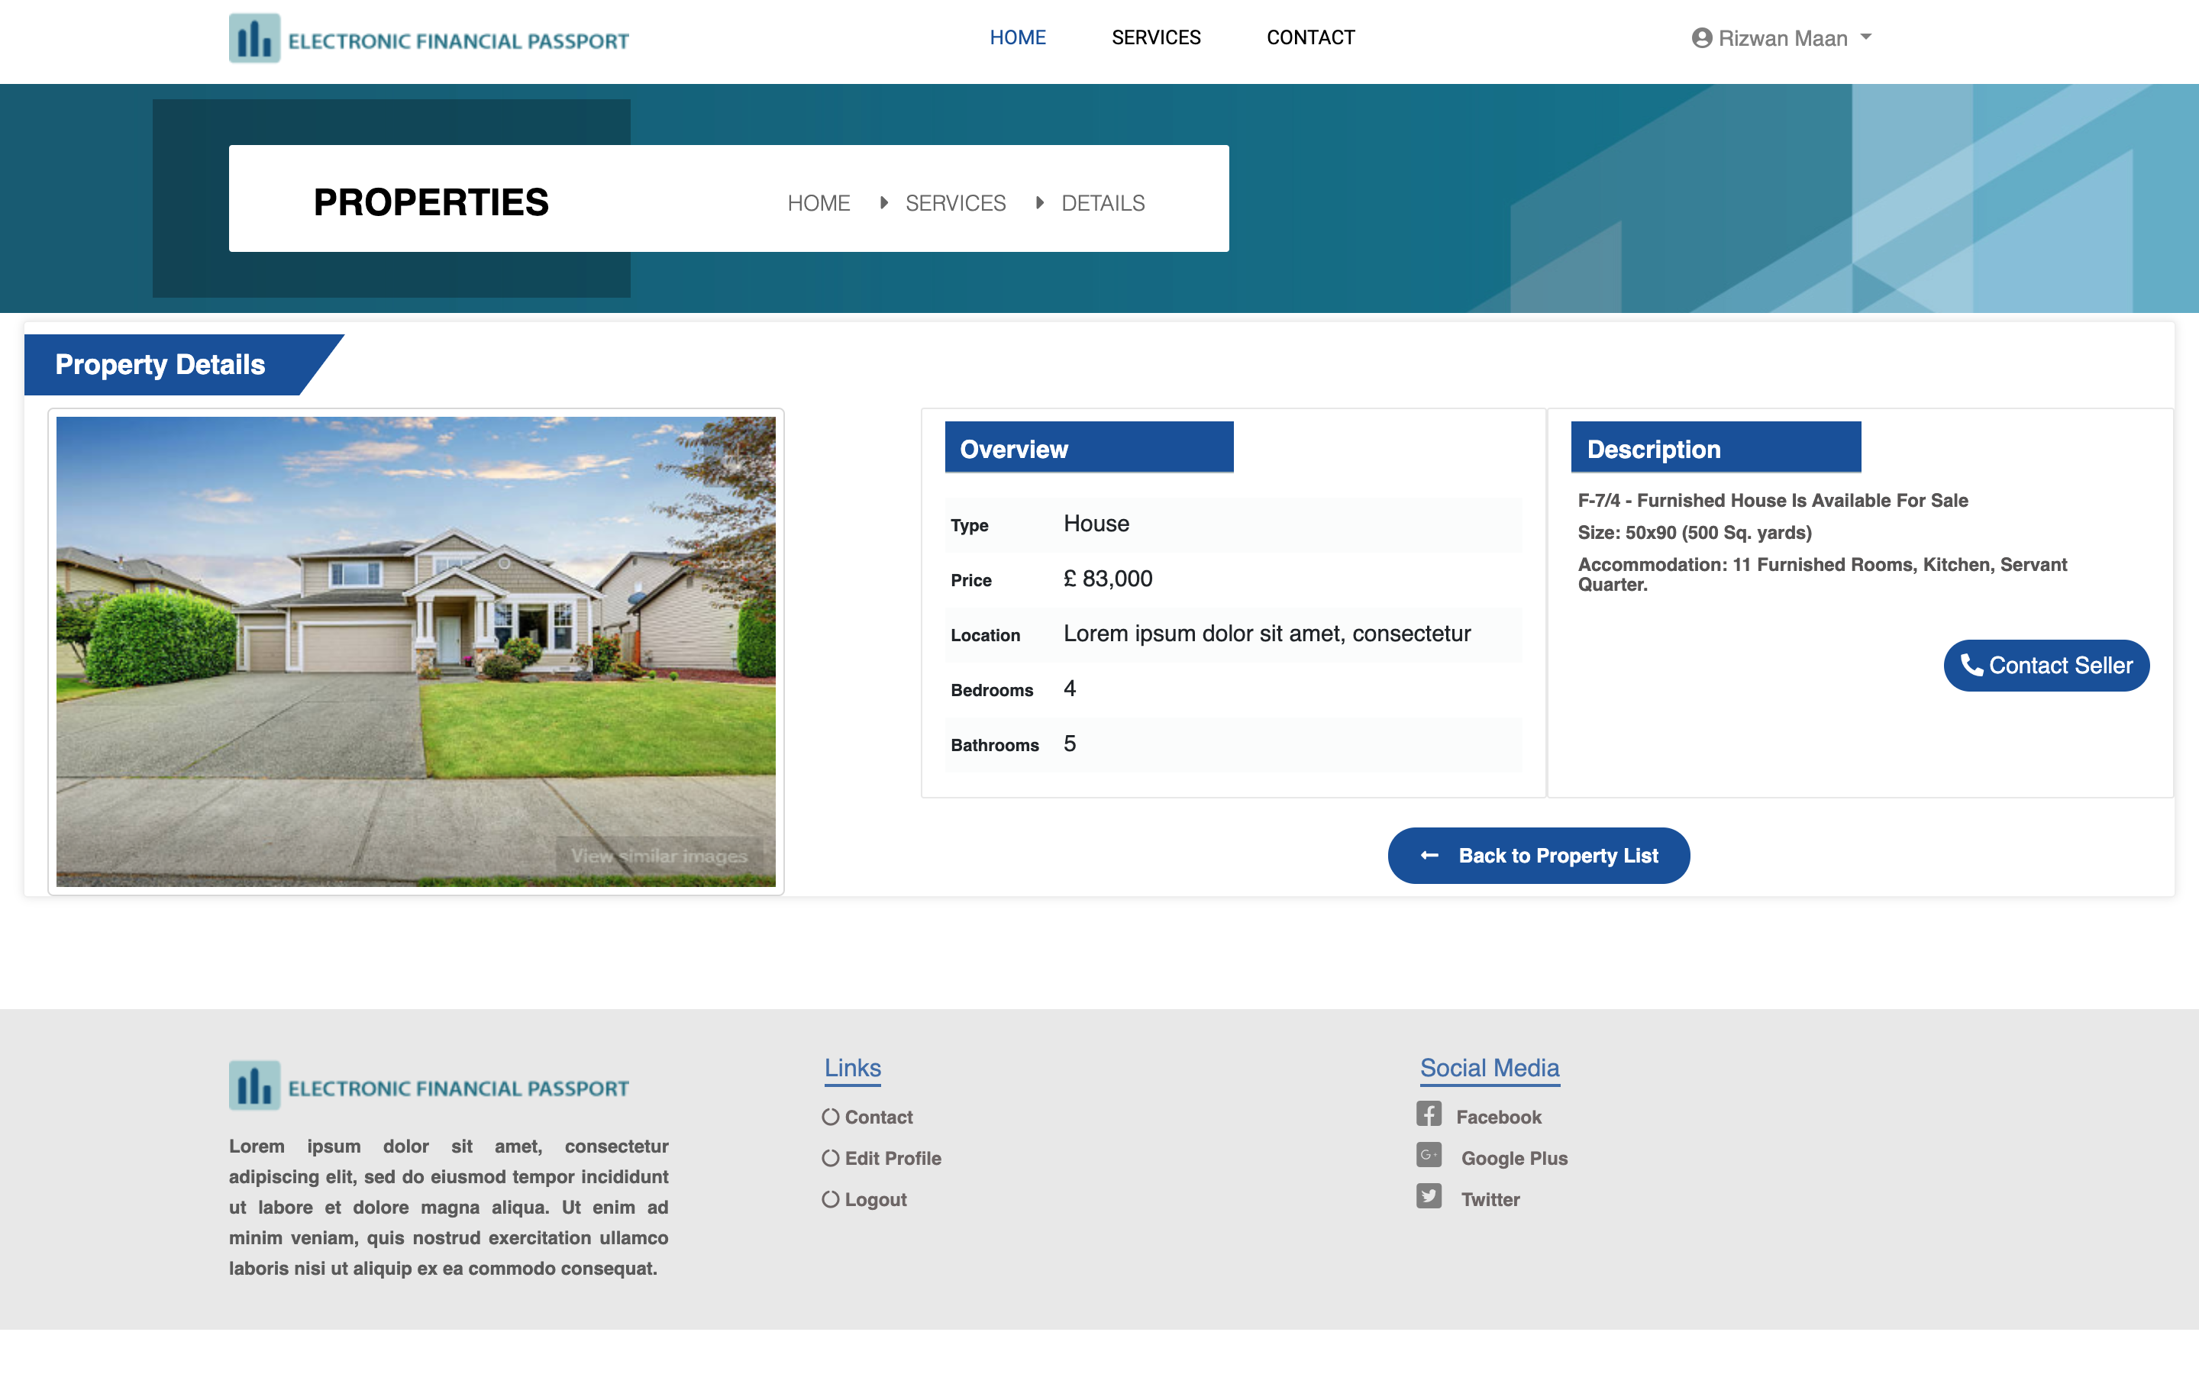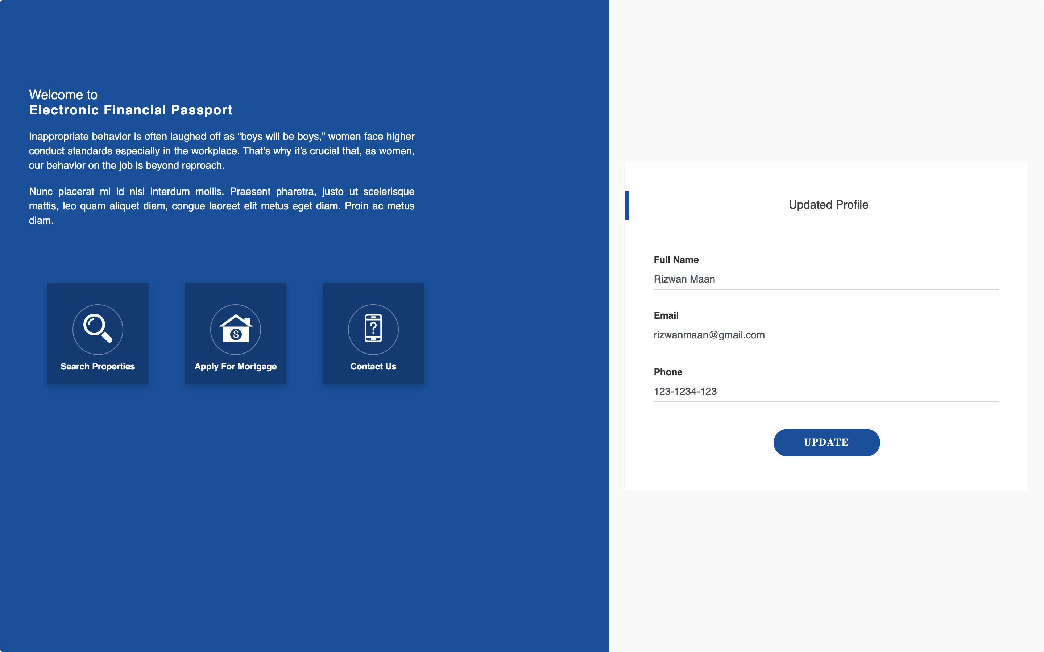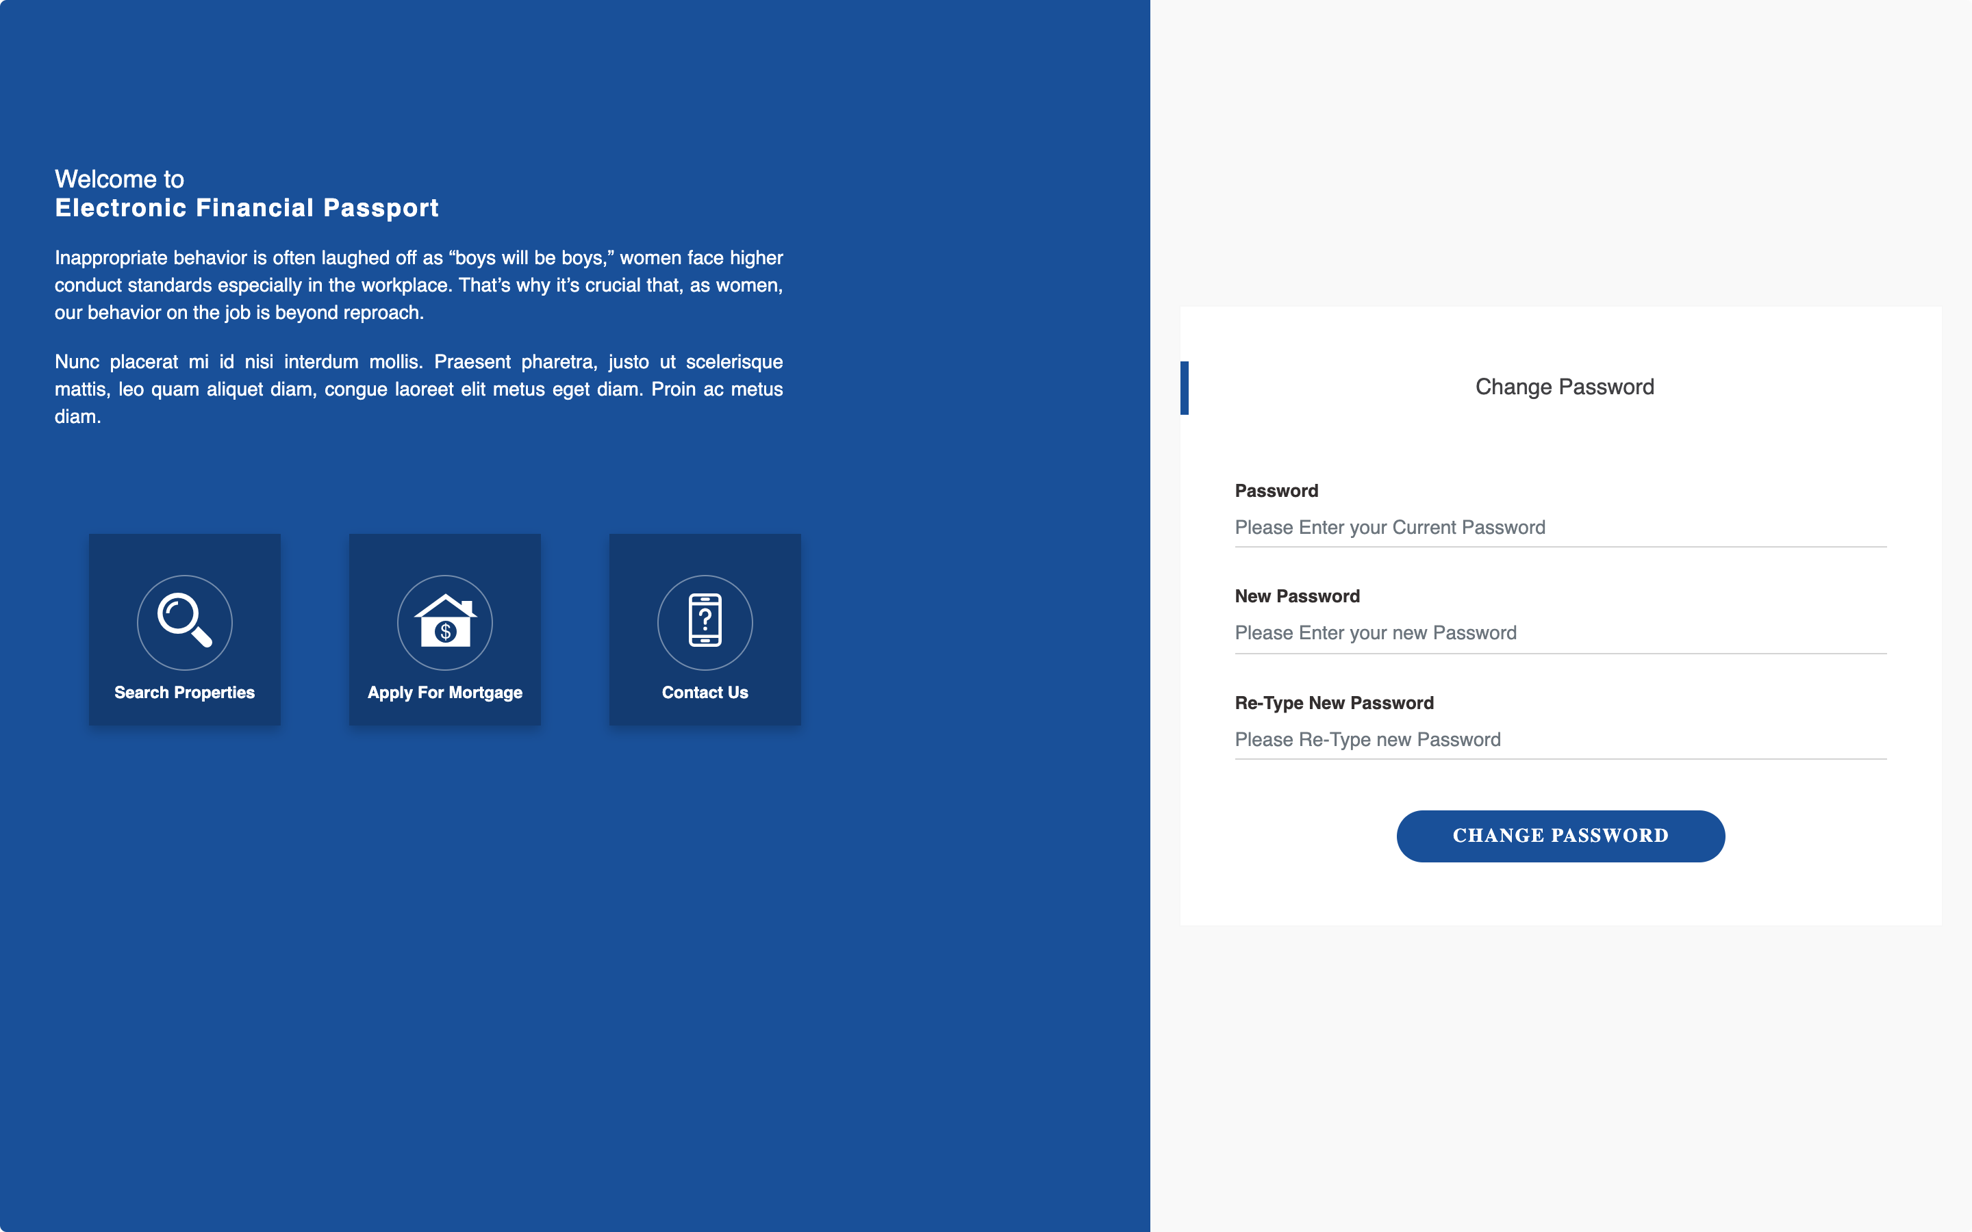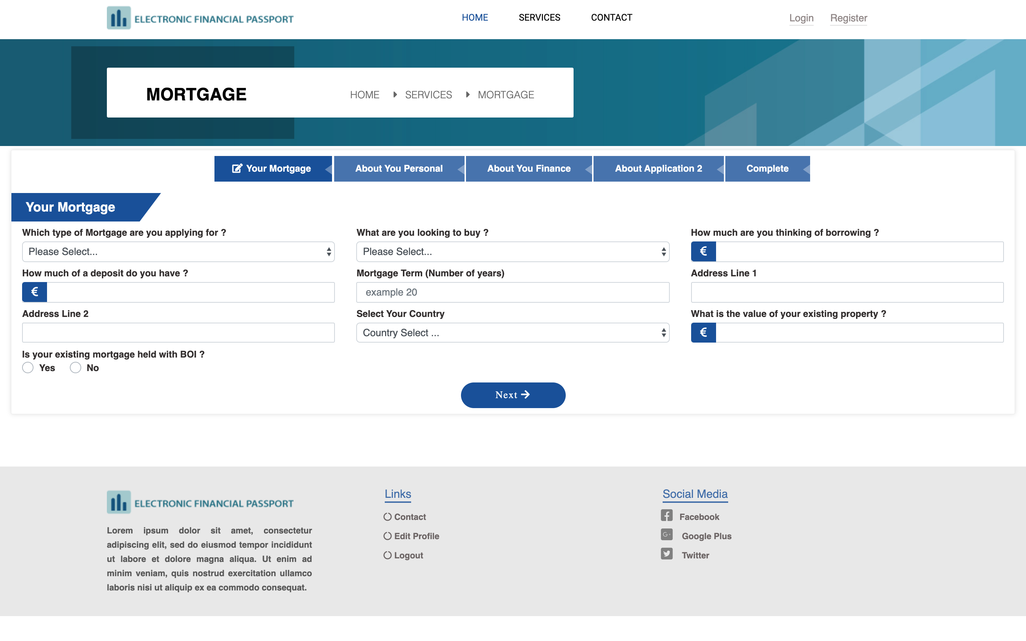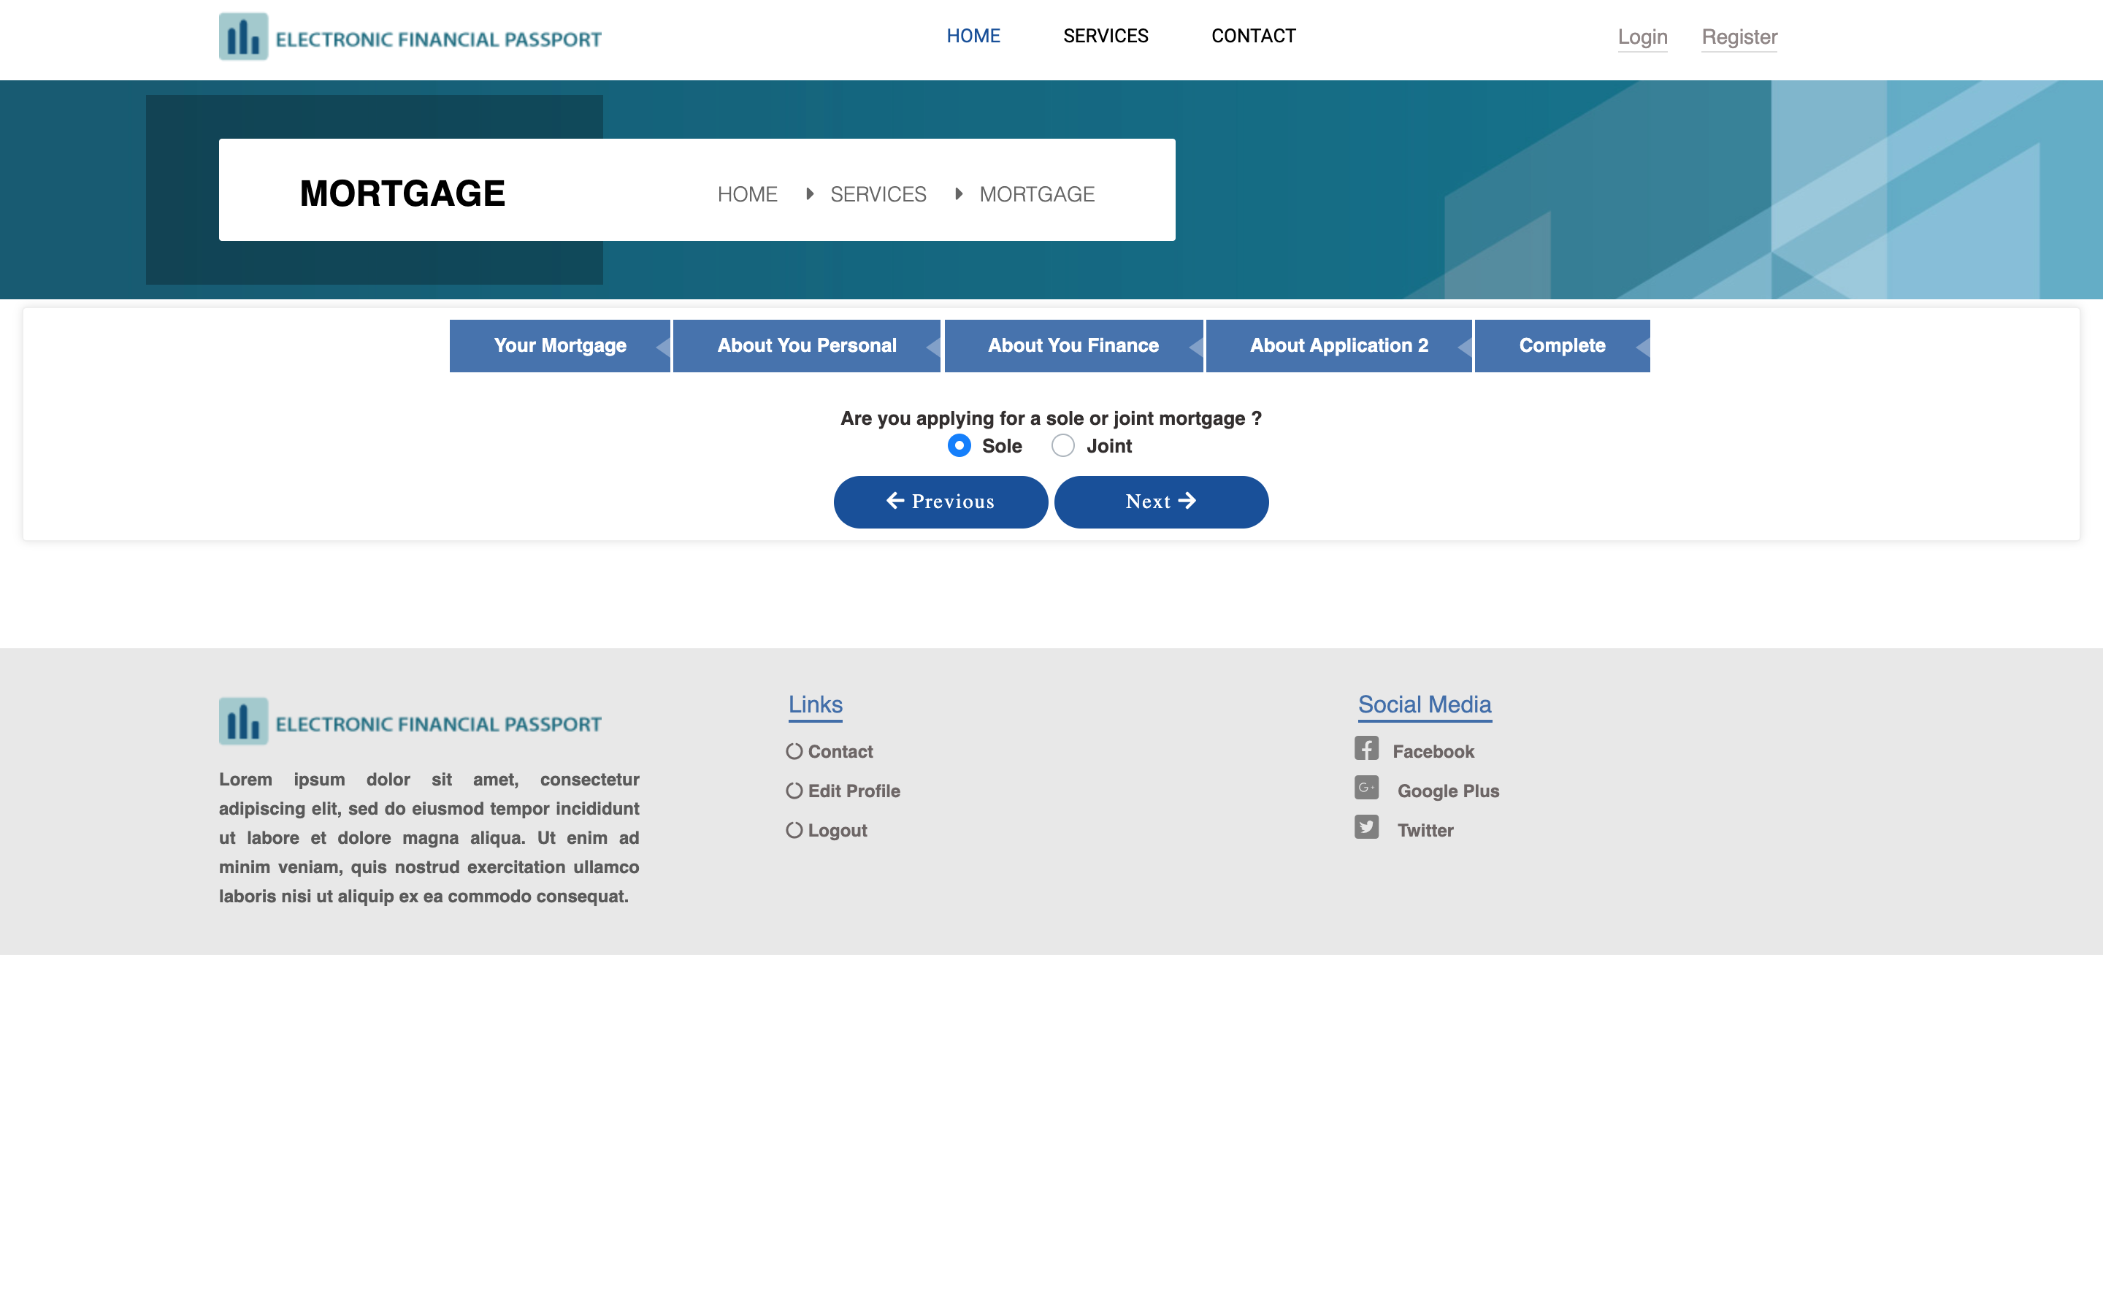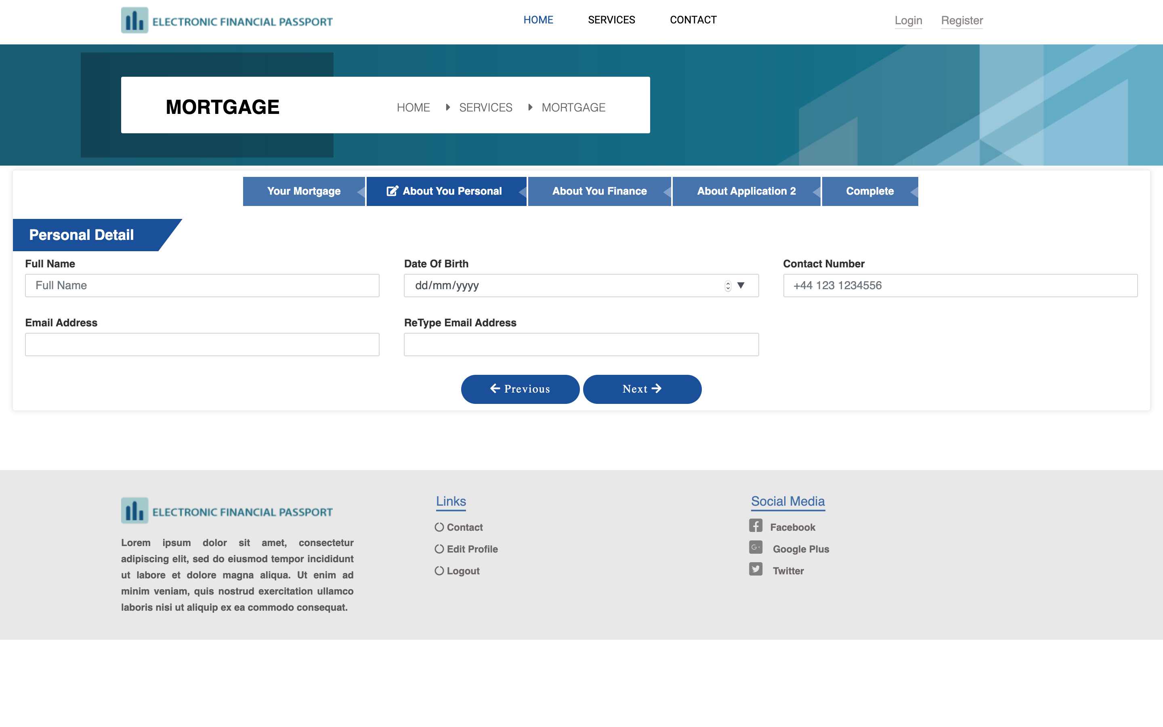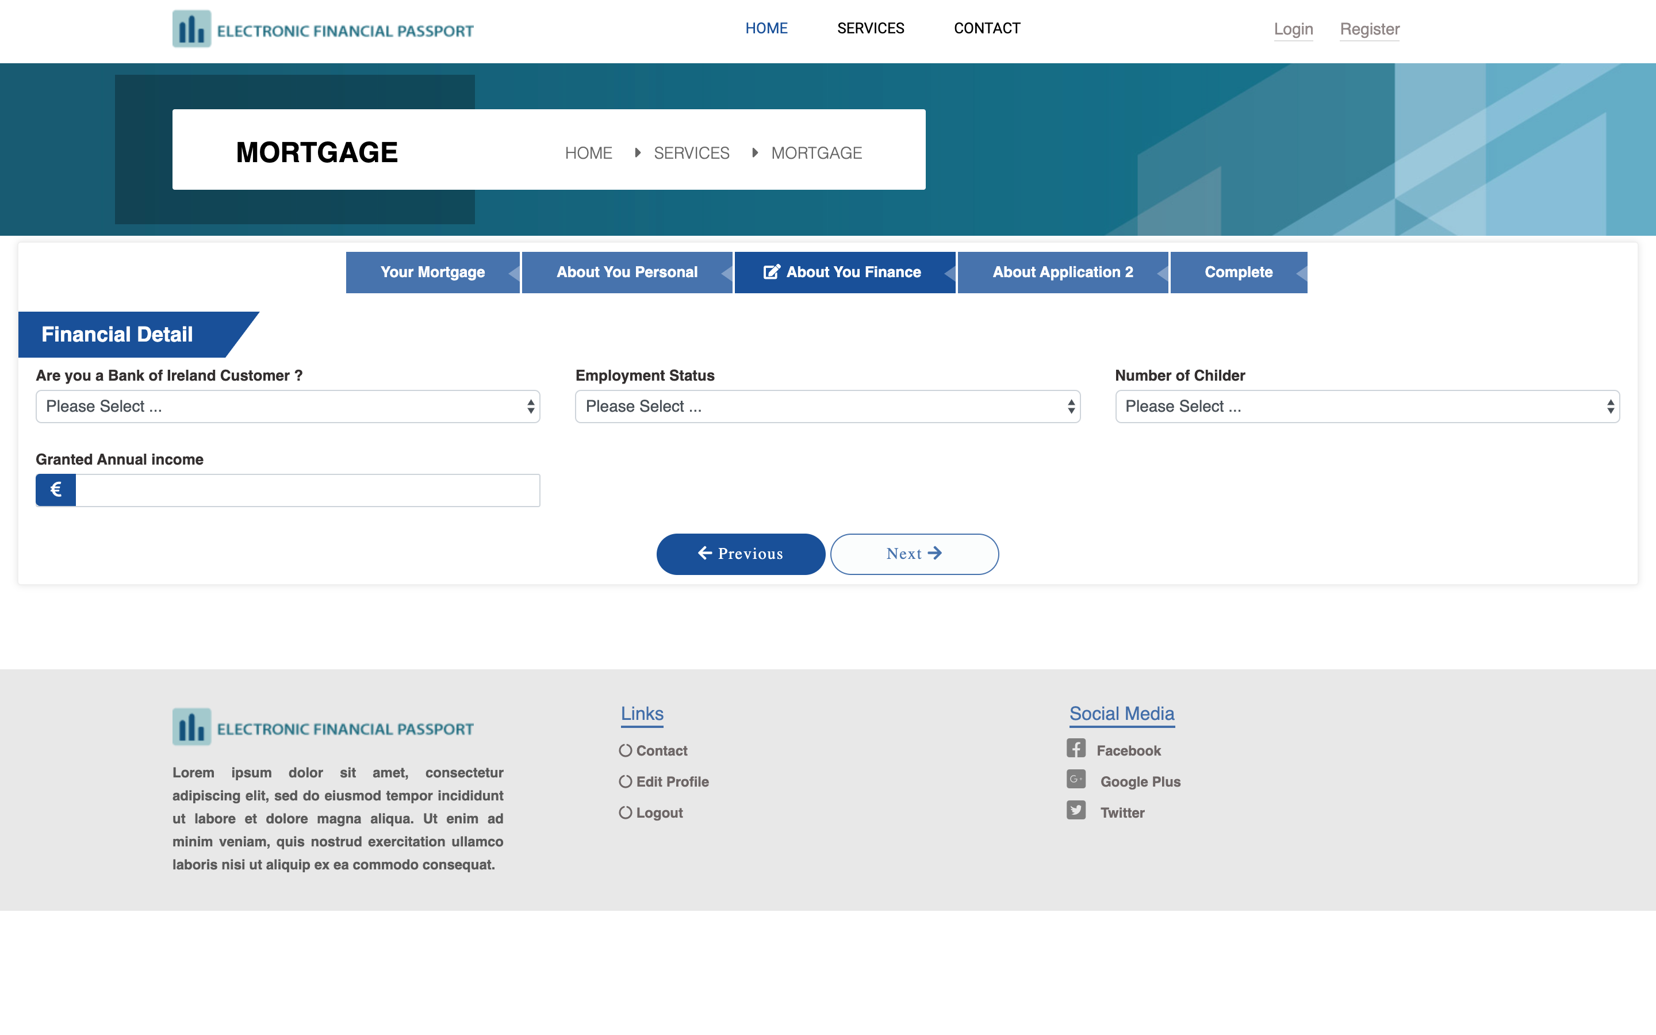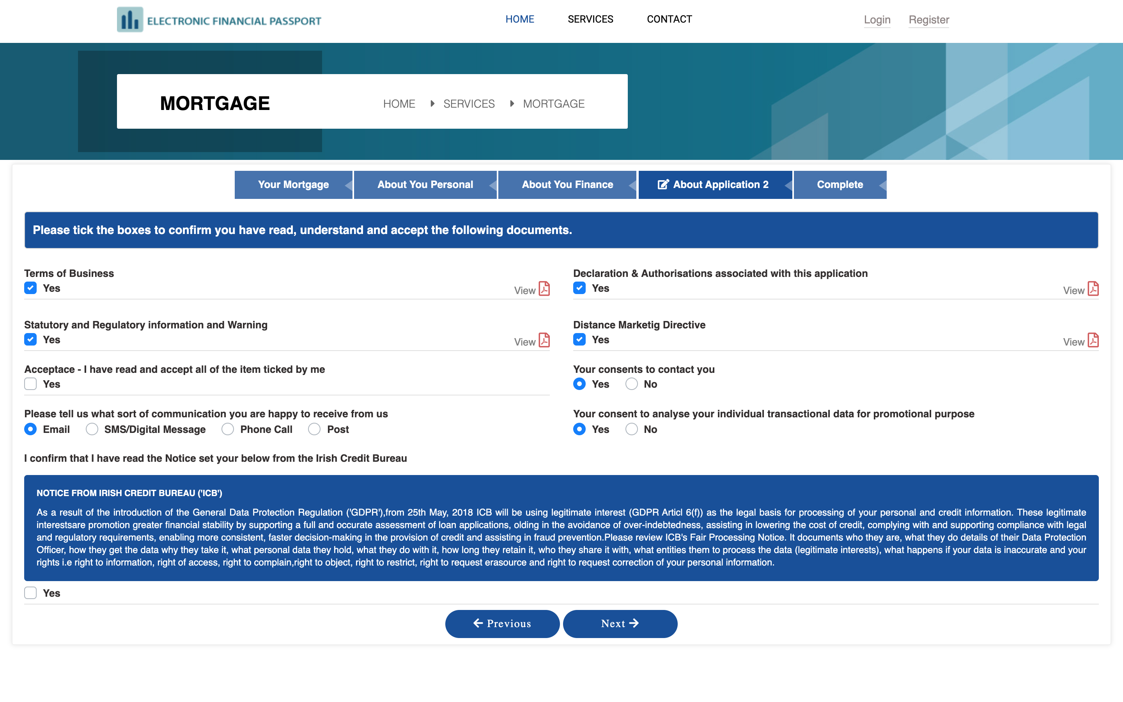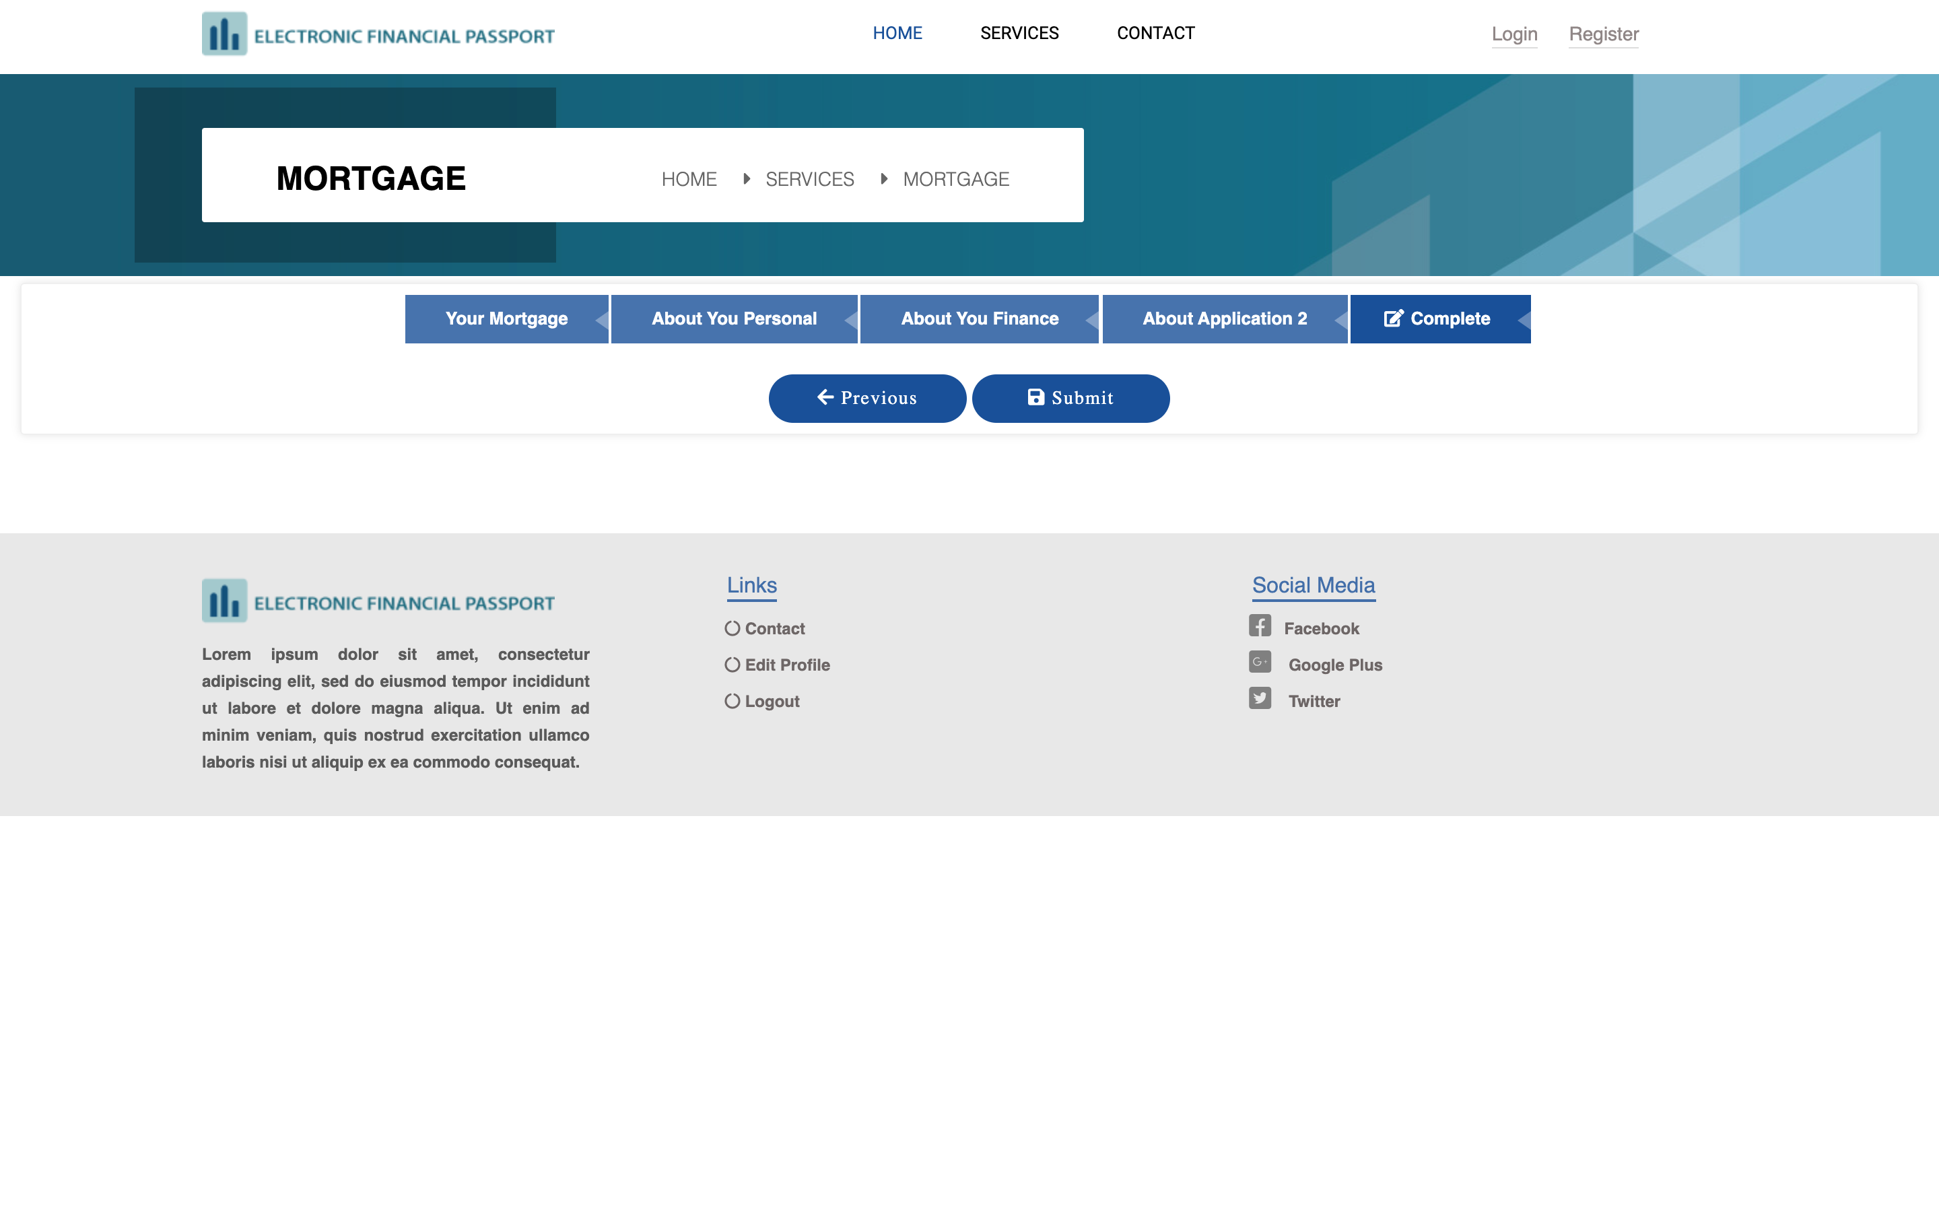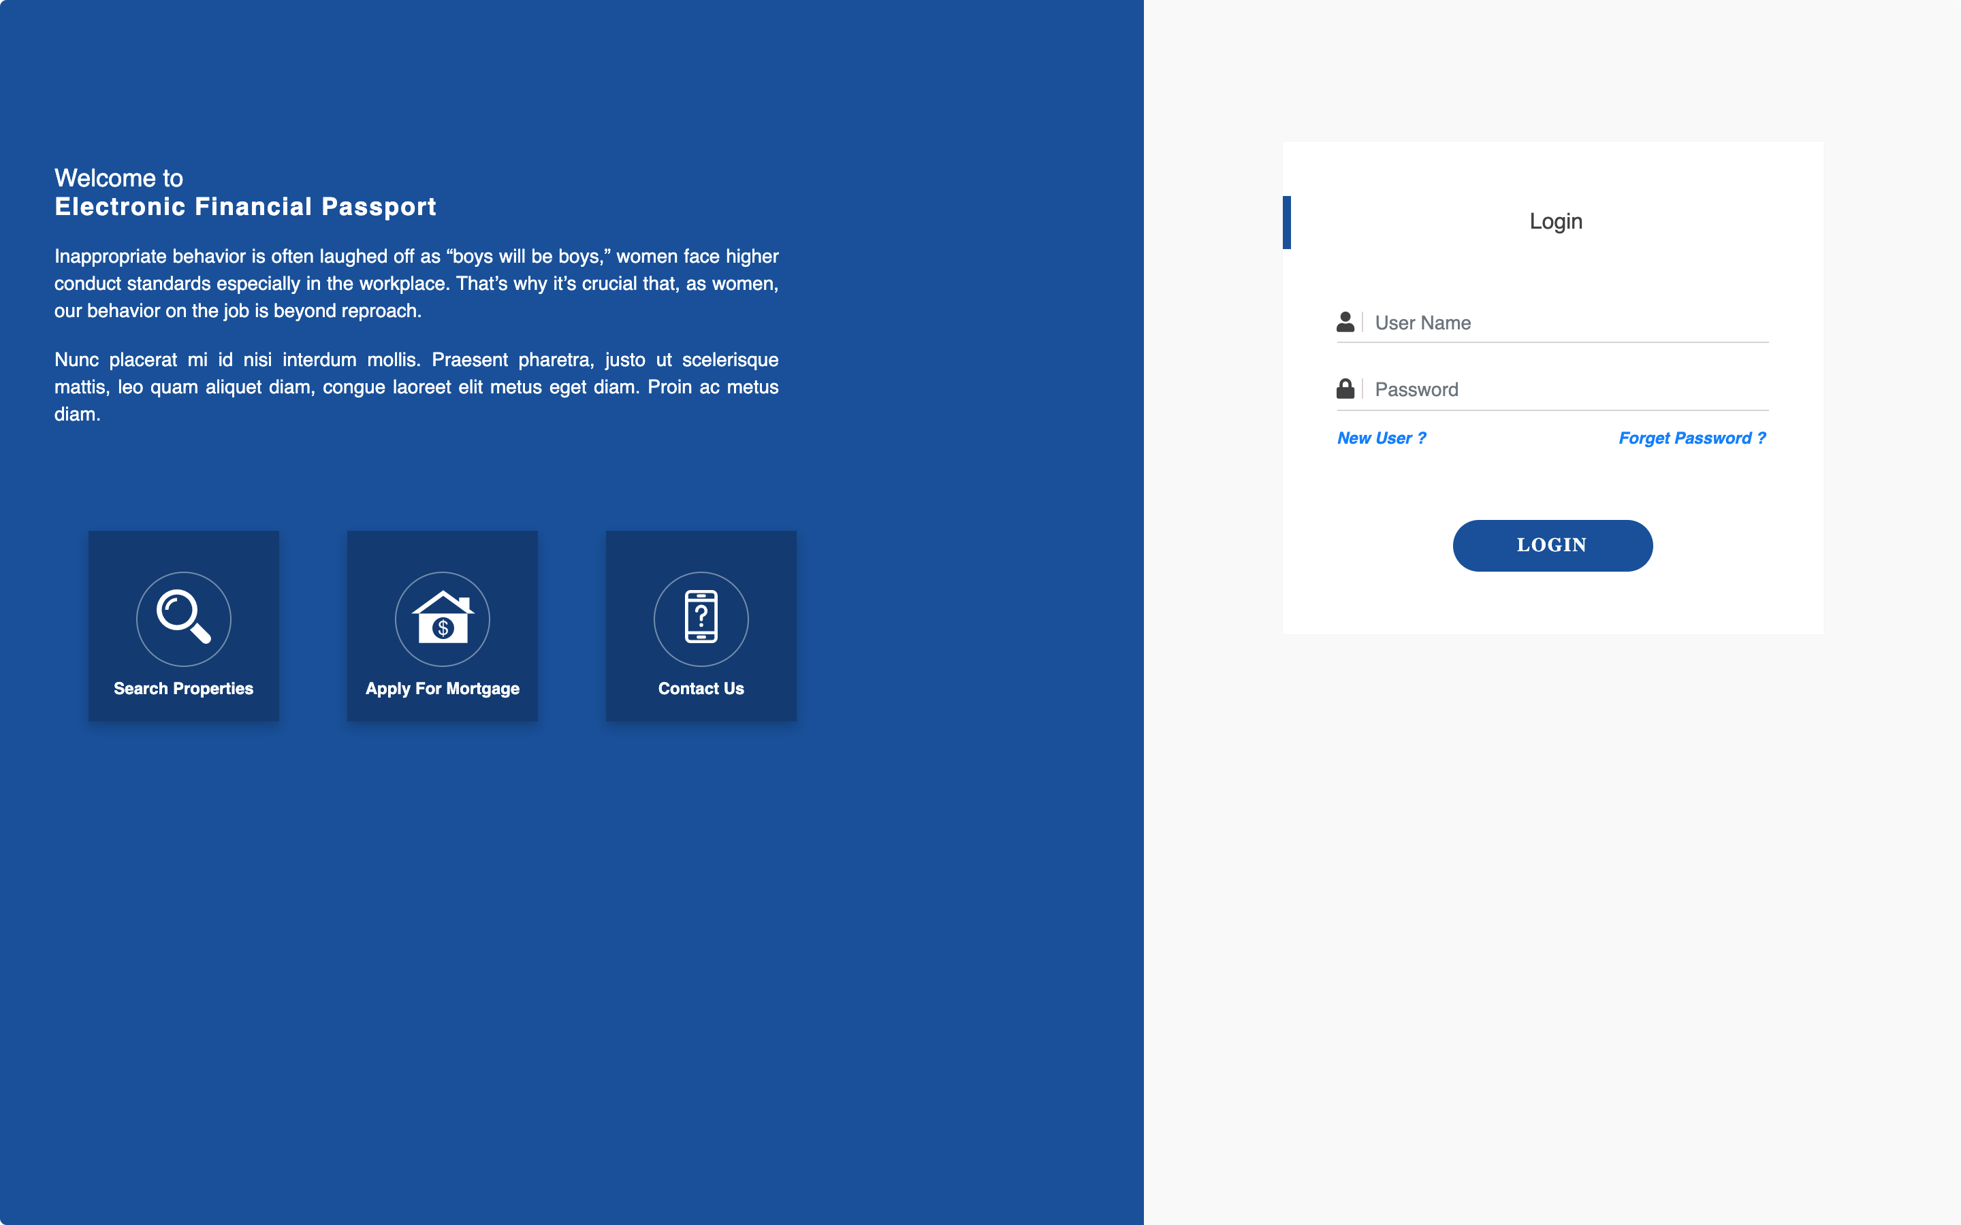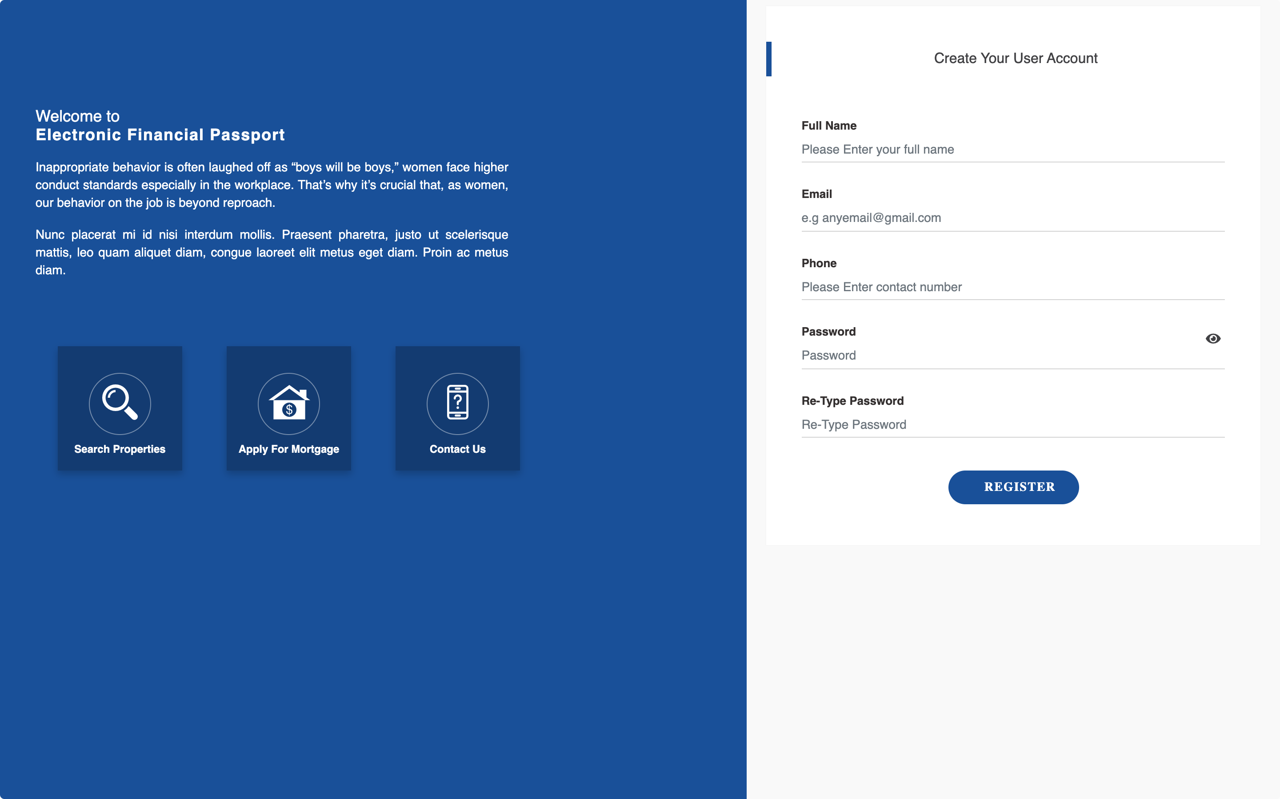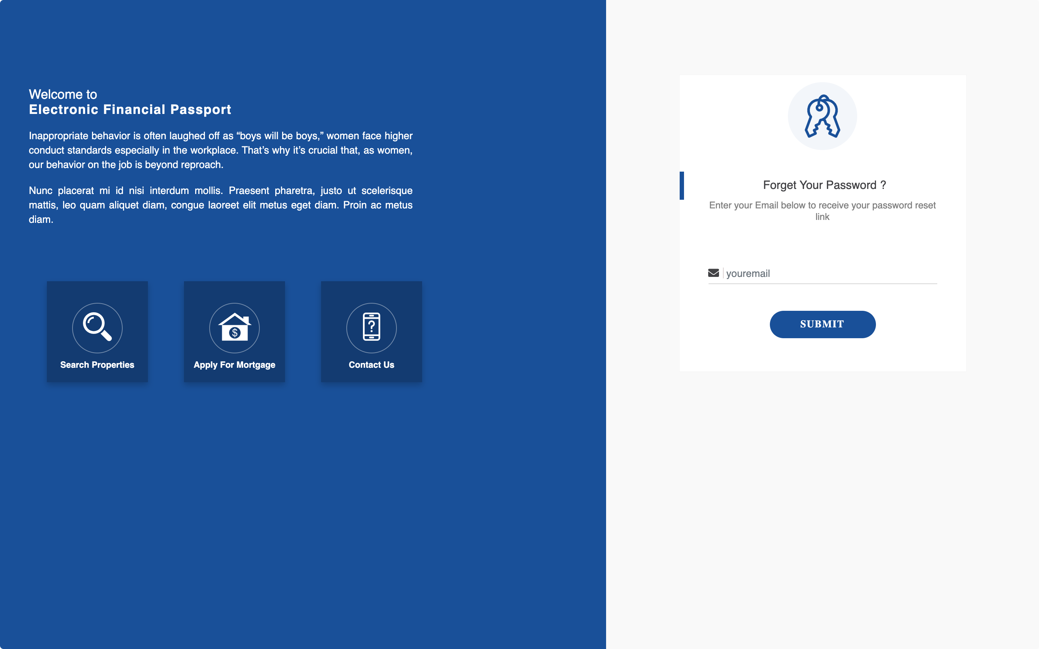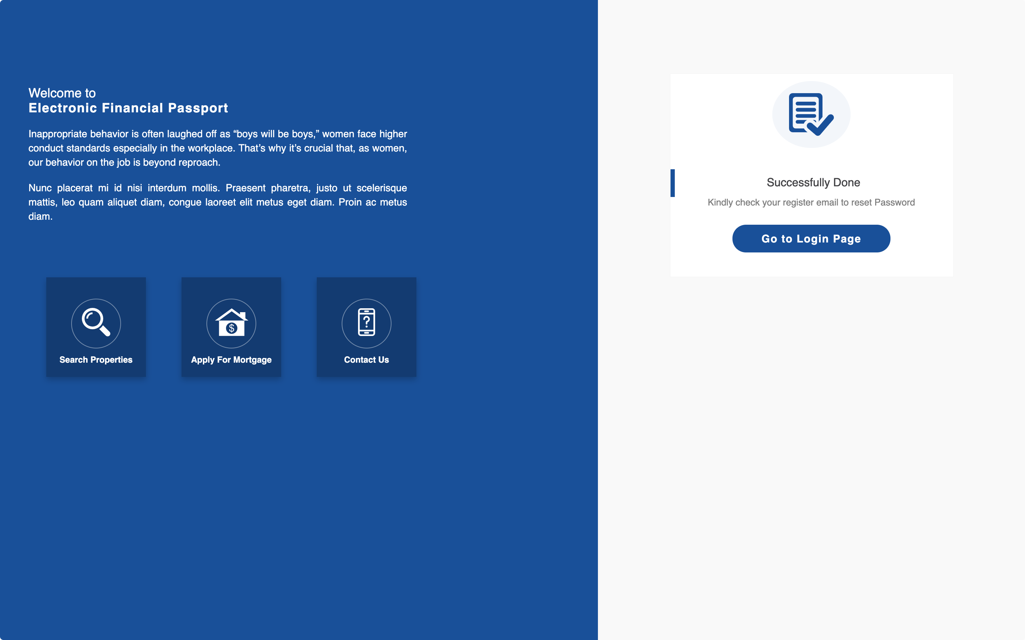

Validation
The process in which the HTML as well as CSS based webpage errors checking is performed, it is known as the validation. It includes numerous important modules as well as concerns. The HTML as well as CSS code is required to be validated so that it would be according to the W3C standards. The W3C standards are being made so that unbalanced HTML tags in the documents which includes the stray characters, duplicate IDs, missing or invalid attributes and other recommendations would be handled as well as resolved.
The code is mostly pasted in the W3C and the validation is clarified. This helps in filling the data in the database with the clean information. It reduced the noise as well as helps in the enhancement of the quality of the user information. The typo errors made by the user which could not be handled anyway can also be resolved with the help of validated forms. For example if the user have entered a five digit numeric value in the year section, it would not be accepted. Also if someone have inserted an alphabet in the numeric input box, it would also not be accepted. There are many other reasons due to which the HTML validation is important which includes the ensuring of the technical quality of web pages.
The underneath web page is being validated and on leaving the empty sections, would result in the error invoking that is very important to be handled. All the webpages are being validated so that there would be no or very less error possibility as well as the quality of the web pages would also be improved.
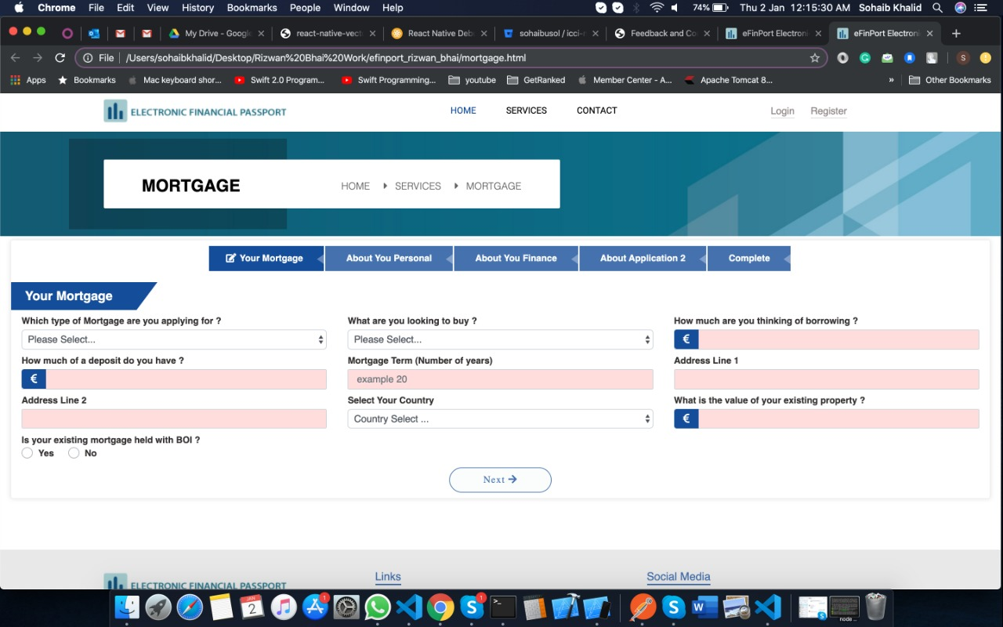
For the purpose of validating the HTML webpages as well as code, the o HTML (http://validator.w3.org/) is being used. On the other side, for the purpose of validating the CSS code, the CSS (http://jigsaw.w3.org/css-validator/) is being used. Both are very important and well recognized as the best in the market for the validation purposes.
After the validation, the final producing of the result was the corrected version of the HTML code. This code is finally used for the completion of the product/website. The code validation is also an important process which helps in producing the completely clean code. The valid HTML is also an important figure that includes the grammar, vocabulary and syntax followed enmity.

Evaluation

Usefulness (usability and utility)
The website is properly functional. All the calculations as well as other necessary data input and output sources are interlinked and connected properly with a keen precision. While discussing the utility of the website, it comes with the discussion of the detailing based on the webpages navigation, and the text boxes functioning. The input of the data in the databases is also properly connected as well as many other aspects. The website forms and design is properly selected as well as tailored so that there would be no confusion for the user. The user can fill the data in the forms one after the other. The important details are being added with red star on the right top of each entity while the non-important ones are left simple.
The colors of the website are navy blue which helps in keeping the site much formal and less floral. It helps in keeping the user’s focus on the computer so that there would be no or very less diversion. The colors play an important role in keeping the user on the site and work as per needed.
The site can be improved with more functionalities added that includes the navigation to the helping websites which includes the law enforcement sites. It is important to know that the quality of the experience of user is very important. The more he will be focused, the positive impact on the user would be improved. In future the website would be enhanced from just mortgage to many other functions as well.

Search Engine Optimization (SEO)
There are many search engine optimization techniques that are added in the website. Some of the most famous techniques that are observed to be commonly used in all sites include the Publish high-quality content, Optimize page titles and Meta descriptions, Optimize page content, SEO Images and other multimedia elements, URL optimization, Headings and content formatting, External links, as well as the Internal links. All of them are very important and they are used preferable for the enhancement of appearance of the website as well as its accessibility to the user with some ordinary keyword searches.
Optimize page titles and Meta descriptions.
The website pages are being titled as per their functions so that the user can directly reach them effectively as well as efficiently.
Optimize page content.
The optimization of the page contents was made on the very first place in almost all the web pages of the website. It helps in the enhancement of the relevance of the site functions as well as the quality of the content.
Headings and content formatting.
The content added in the website is being formatted as per the standards so that the searches would not divert or the site would not be improperly ranked.
SEO Images and other multimedia elements.
The images are being added with proper tags as well as mat-titles so that they would also be ranked in the searches.
URL optimization.
The URL optimization is ready to be made as it is very important when uploaded on the server. It is one of the most important part of the site optimization.
Internal links
There are internal links which navigate the site main content and functional pages to the descriptive pages. They are required so that the user will stay on the site and could fulfill his needs with the help of the content in it.
External links.
The external links are also being added so that the related articles as well as other blog posts would be accessed by the user on one click.
Some of the above mentioned Search Engine Optimization are not included in the website or added due to the lack of availability of resources. They will be added in the future for the enhancement of the website functionality as well as quality of the experience.

Accessibility
aXe: The Accessibility Engine
Axe is the World's most popular accessibility testing toolkit built on the World's most popular accessibility rules library. Axe is ideal for development teams to test their Web, Android and iOS applications to help identify and resolve common accessibility issues.
WAVE: Web Accessibility Evaluation Tool
WAVE is a web accessibility evaluation tool developed by WebAIM.org. It provides visual feedback about the accessibility of your web content by injecting icons and indicators into your page. Version 1.0.5 adds the shortcut key, context menu, allows analysis of local pages, and fixes other various bugs. 2017
Tota11y: an accessibility visualization toolkit
The tota11y panel have help you visualize how your site performs with assistive technologies by allowing you to look at issues such as Headings, Color contrast, Link text, labels or Image alt tags.
AI Inspector Sidebar (Firefoxonly)
Web accessibility evaluation tool for Firefox based on WCAG 2.0 and ARIA. The latest version is being used. The Firefox ESR will be your only installed version.

Conclusion
In a nutshell, the report is including the details about the website. The input of the data in the databases is also properly connected as well as many other aspects. It helps in keeping the user’s focus on the computer so that there would be no or very less diversion. The more he will be focused, the positive impact on the user would be improved. After the validation, the final producing of the result was the corrected version of the HTML code. The typo errors made by the user which could not be handled anyway can also be resolved with the help of validated forms. The HTML as well as CSS code is required to be validated so that it would be according to the W3C standards. The website is properly designed to help in storing the data and several important details that are required to understand the basic rules applied on the mortgage as well as it will also help in the demonstrating the process of how to handle as well as overcome the issues while managing or starting a mortgage deal. The targeted audience would be the people who are interested in the mortgage as well as the investors that are focusing on capturing the market of mortgage. They will be added in the future for the enhancement of the website functionality as well as quality of the experience.

References
[1] Developing Business Applications for the Web: With HTML, CSS, JSP, PHP, ASP. NET, and JavaScript. MC Press, LLC. Hur, C., & Ubelhor, L. [Accessed December2019].
[2] HTML, CSS, and JavaScript All in One: Covering HTML5, CSS3, and ES6, Sams Teach Yourself. Sams Publishing. Meloni, J. C., & Kyrnin, J. [Accessed December 2019].
[3] Web Programming with HTML5, CSS, and JavaScript. Jones & Bartlett Learning. Dean, J. [Accessed November 2019].
[4] Web Design with HTML & CSS3: Complete. Cengage Learning.
Fei, J., Hu, K., Ruan, Q., Wang, P., & Zhu, X. W. (2017). U.S. Patent No. 9,767,083. Washington, DC: U.S. Patent and Trademark Office. Minnick, J. [Accessed December 2019].
[5] Mendes, J., Laranjeiro, N., & Vieira, M. (2018). Toward characterizing HTML defects on the Web. Software: Practice and Experience, 48(3), 750-757. Mendes, J., Laranjeiro, N., & Vieira, M. [Accessed December 2019].
[6] CSS mastery. Berkeley: Apress.Jayaraman, R., Kasthuriswamy, K., Padmanabhan, M., Dharmarajan, S., Thangavel, D. B., & Selamban, P. (2016). U.S. Patent Application No. 14/481,175. Budd, A., Björklund, E., & Bjorklund, E. [Accessed January 2019].
[7] An Approach for Characterizing HTML Defects (Master's thesis). Mendes, J. J. A. [Accessed December 2019].

marking criteria and Student FEEDBACK

This section details the extent to which the assessment criteria are demonstrated by you, which in turn determines your mark. The marks available for each category of skill are shown. Lecturers will use the space provided to comment on the achievement of the task(s), including those areas in which you have performed well and areas that would benefit from development/improvement.

Common Assessment Criteria Applied (Assignment 1) | Marks available | Marks  awarded
1. Engagement with Literature Skills

The required research work is missing from the submitted work. You have simply provided a list of references but these have not been cited in the submitted write-up. (Grade mark: 0.00%) | 25 | 0
2. Knowledge and Understanding Skills

The use of someone else's work does not really demonstrate knowledge and understanding of the skills and this is further evidenced by the discussion of the validation section results. As you have not completed the research exercise properly, this has had an impact on your ability to properly evaluate the website against the requirements of the assignment brief, especially for the accessibility section. (Grade mark: 30.00%) | 20 | 6
3. Cognitive and Intellectual Skills

4. Practical Application Skills

A satisfactory attempt. Please note that the submitted work has used someone else's template and this does not demonstrate your skills and understanding or practical skills. Please note that the University considers this to be an academic misconduct, known as over-reliance on reference materials, see more here: https://www.uwtsd.ac.uk/media/uwtsd-website/content-assets/documents/academic-office/aqh-chapters/chapters---en/Academic-Misconduct-Policy.pdf. Additionally, the work does not actually follow the criteria of the assignment brief and contains a lot of irrelevant work. You were also told not to use Lorem Ipsum text which you have done. (Grade mark: 40.00%) | 50 | 20
5. Transferable Skills for Life and Professional Practice

The report is of a good standard. See your report for additional suggested improvements. (Grade mark: 60.00%) | 5 | 3

Assignment Mark (Assessment marks are subject to ratification at the Exam Board. These comments and marks are to give feedback on module work and are for guidance only until they are confirmed. ) | Late Submission Penalties (tick if appropriate) |  | 29%
 | Up to 1 week late (40% Max) |  | 29%
 | Over 1 week late (0%) |  | 29%

