

Effective Team Working and Communication (BMSW4002_LON)
With Lloyd Beharry
Report on Communication
Communication Models, Skills, Advantages and Disadvantages of Communication Technology


June 28, 2022
By Yordan Georgiev Petrov (212805)
UWTSD London Campus

Contents
Effective Team Working and Communication (BMSW4002_LON) With Lloyd Beharry 0
Introduction 1
1. Models of Communication 2
1.1 Shannon and Weaver Model (1948/49) 2
1.2 Schramm’s Model (1954) 4
1.3 Berlo’s Model (1964) 5
2. Communication Skills 5
3. The Advantages and Disadvantages of Communication Technology 9
3.1 Advantages of Communication Technology 9
3.2 Disadvantages of Communication Technology 10
Conclusion 11
References 12

Introduction

Communication is used daily in all its forms and is considered as a key function of modern people and civilization. Without proper communication cooperation becomes very difficult and with bad communication all kinds of issues can emerge, in life, at work or simple day-to-day tasks. Modern technology also relies on good communication to function and serve us properly. Therefore, it is obviously crucial to modern society. In this report we look at three Models of Communication, Communication Skills and the pros and cons of the Communication Technology, using case studies and personal examples to discuss and to provide recommendations to improve Communication, and Communication Technology.

Models of Communication

Shannon and Weaver Model (1948/49)

“Shannon Weaver model of communication was created in 1948 when Claude Elwood Shannon wrote an article “A Mathematical Theory of Communication” in Bell System Technical Journal with Warren Weaver. (Businesstopia, 2018)“.

The model is the foundation of communication models as it’s often referred to. It is composed of five components – Information, Sender, Message, Channel and Receiver. This is a simple model and explains the basic function of technology. The sender sends information as a message through a channel through which the Receiver gets it or as the explain “Communication has occurred when a message has been sent and received.” (Shannon & Weaver, 1948). This means it is a one, way model.
In class we looked at a case study called “Maria and Pedro” where Maria asks Pedro to get her a chicken on his way home but, he misunderstood that she would wait for him in the kitchen instead. This is a perfect example of Noise in the model and as a result the message was not decoded properly. This function of the model was not added until 1949 as in the image below. The model does not explain how this could be avoided, unlike later published models of communication.
When I reflect on my work experience, I remember many examples like the one in the Case Study. In a busy restaurant environment, there is not much time for communication, and we could easily get confused as waiters. As English is not my native tongue, I sometimes struggle to understand the table numbers because of all the noise and chatter around. Therefore, I always prefer to check the order ticket myself and all the details like the table number to avoid any confusion.

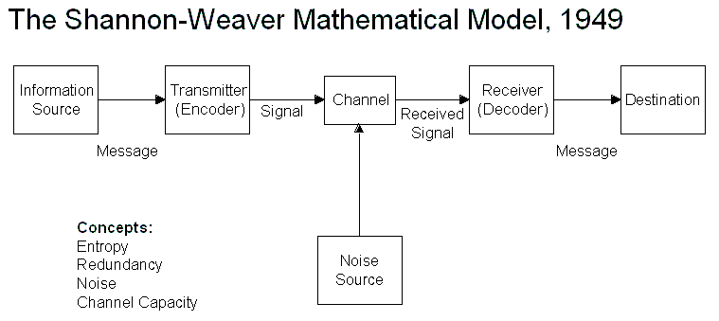

Schramm’s Model (1954)

Wilber Schramm proposed his communication model in 1954. This model is very important because it includes and shows the importance of Encoding, Decoding and Feedback to Communication. When the information reaches the receiver, it’s up to him or a device to decode the message and/or understand it correctly. Then the Sender would need feedback to confirm the information was correctly received and/or decoded. Schramm was convinced the flow of information in Communication is a two-way route.
In the case study “Maria and Pedro” the misunderstanding could have been avoided if there was feedback present, as Schramm explains in his model. If he had called back Maria for example, she would confirm if the message was correctly received, and the confusion would be prevented.
Another example I can come up with from my profession is when a customer orders wine that has a foreign name that I find difficult to pronounce or remember. In such case I always ask them to point it in the menu or I double check myself before I order it. This way I have feedback and I decode with the help of the menu the customer’s desired wine and avoid any issues that could lead to such a misunderstanding.
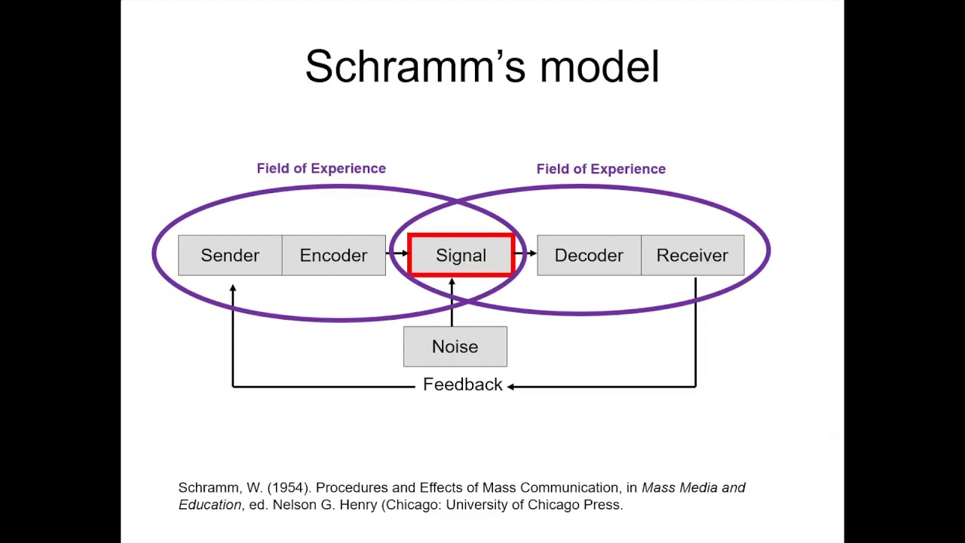

Berlo’s Model (1964)

Berlo’s model was created in the 1960s and is very similar to Shannon and Weaver’s Model from 1948/1949, from which he developed it. It has only four main components - Sender-Message-Channel-Receiver (SMCR) but each is affected by a lot of factors. It also empathizes on the Encoding and Decoding much like Schramm’s Model from 1954. Some of the factors related to each of the four main components of the model are Communication skills, Knowledge, Code, Hearing, Seeing, Social System, Culture etc.
A big criticism here is that there is no feedback included, thus the sender cannot confirm if the message was received and decoded at all. Another one is that Noise isn’t accounted for and so on.
As I reflect on the case study we covered in class – “The Professor and The Village People” I can see what a big influence some of the secondary factors shown in Berlo’s Model had in the situation. The cultural and social differences as well as education made all the difference between the professor’s house and ashes. The language used by the panicked professor was like a code that the common people of the village simply couldn’t decode. There might have been better ways to send the message in this situation, but the attitude also played a role and the result in the case study was clearly bad, all because of failed communication, again highlighting the importance of it and how many, if countable factors can play decisive role in extreme situations like this one.

Communication Skills
Communication involves the use of verbal and nonverbal skills. Both are very important for successful communication, if one of the participants does not have proper communication skills it might lead to poorly communicated and interpreted messages being completely misunderstood.
Verbal communication can be oral or written. Nonverbal communication includes facial expressions, body language, eye contact, signs and gestures and signals. The most important is to send a clear message when using verbal communication. Clarity can be improved when speaking slowly and clearly, using words that describe exactly the meaning and when body language is used correctly to support the meaning of the message that is being communicated.

- An important factor in verbal communication is empathy. If we don’t use empathy in verbal communication, it might come across as senseless. Tone of voice and facial expressions play a big role in empathetic verbal communication.

- Sincerity is another important aspect of successful verbal communication. To show respect and be calm and natural is what shows we are honest and will improve the level of commitment to the communication process.

- It is also important to have eye contact when using verbal communication, it shows that what we are saying is important and we are honest.

To have successful written verbal communication it is most important to know who we are addressing and choose appropriately the language used. If we do not know the person we are writing to, it is best to be formal and avoid everyday language and jargon.
Nonverbal communication occurs all the time. By using eye contact, body language like posture, hand gestures and such, to facial expressions and even the way we are dressed. We shouldn’t contradict our verbal and nonverbal expressions.

- Silence can mean disagreement, lack of desire to communicate or even dishonesty and is an important aspect of nonverbal interaction.
- Body language also uses space to communicate. Most people will let a person they feel close to or like much more in their personal space, unlike if it is a stranger to them, then they would keep a bigger distance and protect their private space. Also, different cultures have different understandings of the meaning of this kind of body language and private space. A good example is most middle eastern Muslim societies where it is a crime to get too close or touch a woman if you are not married.

- Probably the most obvious of the different aspects of body language is posture. The different postures when we stand, sit, or even lay send a strong and clear message about how we feel. For example, if we crossed our arms and legs, it generally is understood as unapproachable.

- Appearances and should be in harmony with the occasions. We should be able to identify the context of a meeting and measure correctly the level of formality.

In class we examined a case study called “A Day with the Chief” where a top salesman named Mark was working for a London branch of a US based corporation was invited to meet the CEO of the company, Mrs. Brown in their headquarters across the Atlantic, in California. He had heard rumors from colleagues that she was a very strict and harsh person, known to have fired people who she did not approve of. That made him nervous and kept him very formal in his behavior. But after they met in her office, and she was very welcoming and kind, he was surprised. After a short time, the conversation became more friendly, he felt her as a friend. Then she asked him for advice on how to improve performance and sales in the London office. Because he was comfortable and less formal, he explained to her like to a friend, using non-formal language, that his boss had made mistakes and that he thinks they deserved to be patted more. After he said that, Mark’s boss became very angry and sent him out, quite rudely. The big mistake he made in this situation was that he misjudged the formality level of the meeting and got too relaxed when he should not have. That probably would not have happened if he kept the formal tone and did not criticize his supervisor. He missed a big chance to impress an important person, even worse, he made a very bad impression because of that.
Another important skill related to communication is effective listening. Active or attentive listening, empathetic listening, a very important skill for good communication but, it is often neglected as it is not taught like reading, speaking, or writing skills. It is hard to be a good listener. As most companies and organizations have focused on increasing the flow of information, it is also of great importance to be able to receive and remember this information. Research shows that most people remember only about 50 per cent of what they heard and only 25 per cent after two months. Furthermore, data reveals that an average employee in the office would typically spend about 39 per cent of the day transmitting information and 61 per cent – receiving information, 45 percent of which is in the form of listening. (Stanton, 2004).
In class we examined a case study called “Multi-tasking Max” in relation to effective and empathetic listening. In the study, Max is a very good event organizer, he worked from home and received bookings and enquiries by phone. The business was new, and he was the only worker, so he had to do everything himself. A customer called Tamara whose wedding he had organized in the past now booked him for her parents’ 50th anniversary, a large event in a special location that he had to book. His hands were full but still, accepted the opportunity. A couple of weeks later Tamara called Max asking to change the date of the event to an early date due to unexpected circumstances. Max was talking to another customer on the other line and quickly agreed. On the day of the anniversary agreed, Tamara and her family went to the hotel they had asked Max to book but, to their unpleasant surprise, another event was taking place on that day. It turned out that it was because Max did not pay much attention to her request to change the date. Because he was talking to another customer at the time and didn’t write down the new date in his notebook, he forgot about it. She was very upset and angry at him; the whole plan fell apart. When she called him, crying and shouting, very rudely, she told him that she will never trust him and will tell all her friends how he failed, called him rude names, and refused to re-organize the event, even when he offered half price and many apologies. Because he wasn’t actively listening to her, when she requested a date change, and agreed so quickly, he failed miserably. In this case it is very clear how important listening is and what dire effects it could have on communication. The result is a disaster.

“It is impossible not to communicate – that is, the absence of words does not mean that there is absence of communication.” (Stanton, 2004). Even when the information is received and understood completely, it is still not guaranteed that the task or request will be executed properly if it is not accepted and agreed upon. There for, every communication skill is important and has its part in successful communication, verbal or non-verbal and should be developed and used properly.

The Advantages and Disadvantages of Communication Technology
Like any other technology, communication technology gives us many advantages, as well as some disadvantages that cannot be ignored. Communication is crucial for a successful business and any environment. It improves team effectiveness, helps reduce conflict, improves relationships – internally and externally, enhances worker commitment and builds a supportive network.

Advantages of Communication Technology

Modern communication technology certainly provides great benefits in any environment where communication is present. “Information - Communication Technology (ICT) is a general expression for a variety of different computer, information and communication devices, applications, network and services.” (Ramey, 2022).
Here are five advantages of communication technology:
- Communication – emails; smartphones and social media; internal and external business communications; online video conferencing.
- Access to Information – online search engines provide cheaper, quicker, efficient access to information, increasing productivity and quality of life.
- E-Commerce – “IT can help an organization to enhance their competitive edge in the marketplace, by encouraging knowledge transfer and strategic thinking” (White, 2021)
- Entertainment – Access to on-demand content in real time from any location and distance.
- Address Mapping – GPS, Navigation – we cannot imagine life and business without this technology.
- Creation of Employment – Remote work cuts costs and provides high paying jobs in many sectors that would not exist otherwise.
- Cuts through Cultural and Language Barriers – it has never been easier to communicate with people and business from cultures and languages.

Disadvantages of Communication Technology

With every technology comes some disadvantages, and communication technology is no exception. Here are some of the disadvantages of modern communication technology that an organization face:
- Privacy – Our privacy has never been under such constant pressure due to the internet, social media, etc. Businesses must invest in security since they might be a victim of cyber attacks and private information could be stolen or leaked, causing major losses for the involved.
- Poor Substitute for Face-to-Face Communication – “This has resulted into increased bad relationships at work. Even though the shy ones will benefit from this technology , but they will also be denied the chance to learn how to interact with others.” (Ramey, 2022)
- Online Bullying – As people become more and more connected, a new type of bullying appears – cyberbullying. Many falls victim to on-line tyrants or trolls. It may include spreading lies, sending hurtful, abusive, or threatening messages, images, or videos via messaging platforms and impersonating someone and sending mean messages to others on their behalf or through fake accounts. (UNICEF, 2022)

Conclusion
Communication has always been the center of importance to human civilization. We live in the era of communication and communication technology was the key to achieving modern civilization. It will never cease to develop. The foundation were the models of communication, then the Internet and social media. It is hard to tell what the next big change will be but, it is certainly coming.

References
Berlo, D. K., 1960. Process of Communication. Hardcover ed. s.l.:International Thomson Publishing.
Businesstopia, 2018. Shannon and Weaver Model of Communication. [Online].
Ramey, K., 2022. Advantages and Disadvantages of Communication Technology in an Organization. [Online]
Available at: https://useoftechnology.com/advantages-disadvantages-communication-technology-organization/
[Accessed 5 September 2022].
Schramm, W., 1954. The Process and Effects of Mass Communications. 1st ed. Illinois: University of Illinois Press.
Shannon, C. & Weaver, W., 1948. The Mathematical Theory of Communication. 1st ed. Illinois: University of Illinois Press.
Stanton, N., 2004. Mastering Communication. New York: Palgrave Macmillan.
UNICEF, 2022. Cyberbullying: What is it and how to stop it. [Online]
Available at: https://www.unicef.org/end-violence/how-to-stop-cyberbullying
[Accessed 5 September 2022].
White, D., 2021. 5 Advantages and Disadvantages of Information and Communication Technology in Business. [Online]
Available at: https://www.techfunnel.com/information-technology/5-advantages-of-information-and-communication-technology-in-business/
[Accessed 5 September 2022].

