

Entrepreneurship (LCBB5001)
Name: Bianca Petronela Paunescu

Student ID: 2024896

Name of Lecturer: Riaz Bhatti

Title
Business Plan

Table of Contents

- Business Description……..………………………………………..…......2
- Industry Analysis…………..………………..…………………….….…...3
- Operations and Management Team....………………………………....7
- Marketing….…………………………………………………………....….10
- Financials…….………………………...………………….………..….....15
- Reference list…………………………….……………………………......18

BUSINESS DESCRIPTION / MARKET OPPORTUNITY
LOGO: 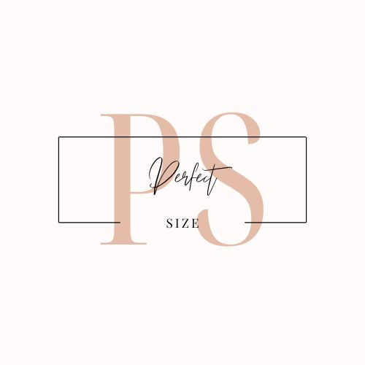

Shopping should be a relaxing and fun activity. In the post-Covid 19 world, where shopping takes place mainly online, it has become more and more difficult finding the right size when it comes to clothing. This is one of the reasons why a lot of buyers abandon the shopping card, as they are being unsure of the sizes proposed by the sites.
Our company, PerfectSize, has now came with a solution to this hustle. Using AI technology, all women can have their own fully customized gym wear, without even leaving the comfort of their home. After they find what they like on our website, they simply download the virtual fitting room app to take a 3D scan of the best-fitting item. Once that is done, we use AI to custom-design and manufacture gym wear just for them and we deliver straight to their doorstep.
The innovation behind the PerfectSize app is what sets our company apart from other competitors, as we were able to envision the future of online shopping and bring it to our customers.

INDUSTRY ANALYSIS

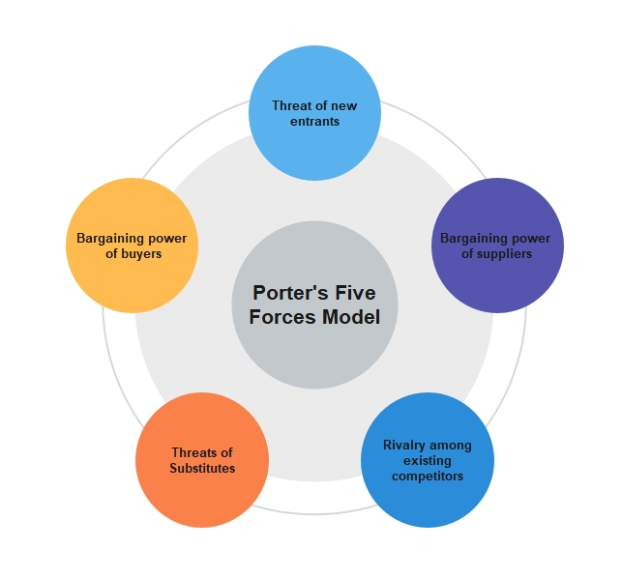
Using Porter's 5 forces will help a company better understand how profit is distributed among the 5 forces in a given industry (Brujil, 2018).
Creating a competitive strategy to generate long-term value for stakeholders and coming up with new, engaging ways to surprise customers are both necessary to survive in today's hypercompetitive market environment. In order to shape an organization's future, it is more important to outperform and outthink competitors than it is to simply place the organisation to seek a competitive advantage (Barringer, B., Ireland, D., 2019).

Threat of new entry
We are looking at a new and revolutionary market, different from the options available on every site or every retail shop. The costs involved for entering this market tend to be higher than usual, as we are not only required to have a physical/virtual space and a stock but innovating the shopping experience through an Artificial Intelligence app, which requires constant updates.

Threat of substitutes
We are a focused gym wear company who are using an inventive technology in order to provide the best customised items to customers. First of all, we have a good clothing range, from bras to top to leggings. Not having vast categories of clothes, helps provide better attention to each item, constantly improving quality and features.
Secondly, the main focus is not on clothing per se, but on the experience of buying a new gym wear set, knowing for sure it will be the right size and fit.
Therefore, looking for a substitute which can replace the product and the experience is not easy.

Bargaining power of customers
After Covid-19, people got used to a more casual way of dressing, mainly due to the fact that they spent most of their time indoors. Even now, with restrictions being lifted, people still prefer a comfortable attire for day-to-day activities. Hence why gym wear has become more popular than ever, no longer being used strictly in the gym, but indoors and outdoors as well. There are many gym wear options available on the market, however not many of them use AI technology to improve their services. This provides our company with an advantage when it comes to pricing and deals.

Bargaining power of suppliers
When it comes to supplying the clothing, changing suppliers won’t make a massive difference to the product, as we will be looking for suppliers who can offer competitive prices, use similar or improved materials and who are able to create new designs.
However, maintaining a good relationship with the app developers goes a long way. They are the ones who understand the vision we had when we implemented the app and they will have to constantly make improvements and updates and fix any bugs that might appear on the app (Investopedia Team, 2022).

Competitive Rivalry: who are your main competitors and how can you differentiate yourself from them

As the business is very innovative, there are not many competitors based on the market research.

Name of competitor | Differentiation
Competitor 1  Amazon | Our shop is a niche shop, focusing on female gym wear clothing and using all the resources to provide the best options for all customers. Apart from that, the AI app is different than the app used by Amazon, as our app helps the customer order their right size and fit, where Amazon provides a virtual wardrobe where customers are able to see how the clothes will look on them.

OPERATIONS AND MANAGEMENT TEAM
OPERATIONS
PerfectSize Ltd. is a private limited company established in UK and it’s a separate entity from its owners (Gov, 2022). We are a small-medium size business, with the opportunity to become a leader in the revolutionised gym wear industry. In UK, there are four types of companies, such as:
- Public limited company (PLC)
- Private company limited by shares
- Private company limited by guarantee
- Private unlimited company
We choose private business limited by shares because is the most common type of company in the UK, with over two million registered at Companies House. They are more frequently known as private limited corporations, and their names must include the word "Limited" or the abbreviated suffix "Ltd."
The fact that, like public limited companies, the amount for which shareholders are liable in the event that the company is dissolved is limited to the reserves of the firm, is one of the primary reasons why this specific type of company setup is so popular (Netlawman, 2022).

Client experience: PerfectSize is a women gym wear clothing company, which uses an innovative AI technology to provide customised items and the best fit to customers. Once the item has been selected, AI app works as a virtual wardrobe. A virtual scan of the individual wearing their ideal bra, tops, leggings, takes place, to analyse their height, weight, etc. Then a set of questions must be answered, including questions like size, fit, length. And it’s done! It all takes 2 minutes.
The clients receive their order, and they are pleased to find that the items fit them perfectly!

Business operations:
Clothing side of business: Our range of clothes includes:
-bras (will have options to select a different size, choice of colour and design)
-tops (will have options to select a different size, choice of colour and design)
-shorts (will have options to select a different size, choice of colour and design)
-leggings (will have options to select a different size, choice of colour and design)
The clothes are manufactured in China and our supplier sends the stock to our warehouse in London. Two vans are always ready to pick up an order and delivery it on time.

AI App side of business:
The App has been developed to make it easier for customers to find their perfect fit, using artificial intelligence, and it took a year to finalise the product. The IT team has been working hard on making the process as simple as possible, hence why with only a couple of pictures and a few questions, everyone can get the right size for them.

How would you generate revenue for your business? E.g., How would you prevent loss of revenue?
Our strategies when it comes to attracting customers and generating revenue are the following:
- Promotions on social media and website
- Offering discounts to returning customers
- Email marketing
- Listing the products on different platforms
- Stay in touch with customers by sending them newsletters, reminders, etc.

MANAGEMENT TEAM

Name | Skills | What do they bring to the firm
Bianca Paunescu-CEO (Chief Executive Officer) | Project Management & Decision Making | Bianca is involved in any decision-making process and oversees all business processes.
John Smith-COO (Chief Financial Officer) | Finance & Problem solving | John is the bookkeeper, the one overseeing all the finance aspects of the business.
George Hoskin-CTO (Chief Technological Officer) | IT & Technological | George is dealing with the website and the app, debugging them, the ensure a smooth process for our customers.
Gemma Holland-CMO (Chief Marketing Officer) | Marketing & Creativity | Gemma creates and updates all our social media pages and advertisement analysis.
Katie Phillips-Operations Manager | Customer service & Packaging | Katie is supporting our customers with all their enquiries and questions and also deals with the packaging process.

MARKETING: The Four P’s must be used to describe your marketing strategy
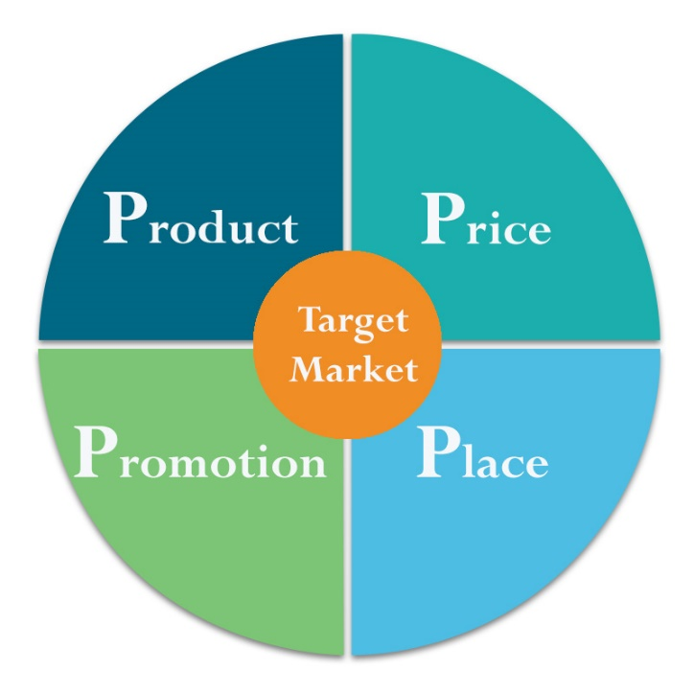
The process of generating, conveying, delivering, and exchanging products and services that are valuable to customers, clients, partners, and society at large is known as marketing. A marketing idea known as "the four Ps of marketing" enumerates the four essential components of any marketing strategy (American Marketing Association, 2022).

Product: Brief description of your product

“Product” refers to the goods and services we offer to our customers. Product attributes include quality, features, options, services, warranties, and brand name (Ehmke, C. et al).
What we offer is a bundle of goods and services. We pay close attention to the needs our product bundles address for customers. Other important aspects of product may include an appropriate product range and design. We are bringing on the market a selection of gym wear for women, various colours, patterns and designs and we are providing the right tool to our customers to find their perfect fit, using PerfectSize App.

Our product bundle, including the clothes and the App, meets the needs of a particular target market. Our target market is females excited about gym wear, who can benefit from our user-friendly app in their journey of finding the right size for them, exploring a vast range of colours and patterns. Customer research is a key element in building an effective marketing mix. Our knowledge of our target market and our competitors will allow us to offer a product that will appeal to customers and avoid costly mistakes (Ehmke, C. et al).

Price: How much would you charge for your product and what is the basis for the price chosen?
Our pricing strategy results in a price that covers our cost per item and includes a profit margin and reflects the proper positioning of our product in the market. A product's overall success can be significantly impacted by its pricing. For instance, if we price our goods too expensive, just a small portion of the target market's participants are likely to purchase it. Similar to this, if we price our products too low, some consumers may opt not to purchase them because they believe the goods to be of worse quality, which would lower our potential profit margins (Coursera, 2022).
Based on our product, client demand, and the competitive landscape, we have a few strategies when it comes to pricing.
- Cost-plus: Increases a product's profit by a predetermined percentage over its production costs. An essential component of this pricing strategy is accurately estimating fixed and variable expenses.
- Value-based: Considering how the buyer perceives value (rather than on our costs). All features of the goods, including non-price factors like quality and reputation, affect how the buyer perceives it (HubSpot,2022).
This leads us to the following prices:
- Bras: £35
- Tops: £40
- Shorts: £35
- Leggings: £40

Promotional Mix: What techniques would be used in promoting your product?

We have access to a wide range of marketing techniques. The new digital era brought a multitude of marketing tools, with content marketing, email marketing, and social media marketing being just a few of the additional channels. (Coursera, 2022).
Our main marketing channels are Instagram and Tik Tok. We have paid advertisement, which is an automated process and redirects potential customers straight to our Instagram/Tik Tok shop or to our website.
Apart from that, influencers are helping us promoting our company by using our products on live videos or various posts and so we manage to attract their followers on our platforms.
Constantly updating our websites and social media platforms, re-posting pictures/videos of our customers, being responsive to questions about our products is the key the ensure our presence in the online environment.

Place (Distribution strategy): How would your product be distributed?
Finding the ideal location to market and sell our goods is crucial for reaching our target market. For the time being, we are using our online presence to generate sales, through our e-commers shop and social media platforms. In the months to follow, we aim to expand our influence and enter collaborations with bigger retail shops, such as JD Sports or SportsDirect.

FINANCIALS

Sources of funds: where would you be getting funds from?
Funds are a main component of any business. There should always be a balance when it comes to the origin of funding.
Options for fundings are Banks, Investments, Governmental fundings/Grants, Credit cards, Personal savings, Family and friends (Wenta, 2022).
PerfectSize has gathered the funds from Governmental grand for start-ups, personal savings of Management team and investments from family members.

Use of funds

 | Month 1 (£) | Month 2 (£) | Month 3 (£) | Month 4 (£) | Month 5 (£) | Month 6 (£)
Revenue (from your operations and marketing section) | 21,480 | 23,628 | 25,991 | 28,590 | 31,449 | 34,594
Fixed Costs  (List out your fixed costs)  -Rent for warehouse  -Licensing costs  -App software  -Salaries  -Phones and Internet  -Loan repayment  -Website domain | -3,000  -800  -1,000  -7,000  -500  -900  -200 | -3,000  -800  -1,000  -7,000  -500  -900  -200 | -3,000  -800  -1,000  -7,000  -500  -900  -200 | -3,000  -800  -1,000  -7,000  -500  -900  -200 | -3,000  -800  -1,000  -7,000  -500  -900  -200 | -3,000  -800  -1,000  -7,000  -500  -900  -200
Variable Costs  (List out your variable costs)  -Material Stock  -Maintenance for warehouse and vans  -Packaging  -Traveling costs  -Marketing costs  -Office consumables (stationary, coffee and teas, etc) | -2,000  -1,000  -500  -400  -500  -100 | -2,200  -1,100  -550  -440  -550  -110 | -2,420  -1,210  -605  -484  -605  -121 | -2,662  -1,331  -665.5  -532.4  -665.5  -133.1 | -2,928.2  -1,464.1  -732.05  -585.64  -732.05  -146.41 | 3,221.02  -1610.51  -805.26  -644.2  -805.26  -161.05
Profit | 3,580 | 5,278 | 7,146 | 9,201 | 11,461 | 13,947

Reference list
- American Marketing Association. (n.d.). The Four Ps of Marketing. [online] Available at: https://www.ama.org/marketing-news/the-four-ps-of-marketing [Accessed 21 Dec. 2022].
- Bruijl, G.H.T. (2018). The Relevance of Porter’s Five Forces in Today’s Innovative and Changing Business Environment. NZ: BizChange (NZ) Ltd.
- Coursera (2022). The 4 Ps of Marketing: What They Are and How to Use Them. [online] Coursera. Available at: https://www.coursera.org/articles/4-ps-of-marketing [Accessed 20 Dec. 2022].
- Ehmke, C. et al., Marketing’s Four P’s: First Steps for New Entrepreneurs. Purdue University.
- GOV.UK (2012). Set up a private limited company. [online] GOV.UK. Available at: https://www.gov.uk/limited-company-formation [Accessed 19 Dec. 2022].
- HubSpot (2022). The Ultimate Guide to Pricing Strategies. [online] Available at: https://blog.hubspot.com/sales/pricing-strategy [Accessed 22 Dec. 2022].
- Investopedia Team (2022). Porter’s 5 Forces Explained and How to Use the Model. [online] Available at: https://www.investopedia.com/terms/p/porter.asp [Accessed 22 Dec. 2022].
- Netlawman.co.uk. (2022). What Types Of Company Are There In The UK? [online] Available at: https://www.netlawman.co.uk/ia/types-uk-company [Accessed 20 Dec. 2022].
- Barringer, B., Ireland, D., (2019) Entrepreneurship: Successfully Launching New Ventures. Sixth edition; Global edition. Harlow, England: Pearson.
- Wenta (2022). Sources of finance for your business. [online] Wenta. Available at: https://wenta.co.uk/the-business-bookshelf/articles/sources-of-finance-for-your-business/ [Accessed 23 Dec. 2022].

