Appendices
Figure A: Demonstrating scanned hand written notes taken from discussion with the classroom teacher during observations focused on critical incidents, own work, (2022) Personal Journal, University of Wales Trinity and St David.

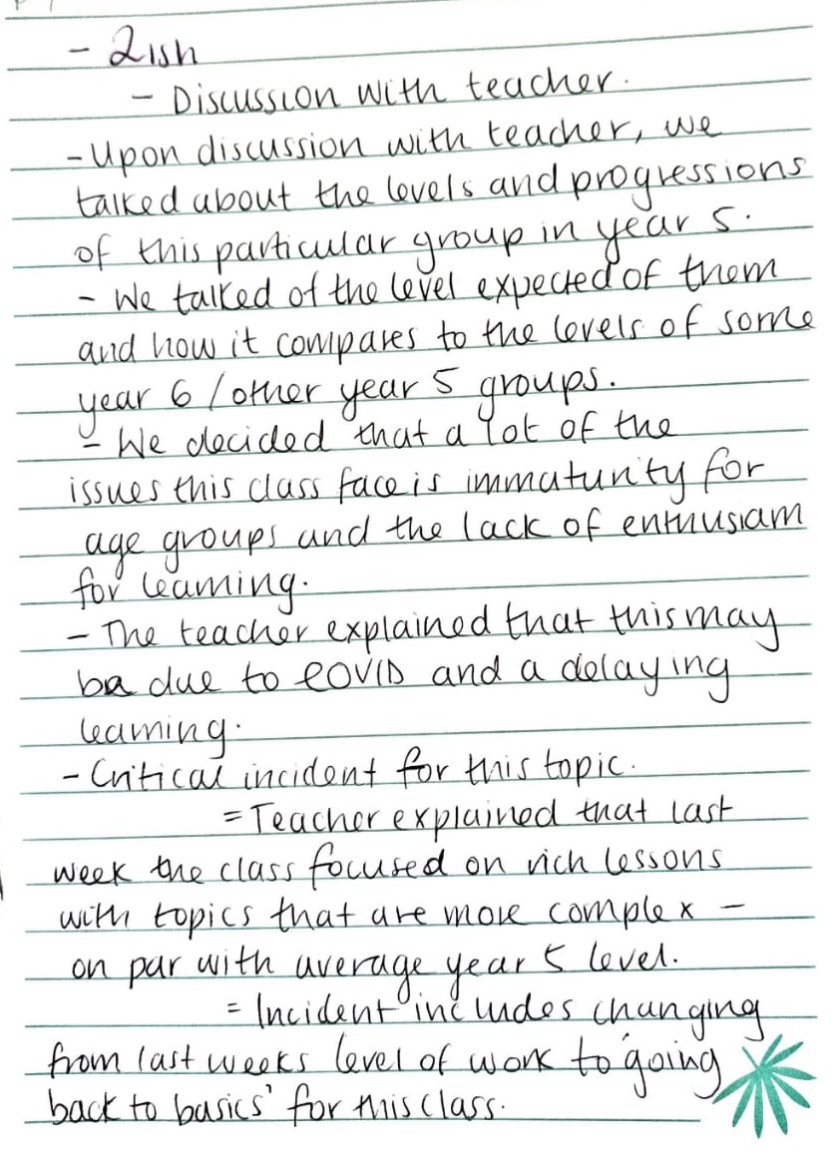

Figure B: Demonstrating scanned hand written notes taken from discussion with the classroom teacher during observations focused on critical incidents, own work, (2022) Personal Journal University of Wales Trinity and St David.

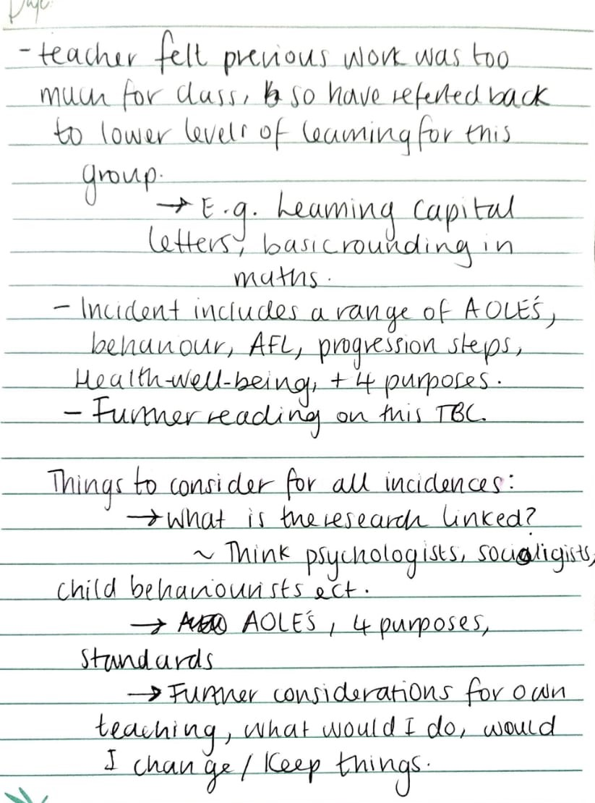

Figure C: Demonstrating scanned hand written notes of record 1 of classroom observations focused on critical incidents, own work, (2022) Observation Field Notes: University of Wales Trinity and St David. 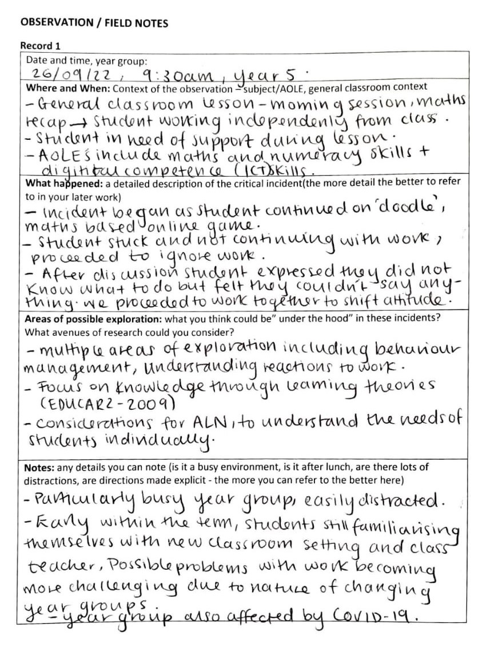

Figure D: Demonstrating scanned handwritten notes of record 2 of classroom observations focused on critical incidents, own work, (2022) Observation Field Notes: University of Wales Trinity and St David.
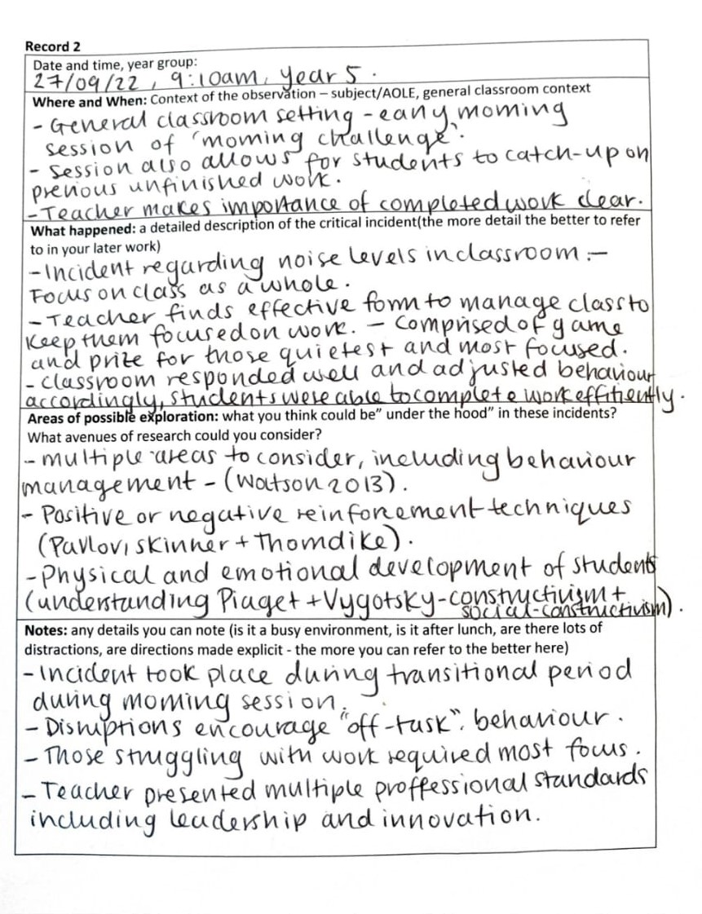
Figure E: Demonstrating scanned hand written notes of record 3 of classroom observations focused on critical incidents, own work, (2022) Observation Field Notes: University of Wales Trinity and St David.

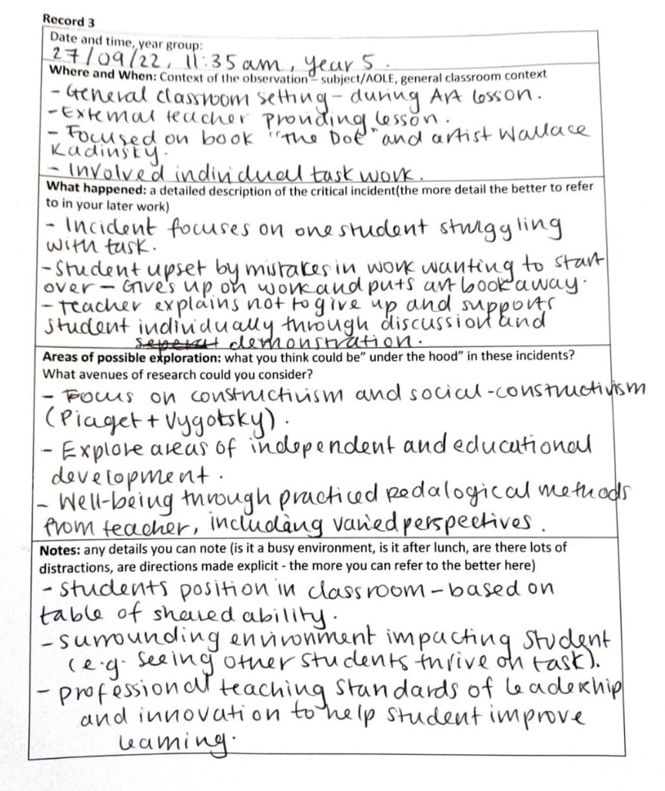

Figure F: Representing artwork of the children's book, “The Dot” written and illustrated by Peter H. Reynolds. - Reynolds, P. H. (2003) The Dot [Book Illustration] Available at: https://www.thedotcentral.com/ (Accessed 3 November 2022)


Figure E: Representing the work of artist Wallace Kadinksy, displaying his infamous circular paintings. -Kandinsky, W. (1913) Squares with Concentric Circles [Watercolour, Gouache and Crayon on Paper] Available at: https://www.wassilykandinsky.net/work-370.php (Accessed: 3 November 2022)

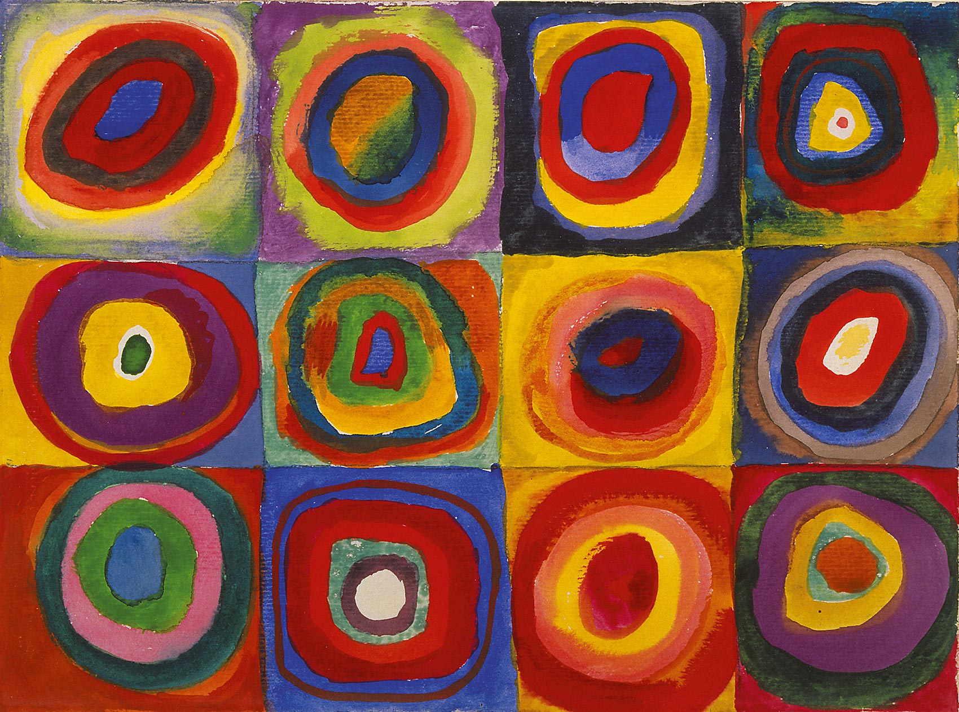

Figure G: Representing a diagram describing Vygotsky’s Scaffolding Theory. Diagram explains the relationship between ZPD and independent learning in students. Dr Serhat Kurt, 2020, Vygotsky’s Zone of Proximal Development and Scaffolding, Educational Technology,[Diagram] Available at: Vygotsky's Zone of Proximal Development and Scaffolding - Educational Technology (Accessed: 2 November 2022)

Inability to Learn
ZPD
(Zone of Proximal Development)
Independent Learning
The Vygotsky Scaffolding Theory

Figure H: Representing the diagram of Gibbs’ Reflective Cycle, demonstrating six systematic approaches.: Annie Pendrey, 2022, The Little Book of Reflective Practice: A Practical Guide to the Early Years, Routledge, p. 81

Description
Feelings
Evaluate
Analyse
Conclusion
Action Plan

Gibbs’ Reflective Cycle

Figure I: Representing a table conducting Brookfields reflective journey of the Four Lenses. Annie Pendrey, 2022, The Little Book of Reflective Practice: A Practical Guide to the Early Years, [Table created from information] Routledge, pp. 65-66



