Anita Valeria Barna
(2012749)
Dissertation
(LCBB6000)
Dissertation proposal

A STUDY OF THE EFFECTIVENESS OF INFLUENCER MARKETING ON CONSUMER BEHAVIOR.

Table of Contents
Chapter 1: Introduction 3
Talk about topic 3
Rationale of the study 3
Purpose of the research 4
Chapter 2: Literature Review 4
Chapter 3: Research Methods and Methodology 6
What research methodology and why? 6
What research philosophy and why? 7
What research paradigm and why? 7
What research approach and why? 8
What research strategy and why? 8
Time Horizons 8
Sampling methods and why 8
Data collection methods/tools 8
Ways of interpreting data/How are you going to interpret data? 8
Ethical consideration of the research 9
Chapter 4:Time prospects of the research (Gnatt chart) 10
Conclusion 10
References 10

Chapter 1: Introduction

Talk about the topic.
Celebrity endorsement has become an increasingly common method for brand names to communicate with their target group in latest years. Innovator marketing is the method of selling goods or services by partnering with social media influencers who have a big and committed following. But how efficacious is viral marketing in shifting consumers?
According to the study, the influencer market has a huge impact on the behaviour of consumers (Chopra, 2020). Based on the Influencers Hub survey, 63% concluded that the prevalence of advertiser suggestions more often than traditional advertising channels (Lee, and Kim, 2020). This is because users recognize influencers to be genuine and likable, and people believe they possess about their greatest interests in mind.

Rationale of the study
It is important to study the effectiveness of influencer marketing on the behaviour of consumers for some reasons:
- To understand how marketing is affected by authenticity.
- To understand the effect of social media on the behaviour of consumer
- To analyse the best practices for influencer advertising
- To enable brands to make informed marketing decisions.
- To notify future social media and marketing research

Purpose of the research
Aim:
The main aim of this research is to analyse the impact of influencer marketing on consumer behaviour.
Objectives:
- To examine how influencer marketing impacts consumer attitudes toward brands.
- To examine whether social media marketing influences consumers' purchases and behaviours.
- Recognize the issues that contribute to influencer marketing campaign success or failure.

Research Questions:
- What is the effect of influencer marketing on the behaviour of consumers towards the brands?
- How much does social media marketing impact consumers' procurement intentions and behaviours?
- What are the major factors which work for the success or failure of influencer marketing campaigns?

Chapter 2: Literature Review
According to Chopra, et al., (2021) in the latest days, content marketing has grown to be a prevalent business strategy as brands seek to connect with their intended demographic through social media influencers with sizable and committed ones that follow. This part of the study will offer a summary of the existing research on the efficiency of advertiser advertising on consumer behaviour. Several investigations into the effect of advertiser marketing on customer behaviour have found that this may be a highly effective approach for generating revenue and improving awareness of the brand. According to a Chetioui at al., (2020) study, 39% of marketing firms survey conducted were thinking about raising their advertiser marketing spend in 2021, and 57% said marketing strategy was more successful than other kinds of sales promotion. Users believe in influencer marketing and regard them as trustworthy authoritative sources of knowledge, which is one of the causes why celebrity endorsement can be efficacious. According to a study conducted by De Veirman, et al., (2019), 63% concluded that the prevalence of bloggers is more than traditional marketing, and 58% have purchased something predicated on an advertiser suggestion.
Endorsers can help companies obtain targeted marketing spectators in addition to fostering trust. Tastemakers generally have a narrow topic or specialization in which they positively that are also engaged. This implies that businesses can collaborate with tastemakers whose audiences are like their target audience, making sure that one ‘s target markets are seen by the correct individuals. According to a Vrontis, and et.al., (2021) study, a marketing strategy can yield 11 times the ROI of traditional forms of advertising. When it arrives to influencers, there are some difficulties and possible risks to be cognizant of. Sincerity and clarity in advertiser partnering are the primary obstacles. Customers are growing increasingly sceptical of paid posts, and bloggers have been chastised for selling merchandise without revealing their financial connection to the company. This can cause adherents to lose confidence as well as credibility.
Some research has suggested best practices for influencers to tackle these obstacles (Argyris, and et.al., 2020). According to a study conducted by Influencer Marketing Hub, manufacturers should select bloggers whose beliefs and hobbies align with their own, and work collaboratively with thought leaders to skills, and elevate materials that connect with their viewing public. The survey also advises brands to know this information by revealing paid posts and trying to follow directions. In conclusion, a study indicates that content marketing may represent an efficient method for trying to drive buyer behaviour, yet it comes with obstacles or possible perils. Brand names can use influencer marketing to reach the people they want and accomplish their sales objectives by collaborating with the right content and adhering to guiding principles for validity and clarity.

Chapter 3: Research Methodology and Methods

What research methodology and why?
The research methodology is the principle that governs how research should be conducted. In this survey I am going to use the qualitative methodology to research the relative data. Qualitative data can assist with clarifying any developments or patterns discovered during the literature review by providing information about the fundamental behaviours, opinions, and possible motives that keep driving customer behaviour to influencer marketing Berne-Manero, and Marzo-Navarro, (2020.). The research methodology begins with the definition of the fundamental philosophy, followed by the selection of approaches, methods, and strategies, as well as the establishment of time horizons, all of which lead to the study design - the key techniques and processes for data collecting and examination (Figure 1).

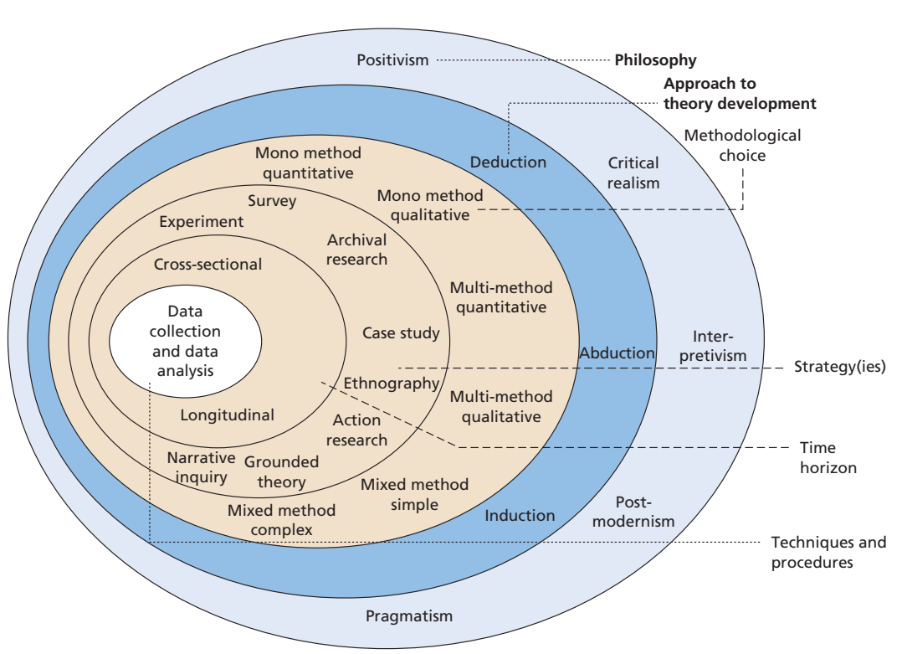
Figure 1. Research onion
Source: author following Melnikovas, A. (2018)

What research philosophy and why?
Interpretivism is a research philosophy that can be used for a subjective inquiry into the efficacy of entrepreneur advertising on customer behaviour. It allows investigators to get a more thorough grasp of humans' personal perception in a specific social setting as well as to investigate the subtleties of customer behaviour against marketing strategy (Martínez-López, and et.al., 2020).

What research paradigm and why?
In this, the constructivist paradigm is considered as a suitable research approach for this study for understanding the effectiveness of influencer marketing on the behaviour of consumers. It helps the researchers to manage the perceptions of consumers and their attitudes toward the marketing strategy. Thus, it helps to gain insights into the effectiveness of the target and engage the consumers with the help of influencer marketing.

What research approach and why?
In-depth focus group discussions and interviews, for example, may be utilized to obtain rich, comprehensive information regarding customer preconceptions, behaviours, but also personal stories with influencer marketing Weismueller, and et.al., (2020). This approach enables investigators to examine attendees' individual feelings as well as the contexts of culture and society wherein they socialize with influencer marketing.

What research strategy and why?
A case investigation is an investigation strategy that's suitable for conducting a qualitative inquiry into the efficacy of influencer advertising on customer behaviour. This survey may assist investigators to attain a rather more nuanced grasp on the effect of this advertising strategy on consumers when going to study its efficiency of entrepreneur marketing in influencing consumer behaviour.

Time Horizons
The survey will include cross-sectional research, because the research is short-term and will take place over a 10-week period.

Sampling methods and why
Purposive or semi-sampling methods, such as random selection, snowballing, or maximum variation sample selection, can be used in the study. These processes permit the researcher to choose people involved according to requirements such as time of life, gender, or environmental exposures to content marketing, resulting in a more varied and reflective population for the research (Breves, and et.al., 2019).

Data collection methods/tools
Focus Group: Focus groups may be employed to learn about buyers' interactions of influencer marketers, behaviours towards it, and the effect it currently has on one ‘s actions.

Ways of interpreting data/How are you going to interpret data?
Explanation-building: Using the data collected, researchers can construct descriptions of the procedures and systems that impact customer actions in relation to blogger marketing content. They could really, for instance, determine the variables that affect consumer interest with entrepreneur marketers, as well as the implications they have on their purchase behaviour.

Ethical consideration of the research
1. Informed consent: All those participating in the research, along with buyers, tastemakers, and salespeople, must provide written consent.
2. Confidentiality and privacy: Investigators must guarantee that all information received is remain secret and is not revealed to any unauthorized people or organizations.
3. Especially vulnerable protection: Researchers must ensure that disadvantaged people, such as young kids and those who have disabilities, are not harmed, or manipulated within the study.
4. Appropriate data use: Investigators must only use data gathered during the investigation for humanitarian purposes, like analysing and presenting the results, rather than for a different purpose which may damage or contravene the attendees' entitlement (Berne-Manero, and Marzo-Navarro, 2020).
5. Conflicts of curiosity: Investigators must reveal each and every possible bias, such as financial or personal preferences, that could actually influence this same study and its conclusions.
6. Ethical findings reporting: Researchers should indeed document the original study precisely, impartially, and even without prejudices.

Time prospects of the research (Gantt chart)
Activity | Week 1 | Week 2 | Week 3 | Week 4 | Week 5 | Week 6 | Week 7 | Week  8 | Week  9 | Week  10
Introduction
(Background, rationale of the study, aim, research objectives, research questions)
Literature review
Research methodology
Creating the questionnaire
Collection of data
Analysis of data
Discussion of data
Conclusions and Recommendations

Chapter 4: Conclusion
From the above study, it can be concluded that the research proposal helps to understand the effectiveness of influencer marketing on consumer behaviour. Further, the study provides an understanding of using various research methodologies for the study and provides vast knowledge. It will be considered an important part of the understanding and the research method gives clear ideas for using the techniques in the research. The literature review helps to understand the various objectives of the study and enhances the ideas.

References
Argyris, Y.A., Wang, Z., Kim, Y. and Yin, Z., 2020. The effects of visual congruence on increasing consumers’ brand engagement: An empirical investigation of influencer marketing on Instagram using deep-learning algorithms for automatic image classification. Computers in Human Behavior, 112, p.106443.
Berne-Manero, C. and Marzo-Navarro, M., 2020. Exploring how influencer and relationship marketing serve corporate sustainability. Sustainability, 12(11), p.4392.
Breves, P.L., Liebers, N., Abt, M. and Kunze, A., 2019. The perceived fit between instagram influencers and the endorsed brand: How influencer–brand fit affects source credibility and persuasive effectiveness. Journal of Advertising Research, 59(4), pp.440-454.
Chetioui, Y., Benlafqih, H. and Lebdaoui, H., 2020. How fashion influencers contribute to consumers' purchase intention. Journal of Fashion Marketing and Management: An International Journal, 24(3), pp.361-380.
Chopra, A., 2020. Influencer Marketing: An Exploratory Study to Identify Antecedents of Consumer Behavior of Millennial. Business Perspectives and Research, 9(1). doi: 10.1177/2278533720923486 (Accessed: 06 April 2023).
Chopra, A., Avhad, V. and Jaju, A.S., 2021. Influencer marketing: An exploratory study to identify antecedents of consumer behavior of millennial. Business Perspectives and Research, 9(1), pp.77-91.
De Veirman, M., Hudders, L. and Nelson, M.R., 2019. What is influencer marketing and how does it target children? A review and direction for future research. Frontiers in psychology, 10, p.2685.
Melnikovas, A. (2018). Towards an Explicit Research Methodology: Adapting Research Onion Model for Futures Studies. Journal of Futures Studies, 23(2). https://doi.org/10.6531/JFS.201812_23(2).0003.
Lee, S. and Kim, E., 2020. Influencer marketing on Instagram: How sponsorship disclosure, influencer credibility, and brand credibility impact the effectiveness of Instagram promotional post. Journal of Global Fashion Marketing, 11(3), pp.232-249.
Martínez-López, F.J., Anaya-Sánchez, R., Fernández Giordano, M. and Lopez-Lopez, D., 2020. Behind influencer marketing: key marketing decisions and their effects on followers’ responses. Journal of Marketing Management, 36(7-8), pp.579-607.
Melnikovas, A. (2018). Towards an Explicit Research Methodology: Adapting Research Onion Model for Futures Studies. Journal of Futures Studies, 23(2). https://doi.org/10.6531/JFS.201812_23(2).0003.

Vrontis, D., Makrides, A., Christofi, M. and Thrassou, A., 2021. Social media influencer marketing: A systematic review, integrative framework and future research agenda. International Journal of Consumer Studies, 45(4), pp.617-644.
Weismueller, J., Harrigan, P., Wang, S. and Soutar, G.N., 2020. Influencer endorsements: How advertising disclosure and source credibility affect consumer purchase intention on social media. Australasian marketing journal, 28(4), pp.160-170.

