
FINAL PROJECT – Design and Implementation of a New Maintenance Initiative
Gill, Liam (L.M.) – P148130
B-Eng Manufacturing Systems Engineering – Supervisor: Andrew Thorn
4/30/19

Statement of Authenticity

The work and results found in this dissertation is the author’s original research and results.
This thesis is the result of the author’s original research. It has been composed by the author and has not been previously submitted for examination which has led to the award of a degree.
All sources of information and supporting evidence have been acknowledged.

Signed: Date:

Abstract
This report has been created to carry out an investigation into the consistent underperformance of the AJ machining block line. During the months of January, February and March the line only achieved an average production of 18.52 Jobs Per Hour (JPH) against a target of 23.6 JPH. This finding was further supported by a machine availability of 67.5% during these months, far below the recognised world class standard of 90%.
This report used the Lean Six Sigma methodology to attempt to get to the root cause of the underperformance of the line. As part of this methodology DMAIC was put into practice. During the analysis of data gathered about line, JPH, OEE, machine availability and MTBF v MTTR were used as metrics to carry out the investigation.
From the metrics gathered, the report used various Lean Six Sigma tools such as FMEA, Process Mapping, VOC, SIPOC and 5Y’s to establish that a large contributor to the poor performance was the maintenance strategy that was in place. The current maintenance strategy was a run-to-failure approach, causing high volumes of machine downtime and low MTBF.
Once the largest contributing root cause was established, this report suggested that a new maintenance initiative should be put in place. After investigating various different potential solutions, it was found that the most effective maintenance strategy for the current situation was preventative maintenance.
After the implementation of the suggested maintenance plan the line was monitored, and it was found that this improved the performance of the line. This improvement was seen by an increase in machine availability of 5.28% and an increase in OEE of 13.68%. These improvements resulted in an average JPH increase of 2.53 during the two monitored periods before and after the project was carried out. The JPH improvement could result in improved income to the line of £84,856 per week whilst only incurring an extra cost of £2,714.54 per week to support the role of the preventative maintenance team.

Table of Contents
Statement of Authenticity 1
Abstract 2
Table of Figures 6
Introduction 8
History of Bridgend Engine Plant 8
Future of Bridgend Engine Plant 8
This Project 9
Aims and Objectives of Project 10
Timing Plan 11
Research/literature survey 13
Lean Six Sigma 13
DMAIC 14
Define 15
Measure 16
Analyse 16
Improve 17
Control 17
Cost of Quality 17
OEE 18
Downtime Relation to 6 Big Losses in OEE 19
Maintenance Strategies 19
Preventative (Scheduled) Maintenance 20
RCM 20
Run-To-Failure 21
Change Management 21
Damage to Reputation 22
Work Carried Out 23
Define 23
Problem Statement 23
Business Case 23
Project Charter 24
Voice of Customer 26
SIPOC 29
Process Map 30
Define Conclusion 32
Measure 34
Data Collection Plan 34
FMEA 35
Pareto Chart 36
Machine Availability 39
Overall Equipment Effectiveness (OEE) 41
Cost of Overtime 44
Measure Conclusion 45
Analyse 47
Top 10 Faults 47
The Five Why’s 48
Cause and Effect 50
MTBF and MTTF 52
OEE 56
Analyse Conclusion 56
Improve 58
Improvement Alternatives 58
Maintenance Strategy Selection 60
Preventative Maintenance Plan 62
Cost Benefits 70
Updated FMEA 72
Improvement Conclusion 74
Control 76
Sort 76
Set 76
Shine 77
Standardize 77
Sustain 78
Results 79
Machine Availability 79
MTBF v MTTR 81
Machine OEE 84
Machine JPH 86
Discussion and conclusions 88
Reference List 89

Table of Figures
Figure 1 - Project Plan for Written Report 11
Figure 2- Project Plan for Work Being Carried Out 12
Figure 3- The Keys to Lean Six Sigma (Maxim Consultants, 2015) 14
Figure 4- Project Business Case 24
Figure 5- Project Charter 25
Figure 6- Voice of Customer 27
Figure 7- Critical to Quality (CTQ) 28
Figure 8 - SIPOC Map 29
Figure 9- AJ Block Line Layout 30
Figure 10 - Line Layout Process Map With Schematic Removed 31
Figure 11- Line Layout Process Map Legend 32
Figure 12 - FMEA Table 36
Figure 13 - Pareto Chart Data Collection 37
Figure 14 - Pareto Chart of Block Line Faults 38
Figure 15 - Machine Availability - January 39
Figure 16 - Machine Availability - February 40
Figure 17 - Machine Availability - March 40
Figure 18 - Machine OEE - January 41
Figure 19 - Machine OEE - February 42
Figure 20 - Machine OEE - March 42
Figure 21 - Data Gathering for OEE 43
Figure 22 - OEE Benchmarks (Clarity Visual Management, 2019) 44
Figure 23 - Frequency, Duration and Average Stoppage Time for Top Faults 47
Figure 24 - Average Duration of Top Occurring Faults 48
Figure 25 - 5Y's on Clamping Fixture Seating Check Fault 48
Figure 26 - 5Y's on Spindle Motor Cooling Temperature Not OK Fault 49
Figure 27 - 5Y's on Tool Breakage Check System Fault 49
Figure 28 - Cause and Effect of Block Line Not Achieving JPH Target 50
Figure 29 - MTBF v MTTR - January 52
Figure 30 - MTBF v MTTR - February 53
Figure 31 - MTBF v MTTR - March 53
Figure 32 - MTTA - January 54
Figure 33 - MTTA - February 55
Figure 34 - MTTA - March 55
Figure 35 - Comparison of Improvement Solutions 58
Figure 36 - Improvement Solution Scores 59
Figure 37 - Suggested Maintenance Strategies Comparison 61
Figure 38 - Maintenance Strategy Scoring 61
Figure 39 - Potential Maintenance Tasks 63
Figure 40 - Mechanical Checks 66
Figure 41 - Pneumatic and Hydraulic Checks 67
Figure 42 - Electrical Checks 68
Figure 43 - Four Week Example of Preventative Maintenance Schedule 70
Figure 44 - Suggested Maintenance Spares Kit 71
Figure 45 - Updated FMEA Table 73
Figure 46 - Updated FMEA Comparison 74
Figure 47 - Highlighted Selected Preventative Maintenance Area 76
Figure 48 - Re-Order Point Calculations for Spare Items 78
Figure 49 - Machine Availability - August 79
Figure 50 - Machine Availability - September 80
Figure 51 - Machine Availability - October 80
Figure 52 - Resultant MTBF v MTTR - August 81
Figure 53 - Resultant MTBF v MTTR - September 82
Figure 54 - Resultant MTBF v MTTR - October 82
Figure 55 - MTBF v MTTR Comparison Before and After Maintenance Initiative 83
Figure 56 - Resultant OEE - August 84
Figure 57 - Resultant OEE - September 85
Figure 58 - Resultant OEE - October 85
Figure 59 - Resultant JPH 86
Figure 60 - JPH Comparison Before and After Maintenance Initiative 87

Introduction

History of Bridgend Engine Plant
Ford Motor Company was first created by Henry Ford on June 16th 1903 with one simple vision in mind,
“I will build a car for the great multitude. It will be large enough for the family, but small enough for the individual to run and care for. It will be constructed of the best materials, by the best men to be hired, after the simplest designs that modern engineering can devise. But will be so low in price that no man earning a good salary will be unable to own one – and enjoy with his family the blessings of hours of pleasure in Gods great open spaces.” (Hoffman, 2012)
Since this day, Ford Motor Company went on to help create the middle class and revolutionized manufacturing with the moving assembly line. Currently Ford Motor Company employs 166,000 people across 71 manufacturing plants around the world.
Construction first started on Bridgend Engine Plant in 1977 and production started in 1980. Since production in the plant began the CVH, Zeta and Volvo SI6 engines have all be manufactured at this plant, and currently the Sigma, Jaguar Land-Rover AJ and Dragon engines are all produced here supporting a total of 1,700 jobs.

Future of Bridgend Engine Plant
There is a new engine being produced at Bridgend Engine Plant with job one completed in 2019, and so it appears there could be a bright future for the plant, however there are some factors that could negatively influence the future of the plant.
Currently in Bridgend Engine Plant (BEP) there is a target cost saving of £25 Million for this year. The reason for this dramatic cost saving is to stay competitive with other rival plants within Ford Motor Company such as the Craiova plant in Romania, at this location they have a far lower wage cost than in Bridgend, so it is vital that BEP is as competitive as possible.
Further to the cost savings, with the United Kingdom soon expecting the leave the European Union there is a lot of nervousness for large manufacturing companies to commit to a future within the United Kingdom due to potential extra tariffs that could be incurred as part of leaving the customs market. The points highlighted show that although there is a potential for a great future at BEP there are however obstacles that could hinder this future, so it is extremely important to be as cost effective and productive as possible to remain competitive and secure a long-term future.

This Project
This project has been put in place to carry out a full investigation and analysis into the underperformance on the AJ Block machining line. Currently this line is consistently underperforming by only achieving an average JPH of 18.52 against a target of 23.6. This average was taken over a three month period between January, February and March.
The JPH being achieved currently is only 78.47% of the target value and although this may not appear to be a huge issue, when the value of the lost production is calculated there is a potential extra £4,639,700 annually that could be earned by achieving the target JPH. This value was calculated against a finished part sale to AJ Assembly of £215.
For the data gathering of this project the Ford Motor Company’s POS monitoring system will be used. Historically the POS system has not been operating effectively as a knowledgeable employee with the responsibility of maintaining POS had retired and was not fully replaced in his role. Since this time the knowledge of other team members has grown and now POS monitoring is reporting accurately.

Aims and Objectives of Project
The AJ machining line within Bridgend engine plant has been in operation since 1996 and is responsible for the production of 120,000 engine head and blocks on behalf of an outside customer. This customer is Jaguar Land Rover. It has been established that AJ machining block line has not been reaching its required Jobs Per Hour (JPH) target of 23.6.
It is the aim of this project to carry out improvements on the AJ Block line that will have a positive influence on the performance of the line. The Performance being targeted during this project will be to increase the JPH and decrease downtime. Currently the line is achieving 18.52 JPH which is only 78.47% of target value.
To support this aim of the project there have been a number of objectives set out, these objectives are;
- To investigate reasons for the current low JPH rates
- Introduce new maintenance initiative
- Increase Mean Time Between Failure (MTBF)
- To develop ways in which to improve the overall equipment effectiveness (OEE).

Timing Plan
To ensure that the deadline for the written report is met and the work is of a high standard a project plan has been put into place. This project plan will cover all areas of the project from the selection of a project to carry out to proof reading and hand in date.
The Project plan that has been established can be seen in fig 1.

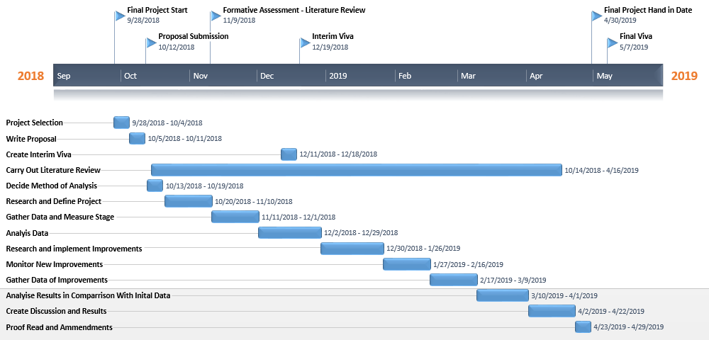
Figure 1 - Project Plan for Written Report
As is highlighted in the project plan all aspects of the report are covered. This project plan will allow for effective time management and ensure that all the milestones of the project such as proposal submission, Final Viva and Final Project Submission Hand in Date will be met and the work will be of a high standard.
Further to this, a project plan has been created to break the project down further, to guide in the completion of the work to be carried out for the project.
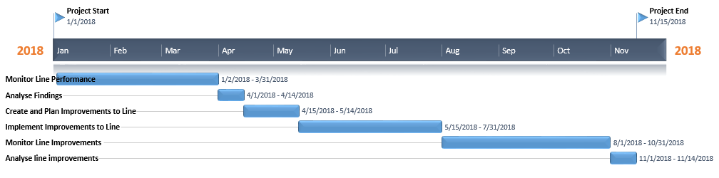
Figure 2- Project Plan for Work Being Carried Out
This plan outlined in fig 2 has allowed for large amounts of time to carry out the monitoring of the performance of the line both before and during this project. The reason for this large amount of monitoring time is so as much data as possible can be gathered, allowing for more accurate findings.
Both of these plans are flexible and there is the allowance for alterations to the time line, the reason for this is because there may be unforeseen circumstances that could arise and effect the work being carried out.

Research/literature survey
To carry out this report, a number of different areas will need to be fully investigated to ensure all the procedures and processes being carried out are accurate and effective. During the period of carrying out the investigation, depending on findings there are going to be further areas that will need to be researched and added to this section. As the aim of this report is to use the Lean Six Sigma methodology to carry out the report, this is the first topic that will be researched.

Lean Six Sigma
Six sigma was created by Motorola in 1986, with the aim in mind of reducing the amount of defects produced during production to 3.6 parts per million opportunities. It is stated by Motorola that by 2005 the creating and implementation of six sigma had saved the company over $17 Billion.
Six sigma is a quality improvement process and is considered the most effective methodology for problem solving to improve business and organizational performance (Craig, Neil, & Bruce, 2005, Page 1) by improving quality. To be the most effective methodology, six sigma uses a rigorous and structured approach to help improve the quality and performance of an organisation and to solve complex problems (Morgan & Brenig-Jones, 2014, Page 1).
Lean is a production and manufacturing model that focuses on using strategies and methods to eliminate waste and carry out continuous improvement within a business or organisation (Sweeney, 2015; Page 23).
Lean was created and developed by Taiichi Ohno in the early 80’s as part of the Toyota Production System (Ohno, 1988) to eliminate 7 wastes that Taiichi identified. The seven wastes that Taiichi was referring to can be categorised as;
- Defects
- Over processing
- Waiting
- Non-Used Employee Talent
- Transportation
- Inventory
- Motion
- Excessive Production
(Sweeney, 2015)
Six sigma can be used in conjunction with Lean principles to create a process in which a business or organisation can continuously improve on the reduction of its defects and waste, this process is known as Lean Six Sigma. This is supported by Sweeney (2015; Page 23) when they state ‘from the root doctrines of the lean and six sigma programs, we can see a basic compatibility and a shared goal: the elimination of variation.’
There can be considered four keys or pillars to lean six sigma these are Quality, Speed, Variation & Defects and Process Flow (George, Rowlands, & Kastle, 2004). An example of this can be seen in Fig 3.

Figure 3- The Keys to Lean Six Sigma (Maxim Consultants, 2015)
As can be seen from fig 3, the two pillars of Speed and Quality will result in a ‘Customer Delight’ and a reduction of Variation & Defects as well as improved Process Flow will result in an ‘Improved Process’.
This report is looking to implement a Lean six sigma methodology, using the DMAIC approach to establish a solution to the outlined problem of the AJ Block line consistently underperforming and not achieving its set out targets. The reason for this is that DMAIC improves processes by using facts and data to establish the root cause of failures, thus eliminating the inclusion of people influencing the findings due to what they may think the issues are, but instead arriving at the true reasons for the issues being outlined.

DMAIC
Lean Six sigma uses a tool known as DMAIC to help achieve its goals of waste and defect reduction. (Holpp & Pande, 2001). DMAIC is a structured methodology that is widely used in business to solve problems occurring from speed, quality and cost (George M., Rowlands, Price, & Maxey, 2005; Page 1). The acronym DMAIC stands for;
- DEFINE - The system, goals, requirements and VOC
- MEASURE - Critical elements of the process and collect necessary data.
- ANALYSE - Collected data to identify root defect causes and relationships between all factors.
- IMPROVE - The process using six sigma and other innovation tools based on collected data.
- CONTROL - The process during future executions to ensure consistent adherence to quality standards
(Sweeney, 2015)
Within each step of the DMAIC process, there are tools that can be used to get a full and complete understanding of the problems being investigated. Some of the tools that can be used and actions that need to be carried out in each step are;

Define
Project Charter – Within the project charter the project is defined and covers areas such as the team members involved, the Problem Statement, the objective and scope of the project as well as supporting metrics to justify the project. It is believed that 50% of a projects success is down to how well the project is defined (Gygi & Williams, 2012; Page 336)
Collect Voice of Customer and CTQ – By speaking to the customer you can determine the customers’ requirements. From this then it is possible to convert their requirements into measurable metrics that can be used as the Critical to Quality CTQ requirement. (Morgan & Brenig-Jones, 2014; Page 55). When considering the customer, Kumar (2006; Page 55) defines two types of customer, internal and external. The internal customer is a part of the total process such as the next operation in the manufacturing process or the assembly line receiving manufactured parts. The external customer can be considered the users of the product or services.
Create Process Map – A process map resembles an overall picture of a line or process that outlines different sections such as start, process, decision, transport and inspection (Craig , Neil, & Bruce, 2005; Page 252-253). By creating a process map a better understanding of the process can be obtained as well as being able to identify areas such as wasted movements and bottlenecks.
Project Management Plan – The project management plan that can be used can include a detailed schedule of activities such as timing plans and Gantt charts. Furthermore this can include the potential results of the project and the possible barriers or obstacles that could hinder the project goals (George M., Rowlands, Price, & Maxey, 2005; Page 7)

Measure
FMEA – A process ‘Failure Mode and Effects Analysis’ (FMEA) can be used to improve an existing process by understanding in which ways the process can fail and the risks associated with each of these failures. These risks can then be prioritized and actions can be identified to reduce the risk of failure.
Pareto Chart – To help focus a team on the lager problems that are occurring within a process a Pareto chart can be used. A Pareto chart shows the frequency of different failures that occur within a process. By using this tool a team is able to pin point failures occurring with a high frequency and seek to resolve and eliminate these issues. It is thought that up to 80% of failures can be contributed by 20% of the issues, and so by eliminating the 20% of issues the failures can be reduced by 80% (Parmenter, 2007; Page 41).

Analyse
Cause and Effect Diagram – A cause and effect diagram is also known as a fishbone diagram, it was created by Dr Ishikawa and can be a useful tool for displaying and grouping ideas generated from a brainstorming session (Morgan & Brenig-Jones, 2014; Page 141). The idea of a cause and effect diagram is to have a question such as ‘why SMS is not being carried out?’, then look at the potential effects of this under the six categories of manpower, machines, materials, methods, measurements and environment (George M., Rowlands, Price, & Maxey, 2005; Page 147). From this point the diagram can be streamlined be removing the points that are not relevant.
Root Cause Analysis – To get to the root cause of problems possibly highlighted in the cause and effect diagram, it will need to be verified as a legitimate issue. One method of doing this would be to carry out what is known as the 5 WHY’s. For this, establish the original issue and continuously ask ‘Why this issue is occurring?’ until the root cause is established (Okes, 2009).

Improve
Develop Potential Solutions – during this step the criteria that will need to be met in order to improve the process will be outlined, then the potential solutions that meet the criteria will be identified and evaluated to come up with the best solution.
Pilot the Best Solution – To determine if the best solution will indeed have the desired effect of resolving the issues of poor performance due to excessive downtime and poor JPH then a pilot can be carried out to test the theoretical findings for validity.
FMEA Update – with the new measures in place, it can be beneficial to update the previous FMEA to establish whether the previous chances of risk has been reduced, thus highlighting the success of the work carried out.

Control
Document New, Improved Procedures – Any changes that are being championed will need to be documented and sorted as the new methods of work.
Training – Training will need to be given to all team members involved with the line, and will play any vital part in the new procedures being put in place. This is to ensure all the new practices are maintained and adhered to without falling back into old habits.
Monitor Implementation – The new procedure and changes implemented by a project need to be monitored to ensure the effectiveness of the changes. Further changes and improvements could be considered at this stage if the desired results are not obtained.
Audit Results – From the improvements made carry out an audit and assign real value figures to the savings that have been made (George M., Rowlands, Price, & Maxey, 2005; Page 18.)

Cost of Quality
The cost of a manufactured part only accounts for the component travelling through the system on a FTT basis. It is because of this, the cost of quality could be defined as the difference in the current cost of production and the cost that could be obtained if no errors were to occur in the production process (Schmidt & Pearson, 2019).
When considering quality within the manufacturing environment Carey (2001) states that “Phillip Crosby defines quality in terms of performance that produces zero defects. When defects are produced, it increases the cost of producing quality products or services, producing quality means conformance to requirements.”
As a result of increasing costs and reducing profitability as a component has to be reworked or repaired, FTT can be used as a metric to determine the efficiency of a line. For this reason it is possible that in this report FTT data can be used as a measurement tool.
Some of the factors that will affect the cost of quality within a manufacturing environment are reworked parts, scrap and warranty claims. A further cost that could be incurred as a result of poor quality is a loss of goodwill and sales with customers (Farooq, et al., 2017).
As errors move through the production and assembly process the cost of that error grows. The reason for this is for each step in the manufacturing process carried out on a component, there has been value added through the means of machine availability, power consumption and tool life, so the earlier the defects are found during the production process, the less cost due to quality loss that will be incurred. Further to this, as a component is moved on to the customer then on average the cost to eliminate failure is five times larger than during the manufacturing process.

OEE
OEE is the overall equipment effectiveness. The aim of OEE is to establish the effectiveness of a system, this system could be a sole machine or a high level view of a line as a whole (Stamatis, 2010; Page 25).
A systems OEE takes into account three separate factors for the calculation. These factors are availability, quality and performance. Saha, et al., (2016; Page 4) define OEE as the effectiveness of a machine or production line that is used for the manufacturing process, and that it can be calculated by the following formula;
$$OEE=Availability X Performance X Quality$$
Where;
$$Availability=\frac{Net Operating Time}{Planned Operating Time}$$
$$Performance=\frac{Actual Rate of Production}{Planned Rate of Production}$$
$$Quality=\frac{Good Parts}{Total Parts}$$
For the metrics outlined in the OEE there are different recognised values that need to be achieved to be considered world class. These values are;
 | Availability | Performance | Quality | OEE
World Class | 90% | 95% | 99% | 85%

Further to this there a number of different standard benchmarks in OEE that are recognised in the manufacturing industry, these benchmarks are;
Benchmark | Perfect | World Class | Average | Poor
OEE | 100% | 85% | 60% | 40%

Downtime Relation to 6 Big Losses in OEE
There are a number of factors or lost opportunity costs that can affect the OEE of a system, these are known as the six big losses. The six big losses can be identified as;
- Breakdowns and unplanned stoppages
- Excessive time during set-up, changeover or adjustments
- Minor stoppages or system idling
- Running machines or system at reduced speed
- Losses due to start-up
- Systems causing scrap, defective parts or rework parts.
The reasons for this is the losses ‘Breakdowns’ and ‘Set-up/Adjustments’ will impact the value obtained for the machine availability by reducing the available operating time.
The losses ‘Minor Stoppages/Idling’ and ‘Reduced Speed’ will also affect the availability of the machines by reducing the amount of actual operating time.
Finally the losses ‘Start-Up’ and ‘Scrap, Defective Parts or Rework parts’ will impact machine availability by reducing the effective operating time.

Maintenance Strategies
As part of this project it has been highlighted that there will need to be a change in the way the maintenance is carried out on the line. It is the aim of this project to allow the breakdown maintenance to continue as it is doing to currently, however it is hoped that the volume of breakdown maintenance needed will be reduced by creating a new service plan for the CNC machines on the line. This finding is supported by Kennedy & Jardine (1970; Page 147) when they state ‘planned maintenance reduces the number of breakdown maintenance required’
In order to decide the correct maintenance strategy that should be implemented on the line some of the most used methods have been investigated. These methods are;

Preventative (Scheduled) Maintenance
Preventive (scheduled) maintenance is periodically inspecting and repairing items or components. The aim of preventative maintenance is to create a schedule where the serviceable components on a machine are replaced as close to the end of their recommended usage hours without them failing (Thorn, Maintenance, 2019). The time expected for the failure of components can be established by either historical reporting of the ordering of components for pervious replacement or by obtaining the manufacturers recommendations. The benefits of using a preventative maintenance strategy are the maximization of machine availability, higher product quality and reduced maintenance costs (Water, 2015). There are however some drawbacks to using a preventative maintenance strategy such as the need to never let the schedule slip, this is because the schedule can be neglected at times due to production pressures.

RCM
Reliability-centred maintenance (RCM) is 'A process used to determine what must be done to ensure that any physical asset continues to do what its users want it to do in its present operating context.' (Holpp & Pande, 2001) (Moubray, 1997). It has been established that RCM can be used to create planned maintenance schedules that will give an acceptable level of operability, an acceptable level of risk, in a manner that is cost-effective. The RCM process answers the seven following questions;
- What are the functions and associated performance standards of the asset in its present operating context?
- In what ways does it fail to fulfil its functions?
- What causes each functional failure?
- What happens when each failure occurs?
- In what way does each failure matter?
- What can be done to predict or prevent each failure?
- What should be done if a suitable proactive task cannot be found
(Thorn, 2019)
The Benefits of using the RCM approach to a maintenance strategy are that there will be an improved performance on the production line due to increased availability and that will cause increased profitability (Kelly, 1997; Page 228).

Run-To-Failure
Run-to-failure (breakdown maintenance) is running components to failure before replacing them. With this method of maintenance components are generally only replaced on an emergency basis. The benefits of this are the machine will not need to be taken offline for servicing and there may be a cost saving involved with replacing components less frequently, however the drawback is that upon failure the machine could be out of service for a long period, and this would have a large financial impact on the company (Thorn, Maintenance, 2019).

Change Management
Change management has been included in this section of the project as it has been established that there will need to be changes undertaken on the observed line, to ensure this is done effectively and efficiently change management needs to be researched.
For a company to continue to be successful and proactive it will need to use data and forecasts from its industry to adapt and to set new directions or organizational structures (Deimler & Reeves, 2011; Page 9). Campbell & Craig (2005) also state reactive change can be ‘forced upon an organization arising from a need to react to change in the organizations environment’. The changes this project is looking to implement can be considered reactive, as there needs to be changes made as a matter of urgency to improve the performance and profitability of the line. It is believed by Lewin that any organisational changes that occur within a company will be met with some amount of resistance to those changes, (Simms, 2005; Page 124) and so any changes made will have to be managed correctly to minimize resistance.
To manage change effectively Lewin’s three step model for change can be used as is recommended by Simms (2005; Page 124). In this process the three steps outlined are ‘Unfreeze’, ‘Change or Movement’ and ‘Refreeze’. During the unfreeze step there can be resistance to the change, however it is thought that there are methods in which to reduce this resistance (Simms, 2005; Page 124), these methods are;
Education – Inform the workforce why there is then need for change and they will be more likely to support the changes.
Exploitation – Identifying areas in which the workforce are not currently happy and using these areas as leverage for change.
Creating Forces for Change – Such as budget cut or cut backs.

Damage to Reputation
The Cambridge English Dictionary (2019) states reputation is “the opinion that people in general have about someone or something, or how much respect or admiration someone or something receives, based on past behaviour or character”
According to Fitzsimmons & Atkins (2017) a good reputation is the most important asset a company can poses and that “Reputations are lost when the perception of an organization is damaged by its behaviour not meeting stakeholder expectations.”
The reputation of a company can be vitally important to its success. Martin, Cooper & Burke (2011) state that the investment community believe that a reputation of a company is worth 30%-50% of its value.
It is due to these findings that this report finds there is a vast importance of maintaining the company’s good reputation and will strive to minimize any negative influences such as late deliveries and defective parts.

Work Carried Out
To carry out this investigation, the Lean Six Sigma DMAIC approach is going to be used obtain a high level view of the line, attempting to establish some of the reasons why the line could possibly be failing to reach its JPH target. To be able to carry out this high level view of the line the POS monitoring system in Bridgend engine plant was used to gather data for the whole line. This information has been gathered for the previous three months.
By obtaining this information further analysis will be carried out to establish the root cause or causes of the lines underperformance and will seek to establish an improved system to reduce or eliminate the root causes.

Define
The define section of this project is going to set out to use a variety of tools such as a project charter, the VOC, SIPOC and a process map. The purpose of this is to gain a high level view of the line and obtain a deeper knowledge of the problem.

Problem Statement
For this project a problem statement has been created to outline the current situation and the problems occurring. To help gain support from management, the problem statement will define the severity of the problem, the location and the potential financial impact. The problem statement created reads;
‘The AJ Block machining line is underperforming by consistently not reaching its production targets. This finding is supported by the average monthly average during January, February and March. These JPH values are consistently only achieving 78.47% of the targeted 23.6 JPH. As a result of this underperformance there is a potential loss of £4,639,700 annually ’.

Business Case
To justify an investigation and project to resolve to issue of the underperformance of the AJ Block line within Ford Motor Company’s Bridgend Engine Plant, a brief business case was created simply stating the scale of the issue not just in achieving targets but also with a financial cost involved too. The business case that was created can be seen in fig 4.
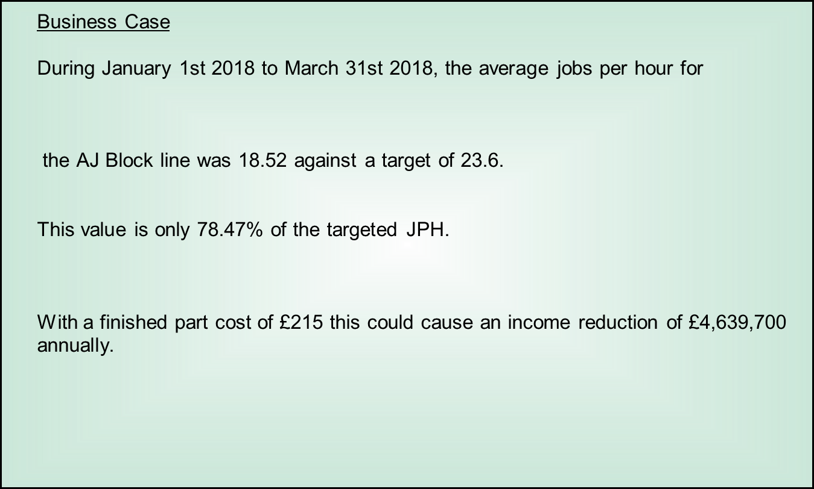
Figure 4- Project Business Case
As can be seen in fig 4 during the months of January, February and March 2018 the AJ Block line only achieved an average of 18.52 Jobs Per Hour (JPH) against a line target of 23.6 JPH. The JPH being achieved is only 78.47% of the target and as a result of this by not achieving this target there is a potential loss of £4,639,700 annually.

Project Charter
The next step to be taken in the define phase is to create a project charter defining the different areas of the project. This project charter will include things like the project members, objectives & scope of project and the problem statement. The project charter that has been created can be seen in fig 5.
Figure 5- Project Charter
As can be seen in fig 5 the project champion is Jonathan Richards, the AJ Block line manager, and the team members are Liam Gill, Mark Williams and Andrew Mayled. The problem statement that has been created for the project statement is as follows, ‘The AJ Block machining line is underperforming by consistently not reaching its production targets. This finding is supported by the average monthly average during January, February and March. These JPH values are consistently only achieving 78.47% of the targeted 23.6 JPH’. Further to the problem statement outlined the objectives and scope are also highlighted in the project charter, the objectives and scope of the project read, ‘It is the desire of this project to identify the reasons why the line cannot achieve its set targets. By doing this the project aims to eliminate these issues to allow the line to achieve its JPH targets on a consistent basis. This project has the scope to carry out all work such as changing working practices but is limited to only carrying out work that is financially viable as the line is due to end production in 2020.’. The objectives and scope explains that the project has the full support of management to do whatever is necessary to improve the performance as long as it is financially justifiable to the line. To further support and justify this project both JPH and R@R metrics have been included. The metric outlining JPH illustrates the underperformance of the line, highlighting the values achieved through January, February, March and April. These values are 18, 18.28, 19.01 and 19.86 JPH respectively. The secondary metric used was R@R percentage, this was calculated by JPH divided by Cyclic Capacity. The values outlined in the metric are 57.62%, 57.67%, 59.95% and 62.65% for January, February, March and April respectively against a target of 74.40%. This metric further illustrates the poor performance of the line.

Voice of Customer
To help determine exactly what needs to be carried out as part of this project, ensuring its aim of improving the performance is achieved, the voice of the customer (VOC) was established. The purpose of this was to establish what both internal and external customers require from the line to become satisfied. For this VOC the internal customers were considered the AJ Block workforce and the AJ Assembly line. The external customer being considered is Jaguar Land Rover, this is because they are the purchasers of the part being manufactured. By using the VOC gathered, they will be converted into metrics known as Requirements/Critical to Qualities (CTQ), these can then be used as a metric to establish whether the project has been successful or not. The VOC that was gathered can be seen in fig 6.

CUSTOMER | VOC | KEY ISSUES | REQUIREMENT/CTQ
Ford Workforce | Dissatisfied with the extra workload. | Workforce wants workload to remain normal without need for excessively restarting faulted machines. | Well running machines that have minimal downtime.
AJ Assembly | Delaying the assembly of AJ engines and affecting their scores and targets | Management want delivery of finished blocks to assembly line on time. | Target JPH of block line being achieved with minimal downtime of machines.
Jaguar Land Rover Vehicle Assembly | Delaying the assembly of vehicles at other plants. | Ensure engines reach the vehicle assembly plants without faults and on schedule. | Target JPH of block line being achieved with minimal downtime of machines and on time delivery of products.
Figure 6- Voice of Customer
Fig 6 has identified that the AJ Block line workforce are dissatisfied with the extra workload being created by the machines excessively faulting and having to continuously restart the machines. This was converted into a CTQ that states ‘Well running machines that have minimal downtime’.
The next customer was AJ Assembly, they stated that by the block line not achieving its targets, it was not possible to deliver the correct quantity of finished parts to them on time, this then has a knock on effect to the assembly scores as they are not able to meet their JPH targets and to deliver their products in the right quantity and time frame. The metric CTQ derived from this was ‘Target JPH of block line being achieved with minimal downtime of machines.’ This would then ensure delivery targets to the AJ Assembly line would be met.
The last customer considered was the external customer Jaguar Land Rover (JLR), they are dissatisfied as the lines is responsible for delaying vehicle assembly at their plants and causing delays to customers, this would have a negative impact on their reputation. The CTQ was established as ‘Target JPH of block line being achieved with minimal downtime of machines and on time delivery of products.’ This CTQ again would reduce the negative impact it is having on the AJ assembly line and allow them to deliver their targets to JLR, and in turn allow them to deliver their vehicles to their customers on time.
The CTQ points that have been established from the VOC can now be added alongside other CTQ’s in a CTQ table. The purpose of this table is to highlight the importance of each of these CTQ points by separating them into one of three categories;
- Must Be
- Performance
- Delighters
AJ Block Line CTQ’s
Must Be – CTQ’s that are a critical priority to be improved
- Engines machined with no undetected faults
- Build schedules met
- Target JPH of block line achieved with minimal downtime and on time delivery of products
- Delivery schedules met
Performance – CTQ’s that will improve the competitiveness of the product
- Well running machines that have minimal downtime
- Zero defects
- Minimal Reworks
- 100% flow
- Stockpile of ‘Good’ Blocks that can be used as a buffer in the event of another similar situation
Delighters – Non essential improvements that can be made but may escalate one day
- Happy workforce
- Clean Blocks
- Blocks machined and delivered ahead of schedule
Figure 7- Critical to Quality (CTQ)
As can be seen in fig 7, the CTQ ‘Well running machines that have minimal downtime’ identified as part of the VOC has been highlighted under ‘Performance’ in the CTQ table. The purpose for this CTQ being categorised as ‘Performance’ is because it will have the effect of improving the competitiveness of the product by improving the performance of the line, thus making the line more cost efficient. The other CTQ ‘Target JPH of block line achieved with minimal downtime and on time delivery of products’ identified in the VOC has been categorised as ‘Must Be’. The reason for this is because this CTQ is a critical priority to be improved because if the target JPH cannot be met then the delivery deadlines will not be met and this will result in fines being imposed on Ford Motor Company from JLR for not upholding their contract.

SIPOC
A SIPOC map has been created to map the process of the block manufacturing process from a high level. From this high level view of the process the scope of the project is made clear and it can be defined what the inputs are, who the customers are and all the activities within the process. The SIPOC map created for this project can be seen in fig 8.
S  SUPPLIERS | I  INPUTS | P  PROCESS | O  OUTPUTS | C  CUSTOMERSR
•MP&L providing rough stock from storage.  - Cup Plugs  - Loctite | - Each Operation has an input to the finished product | - Input rough stock  - Carry out machining ops  - Fix to adaptor plate  - Carry out further machining ops  - Wash part  - Apply Loctite and cup plug  - Buy off | • Fully machined and partly assembled AJ blocks with cup plugs fitted | - •AJ Engine Assembly  - Vehicle assembly plants  - Jaguar Land Rover
Figure 8 - SIPOC Map
Within this process it can be seen there are three suppliers that all contribute to the final product. The rough block stock, cap plugs and Loctite. It has been established that all the different ops with the exception of OP 360 which mounts the block to the platen, and OP 160 (wash) will have an input to the final product due to each of them adding value as the product moves through the line.
The output of the production process is a fully machined, in spec engine blocks with cap plugs fitted. The customer of this output is both the AJ assembly as the internal customer and JLR as the external customer.

Process Map
A process map of the line would be an important factor during the design phase as this could outline any inefficiencies of the line layout. These inefficiencies would create waste in the form of transportation or movement under the Lean principles as is described in the literature review. To create a line layout, firstly a high level view of the line will be obtained highlighting the different operations and their locations. This can be seen in fig 9.
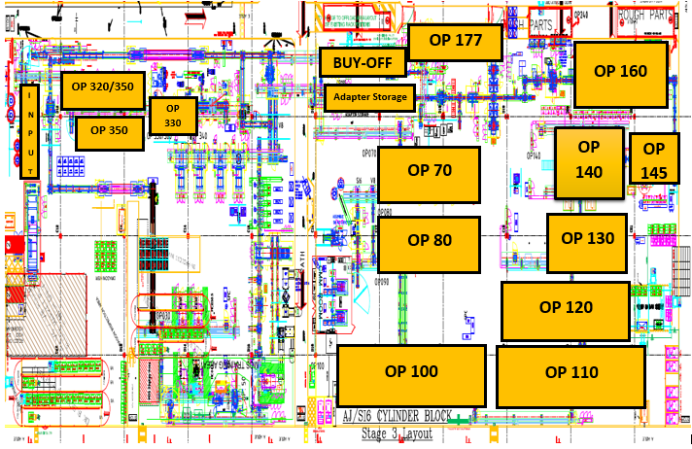
Figure 9- AJ Block Line Layout
From this projection of the line the layout image can be removed, and directional arrows can be introduced to illustrate movements within the machining process. During this process map there has been no symbols for question that have been included, the reason for this is because at the end of every bank of CNC machines there is an SPC station where the gantry will periodically place machined parts for inspection, during this time the machines will remain in operation. This can be seen in fig 10.
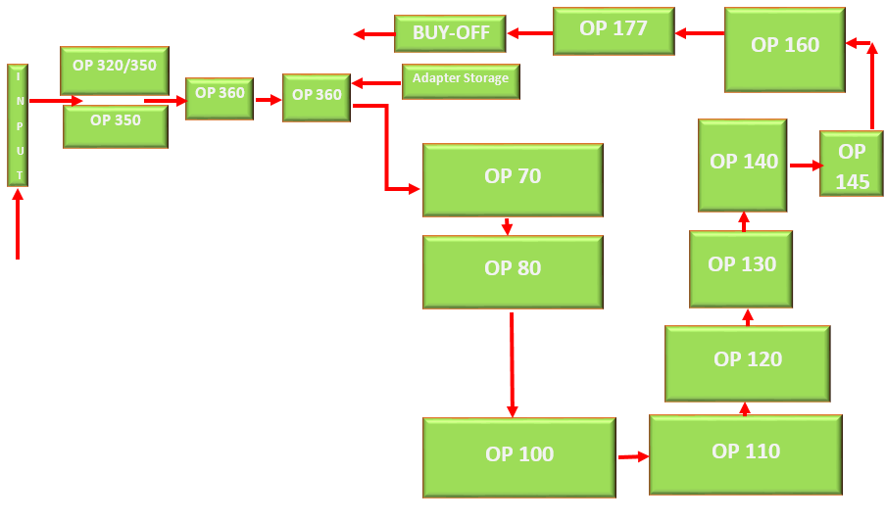
Figure 10 - Line Layout Process Map With Schematic Removed

Block Line Legend
INPUT | Blocks Loaded onto Line – Manual Operation
OP 320/350 & OP350 | CNC Operation
OP340 | Wash
OP360 | Blocks Fixed to Adaptors
OP70 | CNC Operation
OP80 | CNC Operation
OP100 | CNC Operation
OP110 | CNC Operation
OP120 | CNC Operation
OP130 | CNC Operation
OP140 | Cylinder Honer
OP145 | Cylinder Honer
OP160 | Wash
OP177 | Cup Plug Fixing Station
BUY-OFF | Final Inspection and Part Buy-Off
Figure 11- Line Layout Process Map Legend
Fig 10 highlights there is a large amount of excessive movement between OP80 and OP 100, currently the time it takes to travel between these operations is 1 Min 7 Secs. Furthermore there is separation and longer than required movement of the adapters from adaptor storage across a walkway to OP 360, where the Blocks are fixed to the adaptors before being transferred back across the walkway to continue production, currently the time taken to carry out this process is 3 Mins and 20 Secs, in comparison to this the amount of time it takes for the same block to travel between the OP70 and OP80 gantries is 39 Secs. Both of these areas highlight waste within the machining process and will contribute to the underperformance of the line.

Define Conclusion
It has been established by the define section of this project that a potential huge loss to the company is occurring due to lost production by the underperformance of the line. This underperformance is consistently failing to achieve the target of 23.6 JPH, the actual JPH being achieved that is 78.47% of the target. Annually could relate to an income increase of £4,639,700 if the target was being achieved.
It is the aim of this project to carry out improvements on the AJ Block line that will have a positive influence on the performance of the line. To support the aim of this project there have been a number of aims to help achieve this, these objectives are;
- Introduce new maintenance initiative
- Increase Mean Time Between Failure (MTBF)
- Improve efficiency and performance of machines
- Increase Overall Equipment Effectiveness (OEE)
The customers of the AJ block line have been identified as AJ Assembly (internal) and JLR (external), after establishing these customers it was investigated what the VOC was and what CTQ metrics could be derived from them, the CTQ that were derived were;
- Well running machines that have minimal downtime.
- Target JPH of block line being achieved with minimal downtime of machines.
- Target JPH of block line being achieved with minimal downtime of machines and on time delivery of products.
In this section it was highlighted by the process map that there are some inefficiencies in the line layout and there is room for improvement that to increase production by reducing the lean waste of excessive transportation and movement.

Measure
To obtain a full and complete understanding of the potential reasons for the underperformance of the AJ Block line, this section of the project will use tools outlined in the literature review for DMAIC to collect data that help could develop a better understanding of the issues.

Data Collection Plan
For the purpose of this report Liam Gill will be personally responsible for the data collection required. There will be a variety of relevant data that will be collected to obtain a full understanding into the underperformance of the line. Some of the data that will be collected is the average values for JPH, OEE, Machine Availability and MTBF v MTTR. The reason these metrics have been selected for collection is because they will all have an effect of the performance of the line and any issues highlighted here may be addressed and have a positive impact on performance.
During the process of collecting the project data the ‘POSMON’ system within Ford Motor Company was used. This POSMON system is a live machine feedback system that reports current and previous machine status worldwide within the Ford Motor Company intranet. It has been recognised that in recent years the ‘POSMON’ system has had reduced accuracy in data collection. It has been established that this is no longer an issue, the reason for this is due to when POSMON was reporting accurately, it was largely due to an experienced and knowledgeable member of staff maintaining the system. The cause of inaccuracies occurred when the mentioned person retired with no person with the same skillset to replace him, now however this role has been made a dedicated position and a new staff member has repaired the system to full reporting order (Richards, 2018). The ‘POSMON’ system is now an extremely useful tool for data collection as it can identify constraints and bottlenecks within a line as well as historical data such as machine availability.
The data collected for this project was carried out between the dates of 01/01/2018 and 31/03/2018. The reason for these selected dates was because the line at this time was identified as a performance concern for the plant. Furthermore the line was in full production during this time as there was no plant shutdown and all bank holidays were fully manned for line production.

FMEA
The FMEA analysis illustrated in fig 12 has been created to investigate what the ‘Failure Modes’ are causing the line to underperform, the causes for the ‘Failure Modes’ could be then be established from this. By using these it can then be understood what measures are in place to prevent or minimise the ‘Failure Modes’. When a complete understanding is obtained for the ‘Failure Modes’ then a score can be assigned to them depending on severity, 1 meaning a low risk and 10 meaning high risk and of a serious impact to the line.
The scores that are assigned in this table are in the following coulombs;
- Severity –The severity of the effect of the failure mode occurring
- Occurrence – How frequently the fault mode would affect the quality of a product
- Detection – Detection is how effective the preventative measures in place are
When the values for severity, occurrence and detection have been established they are then used to create a Risk Priority Number (RPN), this number will have a value between 1 and 1000 with larger values requiring action sooner than the lower values. The RPN is calculated by;
$$RPN=Severity X Occurence X Detection$$
Figure 12 - FMEA Table

Pareto Chart
From the findings of the FMEA table it has been identified that a large contributor to the line not achieving its JPH target is down to stoppages due to faults on the machines requiring resetting or maintenance to be carried out. To further investigate these contributors a Pareto chart will be created to highlight the failure on the machines and their relative importance in comparison to other failures.
That data that was collected and used as the input for the Pareto chart can be seen in fig 13.
Figure 13 - Pareto Chart Data Collection
These findings of the top ten faults of the block line show that all of these faults occur on the Specht CNC machines, highlighting that these machines are a major cause for concern. These faults have resulted in a total downtime of 28,178.29 mins in Jan, 29,861.07 mins in Feb and 34,500.63 mins in March. This is a total of 92,539.99 mins or 1,543.33 hours cumulative over the three months. To put these values into context, on average, during one 24 hour period there is cumulative total of 17.15 hours of downtime that occurred solely due to these top ten faults, this is not inclusive of any other faults that also may occur.
The resulting Pareto Chart from this data can be seen in fig 14.
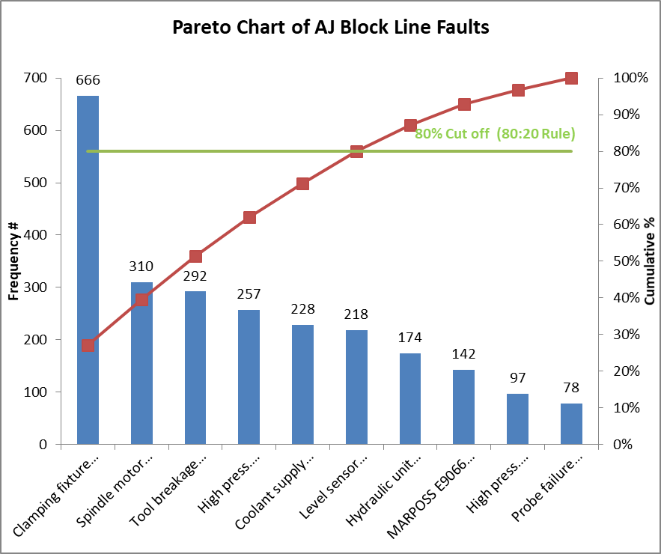
Figure 14 - Pareto Chart of Block Line Faults
In the Pareto chart the x-axis represents the top ten fault causes, the y-axis represents the frequency of the failures, the red line represents the cumulative percentage total of the faults and the green line represents the 80:20 cut off rule where it is suggested that 80% of the faults can be resolved by rectifying 20% of the problems (Tanabe, 2018).
The Pareto chart in fig 14 shows that the largest failure causing the machines to fault is ‘Clamping Fixture Seating Check Fault’. The frequency for this fault far exceeds the other with a tally that is in excess of 350 more failures than the next leading cause ‘Spindle Motor Cooling Temperature Not OK’. By using the chart it can be seen that 80% of the machine faults occur due to the following faults;
- Clamping Fixture Seating Check Fault
- Spindle Motor Cooling Temperature Not OK
- Tool Breakage Check System Fault
- High Pressure Coolant For Spindle – Flow Fault
- Coolant Supply Pressure Fault
- Level Sensor Emergency High Level

Machine Availability
To obtain a deeper understanding of the line, the machine availability has been researched to understand the scale of the line underperformance. To calculate the machine availability the following formula is used;
$$Machine Availability= \frac{Running Time}{Scheduled Run Time}$$
The findings from the machine availability research can be seen in Fig 15 Fig 16 and Fig 17.
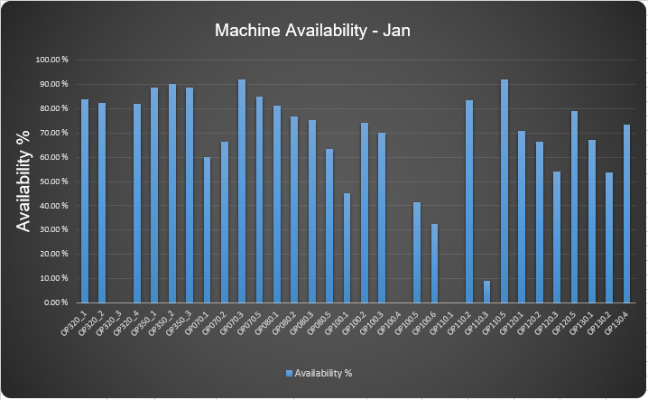
Figure 15 - Machine Availability - January
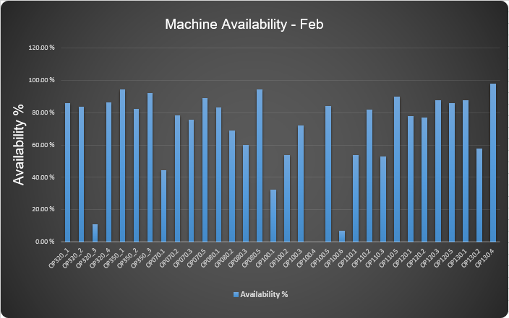
Figure 16 - Machine Availability - February
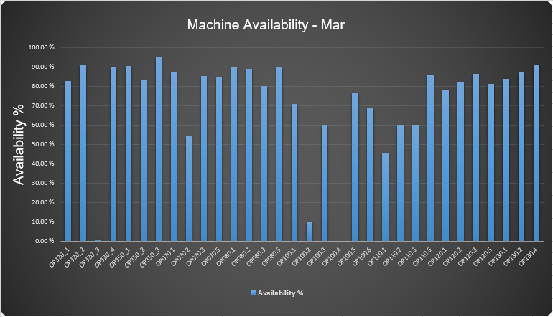
Figure 17 - Machine Availability - March
The findings of the research into the amount of availability with each of the machines on the line show that there was an average of 63.36% during the month of January, 66.59% in February and 72.54% in March. The average of these is 67.5% over the three months. This falls 22.5% below the 90% level that is accepted and considered world class.

Overall Equipment Effectiveness (OEE)
To carry out further measurement of the underperforming AJ block line, data has been gathered for the overall equipment effectiveness of all the CNC machines during the months of January, February and March. The findings from this data collection has been placed into three column charts that can be seen in fig 18, fig 19 and fig 20.
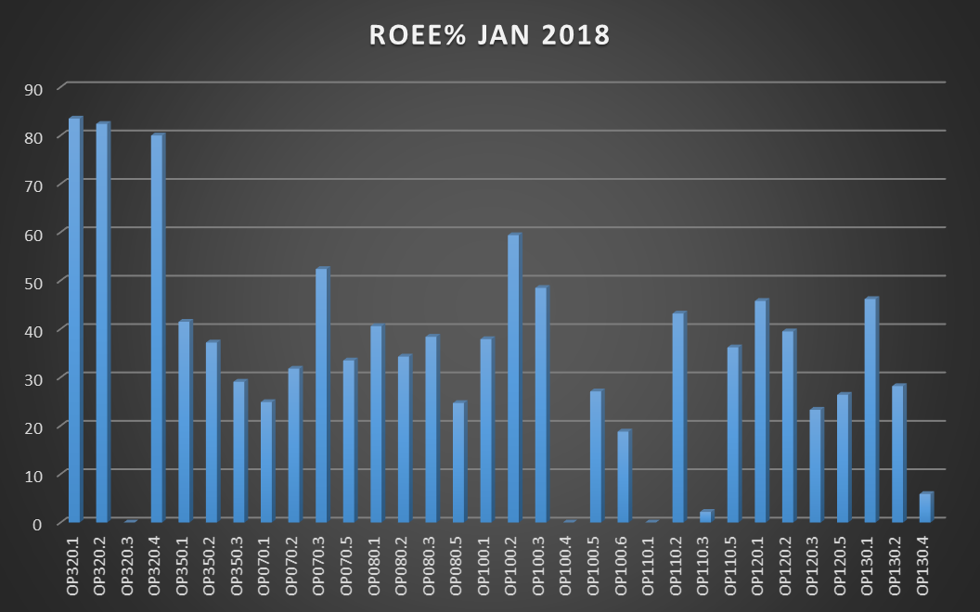
Figure 18 - Machine OEE - January
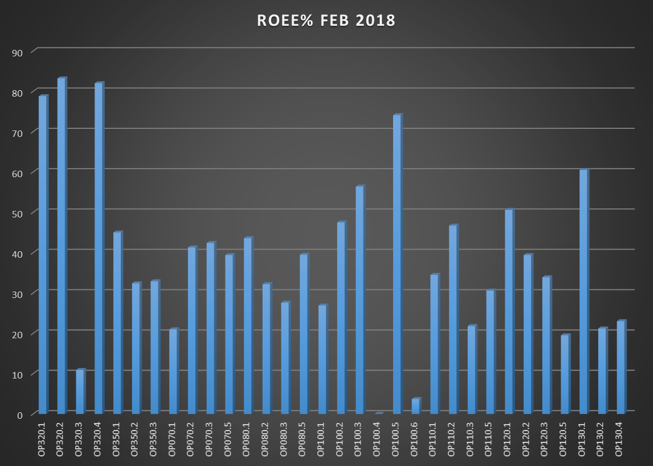
Figure 19 - Machine OEE - February
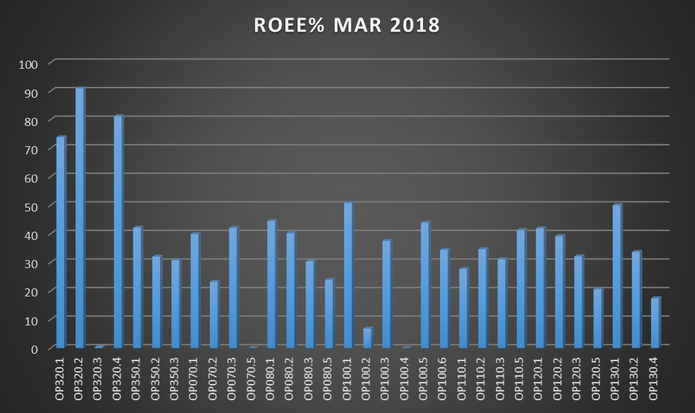
Figure 20 - Machine OEE - March
The data for the calculation of machine availability and machine OEE has been obtained from the POSMON system that is used by Ford Motor Company. The data that was gathered can be seen in Fig 21.
Figure 21 - Data Gathering for OEE
The OEE for this report has been calculated by the following formula;
$$Availability X Performance X Quality=OEE$$
During the month of January the average OEE for all the CNC machines on the block line was 36.22%. This value is far below the world class industry standard of 85% as is stated by Ahmad & Benson (1999; Page 24). This is also true for the months of February and March with values of 40.08% and 36.72% respectively. This results in an average of the three months monitored of 37.67%. This result currently puts the line at a level that is below the ‘Low’ margin in OEE standards as it outlined by Ahmad & Benson (1999; Page 24). This is illustrated in Fig 22.
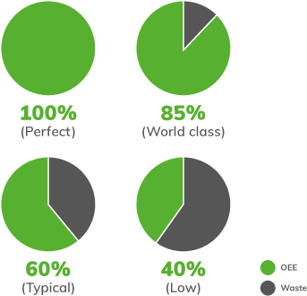
Figure 22 - OEE Benchmarks (Clarity Visual Management, 2019)

Cost of Overtime
Due to the line not achieving its production targets there has been full production on Saturday nights for 12 hours to help raise the production values (Richards, 2018). This overtime requires two of each mechanical and electrical trades as well as six operators. Furthermore, due to this overtime occurring over a Saturday night to Sunday morning there is an extra shift premium, this equates to time and a half on the first 6 hours until midnight, and double time on the 6 hours past midnight. The cost of this overtime has been calculated;
$$Mechanical=2 X \left(£24.50 X 12\right)=£588$$
$$Electrical=2 X \left(£24.50 X 12\right)=£588$$
$$Operator=6 X \left(£21.25 X 12\right)=£1530$$
$$Total Standard Cost=£588+£588+£1530=£2706$$
$$Total Including Overtime Premium=£2706 X 1.75=£4735.50$$
The calculations show that there is a total of £4735.50 spent each week on overtime for one 12 hour shift with the intention of building more parts to meet the build schedule.
This calculation for the cost of overtime over the twelve hour period does not take into account extra costs such as extra energy used for lighting, machine operation and heating that would increase the cost of overtime.

Measure Conclusion
The data that has been gathered for this section was done so by using the POSMON system within Ford Motor Company. It has been acknowledged that although POSMON has not been entirely reliable in the past, it has now been rectified and works as a reliable data collection tool.
The FMEA table found that there are many potential causes for the excessive downtime that is occurring on the line, some of these reasons are;
- Machine Cleaning
- Minor Stoppages
- Major Stoppages
- Machines under Repair
- Machines in breakdown
For each of these potential reasons, they were assigned severity values and it was identified for each of them what potential solutions could be put in place for the reduction of the severity of each of them.
Building from the findings of the FMEA, a Pareto chart was created to identify each of the top 10 faults and what impact they had on downtime of the machines. The top 10 faults that were identified for the line were;
- Clamping fixture seating check fault
- Spindle motor cooling temperature not OK
- Tool breakage system fault
- High pressure coolant for spindle – Flow Fault
- Coolant supply pressure fault
- Level sensor emergency high level
- Hydraulic unit oil level below minimum
- MARPOSS E9066 in fault
- High pressure coolant for spindle – flow fault
- Probe failure check/clean calibration holes
The cumulative total of these top ten faults was 2,462 occurrences. This resulted in a total downtime of 1,543.33 hours cumulative over the three months. The Clamping fixture seating check was found to have the highest number of occurrences with 666 times.
It was found by this report the availability of the machines during the monitored period of January, February and March there was an average of 67.5%, this value is 22.5% below the 90% that is considered to be world class. Further to this the average OEE over the same three month period was found to be 37.67%, again this value is far below the accepted world class standard of 85%.
To attempt to improve the underperformance of the line and meet the production targets, there has been overtime shifts on every Saturday night, the cost of these overtime shifts amounts £4735.50 for staffing for one twelve hour shift.

Analyse
During this analysis section of the report, the data gathered will be analysed to establish the root causes for the production line failings. Some of the data to be investigated will be the Mean Time Between Failure (MTBF) of the machines in comparison to the Mean Time To Repair (MTTR). In addition to this, further analysis will be carried out on the MTTA of the machines and the faults that are occurring.
The data gathered for this section has come from the POSMON system within ford motor company. The POSMON system is a live machine feedback system that reports current and previous machine status worldwide within the Ford Motor Company intranet. Historically POS has not been operating effectively as an employee with a wealth of knowledge had retired from their role and they were not fully replaced. Now POS has been repaired and this issue has been rectified and so the system is now reporting correctly.

Top 10 Faults
As was discussed in the measure phase there has been data gathered on the top 10 faults occurring on the line. It will now be established whether these frequent faults are considered minor stoppages or breakdown stoppages. For the purpose of this report, stoppages under a 15 minute duration will be considered a minor stoppage. As the POSMON system does not allow for the individual investigation of each fault, the collective duration of machine stoppage for each fault will be used and divided by the frequency of stoppages to establish an average stoppage duration for each fault. The findings from the data collection on this topic can be seen in Fig 23 and Fig 24.
Figure 23 - Frequency, Duration and Average Stoppage Time for Top Faults
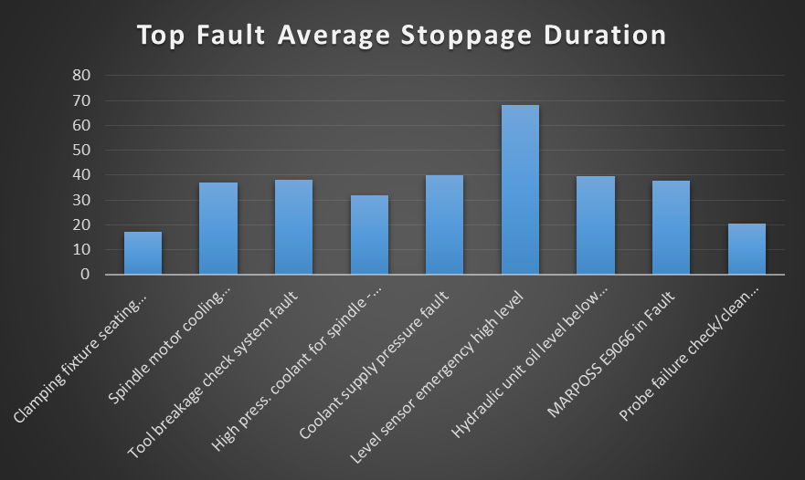
Figure 24 - Average Duration of Top Occurring Faults
As is illustrated in Fig 23 and Fig 24 there is not one of the top faults that has an average stoppage time of less than 15 minutes. This shows that all of the stoppages are considered breakdown stoppages. It is unclear whether the reason for these stoppages having such a high duration is due to the fault being complex, or whether it is due to an extended period of time before operators attend the machine in fault.

The Five Why’s
To get a better understanding of the reasons behind why these faults are occurring, the 5Y’s tool is going to be used on the top 3 highest frequency faults. The faults that will be investigated are ‘clamping fixture seating check fault’, ‘spindle motor cooling temperature not okay’ and ‘tool breakage check system fault’. These results can be seen in Fig 25, Fig 26 and Fig 27.
Figure 25 - 5Y's on Clamping Fixture Seating Check Fault
In fig 25 there are a number of possible causes to the fault ‘clamping fixture seating check fault’, each of these have been identified in the table. One possible reason is due to no SMS plans in place to periodically replace the non-return valves, instead a breakdown maintenance plan is used and so are only replaced after failure. Another possible cause is due to pressure from management to return machines to production as fast as possible, rather than allowing the maintenance team to correctly resolve the problem. The last identified potential reason for the fault was perished hoses causing a pneumatic air leak.
Of these three potential fault causes, two of them could be resolved by carrying out appropriate maintenance rather than a breakdown maintenance strategy. The third issue could be resolved by a changing of culture from management to allow the maintenance teams more time to correctly carry out repairs, this could be done by educating staff that by completing repairs correctly rather than taking shortcuts, will result in long term higher machine availability.
Figure 26 - 5Y's on Spindle Motor Cooling Temperature Not OK Fault
This report finds there is only one possible cause to the fault ‘spindle motor cooling temperature not OK’. This cause is the glycol coolant level of the spindle chiller unit is too low. These low levels occur over time and could easily be resolved by carrying out scheduled SMS to refill the tank.
Figure 27 - 5Y's on Tool Breakage Check System Fault
The fault with the third highest occurrence is ‘tool breakage check system fault’. There are two potential causes to this fault according to this report, these are backlash in one or more of the axis and perished seals in either the laser or receiver, allowing coolant in. It is the belief of this report that these potential causes could be prevented by introducing a SMS plan that covers cleaning or replacing the seals of the laser and receiver. The plan should also include backlash check on each of the axis.

Cause and Effect
To carry out further analysis into the fundamental issues that are causing low JPH production, a cause and effect analysis has been created to help identify what the root cause of the failings. This diagram can be seen in fig 28.
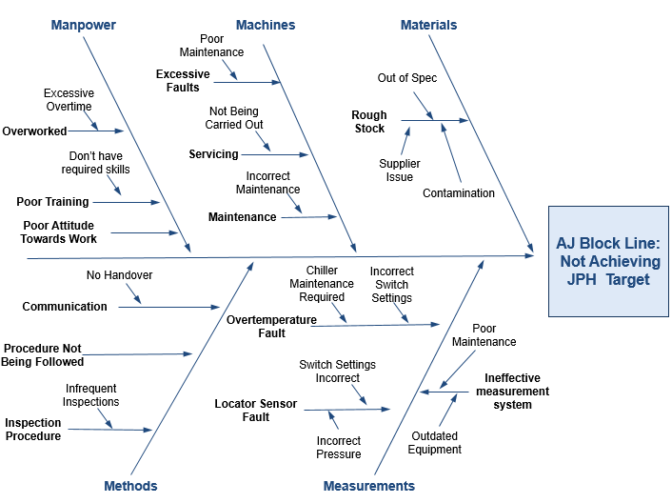
Figure 28 - Cause and Effect of Block Line Not Achieving JPH Target
As part of the cause and effect investigation that can be seen in fig 28 there have been five areas that have been identified for further analysis into why the line is underperforming. These five areas are Manpower, Machines, Materials, Methods and Measurements. The analysis findings for each of the five areas are;
- Manpower – Some of the potential contributing factors highlighted under manpower is poor attitude towards work, this is clear when operators take an excessive amount of time to attend any machine stoppages, and this could be for many reasons such as being distracted by their mobile phone or by sleeping. Another possible contributing factor is poor training, this would be highlighted during a machine stoppage where they do not have the knowledge to resolve simple issues. The last factor is staff being overworked with overtime shifts due to the need for extra production. It is the finding of this report that all of these issues could be reduced by providing appropriate training on the machines and the need for a good work ethic to be able to achieve the line targets.
- Machines – The machines area has highlighted servicing of machines is not being carried out, which is causing excessive stoppages and downtime. Further to this it has been found that machines are not always being repaired in the correct manner, but taking shortcuts instead. This could be for one of two reasons, either the maintenance team do not want to spend extra time carrying out the job correctly or there is pressure from management to return the machine to production as soon as possible to achieve production targets. These issues can be resolved by creating and implementing an effective new maintenance plan to ensure all recommended services get carried out, and by having an understanding from management that it would be more productive in the long term to carry out repairs correctly.
- Materials – The findings from the materials area is there could be defective rough stock arriving in plant. These parts may contribute to waste occurring due to being out of tolerance, however the contribution to downtime from this area should not be significant.
- Methods – There have been two main problems highlighted under the method branch. These are the infrequent maintenance inspections being carried out and poor communication. The reason infrequent inspections could contribute to the underperformance of the line is by not having the correct procedures in place to ensure maintenance is carried out. The poor communication can be a large causing factor because if no handover is carried out between shifts, then they could be unable to continue the work started, and so machines undergoing maintenance are likely to remain out of production until the original maintenance team return to work. The infrequent maintenance inspections cause can be rectified by implementing a new maintenance plan and ensuring it is carried out. The communication issue can be resolved by educating the maintenance teams of the importance of good communication.
- Measurements – The potential causes highlighted in the measurement branch are largely to do with the many machine switches and the measurements they are reading. It is the finding of this report that all the switch measurement issues can be resolved by carrying out maintenance inspections. The reason for this is many of the switches are not set correctly, mainly due to previous maintenance carried out and adjusting switch settings to return the machine to production rather than investigating the root cause. The other reason for the switches failing to obtain the correct measurement is for general faults such as spindle over temperature and fluid leaks, both of which could be eliminated by carrying out maintenance.

MTBF and MTTF
It has been established that the line is experiencing a high frequency of machine faults, contributing to a large amount of downtime, this is then largely contributing to the underperformance of the line. Due to these findings it has been decided that this report will now collect data and investigate the Mean Time Between Failure and the Mean Time To Repair. These findings can be seen in fig 29, fig 30 and fig 31.
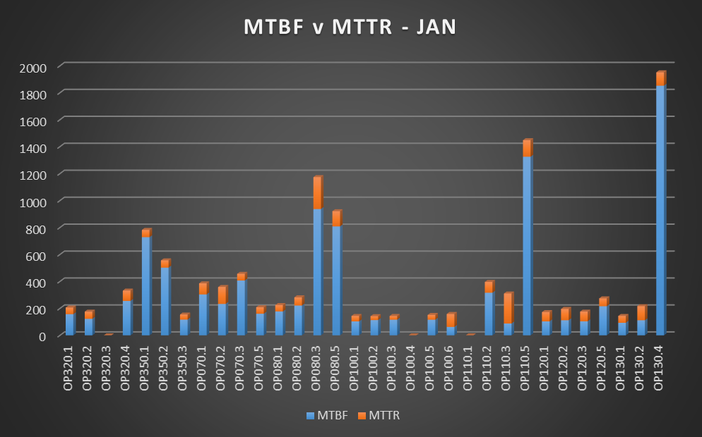
Figure 29 - MTBF v MTTR - January
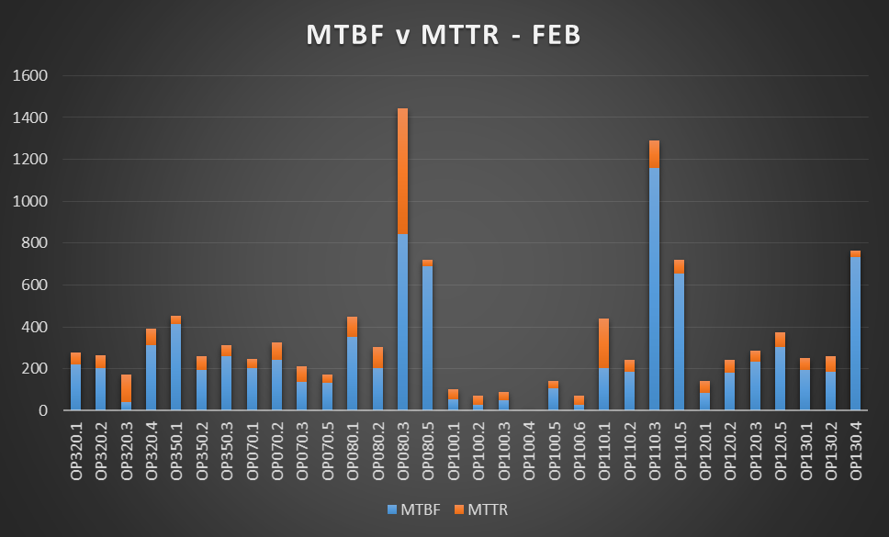
Figure 30 - MTBF v MTTR - February
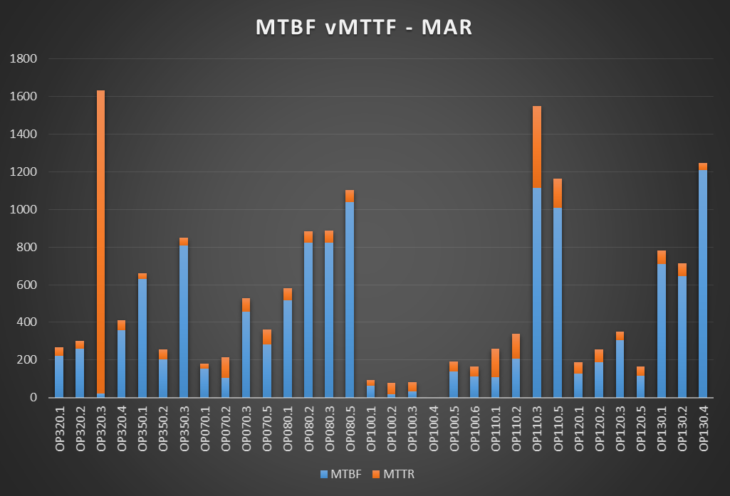
Figure 31 - MTBF v MTTR - March
When investigating MTBF v MTTR the ideal situation is to have as high a value as possible for the MTBF and as low as possible value for MTTR. This would indicate the machines very rarely breakdown, but when they do the repairs take a minimal amount to time before returning the machine to production.
This ideal situation is not currently the case on the AJ block line, the average amount of time between failures during the months of January, February and March are 311.37 mins, 276.17 mins and 400.19 mins respectively. This is not a desirable figure as on average during the three highlighted months there was a breakdown every 329.24 minutes or 5.49 hours. Also it is shown that each of these breakdowns has an average MTTR of 92.32 minutes.
To get a further understanding of why the MTTR is so high this report will also research the Mean Time To Attention (MTTA) for the machines during the same months. The data collected on this can be seen in Fig 32, Fig 33 and Fig 34.
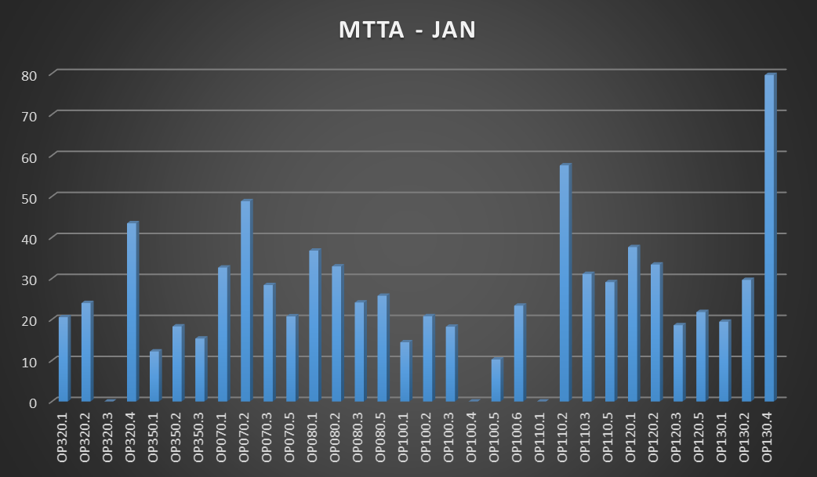
Figure 32 - MTTA - January
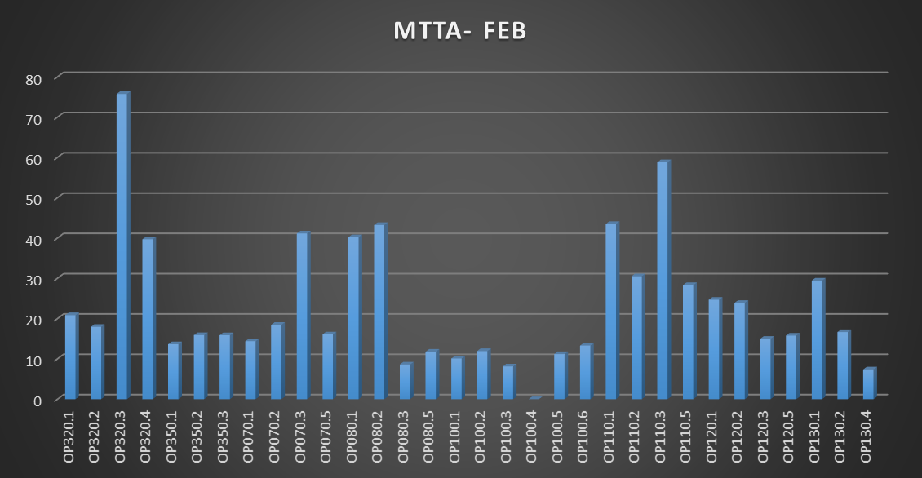
Figure 33 - MTTA - February
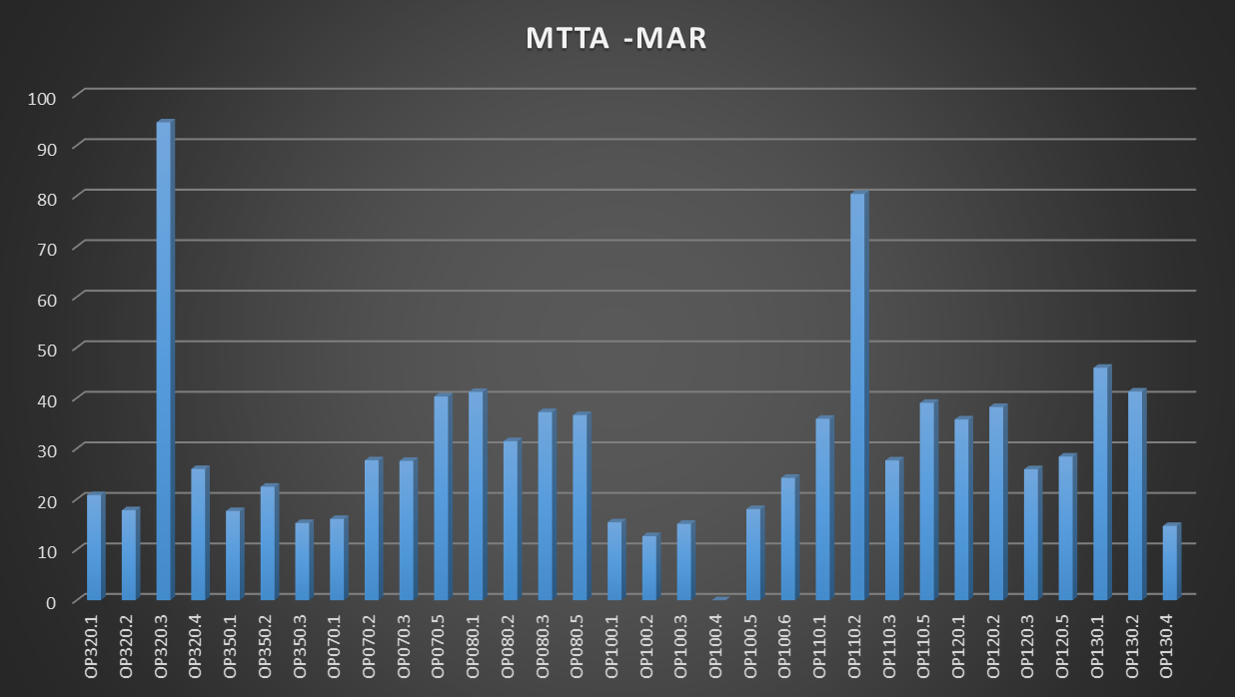
Figure 34 - MTTA - March
The data gathered in fig 32, fig 33 and fig 34 outline that in addition to already large MTTR, the MTTA of the machines is also high, further effecting the underperformance of the line. The average MTTA for the line during the months of January, February and March are 25.92 minutes, 23.20 minutes and 30.36 minutes respectively. Over the three months this gives an average of 26.49 minutes MTTA.
It is the belief of this report that the MTTA can be reduced by educating the operators about the importance of attending machines on stop as fast as possible, to ensure they are promptly returned to production, and how by doing this it will affect the productivity and ultimately future of the plant. It has further supported the need for a reduction in machine stoppages through the use of a new maintenance strategy. This is believed because currently the line operates a breakdown maintenance strategy. This strategy is highly expensive due to its impact of increased machine downtime and reduction of production.

OEE
The overall average OEE values for each of the machines during the months of January, February and March have all been highlighted in the measure section in fig 18, fig 19 and fig 20. This shows that these values fall far below the recognised world class standard of 85% with values of 36.22%, 40.08% and 36.72% in the months of January, February and March respectively. The overall average OEE of these months is 37.67%, and falls in to the ‘Low’ category.
The findings from the data gathered on the average machine MTBF and MTTR show that there is a poor ratio between the two. By having a lower MTBF value and a higher MTTR value this will negatively affect the machine availability, and thus negatively affect the OEE values. It is the belief of this report that by addressing the problems addressed causing the poor MTBF and MTTR value that the availability of the machines will be improved as will the machines OEE.

Analyse Conclusion
During this phase of this report it was first established the duration of the top 10 faults that are occurring. After reviewing this data it was found on average, not one of the top faults had a duration of less than 15 mins, this shows that none of the average stoppages are considered minor stoppages. From this finding it was then decided to further review the top three faults by using the tool 5Y’s to help establish the root cause of the faults. The top three faults used were ‘clamping fixture seating check fault’, ‘spindle motor cooling temperature not okay’ and ‘tool breakage check system fault’. The finding from this showed a large contributing factor to these faults was there is no maintenance being carried out on the machines, and by carrying out maintenance a majority of these faults could be avoided. Another potential contributing factor found was the pressure from management to return machines to production as fast as possible to achieve production targets, by doing this it does not always allow the maintenance team to carry out repairs correctly and instead shortcuts have to be taken, causing further faults in the future.
A cause and effect chart was also created to look at the potential root causes to extra downtime from the five areas of Manpower, Machines, Materials, Methods and Measurements. It was found by carrying out this analysis that again many of the root causes to the issues highlighted in fig 28 could be reduced or prevented by carrying out relevant maintenance and obtaining less pressure from management to return machines to production without carrying out repairs correctly.
To further analyse the faults and their frequency the MTBF was compared with the MTTR, with the ideal situation being that the MTBF was as large as possible and MTTR was as short as possible. The data gathered showed this was not the case, instead it was found the average MTBF for the line during the months of January, February and March was 329.24 minutes or 5.49 hours. Also it is shown each of these breakdowns has an average MTTR of 92.32 minutes. Further to this finding it was also found the average MTTA during the same three month period was 26.49 minutes.
After gathering and analysing this data, it is the belief of this report that the current maintenance practices on the line need to change with the full support of management. The current maintenance strategy being used is breakdown, this is causing a high amount of downtime on the line at a large cost of lost production, contributing to the underperformance. This report suggests that a new maintenance strategy should be put in place, this would reduce the amount of stoppages of the machines which would increase the MTBF which could then allow the maintenance team and operators to decrease the MTTR and MTTA of any remaining stoppages or breakdowns that do occur. All of this would then increase the lines JPH and improve the lines overall performance.

Improve

Improvement Alternatives
In order to generate the best solution for the problem of the AJ Block line consistently underperforming, firstly all options must be considered for implementation. From the previous sections of investigation it has been established that the solution to be implemented should meet a criteria that will make it an effective option. The criteria that should be met is partly derived from the CTQ’s that were identified from the VOC in the define section, the criteria identified is;
- Help minimize out of tolerance parts
- Help meet build schedules
- Help achieve Target JPH of block line
- Help meet delivery schedules
- Reduced Downtime
- Reduce number of faults
- Reduce cost of production
There are a number of potential solutions that could help meet some or all of these criteria points, these potential solutions can be seen in fig 35. The criteria that have been identified as part of a new solution requirement have been assigned a weighting score of importance between 1 - 10, 1 being of low importance and 10 being very high importance.
Figure 35 - Comparison of Improvement Solutions
Fig 35 outlines that there are a total of five potential solutions suggested by this report that could benefit the line and help work towards the improvements in performance. The scores that were obtained for each of the potential improvement suggestions can be seen in fig 36.
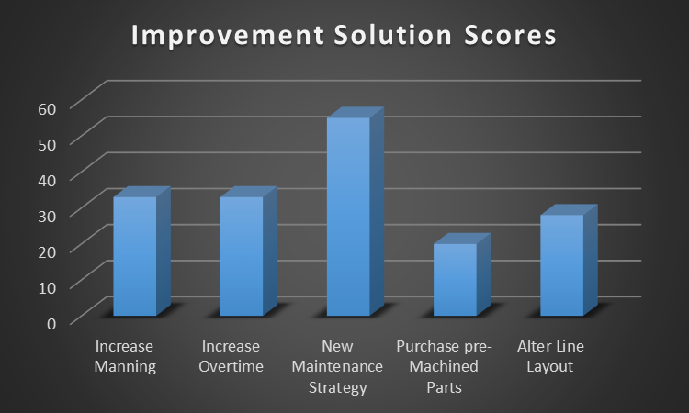
Figure 36 - Improvement Solution Scores
The first solutions suggested were to increase the volume of manning and to increase the volume of overtime, these solutions would help meet build schedules, improve JPH, help meet delivery schedules and reduce machine downtime. However these solutions would increase the costs on the line and would not minimize the amount of parts machined out of tolerance. As a result they both achieved a score of 33.
The same benefits and drawbacks were found for the solution of purchasing in pre-machined parts, which scored an overall 20. One solution, improve the layout of the line would give the added benefit reducing cost of production due to the minimizing of wastes, highlighted in the process map section of define such as transportation or excess movement as is defined by lean principles. This solution would however cost a large amount of money, and with only a limited time remaining on the production line, this would not be a viable solution and so as a result had a score of 20.
The highest regarded solution for the underperformance of the line found by this report is to create and implement a new maintenance strategy, scoring the highest amount of 55. It is the belief of this report that a new maintenance strategy would meet all the criteria required. The reasons for this are;
- Out of tolerance parts would be reduced by highlighting and eliminating backlash.
- Build schedules would be increase due to improved machine OEE
- Higher machine availability would help achieve target JPH
- Delivery schedules would be met by achieving target JPH
- Downtime would be reduced by reducing number of faults
- Number of faults reduced by repairing and replacing components before failure
- The improved performance and output from the time in the same timeframe would reduce the overall cost of machined components.

Maintenance Strategy Selection
It has been established the preferred and most suitable improvement plan is to create a new maintenance strategy that will help improve the OEE of the machines, and as a result improve the performance of the line. The same method used for the decision on which improvement solution to be implemented will be used to help identify which maintenance strategy would be most suited for this project.
The criteria that will be used for this selection process will be;
- Time to implementation
- Manning Cost
- Effectiveness
- Implementation cost
- Complexity of implementation
The different maintenance strategies to be considered for implementation will be reliability centred maintenance (RCM), condition based monitoring, run to failure (breakdown) and preventative (scheduled) maintenance. In this selection process the different maintenance strategies will be allocated a score based on how well they perform in each of the criteria, 10 being the highest score and 1 being the lowest. The findings from this can be seen in fig 37 and fig 38.

Figure 37 - Suggested Maintenance Strategies Comparison
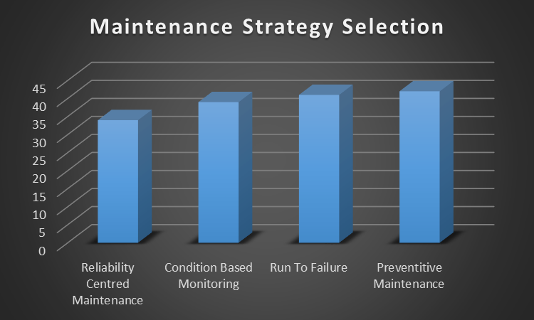
Figure 38 - Maintenance Strategy Scoring
As is outlined in fig 37 and fig 38, RCM scored 34, CBM scored 39, run to failure scored 41 and preventative maintenance scored 42. It is the belief of this report that in real world conditions the run to failure approach should not be considered, as it is currently being implemented and is proving to be highly ineffective and a large contributor to the underperformance due to high volumes of faults and downtime.
This report has decided not to move forward with the RCM approach to maintenance. The reason for this is it can take an extended period of time to gather all the data required for effective implementation, this would be an issue due to the limited length of time remaining in the life of the line. It is acknowledged that this form of maintenance would be highly effective in its role if there was currently more data available, and would likely then have been the selected option.
This report has established that the best suited form of maintenance to implement is preventative maintenance. The reason for this is it would be effective in its role of improving the OEE of the machines, it was be relatively fast to obtain data on suggested tasks and would not require a high volume of manning. This report does suggest that in-built with the preventative maintenance tasks, are also CMB tasks included such as lead screw backlash checks. It is believed that combining these two forms of maintenance would be highly beneficial to the machines and will largely contribute to the improved performance of the line.

Preventative Maintenance Plan
To improve the condition and performance of the line it has been suggested that a new maintenance strategy is put in place for the Specht machines. This report believes a new preventative maintenance schedule as well as a dedicated team to undertake the work would improve the availability of the Specht machines and so would result is higher JPH scores as well as improved efficiency of machines. To effectively create a new preventative maintenance plan it must first be understood what tasks are value add and what tasks are not viable in carrying out. To get a full understanding of these tasks a table has been created outlining each potential task as well as the implications involved if the component were to fail. In this table it has only been considered what invasive checks will be value add, this is due to the fact the non-invasive checks will allow the machine to stay in production and so will not impact its performance. This table can be seen in Fig 39.

TASK | TASK DURATION | IMPLICATIONS OF FAILURE
Check Condition of Toothed belts of the W-, X-, Y-, Z andC2-axis | 1 Hour | Belts snapping cause potential for machine to crash and damage itself
Nylon roller and tension belt condition of roller blind axis cover | 10 Mins | Roller blind becoming lose and cause damage to internal components
Lube Cycle Test | 2 Mins | Bearing and bearing rails failing
Lead Screw Backlash Check | 30 Mins | Out of spec parts or machine crash
Tool magazine (radial backlash, rollers functionality) | 20 Mins | Spindle crashing into magazine or ripping tool from pockets
W-Axis Hose Change | 5 Hours | Fluid leak and machine stoppage
Z-Axis Hose Change | 7 Hours | Fluid leak and machine stoppage
Spindle tool seat and clamping force check | 15 Mins | Out of spec parts
Fixture Clamping Check | 10 Mins | Out of spec parts
Spindle Runout Check | 10 Mins | Out of spec parts
Cleaning high pressure coolant filter | 1 Hour | Blocked filter fault
Inspect and replace W-Axis energy chain | 6 Hours | Breakage and damage of fluid hoses
Inspect and replace Z-Axis energy chain | 6 Hours | Breakage and damage of fluid hoses
Tram W over Z | 10 Mins | Out of spec parts
Replace Pneumatic Non-Return valves | 5 Mins | Part seating faults
Hydraulic oil tank Filter Replacement | 15 Mins | Blocked filter causing faults on machine
Top up Hydraulic Oil Tank | 10 Mins | Machine faulting due to low level sensor
Replace Pneumatic filter elements | 10 Mins | Blocked elements and bad quality air in system.
Replace filter mat and top up coolant of Rittal re-cooling system | 15 Mins | Spindle overheating and wearing out at accelerated rate.
Check for correct function and manipulation of E-stops | 25 Mins | Health and safety concern
Spindle Change | 4 Hours | Tool Clamping Faults
Magazine Gearbox Change | 7 Hours | Miss location and potential damage to magazine
Figure 39 - Potential Maintenance Tasks
The checks highlighted in fig 39 have been gathered from the maintenance manuals and by holding discussions with the current maintenance team. By investigating the implications of the failure to perform these checks it has been established that some of these checks can be eliminated. The checks will not be considered are;
Spindle Change – the duration it takes for a spindle to be replaced is approximately 4 hours excluding the time it takes to diagnose the issue. This would require the machine to be down for this period and so, for that reason due to the loss of production that this will not be included in the maintenance schedule. Furthermore if the spindle does fail then it will only cause faults with no damage and the expected usage of spindles is over 2 years.
Inspect and replace w-axis and z-axis energy chains – the expected life usage of the energy chains is over 5 years, this could be extended depending on what the environmental conditions of the machines are. The implications of these failing will only potentially cause damage to the hoses and cables within. To change these components would take approximately 6 hours each and so this is too long for the machine not to be operational. As a compromise it was decided that these would not be replaced as part of the new preventative plan but instead they would be inspected for any damage as well and cleaning the area surrounding so it is in a clean environment to extend its life expectancy.
Remove and clean high pressure coolant filter – on further investigation this filter has a self-clean function build into the program of the machine and so it will be cleaned every 6 hours of run time. Due to this fact there is no reason to add the additional 1 hour of downtime required to manually clean the item and so it will not be included within the plan.
W-axis and z-axis hose change – the life expectancy of the hoses within the machines is 6 years depending on the working environment of them. Because it would take 5-7 hours the replace the hoses and the result of these failing would only cause a leak the replacement of these will not be included within the plan. Instead of replacing them, to ensure that they last as long as possible before failure they will be inspected as part of the plan their working area will be cleaned.
Check Condition of Toothed belts of the W, X, Y, Z andC2-axis – this check has not been highlighted for removal from the preventative plan, but will be amended. The reason for this is the C2 and Y-Axis belts are located on the top of the machine, and the access to them is not possible without scaffolding in place. To get the required scaffolding in place it would require a cost of £500 and approximately 2 hours of complete lost production due to the gantry needing isolation during erection. For these reasons the condition checks will only be carried out on the W, X and Z-axis belts. However if there is already scaffolding in place on the machine being serviced then the C2 and Y-axis will also be checked.
Magazine gearbox change – The magazine gearbox change will not be included in the new preventative maintenance due to the time and resources required for the task. To carry out this task would require three people plus spider crane and operator rental, costing approximately £750. Further to this, scaffolding would be required at a further cost and loss of production. As an alternative to the replacement of the magazine gearbox, it will be checked and measured for backlash to ensure it is still fit for purpose. This backlash value will then be recorded and monitored to ensure it is not drastically increasing.
After removing the checks that are not viable to the suggested servicing plan of the machines, meetings were made with representatives from each of the maintenance shifts to obtain their feedback on the suggested. From this meeting, further suggestions were made for extra checks that could be carried out. As the final checks for the preventative maintenance plan were now selected, they will be placed in to a final plan, this plan can be seen in fig 40, fig 41 and fig 42.
Figure 40 - Mechanical Checks
Figure 41 - Pneumatic and Hydraulic Checks
Figure 42 - Electrical Checks
With the final preventative maintenance plan being established and agreed upon, the next thing to be established is the frequency of the servicing. The manufacturer’s manuals will be used to establish the recommended timescales on the servicing of each individual components. During this investigation it was found that the optimal servicing frequency is three time per year for each of the Specht machines. This report believes that the best way to carry out the servicing plan is one machine per day, so the line availability is not affected drastically. As to not create a bottle neck in the production line over a week long period, this report has decided that the servicing will be staggered across the different OP’s over the course of each week, for example if an OP70 cell is being serviced on a Monday then another OP70 cell will not be done on the same week. Further to this there are single path machines that will also require servicing, these will be carried out on every fourth week, at a frequency of once per year as to not affect production. A four week example of the maintenance schedule can be seen in fig 43.
Figure 43 - Four Week Example of Preventative Maintenance Schedule

Cost Benefits
Currently, due to the lines underperformance and the need to achieve production targets there has been 12 hours overtime every Saturday night to increase production (Richards, 2018). The overtime that is put on to run the line is two mechanical trade, two electrical trade and six operators. Because the hours that are worked are overtime, there is also a shift premium on the hours worked. This shift premium is time and a half for the six hours until midnight and double time for the six hours past midnight. The cost of this overtime each week can be calculated as;

$$Mechanical=2 X \left(£24.50 X 12\right)=£588$$
$$Electrical=2 X \left(£24.50 X 12\right)=£588$$
$$Operator=6 X \left(£21.25 X 12\right)=£1530$$
$$Total Standard Cost=£588+£588+£1530=£2706$$
$$Total Including Overtime Premium=£2706 X 1.75=£4735.50$$
This calculation for the cost of overtime over the twelve hour period does not take into account the extra costs such as the extra energy used for lighting, machine operation and heating that would increase the cost of overtime.
The suggested preventative maintenance plan by this report would require manning of two trade at wage grade level 5. This would result in a wage cost of £1837.50 per week.
Also in addition to this wage cost, there would also be the cost of the maintenance spares required for the preventative maintenance tasks (fig 44) and the potential cost of machine downtime required to carry out the tasks.
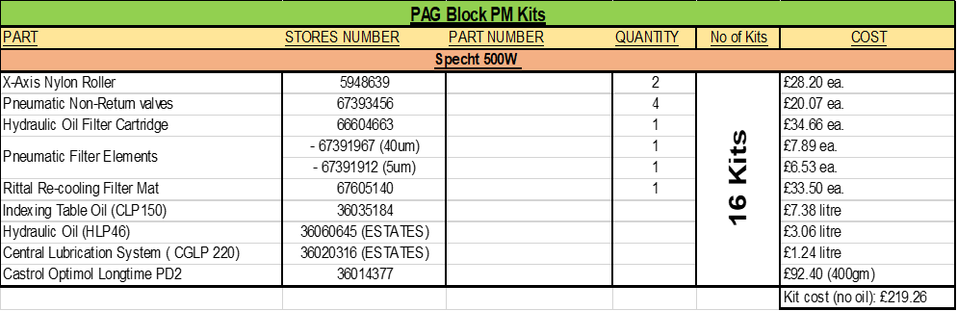
Figure 44 - Suggested Maintenance Spares Kit
The components suggested to be replaced during the maintenance plan amount to a total of £219.26 per day excluding oil. This equates to £877.04 per week based on four machines being serviced per week.
The amount of downtime that is required as part of carrying out the preventative maintenance is a total of 20 hours per week based on machine downtime of 5 hours per day, on 4 machines per week. This extra downtime could potentially cost the line £126,850 per week, however this would only be the case if the machines being serviced were at the bottleneck of the line, creating further constraint. To avoid this from occurring it is the suggestion of this report that the four machines being serviced each week are on a flexible basis, and so can be swapped with other machines from the same week to ensure that all machines are either prior to or after any line bottlenecks, ensuring no extra constraints are created. This flexibility would eliminate the potential cost of £126,850, leaving the total cost of implementing the new preventative maintenance plan at £2714.54.

Updated FMEA
As the final preventative maintenance plan has now been established the FMEA table from the measure section of this report has been updated to include the new RPN values. These values would have been affected by the implementation of the control measures in the preventative maintenance plan. The new updated FMEA table can be seen in fig 45.
Figure 45 - Updated FMEA Table
The FMEA table seen in fig 45 uses the same potential causes of downtime as in the original seen in the measure phase, but now includes further coulombs that give an updated RPN value in acknowledgement of the improvements that are being suggested. It can be seen there are some significant reductions in RPN values after the suggested preventative maintenance plan. A Comparison between the RPN values before and after the preventative maintenance can be seen in fig 46.
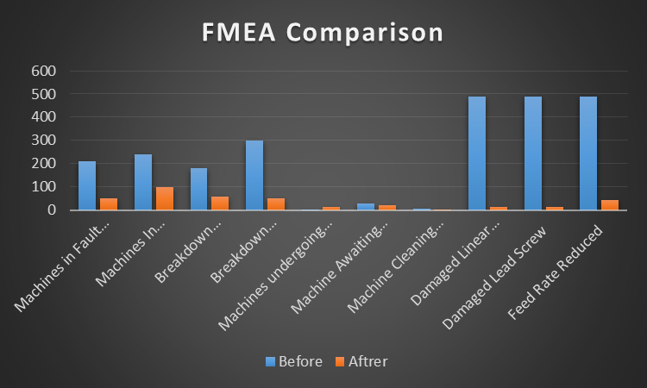
Figure 46 - Updated FMEA Comparison
The comparison shown table shown in fig 46 illustrates that there are significant reductions in RPN values once the preventative maintenance has been included. Some of the largest reductions are damaged linear bearings, damaged lead screws and reduced feed rates. All of these have a reduction in excess of 450.

Improvement Conclusion
In this section it was identified a number of different solutions that could have the effect of improving the line performance, some of these solutions included increasing manning, implementing a new maintenance strategy, increasing overtime and altering the line layout. After investigating the solutions further it was shown that the best solution for improving the line performance was to implement a new maintenance strategy.
Although four different maintenance strategies were highlighted, after looking into the suitability of each it was established the most suitable strategy would be the use of a preventative maintenance plan. This plan was then created by identifying which tasks were value add and suitable to be carried out as part of the plan and a final preventative maintenance plan was created.
By allowing for flexibility in the maintenance schedule this report finds that any bottlenecks in the line can be avoided and so the maintenance can be carried out without any effect on production. This would result in the total cost of implementing the new preventative maintenance team being £2714.54 per week. The updated FMEA table shows that there is a potential to reduce the RPN values with some of the failures by over 450.

Control
In order to effectively control the changes that have taken place as a result of this project the 5S method will be used. The 5S method is made up of five separate steps, Sort, Set, Shine, Standardize and Sustain.

Sort
Normally in this section there would be the need for eliminating waste from the current process, removing any unnecessary materials, outdated equipment and broken parts. In this project however there has been a new maintenance initiative set up and so the need to tag and remove any waste is not needed as there has been no period to allow this to build up.

Set
During this phase the first step that was taken was to identify an unused area that could be designated for the use of the new preventative maintenance team and a storage area for their tools and spare components. The area that was identified for the dedicated preventative maintenance area can be seen in the red highlighted area in fig 47.
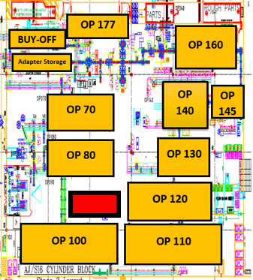
Figure 47 - Highlighted Selected Preventative Maintenance Area
In the selected area it was decided that there would be one work bench with a vice attached, a designated area for the storage of tools, shelving for spare parts and ‘Kit Boxes’ set up for the 4 machines being serviced during that week.
Further work was carried out during this phase was the creation of a new dedicated ‘Drop Zone’ where all Preventative Maintenance Team deliveries would take place, the purpose of this was to ensure that there was no wasted time attempting to source any orders that had been placed and so that none of the deliveries could be removed without consent of the Preventative Maintenance Team.

Shine
During the shine phase of the 5s system, the new maintenance area was cleaned to a high standard that was agreed to be maintained by all members of the team. Further to this floor markings were created to ensure all items such as tool boxes remained in these areas and so high cleanliness levels were maintained.
A shadow board was created during this phase to ensure all tools were returned after each use and were placed in their designated area. This would help maintain cleanliness and monitor the team’s tools for any missing pieces.
Two separate shelves were identified here for the correct storage of all the spares needed for the machine services and for the remaining tools that were not suitable for shadow board placement such as the Kelch Meter.

Standardize
To standardize the working area single point lessons were created to highlight the cleanliness standards required for the area. In addition to this labels were created to highlight the location that all pieces of equipment and spares should be stored.
To determine the amount of stock to be carried and the re-order points of the stock, the ‘Re-Order Point’ model was used with the assumptions of constant demand and constant lead time. The reason for these assumptions is because as is highlighted in the maintenance schedule in fig 43, there will be a service carried out on four machines per week only and after discussions with the supplier Eriks there would be a constant lead time on ordered parts providing there are no unforeseen circumstances.
The calculation used as part of the re-order point model was;
$$ROP=Daily Demand X Lead Time$$
This findings from these calculations for each of the spare components can be seen in fig 48.
Figure 48 - Re-Order Point Calculations for Spare Items
Once these values were obtained further labels were created and clearly displayed by the items storage location so that it was known at what level replenishment would need to be ordered.

Sustain
In Bridgend Engine Plant there is a shorter shift that takes place on Fridays when following the ‘Days’ shift pattern, and for this reason it does not allow enough time for the completion of a machine service. To maintain high working standards during this time it has been decided that the Friday’s short shift will be kept clear of services so other tasks can be carried out to sustain the working practices laid out. The tasks that will be carried out are;
- Stock Check – Check stock levels against re-order points and place order if necessary.
- Sign Off Work – Sign off SMS sheets and close down work orders.
- Raise Work Orders – If any further work is needed beyond the scope of the preventative maintenance team, work orders will need to be raised against the shift maintenance teams.
- Clean work area and equipment – Ensure work area and equipment are maintained to the Single Point Lesson standard.
- Re-Visit Incomplete Services – If for any reasons there has been a service that was not able to be completed then it will be re-visited and completed.
By following completing these tasks on each Friday then the high working standards that have been set out by this report will be able to be maintained.

Results
All the work that has been carried out in the project was done with the intention of improving the performance of the line. The metrics of machine availability, MTBF v MTTR and OEE will be used to establish whether this project has been successful in its aim. As was the case during the initial monitoring of the line, to establish if the line has improved its performance there will be a monitoring period of three months during the months of August, September and October.

Machine Availability
The first metric that will be measured to monitor for any improvements made will be the machine availability. The machine availability for each of the machines were monitored over a three month period and can be seen in fig 49, fig 50 and fig 51.
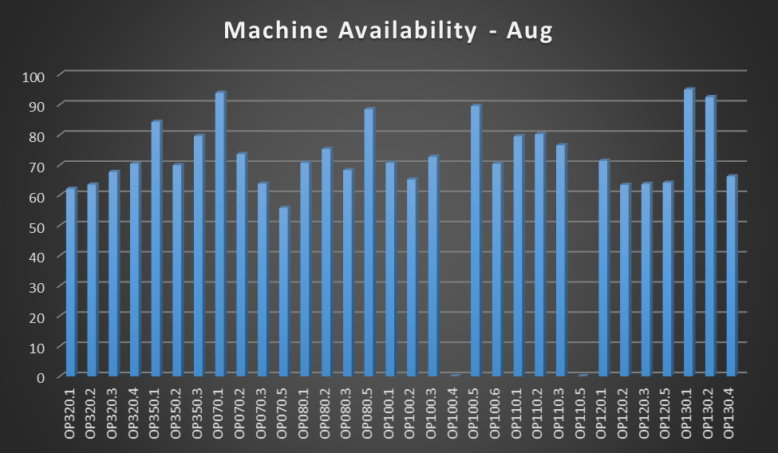
Figure 49 - Machine Availability - August
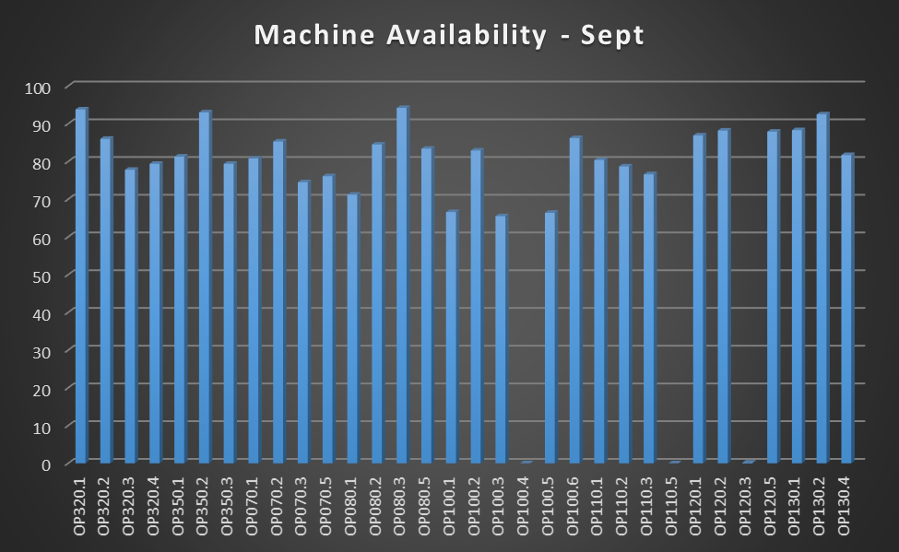
Figure 50 - Machine Availability - September
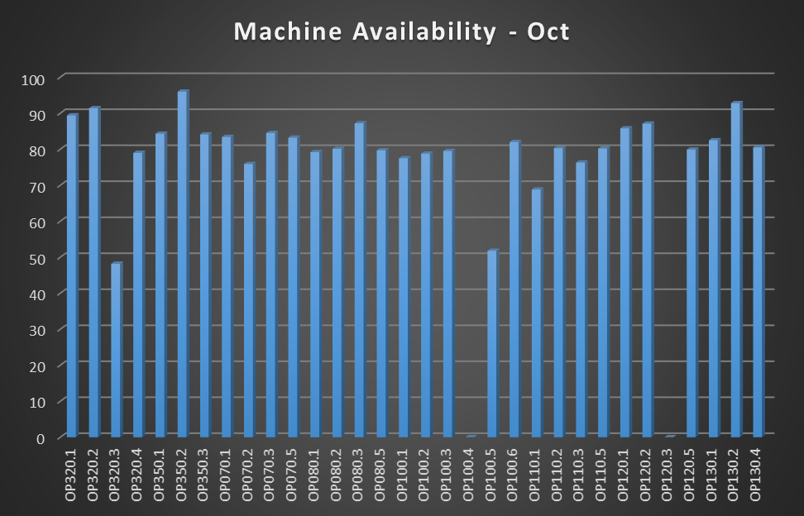
Figure 51 - Machine Availability - October

The tables in fig 49, fig 50 and fig 51 highlight there was an average machine availability of 69.01%, 74.05% and 75.29% during the months of August, September and October respectively. Overall this provides an average of 72.78%. This value is an increase of 5.28% over the previous average of 67.5% during the months of January, February and March, putting the improved average only 14.71% below the accepted world class average of 90%.

MTBF v MTTR
To further investigate the improvements of in the average machine availability, the metric comparison between MTBF v MTTR will also monitored to establish whether there has been improvements made in this area as a result of the improved maintenance initiative. The monthly average for MTBF v MTTR during the months of August, September and October can be seen in fig 52, fig 53 and fig 54.
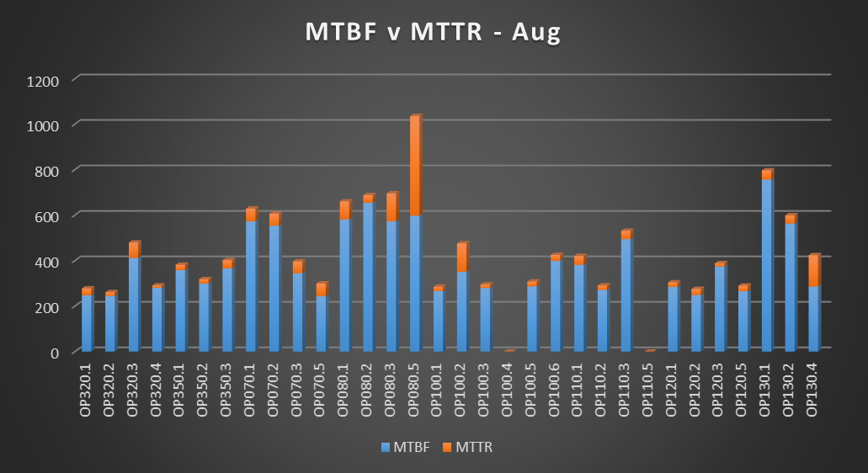
Figure 52 - Resultant MTBF v MTTR - August
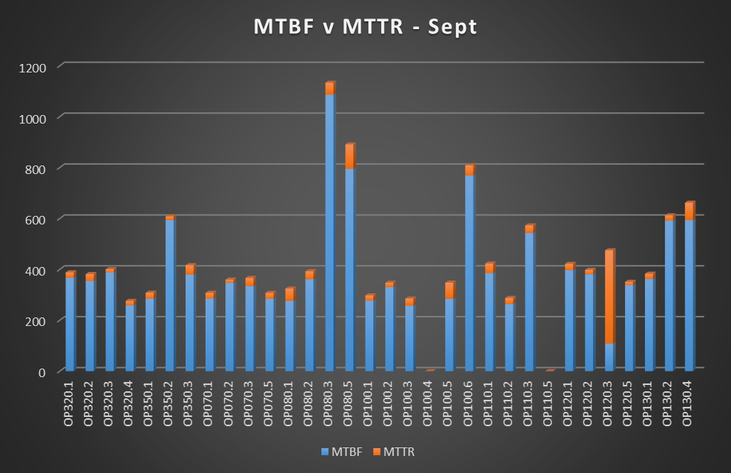
Figure 53 - Resultant MTBF v MTTR - September
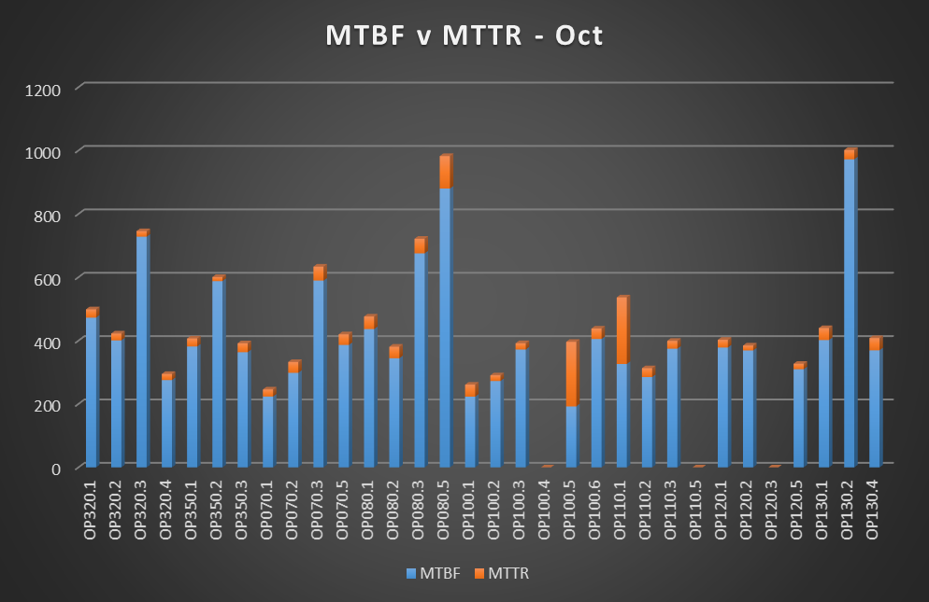
Figure 54 - Resultant MTBF v MTTR - October
The findings from the observation of the MTBF and MTTR show that the average for the MTBF during the three months was 369.55 mins, 383.62 mins and 384.22 mins. Further to this it has been shown that the average MTTR during the same three month period was 53.31 mins, 39.55 mins and 39.10 mins. Both the values found for MTBF and MTTR show a trend in improved MTBF and decreased MTTR. The current findings for MTBF and MTTR are compared with the original findings in fig 55.
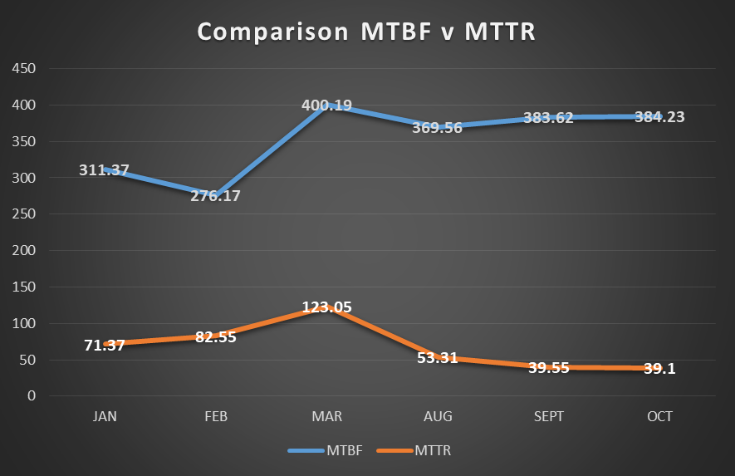
Figure 55 - MTBF v MTTR Comparison Before and After Maintenance Initiative
Fig 55 shows that there was an increasing trend in the MTTR during the originally monitored months or January, February and March. After the implementation of the preventative maintenance plan the MTTR was reduced by 69.74 mins in the month of August, then a trend in reduction of the MTTR continued through to the month of October.
Further to this the resulting MTBF shows an increasing trend during the months of August, September and October. Although there was a higher average MTBF during March (400.19 mins), the original monitoring period shows instability and it is likely that the month of March was a one off.

Machine OEE
During the months of January, February and March where the initial monitoring of the line took place the OEE was 36.22% 40.08% and 36.72% respectively. It was established that this score was far below the well-recognised world class level of 85%. On an average during these three months the average was 37.67%, which is considered below the low level.
The resultant OEE for the three monitored months can be seen in fig 56, fig 57 and fig 58.
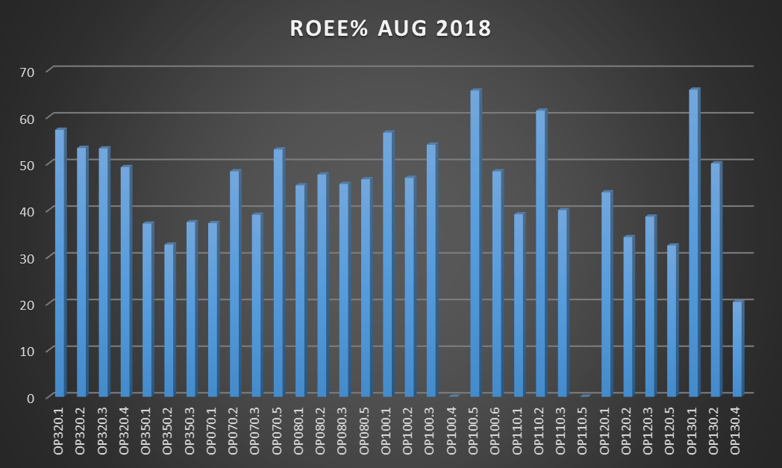
Figure 56 - Resultant OEE - August
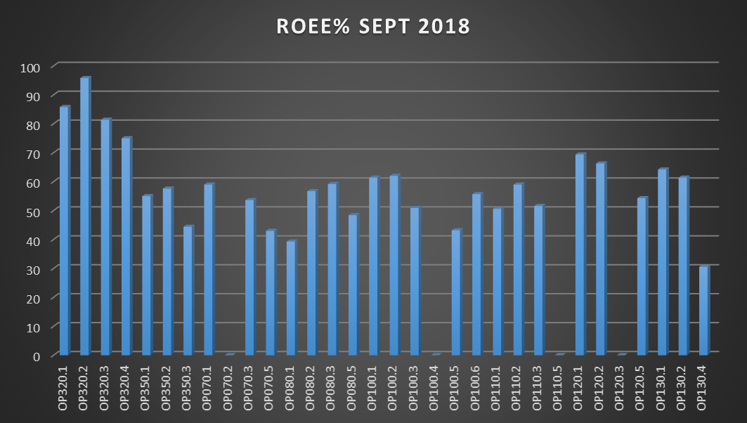
Figure 57 - Resultant OEE - September
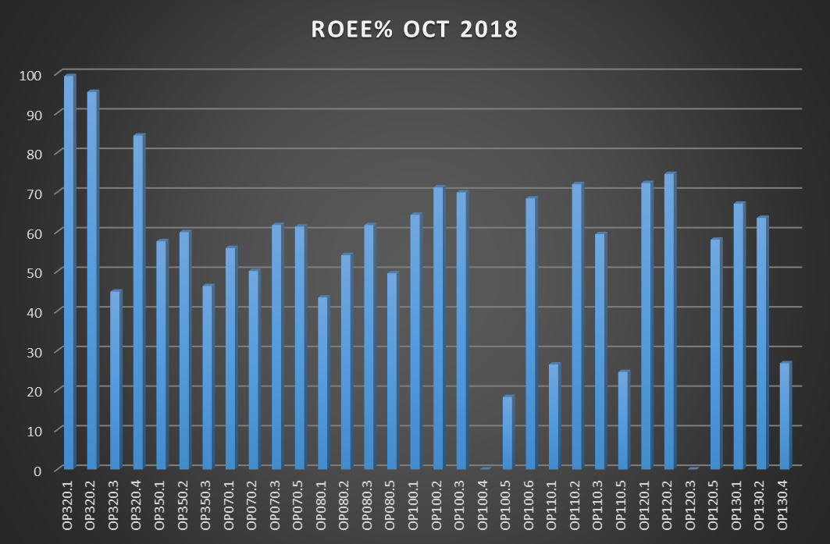
Figure 58 - Resultant OEE - October
The graphs shown in fig 56, fig 57 and fig 58 show the average OEE value for the months of August, September and October was 44.5%, 52.74% and 56.8% respectively. This then provides an average of 51.35% over the three months. With the average across the months of January, February and March being 37.67%, the implementation of the new preventative maintenance plan have resulted in an increase in average machine OEE of 13.68%. Although this is still not considered world class it is now above the previous low level and is now nearer to the typical level.

Machine JPH
With the aim of this report to improve the performance of the line by increasing the production on the line. The metric of JPH will be used to establish whether this goal has been achieved or whether further initiatives will be required to achieve this goal. The resulting JPH after the implementation of the preventative maintenance plan and a comparison to the original JPH can be seen in fig 59 and fig 60.
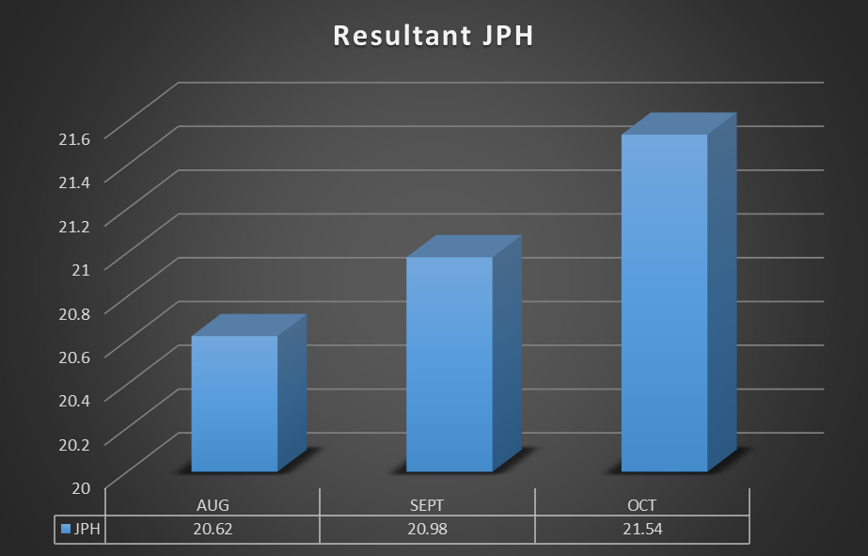
Figure 59 - Resultant JPH

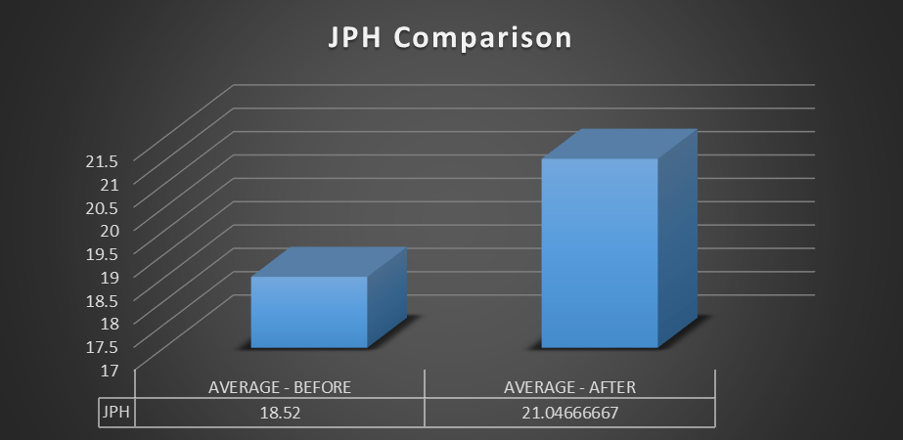
Figure 60 - JPH Comparison Before and After Maintenance Initiative
Fig 59 shows that there is a steady increasing trend in JPH during the months of August, September and October with values of 20.62, 20.98 and 21.54 respectively. This indicates that improvements are continuing to be made. The average of these months is 21.05, an increase of 2.53 over the average JPH value of the months of January, February and March.

Discussion and conclusions
The aim of this report was to carry out an investigation into the underperformance of the AJ Block line in Bridgend engine plant. This underperformance was seen in the average JPH values though the months of January, February, March and April with an average of 18.52 JPH. The target JPH of the line is 23.6 JPH and so on average these values were only achieving 78.47% of the line target.
This report used the lean six sigma methodology to establish the root cause of the lines underperformance, and found that the current maintenance strategy of run-to-failure was a large contributing factor. This was established by the discovery through OEE metrics that there were far below world class standards being achieved for machine availability. After discovering this it was found that this low availability was being caused by excessive amounts of machine stoppages due to faults that could be avoided if appropriate maintenance was being carried out.
By establishing the root cause of the underperformance was due to a poor and ineffective maintenance strategy, this report analysed the different solutions and suggested that a new preventative maintenance strategy should be put in place. To create the new maintenance plan to be carried out the manufacturers recommended maintenance plans were used and cross referenced with suggestions from the shift maintenance teams to create a final plan that had only value add checks being carried out.
The recommended suggestion by this report were put into place and as a result there was an increase in machine availability of 5.28% on average over the three month monitoring period. This increase machine availability was achieved by increasing the average MTBF and reducing the MTTR by 49.89 mins and 48.34 mins respectively.
By increasing the machine availability and machine performance the average machine OEE was increased by 13.68% as a result of the preventative maintenance being carried out. The original aim of this report has been achieved by improving the performance of the line and as a result the average JPH has increased by 2.53 over the monitoring period in comparison to before the project was carried out.
With the cost of a block being sold to the assembly process for a value of £215 this extra JPH could result in improved income to the line of £84,856 per week whilst only incurring an extra cost of £2,714.54 per week to support the role of the preventative maintenance team.

Reference List
Ahmad, M. & Benson, R., 1999. Benchmarking in the Process Industries. 2nd ed. Rugby: Institute of Chemical Engineers.
Cambridge English Dictionary, 2019. Reputation. 1st ed. Cambridge: Cambridge English Dictionary.
Campbell, D. & Craig, T., 2005. Organisations and the Business Enviroment - Second Edition. Oxford: Elsevier Butterworth Heinemann.
Carey, A., 2001. Effective risk management in financial institutions: the turnbull approach. Balance Sheet, 9(3), pp. 24-27.
Clarity Visual Management, 2019. TPM – Total Preventative Maintenance. [Online]
Available at: https://www.clarityvisualmanagement.com/technique/tpm-total-preventative-maintenance/
[Accessed 12 March 2019].
Craig , G., Neil, D. & Bruce, W., 2005. Six Sigma for Dummies. New Jersey: Wiley.
Deimler, M. & Reeves, M., 2011. Adaptability: The New Competitive Advantage. Harvard Business Review, p. 9.
Farooq, M., Kirchain, R., Novoa, H. & Araujo, A., 2017. Cost of quality: Evaluating cost-quality trade-offs for inspection strategies of manufacturing processes. International Journal of Production Economics, 188(1), pp. 156-166.
Fitzsimmons, A. & Atkins, D., 2017. Rethinking Reputational Risk: How to Manage the Risks that can Ruin Your Business, Your Reputation and You. 1st ed. London: Kogan Page Publishers.
George, M., 2010. The Lean Six Sigma guide to Doing More with Less. New Jersey: John Wiley & Sons..
George, M., Rowlands, D. & Kastle, B., 2004. What is Lean Six Sigma. New York: McGraw-Hill.
George, M., Rowlands, D., Price, M. & Maxey, J., 2005. The Lean Six Sigma Pocket Toolbook. New York: McGraw-Hill.
Go Lean Six Sigma, 2018. Define – Phase 1. [Online]
Available at: https://goleansixsigma.com/define-phase-1-of-5-of-lean-six-sigma/
Go Lean Six Sigma, 2018. Measure – Phase 2. [Online]
Available at: https://goleansixsigma.com/measure-phase-2-of-5-of-lean-six-sigma/
Gygi, C. & Williams, B., 2012. Six Sigma for Dummies. New Jersey: Wiley.
Hoffman, B. G., 2012. American Icon: Alan Mulally and the Fight to Save Ford Motor Company. 1st ed. New York: Crown Publishing Group.
Holpp, L. & Pande, P., 2001. What Is Six Sigma?. New York: McGraw Hill Professional.
Islam, K. A., 2006. Developing and Measuring Training the Six Sigma Way: A Business Approach to Training and Development. San Francisco: Pfeiffer.
Jones, E., 2014. Quality Management for Organizations Using Lean Six Sigma Techniques. Boca Raton: CRC Press.
Kelly, A., 1997. Maintenance Strategy. Oxford: Elsevier.
Kennedy, A. & Jardine, S., 1970. Operational Research in Maintenance. New York: Barnes and Noble.
Kumar, D., 2006. Six Sigma Best Practices: A Guide to Business Process Excellence for Diverse Industries. 1st ed. Fort Lauderdale: J. Ross Publishing.
Martin, G., Cooper, C. & Burke, R., 2011. Corporate Reputation: Managing Opportunities and Threats. Surrey: Gower Publishing.
Maxim Consultants, 2015. http://maximconsultants.com/lean-six-sigma/. [Online]
Available at: http://maximconsultants.com/lean-six-sigma/
Morgan, J. & Brenig-Jones, M., 2014. Lean Six Sigma For Dummies. Chichester: Wiley.
Moubray, J., 1997. Reliability-centered Maintenance. New York: Industrial Press Inc.
Ohno, T., 1988. Toyota Production System – Beyond Large Scale Production. New York: Productivity, Inc.
Okes, D., 2009. Root Cause Analysis: The Core of Problem Solving and Corrective Action. Milwaukee: ASQ Quality Press.
Parmenter, D., 2007. Pareto's 80/20 Rule for Corporate Accountants. New Jersey: John Wiley & Sons.
Productivity Press Development Team, 1999. OEE for Operators: Overall Equipment Effectiveness. 1st ed. New York: Taylor & Francis.
Richards, J., 2018. AJ Machining Manager [Interview] (3 January 2018).
Saha, D., Syamsunder, M. & Chakraborty, S., 2016. Manufacturing Performance Management using SAP OEE: Implementing and Configuring Overall Equipment Effectiveness. 1st ed. New York: Apress.
Schmidt, R. & Pearson, L., 2019. Estimating the cost of quality of errors in the analytical phase. Clinica Chimica Acta, 495(1), pp. 60-66.
Simms, H., 2005. Organisational Behavoiur and Change Managment. Cambridge: Select Knowledge Limited.
Sixsigma Institute, 2017. Six Sigma DMAIC Process - Define Phase - Capturing Voice of Customer (VOC). [Online]
Available at: http://www.sixsigma-institute.org/Six_Sigma_DMAIC_Process_Define_Phase_Capturing_Voice_Of_Customer_VOC.php
Stamatis, D., 2010. The OEE Primer: Understanding Overall Equipment Effectiveness, Reliability, and Maintainability. 1st ed. Boca Raton: CRC Press.
Swan, E., 2016. Failure Modes & Effects Analysis (FMEA). [Online]
Available at: https://goleansixsigma.com/failure-modes-effects-analysis-fmea/
Sweeney, B., 2015. Lean Six Sigma and Lean Quickstart Guides. New York: ClydeBank Media.
Tanabe, K., 2018. Pareto’s 80/20 rule and the Gaussian distribution. Physica A: Statistical Mechanics and its Applications, pp. 635-640.
Tennant, G., 2001. Six Sigma: SPC and TQM in Manufacturing and Services. Hampshire: Gower.
Thorn, A., 2019. Maintenance. Swansea, University of Wales Trinity St David.
Thorn, A., 2019. Reliability Centered Maintenance. Swansea, University of Wales Trinity St David.
wastewater, W. &., 2015. Preventative maintenance processes for water. Filtration + Separation, pp. 36-37.

