University of Wales Trinity St David

Master of Arts: Outdoor Education

Philosophical and Cultural Perspectives on Outdoor Education – BMOE7016

Assessment 1

Outdoor Education as a Site of Cultural Struggle

Word Count = 3574 / 3750

Student – 2415962

Bethan Schofield

The definition, practice and theory surrounding Outdoor Education (OE) has been a popular discourse for over one hundred years (Vooys 2018). The practice has been given numerous titles, such as outdoor adventure education, experiential education, community-oriented schooling, ecological and environmental education (Roberts 2012). These titles have one connecting feature, they all take place outside, in the open air (Beams & Pike 2013). The historic outcomes and goals have also changed from that of moulding young men to be ready for war, and developing of the potential future leaders of the country (Loynes 2008). The current goals and outcomes however are a lot more varied and broader, involving both educational and leisure goals (Humberstone et al 2018), and not just including the physical challenges of adventure pursuits, but also the psychological benefits of being outside and closer to nature (Brookes 2022), and the opportunities to learn about the world around us, and environmental changes (Ogilvie 2013), along with the possibility of building resilience (Loynes 2008). The exposure to challenging situations is especially important for children, to help build resilience and self-confidence (James & Prout 2014), which are personal skills that help individuals get through any challenging situations throughout life (Segrin & Flora 2011). This photo essay will explore and critique the sociocultural dimensions of OE within urban areas, with a key focus on the provision of OE for children, up to the age of eighteen.

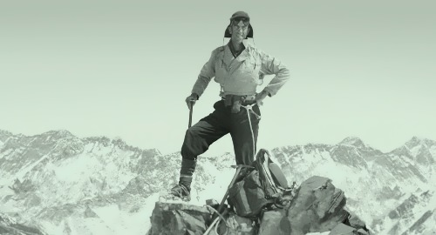 (Image 1 - mirfaces.com, 2024)

Mountaineering is amongst one of the earliest forms of outdoor adventure pursuits, being a popular activity worldwide. Many explorers’ attention was drawn to the vast number of mountains in the Himalayas, one of which was named Mount Everest during a geographical report in 1856 (Waugh 1857). The mountain was named after Sir George Everest, the man who led an expedition during 1841 where several Himalayan peaks were assessed within its landscape. On 29th May 1953, the summit of Mount Everest, the highest mountain on earth, was reached for the very first time, by New Zealand born Edmund Hillary and one of his Nepalese Sherpa’s, Tenzing Norgay. There had been over a dozen attempts to ascend Mount Everest prior to this, some of which ended with fatalities, that including both Andrew Irvine and George Mallory in 1924, British explorers and climbers who were on an expedition with the Royal Geographical Society and Alpine London Club (Griffiths 2020). During this era, mountaineering was an elite character defining exclusive sport, solely consisting of upper-class white males, mostly from military backgrounds. Whilst this level of mountaineering was inaccessible in the United Kingdom, groups of young men were led out on expeditions in order to develop personal skills and build resilience needed to become the next generation of leaders and war time heroes (Nicol 2007).

Yet, during the late 1800’s, densely populated urban areas such as London, Birmingham, Manchester and Liverpool, were facing issues of hooliganism, petti crimes and theft from the younger generations (Davies & Pearson 1999). During the early 1900’s, young people were still struggling but with different issues, described by Hahn as the six declines (Vooys 2018). Decline of fitness and skill were a couple of these. Various organisations, groups and clubs were formed all with a similar goal, to engage the younger generations in activities and challenging environments, in order to improve their moral standing (Loynes 2008). Religious groups formed youth club projects and Sunday schools, whilst other organisations created groups such as the Boys Brigade, and Scouts (Pugh 1999). Opportunities were also created for young women, as Smith (1997) wrote about how in the eighteen nineties, Emmeline Pethick and Mary Neal took groups of young women from the West End of London, removed them from the exploitation of the tailoring and dress trade, and were introduced to holiday camps where they played games and were able to rid the frustrations created by the horrific workhouse conditions. These early forms of OE took the younger generations out of the cities and into rural areas for expeditions, adventure and opportunities which they could not access within their home environment, albeit they returned with self-growth, and an increase in self-confidence (Roberts 2012). However, Potter & Gray (1999) would argue that those living in urban areas are unable to fully appreciate and gain from any form of OE within their home environment due to it not being ‘wild’ enough.

 (Image 2 - Schofield, Dordon, November 2024)

Other initiatives aimed at getting the youth outdoors, learning lifelong skills and staying out of trouble were created, such as the Duke of Edinburgh Award, in 1956 by Kurt Hahn (Vooys 2018). Although initially created to inspire the younger generations to become more involved in their local communities, and was only available for boys, it rapidly grew in popularity and was soon open for girls as well (DofE.org 2024). Young adults are given the opportunity to help out in their local community, go on expeditions and learn lifelong skills, some of whom would never have been given the opportunity to gain these experiences (Bolding 2021). Bolding (2021) argues that the DofE award should be available to all children through State High Schools, her suggestion is backed up by the results from a study completed in 2007 by the University of Northampton. Published in 2009, the report highlights the positive experiences gained by those attending and completing their DofE awards. It also highlights the results of those from urban environments, such as London, including numbers attending. These all show a high number of attendees in major urban environments. Albeit, what the report does show is that London has the lowest number of voluntary staff for their DofE projects (Campbell et al 2009), and that a previous report had highlighted an issue with attainment of staff in urban areas. Yet, the report does state that the failure ratings are mostly impacted by the way a unit is managed, and not the area in which it is located. Lines & Blenkinsopp (2002) agree, and states that the volunteers for DofE are essential in supporting the unit.

Despite London being a major urban environment, it appears that OE organisations such as the DofE are thriving, despite not having direct access to wild area. However, other areas within a major city that could offer OE opportunity, such as local play areas, may not be doing so well. Image 3 below shows a children’s playground in London during the 1980’s. This image has been sourced from a family blog page, where they discuss outdoor adventure playgrounds, and is being compared to the vast number of similarly themed play areas across Europe, of which were initially created by adults during the 1940’s, to encourage children to take risk in order to build resilience (Cherie 2014). These play areas were built using mostly natural resources and materials, some of which created hazards such as the possibility of splinters, or a scrape from a nail, yet these areas were deemed acceptable and had minimal parent or adult intervention (Zamani 2016). Children were able to create their own spaces within these play areas, thus encouraging their creativity, and promoting a natural environment for social development. Wattchow & Brown (2011) agree that the place in which children are experiencing adventure and learning does not necessarily have to be a wild place or within the wilderness. This form of unstructured play has developed from early theories on education and learning within nature, from the era of Romanticism (Roberts 2012).

These child centred learning theories came from 18th century philosophers such as Jean-Jacques Rousseau, who believed that children learn best when in nature and from first hand experiences. Also, from Friedrich Froebel who stressed the importance of free play and creativity in the outdoors (Knight 2013). Yet these areas of creative autonomous play are now in decline (Casey 2007), and are being replaced with play grounds offering set exercises and activities, which do not challenge the imagination of the children (Knight 2011). Brown & Patte (2013) explain how these pre-determined areas of play do not challenge children enough to encourage self-development, as they have removed the element of risk taking. Tovey (2007), argues that these modern, sanitised, play areas have only stretched the imaginations of the designers. Whilst the play area in image 4 shows a child taking the risk of climbing around the bars, this area was already designed with safety in mind, whereas the adventure play area in image 3 has greater element of risk and offers more opportunity for creative play. Despite these changes in design of outdoor adventure play areas, theorists still agree that children learn best from first hand experiences (Bruner 1972) and also from being outdoors in a natural environment (Smith & Knapp 2009).

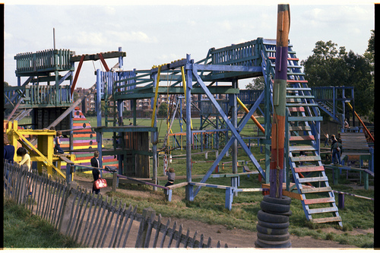
(Image 3 – MillerArtWork, 2024) (Image 4 – Methodwriter85, 2024)

With the above-mentioned theories of education and learning in mind, along with the definitions of OE, the question is, should urban adventure play areas are viewed as OE environments? And if so, should there be more natural organic areas which encourage creativity? A recent study by Wood, (Gladwell & Barton (2014), shows that young children are more physically active when playing on an open space such as a field, compared to a playground. Greenaway (2008) states that as soon you leave the confines of an indoor environment you pass the threshold into the outdoors, where learning takes a different form; breathing in fresh air and changes to perspective. Loynes (2008) describes the outdoors as a learning environment, a space and place providing opportunity for personal development and growth: having moved away from the social elitists who dominated the environment, to that of a space and place for all. Unfortunately, with the increase and appetite for risk taking increase during the sixties and seventies, so did the accidents and occasional fatalities (Ogilvie 2013), resulting in many adventure playgrounds being overhauled and sanitised. Yet, between 1986 and 1999 there was just five fatal accidents which took place on playgrounds in the UK (Tweed 2002), compared to the number of fatal accidents taking place in other outdoor adventure activity environments, this was minimal. Albeit, accessible play areas for young children began to take on a new appearance, and designers now incorporate outdoor areas of play into new residential inner city and rural developments. Reggio (2002) stresses the importance of cities being a safe place for children, where they can meet friends and play.

(Image 5 – BBC 2023)

Image 5 shows a new play area recently built in the city of Sheffield, the appearance of which indicates a close link to that of the play area in image 3. It has been constructed using similar materials, with taller elements and areas to climb, yet there is little opportunity for children to be creative with play in this area. It has also been very well sanitised, should accidents happen, there is a rubber matting below the grass to soften bumps and falls, and the slide has been encased creating a tunnel effect. One could argue that the opportunity for risk taking has also been removed, as every activity available is pre-planned and designed for a set purposed, however children can decide on when and how to take their own risks, as everyone has the right to take on the challenges they face within outdoor activities (Barton 2007). Image 6 is another example of a newly built outdoor play area within the city of Stafford. Despite the surroundings of this play area being less urban and built up than that in image 5, it has many similarities. The slides have been made into tunnels, the dominant construction material is wood and every piece of equipment has an already pre-determined set activity. There is very little chance of fatal accidents taking place in either of these play areas, as there is very little opportunity for children to explore their own self-confidence and develop a sense of risk and build resilience. A recent study by Mears et al (2020) highlights the importance of having functional green spaces in close proximity to urban residential areas for children, in order to increase children’s physical activity levels, to combat the epidemic of childhood obesity. The results of this study shows that children living in more urbanized areas, where greenspaces are not easily accessible, have a greater percentage of childhood obesity.
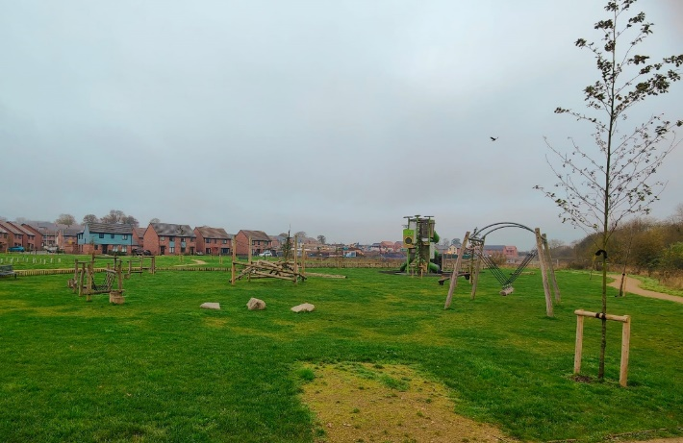
(Image 6 – Schofield, Stafford, 15th November 2024)

These images of play areas are a stark contrast to that of post war times, when many inner-city children were able, and allowed, to play on the rubble fallen from the destruction of wartime bombing (See Image 7). Other risky areas children played in include alongside railway lines, in waste disposal sites, and in rivers and lakes. Of course, these areas are now considered dangerous for children to be near, but during this era children had a lot more freedom and autonomy over their unstructured outdoor physical activities (Ilmi et al 2018). This gave children the opportunity to naturally learn about risk taking, learning about their own abilities, and developing their personal self-confidence, and building resilience. This historic image of children playing, in what is now viewed as high-risk areas, could be perceived as a highly adventurous rescue free area. Cloutier (1999) states that the concept of rescue free areas is important to the very existence of adventure, as it enables individuals to freely make their own decisions about how to respond and react to a situation. The UK has restricted or removed all possible spaces these children used to play in, and over sanitised their accessible playgrounds, however, other European countries are still very passionate about providing children with areas in which they can create their own play and chose to take risk by choice. Forest School originated in Denmark in the 1950’s (FSF 2024), however Scandinavian culture has a philosophy of outdoor life known as friluftsliv; leading a lifestyle of connecting freely and spiritually with the outdoors and nature (Sjödin et al 2024).

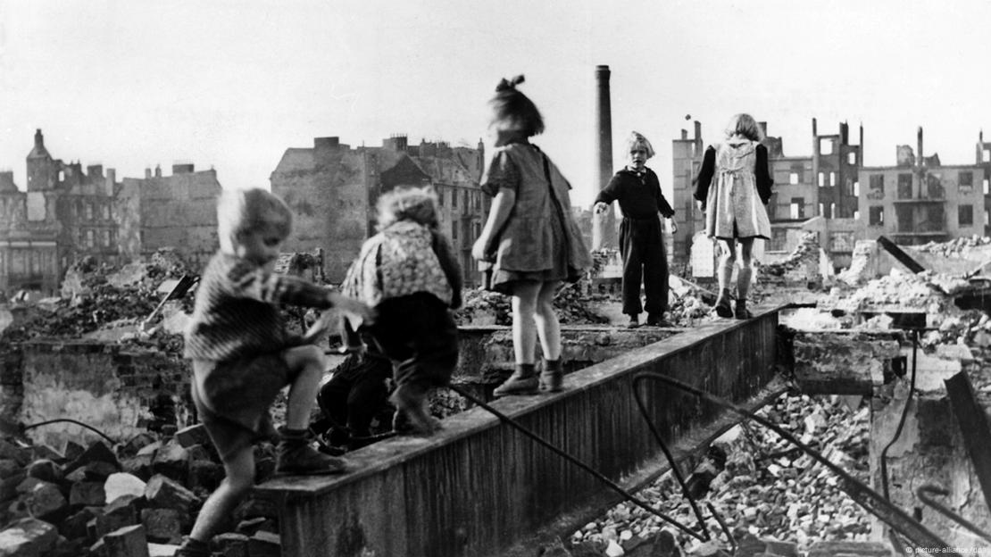 (Image 7 – DW 2015)

The UK has taken onboard the Danish practice of Forest School and has been implementing these OE sessions since the nineteen nineties (GFS 2024). The Forest School Foundation (FSF) (2020) reports that the first Forest School in Denmark was formed in nineteen fifty-two, when a few mothers started meeting daily in local woodlands with their young children as there was a shortage of indoor education centres for younger children. Yet in Sweden, records of outdoor learning date back to nineteen twenty-eight. Despite it being a popular form of OE in its Scandinavian country of origin, in the United Kingdom (UK), Forest School is still a relatively new form of OE (Garden & Downes 2023), and the first school setting took place in England in nineteen ninety-five (Cree & McCree 2012). Forest School involves a large diverse range of activities all aimed at creating an enabling, yet challenging environment, designed to encourage and support child development in several ways: personal development, physical development and cognitive development (Cree & McCree 2012). Yet the UK faces sociocultural struggles with the implementation of Forest School, and the frequency in which it takes place (Leather 2016). Leather (2016) explains how the UK faces implementation issues due to the sessions being theorised around play, whereas the UK education system does not incorporate play into the curriculum beyond stage 2. Also, that forest school is a social construct, built from the translation of friluftsliv meaning “free air life”.

Garden (2023) stresses the importance of risky play within forest school and how this supports child development, yet in the UK, progression of the risk averse culture impacts on the correct implementation of forest school. Other European countries value the importance of play and autonomy much greater than the UK, despite there being many proven theories and studies completed showing how children’s free play is an essential aspect to child development (Tovey 2007). Moss (2016) argues that the UK government does not yet hold enough value on OE, and that it is too focused on attempting to get children to meet certain learning outcomes and criteria at specific ages. Moss (2016) states that risk taking is an essential part of child development, and that there is an element of risk in all OE (Gair 1997). Albeit, in the UK, many parents have a concern about the risks when children are playing in the outdoors (Brock et al 2019), yet those that do attend forest school sessions become part of their own little micro-community and all are contributing in some way to their child’s social and emotional development (Blackham et al 2021).

Some play areas have been designed to replicate similar challenges of a forest school environment, as seen in image 8, and have been strategically positioned within an outdoor woodland space which gives the feel of forest school and the outdoors. This particular space is in the town of Llangollen in Wales, but similar areas can be seen across the UK. You will notice that the actual play activity involved is not too dissimilar to that in image 7, where children are taking risk, learning balance and coordination. It is also similar to that in image 9, in a forest school session, where children can choose to attempt a challenging activity which they perceive to be a risk. However, forest school settings are usually set up and assembled for the days group, and are not accessible to all at any time of day. Whereas, that in image 8, along with the play areas in images 5 and 6 are permanent structures.

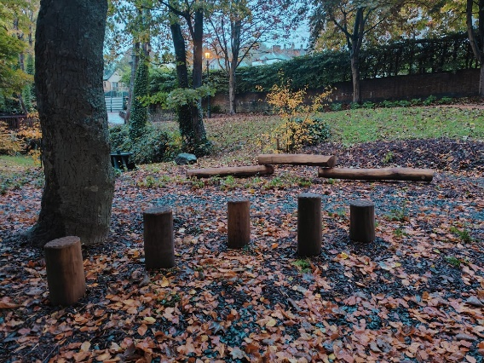 (Image 8 – Schofield, Llangollen, 19th October 2024)

Images 9 and 10 were taken at a family forest school session, ran by a local forest school, whom usually run sessions during the day, on a weekday, during school hours, and so they are only available to families with children under school age, or those who have chosen to home school their children. This eliminates the accessibility to a vast number of children who will be in school whilst the sessions are taking place. However, it does provide the opportunity to follow the six principles of forest school, one of which one states that the benefits of forest school are achieved over long-term regular sessions, and not just one-off events. Although many schools now run forest school sessions, they are not true to the authentic forest school ethos (McCree 2019). Garden (2024) talks about the power struggles between forest school practitioners and primary school teachers, when these sessions take place in local primary schools, and that teachers struggle to hand over the element of power to the forest school practitioners whom run a more child led autonomous learning environment.

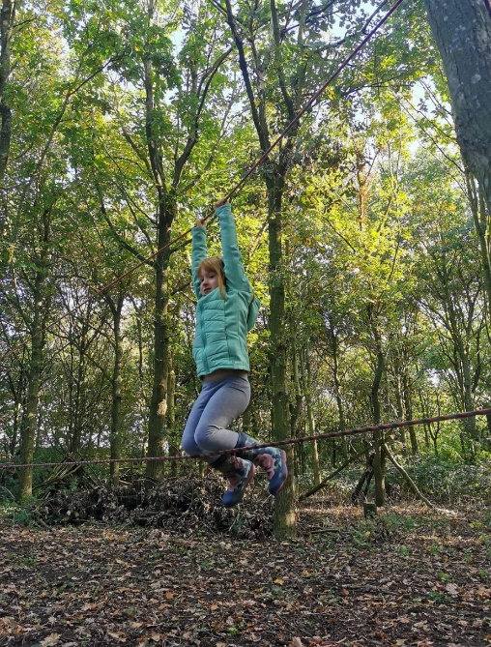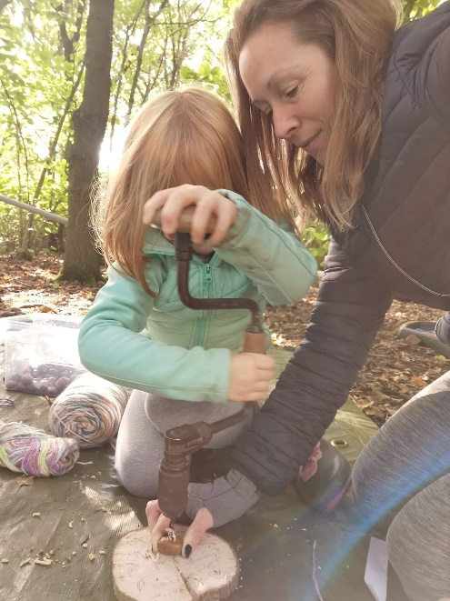
(Image 9 & 10 – Schofield 8th October 2022)

Image 11 and image 12 show examples of indoor replications of some outdoor adventure activities. These indoor, sometimes portable, substitutes for outdoor adventure activities provides opportunity for those who do not have access to participate, however, Beard (2003) would argue that one’s senses are heightened by being in the outdoors and that is the ‘key’ ingredient to the overall experience. James (2000) agrees, and states that the mountains and moorlands speak for themselves, as the natural environment evokes spiritual and emotional feelings. Not only is being outdoors a great benefit to mental health, but also physical health, as Kelly & Potter (2011) discuss the overall health benefits of outdoor adventure education. These indoor alternatives also offer opportunities for those in urban and inner-city environments to participate in such activities, thus being physically active and improving physical, mental and social well-being. But, do these indoor substitutes class as OE?

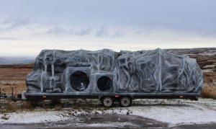
(Image 11 – Big Foot Events, 2024)

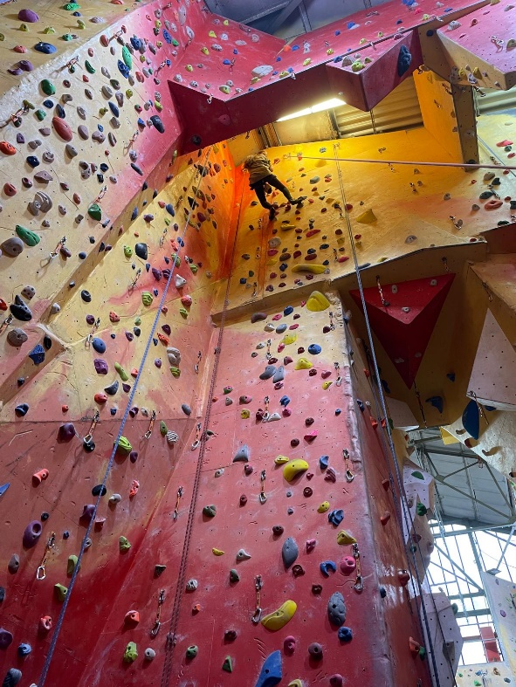
(Image 12 – Kettle, November 2024.

To conclude this exploration of OE, of which there are many struggles within the UK, from the early ideologies and hegemony of the social elite, with the white male dominant stance on the sport of exploring and mountaineering, to the current struggles with how the UK has adopted and commercialised forest school, along with the difficulty in establishing and preserving natural areas of OE within inner city urban areas.

The risk averse culture within the UK, which stemmed from a post-war era of freedom and choice when children were able to have more control of their play opportunities, resulting in accidents, injuries, fatalities and blame. This risk averse society has become the norm within the UK, and makes the establishment of traditional forest school OE a struggle, along with the national curriculum not permitting schools and practitioners to be autonomous with their lessons and learning styles. The perception and level of risk is different to individuals, adults and children, yet children are often held back and not allowed to take risks. An outdoor lifestyle culture as seen in other European countries is not mirrored within the UK, and so creates another struggle to how forest school is received and practiced with the UK.

Within urban areas, whilst there may not always be accessible woodlands, mountains, and rocks to climb, there are alternatives and schemes which promote and enable outdoor activities. However, it would be beneficial to run a study on how much of the population within a city make use of the spaces they have, or if they would prefer to use indoor substitutes. The results of such a study could then be used to answer the questions of if OE needs to take place in the wilderness, or if indoor alternatives will suffice.

References:

- Barton, B. (2007). Safety, Risk & Adventure in Outdoor Activities. London: Sage.

- Beard, C. (2003). The Circle and the Square: Nature and Artificial Environments, in Humberstone, B., Brown, H. & Richards, K. (2003). Whose Journeys? The Outdoors and Adventure as Social and Cultural Phenomena, Critical Explorations of Relationships between Individuals, ‘others’ and the Environment. Cumbria: The Institute for Outdoor Learning.

- Becker, P. & Schirp, J. (2008). Other Ways of Learning. Marburg: OEO.

- Berry, M. & Hodgson, C. (2011). Adventure Education, An Introduction. Abingdon: Routledge.

- Blackham, L., Cocks, A. & Bunce, L.T. (2023) ‘“Our Forest School isn’t Just the Trees.” Forest Schools: Micro-Communities for Social and Emotional Development’, Journal of Adventure Education and Outdoor Learning, 23(2), pp. 158–169. Available at: https://doi.org/10.1080/14729679.2021.1984964.

- Bolding, M. (2021). Is the DofE Award Relevant to Today’s Students? The Times Educational Supplement; London. 3rd December 2021. Accessed on: 12th November 2024. https://www.proquest.com/trade-journals/is-dofe-award-relevant-today-s-students/docview/2604735498/se-2?accountid=130472

- Brock, A., Jarvis, P. & Olusoga, Y. (2019). Perspectives on Play, Learning for Life. London: Routledge.

- Brookes, A. (2022). A Paradigm Shift that never was. (A Critique of Neo-Hahnian Outdoor Education Theory Part Three). Journal of Outdoor and Environmental Education. (2023). 26:153-165. https://doi.org/10.1007/s42322-021-00088-5

- Brown, F. & Patte, M. (2013). Rethinking Children’s Play. London: Bloomsbury Publishing Ltd.

- Bruner, J.S. (1972). Nature and Uses of Immaturity. American Psychologist Vol 27, Issue 8, pp. 687–708. https://doi.org/10.1037/h0033144

- Campbell, J., Bell, V., Armstrong, S.C., Horton, J., Mansukhani, N., Matthews, H. & Pilkington, A. (2009). The Impact of the Duke of Edinburgh’s Award on Young People. The University of Northampton, Centre for Children and Youth. June 2009.

- Casey, T. (2007). Environments for Outdoor Play, A Practical Guide to Making Space for Children. London: Paul Chapman Publishing.

- Cherie, M. (2014). Adventure Playgrounds Outdoors: What and Why? International Mama. Viewed on: 12th November 2024. https://www.intentionalmama.com/home/outdoor-adventure-playgrounds-children-what-why

- Cree, J. & McCree, M. (2012). A Brief History of the Roots of Forest School in the UK. Horizons: Institute for Outdoor Learning. No 60. 2012. Accessed on: 28th October 2024. https://outdoor-learning-research.org/Portals/0/Research%20Documents/Horizons%20Archive/H60.History.of.FS.pt1.pdf?ver=2014-06-23-151226-000

- Cree, J. & McCree, M. (2012). A Brief History of Forest School in the UK – Part 2. Horizons: Institute for Outdoor Learning. No 62. 2012. Accessed on: 29th October 2024. https://outdoor-learning-research.org/Portals/0/Research%20Documents/Horizons%20Archive/H62.HistoryofForestSchool.Pt2.pdf?ver=Wpb6EbXegf6EtexxzCr2Mg%3d%3d

- Davies, A. & Pearson, G. (1999). Introduction to Deliquency and Deviant Social Behaviour. British Journal of Criminology. 1999-01, Vol 39, Issue 1, pp. 1-9. https://doi.org/10.1093/bjc/39.1.1

- FSF. (2020). A Brief History of Forest Schools Around the World. Forest School Foundation. 9th October 2020. Accessed on: 28th October 2024. https://www.growingwildforestschool.org/post/the-brief-history-heritage-of-forest-schools-around-the-world

- FSF. (2024). Forest School History & Philosophy. Forest School Foundation. Accessed on: 19th November 2024. https://www.theforestschoolfoundation.org/background-information-history

- Gair, N.P. (1997). Outdoor Education, Theory and Practice. London: Cassell.

- Garden, A. (2023). ‘The Case for Space in the Co-Construction of Risk in UK Forest Schools’, Education 3-13, 51(8), pp. 1281–1292. Available at: https://doi.org/10.1080/03004279.2022.2066148.

- Garden, A. (2024). ‘Foucault and Power: UK Forest School as a Socially Constructed Space for Early Years Teachers and Forest School Leaders’, Education 3-13, 0(0), pp. 1–14. Available at: https://doi.org/10.1080/03004279.2024.2404687.

- Garden, A. & Downes, G. (2023). A Systematic Review of Forest Schools Literature in England. Educatio n 3-13. Vol 52. No 2. Pages 320 – 336.

- GFS. (2024). Exploring the History of Forest School’s in the UK: Origins, Development, and Beyond. Greenways Forest School. Accessed on: 19th November 2024. https://www.greenwaysforestschool.com/post/exploring-the-history-of-forest-schools-in-the-uk-origins-development-and-beyond

- Greenaway, R. (2008). A View into the Future: The Value of Other Ways of Learning and Development, in Becker, P. & Schirp, J. (2008). Other Ways of Learning. Marburg: OEO.

- Griffith, A. (2020). Cinema in Extremis: Mount Everest and the Poetics of Monumentality. Sydney: Indiana University Press; Film history (New York, N.Y.), 2020-03, Vol.32 (1), p.40-71. DOI: 10.2979/filmhistory.32.1.02

- Humberstone, B., Brown, H. & Richards, K. (2003). Whose Journeys? The Outdoors and Adventure as Social and Cultural Phenomena, Critical Explorations of Relationships between Individuals, ‘others’ and the Environment. Cumbria: The Institute for Outdoor Learning.

- Humberstone, B., Prince, H. & Henderston, K.A. (2018). Routledge International Handbook of Outdoor Studies. New York: Routledge.

- Ilmi, H.S., Gheda, M.L.M. & Yusof, N.A. (2018). ‘Neighbourhood Safety and Outdoor Play Activities among Urban Children in Shah Alam, Malaysia’, IOP Conference Series. Materials Science and Engineering, 401(1). Available at: https://doi.org/10.1088/1757-899X/401/1/012031.

- James, T. (2000). Can the Mountains Speak for Themselves? Scisco Conscienta. Vol 2, Issue 2: 1-4. USA.

- James A. & Prout, A. (2014). Constructing and Reconstructing Childhood: Contemporary Issues in the Sociological Study of Childhood. Taylor & Francis Group.

- Jeffs, T. & Ord, J. (2018). Rethinking Outdoor Experiential Learning, and Informal Education, Beyond the Confines. London: Routledge.

- Kelly, J. & Potter, J. (2011). Adventure Education: Physical Exercise and Health in Berry, M. & Hodgson, C. (2011). Adventure Education, An Introduction. Abingdon: Routledge

- Knight, S. (2011). Risk and Adventure in Early Years Outdoor Play, Learning from Forest Schools. London: SAGE Publications Ltd.

- Knight, S. (2013). Forest School and Outdoor Learning in the Early Years, 2nd Edition. London: SAGE Publications Ltd.

- Knight, S. (2013). International Perspectives on Forest School, Natural Spaces to Play and Learn. London: SAGE Publications Ltd.

- Knight, S. (2024). Forest School Forward. Horizon. May 2024. Pg 14-16.

- Leather, M. (2018). A Critique of “Forest School” or Something Lost in Translation. Journal of Outdoor and Environmental Education. https://doi.org/10.1007/s42322-017-0006-1

- Lines, A. & Blenkinsopp, S. (2002). Volunteering Within the Duke of Edinburgh's Award. http://www.nfer.ac.uk/research-areas/pims-data/summaries/devvolunteering-within-the-duke-of-edinburghs-award.cfm

- Loynes, C. (2008). Narratives of Agency: The Hero’s Journey as a Construct for Personal Development Through Outdoor Adventure, in Becker, P. & Schirp, J. (2008). Other Ways of Learning. Marburg: OEO.

- Loynes, C. (2008). Social Reform, Militarism and Other Historical Influences on the Practice of Outdoor Education in Youth Work. Journal of Adventure Education and Outdoor Learning. Vol 9, Iss 1. New York: Routledge.

- McCree, M. (2019). When Forest School isn’t Forest School in Sackville-Ford, M. & Davenport, H. (2019). Critical Issues in Forest Schools. London: Sage.

- Mears, M., Brindley, P., Baxter, I., Maheswaran, R. & Jorgensen, A. (2020). ‘Neighbourhood greenspace influences on childhood obesity in Sheffield, UK’, Pediatric Obesity, 15(7), p. e12629. Available at: https://doi.org/10.1111/ijpo.12629.

- Moon, J.A. (2004). A Handbook of Reflective and Experiential Learning, Theory and Practice. Abingdon: RoutledgeFalmer.

- Moss, P. (2016). “Why Can’t we get Beyond Quality?” Contemporary Issues in Early Childhood. 17 (1): 8–15. https://doi.org/10.1177/1463949115627895

- Nicol, R. (2007). Outdoor Education: Research Topic or Universal Value? Part One. Journal of Outdoor Education and Outdoor Learning. 2:1, 29-41. https://doi.org/10.1080/14729670285200141

- Ogilvie, K.C. (2013). Roots and Wings: A History of Outdoor Education and Outdoor Learning in the UK. Lyme Regis: Russell House Publishing.

- Pike, E.C.J. & Beames, S. (2013). Outdoor Adventure & Social Theory. London: Routledge.

- Potter, T.G. & Gray, T.L. (1999). Should we use Urban Settings to Promote Adventure Education, in Wurdinger, S.D. & Potter, T.G. (1999). Controversial Issues in Adventure Education, A Critical Examination. America: Kendal/Hunt Publishing Company.

- Pugh, C. (1999). Christian Youth Work: Evangelism or Social Action? The Encyclopaedia of Pedagogy and Informal Education. Viewed on: 11th November 2024. https://infed.org/mobi/christian-youth-work-evangelism-or-social-action/

- Reggio, E. (2002). Child Friendly Cities: Good Governance in the Best Interests of the Child. Thousand Oaks, CA: SAGE Publications; Environment and urbanization, 2002-10, Vol.14 (2), p.45-58. Available at: https://doi.org/10.1177/095624780201400204.

- Roberts, J.W. (2012). Beyond Learning by Doing, Theoretical Currents in Experiential Education. New York: Routledge.

- Segrin, C. & Flora, J. (2011). Family Communication, 2nd Edition. London: Routledge.

- Sjödin, K., Quennerstedt, M.& Öhman, J. (2024). ‘The Meanings of Friluftsliv in Physical Education Teacher Education’, Sport, Education and Society, 29(6), pp. 744–757. Available at: https://doi.org/10.1080/13573322.2023.2187770.

- Smith, M. (1997). Emmeline Pethick, Mary Neal and the Development of Work with Young Women. Infed.org. Accessed On: 24th October 2024. https://infed.org/emmeline-pethick-mary-neal-and-the-development-of-work-with-young-women/

- Smith, T.E. & Knapp, C.E. (2009). Beyond Dewey & Hahn: Foundations for Experiential Learning, Volume 1. Wisconsin: Raccoon Institute Publications.

- Tovey, H. (2007). Playing Outdoors, Spaces and Places, Risk and Challenge. London: Open University Press.

- Tweed, J. (2002). Playground Dangers are Low: says Report! Nursery World.com, accessed on 14th November 2024. Nursery World - Playground dangers are low, says report

- Vooys, P.J. (2018). Balance and Purpose: Exploring Hahn’s Influences. The Outward Bound Canada Journal of Education. September 2018. Vol 12.

- Wattchow, B. & Brown, M. (2011). A Pedagogy of Place, Outdoor Education for a Changing World. Australia: Monash University Publishing.

- Waugh, A.S. (1857). On Mounts Everest and Deodanga. Proceedings of the Royal Geographical Society of London. Vol 2, No 2. (1857 – 1858), pp.102 – 115. https://doi.org/10.2307/1799335

- Whincup, V.A., Allin, L.J. & Greer, J.M.H. (2023). ‘Challenges and Pedagogical Conflicts for Teacher-Forest School Leaders Implementing Forest School within the UK Primary Curriculum’, Education 3-13, 51(1), pp. 1–12. Available at: https://doi.org/10.1080/03004279.2021.1942948.

- Wood, C., Gladwell, V. & Barton, J. (2014). ‘A Repeated Measures Experiment of School Playing Environment to Increase Physical Activity and Enhance Self-Esteem in UK School Children.’, PLoS ONE, 9(9), pp. 1–5. Available at: https://doi.org/10.1371/journal.pone.0108701.

- Wurdinger, S.D. & Potter, T.G. (1999). Controversial Issues in Adventure Education, A Critical Examination. America: Kendal/Hunt Publishing Company.

- Zamani, Z. (2016). ‘The Woods is a More Free Space for Children to be Creative; Their Imagination Kind of Sparks out There’: Exploring Young Children’s Cognitive Play Opportunities in Natural, Manufactured and Mixed Outdoor Preschool Zones. Journal of Adventure Education and Outdoor Learning. Vol 16, No 2. 172–189. https://doi.org/10.1080/14729679.2015.1122538

Images:

Image 1 – Mirfaces.com. (2024). World of Faces, Famous People all over the World. Edmund Hillary – First Man to Climb Everest. 2015 Mirfaces. Viewed on: 11th November 2024. https://mirfaces.com/edmund-hillary-first-man-to-climb-mount-everest/

Image 2 – Schofield, B. (2024). Dordon, Staffordshire. 25th October 2024.

Image 3 – Millerartwork. (2024). An Adventure Playground in London in the 1980’s, in Adventure Playgrounds Outdoors: What and Why? Intentional Mama. Viewed on: 12th November 2024. https://www.intentionalmama.com/home/outdoor-adventure-playgrounds-children-what-why

Image 4 – Methodwriter85, (2024). 1980’s McDonalds Playground. Reddit.com. Viewed on: 11th November 2024. https://www.reddit.com/r/GenX/comments/my2mnz/1980s_mcdonalds_playground/?rdt=62526

Image 5 – BBC (2023). New Sheffield City Centre Park Open to Public. BBC. 3rd April 2023. https://www.bbc.co.uk/news/uk-england-south-yorkshire-65138973

Image 6 – Schofield, B. (2024). Stafford, Staffordshire. 15th November 2024.

Image 7 – DW. (2015). Refugees Then and Now. DW.com. Accessed on: 18th Novermber 2024. https://www.dw.com/en/what-germanys-postwar-refugees-taught-us-about-integration/a-18575558

Image 8 – Schofield, B. (2024). Llangollen, Wales. 19th October 2024.

Image 9 – Schofield, B. (2022). Anslow, Staffordshire. 8th October 2022.

Image 10 – Schofield, B. (2022). Anslow, Staffordshire. 8th October 2022.

Image 11 – Big Foot Events (2024). Hire a Mobile Cave. Big Foot Events. Accessed on 20th November 2024. https://bigfootevents.co.uk/hire/hire-a-mobile-cave/

Image 12 – Kettle, N. (2024). Red Point Climbing Centre, Birmingham. 3rd November 2024.

