MA (Education) Module: Leading Effective Learning and Teaching (Pedagogy) EAS
Module code: M7X01462
A consideration of the opportunities and challenges for the development of a pedagogy to deliver the Curriculum for Wales.
Portfolio introduction
In Successful Futures, Donaldson (2015:63) explains that successful implementation of the New Curriculum for Wales ‘will depend ultimately on what happens in classrooms.’ According to Donaldson, (2015:63) pedagogy is about ‘more than teaching’ and is the ‘considered selection of methods in light of the purposes of the curriculum and the needs and developmental stage of the children and young people.’ (2015:63)
Donaldson (2015:63) makes it clear that his pedagogical recommendations ‘do not imply an emphasis on any particular teaching approaches’ and that classroom teachers are best placed to make decisions about teaching and learning based on their context and purpose. Although Donaldson suggests that a ‘number of pedagogical principles relate directly’ to the purposes of the New Curriculum and the assessment arrangements, it is clear that his twelve pedagogical principles have been written to ‘promote effective learning in particular contexts’ and excellent teaching delivered by knowledgeable practitioners. (Donaldson, 2015:63)
This portfolio aims to consider and evaluate some of Donaldson’s twelve pedagogical principles and will analyse the potential impact of embedding these in Welsh schools based on academic research and learning visits. It will identify and reflect on existing pedagogy observed in two pioneer schools and two non pioneer schools (primary and secondary) and aims to identify the challenges facing schools in Wales as they begin to interpret the philosophy and guidance set out in Successful Futures. The strategic plan and accompanying poster will consider how a pedagogical vision and ethos can be created and shared at all levels of a school community.
Task 1 – A review of relevant research and literature.
In Successful Futures, Donaldson (2015:63) describes good teaching as being ‘of central importance to effective learning.’ Donaldson states that ‘good teaching’ is considered to be:
- An understanding of the social and psychological factors that influence learning
- Subject and methodological expertise
- Sound classroom craft skills
- The ability to excite and inspire children to want to learn and be able to learn independently
In response to the recommendations of the Furlong report which emphasised the need for a more ‘expansive form of teacher training,’ (Furlong, 2015:7) the Welsh Government revised the professional standards and placed pedagogy at the centre. The seventeen descriptors for teaching in Wales ‘describe the skills, knowledge and behaviours that characterise excellent practice and support professional growth.’ They are also designed to ‘reflect practice that is consistent with the realisation of the new curriculum.’ (Welsh Government, 2017) These standards are no longer designed to support teacher compliance against narrow objectives but represent a continuum of development for an aspirational professional journey for teachers in Wales. Two thirds of the standards refer to effective pedagogy and require the teacher to ‘consistently secure the best outcomes for learners through progressively refining teaching, influencing learners and advancing learning.’ (Welsh Government, 2017) The remaining standards require teachers to study pedagogical methods, innovate their practice and collaborate with other professionals in order to further develop their classroom practice. For school leaders a further set of professional standards has also been written with a strong focus on developing a clear and appropriate pedagogical vision.
It is, therefore, fundamental to the success of the new curriculum for Wales that a whole school pedagogical vision which supports the four purposes and considers the guidance of the new professional standards and Donaldson’s own recommendations is created and understood by all members of the school community.
For the benefit of this portfolio I have chosen to group and consider the twelve pedagogical principles under the following headings: pedagogical aims, requirements and suggested teaching methodologies.
Pedagogical aims
A fundamental pedagogical aim of the new curriculum is that it is underpinned by the four purposes. If these purposes are supported, they should ‘guide all future decisions about national and local educational priorities and underpin all teaching and learning in Wales.’ (seneddresearch, 2015) The overarching purpose of Education in Wales as described by the Cabinet Minister for Education is that ‘learners will enjoy teaching and learning that inspires them to achieve in a collaborative and innovative education community.’ (Welsh Government , 2017) Gill and Thompson suggest that ‘a strong sense of purpose is needed to improve the quality of one’s life, not for the sake of achievement per se.’ A warning that a pedagogical purpose ‘does not justify performance targets that are imposed from outside’ is also provided by Gill and Thompson. (Thompson, 2012:28)
Biesta, Priestley and Robinson consider the importance of a clear purpose when designing pedagogy which requires high levels of teacher agency such as that required by the new curriculum for Wales. They suggest that a ‘clear and robust professional vision of the purposes of education requires collective development and consideration.’ Biesta, Priestley and Robinson also suggest that institutional beliefs can play a ‘motivating role in the achievement of agency.’ (Biesta, Priestley & Robinson, 2015:68) This supports Donaldson’s intention to ‘release the creativity and energy of teachers to provide rich learning for children and young people’ through a consistent focus on the four purposes of the new curriculum for Wales. However, it is also important to consider that teacher beliefs are ‘an ecological construct, subject to structural, cultural and material influences.’ (Biesta, Priestley & Robinson, 2015:68) As a result of the highly prescriptive legacy curriculum, teachers are driven by short term outcomes and, therefore, a clear understanding of the four purposes is crucial if education in Wales is to adapt to the requirements of the new curriculum.
Donaldson emphasises the importance of encouraging positive relationships and the development of social and emotional skills. Hattie and Yates also suggest that ‘when teacher-student relationships are characterised by closeness, students show greater levels of overall school adjustment.’ (Hattie & Yates, 2014:66-68) An effective vehicle for developing positive relationships in the teaching classroom is carefully designed collaborative activities. The NCRM Principles for Effective Pedagogy suggest that ‘Learners should be encouraged and helped to build relationships and communication with others for learning purposes.’ Teachers are advised ‘not to leave the social dimension to chance.’ (Nind, 2015) In the new professional standards, teachers are also encouraged to ‘involve partners in learning’ and also to ‘listen to learners to inform all stages of learning.’ Teachers are advised to ‘observe, team teach, elicit critical advice and support and to take an active role in the wider education community.’ (Welsh Government, 2017) In a visited pioneer primary school (School A), learners across the school are grouped for all teaching and learning activities. Pupils visit learning stations and complete highly structured tasks as a team. Learning tasks are designed to provide authentic opportunities. The most recent Estyn report for the school describes the learning as ‘creative and skills-based’ It is also praised for its ‘purposeful work with a range of partners to support and to develop pupils’ learning and wellbeing’ Pupils are often visited by guests to provide a stimulus and a context for learning. This authenticity is another suggested pedagogical aim of the new curriculum. Mick Waters suggests that this collaboration with outside bodies and individuals helps learners to ‘bring the world into range’ (Donaldson, 2015) In the pioneer primary school, following advice from Estyn to ‘ensure that pupils have a clear understanding of how to improve their work,’ and to ‘develop greater independent learning in the Foundation Phase,’ (Estyn, 2017) the learning groups are trained to provide effective and detailed feedback based on co-constructed success criteria. Following group work, pupils leave their group to work on directed individual improvement activities.
Sharratt states that if collaboration is to work, it ‘must have a framework and an acceptance of structures in the way that we do things.’ (Sharrat, 2019) Kuhlthau, Maniotes & Caspari suggest that collaborative learning ‘espouses investigation, exploration, search, quest, research, pursuit and study’ and is ‘enhanced by involvement with a community of learners, each learning from the other in social interaction.’ (Kuhltau, 2007) In his chapter on cooperative learning, Hattie suggests that ‘when there is some structure to peer learning, then the power of peers can be unleashed.’ He explains that ‘students are more able to collectively make and learn from errors, and their conversations can assist in having the goals, learning intentions and success criteria from a lesson spelt out for all.’ (Hattie, 2009) The headteacher of the observed pioneer primary school found that the standards of their outcomes slipped as the new collaborative structure was embedded and the pupils relied less on teacher guidance. A member of the leadership team was appointed to have the responsibility of closely monitoring standards and offering guidance and bespoke professional development to teachers as required. This would need to be considered as schools experiment with Donaldson’s pedagogical principles.
Pedagogical requirements
Donaldson suggests that connections within and between Areas of Learning and Experience (AoLE) should be made. Quoting from the OECD, he states that ‘the capacity to make connections and transfer knowledge and understanding across different contexts in order to address unfamiliar problems’ is a ‘defining feature of twenty-first century education.’ (OECD, 2013) Donaldson indicates that the new ‘Areas of Learning and Experience’ should not be seen as ‘distinct entities or timetabled subject areas.’ The new curriculum asks that teachers develop ‘powerful connections to improve and reinforce learning.’ Hattie ranks integrated curricula programmes as having a moderate (0.39) impact on learning with an increased impact on pupils of Primary school age (0.56) but it is important to note that these results were based on only two studies of thirty settings. (Hattie, 2009)
The larger pupil and staff numbers of most secondary schools would mean that it will be challenging to develop meaningful opportunities to integrate curriculum areas and develop a supporting timetable and staff training programme. Donaldson suggests that ‘common questions, concepts or skills should be explored.’ (Donaldson, 2015:68) The current subject specialising curriculum model can, therefore, be a good place to start to find out ‘what matters’ in the existing subject areas with the help of the teacher experts before starting to connect the areas together in a meaningful way. The pedagogy of the new curriculum could also be seen as an opportunity to provide learners with ‘powerful knowledge.’ This is defined by Young et al as ‘enabling students to acquire knowledge that takes them beyond their own experiences’ (Young, 2014) due to the fact that the ideas of powerful knowledge are ‘systematically related to each other in groups that we call subjects or disciplines.’ (Young, 2014) Learners begin to think outside subject areas and make important connections. Beane also suggests that by ‘applying knowledge to questions that have personal and social significance, the boundaries between separate subject areas are dissolved and knowledge is repositioned.’ He also states that ‘because knowledge is actually put to use, young people are pressed towards higher standards as they confront more challenging skills.’ (Beane, 1997) Donaldson’s principles suggest that challenge should be built into the new curriculum whenever possible.
The new curriculum also requires ‘the skills of literacy, numeracy and digital competence to be reinforced across the curriculum.’ (Donaldson, 2015) The development of these skills is considered by Donaldson to be the responsibility of the whole school community across the continuum of learning. Progression in these skills will be tracked by the LLC and Mathematics and numeracy AoLE through the literacy and numeracy framework and this would strongly require effective pedagogical collaboration between clusters. A recently visited pioneer secondary school cluster (School B) has invested heavily in improving cross-cluster links through numeracy with a significant improvement in learner outcomes. The most recent Estyn report concludes that ‘the extent of the improvement at key stage four is considerably greater than the average improvement in the family of schools, and in schools nationally, in every key performance indicator.’ (Estyn, 2016) The Headteacher stated that the National Numeracy Test reasoning and procedural outcomes have been strong across the cluster with many Year 6 pupils achieving level 6 before completing Key Stage 2. Teachers have developed a shared maths pedagogy and set of assessment criteria to support moderation and have attended joint CPD events which has allowed for effective pedagogical transition between schools. The remaining four wider skills ‘should be developed across the all four phases of education, providing clear routes for progression from Foundation Phase through to the Welsh Baccalaureate Qualification.’ (Donaldson, 2015)
Suggested Teaching Methodologies
Donaldson’s aim for teachers is that ‘much of the existing complexity will be reduced’ and that ‘teaching and learning approaches will be less constrained by detailed prescription and narrow performance measures.’ The teaching methodologies used to assess learner progress and inform teaching and learning next steps underpin the development of the pedagogy for the Curriculum for Wales. Unlike the assessment driven legacy curriculum, assessment will be used as ‘a constructive and integral part of teaching and learning.’ Donaldson makes it clear that ‘one of the challenges for secondary teachers will lie in developing the skills needed to assess the kind of deep and applied learning that the Review recommends.’ (Donaldson, 2015) Donaldson provides a full chapter on the proposed assessment arrangements for the new curriculum but makes it clear that that ‘assessment arrangements should align with the purpose of learning: assess what matters and avoid unnecessary bureaucracy.’ The progression steps should help the school community to understand what pupils might be expected to achieve at a particular stage in their education and should not be used as a checklist to be assessed. This is a move away from the current age based descriptors of the National Curriculum and offers pupils the opportunity to develop at their own pace without the risk of the ‘destruction of their dignity’ that Professor Hargreaves warns of in his 2008 report to the Specialist Schools and Academies Trust. (Hargreaves, 2008)
Donaldson (2015) suggests that ‘good teaching and learning means employing assessment for learning principles.’ Dylan William (2011) considers assessment as a ‘central process in instruction and adaptive to the learner’s needs.’ He further explains that ‘formative assessment involves getting the best possible evidence about what students have learned and then using this information to decide what to do next.’ William offers ‘five key strategies of formative assessment;’
- Clarifying, sharing and understanding learning intentions and criteria for success
- Engineering effective classroom discussions, activities and learning tasks that elicit evidence of learning
- Providing feedback that moves learning forward
- Activating learners as instructional resources for one another
- Activating learners as owners of their own learning (William, 2011)
Donaldson suggests that ‘effective teacher assessment can double the rate of learning.’ Hattie also suggests that effective feedback is ‘associated with an effect size of 0.73 indicating that it is one of the most powerful factors implicated in academic learning and resultant achievement.’ (Hattie, 2014) The Sutton Trust also cites feedback as having an effect size of +8 and describes it as ‘high impact for very low cost.’
However, William explains that although ‘the implementation of assessment for learning strategies is relatively straightforward; the challenge is to change practitioner behaviour to embed assessment for learning practices consistently.’ In a recently visited non pioneer secondary school (School C), a two-year CPD programme designed to consistently improve formative assessment techniques had been delivered to all members of staff. Techniques such as exit tickets and coloured cups (to allow pupils to communicate their learning needs with their teacher) were observable in all classrooms visited and were considered by the teaching staff in focus groups as embedded, but staff felt that an agreed language of assessment and robust formative assessment policy was yet to be developed. Pupils were able to identify work that had been completed well but could not explain how it could be improved. The school is now trialling the use of co-constructed and shared success criteria and model answers in English and maths classrooms and teachers and leaders stated in the focus group that book scrutiny feedback suggests that pupils are beginning to take ownership of what success looks like to develop their outcomes. In his chapter on assessment, Donaldson states that ‘a coherent, agreed assessment and evaluation framework with a clear vision and strategy’ (Donaldson, 2015:58) needs to be in place in schools.
Metacognition techniques and self-regulation are not given named status as one of Donaldson’s pedagogical principles but are described as a useful pedagogical vehicle to deliver ‘resilience and intrinsic satisfaction’ and to help learners to learn how to ‘problem solve and think critically and creatively.’ (Donaldson, 2015:71) Metacognition or ‘learning to learn’ is also described as part of principle ten ‘Good teaching and learning encourages young people to take increasing responsibility for their own learning.’ (Donaldson, 2015:69)
The Education Endowment Foundation has found that ‘metacognition and self-regulation approaches have consistently high levels of impact, with pupils making an average of seven months’ additional progress.’ (Education Endowment Foundation, 2018) Metacognition and self-regulation is considered to be more effective ‘when taught in collaborative groups so that learners can support each other and make their thinking explicit through discussion.’ (Education Endowment Foundation, 2018) The skill is broken down as follows in the Teaching and Learning Toolkit:
cognition - the mental process involved in knowing, understanding, and learning;
metacognition - often defined as ‘learning to learn’; and
motivation - willingness to engage our metacognitive and cognitive skills
William (2011:148-152) adds that ‘these skills will only be useful if students are motivated to use them.’ William explains that motivation can be thought of ‘not as a cause but as a consequence of achievement.’ He suggests that an effective learning environment is one that ‘activates students as owners of their own learning.’ (William, 2011) According to Bandura and Schunk (1981:2-3) pupils are motivated when goals are in reach, but also offer challenge.
Under proximal subgoals, children progressed rapidly in self-directed learning, achieved substantial mastery of mathematical operations, and developed a sense of personal efficacy and intrinsic interest in arithmetic activities that initially held little attraction for them. (Schunk, 1981)
In school C pupils are expected to redraft sections of written work using success criteria and model answers as a guide. This has the effect of encouraging learners to develop incrementally and to create a climate of improvement. This experiment was supported by a whole school focus on Dweck’s Growth Mindset Theory (2006) to allow pupils and teachers to understand that ‘everyone can get smarter if they work at it.’ (Morehead, 2012) According to William (2011:116-117) ‘by focusing on improvement, the student is more likely to see ability as incremental rather than fixed, which, is a key characteristic of the most effective learners.’ (William, 2011)
This motivation of the staff is also important to consider when evaluating pedagogical change. Andy Buck (2018:110) explains that ‘central to success is creating a climate where everyone in the school has the highest of expectations.’ (Buck, 2018) Buck further explains that this is challenging for schools to achieve but that ‘clarity of aims and a shared journey to a destination that everyone recognises’ is key to motivation of staff. Leaders need to recognise the strengths of their staff and allow them to lead others.
Hattie and Yates (2014:60-61) report that students ‘benefit substantially’ from direct teacher instruction coupled with ‘structured personal goals.’ The studies suggest that there is also a positive emotional or motivational impact ‘such as students no longer feeling incompetent.’ (Hattie, 2014) Donaldson suggests that ‘good teaching means employing a blend of approaches including direct teaching.’ (Donaldson, 2015:69)
Sharratt (2019:158-159) defines this as ‘scaffolded teaching’ and explains that ‘targeted instruction takes students from where they are to where they need to be.’ Sharratt also suggests that ‘teachers must recognise student needs and interpret them accurately to craft the next steps for instruction.’ (Sharratt, 2019)
In his academic paper ‘12 Principles of Instruction’ Rosenshine (2012) presents ten researched based pedagogical principles which support highly structured and direct teacher instruction. The principles offered by Rosenshine come from three different sources:
a) research on how the mind acquires and uses information; b) the instructional procedures that are used by the most successful teachers; and (c) the procedures that were invented by researchers to help students to learn difficult tasks.(Sherrington, 2019)
According to Hattie and Yates (2014:72-74), Rosenshine’s principles are a set of functions designed to present, practise and evaluate learning. The functions include: ‘initial review, formal presentation, guided practice, feedback, independent practice and follow up review.’ (Hattie, 2014)
Donaldson (2015:65) warns that ‘a particular risk lies in direct teaching being caricatured as didactic, whole-class instruction’ and encourages Welsh teachers to extract the clarity that is provided by the approach. ‘Its essence lies in clear purposes and success criteria, modelling and practice, and regular and insightful feedback.’ (Donaldson, 2015) This precise set of guidelines is exemplified by the PAR model (Petty, 2009) and further explained by Petty. (2009:170-171) Petty explains that the PAR model describes a series of Present, Apply and Review lesson ‘phases.’ Petty suggests that ‘the teacher may visit each of these phases many times’ during a learning sequence and adds that ‘whatever the sequence, it is difficult to imagine a topic being taught well without visiting all three elements in the PAR model.’ (Petty, 2009)
Even though the four purposes of the new curriculum will ‘inevitably require a wide repertoire of teaching and learning approaches.’ (Donaldson, 2015:63) It is the clarity of the ‘essence’ described by Donaldson and the pedagogical scaffolding provided by Petty’s PAR model that has informed the final aspect of this portfolio and is demonstrated by the pedagogical posters in task 3 of the portfolio.
For many non-pioneer schools, the journey to understanding and embedding the Curriculum for Wales is only just beginning. Consequently, there is an insufficient number of recorded Welsh school examples and experiences drawn upon in the critical literature review section of this portfolio. The pioneer schools have been inundated with colleagues hoping to visit their schools and discuss their journeys so far which led to a lack of possible learning visits and discussions to inform the first section. By the end of the 2020-2021 academic year, there are likely to be a wider range of schools to visit and discuss as a comparative tool for the review and this will make for an improved first section.
The effectiveness of the considered pedagogy in all sections of this portfolio has been evidenced with reference to John Hattie’s work in Visible Learning (2009). His book was the result of ‘15 years’ research and synthesis over 800 meta-analyses relating to the influences on achievement in school-aged students.’ (2009: preface) He adds that the book ‘is about using evidence to build and defend a model of teaching and learning,’ and is ‘a fascinating benchmark for comparing many innovations in teaching and schools.’ (Hattie, 2009)
His work has been criticised with some critics suggesting that Hattie’s work is biased by his accepting the validity of ‘the results of the underlying meta-analyses without question’ as ‘most meta-analyses accept all sorts of individual studies of widely varying standards of quality.’ (Slavin, 2018) Slavin suggests that Hattie’s work is relied upon by schools as they select the best teaching approaches because of its apparent clarity and simplicity. However, he summarises his criticism of Hattie by stating that ‘Hattie’s claims are deeply misleading because they are based on meta-analyses that themselves accepted studies of all levels of quality.’ (Slavin, 2018)
The Teaching and Learning toolkit (2018) has also been widely used in this portfolio to support the discussed pedagogical methods. However, the writers of the toolkit warn that:
The Toolkit can only tell us what has been successful, on average, in other contexts, with other pupils, in other schools. This is “what’s worked”, rather than what will work somewhere else. (Higgins, 2017)
In both cases, the intention of the writers was to make it easy for teachers and curriculum writers to choose ‘best bets’ for academic success. It will always then be for schools to select the most effective methods for their own learners in their own settings. However, these studies have made it possible for teachers to evaluate academic research before investing in a new method or approach and this academic engagement is an important requirement for teachers of the Curriculum for Wales.
Donaldson’s twelve pedagogical principles are central to this portfolio; however, it is not necessary for schools to consider all twelve ideas as they write their learning experiences and sequences of learning. Other principles for effective pedagogy are referred to and considered in this section of the essay but are not considered in sufficient depth. Due to the prescriptive legacy curriculum, it is likely that some schools will choose to use the list as a checklist that must be mapped through the curriculum and a means of observing and judging the performance of teaching staff. This portfolio does also not consider the pedagogy that will still be required to meet the demands of the legacy curriculum and performance measures until 2024. A consideration of how the demands of developing the new pedagogy and assuring consistent quality of the old curriculum requirements has a place in this review.

Task 2 – A detailed strategic plan that can be delivered to SMT for the implementation of the pedagogy to support the delivery of the Curriculum for Wales in your setting based on an initial SWOT analysis.
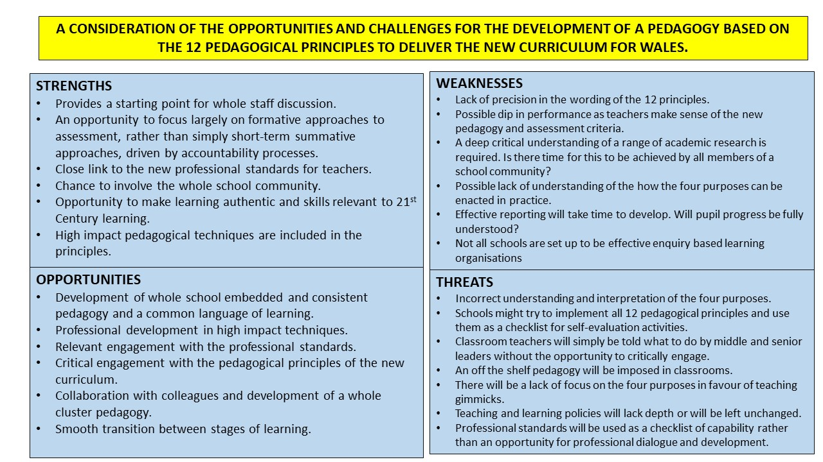
Discussion of SWOT analysis
The new curriculum offers teachers the opportunity to create research led and learner influenced learning experiences. It invites us to engage critically with pedagogy and to select appropriate methods for their learners in their settings. Schools will become effective learning organisations for both pupils and teachers and professional learning will be an everyday aspect of professional practice for teachers and support staff. Assessment arrangements should be used to inform next steps and to help pupils to close the gap between progression steps. The pedagogical principles expect collaboration between AoLE and across age ranges and leadership levels. Learning should be authentic, where appropriate and fit for the demands of the 21st Century.
A lack of prescription in chapter 5 is perhaps the most significant threat to the success of the Curriculum for Wales. Currently, practitioners in secondary schools teach through following highly prescriptive schemes of work and are largely influenced by the demands of the public examinations and level descriptors. According to our group discussions, some schools are already viewing the twelve principles as a checklist to follow and are under the impression that all twelve principles must be embedded in full before September 2020. It is, therefore, imperative that robust professional learning activities at all levels are undertaken over the next two academic years. The capacity of schools and leadership teams to deliver high quality professional learning is another possible threat to the success of the curriculum. The action plan below has been designed to address these concerns.
AN ACTION PLAN FOR THE IMPLEMENTATION OF THE PEDAGOGY OF THE CURRICULUM FOR WALES
In order to successfully implement the new curriculum for Wales, schools will need to complete a range of detailed self-evaluation and professional learning activities. The quality of teaching and critical understanding of the pedagogy of the curriculum for Wales will need to be improved in all schools. The following timetabled action plan details a range of activities that could be undertaken by Welsh schools and has been written in response to the SWOT analysis. The two-part poster has been designed to engage colleagues in a dialogue about pedagogy for the Curriculum for Wales and also provide a proposed structure for the delivery of lessons based on research in section one of this portfolio.
ACTION/PROFESSIONAL LEARNING ACTIVITY | SUCCESS CRITERIA | SUGGESTED TIMESCALE | MONITORING ARRANGEMENTS
JANUARY 2020  Ensure that all members of the school community have been made aware of the need for curriculum change and the role of the school as a learning organisation | Whole staff Professional Learning will have been delivered to ensure that all members of the school community understand the need for change, the philosophy of the four purposes and the pedagogical vision and timetable to develop the school as a learning organisation. | January 2020 | SLT and Directors of Learning (AoLE and pastoral).
SPRING TERM 2020  Completion of the OECD ‘Schools as Learning Organisation’ survey | All teaching and support staff complete SLO survey  Survey results analysed  Results utilised to inform short and long term professional learning requirements.  Future actions will be built into School Development Plan. | Spring term 2020 to complete and evaluate results with whole staff feedback to follow. | SLT lead will cascade feedback through the leadership system.
SPRING TERM 2020  Evaluate the teaching and learning foci of the existing School Development plan | SDP teaching and learning foci are rewritten to be in line with the pedagogical requirements, the results of the SLO survey and whole staff critical understanding of the new curriculum. | Spring term 2020 with final draft completed for September 2020. | SLT and co-constructed with Directors of AoLE and Pastoral system and School Governing body.
SPRING TERM 2020  Detailed self-evaluation against professional standards | Teachers and line managers are fully aware of individual strengths and areas for future professional learning and have an early understanding of how gaps in their knowledge can be closed. | Spring term 2020 with PL programme in place for September 2020. | Whole staff with feedback to SLT by line managers.
SUMMER TERM 2020  Standardisation of self-evaluation against professional standards | Evidence collected through lesson observations, book scrutiny and pupil voice activities will be used to verify the whole staff professional standards strengths and areas for development. | Summer term with PL programme in place for September 2020. | Middle leaders and SLT to complete self-evaluation activities and report against whole staff feedback.
SUMMER TERM 2020  Whole staff professional standards evaluation and follow up standardisation activities will lead to whole school self-evaluation against professional standards of pedagogy | SLT will have a detailed understanding of current pedagogical strengths on which to build and areas for further development decided. All staff will be made aware of the whole school pedagogical areas for development. | Summer term with PL programme in place for September 2020. | SLT and Head teacher to construct a detailed report and facilitate required PL activities.
SUMMER TERM 2020  Directors of Learning to develop a critical understanding of the Pedagogical principles, the agreed areas for development and enquiry methodology | AoLE Strengths and Areas for development known as a result of self-evaluation and critical understanding of the pedagogical principles is secure at Director level | Summer term with whole staff PL programme in place for September 2020 and led by Directors and SLT. | SLT leading to cascading of professional learning by Directors.
SUMMER TERM 2020  Lead Practitioners to be developed as lead enquirers | Pedagogical understanding is secure and enquiry methodology fully understood by Lead Practitioners. | Summer term with whole staff PL programme in place for September 2020. | Directors to ensure that Lead Practitioners are confidently able to develop pedagogical practices through an enquiry methodology.
SUMMER TERM 2020  Two or three of the pedagogical principles will be selected based on whole school areas for development and effect size | Directors and Lead Practitioners will have a deep and critical understanding of the selected principles and will be confidently able to embed these techniques with class teachers using the enquiry model and effective professional learning activities. | Summer term 2020 | Whole school to engage with professional learning activities. Led, monitored and evaluated by Lead practitioners and overseen by Directors of Learning and SLT.
SEPTEMBER 2020-JULY 2021  Gradually introduce common pedagogical approaches across AoLEs using a common language of learning | All staff experiment with the agreed pedagogical approaches through an enquiry methodology. | September 2020-July 2021 | Directors and Lead Practitioners to evaluate and monitor delivery of agreed pedagogy.
SEPTEMBER 2020-JULY 2021  Monitor effectiveness of agreed pedagogical approaches. | Self-evaluation activities are regularly calendared and evaluated and feed into AoLE and whole school decisions. Supporting pedagogical policies e.g. formative assessment are written and shared with all members of staff. | September 2020-July 2021 | SLT, Directors, Lead Practitioners, teachers and pupils to complete monitoring activities and policy writing as appropriate.
SEPTEMBER 2022  A few agreed common approaches are embedded and supported by policy to deliver the Curriculum for Wales | All staff will confidently structure learning using the 12 pedagogical principles as guidance and following school policies. School will report to parents using these principles and progression steps guidance. | September 2022 | All staff

Task 3 – The construction of an A3 poster intended to engage your colleagues in a dialogue about pedagogy for the Curriculum for Wales. A rationale and critical evaluation of the work is also included.
Rationale and critical evaluation of the poster.
Following feedback from a curriculum focus group in my own school and also a group of educational professionals from a range of settings, it was suggested that my poster could either be used in schools as one full document or described in two parts with one half being given to Heads of AoLEs and the other given to classroom practitioners. In light of this feedback, I have chosen to explain the poster in two parts (A and B.)
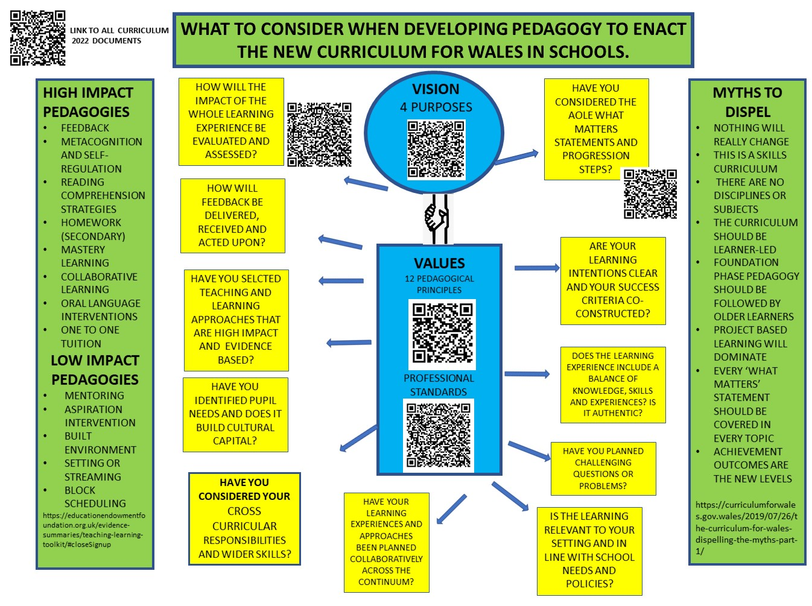
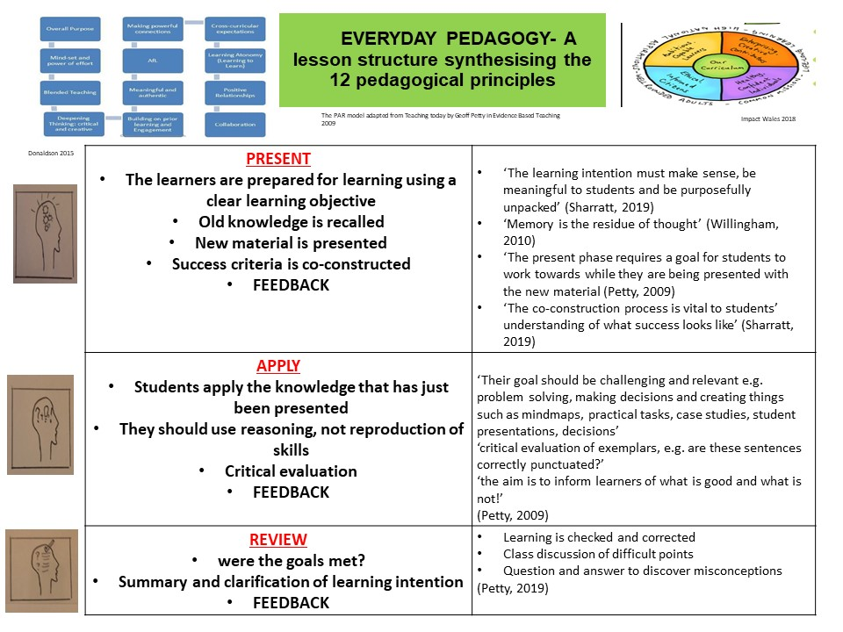
Part A is a consideration of the whole Curriculum for Wales and contains links to accompanying and essential documents such as the professional standards and Donaldson’s twelve pedagogical purposes. Part A of the poster could be used by cross phase AoLE leaders and SLT in the first instance as they collaborate to select appropriate pedagogy and design learning experiences that make sense of the documents.
The central image of part A features the vision and values that are an intrinsic aspect of the Curriculum for Wales. All decisions on the poster should return to these central ideas. When designing learning experiences, it is crucial for practitioners to ask the questions that are featured in yellow boxes. These questions synthesise the intentions of the new curriculum in a way that will engage colleagues in a dialogue about their pedagogical decisions. A similar infographic map was designed by school D (a non-pioneer primary school) and used effectively during an observed weekly staff meeting to co-construct learning experiences. According to the school’s website, the document has been created to ‘highlight the principles of Successful Futures and how we have translated these to meet the needs of our school; it acts as a basis for what we want our children to explore and experience.’ The website further explains that the document provides ‘staff with a focus for discussion and helped to develop their understanding of the principles of curriculum design, as noted in Successful Futures.’ The school also used the ‘Schools as a Learning Organisation’ OECD report and curriculum reform documentation to create their curriculum and this influenced the decision to recommend the completion of this document in the SMT report of this section of the portfolio.
Following feedback from Primary phase colleagues, the phrases ‘collaboration’ and ‘co-constructed’ have been deliberately included in the poster to remind colleagues that the whole school community and cluster schools should be involved in the process of curriculum change at all levels. Assessment is mentioned twice on the poster. In the first instance ‘how feedback will be delivered, received and acted upon’ should be considered throughout the learning experience to guide learner progress. Secondly assessment is referred to in the final review box and should be used at this point in the learning experience to describe progress.
The questions follow the phases of learning experience development if read in a clockwise direction and remind practitioners that impact should be measured, and any necessary tweaks made before the cycle of curriculum development begins again.
A summary of the findings of the Teaching and Learning toolkit is included to the left of part A and is divided into high and low impact pedagogies. These findings have been based on academic research and meta-studies and, therefore, offer practitioners ‘a rich picture of the developing evidence base on how to improve the attainment and wider outcomes of children and young people.’ (Organisation, 2019) The section entitled ‘myths to dispel’ was taken from a Welsh government blog which was written following the draft curriculum consultation period and offers an opportunity for leaders to predict assumptions that are likely to be made by colleagues.
POSTER (PART A)

POSTER (PART B)
Part B of the A3 poster was designed in response to the weaknesses identified in the SWOT analysis and following group discussion in my own setting relating to the urgent need to improve the clarity of our teaching and learning sequences and raise standards. It was considered useful by the focus group to have a document which summarises a possible learning sequence that could be easily trialled in all classrooms and could be used to stimulate pedagogical discussion.
The three-stage lesson sequence responds to the need to extract the essence of Donaldson’s twelve pedagogical principles. When describing the Curriculum for Wales, Donaldson explains that ‘its essence lies in clear purposes and success criteria, modelling and practice, and regular and insightful feedback.’ (Donaldson, 2015)
The PAR model has been adapted from Geoff Petty’s Teaching Today (Petty, 2009) and is further explained by Petty in Evidence-based teaching. (2009) The three stages of ‘present, apply and review’ are explained and exemplified further to make the document more practical for teachers to consider and trial. Academic justification for the learning phases is provided to the right of the phase descriptions.
Feedback is a feature of each phase of the lesson and is capitalised to remind practitioners of its centrality in the pedagogical vision of Donaldson’s Curriculum for Wales. The four purposes are also included on this part of the poster to be considered by practitioners at all times as learning sequences are designed.
Dual coding symbols have been used in part B of the poster to symbolise the lesson phases because ‘in particular circumstances, visual models are said to be more efficient than text in helping readers understand the meaning.’ (Caviglioli, 2019) and the inclusion of visuals offers ‘six benefits to students’ learning that are consistent with the theoretical assertions about human cognitive architecture.’ (Caviglioli, 2019) The opportunities that are offered by dual coding techniques to structure higher order thinking and other metacognitive processes were discussed and considered by the focus group.
When considered as a whole, parts A and B of the poster offer a support document to remind teachers of important questions to consider together when writing learning experiences to deliver the Curriculum for Wales. Pitfalls and myths to dispel provide a useful starting point for discussion for staff and the PAR structure provides teachers with a simple lesson stages support scaffold to trial in the early stages of curriculum development.
PART B

Donaldson’s (2015) twelve principles do not always offer clear, prescriptive guidance and instead require practitioners to engage critically with the described principles. This is a shift from the current and highly prescriptive National Curriculum and assessment arrangements. Given the timescale and the deep critical engagement required by school communities to fully understand the requirements of the Curriculum for Wales, I chose to create some sense making documents to help practitioners to construct possible schemes of work and daily sequences of learning in classrooms.
In light of the focus group feedback, and as explained earlier, I chose to explain the poster in two parts (A and B.) Colleagues in the focus group felt that part A of the poster would support an initial whole staff meeting to engage colleagues with the overarching principles of the Curriculum for Wales and to stress the importance of regular return to the four purposes when designing learning experiences. The group suggested that the arrows should be added to encourage colleagues to understand that Part A of the poster should inform Part B and should offer a structure for learning that is clear for both teacher and learner due to the three-part structure. Some colleagues suggested that a three-part learning sequence might not suit more practical subjects such as Food and Nutrition and questioned how it might be adapted to accommodate their practical lessons. It was agreed that the sequence could be used flexibly, by removing lesson stages as appropriate.
It was clear from the focus group feedback that schools and individual teachers will inevitably approach the implementation of the Curriculum for Wales according to the needs and strengths of their learners. The posters and SWOT analysis do not consider the institutional and historical assumptions that are specific to a learning organisation. Each school will have its own leadership arrangements and a way of making judgements and facilitating professional dialogue that will have an impact on teacher agency and pedagogy in classrooms. The new curriculum will not only ask our learners to be critically evaluative, but also our teachers and this will take detailed training and opportunity to educate our teachers to critically transform knowledge rather than simply delivering it to the students. This portfolio does not deeply consider how this can be achieved in our settings.
The importance of clear vision and reason for change has been explored in this section of this portfolio, but it is not possible to predict if this will be fully understood by all Welsh schools and to know how the four purposes will be interpreted by each learning organisation. For effective change to occur, individual schools must have the opportunity to personalise the change programme as it evolves, and all members of the school community need to understand their own individual role and what is expected of them. This is challenging when the Curriculum for Wales relies on pedagogy repeatedly returning to one set of national beliefs. The posters and SWOT analysis do not consider how the daily working habits of colleagues will change and how this might impact on the beliefs and attitudes towards the new curriculum that might be communicated to others.
In conclusion, this portfolio presents a largely positive reflection of Donaldson’s pedagogical principles and offers an action plan and flexible resources designed to help colleagues to begin to implement the curriculum. However, it is important to note that many colleagues might not have the professional learning time or the necessary research skills to allow them to do this in a similar way and might, therefore, see only threats and weaknesses in the provided documentation and change management guidance. Many schools could choose to implement the new curriculum based on their experiences of the old and could look to simplify the academic demands of a deep reading of the Curriculum for Wales. It is clear that a national approach to the necessary professional learning and schools will be needed and all schools will have a duty to engage with this and to positively motivate their staff to begin the process of implementation.

