Student name: Lukasz Perski Student ID number: 2219674

Date: 10-03-2023

Programme: MBA Part-time Distance

Module: Human Resources Management

Module code: BMMB7007D

Lecturer: Helen Evans

Assignment title: Assignment 1
Report

Contents
Executive Summary 3
Introduction 4
Brief company history 5
What is Talent and Talent Management? 6
Talent Management at Apple 7
Strengths and weaknesses 9
Known issues and controversies. 9
Overview of Apple’s HR data* 11
Apple employees 11
Employment growth 11
Suppliers and manufacturers 12
App design and development 13
Areas for improvement 14
Conclusion 15
Recommendations 16
References 19

Executive Summary

The below report was written to critically evaluate the current Talent Management processes at Apple Inc. (‘Apple’) and identify and evaluate two areas for improvement. This report will consider the workplace environment and the challenges that HRM face when managing and developing talent at Apple. Based on research and information available online, I will attempt to identify strengths and weaknesses and improvement areas and to present a valid business case to address these in this report and further Assignment 2 of this module.
The findings from this report will be used to develop recommendations for Apple's senior management to assist enhance the HR department and how current and potential workers view the company.

Introduction

The following report's aim is to review two potential areas for improvement in Apple Computer, Inc. ('Apple') present Talent Management procedures.
Based on research and data acquired from the company's website and online papers, journals, and other reliable sources, this report will also give an outline of the elements influencing these processes.
For Senior Management at Apple to implement the necessary mitigations to improve the overall company’s situation, the information acquired from the aforementioned sources will be used to summarise in a conclusion and to help to make recommendations for the future.

Brief company history

Steve Wozniak and Steve Jobs founded Apple Computer, Inc. ('Apple') in 1976. The company creates, manufactures, and sells a variety of products, including Macintosh desktop and laptop computers, iPad tablets, iPhone smartphones, Apple Watch smartwatches, Air Pods headphones, software, and online music and video streaming services (Apple TV+, Apple Music).The business, which has its headquarters in Cupertino, California, US was one of the first to have a market value of one trillion dollars in 2018 and three trillion in January 2022. With over 499 Apple stores spread over 22 countries, it has a strong worldwide presence. Although the business was very successful and has a sizable following of devoted customers who praise Apple for its innovation and product quality, it has also come under fire for problems with its business ethics which had an impact on employee retention and talent management. These will be covered in further detail in this assignment.

What is Talent and Talent Management?

In his journal titled ‘Talent Management: A Review of Theoretical Perspectives and a Guideline for Practioners’, Selman Tetik (2017) provided a very comprehensive overview of Talent Management theories and approaches to the topic. In his work, he quoted several definitions of talent and talent management.

This includes the Gallardo et al. (2013) theory, which proposes that there are two definitions of talent: the Subject approach, which defines talent as people, and the Object method, which defines talent as traits of people.

According to Ulrich, talent "is comparable to competence (able to do the job) times commitment (ready to do the task) times contribution (finding meaning and purpose in their work)" (2007).

Talent is defined as "those individuals who may effect organisational performance, either immediately through their contribution or over the long term by demonstrating the highest levels of potential," by Tansley et al. (2007).

Talent Management is “anticipation of required human capital for an organization and the planning to meet those needs” (Mason Andrew Carpenter, Harling, and William Gerard Sanders, 2012). Talent management is about how to use strategic human resources planning for an organisation to achieve its goals. Activities such as recruitment, employee retention, development and training, and rewarding are elements of Talent Management which are also linked to the overall business strategy.

McKinsey (1998) in a research paper titled ‘The War for Talent’ stated “superior talent will be tomorrow’s prime source of competitive advantage. Any company seeking to exploit it must instil a talent mindset throughout the organization, starting at top”. To attract and keep talent according to McKinsey, organisations need to be concentrated on developing an appealing employee value proposition, understanding what drives people to work for a particular organisation, and creating aggressive and multi-sourcing strategies to reach candidates wherever talent could be found. Organisations should increase efforts to cultivate, inspire, and promote talent once it was acquired and develop efficient feedback mechanisms, work on retention methods, and deal with underachievers. These still form the basis of talent management even after more than 20 years.

Lewis and Heckman outlined three methods of talent management (2006). The first perspective includes the department's procedures, such as hiring, training, succession planning, and career management. The second method talks about talent pools while defining talent management. These tactics ensure addressing employee needs and directing how individuals develop through their employment. The selection of the ideal candidates for positions inside the organisation is the subject of a third talent management strategy.
It's important to find, hire, and reward highly competent people.

An organisational culture or mindset in which individuals are regarded appropriately may be referred to as talent management. It gives the company a competitive edge and gives HR professionals an opportunity to understand their role in the strategic planning process of the company (Hughes & Rog, 2008).

Talent Management at Apple

According to the numbers published on Apple’s website, only within the US alone, the company has created over 2,000,000 jobs, with 80,000 employees working directly for Apple, 450,000 employees working for US-based suppliers of Apple and 1,530,000 jobs generated by Apple’s App Store.

Apple’s culture is deeply rooted in the early days of the company when Steve Jobs laid a solid foundation of the visionary and innovative approach of Apple to its employees.

Starting from the recruitment process, there are three to four rounds of interviews with each of the candidates, and the first interview is scheduled usually around two to four weeks from the application. The initial interview is conducted with a group of candidates in which Apple’s recruiters will ask a series of questions related to social-related topics, and role-play scenarios between candidates in which they pretend to be Apple employees and customers. In the end, the entire stage of the process will be screened, successful candidates will be invited to attend a second interview and Apple will undertake background checks. The second interview will be conducted over the phone approximately two to six days following the first interview. Candidates that qualified from the first stage, need to give their opinion about Apple and why they are interested to apply for this position. Following successful assessment, the candidates will be asked to attend a face-to-face interview with the store manager where he will be asked about his experience and respond to hypothetical situation scenarios. The third interview will be conducted by the general manager and questions will be similar to the previous interviews. The candidate might be separately evaluated based on their clothing and appearance. Finally, for the last interview candidate will meet the head manager or different senior manager and will have to answer some more personalised questions about experience and past. Following this interview, the successful and unsuccessful candidates will be notified via email which happens around one to three weeks from the last interview. For successful candidates, Apple does not promise work and life balance as the emphasis is put on hard work and results. There is also no development plan as such as employees are put in charge of their development and encouraged to choose their path to success.

Apple takes a different approach to careers than its rivals because it places the onus on the employee to assume full responsibility for the career and its course. Apple is making its employees independent and taking charge of their careers rather than giving them career routes that can foster a sense of entitlement. Additionally, it forces them to constantly learn new skills that will be helpful in their future careers as well as to independently search for job information and, in doing so, communicate with different departments and functions. Also, this fosters departmental and teamwork cooperation. Further, it encourages variety because employees can switch between departments and functions merely for professional reasons.
There are many resources available at Apple for successful career development such as:
- A library with a selection of publications, books, videos, and job openings.
- Seminars are one-hour sessions that the corporation offers weekly, and which include business insights and employment trends.
- Assessments and counselling sessions are designed to assist Apple employees in exploring various career planning and development options and in receiving the required professional guidance.
- Networking organisations assist staff in learning more about various divisions of the firm and comprehending the qualifications necessary to move from one division to another.
- Apple posts internal job openings on a dedicated internal platform with the necessary qualifications to apply.
There is a great emphasis on innovation and performance with innovation being a dominant attribute. Innovation is closely connected with a company’s strong expectation of continuous innovation from each of the employees, secrecy throughout the entire process and ongoing brainstorming during the design meetings which often are ongoing to the very late stages of the manufacturing/product launch process. The phrase “that is not possible” was forbidden at Apple and every company’s initiative, communication, event, and meeting is dominated by the need to innovate which is the main theme.

For years secrecy was Apple’s main driver of innovation. During the project stage process, development and design teams work in complete isolation and usually, team leaders are not aware of how many multiple teams are assigned to work on the project. Also, employees are asked to sign product/project-specific non-disclosure agreements where they are obligated to not speak about the products they are working on even to their spouses. Their company ID cards are set in a way that they are allowed to enter only the specific areas within the Apple office at Cupertino. They are also banned from taking home any of their work/products in making.

One project is assigned to several project teams at Apple. This is aimed at improving competitive working and maximising innovation as being unable to communicate with each other, teams are assuming that their competitors are well ahead/more innovative than them. Teams always hold two meetings per week to further foster creative thinking towards the conclusion of the design phase. The first meeting focuses on the general problem and how to improve it, while the second is referred to as a "go-crazy" meeting when all the team members are encouraged to brainstorm and come up with fresh ideas. For new ideas to contribute to the degree of innovation, Apple holds these discussions deep into the product development phase.

In terms of the approach to teamwork, the company also believes in agility and the ability to be able to quickly shift focus from one thing to another. Also, in terms of employee focus, the company demands from employees to be able to learn new skills/possess background knowledge in a very short time to be prepared before they start a new project. This makes them prepared but also allows them to be able to respond to changing work-environment.

Regarding rewards and recognition, Apple has a unique approach where employees are given Apple shares to recognise their input and so the value of their reward is becoming permanently linked to the company’s performance and success and provides a long-term investment for the future. Thanks to this approach, employees are not working towards personal success but the company’s overall performance and improved valuation.

A great emphasis is put on the function of managers and the importance of their decisions. While in other companies’ decisions are made collectively, at Apple it is down to individual managers who have been given an increased level of authority and full accountability for their actions and decision. They are solely responsible for their decisions, and it is down to them to ensure that the most creative and innovative outcomes will be achieved within the tight timescales for the new product/service launch.

Strengths and weaknesses

Based on the above, I can identify the following:

Strengths | Weaknesses
1. Complete authority over talent advancement.  2. A reliable mechanism that protects the worker  3. A strong knowledge base.  4. The employee has access to a lot of resources.  5. A variety of cutting-edge course platforms.  6. There are lots of vacancies.  7. Good rewarding system linked to overall company performance. | 1. Significant resources are devoted to advancing each employee's career.  2. Continuous investment in platforms for course development and training.  3. No predetermined career pathways; employees’ choices are made on their own.  4. The hiring process for filling new positions is lengthy.  5. Managers have enhanced levels of authority with very little control above them.

Known issues and controversies.

I researched online sources, and I found the following recent issues and controversies related to Apple’s approach to its employees.

Home working vs. ‘Apple together’ group
Apple employees have started a petition against the company's return-to-work policy, according to a Guardian report, and a Fortune website post titled "Only weeks after returning to the office, many Apple staff are disgruntled and ready to quit" Apple's new post-pandemic working policy has sparked criticism. All staff have received a note from CEO Tim Cook requesting their return to work for at least three days each week beginning in September 2022. According to him, this change would "improve" the business's capacity for flexible work "while preserving the in-person collaboration that is so vital to our culture". One organisation of current and ex-employees known as "Apple Together" claims that this would have the opposite effect because the freedom provided by working from home would increase employee happiness and have a beneficial effect on diversity and productivity. Before delivering their petitions to Apple's management, the group began gathering signatures for them. According to reports, Apple's director of machine learning, Ian Goodfellow, left the company over this policy and moved to Apple's rival, Google, because, in his opinion, they are more accommodating and open.

#AppleToo movement
According to an article by Sebastian Klovig Skelton titled "Apple workers challenge the company on toxic workplace culture" published on September 2, 2021, a group of current and previous workers are publicly criticising Apple about its culture in response to claims that the company's Human Resources department ignored widespread incidents of racism, sexism, discrimination, harassment, and abuse. They claim that most individuals who contacted them regarding how they were treated while working for the corporation either requested information on how to contact the press or how to lodge a complaint with other organisations. They created the "#AppleToo" movement, which has amassed over 500 employee testimonies from all over the company. The common theme connecting described in the article was "hundreds of instances of racism, sexism, discrimination, retaliation, bullying, sexual and other types of harassment, and sexual assault," according to the organisation, is that these accusations were reportedly disregarded by the company's HR personnel.
There are systemic flaws within Apple that need to be addressed, as evidenced by the fact that participants in the #AppleToo campaign have already begun sharing the accounts of those affected in batches of five and combining them based on common themes. Also, they want to regularly publish more articles.
All the testimony offered so far comes from employees who allegedly complained to their bosses and Apple's HR department, who allegedly did nothing about it and allowed employees to continue working in a toxic environment.
Misconduct claims
Financial Times article ‘The women calling out Apple’s handling of misconduct claims’ provided an account from over a dozen female employees who described the way how Apple’s HR department handled their claims of sexual harassment. FT based its article on information gathered from current and past Apple employees and emails sourced from within Apple. Some women stated that there was retaliation for filing their complaints and seven reported that the HR department was not acting in line with their expectations. Some of the complaints, led to the departure of some of the women as they were branded as bad team workers and, in some cases, the company offered financial compensation to avoid liability.
Secrecy violates employees' rights.
An article published by The New York Times on 23 January 2023 titled ‘Regulators Find Apple’s Secrecy Violates Workers’ Rights’ has provided an interesting insight into the outcome of revelations reported by the employees who took part in the #AppleToo movement. According to the article, The CEO of the company, Tim Cook, addressed an email to the workers informing them that the company would do everything in its "power to find those who leaked." This has caused further outrage amongst the employees who decided to take the matter to the US National Labor Relations Board (NLRB) which ruled in favour of the employees. The NLRB determined that Apple and its top executives violated federal law by engaging in behaviours that prevent workers from organising to protect their rights. It has also been mentioned that a formal complaint will be made against Apple if the firm determined to be at blame and the affected employees cannot come to an arrangement.

Overview of Apple’s HR data*

*Based on the US data gathered from Apple’s website: https://www.apple.com/job-creation/

Apple employees

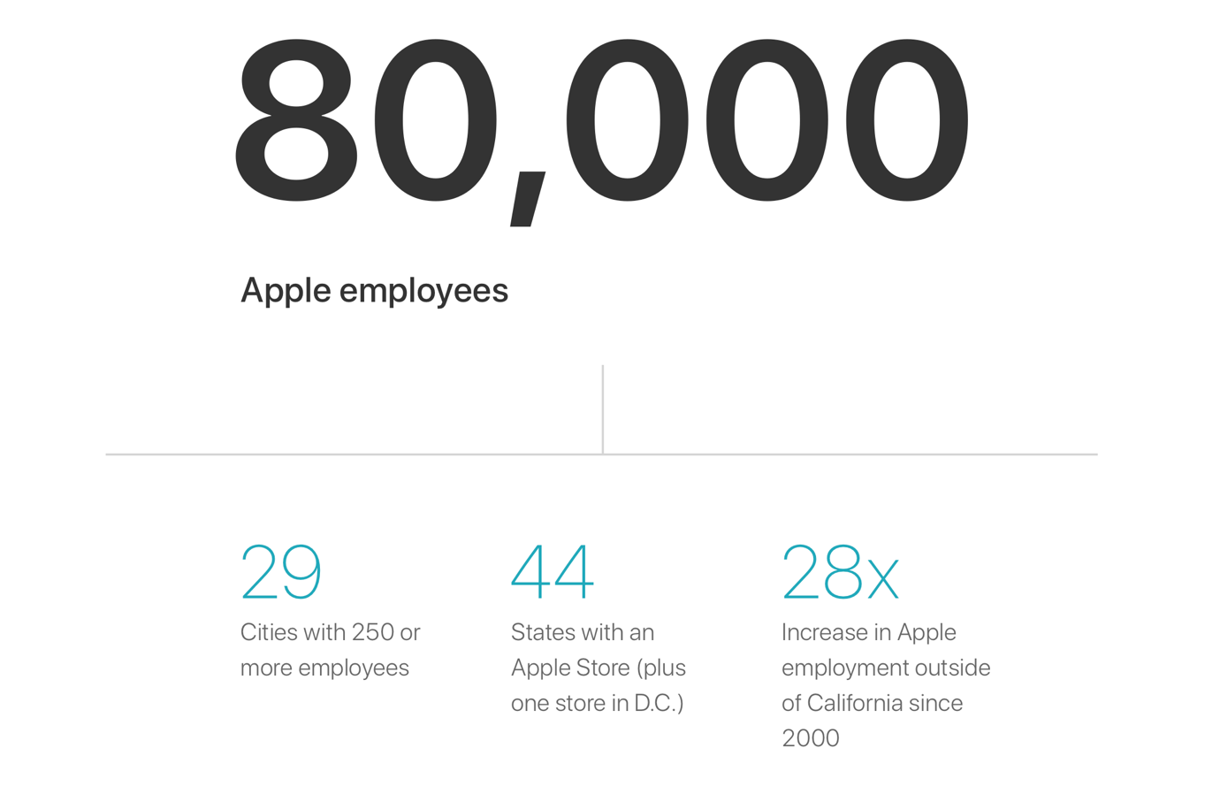
Source: https://www.apple.com/job-creation/

Employment growth

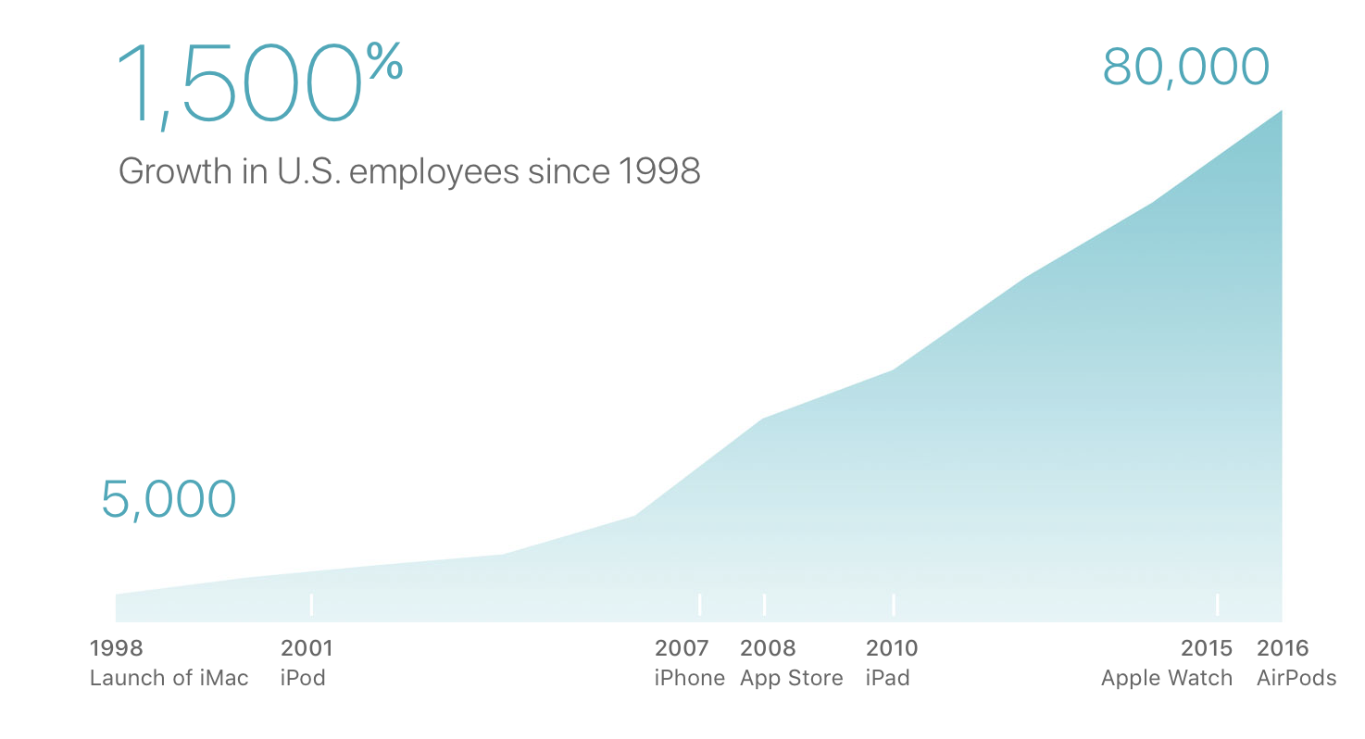
Source: https://www.apple.com/job-creation/

Suppliers and manufacturers

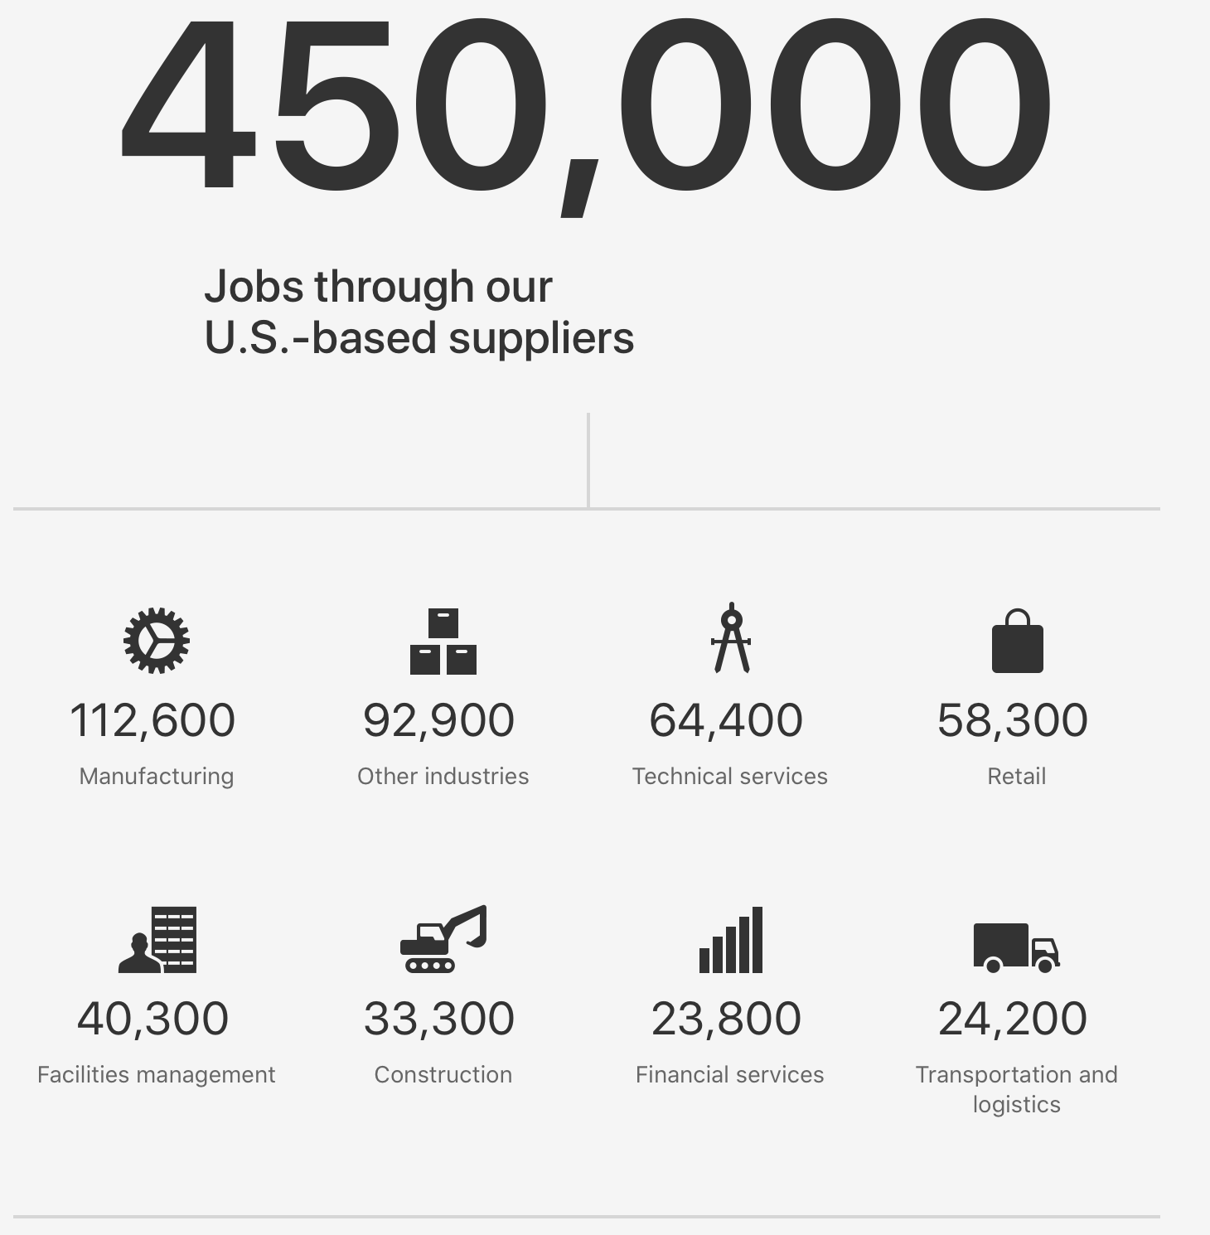
Source: https://www.apple.com/job-creation/

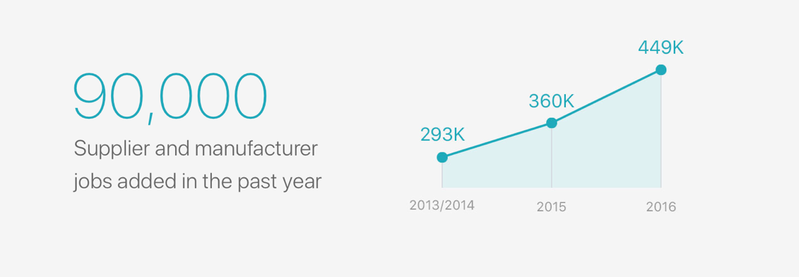
Source: https://www.apple.com/job-creation/

App design and development

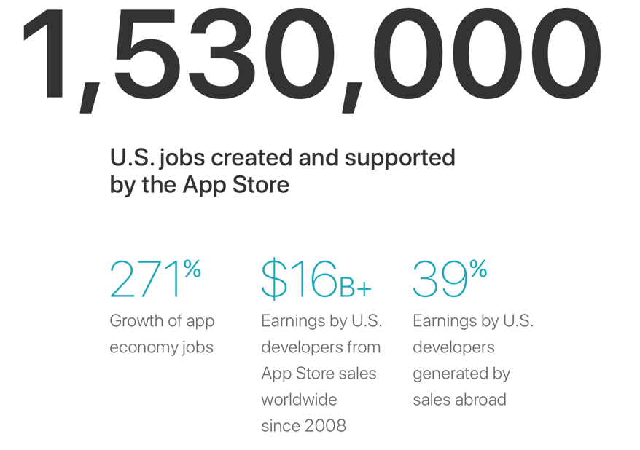
Source: https://www.apple.com/job-creation/
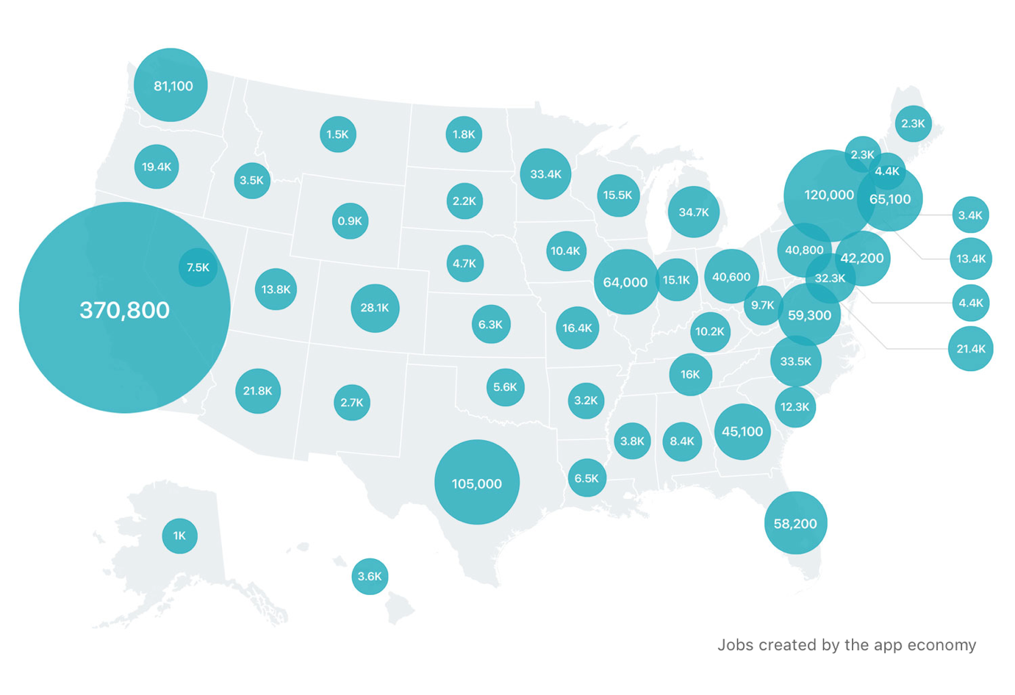
Source: https://www.apple.com/job-creation/

Areas for improvement

Based on the findings there are two specific areas which need to be improved:
- Handling and failing to adequately address allegations of employee misconduct, including handling particular problems like "racism, gender discrimination, discrimination, retribution, harassment, sexual and other types of harassment, and sexual abuse" (Skelton, 2021), which sparked the #AppleToo movement and prompted a number of investigations.
- Access to a fair work-life balance – in terms of not being flexible when it comes to working from home policy. The need to restore the ‘status quo’ after the pandemic in terms of how the company functioned before was stronger than listening to its employees and changing trends and approach to working. This resulted in employees going to the competitors and a complete mismatch of expectations when it comes to how the CEO of Apple and how employees feel about productivity and flexibility.

Conclusion

Apple with its rich heritage and an enormous contribution to the history of personal computers and technology, innovation is without a doubt a legacy of its two founders – Steve Jobs and Steve Wozniak. After 46 years, the company is one of the world's most valuable brands and in 2023 was valued at 2.2 trillion dollars. Every launch of its products is an important event to its fans and consumers around the globe with Apple unveiling the next generation of their innovative technology.

The company has a unique way of approach to talent management, with a comprehensive recruitment process which is aimed at finding the best amongst the best. Their approach to talent development is also different from other companies as Apple is focusing on employees’ self-development and independence when it comes to the future of their careers with an emphasis on continuous learning and being prepared to work on many new projects. The company is also putting a big emphasis on secrecy which is famous for, which is also the foundation of its innovations. Finally, in terms of management – Apple has empowered its project managers giving them almost unlimited authority and accountability for their decisions.

On another side, based on the research on the most current issues associated with them -Apple is being troubled by its policies and approach. Giving managers a wide array of power, which combined with the approach to secrecy, allowed them to foster a toxic culture. This has resulted in many cases of mistreatment of employees and sexual abuse. Employees being unable to find help in Apple’s HR department resorted to an outside means of looking for help and being listened to. Also, their new remote working policy has caused many of the long-term employees to leave Apple for competitors which offer much more flexible working policies.

As a result, this was reflected in the company’s ratings amongst the employees and led to Apple falling from the 10th best employer in 2010 to 84th in 2018 and not making the list at all in 2023, according to the recent report ‘100 Best Places to Work’ which was published by GlassDoor.

Recommendations

Based on the information gathered from this report I would recommend to Apple CEO the following which will be also included in the presentation required for Assignment 2:

- Review their ways of handling misconduct.

According to the article ‘Employee Misconduct: Common Types & How to Address It’ by Tess C. Taylor sourced from Academy to Innovate HR portal, misconduct can be defined as “A purposeful violation of an express or inferred employee policy. This behaviour may result in simple verbal and written disciplinary action, suspension, and employment termination, among other unavoidable repercussions (and possible legal action depending on the severity).”

There are several different types of misconduct such as violence, drug and alcohol abuse, fraud and theft, and harassment which includes sexual harassment, breach of confidentiality, damage to the company’s goods and property and falsification of credentials such as diplomas, work experience, or other documents.

Misconduct can be addressed in the following way:
- Employers need to put a disciplinary policy in place which will be effective and will detail what is the process and what actions will be taken depending on the type and severity of committing the misconduct. An example of such a process is below:
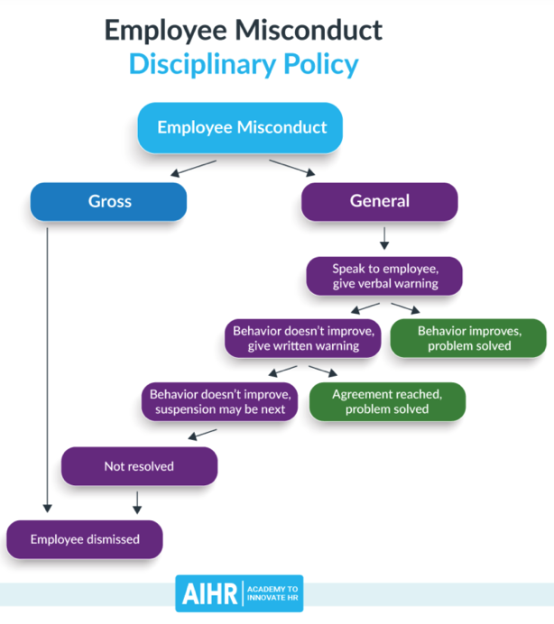
Source: https://www.aihr.com/blog/employee-misconduct/

- Clarify the correct process for reporting misconduct to ensure that the process is covering all possible options and possibilities. This is to ensure that the company will be sufficiently covered from the legal point of view in case they will have to prove their due diligence.
- Ensure that sufficient information related to the alleged misconduct was gathered.
- Act promptly to ensure that the incident will be handled in as short a time as possible to ensure that the process will not be compromised.
- In case of an occurrence of misconduct, ensure that the company policy was communicated every single time when the incident occurred so employees will be reminded that such behaviour will not be tolerated.
- Ensure proper communication with external stakeholders such as clients, suppliers, and press/social networks. This is to prevent spreading the of false information and provide clarity to protect the company’s image.
- In case impartiality cannot be guaranteed, the company should resort to an external workplace investigator to find out what exactly happened and the reasons behind that.
- Provide employees with sufficient training on misconduct as much and as early as possible to ensure their familiarity with the process and consequences of breach.
- When investigating different claims, ensure that each case will be handled in the same and consistent manner.
- The company need to review their misconduct and disciplinary policies regularly to ensure that these are up-to-date and relevant to changing workplace environment.

- Improve employees' work-life balance.

Work-life balance is "the completion of pleasant experiences in the many aspects of everyday life that require a variety of resources, such as dedication, energy, and time, and these resources are spread over all the areas," according to Kirchmeyer (2000).

To improve the situation, Apple needs to improve their work-life balance, boost productivity and creativity and retention in the following ways:
- Set specific rules when it comes to dealing with clients and suppliers – stick to defined business working hours, ensure that the employees will not be bothered on their holidays, and agree on specific client expectations and ways of meeting them while people are away/outside business hours.
- Ensure that the internal working hours are clearly defined and that no employees should be working outside the closing time.
- Introduce a specific set of rules for working parents and single parents to ensure that while work still needs doing, they have time to also take care of personal matters.
- Remote working – a topic which caused the biggest issue for Apple next to failed misconduct handling – introduce a remote working policy and provide employees with all tools and equipment necessary for them to do their work the same way as they would from the office location. Also, consider individual circumstances and personal reasons/or situations of each employee. The COVID pandemic left many employees in a bad emotional/mental health state so this factor should be also taken into consideration as unexpected changes can be unwelcome.
- Communicate with all employees to assure them that the result of their work depends not on how long they are working but on how efficient they can be. Emphasize that while their presence in the office might be beneficial, it is not crucial as ‘the result’ is what counts the most not how long it took someone to achieve it. Employees should be allowed to work remotely from any location – if that is what makes them the most productive/helps them to induce their creative thinking.
- Ensure that employees are fully using their vacation and that there is always sufficient coverage in case they are away.
- Boost physical activity so that regardless of if employees are home-based or office-based they can ensure that their physical health is also important. Organise some fitness video sessions or provide them with gym discounts.
- Improve trust – by allowing employees greater flexibility in terms of their works place choices as long they will do what they have been tasked to do by the agreed deadline.
- Organise family-orientated events such as ‘bring your kids to work’ etc. which would further emphasize the importance of each employee to their employer.
- Down-size or completely close the office to reduce operational and property costs. Same time encourage remote working and emphasize the flexibility of this arrangement and the benefits to further boost employee satisfaction, productivity, and innovation.

References

AIHR. (2021). Employee Misconduct: Common Types & How to Address It. [online] Available at: https://www.aihr.com/blog/employee-misconduct/.

Anon, (n.d.). Employee Misconduct: How to Deal With It in the Workplace? [online] Available at: https://www.cutehr.io/employee-misconduct/.

Bowles, N. (2016). Apple – losing out on talent and in need of a killer new device. [online] the Guardian. Available at: https://www.theguardian.com/technology/2016/jan/28/apple-quarterly-results-iphone-silicon-valley-developers.

Chambers, E. G., Foulon, M., Handfield-Jones, H., Hankin, S. M. and Michales III, E. G., The War for Talent, McKinsey Quarterly - January 1998

Christensen Hughes, J., & Rog, E. (2008). Talent Management: A Strategy for Improving Employee Recruitment, Retention and Engagement within Hospitality Organizations. International Journal of Contemporary Hospitality Management, 20, 743-757.
https://doi.org/10.1108/09596110810899086

Corporate Rebels. (n.d.). Why Didn’t Apple’s Employee Retention Work? - Blog. [online] Available at: https://www.corporate-rebels.com/blog/why-didn-t-apple-s-employee-retention-work.

Fortune. (n.d.). Just weeks after returning to the office, many Apple workers are unhappy and ready to quit. [online] Available at: https://fortune.com/2022/05/02/apple-workers-unhappy-return-to-the-office-hybrid-work-pandemic/.

Gallardo-Gallardo, E., Dries, N., & González-Cruz, T. F. (2013). What is the meaning of ―talent‖ in the world of work? Human Resource Management Review, 23(4), 290–300.

Jackson, A. (n.d.). For the first time in over a decade, Apple and Meta aren’t on Glassdoor’s 100 Best Places to Work list. [online] CNBC. Available at: https://www.cnbc.com/2023/01/11/apple-and-meta-dropped-off-glassdoors-100-best-places-to-work-list-.html.

Kirchmeyer, C. (2000). Work-life initiatives: Greed or benevolence regarding workers’ time? In Trends in organizational behavior, Vol. 7: Time in organizational behavior (pp. 79–93). New York, NY, US: John Wiley & Sons Ltd.

Lewis, R. E., and Heckman, R. J. (2006). Talent management: A critical review. Human Resource Management Review, 16(2), 139–154.

Management-training-guru.com. (2013). HR Strategy at Apple Make Their Employees Creative and Innovative | HR Strategy Tools. [online] Available at: https://management-training-guru.com/2013/12/hr-strategy-at-apple-make-their-employees-creative-and-innovative/.

Mason Andrew Carpenter, Harling, K.F. and William Gerard Sanders (2012). Strategic management : a dynamic perspective : cases. Toronto: Pearson Canada.

McGee, P. (2022). The women calling out Apple’s handling of misconduct claims. Financial Times. [online] 4 Aug. Available at: https://www.ft.com/content/96160847-af3f-44b6-8129-1e39a73a28d3.

Mickle, T. (2023). Regulators Find Apple’s Secrecy Violates Workers’ Rights. The New York Times. [online] 31 Jan. Available at: https://www.nytimes.com/2023/01/31/technology/apple-workers-rights.html.

Peart, N. (n.d.). The Most Important Ways Companies Can Improve Work-Life Balance. [online] Forbes. Available at: https://www.forbes.com/sites/nataliapeart/2020/11/06/the-most-important-ways-companies-can-improve-work-life-balance/.

Reference for Business (2019). Apple Computer, Inc. - Company Profile, Information, Business Description, History, Background Information on Apple Computer, Inc. [online] Referenceforbusiness.com. Available at: https://www.referenceforbusiness.com/history2/31/Apple-Computer-Inc.html.

Skelton, S. (2021). Apple workers challenge company on toxic workplace culture. [online] ComputerWeekly.com. Available at: https://www.computerweekly.com/news/252506157/Apple-workers-challenge-company-on-toxic-workplace-culture.

Tansley, C., Turner, P., Carley, F., Harris, L., Sempik, A., Stewart, J. and Williams, H. (2007). Talent: strategy, management, measurement. London: Chartered Institute of Personnel and Development.

TETIK, S. (2017). Talent Management: A Review of Theoretical Perspectives and a Guideline for Practitioners. Nile Journal of Business and Economics, 2(4), p.40. doi: https://doi.org/10.20321/nilejbe.v2i4.77.

the Guardian. (2022). Apple workers launch petition over firm’s return-to-office stance. [online] Available at: https://www.theguardian.com/technology/2022/aug/22/apple-workers-launch-petition-over-return-to-office-stance.

The impact of Apple's new hiring strategy (2022) UNLEASH. Available at: https://www.unleash.ai/talent-management/the-impact-of-apples-new-hiring-strategy/ (Accessed: February 20, 2023).

Ulrich, D., Brockbank, W., Johnson, D. and Younger, J. (2007), Human resource competencies: Responding to increased expectations. Employee Relations Today, 34: 1–12
‌

