STUDENT NAME:Marian Leba
STUDENT ID:2313869
MODULE CODE: LCBB5015
LECTURE NAME:MD Ashikul Khan
LEVEL 5
COMPONENT 1- INDIVIDUAL REPORT 1000 WORDS
COMPANY SELECTED (MARKS &SPENCER)

Table of Contents
INTRODUCTION 3
Situational Analysis: SWOT of Marks & Spenser Clothing 4
Critical Analysis and Evaluation 6
CONCLUSION 7
References in Harvard Style: 8

INTRODUCTION

Marks & Spencer (M&S) is a well-established UK-based multinational retailer, specialising in clothing, homeware and food businesses (M&S, 2023). Established in 1884, UU has a strong heritage of good quality, value and brand image that is firmly established within the UK retail sector (Johnson et al., 2022). The clothing sector, encompassing women’s wear, menswear, childrenswear and lingerie has traditionally been at the core of its business both in terms of brand identity and financial returns (Mintel, 2023). Once one of the UK's apparel market leaders, M&S has been challenged by both fast fashion, online and value-based high street competition (Deloitte, 2022). Regardless of these challenges it does have high brand awareness and runs more than 900 UK outlets, as well as an online presence that is growing (Retail Gazette, 2023).
The objective of this report is to analyse the internal and external factors that have contributed towards the current standing of M& S’s clothing retail division. To affect this, the paper uses a SWOT technique of analysis that measures the strengths, weaknesses, opportunities and threats of an organization (Gürel &Tat, 2017). Applying this model helps towards organised perception of the firm's strengths and weaknesses, thus enlightening decisions which may be strategic and future competitiveness.
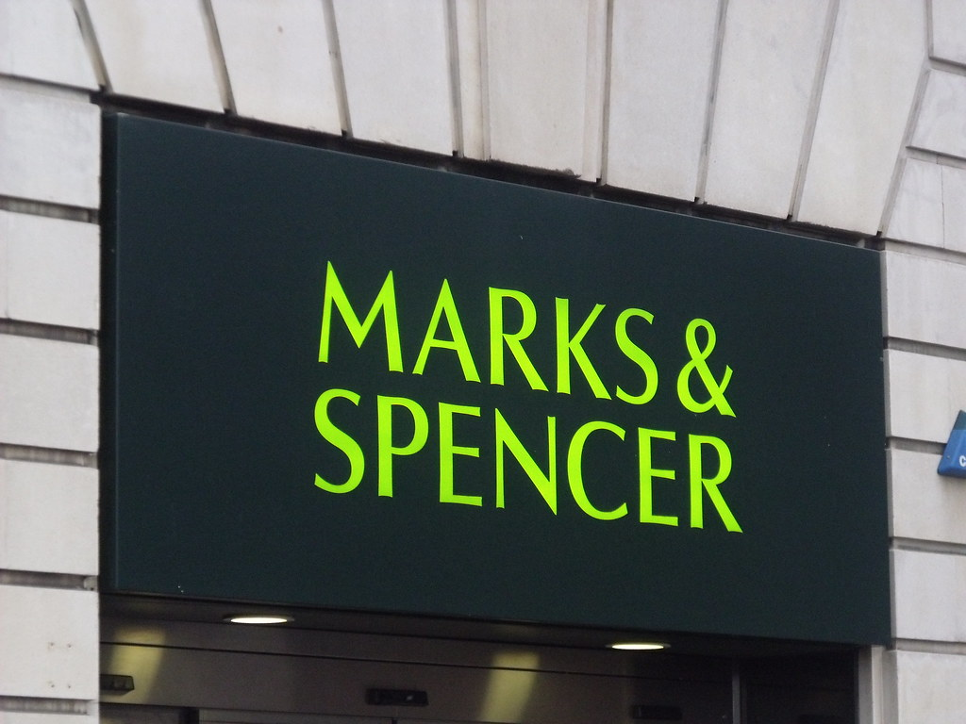

Situational Analysis: SWOT of Marks & Spenser Clothing

The Marks & Spencer clothing arm has its fair share of internal strengths, which help it to weather the digital challenges. The brand has a strong heritage with quality, trust and durability most notably in womenswear, lingerie and school wear (Mintel, 2023). Such heritage causes rather strong brand loyalty among generations of older and middle-income customers who then begin to perceive the brand not as dispensable, but as reliable (Deloitte, 2022). A further opportunity is the extensive UK store footprint that improves accessibility and strengthens brand presence across urban and regional locations (Retail Gazette, 2023). This, together with newer digital investments such as better website shopping experiences and fulfilment partnerships, has left M&S starting to modernise its multichannel execution (Statista, 2023).

Strengths
Brand Reputation for Quality: M&S is well known for its quality and longevity especially in the categories of womenswear, lingerie, and school wear. This reputation tends to drive high customer loyalty, particularly in older and middle-income groups retail.
Weaknesses
Slow Fashion Adaptation: M&S has been lambasted for responding too slowly to can-rapidly shifting fashion trends, which is why more youthful consumers prefer fast-fashion retailers instead.
Brand distinction on value: Compared to value/price led high street and online players, the brand may be perceived as premium which could limit its competitive positioning.
Inventory Issues: Potful purchases and mis-sized inventory positioning have disrupted the pants business profit while demonstrating supply chain flaws.
Opportunities
Online Growth: Shift in consumer preferences towards online shopping creates an opportunity for M&S to grow e-commerce and reach new customer base.
Threats
Intense Competition: Fast-fashion retailers such as Zara, H&M, and online brands like ASOS and Boohoo continue to erode market share by offering trend-led, low-cost products with faster Turnover.
Macroeconomic factors, including inflation and declining disposable income, have reduced consumer spending on non-essential apparel, impacting sales.

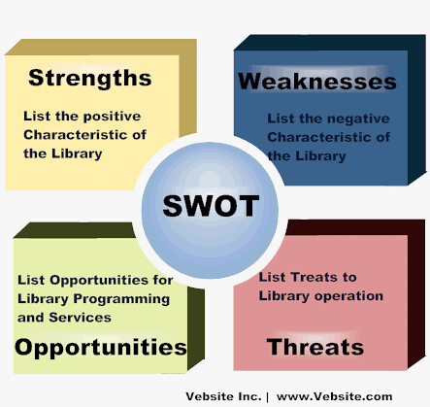

Critical Analysis and Evaluation
SWOT analysis indicates that the strengths of Marks & Spencer’s (M&S) are effectively working towards its competitiveness it is limited by internal weaknesses and external threats. The Resource-Based View (Barney, 1991) emphasizes that firm-specific resources and capabilities including brand image and customer loyalty support to developing sustainable competitive advantage. M&S, as a name with long standing reputation for quality clothing represents an irreplaceable asset (Mintel, 2023). However, strength without innovation can also be a “core rigidity” (Leonard-Barton, 1992). The slow fashion cycles and the backward product development at PZZ make it impossible for the corporation to fully exploit its brand currency (PwC, 2023).
Marks & Spencer’s (M&S) clothing division faces significant challenges that impact its strategic decision-making and overall success. The company’s slow response to fashion trends and higher pricing strategy have led to reduced appeal among younger consumers, who are increasingly drawn to fast-fashion retailers offering trend-led, low-cost products with faster turnover (Marketing91, 2024). This aligns with the Resource-Based View (RBV) theory, which posits that a firm’s internal resources and capabilities are crucial for achieving competitive advantage (Barney, 1991). M&S’s slower product development cycles and conservative design processes hinder its ability to capitalize on emerging trends, affecting its market position.

Additionally, M&S’s extensive physical store network, while enhancing brand visibility, incurs high operating costs, limiting its competitiveness against value-driven rivals (Marketing91, 2024). The company’s over-reliance on the UK market makes it vulnerable to economic downturns and shifts in consumer spending habits (Marketing91, 2024).
To address these challenges, M&S must leverage its brand reputation and invest in agile supply chain management to enhance responsiveness to market trends. Implementing strategies that align with the RBV theory, such as developing unique capabilities in digital marketing and sustainable fashion, could strengthen its competitive advantage and improve overall performance.

CONCLUSION
Overall, a combination of strengths and challenges persist in Marks & Spencer’s clothing division which influence its strategic direction. The company's strong brand identity, large number of outlets in the UK area and it focus on sustainability offer a good base for competitive advantage (Marketing91, 24). Yet the slow pace of change with fashion, the higher price and mismanaged inventory hold it back among style-conscious Generation Z. Furthermore, increasingly challenging and dynamic competitor’s actions on the market add intensified pressure from fast- fashion retailers (NARSFAC Management Centre, 2023).
Using strategic management frameworks such as the Resource-Based View of the Firm (Barney, 1991) emphasizes the role of deploying internal resources digital platforms, sustainable sourcing and brand heritage to enhance differentiation. To retain sustainable success, M&S will have to find a balance between modernisation and tradition by investing in supply chain agility, digital interaction and trend responsive product development. Overall, the key for M&S’s future market competitiveness and profitability is to be able to converge these strategies so they are more in line with what consumers expect of the M&S brand.

References in Harvard Style:
- Barney, J. B., 1991. Firm Resources and Sustained Competitive Advantage. Journal of Management, 17(1), pp.99–120.
- Deloitte, 2022. UK Retail Trends 2022.
- Gürel, E. and Tat, M., 2017. SWOT Analysis: A Theoretical Review. Journal of International Social Research, 10(51), pp.994–1006.
- Johnson, G., Scholes, K. and Whittington, R., 2022. Exploring Strategy: Text and Cases. 12th ed. Harlow: Pearson Education Limited.
- Leonard-Barton, D., 1992. Core Capabilities and Core Rigidities: A Paradox in Managing New Product Development. Strategic Management Journal, 13(S1), pp.111–125.
- Marketing91, 2024. SWOT Analysis of Marks and Spencer (M&S).
- Marks & Spencer (M&S), 2023. Annual Report and Financial Statements 2023.
- Mintel, 2023. UK Clothing Retailing Market Report 2023.
- PwC (PricewaterhouseCoopers), 2023. Retail Outlook 2023.
- Retail Gazette, 2023. How M&S is transforming its clothing business.
- Statista, 2023. Marks & Spencer: e-commerce net sales in the UK 2023.
- NARSFAC Management Centre, 2023.
- ASOS plc, 2023. Annual Report 2023.
- Boohoo Group plc, 2023. Strategic Report.
- Zara (Inditex), 2023. Annual Report 2023.

