

Student Name: Boubacar Sidiki Ouedraogo

Student ID: 2543702

Module Name: Marketing Management

Module Code: LCMB7024

Lecturer’s Name: Laila Maazouz

Work Count: 2626 words

Term 1

Assessment 1: Marketing in a Transitioning World - The Case of BHP Group
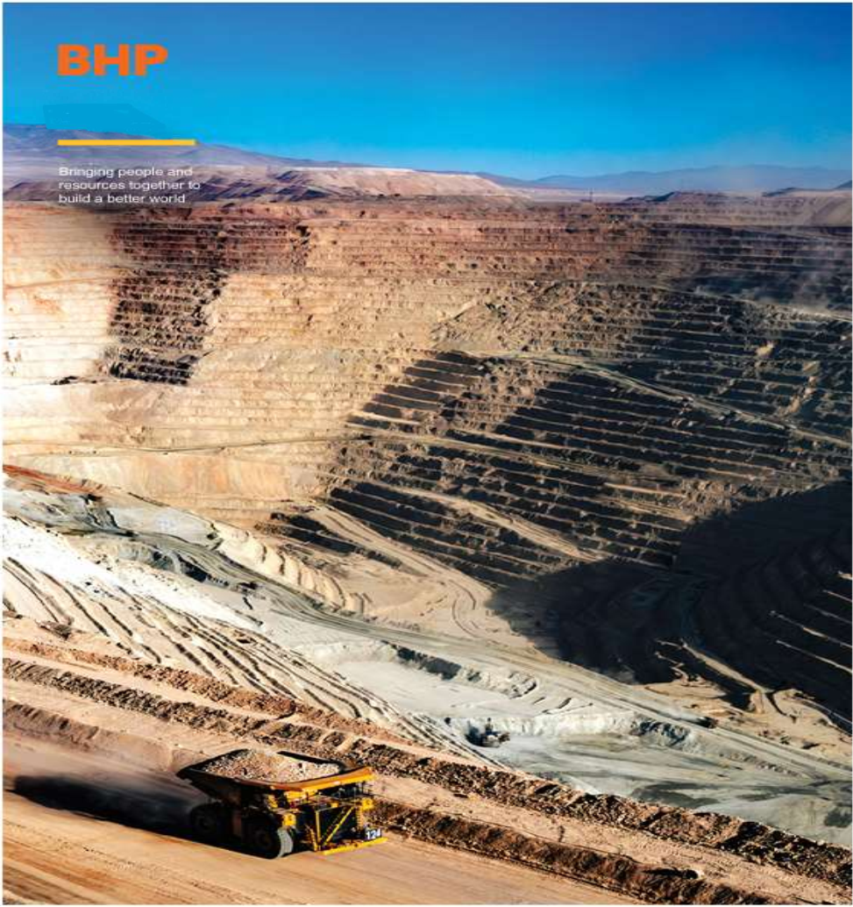

Table des matières
Assessment 1: Marketing in a Transitioning World - The Case of BHP Group I
Table des matières III
LIST OF ABBREVIATIONS: IV
Task 1: Marketing Environment Analysis 5
1.1: Company selection and context 5
1.2: The Natural Environment 6
1.3: The Legal Environment 7
Task 2: Strategic Growth and Competitive Positioning 8
2.1 Strategic Growth Recommendation Using the Ansoff Matrix 8
2.2 Competitive Advantage Through a Lower-Carbon Business Model 9
Task 3: Critical Reflection on AI Usage 11
3.1 Tool Disclosure 11
3.2 Critical Evaluation of AI Output 11
3.3 Contribution Analysis 11
3.4 Ethical and Professional Reflection 12
REFERENCES 13
Appendix A: Mining / Major Projects Countries - 8 countries These are where BHP has mines, processing plants, or major projects. V
Appendix B: Commercial / Office / Trading Presence: There are sales, marketing, trading and HQ offices in 18 countries. V
APPENDIX C: Key Climate Policies Affecting BHP VI

LIST OF ABBREVIATIONS:
BHP: BHP Group Limited
B2B: Business-to-Business
CBAM: Carbon Border Adjustment Mechanism
CAPEX: Capital Expenditure
CSRD: Corporate Sustainability Reporting Directive
CTAP: Climate Transition Action Plan
ESG: Environmental, Social and Governance
EU: European Union
EU ETS: European Union Emissions Trading System
FPIC: Free, Prior and Informed Consent
GHG: Greenhouse Gas
HBI: Hot Briquetted Iron
IEA: International Energy Agency
IPCC: Intergovernmental Panel on Climate Change
IRA: Inflation Reduction Act
IRMA: Initiative for Responsible Mining Assurance
NRBV: Natural-Resource-Based View
OPEX: Operating Expenditure
PESTEL: Political, Economic, Social, Technological, Environmental, Legal
PPA: Power Purchase Agreement
RBV: Resource-Based View
SGM: Safeguard Mechanism
SLO: Social Licence to Operate
tCO2e: Tonnes of Carbon Dioxide Equivalent
WRI: World Resources Institute

Task 1: Marketing Environment Analysis
The mining sector embodies a fundamental contradiction. It supplies the metals required for decarbonisation, yet it is also responsible for a significant share of global industrial emissions. Kotler et al. (2024, pp. 115-117) estimate that the world’s largest firms, including major miners, account for roughly 25% of reported greenhouse gas (GHG) emissions. Within this context, a Political, Economic, Social, Technological, Environmental, Legal (PESTEL) analysis of BHP Group Limited (BHP) reveals that two factors now dominate strategic choice: the Natural Environment and the Legal Environment.

1.1: Company selection and context
BHP was selected due to its scale and its direct exposure to transition pressures. As the largest listed miner by market capitalisation, BHP’s decisions have sector-wide implications (Wood Mackenzie, 2024a, p. 4).
The portfolio is concentrated in copper, iron ore and nickel. Operations span 8 core mining countries (detailed in Appendix A), including Australia, Chile and Canada, with a commercial presence in over 18 countries (detailed in Appendix B) in total (BHP Group, 2024a, p. 12). This commodity mix is central to the energy transition. The International Energy Agency (IEA, 2024, p. 23) forecasts that copper demand will rise by 1.5 times and nickel demand will more than double by 2040, driven by grids, electric vehicles and battery storage. By divesting oil, gas and thermal coal, BHP has repositioned itself to supply inputs for decarbonisation rather than fossil fuels.
Approximately 60% of assets are located in Australia and Chile (BHP Group, 2024a, p. 15). Both jurisdictions face intensifying water stress and regulatory scrutiny. This geographic concentration increases vulnerability but also creates opportunity to lead on response measures.
On sustainability, BHP’s externally audited Climate Transition Action Plan 2024 (CTAP) commits to net-zero operational emissions by 2050 and links executive remuneration to emissions performance (BHP Group, 2024a, p. 8). A USD 4 billion decarbonisation Capital Expenditure (CAPEX) allocation to 2030 signals that the transition is being treated as a capital allocation problem, not only a reporting exercise (BHP Group, 2024a, p. 21).
The market context reinforces the need for change. The IEA Global Critical Minerals Outlook 2024 indicates that volume growth alone will be insufficient. Buyers and regulators are increasingly demanding evidence of production methods (IEA, 2024, p. 67).

1.2: The Natural Environment
Within the PESTEL framework, the Natural Environment has shifted from context to driver. Hart’s (2017, pp. 68-69) Natural-Resource-Based View (NRBV) argues that physical constraints are becoming the primary source of cost and differentiation.
Water scarcity illustrates this shift. The World Resources Institute (WRI, 2023, p. 11) Aqueduct 4.0 classifies basins with withdrawals above 40% of available supply as "high stress". Large parts of BHP’s Chilean and Australian operations fall within these basins. The consequences are practical: delayed permits, higher Operating Expenditure (OPEX), and conflict with local communities. The response has been substantial. BHP committed USD 3.4 billion of the total 4 USD 4 billion decarbonisation CAPEX to 2030 to operate Escondida entirely on desalinated seawater (BHP Group, 2024a, p. 18).
Climate risk is equally material. The Intergovernmental Panel on Climate Change (IPCC, 2023, p. 45) Synthesis Report confirms that extreme weather is disrupting resource operations globally. BHP experienced this in 2023 with an estimated USD 150 million loss from cyclones in Queensland (BHP Group, 2023, p. 52). The corporate response has moved beyond adaptation to active screening. New project proposals are now assessed against forward-looking climate models. There are documented cases where BHP withdrew from early-stage coal expansion options in Queensland after flood and cyclone modelling indicated unacceptable risk to rail and port infrastructure. At the Jansen potash project in Canada, engineering design was modified to account for projected increases in snow load and permafrost thaw by 2050 (BHP Group, 2024a, p. 26). Divestment from certain thermal coal assets was also justified, in part, on long-term climate exposure (BHP Group, 2023, p. 34).
Geology presents a third pressure. Tilton (2018, p. 3) documents declining ore grades across the industry. Wood Mackenzie (2024a, p. 9) estimates that processing lower-grade ore can require up to 30% more energy, increasing both cost and emissions. Paradoxically, this trend increases the value of BHP’s higher-grade copper and nickel assets. The IEA (2024, p. 71) notes emerging willingness among buyers to pay a premium for lower emission intensity per tonne.
Finally, biodiversity and Social Licence to Operate (SLO) have become financial variables. Environmental, Social and Governance (ESG) investors now incorporate biodiversity risk into capital allocation decisions (WRI, 2023, p. 5). Without community consent, projects face delays or cancellation. BHP has responded with long-term renewable Power Purchase Agreements (PPAs) and water infrastructure projects that serve as tangible evidence to communities and financiers (BHP Group, 2024a, p. 30).

1.3: The Legal Environment
The Legal Environment is the second dominant actor. Williamson (2018, p. 22) argues that institutions reduce uncertainty by structuring markets. For BHP, regulation is now defining the rules of competition.
Domestically, Australia’s Safeguard Mechanism (SGM) was tightened in 2023. Facilities emitting over 100,000 tonnes of Carbon Dioxide Equivalent (tCO2e) must reduce emissions by 4.9% per year (Australian Government, 2023, p. 6). This creates a direct compliance cost. BHP’s early investments in fleet electrification and renewable PPAs position it ahead of this curve and reduce future liability (BHP Group, 2024a, p. 24).
Internationally, the European Union (EU) Carbon Border Adjustment Mechanism (CBAM) 2023/956 financial obligations begin on 1 January 2026 (European Commission, 2023, p. 2). Importers of steel, aluminium and other goods must purchase certificates priced at the European Union Emissions Trading System (EU ETS) rate. The practical effect is market segmentation. Metal with verified low emissions enters at a lower cost, while high-carbon metal faces a tax.
Disclosure requirements add a further layer. The EU Corporate Sustainability Reporting Directive (CSRD) mandates Scope 3 reporting (European Commission, 2023, p. 15). This shifts responsibility upstream. BHP’s customers now require emissions data from BHP. Consequently, the product offering is evolving from metal alone to metal plus verified emissions data.
Indigenous law constitutes a final legal dimension. In Australia and Chile, Free, Prior and Informed Consent (FPIC) is legally binding. Failure to secure consent can result in revoked permits and litigation (BHP Group, 2024a, p. 33). Legal risk has therefore moved from compliance functions to executive decision-making.
The overall implication is clear. Law is no longer simply a cost. Early alignment with CBAM and SGM requirements is becoming a basis for market differentiation.
Appendix C summarises the four main policies that are shaping BHP’s choices to 2030. This is focused on policies where BHP has direct exposure through its assets in Australia and its customers in steel and batteries.

Task 2: Strategic Growth and Competitive Positioning
Given the pressures identified in Task 1, volume-led growth is no longer a viable strategy for BHP. This section applies Ansoff’s Matrix to identify an appropriate growth path and uses the Resource-Based View (RBV) and Porter’s frameworks to explain how competitive advantage can be built through a lower-carbon model.

2.1 Strategic Growth Recommendation Using the Ansoff Matrix
Ansoff (2018, pp. 112-115) proposes four growth strategies. Three can be dismissed in the current context (summarised in Appendix D).
Market Penetration assumes that existing products can be sold in greater volumes to existing customers. Demand is not the issue. The IEA (2024, p. 23) already projects strong growth for copper and nickel to 2040. The constraint lies in producing metal that complies with new environmental and legal standards. Increasing output of high-carbon ore would only amplify exposure to CBAM and SGM costs.
Market Development assumes existing products in new markets. BHP already sells to customers in over 90 countries to major steel, automotive and energy companies (BHP Group, 2024a, p. 12). Geographic expansion does not resolve the underlying problem. Regulatory trends toward carbon pricing and ESG disclosure are global. A new customer in Asia will face similar Scope 3 reporting requirements within a few years.
Diversification assumes new products in new markets. For BHP this would imply entry into battery manufacturing or renewable energy development. Such a move would stretch core capabilities and divert the USD 4 billion decarbonisation CAPEX from core assets (BHP Group, 2024a, p. 21). It would also conflict with shareholder expectations that BHP remain focused on mining.
Product Development is therefore the most appropriate strategy (Ansoff, 2018, p. 114). This involves new products for existing customers. For BHP, the new product is certified low-carbon metal. This aligns directly with Task 1 findings. The USD 3.4 billion investment in desalination can be marketed as "zero freshwater copper". A "Future Fit Metals" product line, supported by a carbon, water and social passport, directly addresses CBAM (European Commission, 2023, p. 3) and SGM (Australian Government, 2023, p. 6) requirements.
This product development approach directly responds to the regulatory pressures identified in task 1, positioning BHP to meet evolving customer requirements under CBAM and CSRD.
Another application is in iron ore. Rather than selling raw ore to Chinese mills, BHP is co-investing in green steel pathways. The pilot with HBIS Group in China to produce HBI using hydrogen demonstrates how BHP can move one step downstream without becoming a steelmaker (BHP Group, 2024a, p.29). This captures margin while reducing the customer’s Scope 3 emissions. It transforms BHP from commodity seller to transition partner.
Porter (2016, p. 78) suggests that value can also be captured through limited downstream integration. Co-investment with customers in green Hot Briquetted Iron (HBI) or green cathode production allows BHP to secure long-term offtake agreements while capturing margins 2-3 times higher than those on raw ore. This approach also enables shared responsibility for emissions reduction.
The implication is that growth will derive from redefining the product, not merely increasing output.

2.2 Competitive Advantage Through a Lower-Carbon Business Model
Barney’s Resource-Based View (RBV) (Barney, 2018, pp. 134-137) and Porter (2016, pp. 35-40) Generic Strategies provide a framework for understanding how advantage can be sustained.
First, differentiation through proof. Porter (2016, p. 38) argues that differentiation reduces price competition. In business-to-business (B2B) markets, Spence (2018, p. 360) demonstrates that buyers pay for credible signals when product quality is not directly observable. BHP could issue blockchain-verified "carbon and water passports" for each shipment, detailing Scope 1, 2 and 3 emissions, water source, and community agreements. With CBAM certificates at €75.36/tCO2e (European Commission, 2023, p. 2), verified low-carbon copper could command a 3-5% premium (IEA, 2024, p. 71). Customers subject to CSRD will value this data as it reduces their own reporting burden.
Second, cost leadership through early action. The IEA (2024, p. 88) projects that early adopters of fleet electrification and renewable PPAs could achieve up to 15% OPEX savings by 2030. BHP’s current investments hedge against the SGM’s 4.9% annual reduction requirement (Australian Government, 2023, p. 6). Firms that delay will face higher retrofit costs and penalties, creating a relative cost advantage for early movers.
Third, barriers to entry. Bain (2016, p. 4) identifies capital intensity as a key barrier. BHP’s USD 4 billion decarbonisation commitment to 2030 (BHP Group, 2024a, p. 21) is beyond the reach of most juniors. Being "CBAM-ready" and "Inflation Reduction Act (IRA)-ready" (U.S. Department of Energy, 2022, p. 1) prior to 2026 also creates first-mover access to priority markets. Customers will favour suppliers who can guarantee compliance from the outset.
Fourth, access to capital and customers. Financial institutions increasingly apply ESG criteria to lending. BHP’s audited CTAP improves access to sustainability-linked finance (BHP Group, 2024a, p. 8). On the demand side, CSRD obligations mean customers need reliable Scope 3 data from suppliers (European Commission, 2023, p. 15). Providing this data creates longer-term, stickier contracts. The data itself becomes part of the value proposition.
BHP’s 2023 sustainability-linked loan of USD 10 billion had its interest rate tied directly to Scope 1 and 2 reductions. This lowered borrowing costs by 0.15%. Banks are now pricing risk based on transition plans, not just balance sheets. This financial advantage is not available to firms without audited CTAPs.
Fifth, inimitable resources. Barney (2018, p. 136) emphasises resources that are valuable, rare and difficult to imitate. BHP’s integrated dataset on emissions, water and community engagement across multiple jurisdictions is an example. Combined with technical expertise in desalination and electrification, this forms a resource bundle that competitors cannot easily replicate.
The primary risk remains credibility. Without independent assurance, claims of low-carbon production risks being perceived as greenwashing, with associated legal and reputational consequences (BHP Group, 2024a, p. 35). Alignment with standards such as the Copper Mark or Initiative for Responsible Mining Assurance (IRMA), and third-party audits, will be essential.
In conclusion, competitive advantage will not derive from producing the cheapest tonne. It will derive from producing the most credible, compliant and lowest-impact tonne. BHP’s scale enables early investment, and its brand can support the premium that verified performance commands.

Task 3: Critical Reflection on AI Usage
Artificial Intelligence is now part of academic research, but how it is used matters. For this report on BHP, the decision was made that all analysis and writing would remain the author’s own. AI was only used to assist. This section explains which tools were used, how their output was verified, what was produced independently, and the ethical issues considered.

3.1 Tool Disclosure
ChatGPT and Meta AI were used, but only in a support role. They were used in two ways. First, as an intelligent search engine. Like Google returns links to journals and reports, AI can go further by synthesising the key ideas across those sources. For example, it summarised the IEA Global Critical Minerals Outlook 2024 and the EU CBAM Regulation to grasp them faster. Second, for language. Every argument in this report was then written after reading the original documents.

3.2 Critical Evaluation of AI Output
Because AI can hallucinate, it was treated as a starting point, not a source. The rule applied was: never use an AI idea without checking it. When AI generated an argument or a statistic, the exact source with link, page number and date was requested. Then the BHP report, IEA document or EU regulation was consulted directly to confirm the fact and read the context. Only after confirming was it used to build the argument.
It was also ensured that the topic was understood before using AI. Without familiarity with mining or CBAM, it is easy to be misled by a confident but wrong AI answer. That confirmed that the final judgment has to be human.

3.3 Contribution Analysis
The intellectual work in this report is the author’s own. The author’s contribution: BHP was chosen as the case study. The focus was decided on the Natural and Legal PESTEL factors. The BHP CTAP 2024, IEA reports and academic papers by Hart (2017), Barney (2018) and Porter (2016) were read, and the central argument was built that competitive advantage will come from certified low-carbon metal. Ansoff’s (2018) Product Development strategy was applied and linked it to CBAM and the Australian Safeguard Mechanism.
AI’s contribution: it acted like an advanced search tool that synthesised long reports. It did not structure the argument or make strategic decisions. Control of the final decision was retained.

3.4 Ethical and Professional Reflection
Using AI this way raises clear responsibilities:
First, academic integrity. Presenting AI text as one’s own would-be plagiarism.
Second, competence. AI output must be evaluated by someone with subject knowledge. Without understanding mining, CBAM or SGM, an AI error on emissions data or regulation could go undetected. Competence is therefore required to use AI responsibly.
Third, bias. AI summaries can miss the specifics of mining, water and Indigenous issues, so verification is essential.
Fourth, accountability. As Floridi (2019, p. 89) argues, the author is responsible for the final output. That is why AI must assist, and humans must decide.
AI helped save time on research and phrasing. Critical judgment is what makes this work credible and original.

REFERENCES
Ansoff, H.I. (2018) Corporate Strategy. 2nd edn. London: Penguin.
Australian Government (2023) National Greenhouse and Energy Reporting Safeguard Mechanism. Canberra: DCCEEW.
Bain, J.S. (2016) Barriers to New Competition. American Economic Review, 46(2), pp. 1-10.
Barney, J.B. (2018) Gaining and Sustaining Competitive Advantage. 5th edn. Harlow: Pearson.
BHP Group (2023) Annual Report 2023. Melbourne: BHP Group.
BHP Group (2024a) Climate Transition Action Plan 2024. Melbourne: BHP Group.
European Commission (2023) Regulation (EU) 2023/956: Carbon Border Adjustment Mechanism. Brussels: European Commission.
Floridi, L. (2019) The Ethics of Information. Oxford: Oxford University Press.
Hart, S.L. (2017) Beyond greening: strategies for a sustainable world. Harvard Business Review. 75(1), pp. 66-76.
Intergovernmental Panel on Climate Change (2023) Climate Change 2023: Synthesis Report. Geneva: IPCC.
International Energy Agency (2024) Global Critical Minerals Outlook 2024. Paris: IEA.
Kotler, P., Armstrong, G., Harris, L.C. and He, H. (2024) Principles of marketing. 19th edn. Harlow: Pearson.
Porter, M.E. (2016) Competitive Strategy: Techniques for Analyzing Industries and Competitors. New York: Free Press.
Spence, M. (2018) Job market signaling. The Quarterly Journal of Economics, 87(3), pp. 355-374.
Tilton, J.E. (2018) Depletion and the Long-Run Availability of Mineral Commodities, Resources Policy, 28(1-2), pp. 1-5.
U.S. Department of Energy (2022) Inflation Reduction Act: Clean Energy Provisions. Washington DC: DOE.
Williamson, O.E. (2018) The Economic Institutions of Capitalism. New York: Free Press.
Wood Mackenzie (2024a) Global Copper Market Service. Edinburgh: Wood Mackenzie.
Wood Mackenzie (2024b) Global Mining Majors: Transition Exposure and Market Valuation. Edinburgh: Wood Mackenzie.
World Resources Institute (2023) Aqueduct 4.0: Updated Decision-Relevant Global Water Risk Indicators. Washington DC: WRI.

Appendix A: Mining / Major Projects Countries - 8 countries These are where BHP has mines, processing plants, or major projects.
- Australia - Pilbara Iron Ore, Nickel West, Olympic Dam Copper
- Chile - Escondida, Spence Copper. World’s largest copper mine
- Canada - Jansen Potash project, Copper exploration
- United States - Copper projects in Arizona
- Peru - Antamina Copper Joint Venture
- Mexico - Copper exploration
- Colombia - Cerrejón Metallurgical Coal
- Trinidad and Tobago - Legacy oil and gas assets

Appendix B: Commercial / Office / Trading Presence: There are sales, marketing, trading and HQ offices in 18 countries.
United Kingdom - London HQ / Listing
Singapore - Global marketing hub
China - Trading office
Japan - Trading office
South Korea - Trading office
India - Trading and technology office
Brazil - Commercial office
South Africa - Regional office
Switzerland - Marketing and finance
Netherlands - European office

APPENDIX C: Key Climate Policies Affecting BHP
Policy | Where | How it works | What it means for BHP | Timing | Source
EU Carbon Border Tax CBAM | EU | Carbon charge on steel, iron and aluminium imports | Will likely raise costs for BHP’s iron ore sold to EU mills. Pushes BHP to offer "greener" ore | Full cost from 2026 | European Commission (2023)
Australia Safeguard Mechanism | Australia | 4.9% yearly emissions cut for big sites | Covers 33 BHP sites. BHP must cut emissions or buy credits | 2023 to 2030 | Australian Government (2023)
US Inflation Reduction Act | USA | Subsidies for critical minerals in Electrics Vehicle | Should increase demand for BHP nickel and copper in North America | 2022 to 2032 | U.S. Department of Energy (2022)
IPCC 1.5°C Target | Global | Science benchmark : 43% cut by 2030 | Investors now expect BHP capex to shift to low-carbon metals | By 2030 | IPCC (2023)
Source: Compiled by author from European Commission (2023), Australian Government (2023), U.S. Department of Energy (2022), IPCC (2023)

Appendix D: Ansoff's Growth Matrix applied to BHP Group
 | Existing Products | New Products
Existing Markets | 1. Market Penetration  Increase volume of copper/nickel to existing steel and Electric Vehicle customers.  Rejected: Risk of higher CBAM/SGM costs | 2. Product Development  RECOMMENDED FOR BHP  Launch "Future Fit Metals": certified low-carbon copper, iron ore, nickel with emissions/water passports.  Example: Green copper pilot with BMW/Tesla, HBI with HBIS
New Markets | 3. Market Development  Sell existing high-carbon ore to new geographic markets.  Rejected: Scope 3 reporting is becoming global | 4. Diversification  Enter battery manufacturing or renewable energy.  Rejected: Diverts from core mining, high risk, stretches capabilities

Source: Adapted from Ansoff, H.I. (2018). Corporate Strategy.

