

Assessment 1
PART 1
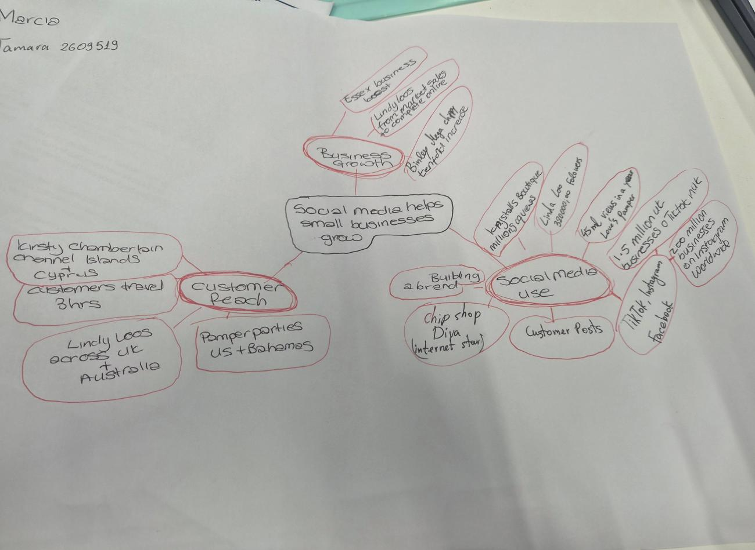

PART 2:

- What is the main idea of the whole text?
The main idea of the whole text is that social media has helped small businesses become recognised and helped their businesses grow. The idea is “Turning likes into livelihoods”.

- What is one key point that supports the main idea, and which specific example from the text shows this?
One key point is the customer reach. A key point that supports this is “ Social media platforms such as Tik Tok and Instagram have made it easier than ever to get noticed by the world”. This is proven by things such as a customer travelling three hours to get a chicken burger after seeing customer posts. Also, a small business such as Lindy Loo’s Boutique moving from a store to completely online but still having customers as far as Austrailia.

- What is a different key point that supports the main idea, and which specific example from the text shows this?
Another key point is that veiws and likes help small businesses. It was said 1.5 million UK businesses operate on Tik Tok and 200 million businesses on Instagram. Krystall’s Boutique racked up millions of veiws, as did Little Loves Pamper bus racking up 45 million veiws. Both businesses said their businesses have thrived and increased since.

- Which part of the text do you think is most important, and why?
The most important part of the text, I feel, is where figures are shown to back wh t is being said, as it shows that what is being read is believable and can be verified.

Reflection:
- What did you find difficult in this task (including in-class components), and why was it difficult?
The most difficult part if this task, for me, was defining what was a key points and their arguments. So though I may pick up in the general point of the text, breaking it down into the key points took some thinking.

- What helped you with this difficulty, and how did it help you?
Talking about the text and getting other opinions helped me pick out and understand the key points and break them down. Discussion helped me see things that I may have missed alone.

