Content Page
Part 1- Study Timetable- page 1
Part 2- AI activity- page 2-12
Part 3- Poster and reference list- page 13-14
Part 4- link to oral presentation also shared with lecture team- page 15
AI acknowledgment- page 15

Time Table
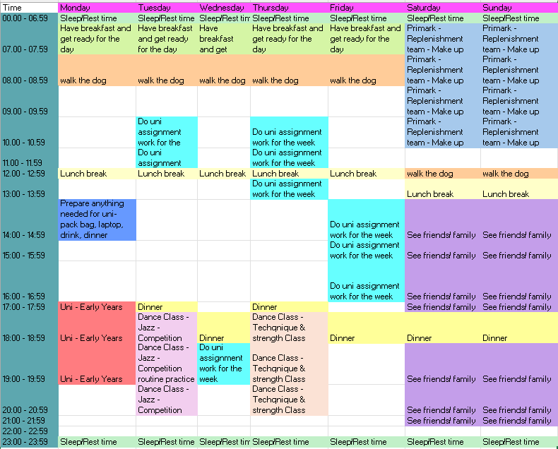

AI activity:
Initial input
Give me some techniques to help with time study management
Initial output
1. Pomodoro Technique — Short bursts, high focus
Work in 25-minute focused intervals, followed by 5-minute breaks. After four cycles, take a longer break (15–30 minutes). Why it works:
- Reduces procrastination
- Prevents burnout
- Creates a rhythm that’s easy to maintain
- Helps you start even when motivation is low
2. Time Blocking — Structure your day
Assign specific blocks of time to specific tasks (e.g., 10–12 revision, 2–3 reading). This removes decision fatigue and keeps your day predictable.
3. Eisenhower Matrix — Prioritise intelligently
Sort tasks into:
- Urgent + Important
- Important + Not urgent
- Urgent + Not important
- Not urgent + Not important This helps you focus on what truly matters rather than what feels loud.
4. Task Batching — Reduce mental switching
Group similar tasks (emails, admin, reading) into one session. This boosts efficiency and keeps your brain in one mode at a time.
5. Time Boxing — Set strict time limits
Give each task a fixed time window (e.g., “Finish notes in 45 minutes”). This prevents perfectionism and keeps you moving.
6. Eat the Frog — Do the hardest thing first
Start your day with the task you’re most likely to avoid. It builds momentum and reduces stress later in the day.
7. 1-3-5 Rule — Daily planning made simple
Plan your day with:
- 1 big task
- 3 medium tasks
- 5 small tasks This keeps your workload realistic and prevents overwhelm.
8. Task Segmentation — Break big tasks down
Divide large study tasks into smaller, manageable steps. This makes starting easier and improves retention.
9. Weekly Review Cycle — Reinforce learning
Set aside time each week to revisit notes, summarise key ideas, and check progress. This strengthens long-term memory and keeps you on track.
Refined input
What about for a university student who also works in the week
Refined output
1. The “Fixed Commitments First” Method
Start your weekly planning by blocking out:
- Work shifts
- Classes
- Commute time
- Non-negotiable responsibilities
This gives you a realistic picture of your actual available study time. Most students skip this step and overestimate their capacity — then burn out.
2. Energy-Based Scheduling
Working students often have unpredictable energy levels. Use this rule:
- High energy → difficult tasks (assignments, readings, problem sets)
- Medium energy → Pomodoro study sessions
- Low energy → admin tasks (emails, organising notes, planning)
This prevents you from wasting your best hours on low-value tasks.
3. Pomodoro Technique (Your Best Friend)
Because your time is fragmented, Pomodoro is perfect. Use:
- 25 minutes work
- 5 minutes break
- After 4 cycles → 15–30 minute break
Why it’s ideal for working students:
- Easy to fit into small windows
- Helps you start even when tired
- Prevents burnout after work shifts
- Keeps you moving through tasks without overthinking
4. Micro-Studying (10–15 minute bursts)
When your schedule is tight, small pockets of time matter. Use micro-sessions for:
- Flashcards
- Reviewing notes
- Watching short lecture clips
- Planning your next study block
These add up surprisingly fast.
5. The 1-3-5 Rule (Realistic Daily Planning)
Working students need realistic daily goals:
- 1 big task (assignment, major reading)
- 3 medium tasks (lecture notes, practice questions)
- 5 small tasks (emails, organising, quick reviews)
This prevents overwhelm and keeps progress steady.
6. Time Blocking (But Light Version)
Instead of rigid blocks, use flexible categories:
- Morning: admin + planning
- Afternoon: classes
- Evening: Pomodoro study
- Weekends: deep work sessions
This gives structure without trapping you in a schedule you can’t maintain.
7. Weekend Deep Work Sessions
Working students often rely on weekends for heavier study. Use 2–3 hour deep-focus blocks with breaks. This is where you tackle:
- Essays
- Projects
- Major revision
- Lab reports
One strong weekend session can replace multiple scattered weekday hours.
8. Task Segmentation (Break Everything Down)
When you’re tired after work, big tasks feel impossible. Break them into tiny steps:
- Open document
- Write heading
- Add bullet points
- Expand one paragraph
Small steps reduce resistance and keep you moving.
9. Weekly Review + Reset
Every Sunday evening (like right now), spend 20 minutes:
- Reviewing what you completed
- Checking deadlines
- Planning the next week
- Adjusting for work shifts
This keeps you organised and prevents last-minute stress.
Validate sources input
Where did you get this information from- include links to websites
Validate sources output
✅ 1. Pomodoro Technique
Newcastle University
https://www.ncl.ac.uk/academic-skills-kit/collections/get-ready-to-study/blog/kelsey-how-to-tackle-exam-periods/ Newcastle’s Academic Skills Kit explicitly recommends the Pomodoro Technique. They describe working in 25-minute focus intervals followed by 5-minute breaks, explaining that this helps students maintain concentration and avoid burnout. They frame it as a practical tool for busy students who struggle with long study sessions.
University of York
https://www.york.ac.uk/students/news/2026/study-tips/ York encourages students to use timed focus periods (30–45 minutes) with breaks. While they don’t name Pomodoro directly, the structure they recommend mirrors Pomodoro’s cycle: focused work + short breaks. Their guidance supports the same principle — breaking study into manageable chunks to maintain productivity.
✅ 2. Breaking Tasks Into Smaller Steps (Task Segmentation)
Prospects.ac.uk
https://www.prospects.ac.uk/applying-for-university/university-life/7-time-management-tips-for-students/ Prospects advises students to break large tasks into smaller, manageable steps. They explain that this reduces overwhelm, makes starting easier, and helps students progress steadily — exactly the purpose of task segmentation.
University of Portsmouth
https://myport.port.ac.uk/study-skills/organisation-and-time-management Portsmouth teaches students to divide tasks into small, clear actions. They emphasise that this helps with motivation and prevents procrastination, reinforcing the same technique.
✅ 3. Prioritisation (Urgent vs Important)
Prospects.ac.uk
https://www.prospects.ac.uk/careers-advice/study-tips/time-management-tips-for-students Prospects encourages students to prioritise tasks by urgency and importance, which directly aligns with the Eisenhower Matrix. They explain that this helps students focus on what matters most rather than reacting to everything at once.
University of Portsmouth
https://www.port.ac.uk/student-life/help-and-advice/study-support/study-skills/time-management Portsmouth also teaches prioritisation using urgency and importance. They show students how to identify high-value tasks and avoid wasting time on low-impact activities.
✅ 4. Planning Your Time / Time Blocking
Newcastle University
https://www.ncl.ac.uk/academic-skills-kit/time-management/ Newcastle recommends creating realistic timetables and planning study sessions in advance. This is the foundation of time blocking — assigning specific times to specific tasks.
St Mary’s University, London
https://www.stmarys.ac.uk/student-life/time-management-for-students St Mary’s advises students to map out fixed commitments first (lectures, work shifts, commuting). This is essential for working students and directly supports time blocking by helping you see where study time can realistically fit.
University of Kent
https://www.kent.ac.uk/your-studies/time-management Kent encourages students to use planners and calendars to block out study periods, deadlines, and personal commitments. This is classic time-blocking guidance.
✅ 5. Doing Difficult Tasks First (“Eat the Frog”)
Newcastle University
https://www.ncl.ac.uk/academic-skills-kit/time-management/ Newcastle calls this technique “Slay your monsters” — meaning tackle the hardest or most dreaded task first. This is the same principle as Eat the Frog: build momentum by removing the biggest mental barrier early.
✅ 6. Realistic Daily Scheduling (1-3-5 Rule Principles)
Prospects.ac.uk
https://www.prospects.ac.uk/careers-advice/study-tips/time-management-tips-for-students Prospects emphasises setting realistic goals and breaking tasks down. This supports the logic behind the 1-3-5 rule: don’t overload your day, choose a balanced mix of tasks.
St Mary’s University
https://www.stmarys.ac.uk/student-life/time-management-for-students St Mary’s encourages students to create realistic weekly schedules that account for work, study, and rest. This aligns with the 1-3-5 rule’s focus on manageable daily planning.
University of Portsmouth
https://www.port.ac.uk/student-life/help-and-advice/study-support/study-skills/time-management Portsmouth recommends planning sessions with buffer time and avoiding over-scheduling — again supporting realistic daily planning.
✅ 7. Using Downtime / Micro-Studying
University of Kent
https://www.kent.ac.uk/your-studies/time-management Kent encourages students to use “in-between times” such as commuting, waiting, or short breaks to review notes or complete small tasks. This is exactly what micro-studying is.
University of York
https://www.york.ac.uk/students/studying/skills/time/ York supports short focus cycles and frequent breaks, which naturally create opportunities for micro-study sessions — especially useful for students who work.
✅ 8. Weekly Review & Reset
Prospects.ac.uk
https://www.prospects.ac.uk/careers-advice/study-tips/time-management-tips-for-students Prospects recommends reviewing progress weekly and planning backwards from deadlines. This is the essence of a weekly reset.
St Mary’s University
https://www.stmarys.ac.uk/student-life/time-management-for-students St Mary’s advises students to plan each week in advance to avoid last-minute stress. This supports the weekly review cycle perfectly.

Discussion of the two techniques
This piece of writing will look at two effective study techniques that can help students manage their workload, organise their learning and help develop positive studying habits. The two techniques that I have chosen for a university student are the Pomodoro technique and breaking assignments into smaller steps. Both techniques will help studying become more manageable. The Pomodoro technique focuses on organising study-time and breaks, whereas breaking assignments into smaller steps focuses on organising the work itself.
The Pomodoro technique includes completing a certain time of focused work followed by a short break. Kelsey in Newcastle University (2026) says a typical cycle as 25-minutes of focused work followed by a five-minute break. Similarly, University of York (2026) recommends shorter work periods followed by regular breaks. Even though structured breaks can provide students with a clear way of organising study sessions it may not work for all students. Smits, Wenzel and de Bruin (2025) did an investigation with 94 university students comparing study techniques, including the pomodoro technique, and they found that there was no overall difference in productivity, task completion, or flow. This suggests that the pomodoro technique should not be automatically considered to be more effective than other approaches.
Breaking assignments into smaller steps involves dividing a large task into clear and manageable tasks. Prospects (2026) recommends breaking larger assignments into smaller goals, University of Portsmouth (2026) also supports this point by saying that you should divide larger tasks into manageable pieces. This will allow the assignment to feel less overwhelming and provide students with a clear vision of what they have to achieve. Breaking work into smaller sections can also help students spread their learning across the week. Sánchez, et al (2026) found evidence supporting spaced learning and doing bits of study overtime can help with long term memory.
Overall, both study techniques supports effective study habits as pomodoro provides a structured study time with breaks, and breaking down tasks helps organise thoughts and work to be completed.
Reference list
Kelsey in Newcastle University (2026) Kelsey: How to tackle exam periods, Academic skills kit available at: https://www.ncl.ac.uk/academic-skills-kit/collections/get-ready-to-study/blog/kelsey-how-to-tackle-exam-periods/ accessed: 20 September 2026
Prospects (2026) 7 time management tips for students available at:https://www.prospects.ac.uk/applying-for-university/university-life/7-time-management-tips-for-students/ accessed: 20 September 2026
Sánchez, M.S, Quince, G.A.L and Vélez, W.A.Z (2026) Systematic review of the effectiveness of neurodidactic spaced learning strategies in long term memory educ. Sci.16(6), 962 available at: https://doi.org/10.3390/edusci16060962 accessed: 20 September 2026
Smits, E.J.C, Wenzel, N and de Bruin, A (2025) Investigating the effectiveness of self regulated, Pomodoro, and flowtime break taking techniques among students behave. Sci, 15(7), 861 available at: http://doi.org/10.3390/bs15070861 accessed: 20 September 2026
University of Portsmouth (2026) Organisation and time management available at: https://myport.port.ac.uk/study-skills/organisation-and-time-management accessed: 20 September 2026
University of York (2026) 7 tips for study and exam success available at: https://www.york.ac.uk/students/news/2026/study-tips/ accessed: 20 September 2026
Reflection on using Microsoft copilot for academic study
Using Microsoft 365 copilot for my assignment was a new experience for me. At the beginning I was unsure about how to effectively use copilot and whether the information it provided was reliable enough to use in my assignment. Reflecting on my experience has allowed me to identify both the benefits and challenges I faced when using copilot.
When I first started using Microsoft 365 copilot, I found it quite confusing. I struggled to understand whether the information it provided me was correct and suitable for my work. I was unsure about how specific my questions needed to be and whether I could trust the information and links it gave me. This made me feel confused and unsure about using copilot because I knew the information I included in my work needed the be accurate and reliable.
As I played around with copilot and became more familiar with how it worked, I started to understand how to use it more effectively. I realised that the inputs I gave copilot had a significant impact on the quality of information it provided. Once I got the hang of using it and learned how to ask the more specific questions, I found it much clear and more useful. Copilot did not only provide me with a link to the website, but also an explanation of what the information on the website provided. This made it easier to have a brief understanding on whether the source was relevant to my research. However, I understood that I still needed to check the information myself to make sure the information was correct and up to date.
I made sure to use the CRAPP test I learned in my lecture to help me check the sources provided by copilot. This was important because some of the links copilot gave me were outdated or no longer available. I found it frustrating and it caused me to become confused on how to get around this because I could not always access the original source to check the information. This taught me that I should not automatically trust the information provided my copilot without checking it myself.
In the future I will continue to use copilot as a stating point for my academic research if allowed. I will also make my prompts more specific and clear to receive more relevant information. I will also continue to use the CRAPP test to check the information copilot gives me before using it in my assignments.

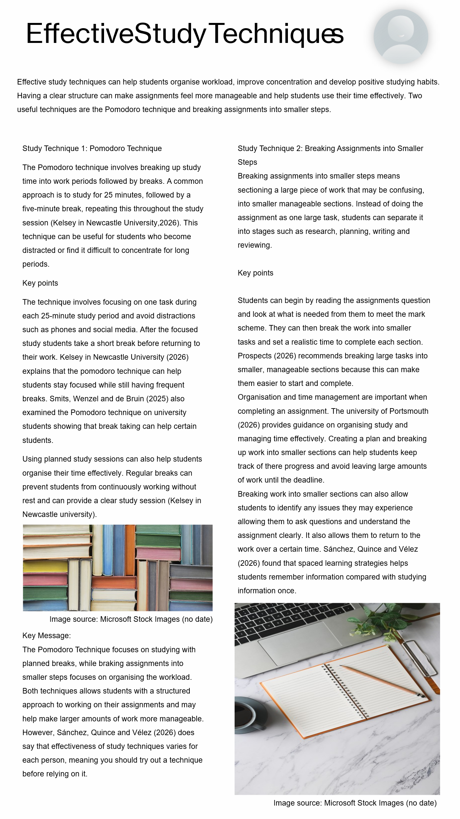
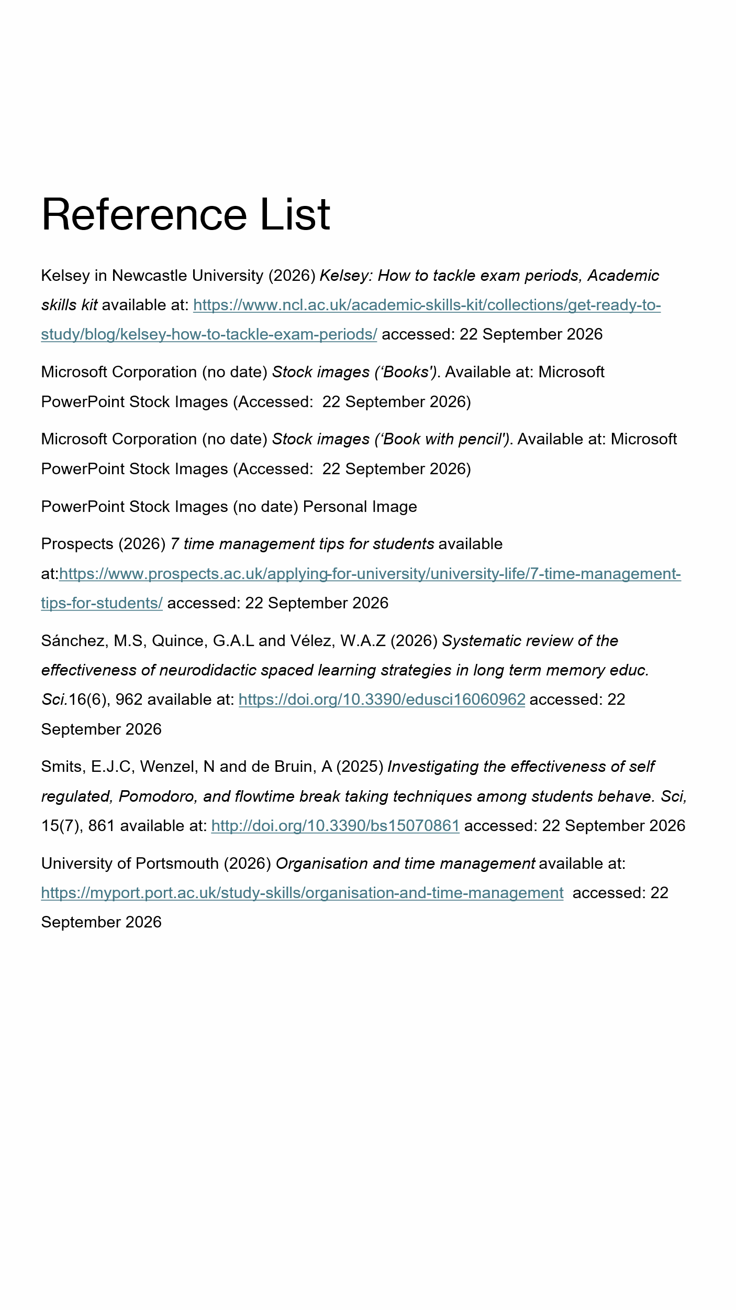
Link for oral presentation:
poster.pptx

I acknowledge the use of Microsoft 365 copilot on 20th September 2026 to find out different study techniques and links of information
Prompts:
- Give me some techniques to help with time study management
- What about for a university student who also works in the week
- Where did you get this information from- include links to websites
I confirm that I have not presented any AI generated text in my own work. I confirm I have copies of my drafts, notes, and other resources I used before, and after the use of AI tools which I may be asked to provide in evidence.

