TRINITY HOTEL & RESTAURANT

EMAIL: trinityhotel @gmail.com
PHONE: 07567875643

37, Shell Road
Swansea, South Wales, SW12BM
Serving Hours: 9:00am to 9pm

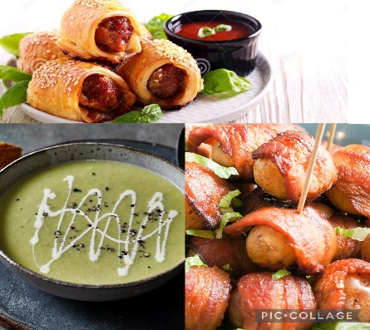
APPETIZER:
Mini Sausage Rolls 3.45
A pleasant light flaky pastry sprinkled with sesame seeds and filled with rich, juicy sausages
Bacon-stuffed Potatoes 2.50
Bowl of crispy tender bacon wrapped around soft potatoes
Leek & Potatoes Soup 3.75
Flavorous soup served alongside buttery bread

Main Course:
Shepard’s Pie 13.10
Minced meat and vegetable covered with a layer of cheese and potatoes
Roast Dinner 17.85
Chicken roasted to perfection served with a portion of peas and carrots along with Yorkshire puddings
Roasted Beef Tenderloin 45.50
Juicy roasted beef tenderloin, caramelized shallots, drizzled in red wine sauce- paired with Cabernet Sauvignon price included
Lobster Risotto 19.45
Made with white wine, cognac, tarragon and arborio rice
Chicken Skewers 38.50
Mouth-watering grilled chicken and vegetables on skewers dressed in garlic honey sauce garnished with parsley. Paired with Chardonnay price all inclusive
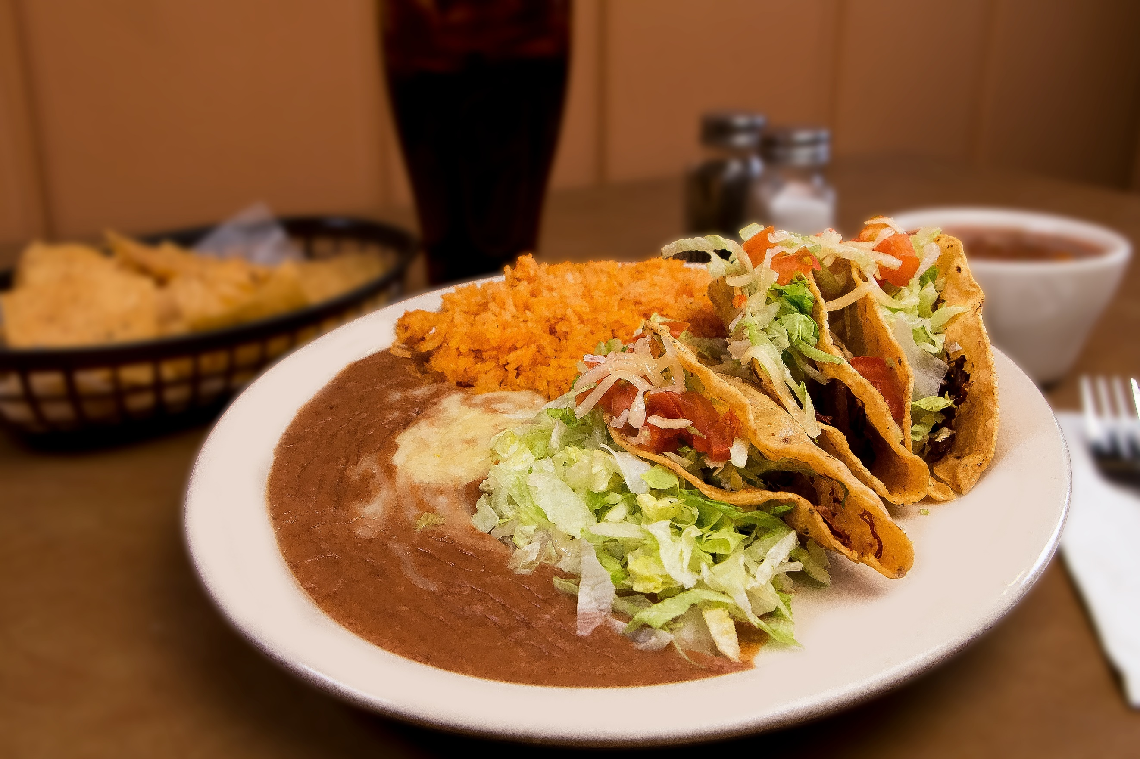

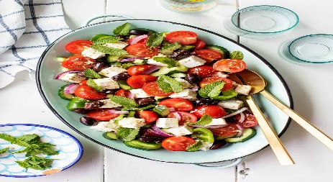
DRINKS:
Traditional Tea 2.30
Beer 1 pint 3.10
Cabernet Sauvignon 17.75
The king of red wines, a beautiful dry wine with spices of vanilla, black cherries and plum(8oz)
Chardonnay 18.80
A ripe, crisp white wine beautifully blended flavours, hinted flavours of apple, pineapple, and citrus (9oz)

DESSERTS:
Fruit cake 3.80
Scottish Scones 2.75
Light and fluffy scones with a layer of butter and jam spread on
Bara Brith 3.00
Delightful traditional Welsh tea bread flavoured with tea, delicious, dried fruits, and pungent spices

We have Halal, Vegan, Vegetarian, and gluten-free options available
Allergy disclosure: Menu options may contain or have come in contact with peanuts, treenuts, soybeans, milk, egg, wheat, shellfish, or fish. Please don’t hesitate to contact management via the number or email above for further allergen information
Cash and card payment is available for customers
For further information and delivery services please ahead to our website linked down below:
www.hoteltrinityrestaurant.co.uk
Ewch i food.gov.uk/ratings i ganfod sgôr hylendid bwyd ein busnes neu gofynnwch inni beth yw ein sgôr hylendid bwyd wrth archebu / Go to food.gov.uk/ratings to find out the food hygiene rating of our business or ask us for our food hygiene rating when you order

SIDE DISHES:
Roasted Potatoes 3.50
A bowl of delicious roasted potatoes with a perfect crunch drizzled in gravy
Fries 2.75
Available in large, medium, and small portions
Greek Salad 2.00
Salad with feta cheese, olives, yellow peppers, red peppers, cucumbers

