Game Design and History
Philip Richmond (2212266)
R W Morgan
ACCA4033

Game Analysis/Review

Contents
List of Figures 4
1 Introduction 5
2 Genre 5
3 Visual style 6
4 Intended Demographic 6
4.1 Casual gamers: 6
4.2 All ages: 6
4.3 Simulation lovers: 6
4.4 Food enthusiasts: 6
4.5 Puzzle and strategy games: 6
4.6 Multiplayer: 6
4.7 Nostalgic seekers: 6
5 Use of audio and visual feedback and its impact on the player 7
6 Game Structure 8
6.1 Tutorial: 8
6.2 Game modes: 8
6.3 Progressive gameplay: 8
6.4 Order taking and cooking: 8
6.5 Time management: 8
6.6 Continued playability: 9
7 Challenges 9
8 Game flow 9
8.1 Taking orders 10
8.2 Preparation 10
8.3 Cooking 10
8.4 Work tickets 10
9 Replay value 11
10 Positive and negative aspects of the game 11
10.1 Positive Aspects 11
10.1.1 Challenging Gameplay 11
10.1.2 Replayability 11
10.2 Negative Aspects 12
10.2.1 Steep Learning Curve 12
10.2.2 Lack of depth 12
10.2.3 Repetitive tasks 12
11 Conclusion 13
12 Bibliography 14

List of Figures
Figure 1 Popular user defined tags for CSD2 on Steam [3] 3
Figure 2 the pressure of rush hour with heghen music 5
Figure 3 In-game list of tutorials from CSD2 6
Figure 4 Above show a similar flow chart for CSD2 [6] 7
Figure 5 In Game Work Tickets 8
Figure 6 Price of CDS2 on 25.10.23 10
Figure 7 CSD2 Game Credits 11
Figure 8 [7] Extra Dev information 12

Introduction
In October 2013 Vertigo Gaming and David Galindo [1] released the game Cook Serve Delicious started a legacy of games that instantly found overwhelmingly positive reviews for its originality and playability [2]. In September 2017, Cook Serve Delicious 2 (CSD2) released with even more unique blend of challenges and time management genre. CSD2 has carved its way into the players’ minds with its engaging and immersive experience.
This report will provide a comprehensive analysis of the game CSD2 gameplay mechanics, replay value, visual style, and more. From its bright artwork and high tempo music which time management challenges, the game offers a rich culinary delight of experiences and presents players with a unique play through journey into the world of restaurant management simulation that keeps them coming back for more.
This report explores CSD2 game structure and challenges it presents, with an impressive storyline gameplay and unique visual style that sets the tone for a retro inspired atmosphere. Additionally, this report will delve into the replay value that keeps many players coming back to the game.

Genre
Cook, Serve, Delicious 2 (CSD2) belongs to the time management and simulation game genre. It challenges players in a high-pressure environment to run a restaurant. This involves managing complex orders, cooking various dishes, and completing various other challenges like using a dishwasher, emptying bins, pest control and dealing with robbers. All of this must be done efficiently and within the time limits. The game’s multitasking and culinary elements define its genre.

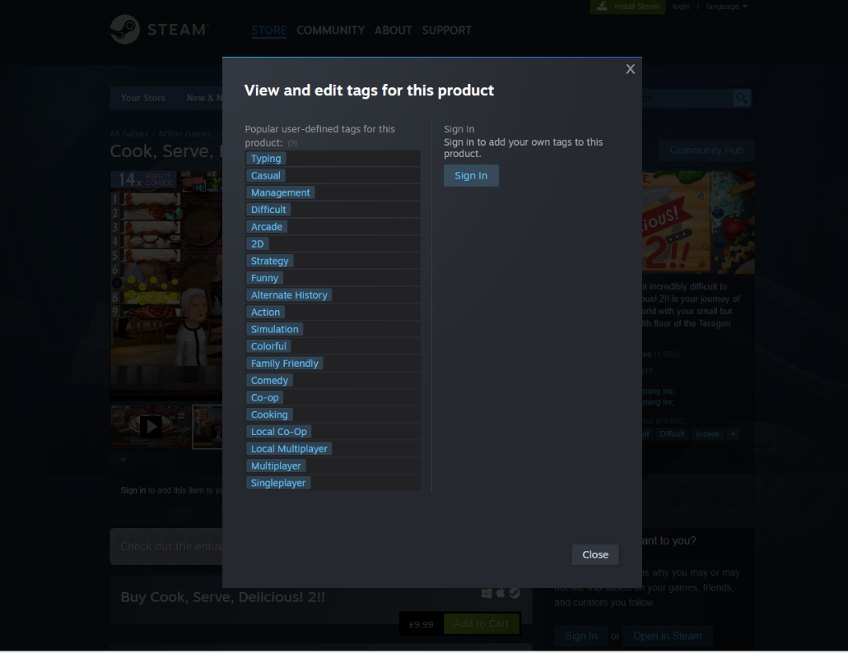
Figure 1 Popular user defined tags for CSD2 on Steam [3]

Visual style
Visual style is an essential part of creating the game experience and can communicate the feel of the game envisioned by the game designer [4]. CSD2 features are very bright and colourful art style in 2-D which is good to look at and visually appealing. The characters, restaurants and foods are well designed and easy to distinguish from each other. The foods are easily recognisable to what they are meant to be. Restaurants layout and kitchen equipment is rendered with a retro style in mind bringing back old-style American restaurants in the 1980s. The animations run smoothly with a very fast paced the kitchen and the characters coming back and forth making you feel that you are in a fast-paced environment. The game offers you a wide selection of avatars catering to all needs. The HUD [5] display works well and smoothly interacts with the full gameplay.

Intended Demographic
CSD2 multiplatform game designed to appeal to a wide varied audience. With an age rating of 12 year and about the game also contain some mild swearing that may turn some parents from allowing their children to have the game (see figure 6). It has a wide appeal to many players, in popular, amongst gamers who enjoy time management and simulation games as well of those players who have a passion for dining out. The accessibility of this came on various platforms makes it is extremely easy it is to make it their goal to game suitable for all skill levels.
CSD2 primarily targets the following demographics:

Casual gamers:
CSD2 easy to use controls make it ideal for most casual gamers will want a fast paced and fun gaming experience without a steep limit learning curve.

All ages:
CSD2 suitable for all ages above 12 and is extremely family friendly which will appeal to all demographic areas.

Simulation lovers:
Players who real from simulations and management will find extended scope and complexity of running a virtual restaurant to be extremely satisfying.

Food enthusiasts:
People who enjoy cooking and have an interest in foods and services are going to find CSD2 draw the gaming interests therefore will enjoy the games focus in preparing food dishes to please customers.

Puzzle and strategy games:
gamers who enjoy strategic and puzzle solving elements will appreciate the extreme challenge of multitasking plus time management and the precision required in hand eye coordination make this game very appealing to.

Multiplayer:
CDS2 multi-game element this competitive side with appeal players will enjoy social gaming experiences with friends and family and the wider gaming community.

Nostalgic seekers:
CSD2 picks and retro inspired style and atmosphere will attract young and old players were trying to immerse themselves in this classic game.

Use of audio and visual feedback and its impact on the player

CSD2 soundtrack composed by Jonathan Greer is one of the main components of the overall game experience. It ties in nicely with the visual style by providing upbeat tunes with energetic bursts that match the in-game event and player’s actions. The soundtrack becomes more intense as orders pile up creating a feeling of being overwhelmed. With the wide range of restaurants and visual styles this gives CSD2 opportunity to give a diverse range of music that adds to the restaurant simulator.
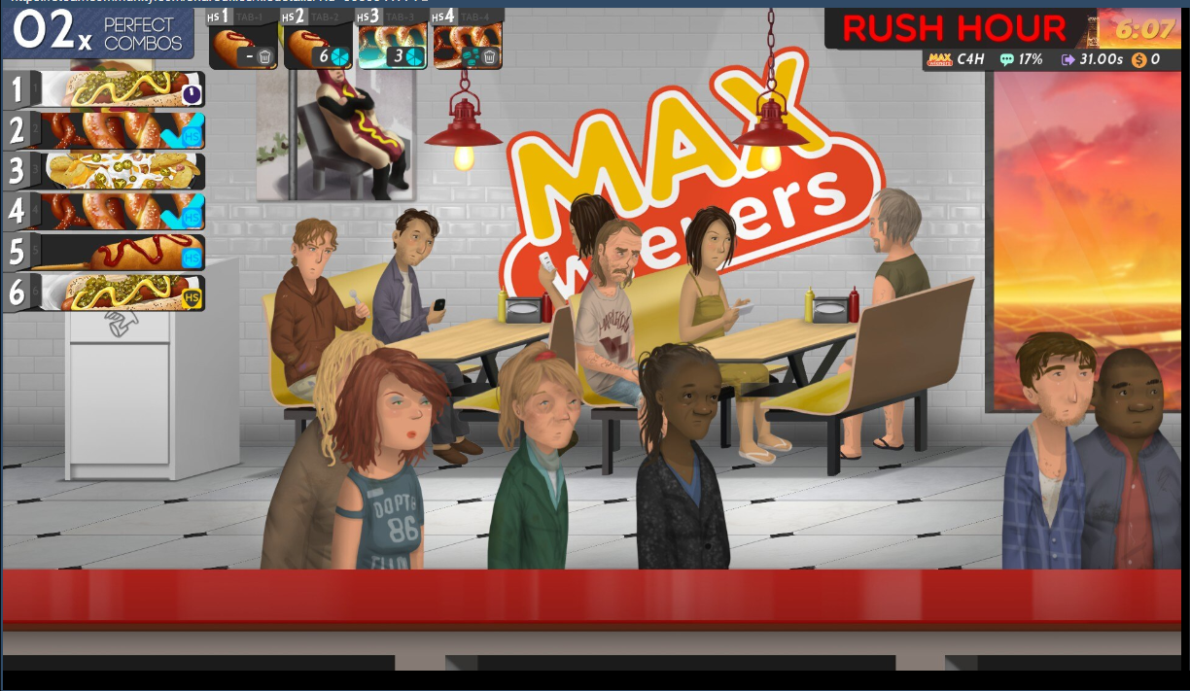
Figure 2 the pressure of rush hour with heghen music

ALWAYS MAKE THE MUSIC MORE EXCITING THAN THE
ACTION ON SCREEN – Rogers, S [6]

Game Structure

Tutorial:
The tutorial offers a step-by-step guide for beginners into the world of Cook, Serve, Delicious 2. It introduces gameplay mechanics and gradually builds the player skills, ready to take on many challenges ahead.
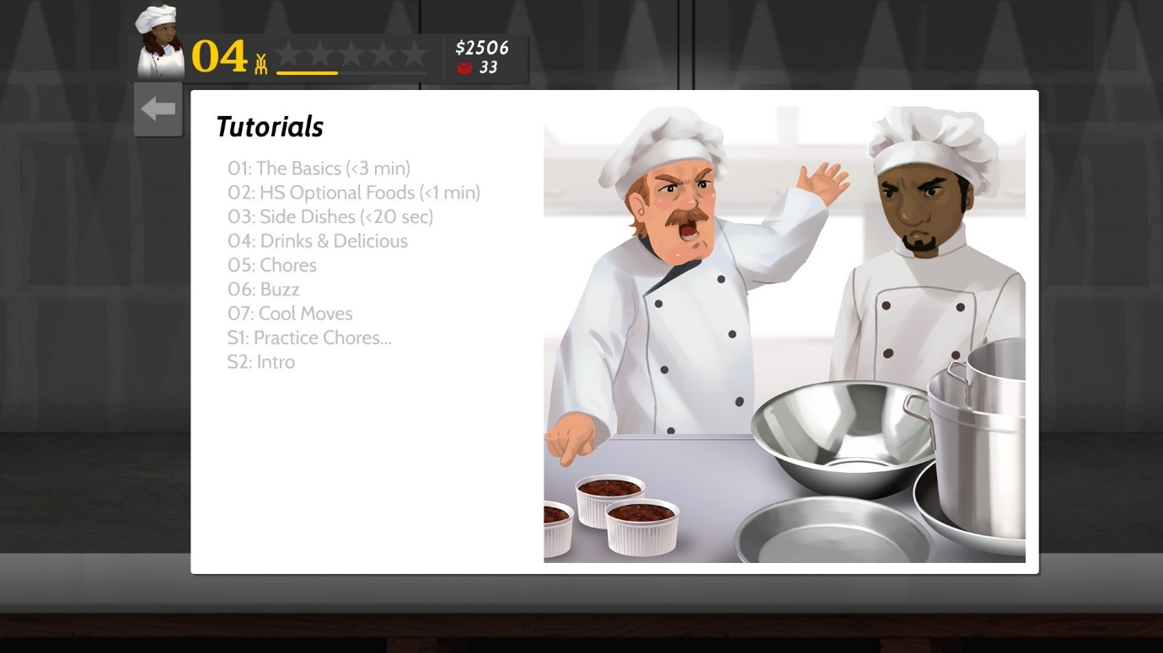
Figure 3 In-game list of tutorials from CSD2

Game modes:
The game offers different modes, including in the main campaign mode which include bronze silver and gold reward system to progress in the standard shift the restaurants. Zen mode can be selected to offer a slower pace, but this mode does not offer the progress you would get in the standard shift mode.

Progressive gameplay:
In the campaign mode you start in the Max Wieners restaurant with four holding station prep areas and the capability to complete six tasks at once. Once the player has mastered this restaurant got perfect day completed, he then can move on to other restaurants different menus and increased difficulty.

Order taking and cooking:
The main gameplay involves taking orders from customers and preparing dishes. You must follow either the written instructions of the picture instructions for each dish, this include selecting ingredients, preparing them, and cooking them to perfection. the game offers a wide variety of dishes and restaurants to unlock with their own unique difficulties.

Time management:
Keeping track of time is a crucial factor in the game. The player needs to efficiently manage cooking times and keep up with customer demands while maintaining the right ingredients and not burning dishes. Speed and accuracy of the key to successful shift.

Continued playability:
The player can invest their earnings in upgrading the restaurants by buying new equipment and unlocking additional recipes. The game continually introduces new restaurant challenges and dishes to keep the gameplay engaging and varied.

Challenges
CSD2 is a thrilling fast-paced cooking simulation game that takes the player in a fast-paced multitasking challenge. Fast paced games are commonly perceived to be increase player engagement [7]. The game’s primary challenge is time management. As orders come in from inpatient customers the gamer must manage various tasks simultaneously, from chopping ingredients monitoring cooking times and taking care the pesky robbers. This relentless pace can overwhelm you while testing your ability in memory to maintain composure under eye watering pressure.
Another challenge lies in the game complex array of menus items. With hundreds of dishes and ever evolving recipes, demands the gamer to remember a complex step and ingredient combination. The game can force you to mix up orders or under cooked dishes leading to unhappy customers with loss of profits. Balancing these tasks can be a mental workout.
With the above challenges players need a degree of dexterity and hand eye coordination, especially when using keyboard and mouse where you need to navigate a virtual kitchen with precision. With the wrong click or press a button can lead to cooking disasters which will add to an already stressful experience.

Game flow
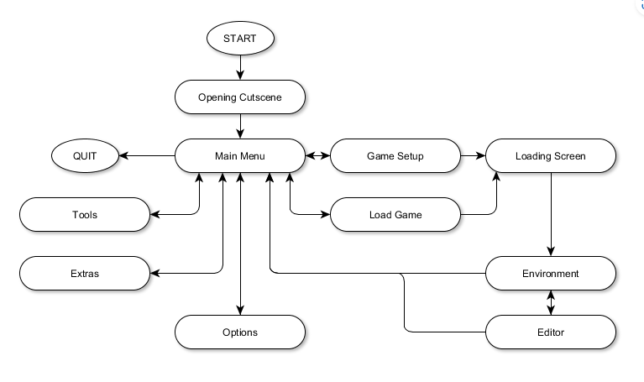
Figure 4 Above show a similar flow chart for CSD2 [8]

Taking orders
Once service starts and customers enter and place orders. The player must act quickly and select and confirm orders.

Preparation
Each specific dish requires ingredients and preparation time, often with varying complexity cooking times.

Cooking
Once the player starts the process of cooking the player then needs to keep an eye on the timing not to overcook/burn or under Cook the food leading to unhappy customers. With multiple items cooking at once this task can be risky.

Work tickets
As the players is in the thick of it, chores called work tickets are added, such as:
- Filling and emptying a dishwasher.
- Trapping pests
- Emptying bins
- Filling up vending machines
- Dealing with blocked toilets
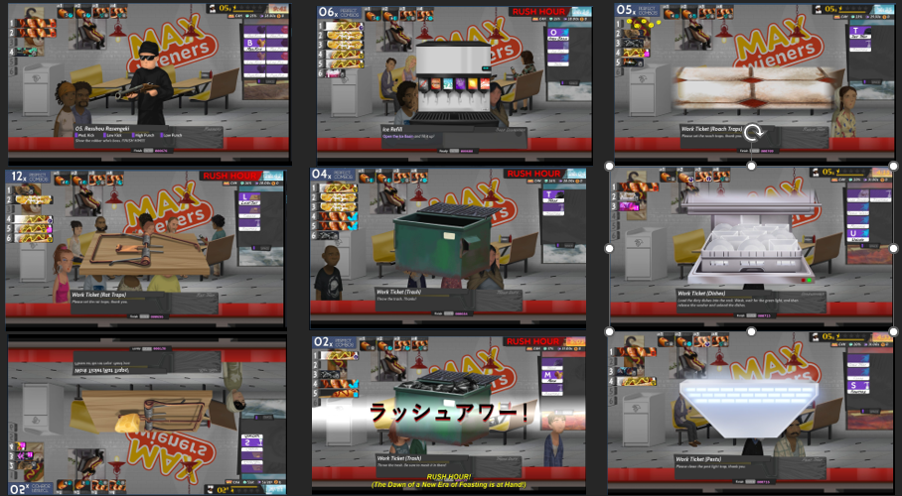
Figure 5 In Game Work Tickets

CSD2 Game flow increasingly gets harder with more complex recipes and higher demands from the players ability to manage the restaurant efficiently. This gives the player an engaging, though stressful, game experience.

Replay value
Replay value is a measure of continued enjoyment when replaying a game [9].CSD2 offers hours of replay value from completing the main campaign with its many choices of restaurants and unique challenges to unlocking countless menus and foods choices to unlock. With plenty of multiplayer options, leaderboards, and achievements to score on help players return for new experiences and challenges.

Positive and negative aspects of the game
CSD2 offers a distinctive and engaging gaming experience for players but like most games, both positive and negative aspects:

Positive Aspects

Challenging Gameplay
The game can provide many levels of challenging gameplay all the way up to the extreme level the player must undertake demanding multitasking with it was in their memory and time management skills, engaging and frustrating the players at the same time giving you a mental workout.

Replayability
CSD2 multiple gameplay modes gives the player plenty of depth and longevity within the game. The game also offers customisation options within its menu and restaurant cosmetics ensuring great replay value keeps the player coming back from the experiences.

Progression
This game gives the player a sense of progress as you build and improve your restaurants in a rewarding way with an engaging storyline that adds depth to the gameplay.

Value for money
CSD2 offers great value for money with plenty of gaming time making it ideal for new players to the gurre of game. See figure below.

Figure 6 Price of CDS2 on 25.10.23

Negative Aspects

Steep Learning Curve
The games quick pace may represent a short-lived gaming experience as players can get frustrated with the steep learning curve and abandoned the game.

Lack of depth
Some gamers might find the games storyline and character may not be in depth and driven enough to more other driven games.

Repetitive tasks
CDSD2 gameplay can be very repetitive to players as its primary gameplay involves taking orders and preparing dishes over and over this might not appeal to gamers seeking a varied gameplay experience.

Conclusion
Overall, Cook, Serve, Delicious 2 is a culinary simulation game that stands out for its unique blend of challenges that can immerse the player in a panic stricken feeling with food orders not being sent out to the standards required, but with nostalgia inducing visuals and a gripping soundtrack the game has an addictive feeling makes the player want to come back and run the perfect restaurant.

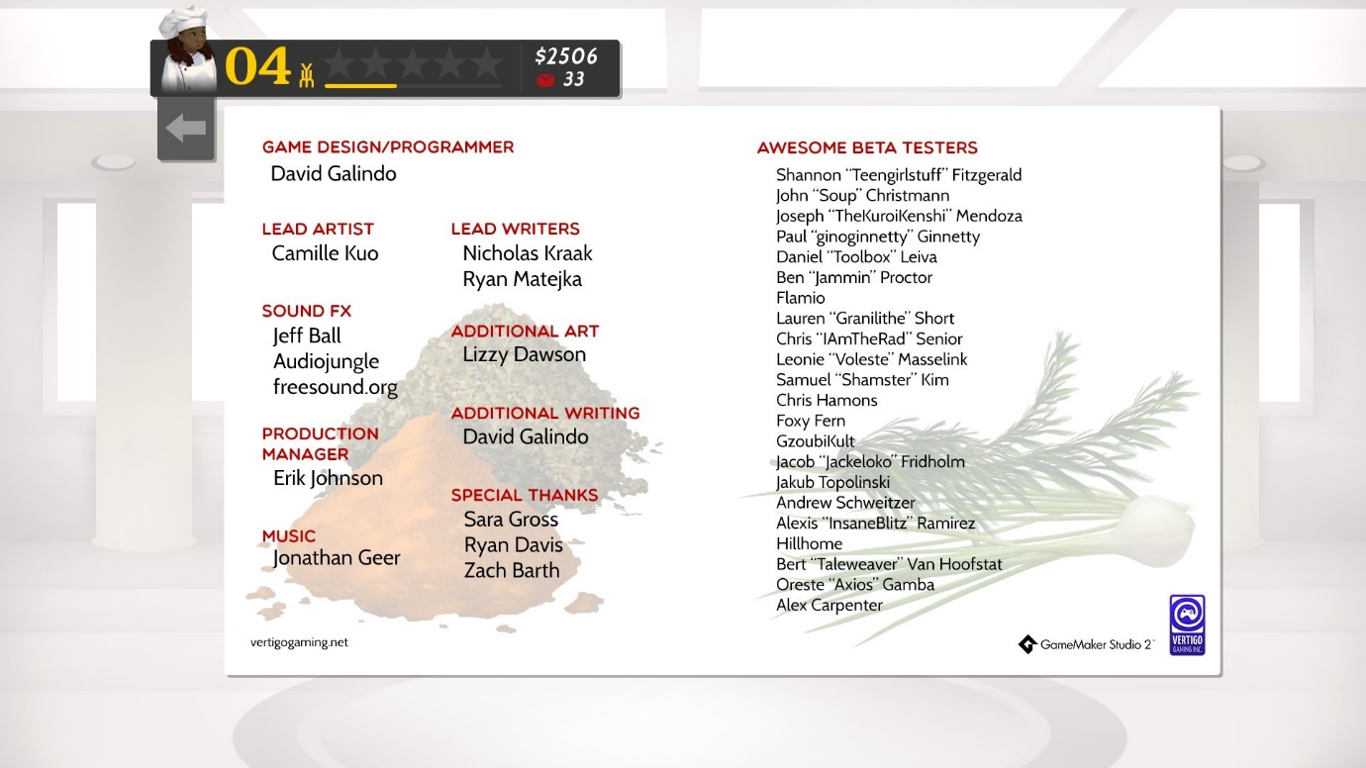
Figure 7 CSD2 Game Credits

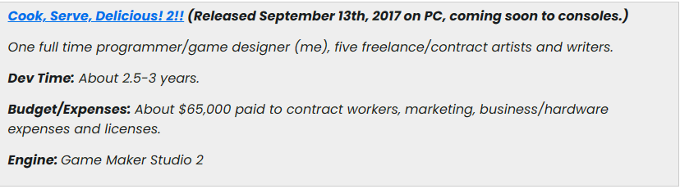
Figure 8 Extra Dev information [10]

Bibliography

[1] | “Toucharcade,” [Online]. Available: https://toucharcade.com/2023/05/15/cook-serve-forever-steam-deck-early-access-interview-mobile-ports-vertigo-gaming/. [Accessed 21 10 2023].
[2] | “Steam,” [Online]. Available: https://store.steampowered.com/app/247020/Cook_Serve_Delicious/.
[3] | “Steam,” Steam, [Online]. Available: https://store.steampowered.com/app/386620/Cook_Serve_Delicious_2/. [Accessed 22 10 2023].
[4] | N. Adamo, S. Garver and H. Dib, “The Impact of Visual Style on User Experience in Games,” EAI Endorsed Transactions on Game-Based Learning , vol. 4, no. 15, p. 153535, 2018.
[5] | S. Roger, Level up!: the guide to great video game design, 1 ed., Wiley, 2010, p. 171.
[6] | S. Rogers, Level up!: the guide to great video game design, 1 ed., Wily-Blackwell, 2010, p. 399.
[7] | H. Anwar, “UWSPACE,” 30 03 2016. [Online]. Available: https://uwspace.uwaterloo.ca/handle/10012/10347. [Accessed 30 10 2023].
[8] | “Revolutionary Game Studio,” 20 06 2015. [Online]. Available: https://revolunarygamesstudio.com/game-screen-flowchart/. [Accessed 29 10 2023].
[9] | M. J. P. Wolf, The Encyclopedia of Video Games: The Culture, Technology, and Art of Gaming, vol. 1, Bloomsbury Academic, 2012, p. 763.
[10] | “Game Developer,” 12 9 2018. [Online]. Available: https://www.gamedeveloper.com/business/how-much-do-indie-pc-devs-make-anyways-part-8-. [Accessed 28 10 2023].
[11] | “Reddit,” Reddit, [Online]. Available: https://www.reddit.com/r/Games/comments/13bxyfl/ama_we_are_david_galindo_and_ryan_matejka/?rdt=33372. [Accessed 22 10 2023].

