

Financial Management for the Hotel Industry

Report Case Study

On

The Seaview Resort

Student name: Alexandra Adriana Popa

Lecturer: Jaliya de Silva

Student ID: 2133013

Module code: BMIH5007

Table of Contents
Introduction 3
Market Analysis 3
Scope and Objectives 5
Financial Performance Analysis 5
Identification of Key Issues 7
Turnaround Strategy 8
Implementation Plan 9
Conclusion 10
References 10

Introduction
Once considered the pinnacle of beachside luxury, the Seaview Resort has fallen on difficult times. The luxurious accommodations and panoramic ocean views at this resort attracted Hollywood's A-listers. The hotel has a long history of excellence in local hospitality, having earned acclaim for its luxurious stays and friendly staff. There have been a growing number of problems at The Seaview Resort in recent years. Guests' tastes are changing because of the proliferation of eco-friendly hotels in the area. There have been a number of issues, such as a reduction in service quality and antiquated infrastructure that have led to its diminishing market share. There is now serious question about the company's capacity to maintain its previous level of revenue and profitability going forward. The purpose of this research is to shed light on the best next steps for The Seaview Resort. Market trends, financial results, and the operational flaws that have led to the resort's decline will all be dissected. The end goal is to design a thorough turnaround strategy to restore the resort's financial health and revive its status as a top-tier vacation spot.

Market Analysis

Evolving Landscape of the Coastal Resort Market
Due to shifting consumer preferences and intense competition, the once-reliable seaside resort industry is facing a crossroads (Page et al., 2017). The traditional beach vacation has given way to a wider range of specialized excursions in response to the needs of today's savvy travelers. Modern travelers seek out unique and personalized holiday experiences, which has led to a proliferation of boutique hotels and specialized service offerings. This fragmentation has challenged established resorts to innovate or face obsolescence.
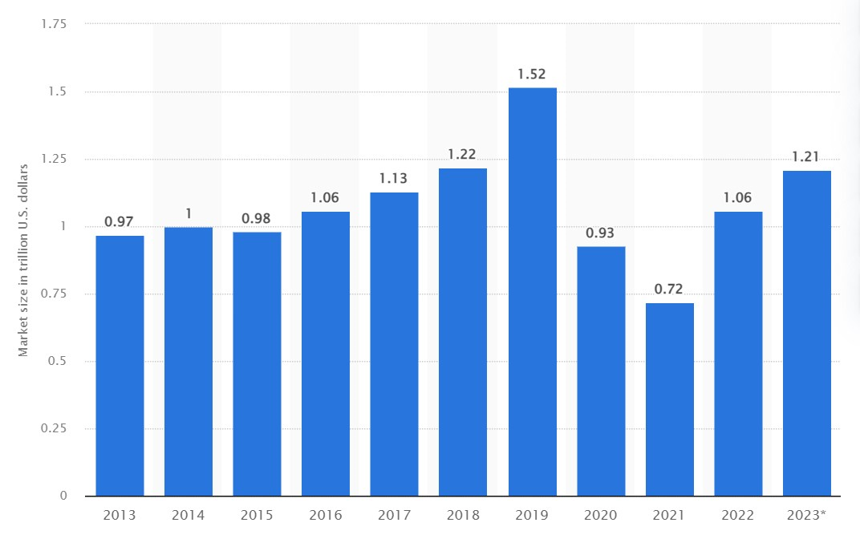
Figure-1: Market size of the hotel and resort industry worldwide from 2013 to 2022, with a forecast for 2023 (in trillion U.S. dollars) (Statista, 2022)

Sustainability and Experiential Tourism Trends
A significant trend reshaping the resort market is the shift towards eco-friendly and experiential tourism. The modern vacationer is increasingly aware of environmental issues and is actively choosing destinations that demonstrate sustainable practices. This heightened environmental consciousness has compelled resorts to adopt green initiatives, such as waste reduction, water conservation, and sustainable sourcing of food and materials (Agarwal et al., 2018). An increasing number of travelers are looking for vacations that provide more than just relaxation, such as opportunities to actively participate in new cultures, try exotic foods, and learn about interesting traditions.

Customer Reviews and Market Perception
It is impossible to exaggerate the significance of online consumer reviews and their effect on market perception. A resort's digital footprint is becoming important in shaping its reputation in the modern era of social media and review platforms (Chapman et al., 2021). The narrative about The Seaview Resort that can be pieced together from comments left by actual guests is one of a once-premier location falling behind the times. Dissatisfaction with old facilities and a lack of care for the resort's upscale reputation are common complaints. These comments highlight the resort's declining popularity and act as a rallying cry for improvement.
To reclaim its market share and client loyalty, The Seaview Resort must begin a revolutionary journey. This means embracing sustainability and establishing a portfolio of experiences that resonate with the ideals and aspirations of today's environmentally and culturally conscious visitors.

Scope and Objectives
The goal of this report is to provide a detailed analysis of the financial results at The Seaview Resort for the three years spanning 2020-2022. It will extensively review income statements, balance sheets, and cash flow statements to discover the primary drivers underlying the drop in profitability. Using these findings, the report will lay out a detailed turnaround strategy to help the resort get back on its feet financially. To secure a long-term and financially fruitful future, The Seaview Resort will implement a strategy to reinvigorate its market position, boost operational efficiency, and increase customer happiness (Holloway and Humphreys, 2022).

Financial Performance Analysis

Income Statement Analysis
Income statements for the Seaview Resort show a worrying drop in sales and net profit margins between 2020 and 2022. Together, falling occupancy and hotel rates contributed to a steady decline in revenue from £520,000 in 2020 to £430,000 in 2022. The loss of pricing and occupancy power implies that the business is unable to adapt to the market.
In the meantime, despite the decline in income, operational expenses increased from £390,000 in 2020 to £450,000 in 2022. This suggests that fixed costs remained high or were not controlled efficiently (Vogel, 2021). Gross profit followed a similar downward trend, halving from £130,000 in 2020 to £80,000 in 2022. Net profit margin, a key indicator of financial health, also decreased sharply from 15% to 4%, signaling reduced operational efficiency and potential issues in cost management or pricing strategies (Mustapha et al., 2020).

Balance Sheet Analysis
As of the end of 2022, The Seaview Resort's balance sheet showed total assets of £1,200,000, with a significant portion tied up in property and equipment, indicating a heavy investment in physical assets. The current assets at £250,000 suggest limited liquidity, which could be a concern for meeting short-term obligations. With £100,000 categorized as inventory, this points to a potentially excessive stockpile of unsold goods or slow-moving supplies (Abdullah, 2018).
Liabilities amounted to £750,000, with a concerning ratio of current liabilities (£180,000) to current assets, raising questions about the resort's short-term financial resilience. Long-term debt constituted a substantial portion of liabilities at £500,000, indicating a leveraged position that could be burdensome given the declining profits.

Cash Flow Analysis
The cash flow statement for 2021 reveals a net cash outflow from operations of -£80,000, which is alarming as it suggests that the core business activities are not generating sufficient cash to sustain operations. Capital expenditures of £30,000, while necessary for maintaining and updating facilities, further strained the cash reserves, resulting in a net cash flow decrease of £110,000 for the year. This negative change in cash balance underscores the urgency for strategic financial management to improve cash generation and control capital spending (Mustapha et al., 2020).
In summary, The Seaview Resort's financial analysis exposes critical vulnerabilities in its revenue generation capabilities and expense management. The decreasing net profit margins and cash outflows highlight the need for immediate attention to cost structures and revenue management. The balance sheet indicates potential liquidity issues that could impair the resort's ability to respond to short-term financial obligations and invest in necessary improvements.

Identification of Key Issues

Financial Performance Shortfalls
- Revenue Decline: Review of financial data highlights a persistent decrease in revenue, with ARR and occupancy rates falling behind.
- Profitability Concerns: Net profit margins have sharply declined from 15% to 4%, well below the industry average of 10-15% for healthy operations (Vogel, 2021).
- Cash Flow Constraints: Negative cash flow from operations suggests that the core business activities are not generating sufficient cash to cover expenses and capital investments.

Operational and Market Position
- Cost Management: Operating expenses have increased despite falling revenues, indicating a cost structure that is misaligned with the resort's financial realities (Jakes, 2016).
- Asset Utilization: A heavy investment in property and equipment with low liquidity raises concerns about the efficiency of asset utilization.

Comparison with Industry Standards
- Profit Margins: The resort's profit margins are underperforming when compared to industry standards, signaling operational inefficiencies (Page and Connell, 2020).
- Liquidity Ratios: The current ratio (current assets to current liabilities) suggests potential liquidity issues, risking the resort’s ability to fulfill short-term financial obligations.

Consumer Trends and Competitive Landscape
- Evolving Preferences: There is a clear shift in consumer preferences towards resorts offering modern, eco-friendly, and experiential tourism that The Seaview Resort has yet to effectively address (Rate et al., 2018).
- Service Quality and Amenities: Customer reviews indicate dissatisfaction with service quality and outdated amenities, directly impacting repeat business and referrals.
- Rising Competition: Newer, modern resorts in the vicinity are setting high benchmarks by aligning with eco-tourism trends and leveraging technology to enhance guest experiences (Veretekhina et al., 2017).
To navigate these challenges, The Seaview Resort must embark on a transformative journey that addresses the key issues identified. The turnaround strategy should focus on enhancing revenue management, streamlining operations to reduce costs, and revitalizing the resort's offerings to align with contemporary market demands and customer expectations.

Turnaround Strategy
The Seaview Resort needs a comprehensive plan to revive its fortunes. Reorganizing finances, boosting marketing, going green, and better serving customers are all parts of a comprehensive plan.

Financial Restructuring
- Cost Optimization: Optimal Cost Management entails taking steps to reduce expenses without lowering the quality of service provided. This could include renegotiating supplier contracts, lowering energy use, and improving personnel schedules (SHENGNAN and Nedelea, 2019).
- Revenue Management: Utilize demand, seasonality, and booking trends to optimize room sales with dynamic pricing techniques implemented by Revenue Management.
- Debt Refinancing: Reduce financial stress by looking into refinancing long-term debt to a new loan with more favorable interest rates and payback conditions (Thompson, 2017).
- Asset Review: Consider selling underutilized assets or repurposing spaces within the resort to generate additional income streams (SHENGNAN and Nedelea, 2019).

Marketing and Service Quality Improvement
- Rebranding Campaign: Launch a rebranding campaign to reposition The Seaview Resort as a modern, eco-friendly destination, highlighting new initiatives and service improvements (Beirman, 2020).
- Digital Presence: Strengthen the resort's online presence through an updated website, search engine optimization, and active engagement on social media platforms (Zoidze et al., 2021).
- Service Excellence Training: Invest in staff training programs to elevate service standards, ensuring that every guest interaction contributes positively to their overall experience (Vellas, 2016).
- Customer Feedback System: Develop a robust system for collecting and analyzing customer feedback to make informed decisions on service enhancements (Zoidze et al., 2021).

Adoption of Eco-Friendly Practices
- Sustainability Certification: Pursue sustainability certifications to credibly market the resort as eco-friendly and attract environmentally conscious travelers (Merli et al., 2019).
- Green Operations: Implement green practices, such as using renewable energy sources, water-saving fixtures, and organic, locally sourced food (Bučar et al., 2019).
- Conservation Initiatives: Partner with local environmental organizations to protect surrounding natural habitats, offering guests the opportunity to participate in conservation efforts.

Customer Experience Enhancement
- Personalization: Utilize customer data to personalize experiences, from tailored greetings to custom activity itineraries, creating memorable stays for guests (Hudson and Hudson, 2022).
- Facility Upgrades: Modernize facilities and amenities to meet current expectations, such as renovating rooms, updating leisure areas, and incorporating smart technology.
- Experiential Offerings: Introduce unique experiences that allow guests to immerse themselves in the local culture and environment, such as guided nature walks, cultural workshops, and wellness programs (Kelly, 2022).

Implementation Plan

Short-Term and Long-Term Actions
In the short term, The Seaview Resort will prioritize immediate cash flow improvement, targeting a 5% reduction in operating expenses within the first six months through strategic cost-cutting measures. Staff training and minor facility upgrades will begin within the first quarter, aiming to enhance service quality swiftly (Phillips et al., 2018). Marketing efforts, especially in digital realms, will be bolstered to achieve a 10% increase in online bookings by the end of the first year.
For long-term sustainability, within 18 to 24 months, the resort will aim to complete significant facility renovations and fully integrate eco-friendly practices, targeting a 15% increase in ARR through these enhanced offerings. The development of experiential tourism packages is expected to increase occupancy rates by up to 20% within two years.

Financial Projections
By implementing dynamic pricing and cost management strategies, the financial projection is to stabilize cash flows within the first year, aiming for a net positive cash flow of £50,000. Within three years, the goal is to restore a net profit margin to at least 10%, equivalent to an increase in net profit to around £70,000, assuming revenue scales back to near £700,000, reflective of improved occupancy and ARR.

Risk Assessment
The resort will maintain a contingency reserve, initially set at 5% of the annual revenue, to address unforeseen costs. Investment in renovations and new initiatives will be closely tied to performance milestones to ensure financial stability is not compromised. To guard against market volatility, the resort will conduct quarterly reviews of the competitive landscape and adjust pricing and marketing strategies accordingly (Arabadzhyan et al., 2021). A flexible strategy will be crucial, with a willingness to pivot up to 10% of the allocated budget to different areas of the plan as market conditions dictate.

Conclusion
The Seaview Resort's financial analysis revealed a concerning decline in profitability, strained by operational inefficiencies and a failure to adapt to evolving market trends. To address these challenges, a comprehensive turnaround strategy has been proposed, focusing on financial restructuring, marketing revitalization, eco-friendly practices, and customer experience enhancements. Recommendations include immediate cost control, improved revenue management, and phased investments in facility upgrades and staff training. Long-term success hinges on rebranding efforts and the integration of unique, sustainable experiences that align with contemporary traveler preferences. The resort's commitment to these strategic initiatives will be critical in steering towards a sustainable and profitable future.

References
Abdullah, N.S., (2018). Corporate governance and performance of hotel industry (IHI).
Agarwal, S., Jakes, S., Essex, S., Page, S.J. and Mowforth, M., (2018). Disadvantage in English seaside resorts: A typology of deprived neighbourhoods. Tourism Management, 69, pp.440-459.
Arabadzhyan, A., Figini, P., García, C., González, M.M., Lam-González, Y.E. and León, C.J., (2021). Climate change, coastal tourism, and impact chains–a literature review. Current Issues in Tourism, 24(16), pp.2233-2268.
Beirman, D., (2020). Restoring tourism destinations in crisis: A strategic marketing approach. Routledge.
Bučar, K., Van Rheenen, D. and Hendija, Z., (2019). Ecolabelling in tourism: The disconnect between theory and practice. Tourism: An International Interdisciplinary Journal, 67(4), pp.365-374.
Chapman, A., Light, D. and Richards, S., (2021). Heritage attractions, competitive pressures and adaptation: the case of the British seaside pier. Journal of Heritage Tourism, 16(5), pp.533-545.
Holloway, J.C. and Humphreys, C., (2022). The business of tourism. Sage.
Hudson, S. and Hudson, L., (2022). Customer service for hospitality and tourism. Goodfellow Publishers Ltd.
Jakes, S., (2016). Social exclusion, resort decline and the English seaside.
Kelly, C., (2022). Beyond ‘a trip to the seaside’: Exploring emotions and family tourism experiences. Tourism geographies, 24(2-3), pp.284-305.
Merli, R., Preziosi, M., Acampora, A., Lucchetti, M.C. and Ali, F., (2019). The impact of green practices in coastal tourism: An empirical investigation on an eco-labelled beach club. International Journal of Hospitality Management, 77, pp.471-482.
Mustapha, M.A.Z.L.I.N.A., Zulkifli, F.Z. and Awang, K.W., (2020). Enhancing sustainability through implementation of balanced scorecard: A case study of beach resorts. Journal of Sustainability Science and Management, 15(1), pp.136-147.
Page, S.J. and Connell, J., (2020). Tourism: A modern synthesis. Routledge.
Page, S.J., Hartwell, H., Johns, N., Fyall, A., Ladkin, A. and Hemingway, A., (2017). Case study: Wellness, tourism and small business development in a UK coastal resort: Public engagement in practice. Tourism Management, 60, pp.466-477.
Phillips, M.R., Jones, A.L. and Thomas, T., (2018). Climate change, coastal management and acceptable risk: Consequences for tourism. Journal of Coastal Research, (85), pp.1411-1415.
Rate, S., Moutinho, L. and Ballantyne, R., (2018). The new business environment and trends in tourism. Strategic Management in Tourism,, pp.1-15.
SHENGNAN, Y. and Nedelea, A.M., (2019). THOMAS COOK UK TOURISM INDUSTRY, THE 2ND LARGEST TRAVEL AGENCY IN EUROPE. Ecoforum Journal, 8(2).
Statista., 2022. Market size of the hotel and resort industry worldwide from 2013 to 2022, with a forecast for 2023 (in trillion U.S. dollars). [online] available at: https://www.statista.com/statistics/1186201/hotel-and-resort-industry-market-size-global/
Thompson, H., (2017). Tourism and income in Greece: A market solution to the debt crisis. Athens Journal of Tourism, 4, pp.97-110.
Vellas, F., (2016). The international marketing of travel and tourism: A strategic approach. Bloomsbury Publishing.
Veretekhina, S.V., Medvedeva, A.V., Vinichenko, M.V., Demchenko, T.S., Karyagina, T.V. and Makushkin, S.A., (2017). Current trends influencing the competitiveness of international tourism. Journal of Advanced Research in Law and Economics, 8(2 (24)), pp.658-669.
Vogel, H.L., (2021). Travel industry economics: A guide for financial analysis. Springer Nature.
Zoidze, T. and Zoidze, T., (2021). Tourism-strategic development factor. Annali d’Italia, (21), pp.13-15.

