D2 ANUP PROBLEM SOLVING COVER

Problem solving and decision making
TITLE:
EXPANDING AN ONLINE BUSINESS IN 2019.

BMSK4004 Anupam Mazumdar
1712412 Douglas Bousquet
Level 4 Term 3 Group3
(4000 word) assignment.

Page 1.
Content
INTRO: What my plans are to cover topic
240 words CHECKED
WHAT IS THE PROBLEM? Defining the perceived problem
0 words
Exploring some factors with analysis
0 words
Testing out findings Fish 1.
0 words
Looking again at deeper factors
0 words
Retesting factors identified from differing standpoints Fish2.
0 words
Concluding summary
0 words
Bibliography listings:

Page 2.

INTRODUCTION:
My report for problem solving and decision making will cover the perceived problem of expansion for an online business platform Changeandeffect.co.uk in 2019. It will be reviewed following the re- education on business skills-set an theories of analysis experienced on the course while studying at the University Trinity St. David, in relation to employability skills in the workplace course 2017 to 2019.
Aspects to be covered will include a review of a current business platform online, changeandeffect.co.uk and it’s intended scope. The perceived problems it faces with a desire to highlight ways of progressing in growth by addressing the identified barriers. In light of business analysis, theories and principles the platform will be reviewed using fish bone an SWOT analysis methods to breakdown the platforms strengths and weaknesses to date and to also establish the required elements for growth, improving and moving forward in 2020 and beyond. An Historical overview will present the context for the then. The analysis should explore the current state now and the ambition outlines, projected planning for a launch in 2020. University study identified improvements from an academic standpoint in the consideration of skills and business mindset required for the growth objectives of the platform mid to long term.

1712412@student.uwtsd.ac.uk
Page 3.
WHAT IS THE PROBLEM? Defining the perceived problem
Problem= Unsatisfactory ROI after 2 years of effort for business online. In business or Not?
Taking a reflective view of the last two years applied to an online platform Changeandeffect.co.uk as a provision for bridging the ‘offline bricks and mortar business operation’ with the ‘online operation’ for business success in 2017 and beyond; desire for expansion with the product would require critical assessment. Sometimes a step back from the forest allows for an appreciation of the trees. The study at the university of Wales Trinity St. David has bought to the fore a timely reminder of the progress made to date with the online platform.
Time equates to money and if you are not making an income; you are not in business! These are common references given in the business world. Yet businesses do not get formed or produce results without some significant thought processes having been considered. Planning and test executions being exercised as part of the course before results can be seen. Normally (small business start-ups) still fighting for survival after three years of activity are deemed as ‘keeping afloat’ in business, even if they have little income to show; have fended off mounting debt or having ben repossessed by banks or finance companies taking advantage of the high fall away rates for a new business venture getting established.

My personal journey started from a life changing occurrence of the birth of son in 1997 and very shortly afterward our separation as he remained with his mother in another land. My reflections at the time resulted in my effort to find alternative ways of raising income, dissatisfied with the working patterns and conditions of the job market ( I had shifted from Home improvement consultant to a shop floor sales assistant) as part of a company downsizing. The marketplace for selling kitchens and bathrooms was on an ‘economically-guided’ contraction and only aggressive sales consultants were remaining in very challenging times. That mentality, although a good experience to be conscious of, did not match my character and in 2012 I left the job. Although scary at the time (Uncertainty of the unknown), I felt little choice as my days
Page 4.
were ‘making busy’ and using up my life feeling like a hollow showroom manakin.
I had been seeking alternative methods of work and was attracted to the online shorter working week of hours of choice / flexi-hours, for significantly larger incomes than I was seeing as a shop floor assistant. These income funnels were often recurring for the work done once and then simply multiplied. (affiliate marketing) Many hours of free time was spent familiarising myself with methods, principles and pitfalls of re-educating myself of the online world. Little did I realise that this self-taught education was a timely transition for which the unsuspecting offline business world would be adopting in a lesser or greater degree in their interaction with customers and business-life interaction. Consciously trying to avoid the position of ‘consumer’ and seeking to be a ‘provider’ after a number of years and significant fees paid out for products and trainings, the success of my journey required that I experience the frustrations and procrastinations, financial difficulties and rewards of persistence (as self-taught discipline) to master the formation of a viable plan for future business success. Ultimately it would come from the sensitivities of life experience coupled with desired interest and the discipline for perseverance applied in my search for success. (Doing what makes others happy making myself happy in the process = success).
[572 wordcount]

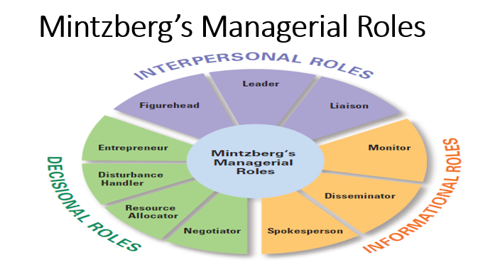

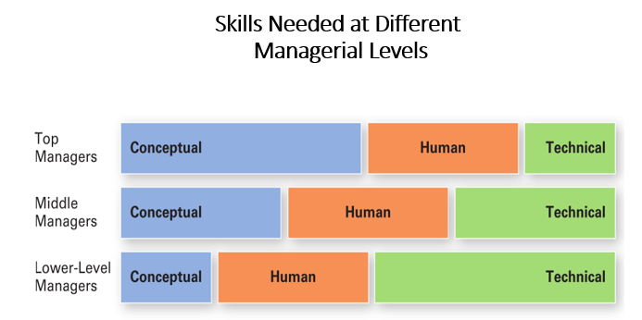

- 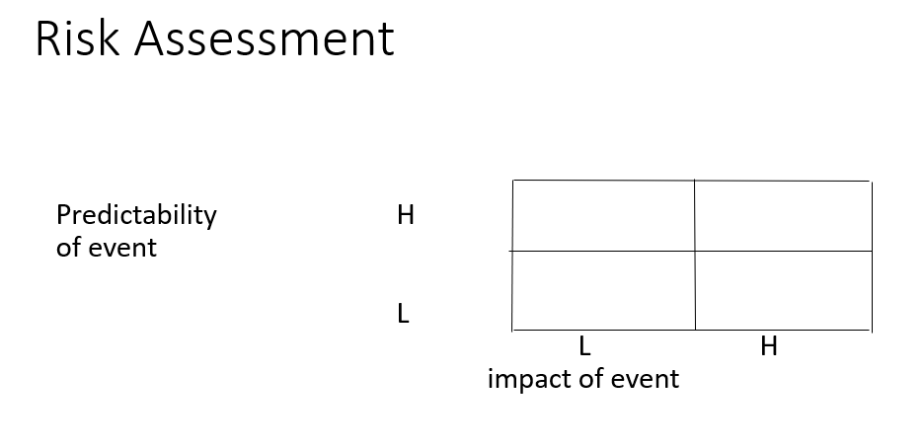Using a risk assessment table of x4 quadrants would indicate that the desired top and outer quadrant would be desired when a great effort applied with the impact of events was equally matched by agreater response rate from contacted prospects converting to clients.
- 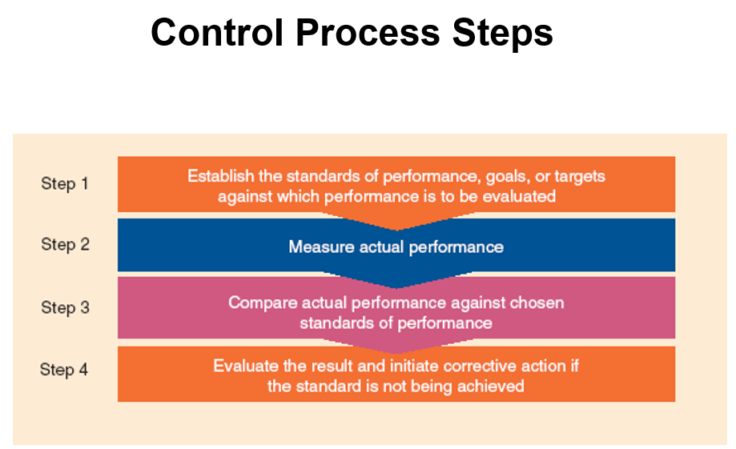Establish standards of performance, goals, or targets against which performance is to be evaluated.
  - Managers need to set their own standards in line with platform.

- Compare actual performance against chosen standards of performance
  - Managers evaluate whether – and to what extent – performance deviates from the standards of performance
chosen in step 1

BIBLIOGRAPHY
- Maund, A., Schreik, M. and Tinkler, P. (2017). Certificate in higher education: Skills for the workplace student yearbook. london: london, pp.181-201.

Page 3.
Page 4.
Page 5.
Page 6.
Page 7.

