Pinot Noir
Pinot noir is a red wine grape variety of the species Vitis vinifera. The name is a French derivative of ‘pine’ and ‘black’ that refers to the varietals’ tightly clustered purple pine, cone-shaped bunches of fruit.
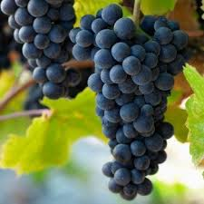
Pinot noir is chiefly associated with the Burgundy region of France. However, it is grown around the world and thrives in cooler regions. Other wine growing regions cultivating Pinot Noir include California, New Zealand, Argentina, South Africa and Australia. In California, some fine Pinot Noir wines can be found in the Sonoma Coast and Russian River Valley. In New Zealand, it is grown in Waipara, Marlborough and Central Otago. Tasmania in Australia with its cooler climate has also become well known for some outstanding Pinot Noir wines.
Pinot noir is an ancient variety that may be only 1-2 generations removed from wild vines. Ancient Romans cultivated it and referred to it as Helvenacia Minor. Later in France it gained its reputation in the Burgundy hillside slopes of Cote d’Or. The wines tend to be of a light to medium body with a bouquet hinting of black cherry, raspberry or currant. The grape’s colour when young is usually much lighter than that of other red wines. It is also used in the production of Sparkling wine by being blended with Chardonnay.
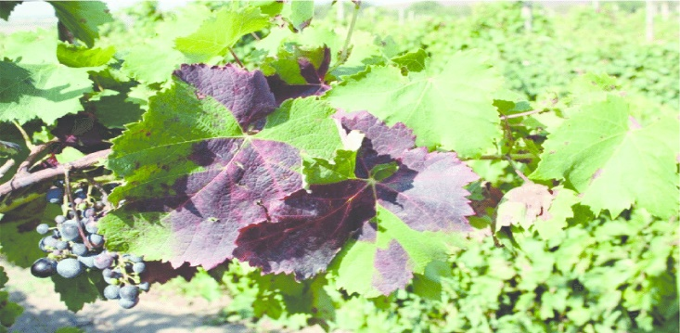
The Leaves of the Pinot Noir variety are generally smaller than those of Cabernet Sauvignon, but larger than those of Shiraz. The grape cluster is small and cylindrical, vaguely shaped like a pine cone. Pinot Noir has a thin skin which makes it highly susceptible to bunch rot and other fungal diseases. The vines themselves are prone to downy mildew, leaf roll, and fanleaf. These complications have given the grape the reputation of being difficult to grow. However, Pinot Noir wines are among the most popular in the world.

