Given the seeming paucity of the archaeological record alongside the very few truly hunter-gatherer groups today, to what extent can palaeoanthropologists ‘fully appreciate why and how humans evolved?’

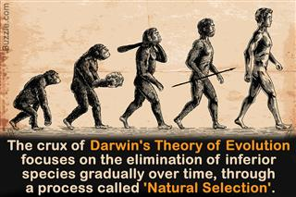

In this essay I will try to show, to what extent palaeoanthropologists can determine how and why humans evolved by looking at the archaeological evidence which is available to palaeoanthropologists today. Looking at how some modern hunter gatherer groups engage in activities today can also be useful in showing how hunter gatherer groups may have acted in the past. Although the archaeological evidence available is somewhat sparse, what is there does give adequate information for the palaeoanthropologist to appreciate how humans have evolved, from living in the trees like our great ancestors the apes, to what we have evolved in to today, modern humans. The archaeological evidence spans from single pieces of skeletons to more complete specimens which show variations of how we have adapted to the conditions we have encountered on this journey through evolution. By looking at the adaptations that have happened it should be possible to see what caused these to happen and why.
Even though Charles Darwin caused minor uproar and was for a time mocked for claiming that we have all evolved from apes in Africa, Darwin was eventually proved right. When Darwin made this suggestion, there were no specimens of our ancestors available for him to base these claims on but since then, many have been found. From the earliest hominoid specimen, Toumai which is the cranium from a Sahelanthropus tchadensis (Wolpoff et al 2005), to more modern-day examples of humans show the evolutionary progress which he put forward in his ‘Theory of Evolution and Natural Selection’ (Darwin 1859).
The archaeological record for the evidence of how humans evolved is very limited, what is there can indeed tell a great deal to palaeoanthropologists about how humans have evolved over several million years. Millions of years ago humans were just apes swinging around in the trees in Africa, but from there we have evolved into the modern-day human Homo sapiens. To see how we have developed from these early ancestors, the best way is to look at the archaeological evidence that is available today.
The earliest evidence available for us to start to find theses answers lies in the cranium of a Sahelanthropus tchadensis known as Toumai, which was found in 2001 by Michelle Brunet and his team in the western part of the Great Rift Valley in Africa, which has layers going back millions of years (Russo & Kirk 2003). This cranium shows the earliest evidence of bipedalism, an early trait which is one of many (brain size, cooking food, speech) that has been attributed to differentiating us from our distant cousins (Ward 2003). The cranium of Toumai is dated to around 6-7 MYA, which is the same period that it is thought we split from the chimpanzees and started on our own path. Examinations of this skull suggest that the anteriorly position of the foramen magnum, where the spine connects to the skull, suggests that this is the earliest example of bipedalism known and quite similar to that of Homo sapiens. The anterior position of the foramen magnum being often explained to be an adaptation for bipedal locomotion due to cervical vertebral column being able to balance the head atop during bipedalism (Russo & Kirk 2013:656). Without the receding back skull of a biped Toumai would be constantly looking down and not straight ahead if not bipedal.
There are 3 major Australopithecus afarensis sites that have been fundamental for our understanding of evolution and these are Maka in Ethiopia with finds from 4MYA (White et al 1993) Laetoli where in 1976, Mary Leakey found fossilised footprints, evidence of bipedal walking and Hadar, where in November 1974, forty percent of the skeleton of a 3.2 million-year-old Australopithecus, later to become known as Lucy was found (Falk 1992:126). This skeleton was of a 110cm fully grown adult who was found by Don Johansen and Maurice Taieb (Leakey 1994:30). Studying Lucy’s skeletal frame gave palaeoanthropologists an insight into how humans were evolving. There is no doubt that Lucy was knock kneed and walked upright, the skeleton, which was absent on Toumai, shows us this. Examination of the skeleton tells us that Lucy was well adapted to tree climbing due to her longer arms, as well as having a walking gait that is upright and bipedal just as it is in hominids. Adaptations in the pelvic girdle of Lucy also show evolutionary factors which are relevant to having a profound effect on bipedality (White et al 2011:270), with Lucy’s pelvis being much more similar to a human than chimpanzees, our closest living relative (Lieberman & Bramble 2006:288).
Studying the skeletons of these specimens help us understand about how they moved around, and it was long thought that bipedalism was fundamental in helping us to evolve in to what we are today. Other arguments on what helped us to evolve are such theories as cooking food, Richard Wrangham (2010) with his cooking hypothesis claims that, the ability of cooking our food before digesting it saved us energy so we could put the energy that would normally be used on digesting food into the expansion of our brain, also the benefits of cooking food were communal and that may of helped with speech (Wrangham 2010).
The arguments that brain size helped with our evolution is inconclusive as the discovery of Mary Leakey’s 3.5 million year old fossilized footprints that show that early hominids were walking upright before the growth of our brains expanded approximately 2 million years ago as shown in the evidence of Homo cerebral cortices that go back that far (Falk 1992:4).Looking at brain sizes of the examples available it is clear that it that bipedalism came before the expansion of the brain, with a chimpanzee having a brain size that is the third of a modern humans it was that our ancestors must have had bigger brains than chimps. With the use of endocasts to measure the brain, Toumai the earliest example had an estimated brain volume of 320-380 cubic centimetres (Nguyen 2011:38).
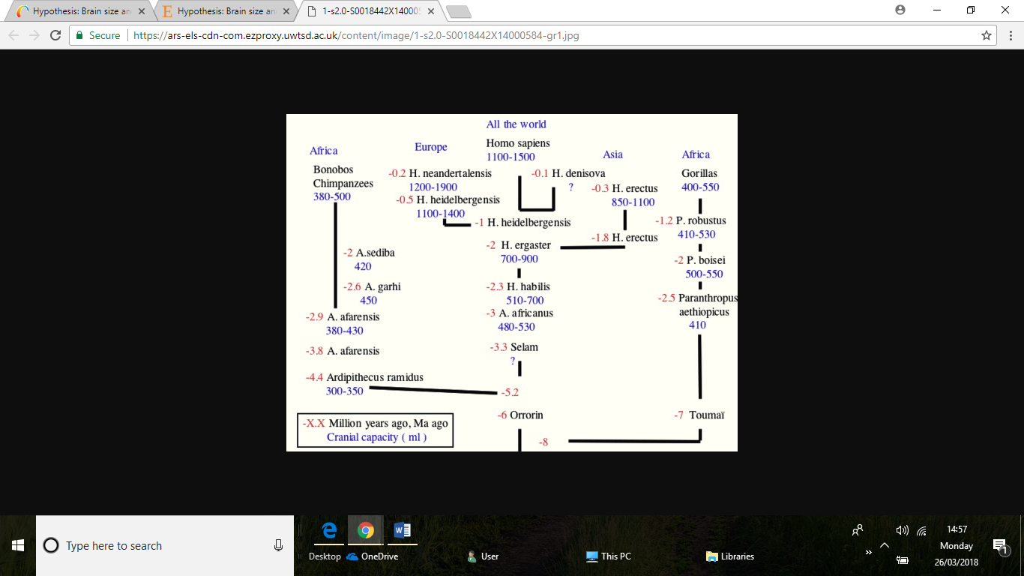
figure 1

It could be argued that brain size really started to explode around 2.3 million years ago with Homo habilis (the first of the homo genus) and this coincides with the fact that Homo habilis or Handyman as named by the Leakeys (Havilland 1974:164), was the first of our ancestors to make use of tools. Although there is an argument that stone tools have been found at Lomekwi 3 a site dating back 3.3 million years which could make Lucy our first toolmaker (Harmand et al 2015). The fossil record for homo habilis only spans for 400,000 years from 1.6 million to 2 million years ago before giving rise to homo erectus (Falk 1992:143). Homo habilis had dexterous hands which enabled him to make use of Oldowan tools that were found with them at Olduvai Gorge by the Leakey’s (Havilland 1974:164) they also had a larger brain sizes than any other genus found, 650-690 cubic centimetres which meant that there was a significant capacity for the processing of information over Australopithecines (Havilland 1974:165). However the body sizes of Homo habilis were very similar to that of Australopithecines being estimated at 100-120 centimetres tall (Will & Stock 2015:16).
Climate change was immense and happening at an alarming rate in east Africa 2 million years ago and this may have influenced the biggest changes to our lineage. Periods of climatic instability could have led to the evolution of humans. With those who could not adapt to this climatic period dying out, those who could problem solve adapted and survived.
The emergence of Homo ergaster being considered the next step in the evolution of humans at around 1.8 million years ago have major adaptive shift in size and stature 160-185 cm tall and weighing 50-70kg as opposed to the Homo habilis’s 20-37kg (Will & Stock 2015:16). Homo ergaster were very similar to modern day humans in physique and build and were known as the Working human, due to his more diverse and sophisticated use of stone tools. Homo ergaster had increased brain size to that of Homo habilis 700-900 cubic centimetres (see figure 1). A good example of a homo ergaster specimen is Turkana boy who was found at Lake Turkana in 1984 by Alan Walker and Kamoya Kimeu and is 1.6 million years old. Turkana boy was estimated to be 8-12 years of age when he died and he was already five feet, five inches (Falk 1992:145), he was also more like modern day humans in terms of stature with similar proportioned arms and legs to humans (Falk 1992:148) unlike Homo habilis.
Homo ergaster is thought to have split with some evolving into homo erectus in Africa and the others evolving into Homo heidelbergensis our common ancestor with Neanderthals. It is Homo heidelbergensis that modern humans Homo sapiens are considered to have descended from along with Neanderthals and Denisovans. Homo heidelbergensis is considered to have lived around 600,000 – 200,000 years ago.
Modern human fossils date back to 200-000 years and at this time we were not the only ones living on the planet, along with homo sapiens there were Neanderthals, Denisovans and the hobbit type people Homo floresiensis. Homo sapiens are the only ones left today though with Neanderthals dying out 40,000 years ago, the hobbit people dying out 12,000 years ago and evidence of Denisovans being present 41,000 years ago.
Looking at the skeletons of these individuals found and how they have adapted to living a life on the open savannah rather than in the trees like they were 10 million years ago, gives good information to the palaeoanthropologist about evolution. The shortening of our arms and the lengthening of our legs show how we adapted to a more bipedal way of life as the forests declined and we ventured out, the changing features of our skull, especially our teeth can give good insight into how our diets adapted from mainly eating fruit to a more meat-based diet. They show how our brains have adapted to the size they are now with endocasts showing how the different parts of our brain have evolved over time (Falk 1992).
The ontological study of the remains is vital in making us understand how humans have evolved. The fact that our brain grows outside the womb unlike chimpanzees show that we spend a longer time learning, we have a longer childhood than other living creatures. There is growing support for the theory that childhood has allowed us to become fully modern human. This stems from, when we are born only humans have a brain a fraction (1/4) of the size than its adult counterpart, chimpanzees and apes are expected to have a fully formed brain at age one (Begley 2004) whereby a human brain would only be 50% at age 1. Not only does this extended learning period benefit the child but it also benefits the care group due to involving more than just one parent, this way extended family such as grand parents become vital in helping care for the child (Crittenden & Marlowe 2006).
Looking at hunter gatherer tribes such as the Hadza show us how they care for their children with ‘allomothers’ who are not the biological mothers but other members of the group giving care for the children, this helps with the survivorship of the infant and a greater investment from all involved to help the child (Crittenden and Marlowe 2006). Things that are distinctly human in this respect is that human childhood is longer than an apes childhood and this has been related to brain size. Without prolonged childhood our brain would have to develop in the womb, and a fully-grown brain would not get through the birthing canal.

Hunter gatherers are also an important way to study how we run, with research into long distance running. Looking at the muscle and skeleton of modern day humans and hunter gatherers alike can show how once bipedalism had become mastered the next step how to run (Lieberman & Bramble 2007). Studies carried out by Lieberman and Bramble (2007), show that the human skeleton is actually more adapted to running than it is to walking. Muscles such as the expanded gluteus maximus which did not appear before the genus homo about 2 million years ago according to the fossil record, is most beneficial for running instead of walking (Lieberman & Bramble 2007:289). Lieberman, also states that humans are more adapted to running long distances than any other mammals on the planet and this is due to Homo being able to self-regulate their body temperature by sweating, which helped them hunt in hot conditions. Whereby animals can only run in burst of 10-15 minutes before overheating humans can run for hours enabling them to tire out the prey and thus overcoming it (Lieberman & Bramble 2007:289). Evidence suggest that it was 2 million years ago when the homo lineage’s eating habits started to change towards eating more meat than they had previously, which coincides with when we started to run more.

Discussion
Within this essay i have looked at cases where skeletal evidence has shown us clearly how we have adapted to bipedality from quadrupedality like our ancestors. There is a clear procession towards us walking more upright and our physique becoming larger, (apart from that of Homo floriensis who died out about 12,000 years ago), and morphologies within our bones which make us human like today. The archaeological evidence is quite clear and as long as we look at each specimen being a typical example of that genus then it is unbiased. Looking at endocasts has shown how the brain differs from our ancestors and has altered and grown over time. Although the evidence is quite sparse, with significant gaps in the timeline, being able to look at this evidence clearly shows the evolution of humankind.
To look at hunter gatherer tribes gives a good insight into how they live their lives, but they are their modern lives today that we are looking at. Ingold says that,
“Thus everyone of us is said to carry, as a fundamental part of our biopsychological make-up, a set of capacities and dispositions that originally arose as adaptations to hunting and gathering in Pleistocene environments (Ingold 2004:213)”.
But there are few truly hunter gatherer groups surviving who are similar to us, that have their own culture, once allowing the palaeoanthropologist to observe they will undoubtedly change their behaviour. The hunter gatherer may tell you they are a better hunter than they actually are, observing them may be the only way to get an accurate view of how they hunt, but surely the presence of an outsider will affect the way they carry out their duties. The climate was changing greatly when the Homo genus was first introduced so we would have had to have adapted quickly. Observing this from a static point in time does not give as much information as the archaeological record can give.
We are all said to carry some Neanderthal DNA but no one is really sure why they died out and we survived, we were very much alike. We even interbred with Neanderthals but they did not survive like we have. They walked upright like us but died out approximately 35-50,000 years ago (Trinkhaus & Shipman 1993:412). Could it be that as Wrangham (2010) cooking helped us on our way to being human with cooking going back as far as cutting meat (2.5 million years) (Wrangham 2010:103), it’s a nice idea that it could help with speech by cooking becoming a communal activity, and Homo gathered around the fire cooking. Many theories seem plausible, it is good that we recognise that these ‘ancestors’ were not as primitive as once thought and this gives the palaeoanthropologist a grounding for their theories.
It may be difficult to understand fully how we evolved but it is clear we evolved gradually over millions of years. We have adapted with the environments and this may have helped us become the last surviving species of Homo hedielbergensis. Whether or not we continue to adapt to this changing climate is yet to be seen. All theories are valid until proved otherwise.
References
Begley, S. 2004. Growing Up Homo Sapien: Big Leap in Human Evolution May Be Result of the Invention Of Childhood. Asian Wall Street Journal.
Crittenden A, & Marlowe, F. 2006. Allomaternal care among the Hadza of Tanzania. Human Nature. Vol 19 (3) pp249-262
Falk, D. 1992. Braindance: New Discoveries About Human Origins and Brain Evolution. Henry Holt. New York
Harmand, S; Lewis, J.E; Feibel, C.S; Lepre, C.J; Pray, S; Lenoble, A; Boes, X; Quinn, R.L; Brenet, M; Arroya, A; & Taylor, N. 2015. 3.3- Million-Year-Old Stone Tools from Lomekwi 3, West Turkana, Kenya. Nature 552. pp 310-315.
Ingold, T. 2004. Beyond Biology and Culture: The Meaning of Evolution in a Relational World. Social Anthropology. Vol 12 (2) pp 209-211
Lieberman, D.E & Bimble D.M. 2007. The Evolution Marathon Running: Capabilities in Humans. Sports Medicine. Vol 37 pp 288-290
Leakey, R. 1994. The Origin of Humankind. Phoenix. Guernsey
Russo, G.A; & Kirk, E.C. 2013. Foramen Magnum Position in Biped Mammals. The Journal of Human Evolution. pp656-670
Trinkaus, E & shipman, P. 1993. The Neandertals: Changing the Image of Mankind. JC. London
Ward, C. 2003. The Evolution of Human Origins. American Anthropologist. Vol 105 (1) pp 77-88
White, T.D. Black, M.T. & Folkens P.A. 2011. Human Osteology. Academic Press
Wolpoff, M.H; Hawks, J; B; Senut, B; Pickford, M; & Ahern, J. 2006. An Ape or The Ape: Is the Toumai Cranium TM 266 a Hominid. PalaeoAnthropology. pp36-50
Wrangham, R. 2010. Catching Fire: How Cooking Made us Human. Profile Books. London.
Will, M & Stock T.J. 2015. Spatial and Temporal Variation of Body Size Among Early Homo. Journal of Human Evolution. Vol 82 pp 15-33
Nguyen, K. 2011. https://books.google.co.uk/books?id=saMDq9eARUcC&lpg=PA45&ots=90HFW6tJaV&dq=toumai%20skull%20size&lr&pg=PA38#v=onepage&q=toumai%20skull%20size&f=false.
[accessed 23/3/2018]

Cover picture buzzle.com
Image 1 Chardin, P. 2014. Hypothesis: Brain Size and Skull Shape as Criteria for a New Hominin Family Tree. Vol 65 (5) pp 376-380

