

Engineering Skills Technical Report
Engineering Skills (ACHA4022A)

Lewis Cummings
2500612
December 2025
Contents
1 Introduction 3
2 Health And Safety With Risk Assessments 4
2.1 Brief 4
2.2 Health and Safety Related to an Engineering Process 4
2.2.1 Engineering Process - The Milling Machine 4
2.2.2 Specific Health And Safety Legislation - The Milling Machine 4
2.2.3 Risk Assessment 5
3 Security Risk Matrix 7
3.1 Brief 7
3.2 Possible Security Threats 7
3.3 Security Risk Matrix 7
3.4 Response To Risk 9
4 Engineers' Role In Society 10
4.1 Brief 10
4.2 Two different organisations with codes of conduct 10
4.3 Relevance to sustainability in motorcycle racing 10
5 Problem Solving 11
5.1 Brief 11
5.2 Problem Solving 11
5.3 Types Of Flow Charts 11
6 Team structure 13
6.2 Team structure 13
6.1 Alternative Team Structure 14
7 Conclusion 15
8 Reference List 16

No table of figures entries found.

Introduction
This report examines the key skills required across all areas of engineering, including motorcycle and motorsport. It emphasises Health and Safety while covering relevant laws and a Risk Assessment. In Chapter 3, the report explores vehicle security and uses a Security Risk Matrix to assess threats and current controls. In chapter 4, professional obligations are highlighted through the research and discussion of two different codes of conduct within respective Organisations, emphasising an engineer's responsibility towards the environment and the sustainability of motorcycle racing and the wider sport. In Chapter 5, the process for Problem Solving in a development team is detailed. Finally, Team Structures are analysed through personal reflection and the proposal of a researched alternative structure.

Health And Safety With Risk Assessments

Brief
This Chapter Explores a process carried out in the university workshops while studying, and the specific Health and Safety legislation that must be adhered to. This is followed by a risk assessment highlighting the risks involved and the PPE required to reduce the risk of Injury.

Health and Safety Related to an Engineering Process

Engineering Process - The Milling Machine
The chosen Engineering Process is Milling Machine. A mill is operated by a user to alter the dimensions of a material. There are many risks of injury when using a Mill, such as hair, clothing, or jewellery getting snagged in the machine, material being ejected (such as swarf), and the possibility of a snapped drill bit. The appropriate processes and legislation must be adhered to.

Specific Health And Safety Legislation - The Milling Machine
PUWER (1998) - The Provision and Use of Work Equipment Regulations require that all work equipment be safe to operate, a standard that must be met regardless of the equipment's origin, age, or condition. The regulations assign these responsibilities to employers and all entities that control the use of the equipment, such as equipment hire firms. (Health and Safety Executive,2024). PUWER also requires machines to be fitted with splash guards. This legislation is relevant to the Mill because it protects staff and students from injuries caused by mechanical faults due to poor maintenance. RIDDOR (Reporting of Injuries, Diseases and Dangerous Occurrences Regulations 2013) is the legal framework that requires employers and other duty holders to report and record specific serious workplace incidents, including fatalities, significant injuries, and near-misses. The goal is to collect and analyse this data to enhance overall workplace safety and prevent similar future accidents (Guzder K, 2019). This Legislation is relevant to the mill, as it is essential that any near misses or accidents do not recur to create a safer environment. PPE is another important piece of legislation to consider when looking at the milling machine. Under the Personal Protective Equipment at Work Regulations 1992, employers must provide suitable PPE at no cost to employees. They also need to ensure the PPE provides sufficient protection against recognised hazards. Workplace risks are kept under control. (McKinnon I,2025). This is highly relevant to the mill, as it greatly improves user safety with goggles, dustcoats, and Steel Cap Boots, which are essential for using the mill.

Risk Assessment

Hazard | Risk Level (Pre-Control) | Control Measures / Mitigation | Required PPE | Risk Level (Post-Control)
Entanglement (Hair, loose clothing, jewellery caught in spindle/cutter) | High | Secure long hair; remove jewellery; wear a fitted dustcoat; ensure the machine is stopped before measuring or adjusting. | Safety Goggles, Steel-Capped Boots, Fitted Dustcoat | Low
Projectile Swarf/Fragments (Eye/face injury from ejected metal chips) | Medium | Ensure the machine guard/splash shield is correctly positioned and closed; use the air gun only when the machine is completely stopped. | Safety Goggles (Mandatory), Fitted Dustcoat | Low
Cutter Contact (Severe laceration/amputation from contact with rotating tool) | High | Never place hands near the cutter during operation; keep hands clear of the traverse path; the emergency stop button is accessible. | Safety Goggles, Steel-Capped Boots | Medium
Material Ejection (Workpiece flying off due to improper clamping) | High | Ensure the vice is correctly tightened; confirm the vice is securely mounted to the table; check the material for secure retention before starting. | Safety Goggles, Steel-Capped Boots | Medium
Slips, Trips, Falls (Contact with oil or swarf on the floor) | Low | Clear up oil spills immediately; sweep up swarf regularly; do not wear open-toe footwear. | Steel-Capped Boots (Non-slip soles) | Low

Table 2.1 Risk Assessment

Security Risk Matrix

Brief
As modern vehicles evolve into highly connected, increasingly autonomous platforms, they present a large, complex security attack surface. Four realistic security threats facing the automotive industry were identified.

Possible Security Threats
The security of connected and automated vehicles faces threats from various complex sources. One significant risk is Remote In-vehicle Communication Compromise, in which hackers target vehicle networks such as CAN and Ethernet. They use methods such as sniffing to intercept data or spoofing to insert harmful data through masquerading or replay attacks (Nasscom Community, 2024). This endangers the integrity of network data, which is essential for safe operation. Another primary concern is Unauthorised OBD Access and ECU Tampering. Attackers gain physical access to the On-Board Diagnostics (OBD) port to connect to Electronic Control Units (ECUs) via the CAN network (Abdulmalik Humayed, 2023). This access allows them to inject harmful code, modify the ECU's memory to alter security keys, or reflash it with custom firmware (Blaese, 2025). These actions can modify vehicle behaviour. A further serious risk is the Supply Chain Attack on Safety-Critical Systems. In this case, an attacker compromises an external component, like software or hardware, which then infiltrates the central system (ICO, 2024). Since vehicles rely on many suppliers, a problem with a single component, such as an ECU, can give an attacker access to critical safety functions, such as braking and steering. This poses a direct threat to human life (José, 2025). The situation worsens because of the High Volume and Diversity of components in modern vehicles. They contain millions of lines of code from various Tier 1 and Tier 2 suppliers. Therefore, an attack on a small supplier can quickly spread malware to thousands of vehicles (Rizvi, Hepp and Jana, 2025). Additionally, relying on automation systems such as GPS and LiDAR introduces vulnerabilities. Hackers can manipulate open-access data to compromise vehicle safety and security (Islam et al., 2023).

Security Risk Matrix

 |  | IMPACT
 |  | INSIGNIFICANT | MINOR | MEDIUM | MAJOR | SEVERE
PROBABILITY | ALMOST CERTAIN | MEDIUM | MEDIUM | HIGH | CRITICAL | CRITICAL
PROBABILITY | LIKELY | LOW | MEDIUM | MEDIUM | HIGH | In-vehicle Communication Compromise (Spoofing/Sniffing CAN/Ethernet)
PROBABILITY | MODERATE | LOW | MEDIUM | MEDIUM | Supply Chain Attack (Compromise of third-party hardware/software components) | Unauthorised OBD Access / ECU Tampering (Physical access/firmware reflash)
PROBABILITY | UNLIKELY | VERY LOW | LOW | Sensor Manipulation / GPS Spoofing (Affecting autonomous control/navigation systems) | MEDIUM | MEDIUM
PROBABILITY | RARE | VERY LOW | VERY LOW | LOW | LOW | MEDIUM
Table 3.1 – Risk matrix
The highest risk, In-vehicle Communication Compromise, has a score of 20. It has a high likelihood of 4 due to easily exploited weaknesses, and a catastrophic impact of 5 on safety controls. Unauthorised OBD Access scores 15, with a medium likelihood of 3 but a catastrophic impact of 5 due to the potential for critical firmware updates. Supply Chain Attack also scores 15, with a catastrophic impact of 5 due to the possibility of fleet-wide malware spread. Its likelihood is medium at 3. Sensor Manipulation/GPS Spoofing scores 12, with a medium likelihood of 3 and a significant impact of 4, as it disrupts autonomous control.

Response To Risk
A multi-layered defence strategy to mitigate communication risks could be proposed, including implementing firewalls to isolate ECUs, using digital safes for secure key storage, applying digital fingerprints for message verification, and implementing a system to detect network anomalies.

Engineers Role In Society

Brief
Chartered Engineers must meet a high professional standard and follow a clear code of conduct. Two well-known organisations that provide these ethical guidelines are the Engineering Council (EngC) and the Institution of Mechanical Engineers (IMechE). These codes outline the basic responsibilities expected of all professional engineers.

Two different organisations with codes of conduct
IMECHE- The Institute of Mechanical Engineers publishes a code of conduct for its members. These can be roughly outlined as their “Four Principles” (Institution of Mechanical Engineers, 2023). The Code requires acting with skill and honesty. It also demands keeping knowledge up to date and refusing bribery. They should support sustainability “You, as an IMechE member, need to recognise the importance of socioeconomic and environmental factors by engaging responsibly with the environment”. (Global Immigration Help, 2023), This means balancing present needs with those of future generations and following all relevant laws. Lastly, engineers must lead in the fight against wrongdoing. (Ateson.com, 2025). Another Institution is the Engineering Council. They are similar to the IMechE, which has four key pillars in its code of conduct, highlighting that engineers should: maintain integrity by acting reliably and rejecting bribery. They should respect others' rights and privacy. Health, safety, and the public good must be their top priorities. They need to follow laws, protect the environment, “Maximise the public good and minimise both actual and potential adverse effects for their own and succeeding generations.” (Engc.org.uk, 2017) Being accurate and thorough means acting competently, managing risks, and presenting evidence honestly. Lastly, leadership involves promoting equality, raising public awareness, and addressing professional concerns. (Engineering Council Guidance for Institution Codes of Conduct, 2017)

Relevance to sustainability in motorcycle racing
The IMechE and Eng codes require engineers to support sustainability by balancing today’s needs with those of future generations. They also emphasise reducing negative environmental impacts. In motorcycle racing, this means designing powertrains with zero or low emissions, such as electric engines or sustainable fuels. It involves using lightweight materials, recycling, ensuring compliance with environmental standards, and managing waste properly throughout the product lifecycle to benefit the public.

Problem Solving

Brief
Engineers in industry regularly encounter unexpected problems during the development of new products. When a fault or issue arises, an engineering team must use robust, organised problem-solving methods to prevent recurrence and reduce delays. Two very effective methods are Root Cause Analysis (RCA) and the 8D (Eight Disciplines) approach.

Problem Solving
Root cause analysis (RCA) is a method for identifying and resolving problems. It helps identify the leading causes of an issue rather than just treating the symptoms. This approach involves looking into what happened and understanding the reasons behind it. The main aim is to stop the problem from happening again. (Latino, 2021) Using Root Cause Analysis (RCA) is a helpful process for an engineering team when they encounter an issue during new product development. It offers a clear, organised method for solving problems, ensuring the solution lasts. The 8D (Eight Disciplines) approach is a structured method for permanently solving problems. It begins with Planning and Teamwork (D0-D1). Next, it focuses on Problem Definition and Containment (D2-D3) to pinpoint the issue. After that, it conducts Analysis and Correction (D4-D6) to identify root causes and apply confirmed lasting solutions. The process ends with Prevention and Recognition (D7-D8), adjusting systems to prevent issues from recurring and recognising the team's work (ASQ, 2019). This is another approach that focuses on clarity and efficiency.

Types Of Flow Charts
“A fishbone diagram provides a structured way to think critically about a problem” (Athuraliya, 2025). A fishbone diagram offers a straightforward way to think critically about a problem rather than just addressing its symptoms. Whether you are troubleshooting a product defect, improving customer service, or fixing a workflow, a fishbone diagram helps you quickly and logically identify the root cause of the issue by simplifying the analysis. (Athuraliya, 2025) See Figure 5.1 for an example. A process flowchart is a visual tool that represents a business or engineering process. It shows a clear overview of how the process operates. It highlights the steps involved, the internal logic, and how various events can alter potential outcomes. See figure 5.2 for an example

Figure 5.1 – Fishbowl diagram (GeeksforGeeks, 2024)
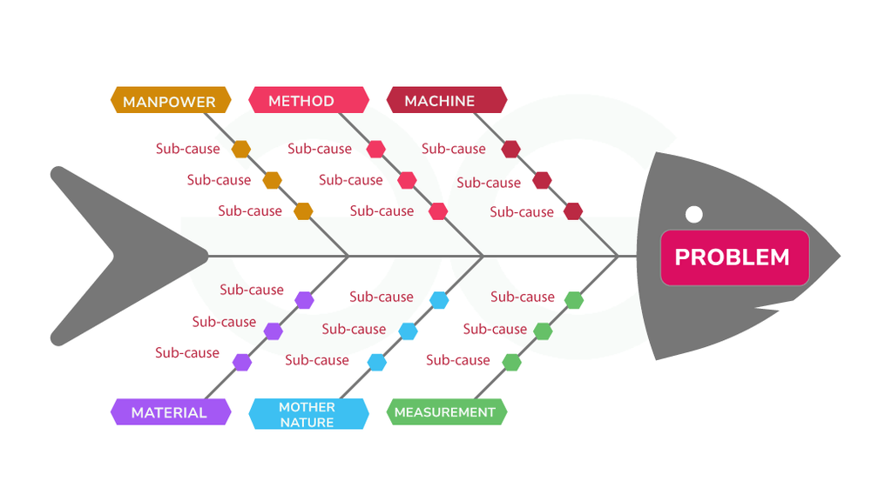
Figure 5.2 Example of Process Flow Chart (TQP, 2022)
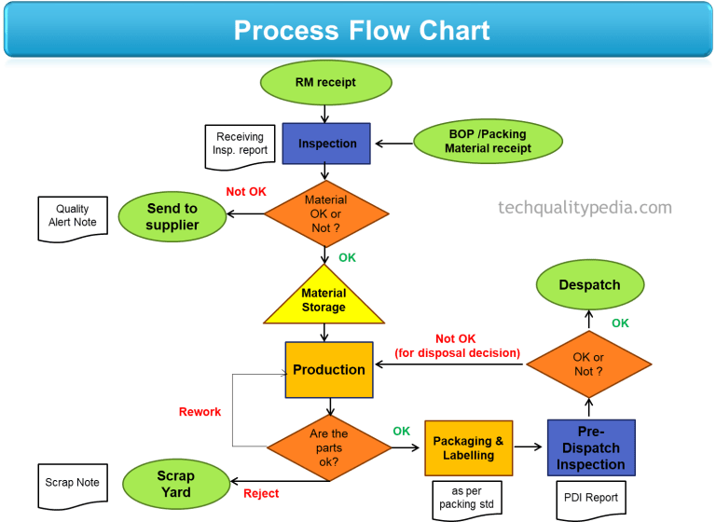

Team structure
My personal experience in applying the principles of effective teamwork comes from a high-pressure situation at a motocross event at Foxhills MX Park. I crashed hard in the first moto, causing significant damage to the bike. The handlebars, exhaust header and subframe were all affected. With just 45 minutes until the second race, our team of 4 people, consisting of me, my father and two friends, had to quickly and successfully make repairs.
Figure 6.1- Bent subframe (taken after race)
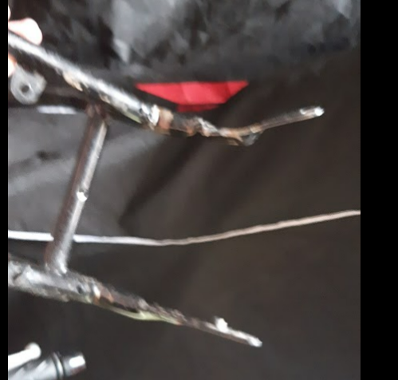

6.2 Team structure
We split into pairs to make the most of the 45-minute deadline. The first of the two groups, which included my father and me, worked on Chassis Integrity and Core Components. We inspected the frame and replaced the handlebars while realigning the front wheel. The second group, composed of two friends, focused on Structural Repair and Final Assembly. They fabricated the temporary subframe mount and conducted the final brake check and torque settings. This setup with clear roles lets us work on both critical and non-critical repairs simultaneously, helping restore the bike's safety and functionality promptly. The decentralised team structure improved speed and efficiency by enabling simultaneous execution of critical repairs, such as forks and subframes. This enabled quick root cause analysis and leveraged distributed expertise. However, this urgency sometimes led to rushing non-critical checks and created high stress. It also resulted in a "functional fix," such as a temporarily fixed subframe, needing immediate follow-up after the race.

Alternative Team Structure
An alternate structure. This format is the foundation for most organisational charts. It creates a transparent chain of command. Roles are arranged from the highest authority, which includes executives, down to directors, managers, and finally the rest of the team. (Team Asana, 2021). This has the advantage over the team structure used because it focuses on quality and safety. By requiring a complete Root Cause Analysis (RCA) first, the Team Leader ensures all damage is identified. The Lead Mechanic then verifies the fix, ensuring it is permanent and of high quality. This process avoids the risks and follow-up required with temporary solutions.
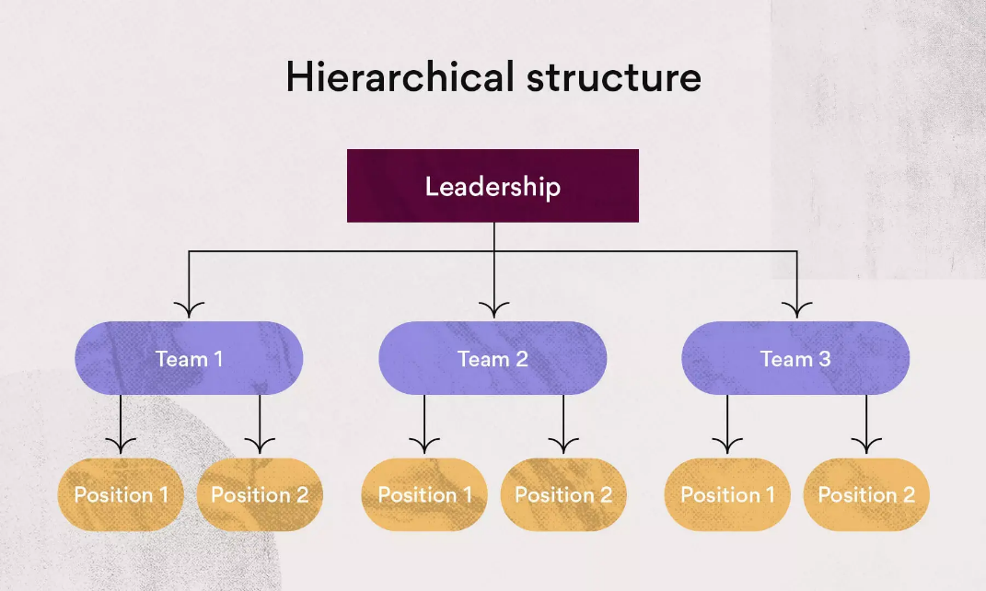
Figure 6.2- Example of Hierarchical structure (Team Asana, 2021)

Conclusion
This report confirms that engineering success depends on ethical discipline and organised analysis. Professionals must maintain integrity, focus on sustainability, especially in motorcycle racing, and protect future generations. Organised methods like RCA and 8D are essential for achieving lasting problem resolution and high product quality. Ultimately, effective team dynamics and strong leadership, whether emphasising speed or control, must support all technical and ethical responsibilities. This report also highlights the importance of health and safety legislation.

Reference List
AKT answer relating to health and safety law. (2014). InnovAiT Education and inspiration for general practice, 8(1), pp.e4–e4. doi:https://doi.org/10.1177/1755738014561380.
ASQ (2019). What is 8D? Eight Disciplines Problem Solving Process | ASQ. [online] Asq.org. Available at: https://asq.org/quality-resources/eight-disciplines-8d.
Ateson.com. (2025). Download: Code of Conduct Regulations - IMechE. [online] Available at: https://ateson.com/downloads/7518/code-of-conduct-regulations-imeche [Accessed 7 Dec. 2025].
Athuraliya, A. (2025). What Is a Fishbone Diagram? | Definition, Uses, Benefits & Templates | Creately. [online] Creately. Available at: https://creately.com/guides/what-is-a-fishbone-diagram/.
Blaese, C. (2025). How to Spot Tampering Around Your Car’s OBD Port - FotoLog. [online] Fotoolog.com. Available at: https://www.fotoolog.com/spot-tampering-around-your-cars-obd-port/ [Accessed 4 Dec. 2025].
Engc.org.uk. (2017). Guidance on ethical practices. [online] Available at: https://www.engc.org.uk/resources-and-guidance/guidance-for-the-profession/ethical-principles.
Engineering Council Guidance for Institution Codes of Conduct. (2017). Available at: https://iagre.org/kcfinder/upload/files/documents/EngC%20and%20SocEnv%20Codes%20of%20Conduct.pdf.
GeeksforGeeks (2024). Fishbone Diagram Cause and Effect. [online] GeeksforGeeks. Available at: https://www.geeksforgeeks.org/biology/fishbone-diagram-example-use/.
Global Immigration Help (2023). IMechE Code of Conduct.pdf. [online] SlideShare. Available at: https://www.slideshare.net/slideshow/imeche-code-of-conductpdf/255695176.
Health and safety Executive (2024). Introduction to machinery safety - HSE. [online] www.hse.gov.uk. Available at: https://www.hse.gov.uk/work-equipment-machinery/introduction.htm.
ICO (2024). Supply chain attacks. [online] ico.org.uk. Available at: https://ico.org.uk/about-the-ico/research-reports-impact-and-evaluation/research-and-reports/learning-from-the-mistakes-of-others-a-retrospective-review/supply-chain-attacks/.
Institution of Mechanical Engineers (2023). Code of Conduct explained - IMechE. [online] www.imeche.org. Available at: https://www.imeche.org/about-us/imeche-governance/governance-and-finance-reviews/code-of-conduct-explained.
Islam, T., Sheakh, Md.A., Jui, A.N., Sharif, O. and Hasan, M.Z. (2023). A review of cyber attacks on sensors and perception systems in autonomous vehicle. Journal of Economy and Technology, [online] 1(1), pp.242–258. doi:https://doi.org/10.1016/j.ject.2024.01.002.
José, L. (2025a). Connected Car Security: Automotive IoT Threats and Protection - Device Authority. [online] Device Authority. Available at: https://deviceauthority.com/connected-car-security-automotive-iot-threats-and-protection/.
José, L. (2025b). Connected Car Security: Automotive IoT Threats and Protection - Device Authority. [online] Device Authority. Available at: https://deviceauthority.com/connected-car-security-automotive-iot-threats-and-protection/.
Latino, B. (2021). A Beginners Guide To Root Cause Analysis (RCA) 2024 | Reliability. [online] reliability.com. Available at: https://reliability.com/resources/articles/beginners-guide-to-root-cause-analysis/.
Lifeenvironmental.co.uk. (2017). Is the release of asbestos reportable under RIDDOR? [online] Available at: https://www.lifeenvironmental.co.uk/news/article/is-the-release-of-asbestos-reportable-under-riddor [Accessed 4 Dec. 2025].
McKinnon, I. (2025). CHAS - Contractors’ Health and Safety Assessment Scheme. [online] CHAS. Available at: https://www.chas.co.uk/blog/ppe-at-work-regulations [Accessed 7 Dec. 2025].
Nasscom Comunity (2024). Cybersecurity for Automotive ECUs – An Introduction | Wire19. [online] Wire19. Available at: https://www.wire19.com/cybersecurity-for-automotive-ecus-an-introduction/ [Accessed 4 Dec. 2025].
Rizvi, A., Hepp, D. and Jana, P. (2025). Winning the automotive software development race. [online] McKinsey & Company. Available at: https://www.mckinsey.com/industries/automotive-and-assembly/our-insights/winning-the-automotive-software-development-race.
Team Asana (2021). Team Structure: 10 Effective Ways to Organize Your Team • Asana. [online] Asana. Available at: https://asana.com/resources/team-structure.
Guzder K, (2019). The Hub | High Speed Training. (2019). What is RIDDOR & Why Is It Important? | RIDDOR Guidance 2019. [online] Available at: https://www.highspeedtraining.co.uk/hub/what-is-riddor.
TQP (2022). Process flow chart in manufacturing | Symbols for process flow chart. [online] Tech Quality Pedia. Available at: https://techqualitypedia.com/process-flow-chart-in-manufacturing/.
.

