
Assignment 2
Learning in the Digital Era

19 December 2025
LONDON CAMPUS
UWTSD
Link A presentation on Self-Evaluation^J Professional Development Plan and Topic Summary (1).mp4
Module Name: Learning in the Digital Era
Module Code: ACCA 4025
Student Name: Gaddisa Abelt
Student ID:2516444
Lecturer’s Name: Dr. Fahad Ahmed
Group:3
Li

Table of Contents
Introduction 2
Main Body 2
Task_1. Self-evaluation 5
Task 2. PROFESSIONAL DEVELOPMENT PLAN 9
Task 3: Unit 4 Topic summary 12
Resilience 12
CONCLUSION 14
References 15

Introduction
This report presents a structured reflection on my learning journey throughout the Certificate of Higher Education in Computer Skills for the Workplace. Using Gibb's Reflective Model as a guiding framework, it critically examines my development across practical class activities, collaborative assessments, and individual tasks [1, pp. 644–668]. The analysis is grounded in a personal SWOT evaluation, which identifies key strengths such as being a quick learner, adaptable, and a self-motivated problem-solver, alongside acknowledged weaknesses in time management and a reluctance to seek support. Building on this self-assessment, the report outlines a targeted professional development plan and concludes with a summary of the vital topic of resilience, connecting theoretical insights to my own growth. Ultimately, this assignment serves not only to document skills acquired but to synthesize experience into actionable learning for future professional success.

Main Body
The main body applies Gibb's Reflective Model to analyses my experiences, detailing the practical skills gained and the emotional journey from initial anxiety to growing competence. It then transitions to a forward-looking professional development plan based on this analysis.

Video Link:
Slide 1 COVER PAGE
Slide 2 CONTENTS

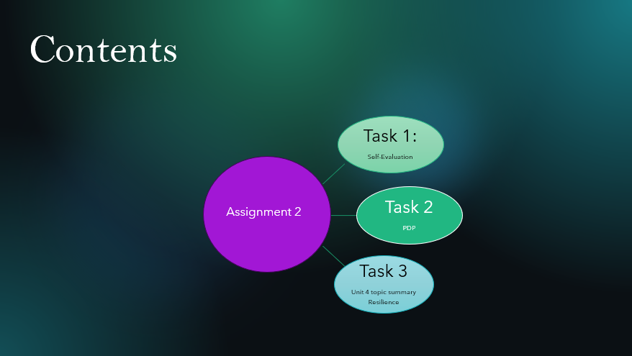

Slide 3 INTRODUCTION
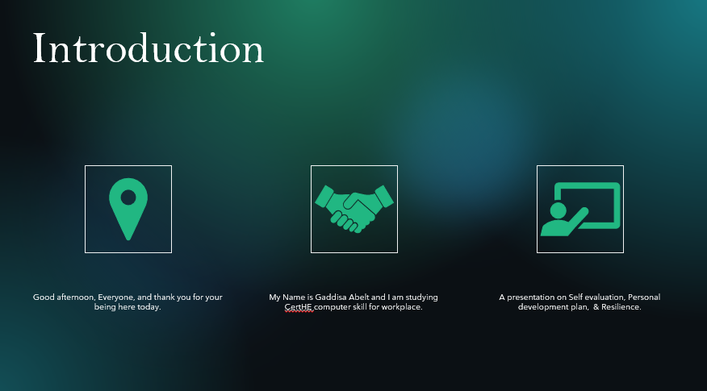

Slide 4 MAIN BODY

Task_1. Self-evaluation
Slide 5 GIBB’s REFLECTIVE MODEL
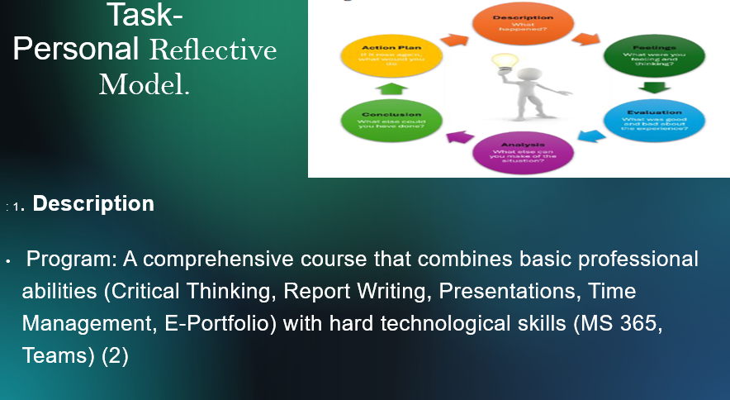

Personal Reflection on Class Activities and Assessments
- Description
I'm working toward a Certificate of Higher Education in Computer Skills for the Workplace with a career focus. The program's goal is to develop the core professional and digital skills needed in a contemporary office. My education is structured around real-world, hands-on application.
Technical Class Activities: Comprehensive, software-focused instruction in a computer lab using a "live demonstration then practice" approach. We use Teams, SharePoint, and Word, Excel, PowerPoint, Outlook, and other key Microsoft 365 apps as well as collaboration tools.
Professional Skills Modules: We learn and use essential workplace skills in addition to technical instruction. This includes using critical thinking and writing to analyses issues and explain solutions, writing reports for official documentation, managing time for individual productivity, making and delivering powerful presentations, and putting together an electronic portfolio to highlight our work and growth [1, pp. 644–668]

- Feeling
I was initially confident in my ability to master software, but I was interested in how "soft skills" like critical thinking would be taught. As I became proficient in Excel or PowerPoint, the technical labs were captivating and immediately fulfilling. However, because they needed more in-depth examination, I originally found the report writing and critical writing modules to be more intimidating. It was difficult but eventually satisfying to create my first official report. At first, creating the e-portfolio seemed overwhelming like an additional chore but as it expanded, it became a source of pride and a concrete documentation of my development. It was intimidating to present my work to the class, but it greatly increased my confidence thereafter.

- Evaluation
Good: The program's comprehensive integration of hard and soft skills is its strongest point. I received tangible tools from the technical labs, and the professional modules taught me how to use those resources wisely and efficiently. For instance, report writing taught me how to communicate the results of my data analysis, and critical thinking helped me choose which Excel function to employ. I was compelled by the e-portfolio to compile all my knowledge, resulting in a useful resource for job application.

Bad: Because we were practicing software, writing reports, and doing presentations all at once, the workload occasionally felt overwhelming. I had to learn how to integrate the skills on my own because the connections between the courses weren't always made clear at first. The program's requirements put time management skills to the test right away [1, pp. 644–668]

- Analysis
Because it mimics the interrelated demands of the actual workplace, this program structure is excellent. Excel is never used in a vacuum; you use it to solve problems (critical thinking), write reports for managers (report writing), and present the results (presentation skills), all while controlling your deadline (time management). The meta-skill of curating one's professional persona is the e-portfolio. The first sense of overwhelm was a part of the learning process; it reflected the strain of the profession and made the time management principles instantly applicable. I learned from the class that being digitally literate involves more than just understanding what a software button does; it also involves using it with purpose, effectively conveying the outcomes, and managing the process.

- Conclusion
In hindsight, I could have integrated the skills more proactively from the start. For instance, I could have used a critical thinking framework to plan my approach to a complex Excel project or used my report writing skills to document my process in a lab session. I should have viewed the e-portfolio not as a final assignment, but as a living document to update weekly, which would have made it less burdensome and more reflective. I also could have formed a study group using Teams to practice both the collaboration tools and peer review of reports and presentations.

- Action to be plan.
To strengthen and develop these abilities, I will:

Maintain the E-Portfolio: To show employers that I am a lifelong learner, I will continue to contribute projects to my e-portfolio after the course.
Apply the Integrated Model: I will intentionally use the integrated model in all future tasks, whether they involve work or additional study: define the problem (critical thinking), choose the appropriate digital tools (M365 skills), execute effectively (time management), document professionally (report writing), and effectively share results (presentation).
Seek Feedback: Seeing it as a cycle of ongoing growth, I will use the framework of the critical writing feedback to ask for helpful criticism on my professional work.
Teach Others: Sharing knowledge is one of the finest methods to solidify it. I'll seek for chances to reinforce my own expertise by explaining a software shortcut or a planning technique to a coworker.

Slide 6 TASK 1: SELF EVALUATION
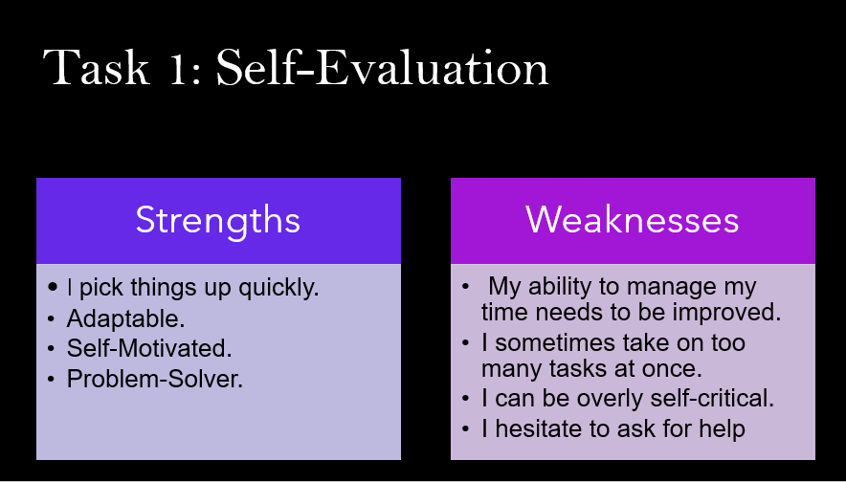
Slide 7 TRAITS GAINED FROM THE SELF EVALUATION
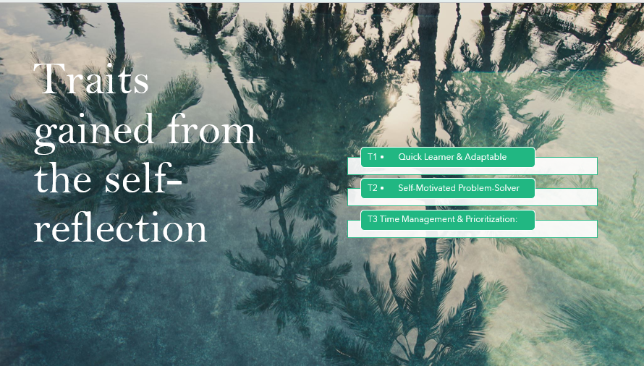
Brief Explanation: Based on my personal SWOT analysis, I have identified the following key strengths and areas for development that directly impact my academic and future professional performance [2, pp. 81–128]
Strengths:
- Quick Learner & Adaptable: I am adept at grasping new concepts and software tools efficiently, allowing me to adjust to new tasks and changing project requirements with agility.
- Self-Motivated Problem-Solver: I possess a strong drive to initiate tasks independently and a persistent, analytical approach to overcoming challenges and finding effective solutions.
Weaknesses:
- Time Management & Prioritization: My ability to plan and prioritize tasks needs improvement. I sometimes take on too many responsibilities at once, which can lead to inefficient workflow and undue stress.
- Reluctance to Seek Support: I can be overly self-critical and hesitate to ask for questions or delegate, which may slow progress or prevent me from benefiting from collaborative insights.

Task 2. PROFESSIONAL DEVELOPMENT PLAN
Slide 8
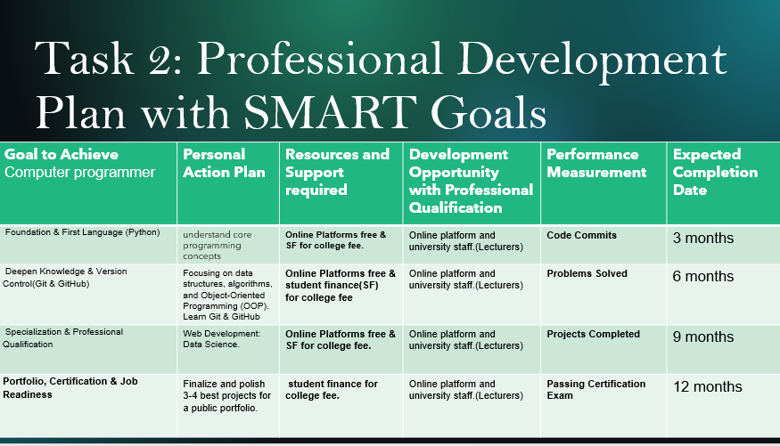
  - Foundation & First Language (Python) Objective: Gain an understanding of fundamental programming ideas.
How: Because Python is so versatile and easy to read, start with it. Study functions, loops, conditionals, variables, and syntax.
Resources: If tuition is paid, use organized college classes and free online resources like Code Academy and free Code Camp to learn programming.
  - Expand the Concepts of Version Control (Git & GitHub)
Objective: Become proficient in collaboration tools and intermediate programming.
How: To build effective code, learn the fundamentals of data structures (lists, trees) and algorithms (searching, sorting). To organize more complex tasks, learn Object-Oriented Programming (OOP). Learn GitHub and Git at the same time to track code changes and work together.
Resources: Keep using university classes and online resources.
  - Certification, Portfolio, and Employment Readiness
Objective: Showcase abilities to potential employers.
4. How: Create a public portfolio (e.g., on GitHub) with three to four well-executed projects from your area of expertise. To verify your knowledge, get the necessary certifications from organizations like the Python Institute and AWS.
Resources: Exam preparation from platform courses; project comments from instructors and online communities.
5. SMART Goals in a Professional Development Plan
Objective: Develop a long-term, practical career plan.
How: Make SMART (Specific, Measurable, Achievable, Relevant, Time-bound) goals. For example: * "Within 6 months, build a full-stack web app using Django and React, document it on GitHub, and apply to 5 junior developer roles.
Support: Make use of this plan to direct your education and ask mentors and university personnel for specific guidance [3]

Task 3: Unit 4 Topic summary

Resilience
Slide 9 UNIT 4 TOPIC SUMMARY
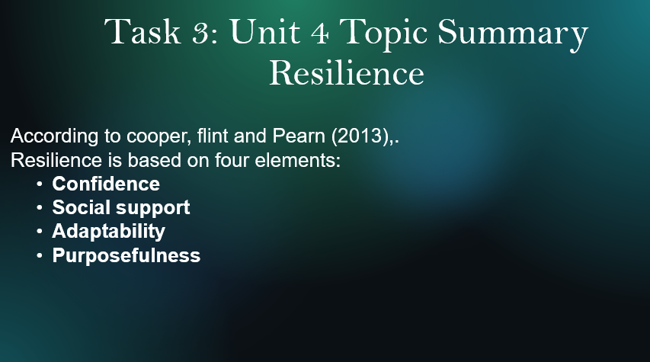
Developing Resilience
In our opinion, the best course of action is for organizations to integrate resilience-building into an overall well-being or change management strategy. Here, we address the two primary elements of such a strategy: individual resilience focused training and development, and broader organizational strategies including effective management techniques that support resilience. High levels of workforce resilience are more important than ever to guarantee long term success and wellbeing for both individuals and their companies, particularly when combined with ever increasing performance demands [4, pp. 145–163]
- Identify the personal skills and qualities that contribute to resilience.
• Understand the importance of resilience as a critical employability skill.
• Define resilience as the personal quality that enables individuals to adapt to adversity and overcome difficult situations.
• Explain how resilience allows people to maintain emotional balance during stress, which can also serve as a protective factor against certain mental health challenges.
• Describe how high resilience enables individuals to not just recover from trauma, but to grow from it emerging stronger, more capable, and wiser [4, pp. 145–163]

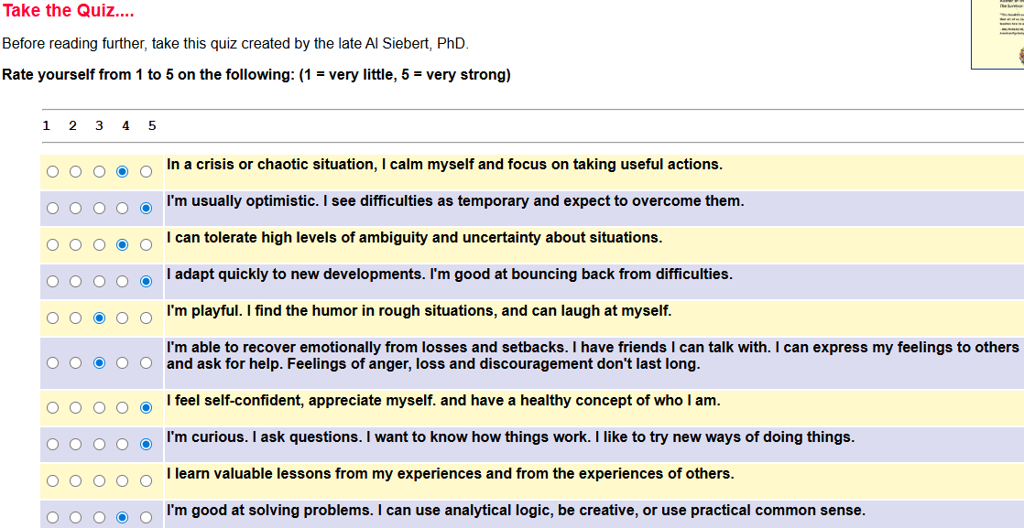

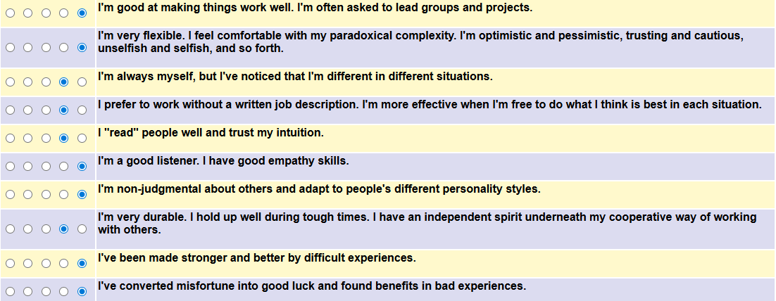

I am surprised for my results on the all the time I see the difficulties as a temporary.
According to cooper, flint and Pearn (2013), resilience is based on four elements:
- Confidence
- Social support
- Adaptability
- Purposefulness

- Confidence
  - Is all about doing what you think is right despite opposition.
  - Self-confidence is an essential part of resilience; however, it is not easy to build.
- Social support
  - It is about building positive relationships with others and seeking support and help from them in dealing with challenges.
- Adaptability
  - It is about
    - understanding your failures
    - Reflecting on them
    - Being open to new ideas and situations
    - Finding the ways to complete difficult tasks rather than give up.
    - According to Dr Cal Crow (2020) Resilient people are introspective. They are making positive change where necessary.[5, pp. 1–15]
- Purposefulness
  - According to psychologist Susan Kobasa and Dr Cal Crow, resilient people are committed to both their lives and goals, which drives them to succeed and gives them a true sense of purpose.

CONCLUSION
Slide 10 CONCLUSION

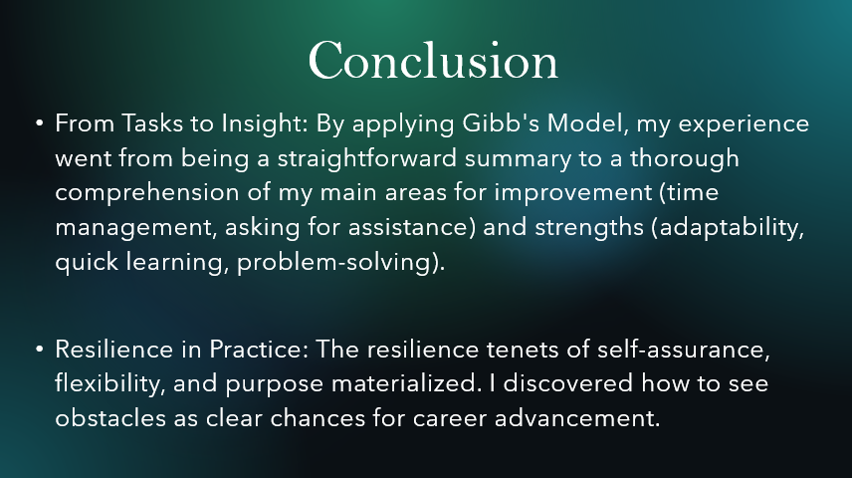

In conclusion, this reflective assignment has provided a meaningful framework to synthesize my educational experiences and self-awareness into a clear blueprint for growth. By applying Gibb's Reflective Model, I moved beyond simply recounting tasks to understanding how my core strengths adaptability, quick learning, and self-motivated problem-solving enabled me to navigate the technical and collaborative demands of the course. Concurrently, this process honestly confronted my developmental areas, particularly time management challenges and hesitation to ask for help, revealing how these can impact efficiency and learning.
The integration of the unit on resilience provided a powerful lens through which to view this journey. The traits of confidence, adaptability, and purposefulness are no longer just theoretical concepts but are directly connected to my own practice of turning challenges into opportunities for development. This reflection confirms that professional competency is a continuous cycle of action, evaluation, and adaptation. Moving forward, I am equipped with not only enhanced digital skills but also a deeper understanding of how to leverage my strengths and proactively address my weaknesses, ensuring I build both the technical proficiency and the personal resilience required for a dynamic workplace.

References

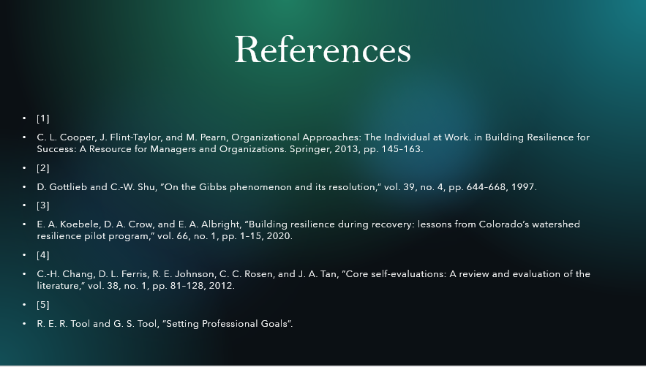

[1]
C. L. Cooper, J. Flint-Taylor, and M. Pearn, Organizational Approaches: The Individual at Work. in Building Resilience for Success: A Resource for Managers and Organizations. Springer, 2013, pp. 145–163.
[2]
D. Gottlieb and C.-W. Shu, “On the Gibbs phenomenon and its resolution,” vol. 39, no. 4, pp. 644–668, 1997.
[3]
E. A. Koebele, D. A. Crow, and E. A. Albright, “Building resilience during recovery: lessons from Colorado’s watershed resilience pilot program,” vol. 66, no. 1, pp. 1–15, 2020.
[4]
C.-H. Chang, D. L. Ferris, R. E. Johnson, C. C. Rosen, and J. A. Tan, “Core self-evaluations: A review and evaluation of the literature,” vol. 38, no. 1, pp. 81–128, 2012.
[5]
R. E. R. Tool and G. S. Tool, “Setting Professional Goals”.

