ENGINE PERMONANCE
CHARACTERISTICS

BEng Engineering
VEHICLE TECHOLOGY (M4X00394)

BILAL MOHAMED AHMED


Contents

1.0 INTRODUCTION 2
1.1 Experiment setup 3
2.0 Formulation and calculation 4
3.0 RESULTS AND ANALYSIS 8
4.0 CONCLUSION 12
5.0 EVALUATION 12
REFERENCES 13

1.0 INTRODUCTION

An internal combustion engine, explosion engine is a type of machine that obtains mechanical energy directly from the chemical energy of a fuel burning inside the combustion chamber. The name is because such combustion occurs within the machine itself.
When the fuel mixed with oxygen in the engine burns an explosion occurs that moves the piston causing the vehicle to advance.

1.1 Experiment setup

Use of an engine dynamometer to measure standard engine variables such as torque, engine speed, time for fuel consumption, ignition timing, manifold pressure and indicated power.
Calculation and plotting of engine variables such as engine power, engine torque, SFC, thermal efficiency and volumetric efficiency against engine speed.
Calculation of BMEP and IMEP, from engine reading and hence calculation of mechanical efficiency.
Engine:
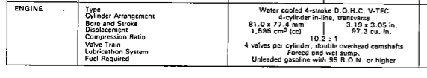
(Source: Honda VTEC Manual 1.6)
Dynamometer:
SCHENNCK; Eddy-Current
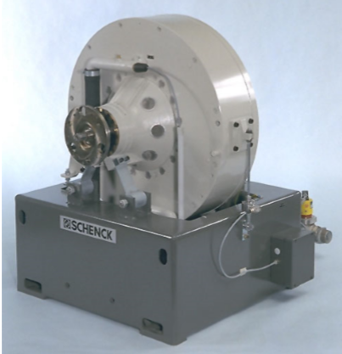
Dynamometer W Series (2001-05-01)
- How it works.

The test specimen, generally a combustion engine, drives the dynamometer. The dynamometer absorbs the power and transforms it into heat energy. The test stand controller x-act controls observance of speed and desired torque. For the test specimen, this can be carried out via a throttle position control unit.

2.0 Formulation and calculation

Where 2πR is the distance in a circular motion (circumference) and W is the load on the engine i.e the force.
- So in engine terms (circular motion) the formula becomes:
$$T=WR$$
Where T = Torque produced by the engine (Nm)
W = Engine Load (N)
R = Radius at which the load acts (m)
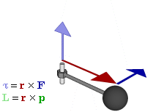
- So now Work done per engine revolution = 2πR and Power = Work done per second.
By equating those formulas;
$$P(BP)=\frac{2πNT}{60}$$

Where N = Engine speed (r/m)
P = Power developed at the engine (w)

- Power correction for varying atmospheric conditions.
To enable tests to be carried out under different atmospheric conditions to be compared a correction factor is used to modify the actual power figures obtained. Although this is an accepted European practice (DIN Standard 70020) it does not have any absolute validity as some engines may not respond to atmospheric changes in this way.
Engine power output is affected by air charge density (hence why your car might feel quicker on a cool crisp morning compared with a warm humid afternoon) and by the flow conditions into the engine. The flow conditions are affected by the Mach number (speed of charge flow relative to the speed of sound) The power correction factor used is given by:
Power Correction Factor = Air density factor x Mach number factor
Which, when simplified gives a factor of:
$$\frac{P_{S}}{P}=\frac{1.01325}{P_{a}}\sqrt{\frac{T_{a}}{293}}$$
Where PS = The corrected power (N)
P = Measured power (N)
$P_{a}$ = Ambient pressure (pa)
$T_{a}$ = Ambient temperature
1.01325 is standard pressure in bar
293 is standard temperature in Kelvin

- Specific Fuel Consumption (SFC)
SFC is measured in kilograms of fuel used per kilowatt hour (kg/kWh) and is an important measure of an engines efficiency in producing power. It enables the designer to determine the best operating conditions for the engine as well as estimating the running costs of the vehicle. Although it rarely quoted for passenger cars it is widely used by truck engineers where the cost of carrying a given load is critical.
$Indicated SFC=\frac{M}{IP}$ $Brake SFC=\frac{M}{IP}$
Where M = Mass of fuel used per hour (kg)
IP = Indicated power (kW)
BP = Brake power (kW)

Now we calculate S.F.C
$$S.F.C=\frac{V×0.75×3600}{t×1000×BP}$$

You need to take care here with the units. Your volumetric flow rate is in l/min.
- Convert this into kg/min by multiplying by the specific gravity of fuel .
(Esso Unleaded Premium ULS Motor Gasoline; BS EN 228: 2008 ; 0.738 specific gravity
- Convert this into kg/hour by multiplying by 60.
- Divide this by the brake power in kW.
- This will give you SFC in kg/kWh.

- Calculation of the engine Capacity (Piston area).
Engines come in varying sizes; the larger the engine the more fuel it can burn in one engine cycle. The size of the engine is known as its capacity and is measured in either litres or cc.
Calculation of the capacity of the engine can be performed using a small amount of data from the engine measurements.
The area of your bore/cylinder can be calculated using the simple formula for the area of a circle:$$A=\frac{πd^{2}}{4}$$
Where d is the diameter of the cylinder bore and can be measured by hand. The distance the piston travels up and down the bore is called the stroke and is represented by the letter ‘l’, this can also be measured by hand. The engine capacity is calculated using the following formula:
$$Engine Capacity =\frac{πd^{2}}{4}x L x 4$$
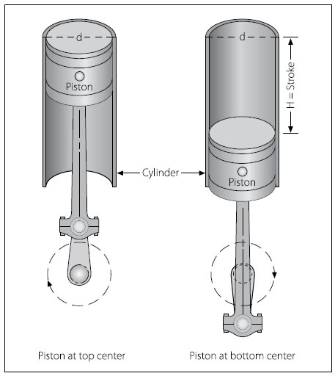
Figure 2 (Bore and Stroke)

- Calculate the B.M.E.P by rearranging the formula.

$$BP=\frac{B.M.E.P ×L×A×N×n}{60×2}$$

- Calculate Break Thermal Effiency.

$$η_{t}=\frac{(BP/1000)}{S.F.C (\frac{kg}{sec})×C.V}$$

Where C.V = (Esso Unleaded Premium; BS EN 228) 44.31 KJ/kg

3.0 RESULTS AND ANALYSIS

After Finishing with all calculations we get the following table:
 |  | Calorific value fuel | Baro | Humidity | Ambient temp | Radius of the torque arm | Specific petrol gravity | Piston Area
 |  | kj/kg | mBar | % | Deg C | m | ms-2 | m
 |  | 44.31 | 1025 | 39.79 | 24 | 0.8158 | 0.739 | 0.000433
Load | Dyno Speed | Fuel Flow Rate | Lambda | Torque | Power | Corrected power (BP) | S.F.C | B.M.E.P | B.T.E
Newtons | rpm | l/min | Lambda | Nm | Kw | Kw | kg/kWh | Pa
110.792 | 1000 | 0.070 | 1.348 | 90.381 | 9.465 | 9.424 | 0.331 | 8063.623 | 0.549
111.063 | 1050 | 0.072 | 1.342 | 90.602 | 9.962 | 9.919 | 0.324 | 8083.350 | 0.564
111.539 | 1100 | 0.074 | 1.333 | 90.991 | 10.481 | 10.436 | 0.313 | 8118.038 | 0.585
112.170 | 1150 | 0.073 | 1.323 | 91.506 | 11.020 | 10.972 | 0.294 | 8163.958 | 0.626
112.938 | 1200 | 0.074 | 1.309 | 92.132 | 11.578 | 11.528 | 0.286 | 8219.826 | 0.648
113.884 | 1250 | 0.079 | 1.291 | 92.903 | 12.161 | 12.109 | 0.289 | 8288.667 | 0.647
114.983 | 1300 | 0.079 | 1.269 | 93.800 | 12.770 | 12.715 | 0.275 | 8368.696 | 0.686
116.186 | 1350 | 0.080 | 1.241 | 94.781 | 13.399 | 13.342 | 0.265 | 8456.219 | 0.721
117.338 | 1400 | 0.084 | 1.222 | 95.721 | 14.033 | 13.973 | 0.265 | 8540.039 | 0.727
118.577 | 1450 | 0.085 | 1.208 | 96.732 | 14.688 | 14.625 | 0.257 | 8630.229 | 0.758
119.670 | 1500 | 0.089 | 1.201 | 97.624 | 15.335 | 15.269 | 0.257 | 8709.803 | 0.764
120.585 | 1550 | 0.093 | 1.201 | 98.370 | 15.967 | 15.898 | 0.260 | 8776.413 | 0.762
121.357 | 1600 | 0.096 | 1.206 | 98.999 | 16.588 | 16.516 | 0.257 | 8832.549 | 0.774
121.978 | 1650 | 0.099 | 1.212 | 99.507 | 17.193 | 17.120 | 0.256 | 8877.792 | 0.783
122.465 | 1700 | 0.100 | 1.225 | 99.904 | 17.785 | 17.709 | 0.251 | 8913.220 | 0.803
122.903 | 1750 | 0.103 | 1.236 | 100.261 | 18.374 | 18.295 | 0.250 | 8945.089 | 0.808
123.391 | 1800 | 0.109 | 1.243 | 100.659 | 18.974 | 18.892 | 0.257 | 8980.597 | 0.790
123.977 | 1850 | 0.114 | 1.245 | 101.137 | 19.593 | 19.509 | 0.259 | 9023.244 | 0.785
124.681 | 1900 | 0.117 | 1.244 | 101.712 | 20.237 | 20.150 | 0.258 | 9074.544 | 0.792
125.468 | 1950 | 0.121 | 1.244 | 102.354 | 20.901 | 20.811 | 0.257 | 9131.822 | 0.802
126.314 | 2000 | 0.126 | 1.242 | 103.044 | 21.581 | 21.489 | 0.259 | 9193.382 | 0.801
127.224 | 2050 | 0.128 | 1.237 | 103.786 | 22.280 | 22.184 | 0.256 | 9259.582 | 0.818
128.165 | 2100 | 0.131 | 1.232 | 104.554 | 22.993 | 22.894 | 0.254 | 9328.102 | 0.830
129.060 | 2150 | 0.134 | 1.225 | 105.284 | 23.704 | 23.602 | 0.252 | 9393.231 | 0.840
129.835 | 2200 | 0.138 | 1.214 | 105.916 | 24.401 | 24.296 | 0.251 | 9449.617 | 0.849
130.413 | 2250 | 0.141 | 1.204 | 106.388 | 25.067 | 24.959 | 0.251 | 9491.728 | 0.855
130.775 | 2300 | 0.145 | 1.201 | 106.683 | 25.695 | 25.585 | 0.251 | 9518.047 | 0.855
130.955 | 2350 | 0.150 | 1.200 | 106.830 | 26.290 | 26.177 | 0.254 | 9531.162 | 0.847
131.048 | 2400 | 0.154 | 1.197 | 106.906 | 26.868 | 26.753 | 0.255 | 9537.942 | 0.845
131.112 | 2450 | 0.156 | 1.192 | 106.958 | 27.441 | 27.323 | 0.253 | 9542.582 | 0.853
131.131 | 2500 | 0.160 | 1.186 | 106.973 | 28.005 | 27.885 | 0.254 | 9543.920 | 0.849
131.081 | 2550 | 0.163 | 1.181 | 106.933 | 28.555 | 28.432 | 0.254 | 9540.351 | 0.849
130.936 | 2600 | 0.168 | 1.180 | 106.814 | 29.082 | 28.957 | 0.257 | 9529.734 | 0.836
130.686 | 2650 | 0.171 | 1.176 | 106.610 | 29.585 | 29.458 | 0.258 | 9511.534 | 0.832
130.396 | 2700 | 0.175 | 1.173 | 106.374 | 30.076 | 29.947 | 0.259 | 9490.478 | 0.828
130.051 | 2750 | 0.178 | 1.171 | 106.092 | 30.552 | 30.421 | 0.260 | 9465.319 | 0.822
129.711 | 2800 | 0.180 | 1.172 | 105.815 | 31.027 | 30.893 | 0.258 | 9440.606 | 0.824
129.394 | 2850 | 0.183 | 1.170 | 105.556 | 31.503 | 31.368 | 0.259 | 9417.498 | 0.821
129.080 | 2900 | 0.188 | 1.167 | 105.300 | 31.978 | 31.841 | 0.262 | 9394.658 | 0.810
128.771 | 2950 | 0.193 | 1.162 | 105.048 | 32.452 | 32.312 | 0.264 | 9372.175 | 0.801
128.520 | 3000 | 0.199 | 1.155 | 104.843 | 32.937 | 32.796 | 0.269 | 9353.886 | 0.785
128.467 | 3050 | 0.206 | 1.147 | 104.800 | 33.473 | 33.329 | 0.274 | 9350.049 | 0.770
128.680 | 3100 | 0.210 | 1.138 | 104.974 | 34.078 | 33.931 | 0.274 | 9365.573 | 0.770
129.074 | 3150 | 0.216 | 1.126 | 105.295 | 34.733 | 34.584 | 0.277 | 9394.212 | 0.765
129.473 | 3200 | 0.218 | 1.112 | 105.621 | 35.394 | 35.242 | 0.274 | 9423.297 | 0.776
129.896 | 3250 | 0.223 | 1.102 | 105.966 | 36.064 | 35.909 | 0.275 | 9454.078 | 0.775
130.363 | 3300 | 0.226 | 1.089 | 106.347 | 36.751 | 36.593 | 0.273 | 9488.070 | 0.784
130.798 | 3350 | 0.229 | 1.079 | 106.702 | 37.432 | 37.271 | 0.272 | 9519.742 | 0.790
131.215 | 3400 | 0.234 | 1.069 | 107.042 | 38.112 | 37.948 | 0.274 | 9550.076 | 0.788
131.575 | 3450 | 0.236 | 1.062 | 107.336 | 38.779 | 38.612 | 0.271 | 9576.306 | 0.797
131.860 | 3500 | 0.242 | 1.054 | 107.568 | 39.426 | 39.256 | 0.273 | 9597.005 | 0.793
132.020 | 3550 | 0.245 | 1.051 | 107.699 | 40.038 | 39.865 | 0.273 | 9608.692 | 0.794
132.027 | 3600 | 0.255 | 1.048 | 107.704 | 40.603 | 40.429 | 0.280 | 9609.138 | 0.775
131.902 | 3650 | 0.258 | 1.044 | 107.602 | 41.128 | 40.951 | 0.279 | 9600.038 | 0.777
131.653 | 3700 | 0.264 | 1.042 | 107.399 | 41.613 | 41.434 | 0.283 | 9581.927 | 0.764
131.332 | 3750 | 0.265 | 1.040 | 107.137 | 42.073 | 41.892 | 0.281 | 9558.552 | 0.769
130.907 | 3800 | 0.269 | 1.038 | 106.791 | 42.496 | 42.313 | 0.282 | 9527.682 | 0.762
130.350 | 3850 | 0.274 | 1.039 | 106.336 | 42.872 | 42.687 | 0.284 | 9487.088 | 0.753
129.694 | 3900 | 0.276 | 1.042 | 105.801 | 43.210 | 43.024 | 0.284 | 9439.357 | 0.749
129.037 | 3950 | 0.283 | 1.045 | 105.265 | 43.542 | 43.355 | 0.289 | 9391.536 | 0.733
128.423 | 4000 | 0.285 | 1.047 | 104.764 | 43.883 | 43.695 | 0.289 | 9346.837 | 0.731
127.832 | 4050 | 0.287 | 1.048 | 104.282 | 44.227 | 44.037 | 0.289 | 9303.834 | 0.726
127.299 | 4100 | 0.289 | 1.048 | 103.847 | 44.587 | 44.395 | 0.289 | 9265.025 | 0.725
126.844 | 4150 | 0.293 | 1.048 | 103.476 | 44.969 | 44.776 | 0.290 | 9231.925 | 0.718
126.404 | 4200 | 0.295 | 1.047 | 103.117 | 45.353 | 45.158 | 0.290 | 9199.895 | 0.717
126.034 | 4250 | 0.297 | 1.045 | 102.815 | 45.759 | 45.562 | 0.289 | 9172.952 | 0.716
125.705 | 4300 | 0.302 | 1.042 | 102.547 | 46.176 | 45.978 | 0.291 | 9149.041 | 0.708
125.313 | 4350 | 0.306 | 1.039 | 102.227 | 46.567 | 46.367 | 0.293 | 9120.491 | 0.703
124.869 | 4400 | 0.309 | 1.036 | 101.865 | 46.936 | 46.734 | 0.293 | 9088.194 | 0.699
124.359 | 4450 | 0.310 | 1.033 | 101.449 | 47.275 | 47.072 | 0.292 | 9051.080 | 0.700
123.728 | 4500 | 0.314 | 1.029 | 100.934 | 47.564 | 47.359 | 0.294 | 9005.132 | 0.690
122.960 | 4550 | 0.317 | 1.026 | 100.308 | 47.794 | 47.589 | 0.295 | 8949.282 | 0.684
122.056 | 4600 | 0.319 | 1.024 | 99.570 | 47.964 | 47.758 | 0.297 | 8883.493 | 0.676
121.062 | 4650 | 0.321 | 1.021 | 98.759 | 48.090 | 47.884 | 0.297 | 8811.101 | 0.670
120.047 | 4700 | 0.321 | 1.018 | 97.931 | 48.200 | 47.993 | 0.296 | 8737.211 | 0.666
119.031 | 4750 | 0.325 | 1.018 | 97.102 | 48.301 | 48.093 | 0.300 | 8663.302 | 0.653
117.941 | 4800 | 0.325 | 1.017 | 96.213 | 48.362 | 48.154 | 0.299 | 8583.943 | 0.648
116.732 | 4850 | 0.326 | 1.015 | 95.227 | 48.365 | 48.157 | 0.300 | 8495.938 | 0.639
115.420 | 4900 | 0.328 | 1.014 | 94.157 | 48.314 | 48.107 | 0.302 | 8400.511 | 0.628
114.094 | 4950 | 0.328 | 1.014 | 93.075 | 48.247 | 48.039 | 0.303 | 8303.995 | 0.618
112.766 | 5000 | 0.329 | 1.016 | 91.992 | 48.167 | 47.960 | 0.304 | 8207.345 | 0.610
111.413 | 5050 | 0.330 | 1.016 | 90.888 | 48.064 | 47.858 | 0.306 | 8108.821 | 0.599
110.011 | 5100 | 0.330 | 1.019 | 89.744 | 47.930 | 47.724 | 0.306 | 8006.809 | 0.590
108.555 | 5150 | 0.331 | 1.020 | 88.556 | 47.759 | 47.553 | 0.309 | 7900.801 | 0.578
107.061 | 5200 | 0.334 | 1.019 | 87.338 | 47.559 | 47.354 | 0.313 | 7792.097 | 0.563
105.581 | 5250 | 0.331 | 1.018 | 86.130 | 47.353 | 47.149 | 0.312 | 7684.402 | 0.557
104.182 | 5300 | 0.332 | 1.017 | 84.989 | 47.170 | 46.967 | 0.314 | 7582.578 | 0.545
102.860 | 5350 | 0.331 | 1.017 | 83.910 | 47.011 | 46.809 | 0.313 | 7486.338 | 0.539
101.672 | 5400 | 0.339 | 1.017 | 82.941 | 46.902 | 46.700 | 0.322 | 7399.850 | 0.519
100.661 | 5450 | 0.344 | 1.016 | 82.117 | 46.866 | 46.664 | 0.327 | 7326.326 | 0.506
99.880 | 5500 | 0.349 | 1.013 | 81.480 | 46.929 | 46.727 | 0.331 | 7269.467 | 0.496
(data results table)

- SFC (Specific Fuel Consumption) against Engine Speed.

As we can see in this chart, the highest sfc values are found when the engine is in its lowest revolution speed (1000rpm) and its highest (5500rpm). Also, we see how the sfc from 1000 to 2000rpm is reduced drastically (0.33 kg/kWh to 0.25 kg/kWh), it maintains a stable consumption until 2500rpm (0.254 kg/kWh) and slowly rises until the end 5500rpm (0.331kg/kWh)
- Torque against Engine Speed

In this graph we can see how the torque rises progressively until 106.900Nm (2500rpm) then remains stable (without many variations) up to 107.500Nm (3600rpm) and begins to slowly descend until it reaches its lowest point 81.480Nm (5500rpm).

- Brake Power against Engine Speed

We can see in the graph that the values of Brake Power ascend slightly more than the values of Engine Speed up to 4800rpm. But to 4800rpm – 5500 rpm the values reduce so slowly (48.157kw – 46.664kw)

4.0 CONCLUSION

From this experiment we can obtain and calculate the necessary values to perform the entire process and demonstrate the engine performance characteristics. If we compare our data with other sources, we can check the accuracy of our data.

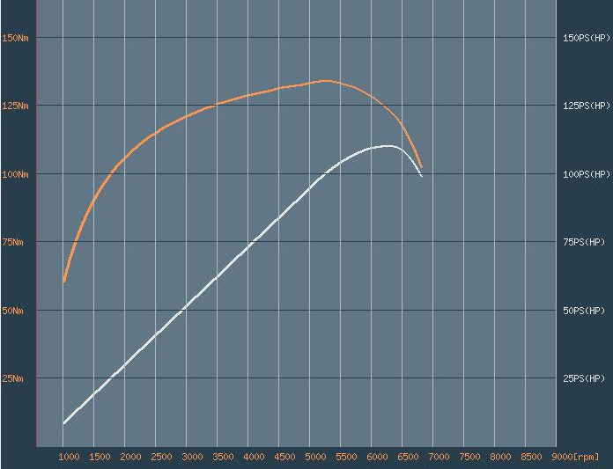
(Source: automobile-catalog.com)

This is a chart is comparing the torque with the horsepower of (1990 honda civic 1.6i catalyst) As we can see in the torque the data that we calculate is in some points inaccurate. In this case the lowest value is in 1000rpm. Many factors can be the cause of these discrepancies, as the current state of the engine, different fuel or different atmospheric conditions.
However, the results are in some way close to the original ones.

5.0 EVALUATION

The dyno session has taught us how it works and how we can calculate all the engine performance characteristics. The results obtained are acceptable, even so a second session to verify this data could be the most logical way to process all the data, although it may be complicated since surely the atmospheric factors will be different.
For better performance in this test, an engine status check. Checking all engine components in this test could make a real improvement as well as the entire process for calculating and obtaining the data, also an special fuel could improve the performance of this engine.
In general, I am happy with the results and for its improvement and truthfulness, there is nothing better than another test (trying to be in the same conditions) but previously check all the engine.

6.0 REFERENCES

1. http://avstop.com/ac/aviation_maintenance_technician_handbook_general/1-22.html (Photo bore stroke)
2. Vehicle Technology. M4X00394. Abi Summerfield. Part 1. Dyno Handout. UWTSD
3. VTEC_Honda 1.6.PDF manual. Honda motor Co., LTD. Service publication office. First Edition 5/90 402 pages. All rights reserved (Moddle. Vehicle Technology. M4X00394. UWTSD)
4. W230 Dyno Spec. © SCHENCK PEGASUS GmbH • Technical Specification Eddy-Current Dynamometer W Series (Moddle. Vehicle Technology. M4X00394. UWTSD)
5. https://www.automobile-catalog.com/curve/1989/1100540/honda_civic_sir_ii.html

