
B.Sc. Level 5
WorkSheet 1:
Facilitating a Virtualised Remote Network Infrastructure utilising Type 1 Hypervisor software, and the RRAS (Routing and Remote Access Services).
Group Name: 1 (EbenAdam)
Date: 2018-01-11
Author(s): Eben Stewart
Complete the following tasks:
Task 1: Verifying No Connection
VERY IMPORTANT:
You should provide screen shots and written narrative/observations where appropriate to record completion of these tasks.

You should already have setup, as a pre-requisite, a suitable environment consisting of:
- Installation of virtual machines in a type 1 hypervisor environment
- Creation of 2 Virtual servers, each with 3 network interfaces, a suitably renamed Backbone Connection and a LAN Switch connection.
- Creation of a Windows 7 client with 3 network interfaces, a suitably renamed Backbone Connection and a LAN Switch connection.
- Appropriate TCP/IP configuration for each of the 3 adapters in the two servers (e.g. 192.168.1, 192.168.10 and 192.168.11 networks)
- Creation of suitable admin level user accounts

Note: The next activity is to disable the Network Interface on the Windows 7 client in the 10 and 11 networks. The only way for these computers to connect to the Backbone network (to access other subnets for example) is utilising each of the networks as a Router. This will be the context in each of our subnets.
192.168.0.1
192.168.0.3
Cardiff
Lab-01-01

192.168.11.1
192.168.11.2
Swansea

[Complete this task on the Windows 7 client]

- Log onto the server
- Right click the 0 network connection – then click Properties, click the TCP/IP protocol and click Properties.
- Select Use the Following IP Address. In the Default Gateway box type the IP Address of the 0 network connection of the Cardiff Server in the network.
Done. Already set because got ahead of ourselves in the worksheets

[Complete this task from Swansea]

- Set the default gateway of the 11 network to the IP address of the 11 network IP Address of the Cardiff server.
Done
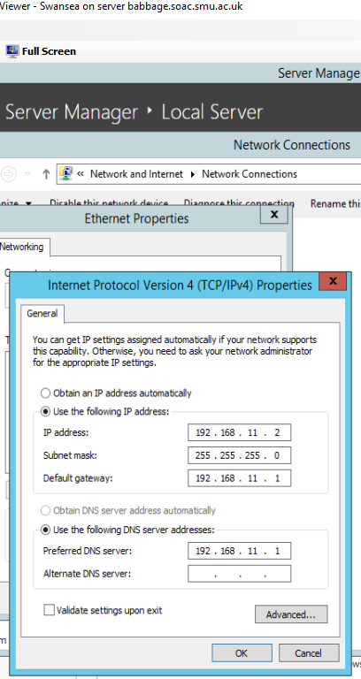
- Use the ping command to attempt to connect to the IP Address of the 11 network IP Address of the Cardiff server.
Done - failed
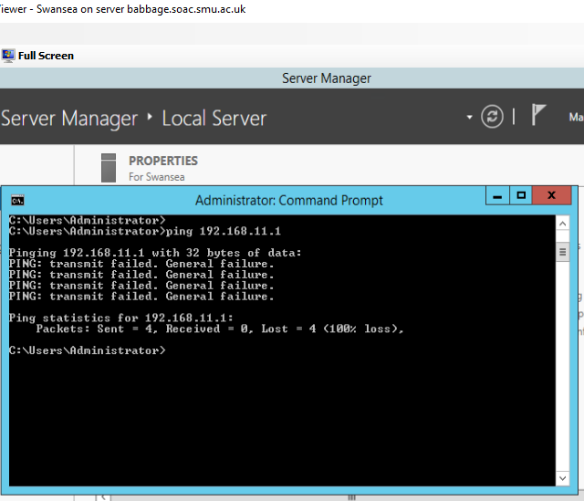
- Use ping to attempt to connect to the IP address of the 0 network IP Address of the Windows 7 client. You should not get any success at this stage.
Done - failed
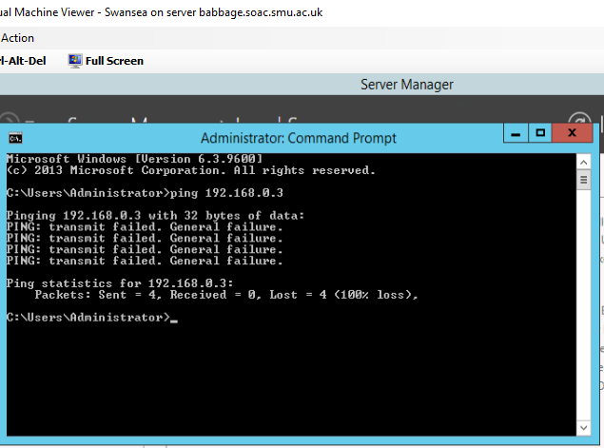

Task 2: Enabling the Routing and Remote Access Service on a Server:
[Complete this task from the Cardiff server]

- Logon to the machine
- From the Server Manager dashboard choose Add Roles and Features
- Choose the Network Policy and Access Services
- Click Next at following page
- Check on Remote Access role.
- When configuring Remote Access, select “Routing”.
- Choose Next/Install.
- Upon completion of the install, choose Start Admin Tools – RRAS (Routing and Remote Access service.
- In the left hand side of the console window right click on your server and choose Configure and Enable Routing and Remote Access.
- Choose next
- Choose Custom Configuration
- Select the LAN Routing option, choose Next
- Click Finish.
- The service should be started (choose Yes if asked by the dialog window).
Done – it was already done
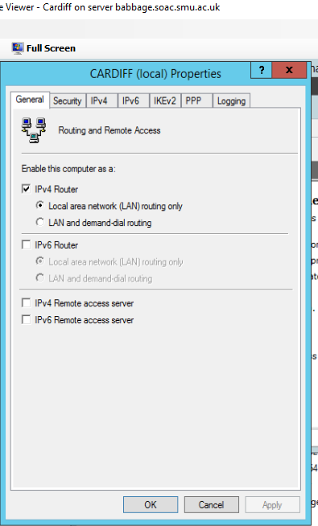

Up to here – Eben only. Start here 2018-02-08

[Complete this task from the Windows 7 client]

Verify Routing to different computers:

- Use ping to attempt to connect to the 11 network IP address of the Swansea server.
- Now try the Internet connection of the other server.
- Finally try to connect to and from the hosts in both of the LAN subnets (e.g. 192.168.0 and 192.168.11)
- You may find that the pings fail
Yes ping failed, because different networks?
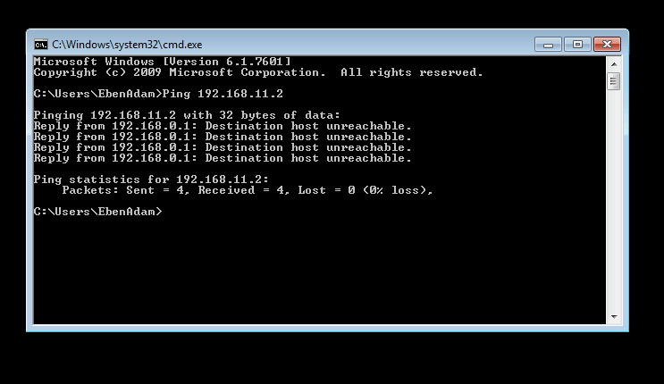
Figure 1 attempt to ping Swansea server from Lab machine - failed

This is because we do not yet know the routes to these other sub-networks. To accomplish this we need to either statically define these routes, or use dynamic routing via a Routing Protocol.

Did up to here Adam & Eben

Task 3: Add Routing Protocols on the Server and Add Two Routing Interfaces to the Routing Protocol on the Server.
[Complete this task from Cardiff]

- Start – All Programs – Administrative Tools – Routing and Remote Access.
- Expand the name of your Server– expand IP V4, right click General and then click New Routing Protocol.
- In the dialog box displayed – choose RIP Version 2 for Internet Protocol, now click Ok.

We tried to do this but right clicking as above did not bring up the correct options.

We will now see how to add two Routable Interfaces to the Routing Protocol that has been enabled as part of TCP/IP suite on our Server

The Routing Protocol will learn of the various Routes to other Networks (in our case Subnetworks), hopefully enabling us to be able to send packets directly to other machines on other networks.

- Right click on RIP then select New Interface.
- In the New Interface Dialog Box, select the 0 network – choose Ok
- Repeat the process but now add the 11 network as an additional RIP Interface.

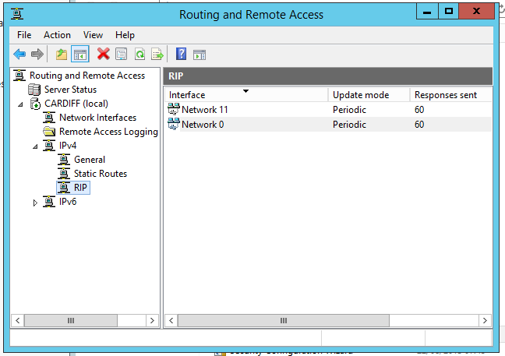
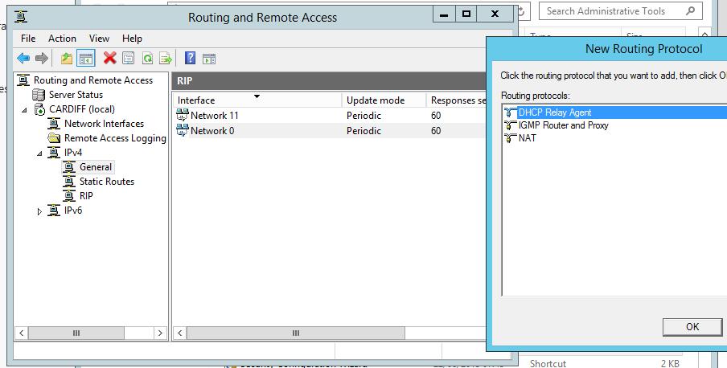
Figure 2 right clicking Routing&Remote Access>IPv4> General - unexpected options

For the last part of this task, look back at your notes and the ping Activities earlier.

You should find that you can now Ping Servers/Clients on other Subnets.

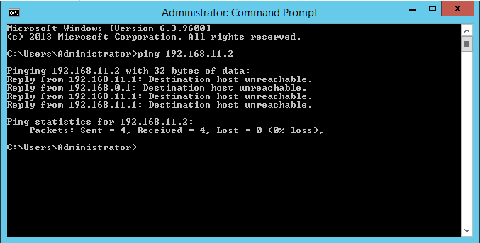
Figure 3 ping attempt - Cardiff to Swansea failed
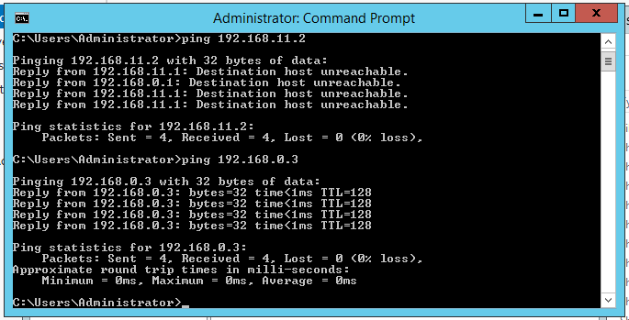
Figure 4 ping attempt - Cardiff to Swansea failed, but pinging from Cardiff to Lab succeeded
Why did the first of these fail?? Cardiff must be pinging from 0 network, but still, ping should work across the boundary now! Let’s try ipconfig to see where we are:
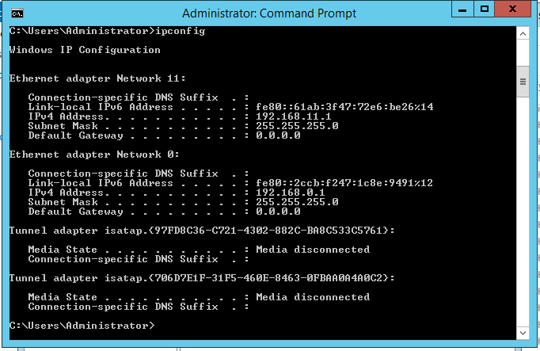
Figure 5 ipconfig result on Cardiff server

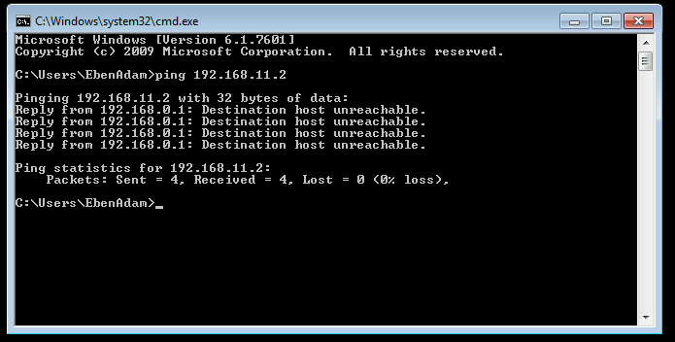
Figure 6 ping attempt - Lab to Swansea - failed

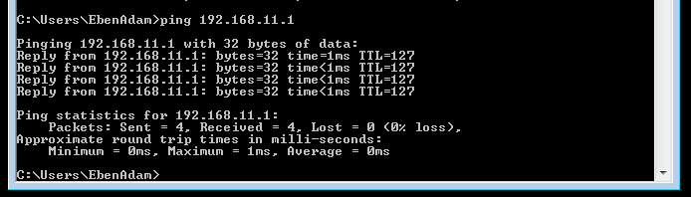
Figure 7 ping attempt - Lab to Cardiff 11 network - success
Why were we able to ping cardiff 11 network from Lab which is 0 network but not then ping Swansea, also on the 11 network from the same place?

Aha! In fig 5, ipconfig shows that ‘media disconnected’ – We went back into the network adaptor settings and found that both lab and Swansea were not connected to the networks although the correct ip addresses and default gateways were set. Connected both and now we can successfully ping from network to network.

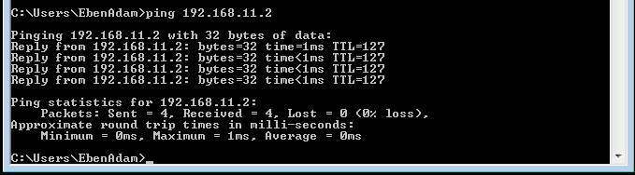
Figure 8 ping attempt - lab to swansea - success. (after connecting both to networks)
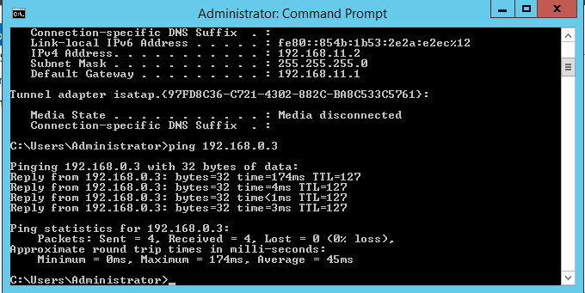
Figure 9 ping attempt - Swansea to Lab success (after connecting both to networks)
So why were the networks disconnected? We are sure that they had been connected…
Task 4: Learning about Local Area Network Routing
Question:
- Open up the command prompt, enter the following syntax: route print

What can you determine from the resulting Routing Table?

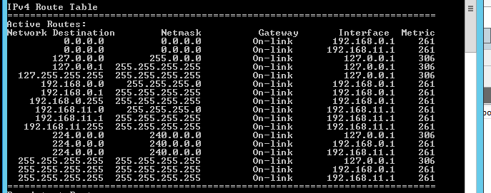
Figure 10 the Routing Table, from Cardiff terminal window
The interfaces for all of the destinations are either the loopback address or one or the other of the Cardiff addresses for the networks (.11. or .0.). So Cardiff is the meeting point of the two networks, therefore the machine upon which to make connections between the two networks.

Task 5: Additional Observation Tasks:
Ensure these tasks are answered in appropriate detail and the sources and source materials are referenced using the IEEE Referencing system.
- Identify the benefits of Type 1 Hypervisor software services and briefly evaluate some suitable products.
- Define the role of Routers in the Network Architecture, what types can be used?
- Identify and discuss the usage of common Routing Protocols, what are the associated benefits of using Routing Protocols?
- Define the role of Routing Tables, what are they. Breakdown and analyze the information a Routing Table provides us with.
- What is the Subnet Mask, what is the significance of this in the Routing Table?
You will find the Answers for this Question are on the bottom of the very page.

B.Sc. Year 2
Network Services and Web Technology Worksheet 2: Routing and Remote Access Services in Windows Server: ARP, Managing TCP/IP & ICMP Operations using Packet Filtering.
Group Name: Group 1 AdamEben
Date: February 9, 2018
Author(s): Eben Stewart & Adam McGowan
Complete the following tasks:
Note: you should take observations and screen captures when completing these tasks. It is also essential to produce an introduction to the scenario for this worksheet; you can only write this summary when you have finished all practical tasks.

Introduction: write intro here, as above

Task 1: Using the ARP Protocol to obtain Physical/Logical Network Node information
You may need to disable Windows Firewall for part 3 of this worksheet.

[Complete this task from Cardiff]

The ARP table ‘maps’ logical IP (Internet Addresses) to Physical Addresses of Network Interfaces, this is how a packet is sent/received on a Network Interface, or if you like, how packets arrive at your machine over the Internet.

- Click Start – run – cmd
- At the command prompt type ARP -A
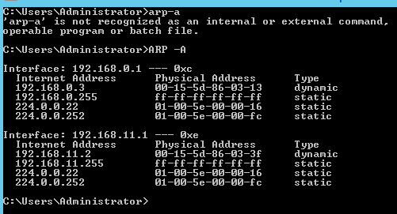
Figure 1 result of arp -a

Hmm, I thought we had assigned these (192.168.0.3 and 192.168.11.2) statically…?

- The information you see displayed comprises of:

- The Interface (NIC’s) in your Machine.
- The Physical (MAC) Address of this NIC
- The Internet Address of this NIC.

You may not at present have any (or you may have very few entries). As you connect to, are connected to; other servers, this ARP Table (MAC Table) will be updated;

One common way to see this in practice, is by using an ICMP operation such as ‘PING’

Attempt to ping other Servers in the network, note on successful attempts, check your ARP Table using the arp –A command, note the entries being updated as more servers connect/are connected to.
???? we don’t know any other working addresses. These are closed networks aren’t they?

Task 2: Permitted TCP and ICMP Operations

[Using Routing and Remote Access Services for configuring IP packet filtering]

[Complete these tasks from Swansea]:

- Navigate to the Server Manager Dashboard.
- Add Roles
- In the list of Server Roles – check on the Web Server (IIS) – Choose Next.
- Choose Next at the Intro to web server (IIS) page.
- At the Select Role Services page, scroll down and check on FTP Service, click Next.
- Now install the service, and wait for the wizard to complete.

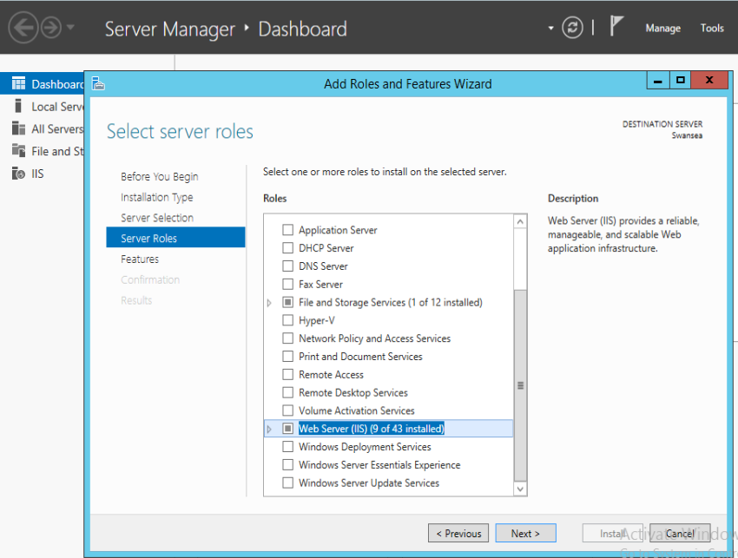
Figure 2 webserver IIS services installed

- Click Start – Administrative Tools - Computer Management
- Expand Local Users and Groups – Right Click on the Users Folder – New User

*VERY IMPORTANT*
Ensure that you Check off the ‘user must change password at next logon
setting’.

Name: ftpuser
Password: P@ssw0rd

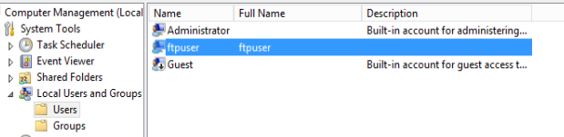
Figure 3 created ftpuser

- Start – Administrative Tools – Internet Information Services Manager.
- Expand the Computer Name – Right click on Sites – choose Add FTP Site
- In Site information type test
- Click on the browse button […] next to Content Directory/Physical Path
- Choose root drive (e.g. C:\Inetpub\ftproot) –

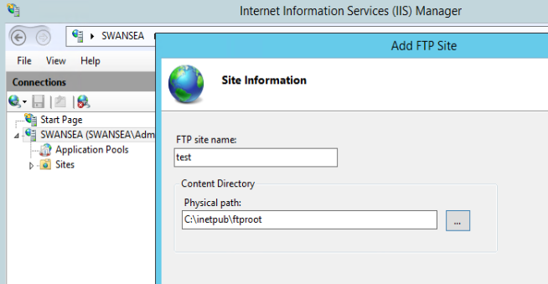
Figure 4 added ftp site 'test'

- Next: At the bindings and SSL settings page – choose No SSL

Not mentioned but we could assign Swansea server address as it seems the ftp service should be running from somewhere and it is on this server… on the other hand, no instructions usually means don’t mess with it so we will leave that setting as ‘All Unassigned’

- Take note of the Port Number (20 & 21) can be used via the TCP protocol when using the FTP Service.
Port 21
- Chose basic authentication as the preferred mode.
- Alongside the authentication textbox, click the drop down menu and choose Specified Users.
- Type in the name of your server (Swansea) followed by a backslash and the user account you created above (e.g. Swansea\ftpuser).
- Ensure you check on both the read\write options. Choose Finish.

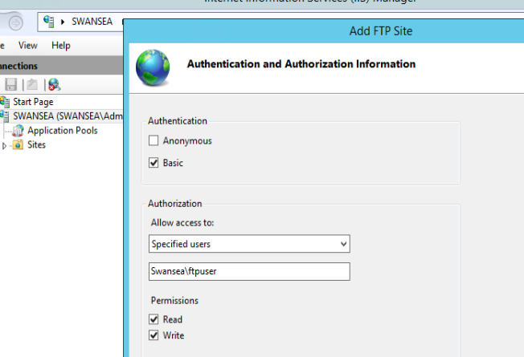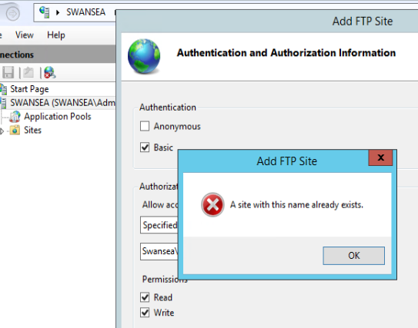
Figure 5 Figure 6 but the site already exists Figure 6 setting up ftp site

Oops! Must have done this months ago!

- We can setup banners/welcome greetings as a way of knowing if we are connecting to the right server.
- To setup a banner, choose Start - Administrative Tools – IIS Manager.
- Expand the servername – Expand sites click on your ftp site you created earlier.
- Choose “FTP messages”.
- Here you can enter banners, welcome greetings and exit messages. Set ‘appropriate’ messages up here – you should indicate to the user that they’re connecting to the Swansea server.

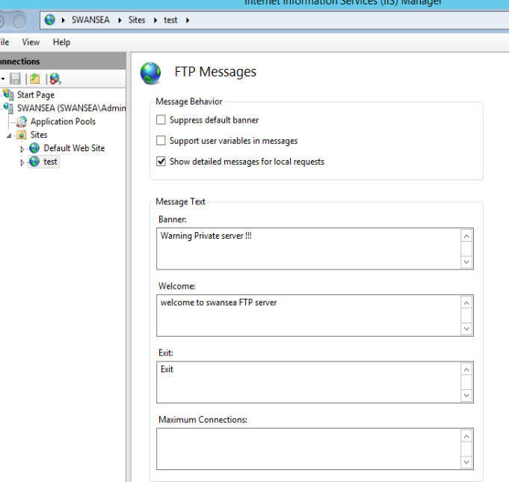

- Click Computer - Within the C:\Inetpub\ftproot directory, create a new text file, call it testftpdownload.txt
- We now have our FTP Server running on the Swansea Server:
- We can upload files to or download files from the FTP server (using the appropriate windows authenticated account).

We are now going to attempt an FTP operation from our Cardiff server (The Router) remember: THE FTP SERVICE IS RUNNING ON THE SWANSEA SERVER.

[Complete this task from the Cardiff]

Important Note: if at any stage your ftp session is ‘timed out’, type CTRL & C and/or type bye at the ftp> prompt;

We need a host directory to store the folder that is going to be ftp’d across from our FTP server.
- Click Start – My Computer – C: and create a new folder called ftpdownloads

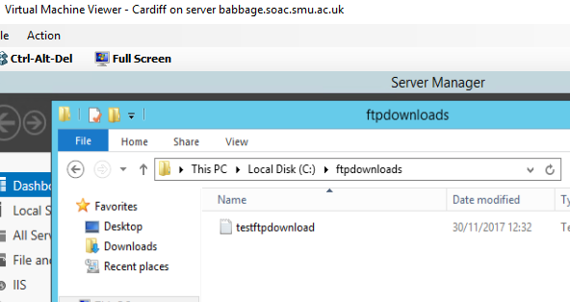
Figure 7 created ftpdownloads folder in c drive

- Click Start – Run – Type in cmd to launch the Command Prompt.
- We are now going to access the ftp service on the Swansea – type the following command:

ftp IP of Swansea Server

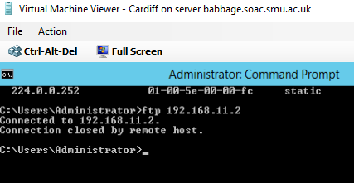
Figure 8 unable to connect to swansea via ftp from Cardiff

Why was the connection closed? It seems it was opened for a moment, then refused by Swansea. Does the below have anything to do with it?
SOLVED - 2018-02-16 – Tim fixed it. He adjusted bindings that had been to a non-existent IP address. Now open to ‘ANY’. ftp now connects.
So we attempted to login, however the wrong password was assigned, so I went back into Computer Management and changed the ftpuser’s password to ‘P@ssw0rd’. We are now able to login as below:

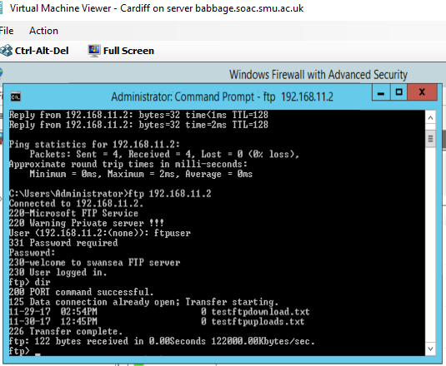
Figure 9 login to ftpuser success. dir successfully lists contents of (remote?) host directory. It already contains the files for the next few exercises, so these were done earlier

You may select any network interface from the Swansea server.

- ftp service should be enabled, nope yes
- servername\ftpuser [don’t type in servername use your own servers name e.g.) User: Swansea\ftpuser.
- password P@ssw0rd.
- You are now logged into FTP server. No, we’re not. Connection refused. yes
- Type dir to give you a list of what is stored in the Host Directory on the FTP Server. Note the file name testftpdownload.txt done – see above screenshot
- We need to change our Host Directory (done at this server not the ftp server) to specify where we want the FTP server to put the file to when it downloads.
- To do this we need the Local Directory Change Command, type lcd c:\ftpdownloads

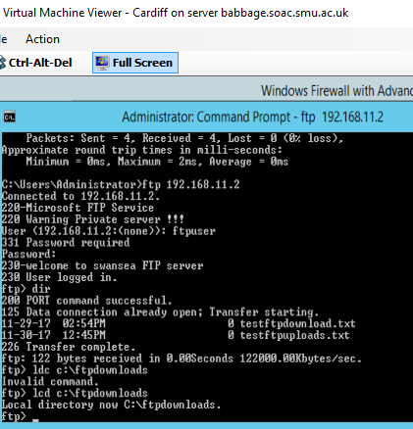
Figure 10 changed ftp host directory to c:\ftpdownloads on Cardiff

- At the ftp prompt, type get testftpdownload.txt
- The ftp program should inform you that the process is complete.

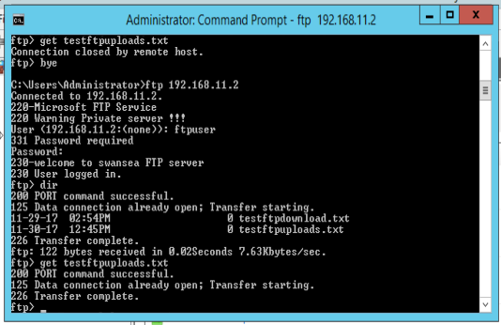
Figure 11 get testftpdownload.txt – success testftpuploads.txt is also already in place so must have been ‘put’ there earlier.

- Go to My Computer, C:\ – create a folder called ftpfilesupload, within this folder create a new text file here call it testftpuploads.txt Done
- In the ftp prompt type the following
- lcd C:\ ftpfilesupload
- dir
- put testftpuploads.txt Done

[Complete this task from Swansea]
- Go to the c:\inetpub\ftproot folder and verify that the file has been uploaded.

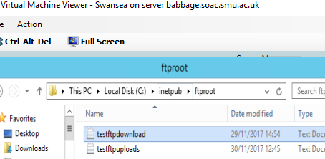
Figure 12 testftpdownload and testftpuploads text files are indeed in the Swansea c:\inetpub\ftproot directory

Task 3: Restricting ICMP Operations Using IP Packet Filtering with the Windows 2012 Server Routing and Remote Access Service
[Complete this task from Cardiff]

BEFORE BEGINNING, PLEASE CHECK THAT THE ROUTING AND REMOTE ACCESS SERVICE IS RUNNING ON YOUR MACHINE.

Configuring a Simple Inbound Filter (Remember filters are configured on the Router as traffic into our network arrives here first).

[Stopping the client from Pinging a Particular Network Host]

- Start – Administrative Tools – Routing and Remote Access Console
- Expand the Computer Name – Expand IP Routing – Then Click General
- In the details pane – right click the Appropriate (think this through) Network Connection interface, click Properties.
(Done this - 12/Feb/2018)

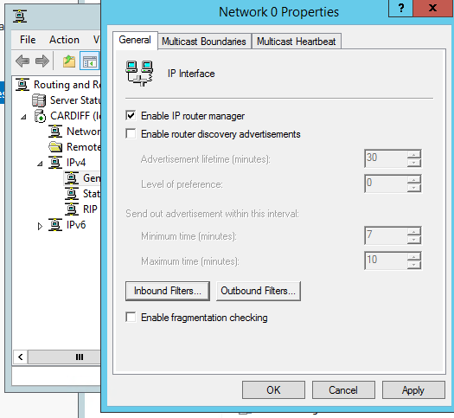
Figure 13 navigating to ICMP inbound filtering

- Click the General Tab – Inbound Filter (anything coming into the Router on this Partner Interface).
- Source IP Address This will be the IP address of the Client that you want to disallow. Set this to 192.168.0.3, and the subnet mask 255.255.255.255.
- Destination IP address: 192.168.11.2
- Destination Subnet Mask: 255.255.255.255 (This is because we know the exact Network/Host Address for the Destination).
- From the Protocol menu – Choose ICMP
- Note: you could also specify the port number here, if you do not specify a port the setting defaults to 255 meaning any type. Ok
(Done this - 12/Feb/2018)

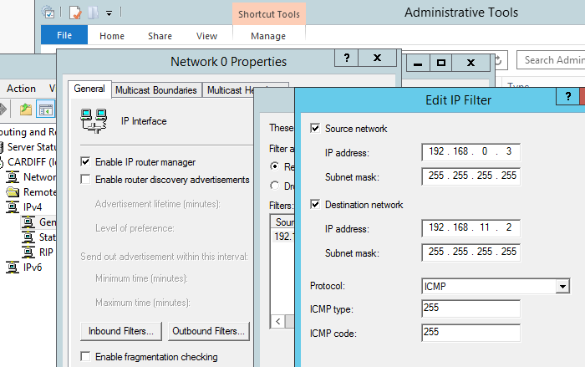(Done – 13.2.2018)

Figure 14 restricting ICMP operations using IP packet filtering stopping Lab from connecting to Swansea

- From the Filters dialog select the Filter Action: Receive all Packets, except those that meet the criteria below

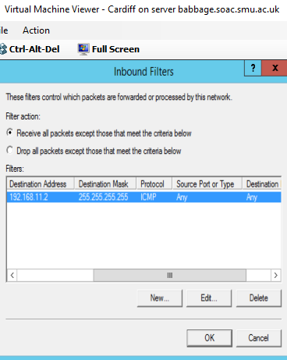and redone 2018-02-16 after ftp was fixed.
Figure 15 inbound filter created on Cardiff between Lab(source) and Swansea(destination) blocking all communication

Rationale:

In this instance, we are creating a filter on a specific interface. If you had other interfaces across the network(s), you’d still be able to ping the other network(s) on Swansea from the client.

To confirm this:

[COMPLETE THIS TASK FROM THE CLIENT

- Attempt to PING Swansea (192.168.11.2) you should NOT get any response from this IP address (you may get a reply from another bound IP telling you this host is unavailable).

(Done – 13.2.2018)

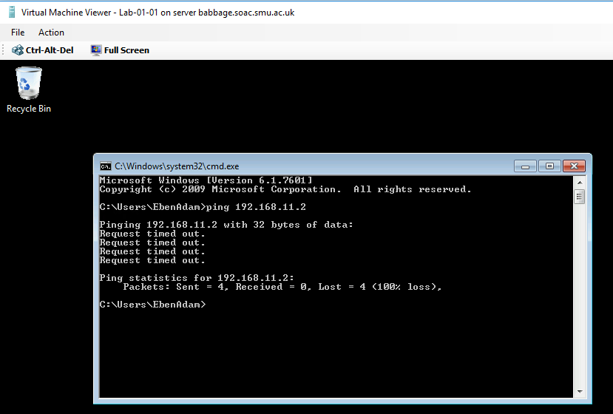
Figure 16 attempting to ping Swansea from Lab machine - failed due to ICMP filter

- Attempt to PING the Cardiff 11 Network address (192.168.11.1) (This time you should find you receive a response)

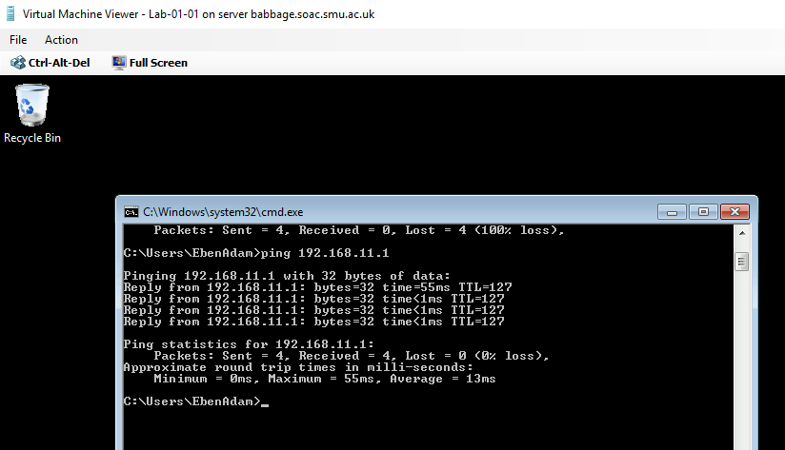
Figure 17 attempting to ping Cardiff from Lab machine - Success

So we do have access to the 11 network, but the specific operation Lab to Swansea is blocked.

Task 4: Restricting TCP Operations Using IP Packet Filtering with the Windows 2003 Server Routing and Remote Access Service.
[Complete this task from CARDIFF]

Configuring an Outbound Filter (packets travelling out of the Router).

First – remove the previous Inbound & Outbound Filters, this helps us avoid ‘Contradictory Filters’.

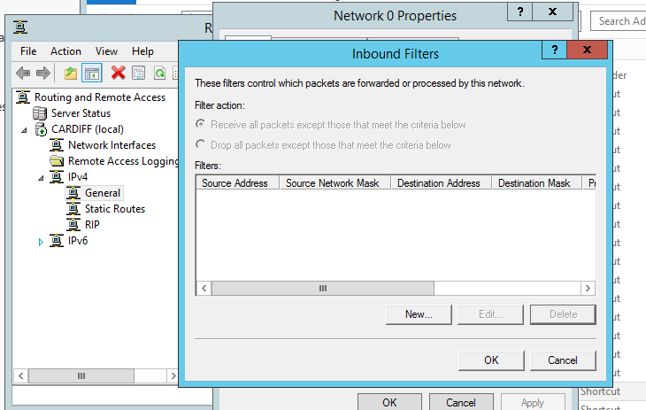
Figure 18 inbound ICMP filter blocking traffic to Swansea from Lab removed (from Cardiff)

Earlier we performed FTP operations from the Swansea Server, we needed to Connect to the FTP Service that was running on this server to complete the FTP operations.

Here we block all outbound traffic from the Router, in this instance we will block everybody from accessing the FTP service that runs on the Swansea Server in our Network.

- Start – Administrative Tools – Routing and Remote Access Console
- Expand the Computer Name – Expand IP Routing – Then Click General
- In the details pane – right click the Partner Network Connection interface, click Properties.
- Click the General Tab – Click Outbound Filter.
- Source and Destination IP Addresses these should be left Blank, as we intend to filter all packets that what to go out from the Router on this interface.
- Protocol: TCP (FTP Service is accessed using TCP port 20/21). You may need an identical rule for 20 and then 21
- Destination Port No: 21 (Note this value from earlier when we checked on default ftp site values). Choose OK.

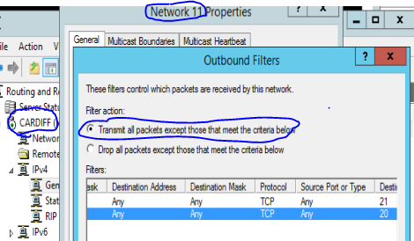
Figure 19 TCP filters on outbound port 20 and 21 to block everyone from accessing the ftp (ports 20 & 21) in Swansea

- From the Filters dialog select the Filter Action: Receive transmit? all Packets, except those that meet the criteria below

[Complete this task from CARDIFF]

- Click Start – Run – cmd
- ftp (and then the IP Address of your Swansea server e.g. the 0 or 11 address
- You should find that you get no reply, we cannot access the FTP service

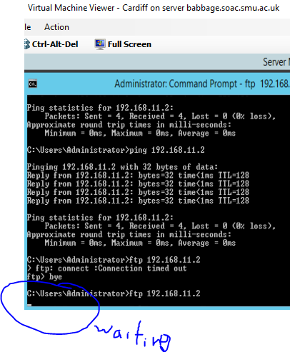
Figure 20 attempt to connect to ftp server on Swansea timed out as all outgoing traffic on that network from Cardiff is blocked
[Complete this task from CARDIFF]

Configuring an Inbound Filter.

First – remove the previous Inbound & Outbound Filters; this helps us avoid ‘Contradictory Filters’.

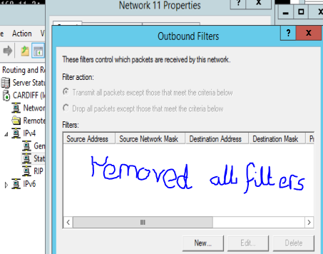
Figure 21 removed all filters from 11 network traffic

Here we block all other Network Traffic, from accessing our FTP Service, with the exception of Cardiff (Our Router), which WILL BE GRANTED ACCESS.

THE NEXT STEP IS EXTREMELY IMPORTANT:
- Start – Administrative Tools – Routing and Remote Access Console
- Expand the Computer Name – Expand IP Routing – Then Click General
- In the details pane – right click the 0 Network Connection interface, click Properties.
- Click the General Tab – Inbound Filter (anything coming into the Router).
- Source and Destination IP Addresses should be left blank, as we intend to filter all packets.
- Protocol: TCP (FTP Service is accessed using TCP port 20/21).
- Destination Port No: 21 (Note this value from earlier when we checked on default ftp site values). Choose OK.
- From the Filters dialog select the Filter Action: Receive all Packets, except those that meet the criteria below.

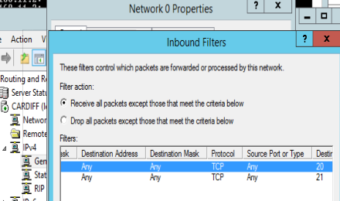
Figure 22 inbound filter on all traffic to anywhere on O network on ports 20 & 21 (ftp)

Only our Router can now Ping the FTP Server as it is the only server that can connect to our FTP Server, via the Partner Connection Interface (which has no filters applied). (11 network)

- See if you can access your FTP server from your Router (NOTE: remember you will need to access the FTP server using the Partner Network Connection IP address

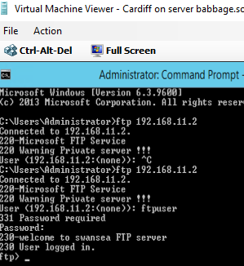
Figure 23 Cardiff can access ftp server with 0 network ports 20 & 21 incoming blocked

- Now see if your friends can access your FTP server from their Network. Since we are completing this so late, there isn’t anyone else to do this with

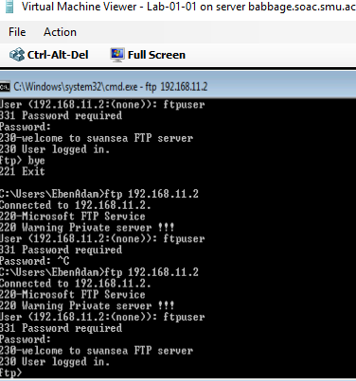
Figure 24 but Lab should not be able to... why can it??

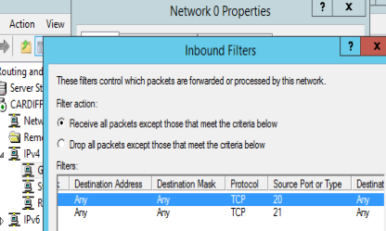
Figure 25 it works as expected, blocking ftp login from 0 network, when inbound rule specifies Source ports 20 & 21 with Destination as 'Any'
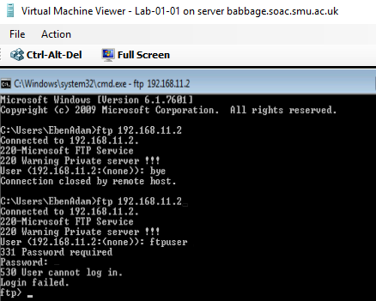 but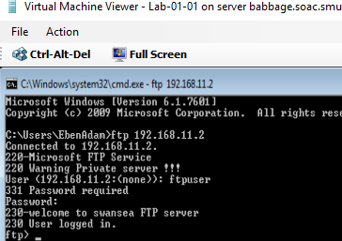
Figure 26 testing inbound rule that should block ftp traffic to source 20 &21 dest any Figure 27 oh no! it connects with source or dest ports 20 & 21 specified
Configuring an Outbound Filter.

[Complete this task from CARDIFF]

Here we will block access to the FTP Server for only our Router (Cardiff). All other Networks should be able to FTP into our FTP Server:

First – remove the previous Inbound & Outbound Filters, this helps us avoid ‘Contradictory Filters’.

- Start – Administrative Tools – Routing and Remote Access Console
- Expand the Computer Name – Expand IP Routing – Then Click General
- In the details pane – right click the Partner Network Connection interface, click Properties.
- Click the General Tab – Click Outbound Filter.
- In the Source IP Address enter the IP Address of the Partner Network Connection on the Router (or the Lower Number Server in your Group).
- Destination IP Address: is the IP address of the Partner Network Connection in the Swansea Server.
- Source Subnet Mask: 255.255.255.255
- Protocol: TCP
- Destination Port: 21
- From the Filters dialog select the Filter Action: Receive all Packets, except those that meet the criteria below.

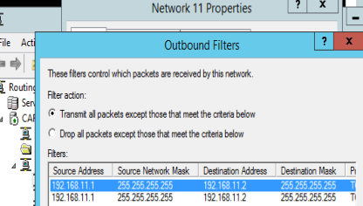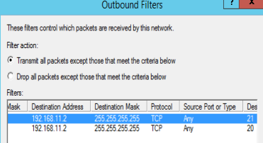
Figure 28 outbound filters that should block traffic through dest ports 20 & 21 from Cardiff server’s 0 network address to Swansea server’s address (on 11 network)

[Complete this task from CARDIFF]

- See if you can access your FTP server from your Router (remember you will need to access the FTP server using the Partner Network Connection).

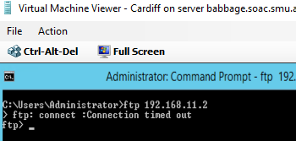
Figure 29 unable to log in to ftp server from Cardiff, connection blocked by outbound filters on traffic through dest ports 20 & 21 from Cardiff server’s 0 network address to Swansea server’s address (on 11 network)

No couldn’t connect.

Rationale:

Our Router will essentially stop itself from sending packets to the Partner Server, via the Partner Network Connection, the filter parameter is the source IP Address: which as specified is indeed the IP Address of the Partner Network Connection Interface on our Router.

No other filters are setup so the Router will forward all other requests from other networks.

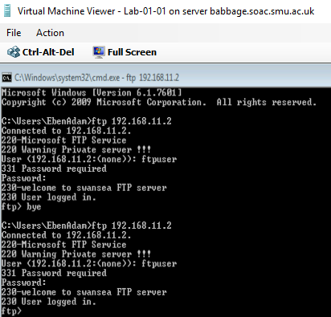
Figure 30 although filters have blocked Cardiff access to ftp server, Lab machine can connect successfully (even though that connection goes through Cardiff)

Task 5: Exercise
Here we want to only allow our Router to FTP. All other traffic from our Router and all other traffic from other networks (including PINGS) must be blocked.

Explain your method for achieving this:
- Remove this last set of filters to start clean and avoid conflicts.
- Then create filters to block all but TCP traffic coming in on ports 20 & 21 from Cardiff’s 11 network to Swansea. As Below:

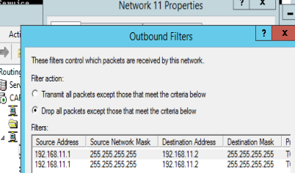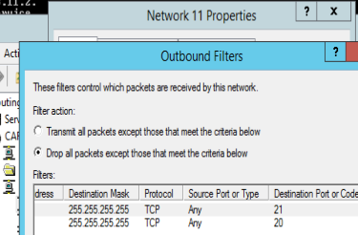
Figure 31 filters restricting all traffic except from Cardiff 1 network address to Swansea on ftp ports (via TCP)

The Cardiff 11 network address is specified as the only permitted source, the Swansea server is the permitted destination and since only FTP traffic is to be permitted, only the ports used for that service are permitted. All other traffic is specified as to be dropped (by selecting ‘Drop all packets except…). These results are illustrated in the figures below.

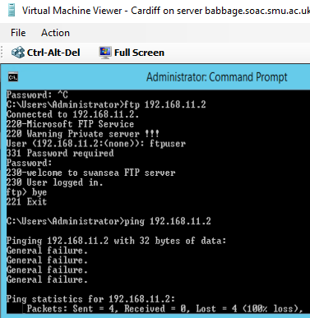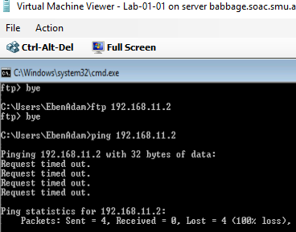
Figure 32 Cardiff can access ftp server on Swansea but cannot ping it
Figure 33 Lab can neither ftp nor ping Swansea
Observational Tasks:

Q1). Describe (using appropriate illustrations) how the ARP process operates in Networking Contexts?

Q2). What is Packet Filtering? In our context, why is Packet Filtering termed ‘IP Packet’ Filtering? Why would you use Packet Filtering in your Network? What are the perceived benefits?

Q3). Why is it possible for contradictory filters to occur when you use packet filtering? Give an example of a Contradictory Filter:

Q4). FTP Server is just one Role/Service we can configure our Server to provide? What other roles can the Server provide that would benefit our Infrastructure in both a local and remote context?

You will find the Answers for this Question are on the bottom of the very page.

Stuck in at end as don’t know where it goes just now:


B.Sc. Year 2
Network Services
Worksheet 3: TCP/IP Configuration using DHCP (Dynamic Host Control Protocol).
Group Name: group
Author(s): 1 Adam McGowan & Eben Stewart
Complete the following tasks:
abstract
Pre-setup
Configure your network such that each virtual machine is connected to each virtual network. I.E. Cardiff, Swansea and Lab-01-01 should each have 3 interfaces, with one interface on Network 1, one interface on Network 2 and the third interface on Network 3. You do not need to assign IP addresses to newly created network interfaces.
Eben – I shut down the VMs to install new network cards, using wksht0 as a guide. On Lab, I mimicked the set dynamic IP, dynamic MAC & enable virtual switch optimization.
But I got this error message:
VMM cannot enable or disable the MAC addresses spoofing or VM network optimization settings because the Virtual Network Adapter associated with virtual machine Lab-01-01 is not connected to a virtual switch.

Connect the virtual network adapter to a virtual switch, and then try the operation again.

Looking at the setup of adaptor 1, I unchecked virt. Switch optimization and it worked. All three machines now have three network adaptors connected to one of the three available networks. DONE
ID: 10692

Task 1: Understanding Different TCP/IP Configurations
We know that Computers use IP addresses to communicate over TCP/IP protocol. Windows 2012 provides three different ways to configure IP Addressing.

Manually – Static IP addresses, usually assigned to Servers running Windows 2012 Server. All the servers on our 192.168.1.0 network are configured, at present with manual/static IP addresses

Dynamically – If a DHCP server is installed IP addresses are assigned automatically on boot-up, DHCP is the default TCP/IP configuration and is in most cases automatically setup on Windows Workstations.

Alternative - When you install Windows 2012 you are automatically configuring that Server to be a DHCP client.

- Obtain an IP address automatically uses a DHCP server for dynamic IP addressing
- Use the following IP address – Statically defines the IP address

If you are a DHCP client, and you are unable to locate a DHCP server, you get your address from a range of IP addresses known as the APIPA (Automatic Private IP Addresses).

An APIPA type address is a class B IP address. It is allocated from the range 169.254.0.1 to 169.254.255.255. It has a Subnet mask of 255.255.0.0. This is a private IP range; you would not find another computer attached to the public internet using any APIPA addresses.

The DHCP client (if no host can be contacted) picks a random IP address from this range, and broadcasts it out on the network. If this address is in use the owner will send a packet informing the client it is already in use. If the IP address is not being used, the client ‘binds’ this IP address to the specific network adapter. The client will send out requests periodically to the DHCP server, until DHCP automatic IP address can be assigned.

VERY IMPORTANT:
BEFORE YOU UNDERTAKE THIS TASK MAKE A NOTE OF ALL STATICALLY DEFINED IP ADDRESSES; YOU WILL NEED THESE LATER ON.

On Cardiff - arp –a:

Note that 3rd interface is within Apipa range.

Figure 1 result of arp -a on Cardiff

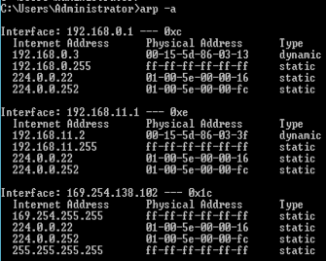
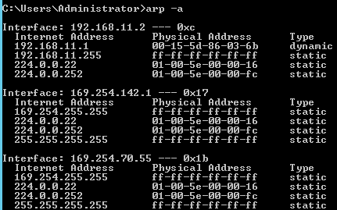
Note that 2nd and 3rd interfaces are within Apipa range
Figure 2 result of arp -a on Swansea

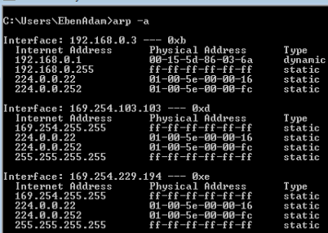

Note that the 2nd and 3rd interfaces are within the Apipa range

Figure 3 result of arp -a on Lab

These new interfaces all have apipa addresses because they were not specifically assigned static addresses when the new adaptors were connected to the networks and the machines have not had access to DHCP servers yet. Once such access is enabled the Apipa addresses should be replaced by dynamically assigned addresses starting 192.168.x.x.

[Complete this task from Swansea and the Windows 7 client?]
* Locate the Apipa setting only for the 0 Network interface
* Set the networking to automatic private IP addressing on both servers?? (You will only need to complete this task on one of your networks).

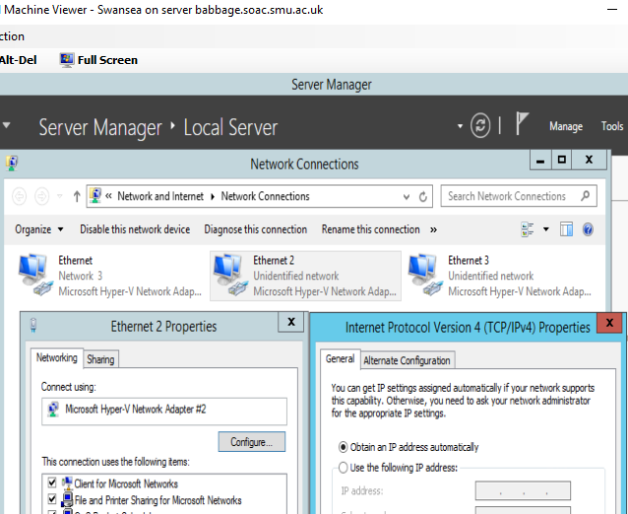
Figure 4 setting Swansea network 2 to use Apipa
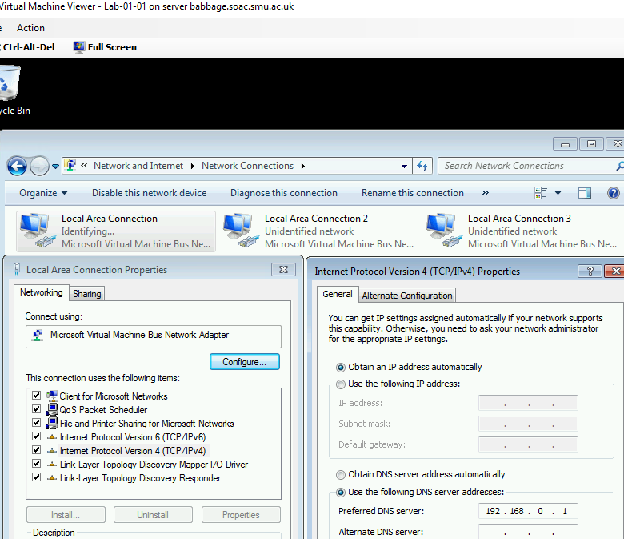
Figure 5 choosing automatic addressing on Lab 0 network

Choose Start – run – cmd
ipconfig/release (just to make sure our static address is completely erased.
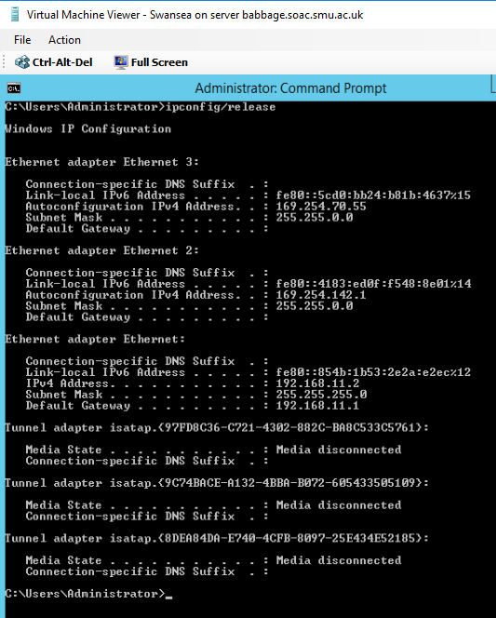
Figure 6 running ipconfig/release on Swansea.
Apipa was set up only for 0 network, so Swansea 11 network interface is still as previously assigned. Ie 192.168.11.2

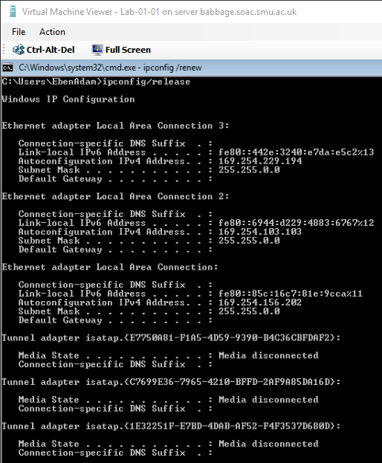
Figure 7 running ipconfig/release on Lab
Lab says Media disconnected on 0 network (Ethernet 2) and both of the newly set up network adaptors have addresses in the Apipa range and no default gateways.
Swansea has Apipa addresses for the two networks it is newly attached to, but still has its old assigned IP address (192.168.11.2) as we did not clear settings on the 11 network, only the 0 network as instructed.

ipconfig /renew, it will take a few moments for our computer to realize that it cannot find a DHCP server on the network.

- We will get an error message informing us the request is timed out (because a DHCP server could not be contacted).

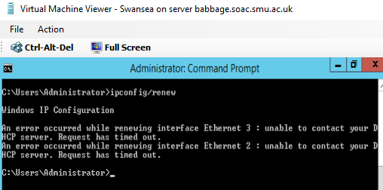
Figure 8 running ipconfig/renew on Swansea.
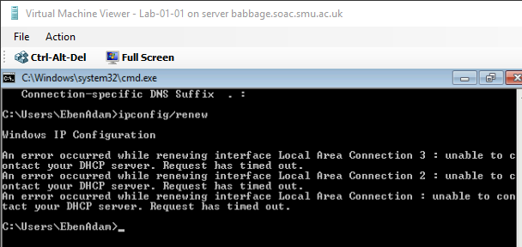
Figure 9 running ipconfig/renew on Lab
As expected, requests timed out as no DHCP server found by either machine. Now both machines know that there is no DHCP server available and hopefully will assign Apipa addresses.

- We should now be able to obtain an APIPA, in the cmd prompt type ipconfig
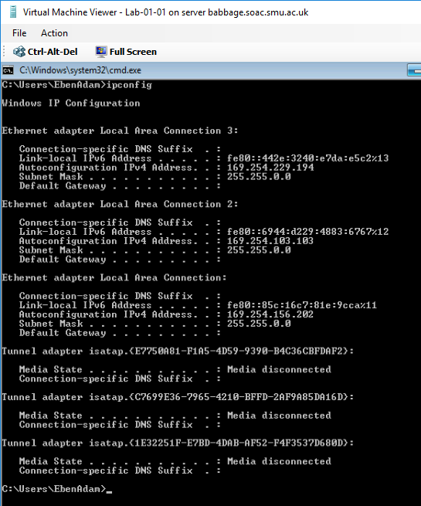
Figure 10 result of running ipconfig on Lab.
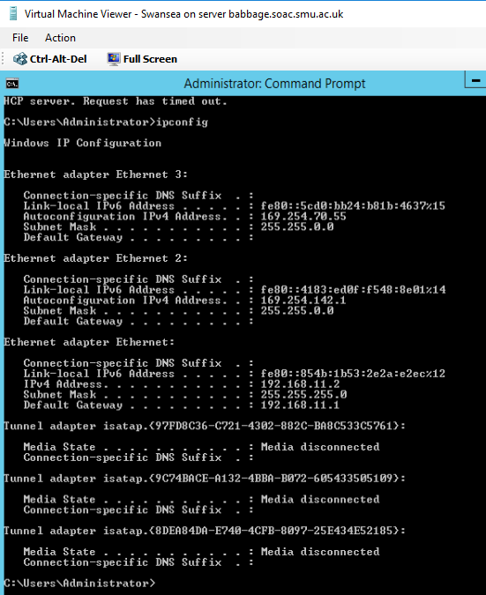
Figure 11 result of running ipconfig on Swansea

- We should now see for our Network Connection, that an Auto configuration IP address has been assigned, with a subnet mask of 255.255.0.0

Yes on both machines 0 network

- We see now that AutoConfiguration has been enabled, note no Default Gateway is assigned. This means that clients beyond the same switch or LAN that live on remotely separate networks cannot PING each other

0 network IPv4 addresses on both machines are autoconfig, No default gateway on either machine.

Try to ping the two other servers on the other network; record what happens.

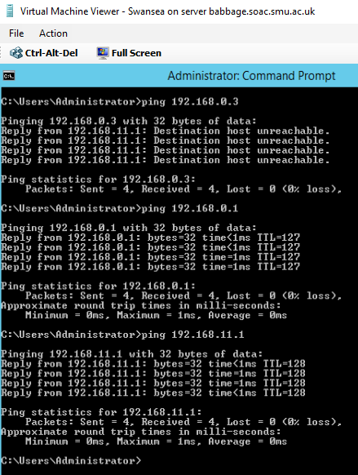
Figure 12 attempted ping from Swansea to both Cardiff IP addresses and Lab's former IP address
Swansea cannot connect to Lab on 0 network but can connect to Cardiff on both of its interfaces. Since its original 11 network IP address nor the 11 network itself were not interfered with, it is not surprising that it cannot ping Lab, which is only reachable through the 0 network, but it can ping Cardiff 11 network address. I’m not entirely clear on why it successfully pinged Cardiff’s 0 network address.

[from here on working with Adam]

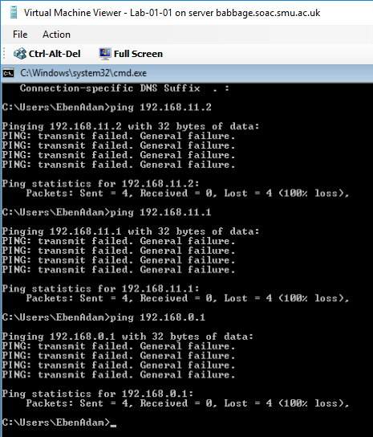
Figure 13 attempted pings from Lab to Cardiff both interfaces and Swansea – failed all
As Lab is only on the 0 network it is not surprising that all pings failed.

Task 2: Installing the DHCP Server
Installing the DHCP Server:

Note: Before we do this task we need to reset our configuration back to the static IP addresses that were entered earlier, do this here.
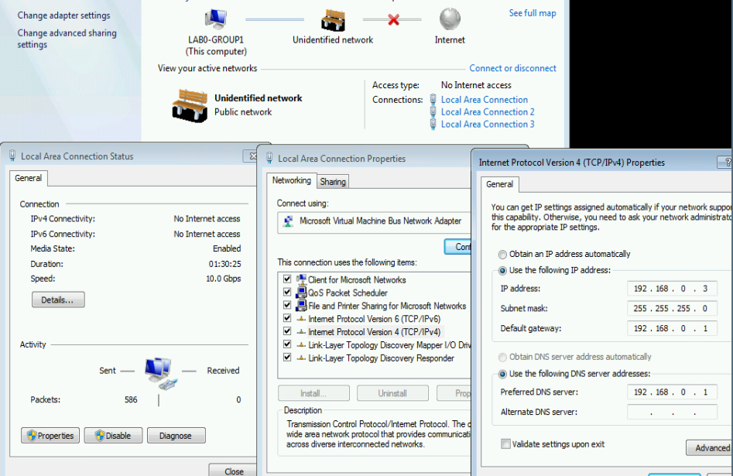
Figure 14 resetting previous static IP address of Lab local connection 1 (0 network)
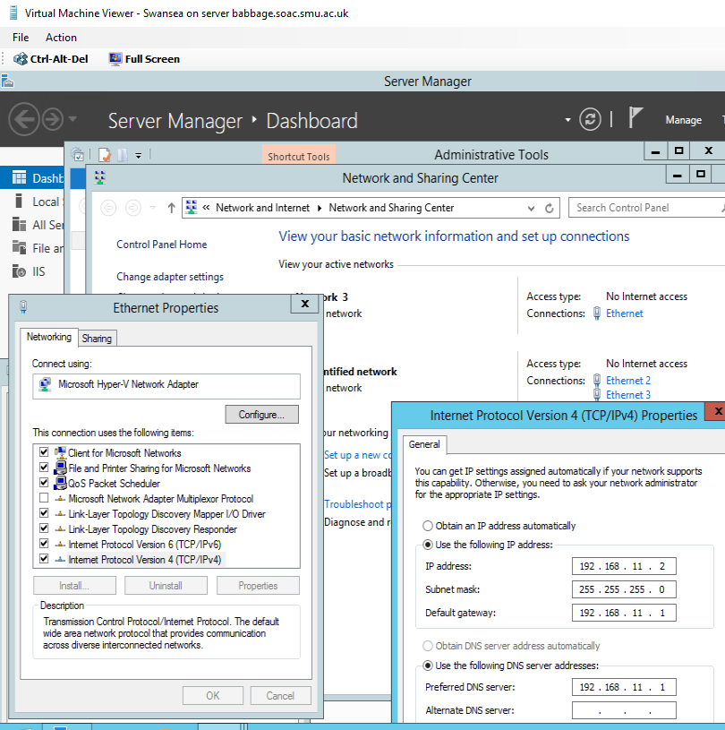
Figure 15 Swansea's settings for 11 network are unchanged

We’ve seen previously how to configure dynamic IP addresses on our Network Adapter. DHCP. DHCP gives us centralized control over IP addresses and TCP/IP default settings (subnets, default gateways). When we set up the DHCP server, we can rely on this server to supply the TCP/IP settings.

DHCP lies at the application layer of the OSI model, it is one of the applications, that utilises the services of TCP/IP.

Note at the moment; the Connection is configured with a Dynamic IP address (as a DHCP client).
Which connection?

[Complete this task from Cardiff]

- Add a role from the dashboard.
- Choose next and the default screen
- From the list of available services to install check on DHCP Server - .
- Choose Next at the next notification page. Complete the dialog.
- Access the DHCP Post-Install configuration wizard.
- Select “Commit.”

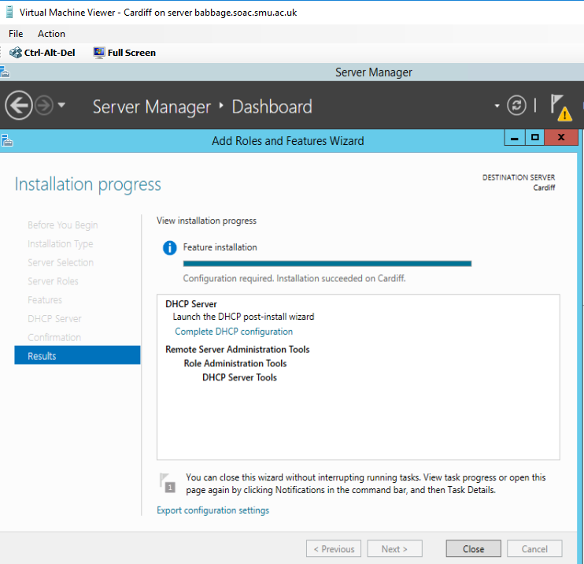
Figure 16 installed DHCP server role on Cardiff. Did I configure it right??

Task 3: Authorising the DHCP Server
YOU WON’T NEED TO DO THIS YET – THIS WILL BE NECESSARY ONLY ONCE WE CONFIGURE ACTIVE DIRECTORY, BUT COME BACK TO COMPLETE IT. WITHOUT COMPLETING THIS STEP, YOUR DHCP SERVER WILL NOT WORK AFTER INSTALLING ACTIVE DIRECTORY.

Authorising the DHCP Server:

One thing that Windows AD Domains protect against, is rogue DHCP servers or rather, the addition of them in our Network Infrastructure. DHCP clients are not really concerned which offer of an IP address they respond to (they just want an IP address).

To avoid network communications problems, we must have a way of ensuring that our clients get a correct address from the right DHCP server in the right scope.

In order for Domain clients to receive IP addresses from a DHCP server, the DHCP Servers must be authorised in Active Directory. To be an authorised the DHCP server must be:
- Running DHCP console
- A member server or a Domain Controller in the Active Directory domain.

[Complete this task from Cardiff]

- Start – Administrative Tools DHCP
- In the Console Tree – Select the Server
- On the Action Menu – click Authorise

- Verify that the DHCP Service is authorised: in Console Tree, press F5 to refresh
Confirm that DHCP Server now displays with a green arrow that points up

- Close the DHCP console.

Task 4: DHCP Scopes
DHCP Scopes:

When we have installed DHCP onto our Network, the next step is to create a scope.

A scope is a range/pool of IP addresses (held within an IP address database), that are valid to be leased/assigned to DHCP clients within a particular NETWORK. Here we will create a scope for our Private Network.

The scope must be configured before clients can use DHCP server for dynamic TCP/IP configuration.

Each subnet is allowed a single DHCP scope that has a single continuous range of addresses. Specific addresses for applications (e.g. Web Servers, Print Servers) should be made exempt/excluded from the range that DHCP scope specifies (e.g. Reserved IP Addresses).

Question.

Why is it important to use Reservations when using DHCP?
The DHCP reservation IP is permanent, so that it is specific with DHCP scope that it would reserve for an amount of time used specific DHCP client. The user can reservation an DHCP if they need a reserve an permanent IP, this enabled devices like print, file transfer server, file storage etc… Adam post this answer to this question in independent work.
Reservations are used for DHCP enabled devices like print and file servers or other application servers that always have the fixed IP address on the network. [1]

Question.

Why is it important to use Reservations when using DHCP?
So that IP Addresses which need to remain constant (static) are not given away by the DHCP server. They need to be taken out of the pool of addresses that the DHCP server might assign and reserved. Eben post this question in independent work.

Tasks:

Part A: [Creating a DHCP scope for initialization of ‘Leasing’ IP addresses to DHCP clients on the 0 network]

[Complete this task from Cardiff]

- Navigate to Start – Administrative Tools – DHCP.
- Expand the server name, right click IPv4 and select “New Scope”.
- Name it “0 Network DHCP Scope”.
- Set the start IP address as 192.168.0.2 and the end address as 192.168.0.254.

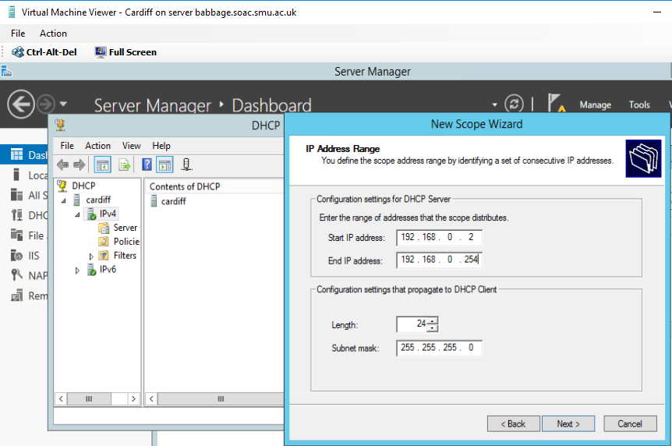
Figure 17 setting up DHCP scope for 0 Network on Cardiff
We chose not to exclude any addresses from the range at this point as we suspect that the now statically assigned Lab machine address is intended to be assigned by the DHCP server.

- At the Select Network Connection Bindings screen choose an appropriate Network Connection adapter.
Do not add an exclusion. okay
An 8 day lease is fine, and normal for a wired connection. 8 days it is
- Select “Yes” and continue.
- Enter the IP address Cardiff on the relevant network and hit “Add”.
- Immediately hit “Next” on the DNS and WINS options.
- Select “Yes, I want to activate this scope now.”

All above instructions followed without a hitch.

Part B: [DHCP Client obtains a leased IP address]

[Complete this task from Swansea]

- Login to the server if needed.
- Choose Start – Control Panel – double click Network Connections.
- Right click the Partner Network Connection

We are assuming you mean the 11 network that Swansea was connected to Cardiff with previously?? Ah, no we just set up

- Choose Properties
- Choose Internet Protocol (TCP/IP) click Properties.
- Check on the Obtain IP address automatically option.
- Check on the Obtain DNS Server address automatically option
- Choose Ok – Close

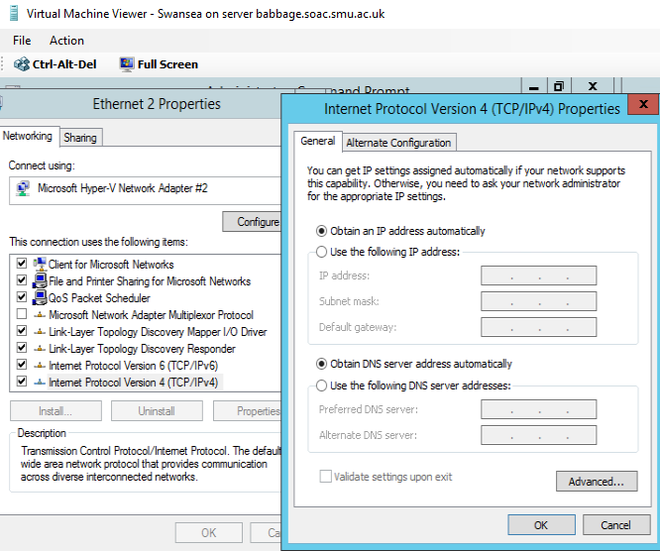
Figure 18 Swansea 0 network (Ethernet 2) connection set to obtain IP address from DHCP server

- Start – Run – cmd
- Type: ipconfig /release

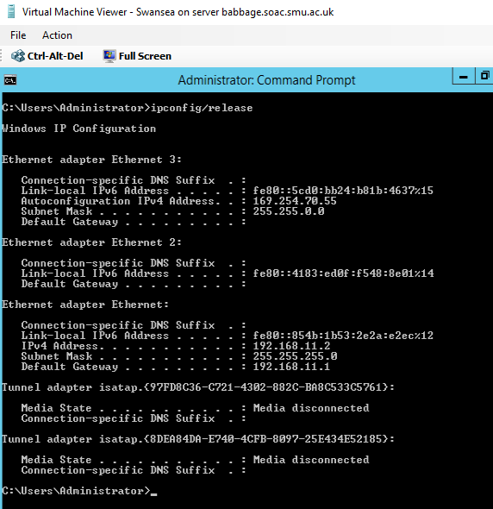
Figure 19 releasing the IP address of Swansea 0 network so that the DHCP server is free to assign it

- Type: ipconfig /renew (to obtain an IP address from DHCP Server)

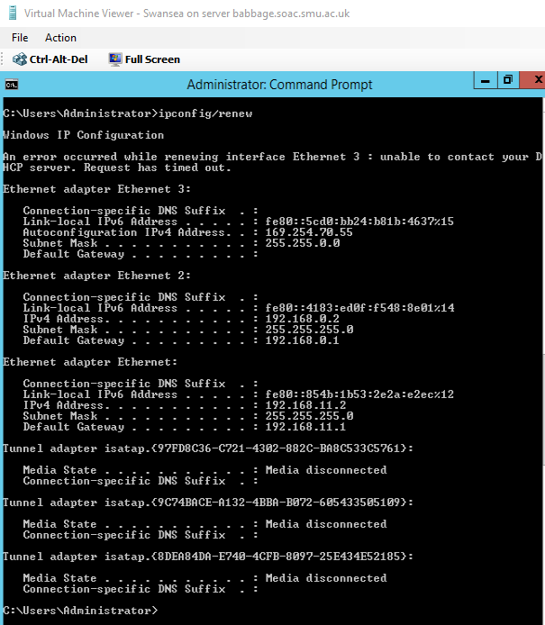
Figure 20 ipconfig/renew results on Swansea
The statically assigned IP address stands. The Apipa address that was on ) network interface (Ethernet 2) has been replaced by DHCP server to the first address in its range.

- Type: ipconfig /all

Verify that the DHCP server IP Address for the Partner Network Connection, is the IP Address of Swansea server.

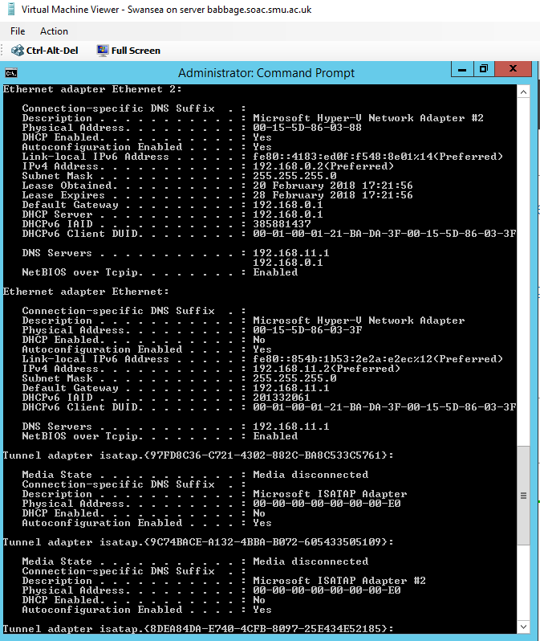
Figure 21 DHCP server address of 0 Network (ethernet 2) is Cardiff's 0 Network address, not Swansea's.
I believe that is correct as we just set up Cardiff to be the DCHP server.

[Complete this task from Cardiff]

- Start – Administrative Tools – DHCP Console
- In the console tree - Click Address Leases, verify that the Computer Name displayed is that of your Partners Computer.

Task 5: Configuring DHCP reservations
Configuring DHCP reservations.

[Complete this task from Cardiff]

- Navigate to Start – Administrative Tools – DHCP.
- Expand the server name, then IPv4 and select “Address Leases”.
- You should see a single lease: 192.168.0.2 – Swansea. We’ll convert this into a reservation.

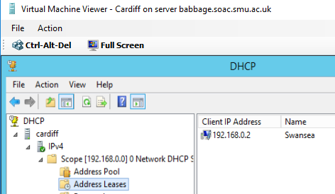
Figure 22 tyhe lease for the only dynamically assigned Address, that of Swansea's 0 Network

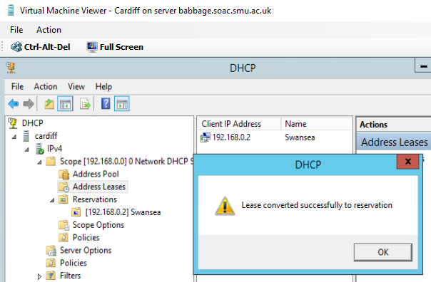
Figure 23 the dynamically assigned address is now reserved

Stopping here for the day, will resume tomorrow, Wednesday
Dual my illness I wouldn’t carry on with this part of the work. - Adam
- Right click the reservation and select “Add to reservation”. This will convert the lease into a reservation. This is the easy way to create a reservation when a lease already exists.

We’ll now create a lease for a computer for which we do not have a lease.

[Complete this task from the Windows 7 client]

- Start – Computer – Right click Network and select “Properties”.
- Change adapter settings.
- Select the 0 network and choose “status”.
- “Details”.
- Copy (exactly) the “physical Address”. It should be in the format 00-00-00-00-00-00, e.g. 00-15-5D-86-03-3F. Close this.

[Complete this task from Cardiff]

- Navigate to Start – Administrative Tools – DHCP.
- Expand the server name, then IPv4 and right click “Reservations” and select “New Reservation.
- Set the reservation name to “Lab-01-01” and the IP address 192.168.0.5.
- Set the MAC Address to the physical address noted above. This must be exact.
- Select “Add”.

[Complete this task from the Windows 7 client]

- Start – cmd.
- Type “ipconfig /release”
- Type “ipconfig /renew”
- Type “ipconfig” – what IP address has been obtained?

[Complete this task from Cardiff]

- Change the reservation for the Windows 7 client to give it the IP address 192.168.0.3.

[Complete this task from the Windows 7 client]

- Start – cmd.
- Type “ipconfig” – what IP address has been obtained? Has it changed? If not, why not?
- Again, release and renew the IP address. Has it changed now?

Task 6: Observational Tasks:
Q). Define the role of the DHCP Server in your Network?
Q). What happens when we have dynamically configured TCP/IP for our NIC, but then consequently cannot contact a DHCP server?
Q). Illustrate (with illustrations!!) the 4 stage process involved when DHCP clients look to obtain an IP address via DHCP?

Q). Describe the advantages of using a relay agent. Explain (with descriptions and illustrations) how and why we would setup the Relay Agent on our Router?

You will find the Answers for this Question are on the bottom of the very page.

Questionnaire task sheet assignment

Student: Adam McGowan

Lecture: Tim Bashford

Table of Contents
Worksheet 1 3
Task 5: Additional Observation Tasks: 3
Worksheet 2 4
Task 6: Observational Tasks 4
Worksheet 3 6
Task 6: Observational Tasks: 6
Worksheet 4 7
Task 4: Observational Tasks 7
Worksheet 5 9
Task: 9
References 11

Worksheet 1

Task 5: Additional Observation Tasks:
Ensure these tasks are answered in appropriate detail and the sources and source materials are referenced using the IEEE Referencing system.
- Identify the benefits of Type 1 Hypervisor software services and briefly evaluate some suitable products.
  - Type 1 Hypervisor software has a fast direct connection of input and output at one way at a time to the operation system to hypervisor and to the host.
  - Type 1 hypervisors are gaining popularity because building the hypervisor into the firmware is proving to be more efficient. [2]
  - With a type 1 hypervisor, there is no operating system to load as the hypervisor that you load IS the operating system. [3]

- Define the role of Routers in the Network Architecture, what types can be used?
  - To connect routers to other networks or multiple computer networks, router are small or big and can be wired or wireless. Routers have a small operation system built in, routers doesn’t require keyboard or display. [4]

- Identify and discuss the usage of common Routing Protocols, what are the associated benefits of using Routing Protocols?
  - A common Routing Protocols of its purpose is to learn of available protocols exist and each router calculates what route is the best.
  - Some of the most common routing protocols include RIP, IGRP, EIGRP, OSPF, IS-IS and BGP. [5]

- Define the role of Routing Tables, what are they. Breakdown and analyze the information a Routing Table provides us with.
  - A routing table is when information is match of its destination when the network examines the packet to where it goes and workout how to send it there. The table also stores information on IP networks and how they can reach directly or indirectly.
  - The table then provides the device with instructions for sending the packet to the next hop on its route across the network. [6]
  - Because all IP nodes perform some form of IP routing, routing tables are not exclusive to IP routers. Any node loading the TCP/IP protocol has a routing table. [7]

- What is the Subnet Mask, what is the significance of this in the Routing Table?
  - Subnet Mask is an organization that masks Addresses network into subnets, to protect IP and Addresses it turns the true address that is assigned into a hidden private number or combination or pin number.
  - It is fixed for the organization. The host address is the part that can be assigned by the organization. This is the variable part, and can assigned any combination of 0s and 1s by the organization. [8]

Worksheet 2

Task 6: Observational Tasks
Observational Tasks:

Q1). Describe (using appropriate illustrations) how the ARP process operates in Networking Contexts?
  - ARP is a mapping IP address so that a physical machine address is recognize the local network.
  - IP Version 4, the most common level of IP in use today, an address is 32 bits long. [9]
  - The internet needs ARP to translate IP networks address that runs on Ethernet and Wi-Fi in order to function.
  - ARP operates at Layer 2 in the OSI model. Protocol support is implemented in the device drivers of network operating systems. [10]

Q2).
- What is Packet Filtering? In our context,
  - This is part of a firewall that is protecting the network from unwanted hackers, unwanted intrusion.
  - On the Internet, packet filtering is the process of passing or blocking packets at a network interface based on source and destination addresses, ports, or protocols. [11]
  - As part of the overall security plan, a firewall restricts access from one network to another network, with the goal of reducing or preventing the spread of unwanted or malicious programs or data. [12]
- Why Packet Filtering is termed ‘IP Packet’ Filtering?
  - So that security is provided to the router and that it can allow or disallow by administrator standby.
  - IP packet filtering is an important element of connecting corporate intranets to public networks like the Internet. [13]
- Why would you use Packet Filtering in your Network?
  - The benefits of using packet filtering in network is the firewall program tools can block access to anything coming from the internet as unwanted intrusion.
  - Packet filtering firewalls is the first generation of firewalls. Packet filters track the source and destination address of IP packets permitting packets to pass through the firewall based on rules that the network manager has set. [14]
- What are the perceived benefits?
I do not understand this question.

Q3). Why is it possible for contradictory filters to occur when you use packet filtering? Give an example of a Contradictory Filter:

  - The inbounds and outbounds can be created to allow what the user wants into the network. If there a server that is not allowed on a private network, it can be blocked by putting it’s IP address into the networks inbound or outbound, this will prevent the unwanted host in as it will time out.
  - it is possible to create contradictory filters. For example, the input filter on one interface allows the inbound traffic but the output filter on the other interface does not allow the same traffic to be sent. The end result is that the traffic is not passed across Router. [15]

Q4). FTP Server is just one Role/Service we can configure our Server to provide? What other roles can the Server provide that would benefit our Infrastructure in both a local and remote context?
  - The FTP which is called Files Transfer Protocol is a standard network used to transfer files to a computer that is either part of a server or a client. This can be created by making files and putting them into the c program system then adding an upload and download with text - note. Then the user has to make a username and password so that the user can connect anonymously in secured.
  - FTP is built on a client-server model architecture and uses separate control and data connections between the client and the server. [16]

Worksheet 3

Task 6: Observational Tasks:
Q). Define the role of the DHCP Server in your Network?

  - A DHCP server role is to enable automatic private IP addresses to assign a network as it holds a pool of IP address for each network.
  - DHCP (Dynamic Host Configuration Protocol) is a server service that dynamically assigns, or leases, IP addresses and related IP information to network clients. [17]

Q). What happens when we have dynamically configured TCP/IP for our NIC, but then consequently cannot contact a DHCP server?

  - I think the TCP/IP gains a high overhead protocol and requires configuration than DHCP server.
  - TCP/IP network, each network client must have a unique IP address and an appropriate subnet mask. Without these items, a client cannot communicate on the network. [17]

Q). Illustrate (with illustrations!!) the 4 stage process involved when DHCP clients look to obtain an IP address via DHCP?

  - DHCP 4 stage in process involved with the clients is: First: DHCPDISCOVER it when the clients can request or broadcast. Second: DHCPOFFER is when the DHCP server can offer network to clients. Third: DHCPREQUEST is when clients asks for IP address from the DHCP offer, and Fourth: DHCPACK it when a new clients join the DHCP server and the DHCP acknowledge the client that it joined and the DHCP updates it’s database.
  - DHCP is a client-server protocol that uses DHCP servers and DHCP clients. A DHCP server is a machine that runs a service that can lease out IP addresses and other TCP/IP information to any client that requests them. [18]

Q). Describe the advantages of using a relay agent. Explain (with descriptions and illustrations) how and why we would setup the Relay Agent on our Router?

  - The relay agent has a password protection.
  - It can enter a global mode.
  - It supports the BOOTP for all clients.

  - DHCP relay agent is any host that forwards DHCP packets between clients and servers. [19]
  - The relay agent supports the server when remoting clients network.
  - Network booting – Clients can use DHCP to obtain the information that is needed to boot from a server on the network. [20]
  - Large network support – To make DHCP support for large networks better: [20]
    - The deployment of DHCP servers can be centralized or decentralized. [20]
    - SC DHCP provides failover between servers, so that when one server fails, the other will cover for it. [20]

Worksheet 4

Task 4: Observational Tasks
Q). What steps does a client take (what is the process involved) when trying to resolve a Name to an IP address?

  - Steps1: to resolve an IP address is to open “cmd” from run and type in the host name this will check the host is active or not.
  - Step2: is to go into my computer but right click on it and view properties click on that and then verify the full computer name.
  - Step3: back to “cmd” in run and type in “ns_lookup host _name”
  - Step4: ping host name this will tell you if out of reach or no media.
  - Step5: goto network right-click open network and share center this then takes you to the network
  - Step6: click on connections that might say “local area connections”
  - Then click on properties and then goto internet protocol version 4
  - Click on properties and you can either obtain an IP address automatically or use the following IP address.
  - Step7: If picked use the following IP address type in the IP for that computer host which might come up in “cmd.” This might fix the resolve.
  - Domain names or IP addresses on a local computer can be resolved by adding entries in the local hosts file on a computer. [21]

Q). Describe how the Recursive Query and Iterative Query Processes resolve DNS Client Requests?

  - When the client requests from the DNS server it either record or error in a message that tells the client the name or file doesn’t exist.

  - Recursive name queries are generally made by a DNS client to a DNS server, or by a DNS server that is configured to pass unresolved name queries to another DNS server, in the case of a DNS server configured to use a forwarder. [22]

Q). Explain the significance of root hints and how this process enables us to resolve names that are not managed (or kept in an authoritative DNS server in our network)?

  - The significance of root hints are when the DNS server stores data, it has a list of records so that the DNS server can use to locate other DNS servers
  - Root hints are used to prepare servers authoritative for non-root zones so that they can learn and discover authoritative servers that manage domains located at a higher level. [23]
Q). We have a Server called Server1, this server will be hosted in a subdomain called ‘subcontA’ with a root domain called nwtraders.msft, answer the following questions:

(1). What is the exact FQDN for this host.
  - FQDN is called Fully Qualified Domain Name, it is for a computer or a host on the internet.
  - The FQDN consists of two parts: the hostname and the domain name. For example, an FQDN for a hypothetical mail server. [24]
(2). Illustrate how the Domain Name System breaks up this FQDN into Host and Domain Namespace.
  - The internet needs and supports the use of a host name to identify both the clients and server. But most important use is a database system known as DNS which DNS runs an application on the internet using the IPV4 or 6, maybe both. Namespace is a set of all names that the DNS use, in the so-called top level domain.
  - DNS is a distributed client/server networked database used by TCP/IP applications to map between host names and IP addresses (and vice versa), to provide capabilities like electronic mail routing information and service naming. [25]
  - Another example to explain the host and namespace: In school, the little kids in primary school look up to the big kids in secondary school. But on the Internet, it’s just the opposite: The big kids are the primary name servers. [26]

Q). Explain how DNS Zones are used in DNS, give examples to illustrate the use of multiple zones and how these can be used to manage resource records of domains. What important factors/characteristics do we need to be aware of?

  - The DNS Zones contain all domain and subdomain names for an example: domain com(for United State)
  - A DNS Zone is a portion of the DNS namespace that has been delegated to other servers/administrators. [27]

Worksheet 5

Task:
A 3-tire web application is an program that organize 3 major parts of a network.
- Workstation which the program gives the user graphical interface which kept on hard disk.
- Business logic acts as a server for clients and requires workstation for clients to use access in graphical interface to which data need for programming which located on hard disk or mainframe.
- Database and programming that reads and writes for the business and workstation this is the third tier which is in a large scale.
Each of the tiers uses clients and server to work on the computer and these three programs act as a packager, the Enterprise uses these software’s to keep all clients and server in order and tidy so nothing is not missing or gone, they also act as a type of cluster so that more than one computer can work on one server than separate. This is bad as there could be failures that can be a disaster to anyone using the computer with unsaved work that could go missing or destroyed, as this could be faults in hardware or power supplies.
3-tier application uses the client/server computing model. Because the programming for a tier can be changed or relocated without affecting the other tiers, the 3-tier model makes it easier for an enterprise or software package. [28]
Server clusters are designed for applications that have long-running in-memory state or frequently updated data. Typical uses for server clusters include file servers, print servers, database servers, and messaging servers. [29]

References

[1] | "DHCP Reservation," TECH-FAQ, [Online]. Available: http://www.tech-faq.com/dhcp-reservation.html. [Accessed 21 Feburary 2018].
[2] | "What's the difference between Type 1 and Type 2 hypervisors?," SearchServerVirtulization, 2018. [Online]. Available: http://searchservervirtualization.techtarget.com/feature/Whats-the-difference-between-Type-1-and-Type-2-hypervisors. [Accessed 19 Feburary 2018].
[3] | D. Davis, "What Is a Type 1 Hypervisor?," Virtualization Software, 12 May 2013. [Online]. Available: http://www.virtualizationsoftware.com/type-1-hypervisors/. [Accessed 19 Feburary 2018].
[4] | B. Mitchell, "What Is a Router for Computer Networks?," lifewire, 13 November 2017. [Online]. Available: https://www.lifewire.com/how-routers-work-816456. [Accessed 19 Feburary 2018].
[5] | S. Hummel, "Understanding Network Routing Protocols," Router Freak!, 13 April 2010. [Online]. Available: https://www.routerfreak.com/understanding-network-routing-protocols/. [Accessed 19 Feburary 2018].
[6] | M. Rouse, "routing table," TechTarget, April 2007. [Online]. Available: http://searchnetworking.techtarget.com/definition/routing-table. [Accessed 19 Feburary 2018].
[7] | "IP Routing Table," TechNet, [Online]. Available: https://technet.microsoft.com/en-us/library/cc958823.aspx. [Accessed 19 Feburary 2018].
[8] | "Subnet Masking and Routing," DePaul University, [Online]. Available: http://condor.depaul.edu/sjost/361/materials/SubnetMask.html. [Accessed 19 Feburary 2018].
[9] | M. Rouse, "Address Resolution Protocol (ARP)," SearchNetworking, September 2005. [Online]. Available: http://searchnetworking.techtarget.com/definition/Address-Resolution-Protocol-ARP. [Accessed 20 Feburary 2018].
[10] | B. Mitchell, "ARP - Address Resolution Protocol," Lifewire, 5 Janurary 2018. [Online]. Available: https://www.lifewire.com/address-resolution-protocol-817941. [Accessed 20 Feburary 2018].
[11] | M. Rouse, "packet filtering," SearchNetworking, [Online]. Available: http://searchnetworking.techtarget.com/definition/packet-filtering. [Accessed 20 Feburary 2018].
[12] | B. D. Blansit, "Journal of Electronic Resources in Medical Libraries," Taylor & Francis Online, 4 September 2009. [Online]. Available: http://www.tandfonline.com/doi/abs/10.1080/15424060903167377?src=recsys&journalCode=werm20. [Accessed 20 Feburary 2018].
[13] | "IP Packet Filtering," TechNet, [Online]. Available: https://technet.microsoft.com/en-gb/library/cc957881.aspx. [Accessed 20 Feburary 2018].
[14] | "Analysis of Packet Filtering Technology in Computer Network Security," Department of Computer Science and Engineering, Sant Gadge Baba Amravati University, India, 4 April 2014. [Online]. Available: http://www.academia.edu/6916852/Analysis_of_Packet_Filtering_Technology_in_Computer_Network_Security_. [Accessed 20 Feburary 2018].
[15] | "IP Packet Filtering," TechNet, [Online]. Available: https://technet.microsoft.com/en-gb/library/cc957881.aspx. [Accessed 20 Feburary 2018].
[16] | B. A. Forouzan, "TCP/IP Protocol Suite (Fourth Edition)," in TCP/IP Protocol Suite (Fourth Edition), New Delhi, India, Tata McGraw-Hill Education Pvt. Ltd., 2010.
[17] | "INSTALLING AND CONFIGURING DHCP," dummies Awiley Brand, [Online]. Available: http://www.dummies.com/programming/certification/installing-and-configuring-dhcp/. [Accessed 20 Feburary 2018].
[18] | "Dynamic Host Configuration Protocol (DHCP)," The Network Encyclopedia, 2013. [Online]. Available: http://www.thenetworkencyclopedia.com/entry/dynamic-host-configuration-protocol-dhcp/. [Accessed 21 Feburary 2018].
[19] | "Chapter: Configuring the Cisco IOS DHCP Relay Agent," IP Addressing: DHCP Configuration Guide, Cisco IOS Release 15SY, [Online]. Available: https://www.cisco.com/c/en/us/td/docs/ios-xml/ios/ipaddr_dhcp/configuration/15-sy/dhcp-15-sy-book/dhcp-relay-agent.html. [Accessed 21 Feburary 2018].
[20] | "Advantages of Using DHCP," ORACLE working with DHCP in Oracle Solaris 11.1 , 2012. [Online]. Available: https://docs.oracle.com/cd/E26502_01/html/E28991/dhcp-overview-12a.html. [Accessed 21 Feburary 2018].
[21] | "Resolving host names with a DNS server," IBM Knowledge Center, [Online]. Available: https://www.ibm.com/support/knowledgecenter/en/SS9JLE_8.2.0/com.ibm.itamesso.doc/concepts/resolving_host_ip_dns_host.html. [Accessed 21 Feburary 2018].
[22] | "Recursive and Iterative Queries," TechNet, [Online]. Available: https://technet.microsoft.com/en-us/library/cc961401.aspx. [Accessed 21 Feburary 2018].
[23] | "What is Root Hints?," IT.geared, 28 October 2011. [Online]. Available: http://www.itgeared.com/articles/1134-whats-is-root-hints/. [Accessed 21 Feburary 2018].
[24] | "About fully qualified domain names (FQDNs)," INDIANA UNIVERSITY, 20 December 2017. [Online]. Available: https://kb.iu.edu/d/aiuv. [Accessed 21 Feburary 2018].
[25] | "Chapter 11. Name Resolution and the Domain Name System (DNS)," Shichao's Notes, [Online]. Available: Feburary. [Accessed 21 Feburary 2018].
[26] | "Serving Up DNS (The Domain Name System) (TCP/IP) Part 2," what-when-how In Depth Tutorials and Information, [Online]. Available: http://what-when-how.com/tcpip/serving-up-dns-the-domain-name-system-tcpip-part-2/. [Accessed 21 Feburary 2018].
[27] | "DNS Zones Explained," Think Like A Computer, 11 June 2011. [Online]. Available: https://www.think-like-a-computer.com/2011/06/11/dns-zones-explained/. [Accessed 21 Feburary 2018].
[28] | "3-tier application," TechTarget, April 2007. [Online]. Available: http://searchsoftwarequality.techtarget.com/definition/3-tier-application . [Accessed 21 Feburary 2018].
[29] | "What Is a Server Cluster?," TechNet, 28 March 2003. [Online]. Available: https://technet.microsoft.com/en-us/library/cc785197(v=ws.10).aspx. [Accessed 21 Feburary 2018].
[30] | "About fully qualified domain names (FQDNs)," INDIANA UNIVERSITY , 2018. [Online]. Available: https://kb.iu.edu/d/aiuv.

