Reflective Account of Multi and Inter-Disciplinary Working for WAST Digital Plan 2024-2029

I confirm this essay is my own original work and does not include text created by a generative artificial intelligence tool.

Charlotte Griffin – Student ID 2507539

Stakeholder Identification

Stakeholder identification is the first step in developing a stakeholder engagement and communication plan, taking time to gain stakeholder input at the start of a plan or project will go on to positively influence its success (Hyseni et al., 2018).
Within the Welsh Ambulance Services University NHS Trust (WAST) Digital Plan for 2024-2029 stakeholders are referred to in generic terms rather than being explicitly referenced and uniquely identified (Welsh Ambulance Services University NHS Trust, 2024). “Patients” and “the people of Wales” are terms used throughout the plan, the main aims it sets out are to improve outcomes and safety for patients, they are a key beneficiary and external stakeholder of the plan. Internal stakeholders that are referenced in the plan include WAST staff, identified as “our people/our staff”, volunteers are also referred to alongside WAST staff. Staff play a key internal role in the plan, many of its aims are to bring improvements that directly benefit staff and the plan also highlights the role staff play in its realisation. The plan names “system partners” as being involved in delivering care and in relation to enabling digital interoperability, however these partners aren’t systematically named or listed in the plan itself.
Referencing these three groups does keep the plan concise and accessible which means more people can read and understand the plan, it also shows the main beneficiaries of its aims. It also avoids issues from the stakeholder list becoming out of date or missing less visible groups.
However, I find that the plans reference to stakeholders is vague and doesn’t give clear information on how they will be engaged or communicated with. The lack of clarity can make the plan appear ambiguous and doesn’t give clear ownership and accountability. The plan could be strengthened by giving further clarity regarding its stakeholders and listing them individually. I believe that there are other key stakeholders that are not named in the plan but that play an important role in the plans aims. Shown below in Table 1 is a list of stakeholders which includes additional stakeholders that I have identified and believe should have been included in the plan along with details of how they would contribute to the strategy.

Table 1 - WAST Digital Plan Stakeholders
Stakeholder | External/Internal | Named explicitly in plan | Details
Patients | External | Yes | Main beneficiary of the plan, users of WAST services
WAST Staff | Internal | Yes | Beneficiary of plan, also play key role in bringing about aims
WAST Volunteers | Internal | Yes | Further beneficiary of the plan and co-collaborator with staff.
Welsh Government | External | No | Provides funding and policy, accountable to for performance
Local Health Boards | External | No | Shared patient records, interoperability requirements
Primary Care Services | External | No | Shared patient records, interoperability requirements
Digital Health Care Wales | External | No | Provides digital systems and national infrastructure
Trade Union Partners | External | No | Staff engagement and input to how digital changes affect staff
Suppliers | External | No | Provide systems, software and hardware
Local Authorities | External | No | Involved in multi-disciplinary patient care and sharing of records
Emergency Services (Police/Fire) | External | No | Share digital and communication systems, work in collaboration in response to incidents
Academic/Research Partners | External | No | Develop and research digital innovations

When the plan speaks about WAST staff they are referred to as one collective group. I think this could be broken down into specific staff groups/directorates, doing this increases ownership and buy-in of all staff and ensures that the plan isn’t viewed as only applying to staff within the Digital Directorate. If staff feel included, especially by leadership, and part of the plan, they are more likely to engage with it and bring about its aims (Mazzetti & Schaufeli, 2022).

Stakeholder Engagement

Effective stakeholder management and engagement is vital for the success of a plan or project, it needs to be ensured that the range of stakeholders all feel that they are appropriately engaged and included in the development and implementation of a plan (Tampio et al., 2022). Different stakeholders will require different approaches and levels of engagement, one way to determine which stakeholders require which approach is to use a power-interest matrix to categorise them. Stakeholders can be mapped according to their levels of power to influence the plan and their interest in the plan and then spilt into four categories which will then determine engagement levels (Abolhasni et al., 2024).

A weakness of the WAST Digital Plan is that is doesn’t include any clear details on how it will engage with its stakeholders, communication plans or how it will receive feedback from stakeholders. Based on Stakeholder Theory (Brugha & Varvasovszky, 2000), I have used a power-interest matrix to map the identified stakeholders that I identified in Table 1 in the WAST Digital Plan, as shown in Figure 1:
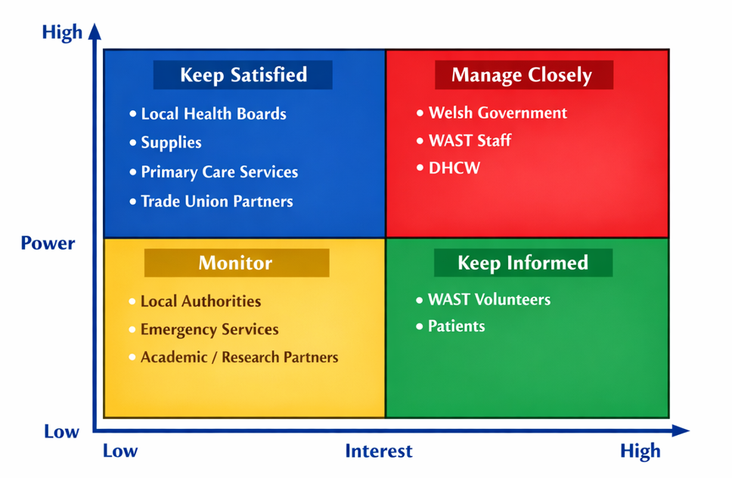
Figure 1 - Power-Interest Matrix - WAST Digital Plan Stakeholders
Once stakeholders have been split into the four different categories in the power-interest matrix this can then define how they are engaged and communicated with. Different positions in the matrix require different approaches and adjusted communication methods. Engagement can be adjusted for the different groups and can take place via different mediums such as face-to-face meetings, email updates, newsletters, access to website/blogs. Tailoring the engagement approaches to stakeholder categories ensures that individuals receive an appropriate level of communication, supporting continued involvement, aware of any changes or updates and effective implementation of the plan (Potthoff et al., 2023).

Communication & Methods

From my experience engaging with a large staff team can present communication challenges to make sure that everyone feels included, can give their feedback, and are kept up to date with developments. In my own area of work my preferred method of communication is to send updates via email to team leaders which can then filtered down directly to team members. This communication can feel more personalised for staff when it comes from their line manager, and my experience has been they are more likely to engage and take on board information in this way. I have experienced a negative side of this approach, that when I have shared an update regarding a change to pharmacy services one team leader did not share the update with their team. This meant some staff were not aware of the changes which led to confusion and reported errors as staff thought records were not displaying correctly. I have learnt from this that it is important to follow up with team leaders to confirm that information has been fully distributed.
When WAST introduced new ambulance performance framework changes, which impacted the way staff categorised and managed calls, to assist staff multiple engagement sessions were run, consisting of drop-in training, FAQ sessions and presentations. Running multiple sessions across different days and times gave a wide range of staff members the opportunity to attend. Due to multiple sessions group sizes remained small, which meant that participants were more included, the sessions were tailored to suit the groups needs and it created opportunities for questions to be asked, which is not always possible in larger groups. Feedback was gathered from staff after the sessions through online forms, feedback was overall positive and staff felt well prepared for the changes and that they had opportunities to raise concerns and ask questions. This feedback was used to shape future engagement sessions. I believe that this approach would be well suited for engaging with stakeholders when implementing a digital strategy. Stakeholder theory recognises that a uniform approach to engagement and communication is ineffective when working with a diverse range of stakeholders (Buhmann et al., 2025). As a “one size fits all” approach is not suitable when engaging with a diverse range of stakeholders, being able to adapt to individual groups overcomes this barrier. The frequency, length and content of the sessions can also be adapted to suit the specific needs of the stakeholder group (Petkovic et al., 2023). Groups can be created based around the power-interest matrix and engagement methods be adapted flexibly to suit the needs of each group, exampled engagement and communication methods are shown in Figure 2:

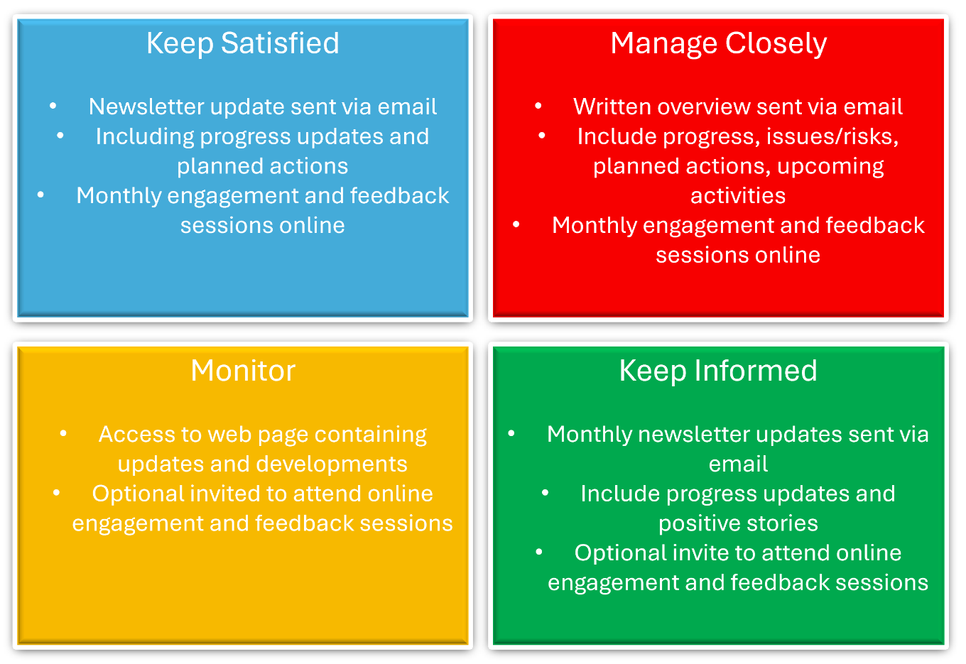
Figure 2 - Engagement and communication methods matrix

Consensus & Groupthink

The term groupthink was first introduced by Irving Janis and happens when a decision-making group agree a decision that reflects a perceived group consensus, often to avoid conflict and isn’t the correct or best decision (Schmidt, 2025). Groupthink brings about a unanimous and cohesive decision over the application of rational and critical decision-making (F.Baumeister & D.Vohs, 2007). This can also mean that less assertive members of a group feel unable to contribute their opinion and are overshadowed by more assertive and dominant group members.
There is a danger of this happening with stakeholder groups, I have had personal experience of groupthink when being in a project meeting. The group was tasked with coming to a decision to name a new tool being used in the service. I observed that once one name had been suggested the group was quick to agree to this suggestion rather than discuss further and provide other alternatives. In the following meeting this issue was raised again and at this time groupthink was avoided as a discussion in deeper detail looking at the possible implications on a new name were addressed and a different decision was made. If this discussion had taken place in the first meeting the groupthink would not have taken place, an appropriate decision would have been made sooner, and unnecessary work and changes would have been avoided. If this decision hadn’t been readdressed there could have been negative impacts on the new tool and its benefits to staff and patients.
Within Janis’ original work on groupthink theory (Janis, 1983), suggestions were made of ways to overcome it and allow a group to work towards a consensus, these suggestions have been adapted to suit healthcare settings successful, examples include appointing a critical evaluator in the group to actively challenge suggested ideas through critical evaluation and being “devil’s advocate”, a role which should be rotated within the group. Leadership members should take the lead in creating a culture that can challenge and debate without penalty. Larger groups should be broken down into smaller subgroups with rotating members (DiPierro et al., 2022). A further strategy and one that I believe could prove most effective is training group members to have an awareness of the concept of groupthink so that they can actively look for and challenge it when it takes place. If members aren’t consciously aware of the possibility of this happening, they are unable to challenge it (Harper et al., 2025). In my opinion, a suitable strategy to avoid groupthink would be to be train staff on groupthink and then routinely address it at the start of meetings, to remind all members that they all have valuable insights and that it is crucial that everyone is heard. This would reinforce that the team needs to avoid falling into groupthink.

References

Abolhasni, M. S., Horoki, A. Z., Sadegh Abolhasani, M., Khah, E. S., Heydaripour, M., & Zarezadeh, M. (2024). Identifying Barriers to the Adoption of Electronic Prescribing: A Stakeholder Analysis Approach Using a Power-Interest Matrix. https://doi.org/10.18502/jebhpme.v8i3.18076
Brugha, R., & Varvasovszky, Z. (2000). Stakeholder analysis: a review. Health Policy and Planning, 15(3), 239–246. https://doi.org/10.1093/HEAPOL/15.3.239
Buhmann, K., Fonseca, A., Andrews, N., & Amatulli, G. (2025). The Routledge Handbook on Meaningful Stakeholder Engagement. Routledge International Handbooks. https://openurl-ebsco-com.uwtsd.idm.oclc.org/contentitem/e001mww:4018457?sid=ebsco:plink:crawler&id=ebsco:e001mww:4018457&crl=c
DiPierro, K., Lee, H., Pain, K. J., Durning, S. J., & Choi, J. J. (2022). Groupthink among health professional teams in patient care: A scoping review. Medical Teacher, 44(3), 309–318. https://doi.org/10.1080/0142159X.2021.1987404
F.Baumeister, R., & D.Vohs, K. (2007). Groupthink. Encyclopedia of Social Psychology, 402–402. https://doi.org/10.4135/9781412956253
Harper, L., Kiamanesh, O., Coderre, S., Kelly-Turner, K., Davis, M., & McLaughlin, K. (2025). Twelve tips to optimize group decision-making in medical education: “Tipping” the scales toward wisdom of the crowd and minimizing groupthink. Medical Teacher, 47(10), 1612–1617. https://doi.org/10.1080/0142159X.2025.2488326
Hyseni, L., Guzman-Castillo, M., Kypridemos, C., Collins, B., Schwaller, E., Capewell, S., Boland, A., Dickson, R., O’Flaherty, M., & Lloyd-Williams, F. (2018). Engaging with stakeholders to inform the development of a computer model for the NHS Health Check programme: a qualitative study. The Lancet, 392, S45. https://doi.org/10.1016/s0140-6736(18)32879-4
Janis, I. L. (1983). The Groupthink Syndrome. Groupthink: Psychological Studies of Policy Decisions and Fiascoes, 174–197. puttincologneontherickshaw.com/authors-blog/the-groupthink=syndrome/
Mazzetti, G., & Schaufeli, W. B. (2022). The impact of engaging leadership on employee engagement and team effectiveness: A longitudinal, multi-level study on the mediating role of personal- and team resources. PLoS ONE, 17(6), e0269433. https://doi.org/10.1371/JOURNAL.PONE.0269433
Petkovic, J., Magwood, O., Lytvyn, L., Khabsa, J., Concannon, T. W., Welch, V., Todhunter-Brown, A., Palm, M. E., Akl, E. A., Mbuagbaw, L., Arayssi, T., Avey, M. T., Marusic, A., Morley, R., Saginur, M., Slingers, N., Texeira, L., Ben Brahem, A., Bhaumik, S., … Tugwell, P. (2023). Key issues for stakeholder engagement in the development of health and healthcare guidelines. Research Involvement and Engagement, 9(1). https://doi.org/10.1186/S40900-023-00433-6
Potthoff, S., Finch, T., Bührmann, L., Etzelmüller, A., van Genugten, C. R., Girling, M., May, C. R., Perkins, N., Vis, C., & Rapley, T. (2023). Towards an Implementation‐STakeholder Engagement Model (I‐STEM) for improving health and social care services. Health Expectations : An International Journal of Public Participation in Health Care and Health Policy, 26(5), 1997. https://doi.org/10.1111/HEX.13808
Schmidt, A. (2025, April 1). Groupthink | Psychology, Decision-Making & Consequences | Britannica. https://www.britannica.com/science/groupthink
Tampio, K. P., Haapasalo, H., & Ali, F. (2022). Stakeholder analysis and landscape in a hospital project – elements and implications for value creation. International Journal of Managing Projects in Business, 15(8), 48–76. https://doi.org/10.1108/IJMPB-07-2021-0179
Welsh Ambulance Services University NHS Trust. (2024). Our Digital Plan 2024 - 2029. https://ambulance.nhs.wales/files/publications/strategies-and-plans/wast-digital-plan-2024-2029/

