Assessment 2 Template
In class work
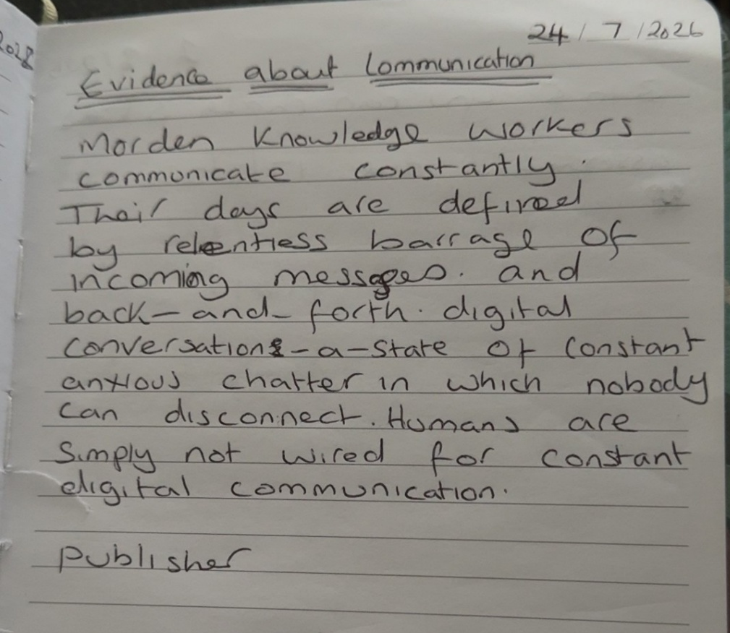
Complete the below TEEL tasks. Please note the use of AI is not permitted for this task.
- Read the paragraph below.
Identify the TEEL structure in the paragraph.

Write the correct part of TEEL next to each sentence in the square brackets.

- T: Topic Sentence
- EXP: Explanation
- E: Evidence / Example
- L: Link Sentence

Paragraph
[ T ] Using data to make business decisions improves efficiency and reduces risk. Many businesses now analyse data to guide pricing, stock levels, and planning. [E] Research from McKinsey Global Institute (2017) found that data-driven organisations are significantly more likely to acquire customers and be profitable than those that rely on intuition. [EXP] This shows that using data can directly improve business performance. [ ] It is not just about collecting information. [ ] Additionally, businesses must also use the data to make informed decisions. [ EXP ] For example, data can highlight which products are selling well and which are not. [ ] This allows managers to adjust quickly and reduce waste. [ ] Over time, these small decisions can lead to higher profits and better use of resources. [ L ] Overall, using data supports more accurate and effective business decision making.

- Find the cohesive devices in the above paragraph and highlight or underline them. Then fill in the answers for each below.

- Device: This shows Purpose: Referring to the research evidence
- Device: This allows Purpose: Explains the information shown by data
- Device: Additionally Purpose: Adds another point

- Choose the strongest topic sentence from the options below.

- Time management is important.
- Time management is important because it helps people organise their work.
- Time management is important because it helps employees prioritise tasks, meet deadlines, and reduce workplace stress, leading to higher productivity.

- Choose the strongest explanation sentence
Topic Sentence:
Good teamwork is important in the workplace because it helps employees achieve shared goals efficiently.
Which is the best explanation?
A) Teamwork happens in many workplaces.
B) When employees collaborate effectively, they can share ideas, solve problems faster, and support each other’s strengths.
C) Some people prefer to work alone.
- Choose the strongest evidence/example
Topic Sentence:
Workplace training is essential because it helps employees improve their skills and performance.
Explanation:
When employees receive proper training, they become more confident and capable in their roles.
Which is the best evidence/example?
a) Training is something companies often provide.
b) A study by LinkedIn (2023) found that 94% of employees said they would stay longer at a company that invests in their learning.
c) Employees go to work every day.

- Choose the best linking sentence
Topic Sentence:
Flexible working hours can improve employee satisfaction and productivity.
Explanation + Evidence:
When employees can manage their own schedules, they are better able to balance work and personal responsibilities. For example, many companies report increased performance after introducing flexible working policies.
Which is the best linking sentence?
A) Flexible working is becoming more common.
B) Employees like flexibility.
C) Overall, flexible working hours contribute to a more productive and satisfied workforce.

Write the final draft of your TEEL paragraph on your chosen topic here. This is the final draft of the paragraph you started in class!
TEEL FINAL DRAFT:
Communication is essential in the workplace as it improves teamwork, reduces misunderstandings, and increases productivity. In a workplace, when employees communicate clearly, they understand their roles, share information effectively, and work together to achieve common goals. Good communication also helps management teams to provide clear instructions and therefore resolve problems quickly. This is shown in a report by Gallup, which shows that organisations with highly engaged employees, experience higher productivity and better business outcomes. This shows that strong communication has a positive impact on both employees and overall company performance. Overall, communication in the workplace creates a more efficient, collaborative, and positive working environment, making it a key factor in the success of any business organization.
References
Gallup (2023) State of the Global Workplace: 2023. Washington, DC: Gallup. https://www.gallup.com/workplace/349484/state-of-the-global-workplace.aspx (Accessed: 2 August 2026).

