

BUSINESS SKILLS FOR INTERNATIONAL HOTEL INDUSTRY

Student name: Emilian Tuluca

Student number: 1814973

Module title:
Business Skills for International Hotel Industry

B4X 01917

Assignment Title: SWOT and PDP

Your Module Lecturer’s Name:
Dale Clarke

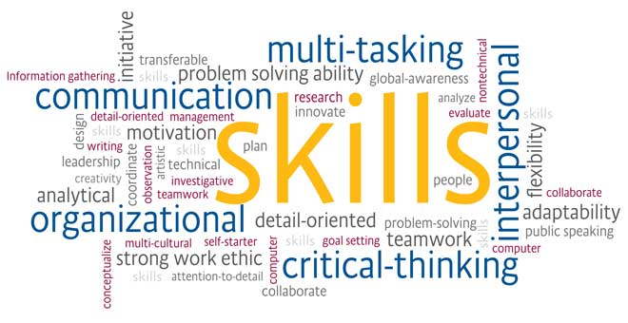

Contents

1. Introduction...............................................................Page 3
2. SWOT....................................................................Page 5-6
3. Skills to Develop.......................................................Page 7
4. My Personal Development Plan...............................Page 8
5. Conclusion..............................................................Page 10
6. References.............................................................Page 11

Introduction
Personal development is important for research to make your own call to future employers. Each individual has a different position to attack a top position In my desire to develop my academic and future engagement skills, I briefly analyzed the acquired acquisitions in which I would like to develop and perfect myself to enable me to advance my post as student and employee.
Comparative internal and external factors, I think analysis can be one of the most harder tasks, but it place a very important role in personal progress. The SWOT analysis of personal skills allows a radiograph of both cognitive and emotional availability. Taking a personal SWOT analysis is an important step towards finding a goal on quality and lifestyle, personal inherent development.
My Current Academic Skills:
- Organisational Skills- Keeping to deadlines, delegating if in charge of a project or task
- Note Taking- Analysing and asking the right questions that help me understand, write key words, keep well organized
- Critical Thinking- Information searching,
- Time Management- Keeping to deadline, Decision making
- Self-Discipline- change perception, Set clear goals
Academic Skills I Want to Develop:

- Digital Skills – IT skills, word processing, writing blogs, Microsoft office, Excel, PowerPoint
- Presentation Skills- Speaking to an audience and keeping them engaged
- Writing Skills- Analyse and write the important things that makes sense and to the point
-Leadership skills-to be able to lead a team
Having hiring features is very important because managers are looking for people who demonstrate employability, dinamic, initiative and have the ability to undertake various opportunities in different areas. To prove soft skills is of prime importance, this is a very important feature that the employer wants to identify with the employee.

My Current Employability Skills

- Team Work – Like working in a group
- Willingness to learn- Like learning new things
- Problem Solving – making decisions to help in the future
- Interpersonal Skills – Like building a rapport with peers, colleagues, client’s
Employability Skills I Want to Develop
- Presentation Skills-have clear information that is presented in reports, business plan, or presentation
- Leadership Skills – Want to be able to have self-confidence,
- Enthusiasm- Want to be able to stay positive and motivated in a task or project .
SWOT analysis is tool often used in the radiography of the present situation of a person, companies, being used to understand the internal environment, but also the external environment in which they operate.
The SWOT analysis is show out in the early phase of the drafting of the project, in the stage of identification and crystallization of the project idea. It allows for a correct radiography of society.
SWOT analysis describes the scientific achievement and brings in the situation where more work is needed. This type of analysis splits your qualities into the four classes: qualities, shortcomings, openings and dangers. A conceptualisation tool that allows you to think about critical analysis and strive to push the next steps, whether they focus a long-term goal, for example. The qualities and maladjustments are internal powers. My own SWOT under this will to commit myself to doing on key areas for me.
My SWOT which includes the following:

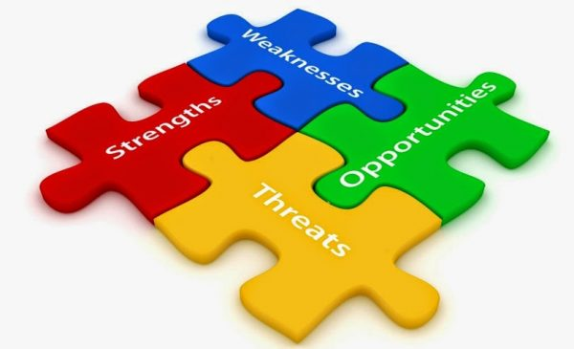

Strength  - Integrity  - Great Communication skills  - Goal orientated  - Responsible  - Problem solver  - Reliable  - Know-how-that I have | Weakness  - Very Limited experience  - Digital skills  - Writing  - Over think  - Too much attention to detail- Could affect time management, deadline
Opportunities  - Be my own bos  - New carcer direction  - More opportunities  - Grow in my own role  - Wider carcer prospects | Threat  • Ability technology change  • Hard competition  • Staying on top of assignments  • Possibility of not passing  • Staying on top of assignments

Skills to Develop
I understand that in order to acquire the qualities that recommend a very good student and a well-trained employee, you must always keep in mind the self-evaluation according to the standards regarding the competencies targeted by the company, by the current requirements.
For this, I will seek to improve my qualities, identify new opportunities for personal development, acquiring IT, specialty acquisitions that can enhance self-esteem and prestige.
Without the qualities targeted by the areas of interest, without the goals and objectives proposed, I understand that I will not have the desired success.
I will gradually take this step during the 2 years of my study, the period during which I will constantly analyze the scientific, cognitive, communication acquisitions and will continue to improve them in the medium and long term.

Personal Development plan
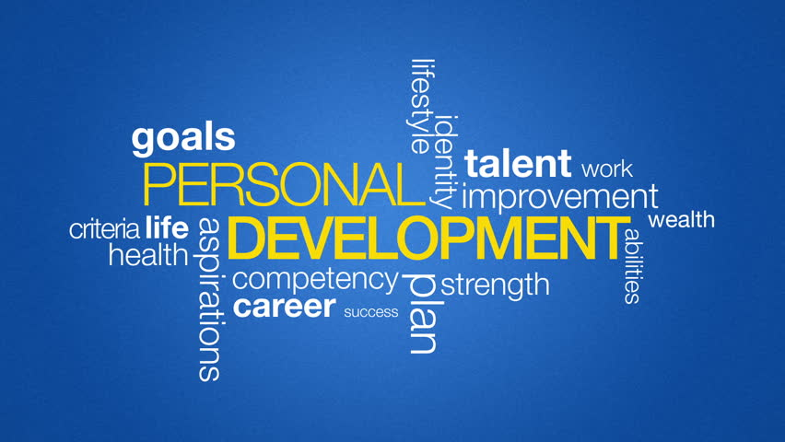

A professional development plan is widely used by both business people and students to set goals and to have a schedule of goals .My personal development plan includes:

-Improving my IT skills-
In the academic environment to progress it is vital, my knowledge to be constantly improved. By attending lessons I want to improve my IT skills. Over the next five years I hope to do on going learning of new IT skills by constantly researching and practicing.
-Improving my consistency –
There are a few areas where I improve my consistency immediately
-Eliminate Procrastination –
Being a procrastinator has caused me much anxiety as I am always on rush to get things done, as a result I found it necessary to make this an immediate goal which I will start working on. Over the next five years I hope to have a weekly diary of the upcoming events, which will be organized in terms of their priority. This will include things that happen in my school life as well as personal life, this will help me to stay on target and not procrastinate.
-Improving my presentation skills –
Presentation skills are very important. I have put into place some strategies that I believe may work in order to attain this goal. Immediately practicing is highly important, I will try to practice my presentation in front of my friends and get them to give their honest feedback, when given presentations I will make use of that opportunity test my improvements as well and then ask my lecturer
-Reducing my distractions –

Immediately plan to get a to do list, this will help me to have a clear view of what I need to get done and deadlines attached to this as well.

Conclusion
The values ​​set out in the hiring skills are skills and characteristics that, in principle, form a suitable person for a job. These are particularly important because they are the foundation for a job. Knowing and evaluating, acting and dynamizing can help anyone achieve their goal. Once I have identified my positive and negative aspects and set a realistic goal, I assume I am at the stage of awareness of my own values, which will allow me to find a job according to the developed skills during the years of study.

REFERENCE

- 2011-2018, (. (2018). Personal Development | SkillsYouNeed. [online] Skillsyouneed.com. Available at: https://www.skillsyouneed.com/ps/personal-development.html [Accessed 26 Nov. 2018].
- Bridgewater UK. (2018). What is a Personal Development Plan and What Can it Mean for you. [online] Available at: https://www.bridgewateruk.com/2016/09/personal-development-plan/ [Accessed 26 Nov. 2018].

