Marketing plan written for

Premier Inn

Student Name

Ridhwaanah Rifat Ahmed

Student ID number

2212158

Marketing Essentials BMIH4005

Lecturer

Luciana-Suardi

Introduction

The purpose of this marketing plan is to attract more customers to the Premier Inn on a rolling basis. The marketing plan is being prepared by the marketing department of Premier Inn and the aim of this marketing plan is to offer promotions to loyal customers. This includes discount cards and loyalty cards, for example ten stays at the Premier Inn will offer a one free stay on the app. Customers can also check into the app and find local nearby restaurants and takeaways that will offer discounts for Premier Inn customers.
To show the company’s marketing plan a SWOT analysis, PESTLE analysis and marketing mix has been used to gather information and show how successful this plan can be for Premier Inn.
Contributor C (2021) ‘A marketing plan is a document developed by company leaders and marketing professionals to guide product development, pricing strategies, distribution channel choices and messaging campaigns.’ Small Business Cron 5th October. Available at: https://smallbusiness.chron.com/purposes-marketing-plan-61663.html (Accessed: 31/11/2022)

Situation Analysis
5 'C's

Compliance (2022) ‘The situation analysis section of a marketing plan describes what is happening in the markets in which the company competes, and analyzes the company's product and distribution trends.’ Wolters Kluwer 6th November. Available at: https://www.wolterskluwer.com/en/expert-insights/building-a-successful-marketing-plan (Accessed: 31/11/2022)

Company:

Strengths | Weaknesses | Opportunities | Threats
Good media coverage and good reputation | Premier Inn current app is for bookings only | Being able to expand to other locations | Fall back from COVID-19
Management experience | Doesn’t cater for high end clientele | The app to expand and offer discounts on other amenities | Cost of living crisis may limit customers
Aggressive pricing for target customers | Has a budget reputation | App to have consumer feedback | Competition with other hotels offering the same service
Locations | Limited customer interaction through the app | Attract a much bigger target audience with the mobile app | Cost of partnership with restaurants
 | Customer retention | Possible expansion with international Premier Inn hotels | Cost of technology

Gowrea V (2022) ‘Many of the Premier Inn hotels are located near airports and great tourist attractions. Some of the hotels are near universities as well. This allows different customer segments to stay near the places where they need to be.’ Howandwhat 19 January. Available at: https://howandwhat.net/swot-analysis-premier-inn-premier-inn-swot-analysis/ (Accessed: 31/11/2022)
Using the SWOT analysis (Please see Appendix 1) the findings show that offering this app for discounts for local restaurants and takeaways nearby to each hotel is a service that can be provided to all Premier Inn locations. This will also attract more customers especially in this current climate now with the decline of economy and cost of living crisis as this will essentially entice customers with the loyalty card and discounts. At the same time the cost of living crisis can also be a threat as some customers may just not be able to afford to go out to eat which can limit how many customers this can bring in with this new app and service.
Schooley S (2022) ‘Consistent business analysis and strategic planning is the best way to keep track of growth, strengths and weaknesses.’ Business news daily 18th October. Available at: https://www.businessnewsdaily.com/4245-swot-analysis.html (Accessed: 1/12/2022)
Gill R (2022) ‘Premier Inn is planning to increase UK room rates this year to offset the impact of rising costs, which are predicted to increase by seven to eight per cent for the hotel sector.’ Business Travel News Europe 12th January. Available at: https://www.businesstravelnewseurope.com/Accommodation/Premier-Inn-to-increase-room-rates-to-offset-rising-inflation (Accessed: 1/12/2022)

Customers:

This app service is aimed at all round customers from singles, to couples and to families. It also includes customers who are on a business trip as this is a service that will benefit everyone. This app can be used all year round but this service can also offer seasonal discounts such as Christmas discounts.

Competitors:

(Please see appendix 2)

Potential new entrant | Availability of substitutes | Power of suppliers | Power of buyers | Competition in the industry
Cost advantages | Cost of change | Uniqueness of service | Number of customers | Number of competitors
Technology protection | Substitute performance | Cost of change | Customer loyalty | Quality differences
Industry growth |  | Number of suppliers | Pricing | Switching costs

Martin M (2022) ‘Using Porter’s Five Forces in conjunction with a SWOT analysis will help you understand where your company or business fits in the industry landscape.’ Business news daily 16th November. Available at: https://www.businessnewsdaily.com/5446-porters-five-forces.html (Accessed: 1/12/2022)

Collaborators:

Premier Inn currently collaborates with two third party channels, Direct connect API and GDS and available to book online through Hotelbooker, SABS Corporate and Concur. Premier Inn is also currently working with GOSH charity and in partnership with FareShare and The Real Junk Food Project to stop food wastage and they also have a partnership with the Business Travel Association.
Frary M (2021) ‘The Business Travel Association (BTA) has announced a new strategic partnership with the UK's largest hotel company, Premier Inn. Throughout 2021, the two organisations will work on improving TMC technology and solutions, refining shared recruitment opportunities and enhancing the customer and partner experience within both sectors.’ Business Travel News Europe 1St March. Available at: https://www.businesstravelnewseurope.com/Accommodation/BTA-signs-partnership-with-Premier-Inn (Accessed: 1/12/2022)

Climate:

Politics | Economy | Society | Technology | Environment | Law
Taxes | Employment rate | Lifestyle issues | Technological issues | Environmental policies | Wages
Stability of government | Exchange rate | Health consciousness | Research funding | Recycling | Rights
Trade restrictions | Inflation | Consumer attitudes and opinions | Impact of emerging technology | Sustainability | Job security
 | Cost of living crisis |  |  |  | Regulations

According to the PESTEL analysis (Please see appendix 3) there are many factors that need to be considered in each area for this app service. An example of lifestyle issues that needs to be considered is that there will be some customers who enjoy a healthy lifestyle and therefore may not want to eat out. They may want to eat at a healthier restaurant therefore this needs to be considered such as choosing a healthier restaurant for these customers. There are other factors that need to be considered using the PESTEL analysis such as the economical factor with the cost of living crisis (Nee chamber, 2022) The cost-of-living crisis has driven product costs up by 30%, and has hammered footfall, with the customers they do have looking to spend less than they otherwise would have’ inflation and employment rates to take into consideration.

Peterdy K (2022) ‘A PESTEL analysis is a strategic framework commonly used to evaluate the business environment in which a firm operates.’ Corporate finance institute 24th November. Available at: https://corporatefinanceinstitute.com/resources/management/pestel-analysis/ (Accessed: 1/12/2022)

Objectives:

The aims of this marketing plan is to attract more customers using the app service by providing discounts from local restaurants and takeaways and offering loyalty cards, using all these findings and analysis’s to be able to come to a conclusion on whether this app service goals are achievable and what the long term plan is for this service.

Strategy

Premier Inn differentiates from other companies because Premier Inn is marketed more for the budget clientele especially in this economy where this app can offer a unique service which is to offer discounts from local nearby restaurants from each Premier Inn or the onsite restaurants at the Premier Inns but also loyalty discount cards through the app too. This is also a different service because this app can be expanded during the holidays such as discounts for Christmas meals but also can expanded to offering discounts on other amenities in the future. This app service will create more traffic for Premier Inn therefore more profit and customer retention in the future and will put Premier Inn in a better position financially.

Gilliland N (2017) ‘Premier Inn has worked hard to instil a sense of confidence in consumers – and this has mainly been achieved by differentiating itself from the competition.’ Econsultancy 30th March. Available at: https://econsultancy.com/what-makes-premier-inn-the-world-s-strongest-hotel-chain/ (Accessed: 1/12/2022)

Tactics
Marketing mix:
Product:
Currently Premier Inn are offering an app which searches for hotels nearby to a customer’s location or the option to add breakfast when booking a room therefore this app will offer customers a lot more options in addition to booking a room.
Place (Distribution):
The app will be a service available on all handheld devices but through the app, customers can make booking for local nearby restaurants which makes it very convenient for customers wanting a hassle free booking.
Price:
As Premier Inns pricing is at a good price for all round customers, the app service will be free for customers with no monthly subscriptions, the discounts for local restaurants will be 20% off this app and after ten stays at any Premier Inn hotels, the next stay is free, the app will be officially displayed on the Premier Inn website.
Rahman M (2021) ‘Generally, the hotel has a value pricing strategy aiming to provide the customers with a great value for their money.’ HowAndWhat 3rd November. Available at: https://howandwhat.net/marketing-mix-premier-inn/ (Accessed: 1/12/2022)
Promotion:
The promotional tactics to be advertised for this app will be directly through the website but also through Premier Inn’s social media apps, through google ads and to use advertisement videos through YouTube including celebrities in these ads. Premier Inn has used this tactic in the past and to also use influencers to promote this app through other social media such as Instagram and Tiktok as influencers are what is current right now and will reach the right target audience.
Forsey C (2022) ‘Just like picking the right channels or social platforms that make the most sense for your brand, pay attention to the industries and trends that make the most sense for you to lean into, or brands that you know most of your target audience is leaning into.’ BlogHubSpot 31st October. Available at: https://blog.hubspot.com/blog/tabid/6307/bid/33820/5-major-challenges-marketers-face-and-how-to-solve-them.aspx (Accessed: 2/12/2022)
Pigden K (2015) ‘The advert showcases a variety of morning settings; all shot within a five-mile radius of Premier Inn locations. Scenes range from a horse racing track with mist in the air, to the sprinklers preparing the pitch for a football match on a winter's day and seagulls setting off on their morning flight. It ends with comedian Henry leaving a Premier Inn hotel to start the day.’ The caterer 28th August. Available at: https://www.thecaterer.com/news/hotel/premier-inn-unveils-25m-advertising-campaign (Accessed: 2/12/2022)
The Economic Times (2022) ‘All the elements of the marketing mix influence each other. They make up the business plan for a company and handled right, can give it great success.’ The economic times 4th December. Available at: https://economictimes.indiatimes.com/definition/marketing-mix (Accessed: 4/12/2022)
Action

The Gannt chart (Please see appendix 4) shows how long it took to prepare each analysis and research and how long it’ll take to run each promotional including feedback whether it’s from vendors or consumers. The decision to run promotions on certain amounts of days was based on how much traction each promotion would receive from consumers which is better with less amount of days, as with the analysis it needed more days to make sure there was plenty of research going into the analysis to have enough information to base the marketing plan on.

Moore K (2021) ‘The next step is thorough market research. This section should give an overview of the industry, define your buyer persona, prepare a competitive analysis, and conduct customer surveys and interviews.’ Shopify 5th November. Available at: https://www.shopify.com/uk/blog/marketing-plan-examples (Accessed: 4/12/2022)

Control

The USP of this app service is that it offers discounts from nearby restaurants and takeaways whether it be fast food or healthy restaurants therefore this app caters for all the customers depending on their lifestyle. The app will also attract more customers and will have a positive attitude toward the hotel by rewarding loyal customers. It will also increase profit as it will bring more customers due to the incentive of having discounts from nearby restaurants and having a free stay at the hotel. The way success will be measured is by how many new customers will be coming through on a monthly basis and how many customers redeem offers and discounts through the app.

Conclusion

In conclusion, there will be some challenges with this marketing plan for example, being able to get some local nearby restaurants or takeaways to give discounts in the first place to Premier Inn customers. This can be overcome by explaining how the increase in footfall will benefit the vendor.
Another challenge could be not getting enough advertisement for the app but also possibly losing out on money for the free stays. This can be countered by limiting the free stays to off peak days and seasons. Premier Inn will need establish a good business relationship with the vendors and the App will need to offset any losses from discounts and offers by increasing traction and usage from the App.

References

Contributor C (2021) ‘A marketing plan is a document developed by company leaders and marketing professionals to guide product development, pricing strategies, distribution channel choices and messaging campaigns.’ Small Business Cron 5th October. Available at: https://smallbusiness.chron.com/purposes-marketing-plan-61663.html (Accessed: 31/11/2022)
Compliance (2022) ‘The situation analysis section of a marketing plan describes what is happening in the markets in which the company competes, and analyzes the company's product and distribution trends.’ Wolters Kluwer 6th November. Available at: https://www.wolterskluwer.com/en/expert-insights/building-a-successful-marketing-plan (Accessed: 31/11/2022)
Frary M (2021) ‘The Business Travel Association (BTA) has announced a new strategic partnership with the UK's largest hotel company, Premier Inn. Throughout 2021, the two organisations will work on improving TMC technology and solutions, refining shared recruitment opportunities and enhancing the customer and partner experience within both sectors.’ Business Travel News Europe 1St March. Available at: https://www.businesstravelnewseurope.com/Accommodation/BTA-signs-partnership-with-Premier-Inn (Accessed: 1/12/2022)
Forsey C (2022) ‘Just like picking the right channels or social platforms that make the most sense for your brand, pay attention to the industries and trends that make the most sense for you to lean into, or brands that you know most of your target audience is leaning into.’ BlogHubSpot 31st October. Available at: https://blog.hubspot.com/blog/tabid/6307/bid/33820/5-major-challenges-marketers-face-and-how-to-solve-them.aspx (Accessed: 2/12/2022)
Gill R (2022) ‘Premier Inn is planning to increase UK room rates this year to offset the impact of rising costs, which are predicted to increase by seven to eight per cent for the hotel sector.’ Business Travel News Europe 12th January. Available at: https://www.businesstravelnewseurope.com/Accommodation/Premier-Inn-to-increase-room-rates-to-offset-rising-inflation (Accessed: 1/12/2022)

Gowrea V (2022) ‘Many of the Premier Inn hotels are located near airports and great tourist attractions. Some of the hotels are near universities as well. This allows different customer segments to stay near the places where they need to be.’ Howandwhat 19 January. Available at: https://howandwhat.net/swot-analysis-premier-inn-premier-inn-swot-analysis/ (Accessed: 31/11/2022)

Gilliland N (2017) ‘Premier Inn has worked hard to instil a sense of confidence in consumers – and this has mainly been achieved by differentiating itself from the competition.’ Econsultancy 30th March. Available at: https://econsultancy.com/what-makes-premier-inn-the-world-s-strongest-hotel-chain/ (Accessed: 1/12/2022)

Martin M (2022) ‘Using Porter’s Five Forces in conjunction with a SWOT analysis will help you understand where your company or business fits in the industry landscape.’ Business news daily 16th November. Available at: https://www.businessnewsdaily.com/5446-porters-five-forces.html (Accessed: 1/12/2022)

Moore K (2021) ‘The next step is thorough market research. This section should give an overview of the industry, define your buyer persona, prepare a competitive analysis, and conduct customer surveys and interviews.’ Shopify 5th November. Available at: https://www.shopify.com/uk/blog/marketing-plan-examples (Accessed: 4/12/2022)
(Nee chamber, 2022) The cost-of-living crisis has driven product costs up by 30%, and has hammered footfall, with the customers they do have looking to spend less than they otherwise would have’ https://www.neechamber.co.uk/cost-of-living-crisis-an-insight-into-the-hospitality-sector/
Peterdy K (2022) ‘A PESTEL analysis is a strategic framework commonly used to evaluate the business environment in which a firm operates.’ Corporate finance institute 24th November. Available at: https://corporatefinanceinstitute.com/resources/management/pestel-analysis/ (Accessed: 1/12/2022)
Pigden K (2015) ‘The advert showcases a variety of morning settings; all shot within a five-mile radius of Premier Inn locations. Scenes range from a horse racing track with mist in the air, to the sprinklers preparing the pitch for a football match on a winter's day and seagulls setting off on their morning flight. It ends with comedian Henry leaving a Premier Inn hotel to start the day.’ The caterer 28th August. Available at: https://www.thecaterer.com/news/hotel/premier-inn-unveils-25m-advertising-campaign (Accessed: 2/12/2022)
Rahman M (2021) ‘Generally, the hotel has a value pricing strategy aiming to provide the customers with a great value for their money.’ HowAndWhat 3rd November. Available at: https://howandwhat.net/marketing-mix-premier-inn/ (Accessed: 1/12/2022)
Schooley S (2022) ‘Consistent business analysis and strategic planning is the best way to keep track of growth, strengths and weaknesses.’ Business news daily 18th October. Available at: https://www.businessnewsdaily.com/4245-swot-analysis.html (Accessed: 1/12/2022)
The Economic Times (2022) ‘All the elements of the marketing mix influence each other. They make up the business plan for a company and handled right, can give it great success.’ The economic times 4th December. Available at: https://economictimes.indiatimes.com/definition/marketing-mix (Accessed: 4/12/2022)

Appendices

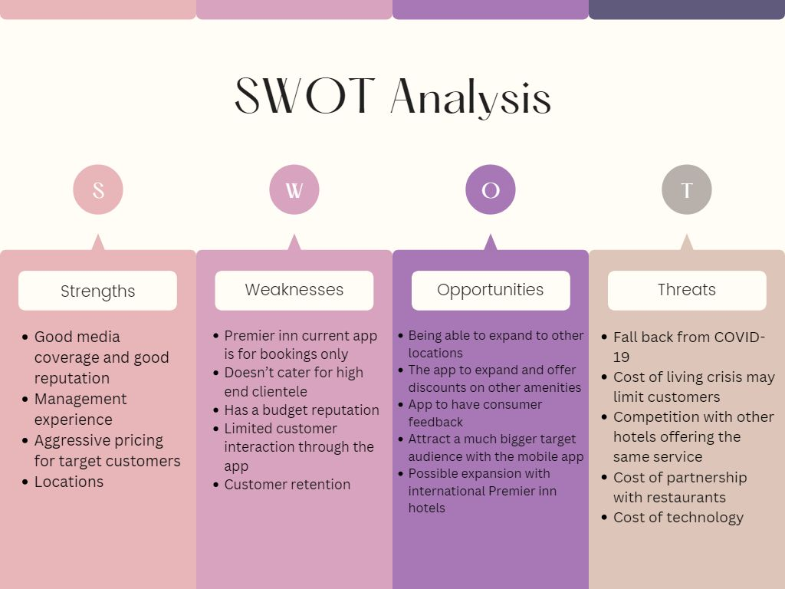
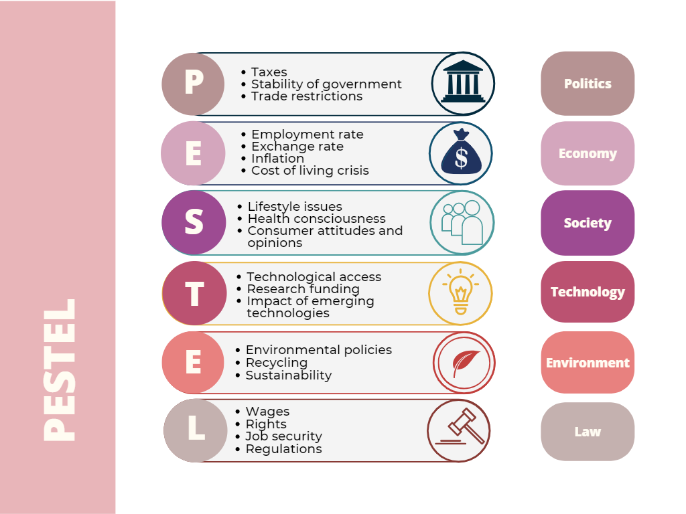
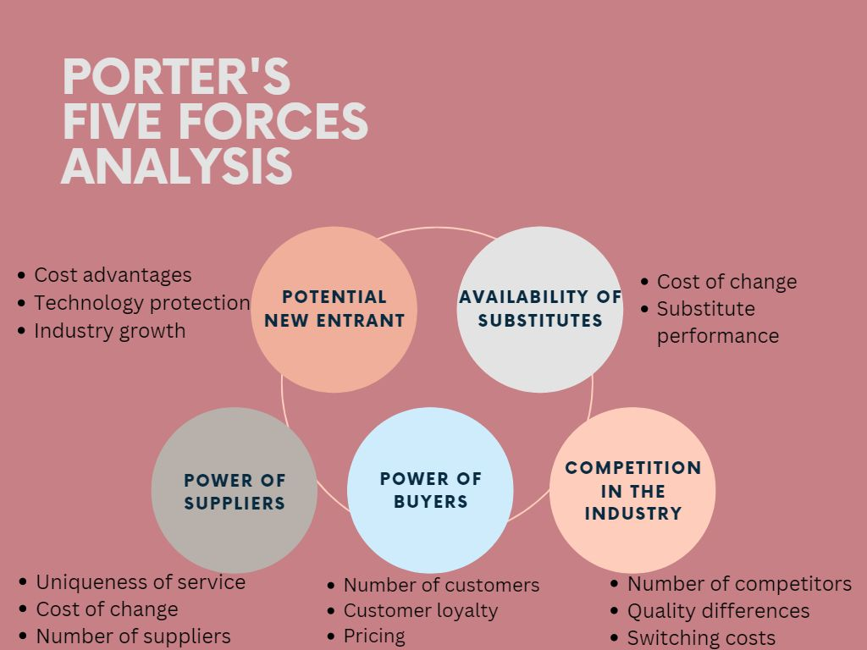

3.

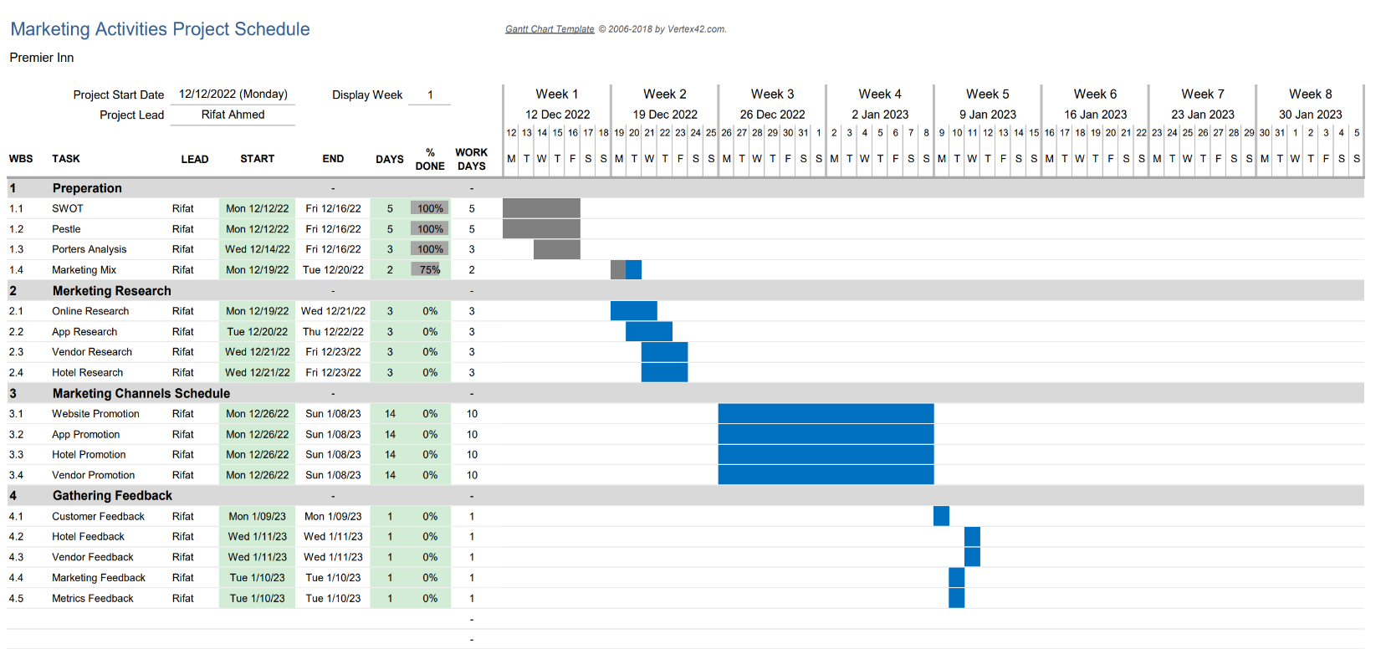
4.

5.


