

Module Name: Digital Skills for Personal and Professional Growth
Module Code: BMSW4008
Student Name: Raluca Costan
Student Number: 2415059
Lecturer: Philippa Fitzgerald
Deadline: 20 June 2025

Task 1

Content

- Analysis Essay
  - Summary of Questionnaire Content
  - Data analysis of the Questionnaire
  - Logo Analysis – RC Tax Expert
  - Website Analysis – RC Tax Expert
    - Visual identity and brand consistency
    - Content structure and keyword optimisation
    - Building trust and online credibility
1.5 Business card Analysis – RC Tax Expert
2. Logo – Fivver.com
3. Website – GoDaddy UK
4. Business cards – Vista Print UK
5. Questionnaire graphics
6. Connection research to strategy and materials
7. Conclusion
8. References

- Analysis Essay

In order to better understand our client’s needs, experiences and expectations, I have designed a brief questionnaire tailored to gather valuable insight into key aspects of RC Tax Expert’s services. Please find below the link of the questionnaire: https://docs.google.com/forms/d/1Ts40eX76BtZQENSjY0r4VhuexM24BWhA7mbTcwHORVo/edit

1.1 Summary of Questionnaire Content

Question Topic | Purpose
Discovery Method | To determine how clients first heard about our services (e.g., referrals, social media), enabling better targeting of future marketing efforts.
Service Preference | To identify which accounting services are in highest demand, such as tax return preparation, payroll, bookkeeping or business advisory.
Website Usability | To assess how easily users can find the information they need on our website, helping us improve its structure and user experience.
Communication Effectiveness | To evaluate client satisfaction with the clarity, responsiveness, and professionalism of our communication via email, calls or meetings.
Key Selection Criteria | To understand what clients value most when choosing an accountant, whether it be cost, reputation, expertise or personalised support.
Suggestions for Additional Services | To gather ideas for future services or resources that could enhance our offerings, such as financial planning tools or automated reminders.
1.2 Data analysis of the questionnaire

Understand client needs is essential for business growth, especially in service sectors like accounting. The responses provide valuable insight into what clients value most and how the business can continue to adapt in a competitive, digital landscape.

Most clients found RC Tax Expert through referrals, showing strong trust and satisfaction. Only a few discovered the service online, suggesting room to improve digital visibility, especially on Google and social media.

The results show that Tax return preparation is the most requested service, reflecting the core needs of sole traders. While other services like advisory and bookkeeping were mentioned less, they present opportunities to offer bundled or add-on services for added value.

Clients rated the website and communication highly, with most giving 5/5 scores. This shows strong performance, though clearer guidance for new users and simple automated updates could further improve the experience.

Most clients prioritised expertise and trust over price when choosing an accountant. This highlights RC Tax Expert’s strength as a quality-driven service and supports offering premium or tailored services.

Clients suggested adding educational content, real-time support and tools like deadline reminders and a tax dashboard. These ideas show demand for more digital tools and guidance, helping RC Tax Expert become a more proactive and trusted advisor.

The feedback confirms RC Tax Expert is strong in core services and client communication. However, there’s room to grow by improving visibility, adding educational tools and automating key processes, listening to clients supports continuous improvement, tools like a digital dashboard or email tips could boost value and strengthen trust.

1.3 Logo Analysis: RC Tax Expert

RC Tax Expert Logo reflects professionalism, trust and a personal approach. The serif ‘R’ suggests expertise and tradition, while the floral design adds elegance and warmth. The navy-blue colour represents stability and confidence, aligning with the tagline ‘Clarity. Confidence. Compliance.’. This branding helps the business sand out as a reliable and approachable choice for small businesses and sole traders.

1.4 Website Analysis: RC Tax Expert

The starting point for al design decisions was understanding who the target audience is, mainly sole traders, small business owners and partnerships across the South West UK. These clients often seek simplicity, trustworthiness and expert guidance.
The RC Tax Expert website was built with a clear objective: to create a user-friendly, mobile-responsive platform that delivers trust, clarity and quick access to essential accounting services. Informed by client feedback, the design focuses on ease of navigation, informative content and strategic SEO integration to increase visibility and engagement (Chaffey and Ellis-Chadwick, 2019).

    - Visual identity and brand consistency
Based on the research insight that clients seek professionalism and trust, I adopted a clean, minimalist visual style using a blue and white colour scheme, which are colours often associated with reliability in the financial sector. Fonts and icons were carefully chosen for clarity and legibility across devices, ensuring a smooth experience whether accessed on desktop or mobile. The overall look reinforces RC Tax Expert’s identity as approachable yet professional, critical for building initial trust.

    - Content structure and keyword optimisation
The site is organised into concise, easy-to-navigate sections including ‘Services’, ‘Why Choose Us’ and ‘Contact’, in response to the survey finding that users value quick access to clear information. Strategic calls-to-action such as ‘Book a free consultation’ appear consistently to guide visitors toward conversion without feeling intrusive.
In addition, SEO strategies were integrated into content planning, Targeted keywords such as ‘tax return preparation for sole traders’, ‘self-assessment help in Bristol’ and ‘accounting services for small businesses’ were embedded naturally in the copy language in the survey and online search behaviour.

    - Building trust and online credibility
Recognising that trust and reputation were top client priorities, the site includes testimonials, professional credentials and direct access to privacy policies and terms of service. Embedding structured data and optimising alt-text on images further supports SEO and accessibility, making the website not only more search-engine friendly, but also more inclusive (Laudon and Traver, 2022).
Tools such as Google My Business and regularly updated blog will further enhance search engine visibility and provide clients with useful, educational content, another feature frequently requested in the client feedback.

1.5 Business Card Analysis: RC Tax Expert

To complement the online presence, professional business cards were designed using Vista Print, following the same client-informed principles of simplicity, clarity and brand alignment.
The business cards were designed to match RC Tax Expert’s clean, trustworthy image. They include only essential details, logo, services, contact info and website, making them easy to read and act on.
Using the same colour and fronts as the website ensures brand consistency, helping clients instantly recognise and trust the business across platforms.
Together with the logo, website and the cards reflect client feedback and modern design principles, practical, clear and built to drive action (Rowles, D. 2017).

- Logo – Fiverr.com

The RC Tax Expert logo was carefully designed to reflect trust, clarity and expertise.





- Website – GoDaddy UK

Websites are essential tools for communication, marketing and building relationships with audiences across different sectors (Kotler, Kartajaya and Setiawan, 2021).

Website: www.rctaxexpert.com

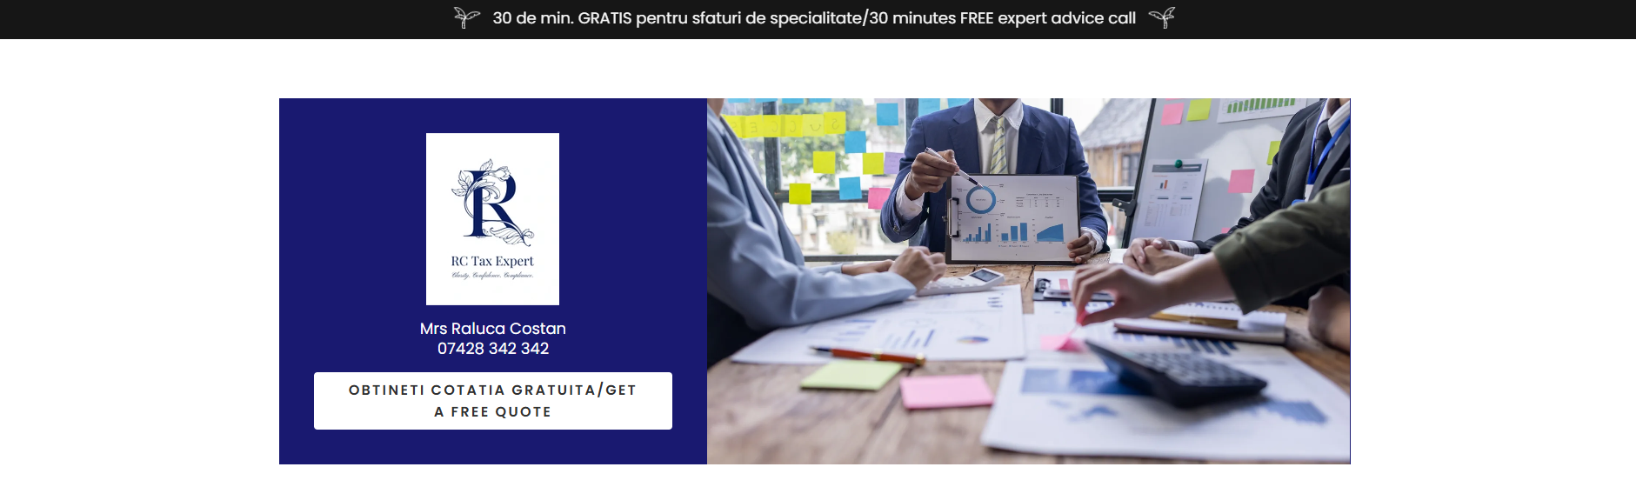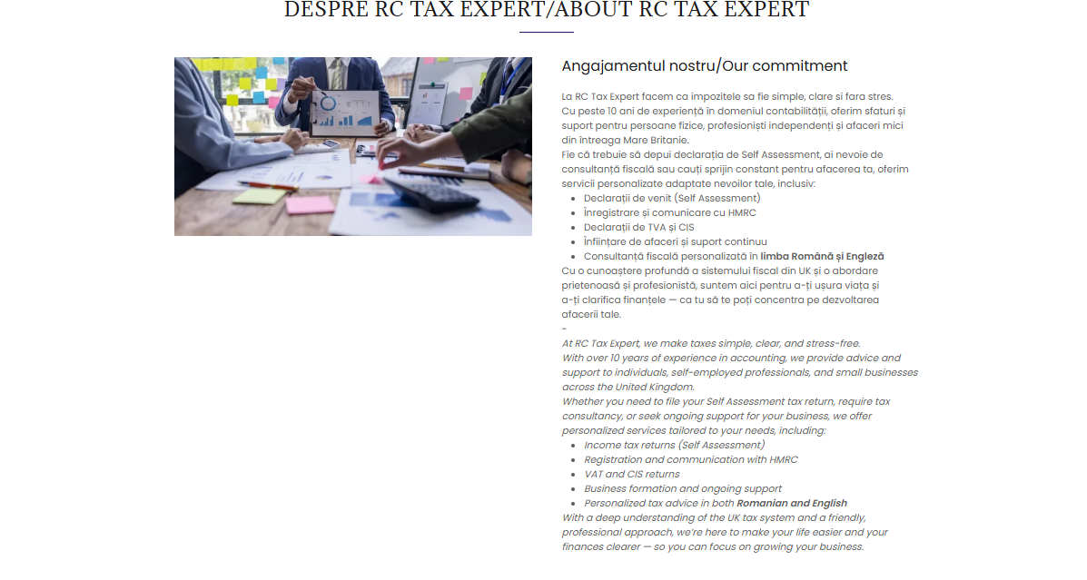
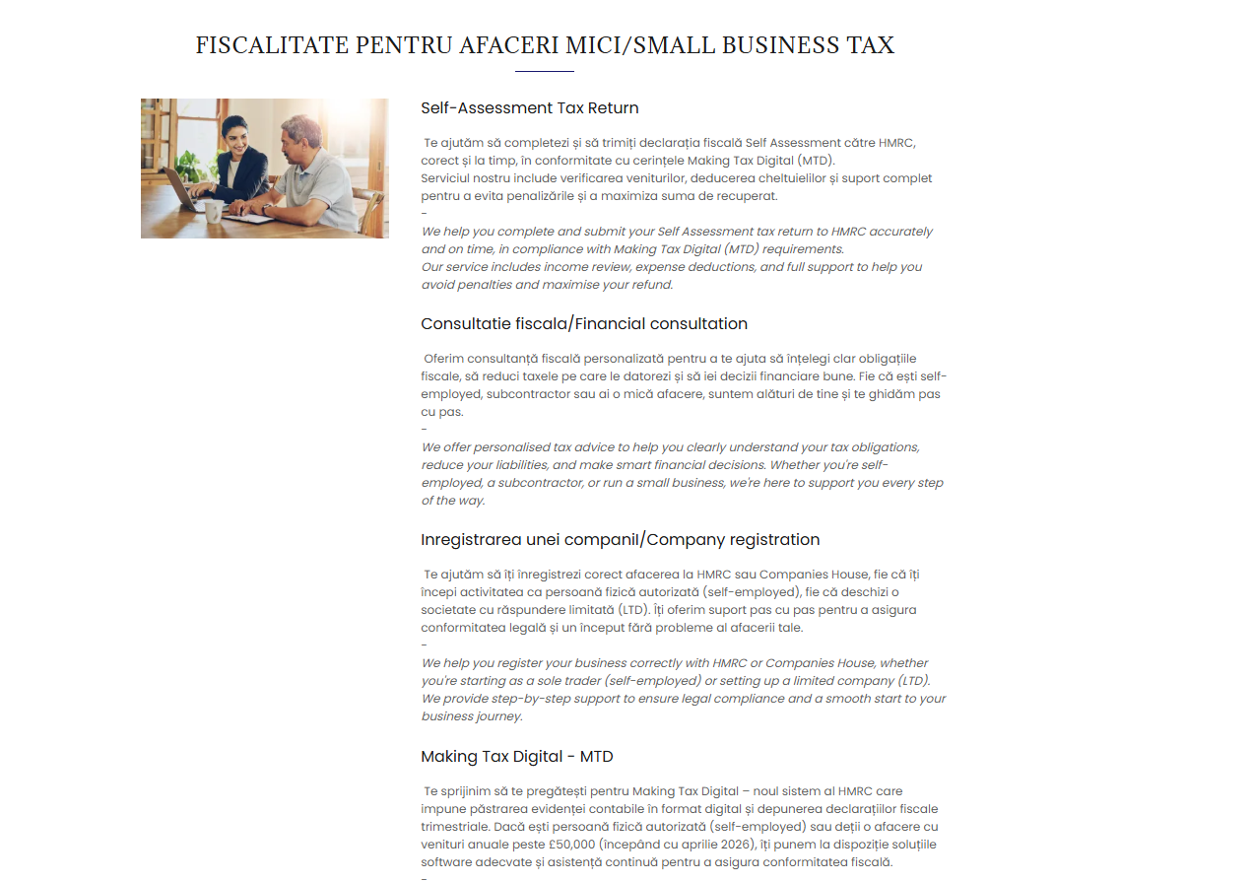
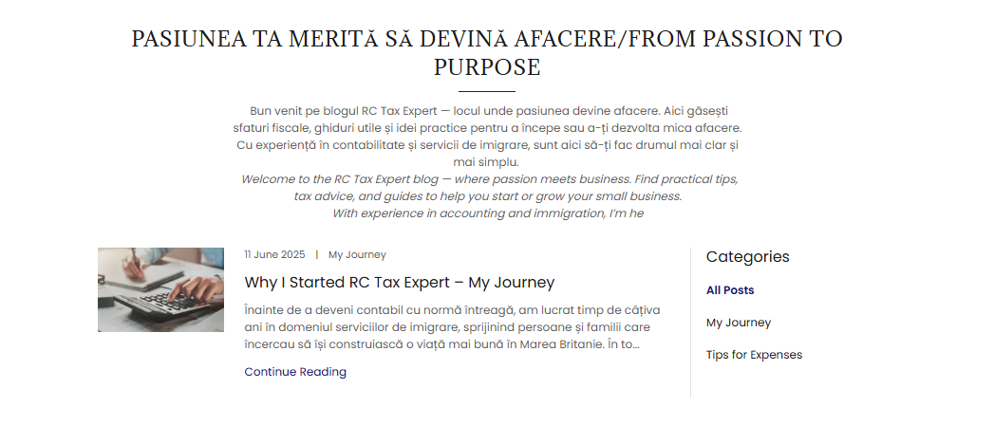
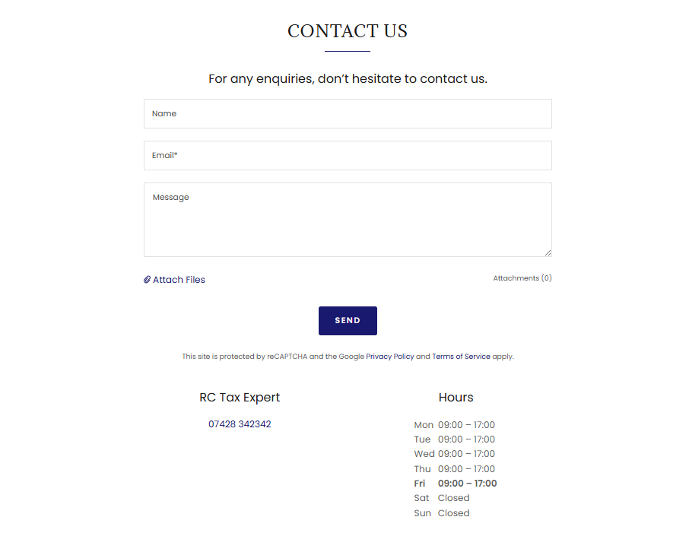
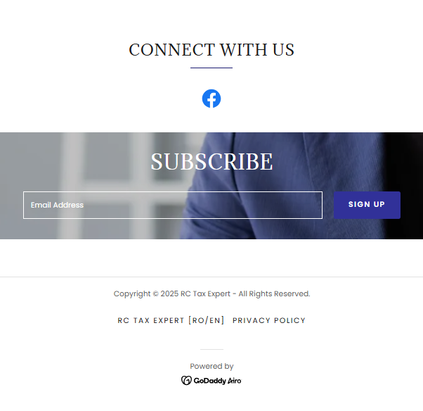
- Business cards – Vista Print UK

Business cards are small, portable tools that provide essential contact information and create a lasting first impression in professional settings. They serve as a quick and effective way to network, promote a brand and establish connections between individuals and business (McKee, 2010).



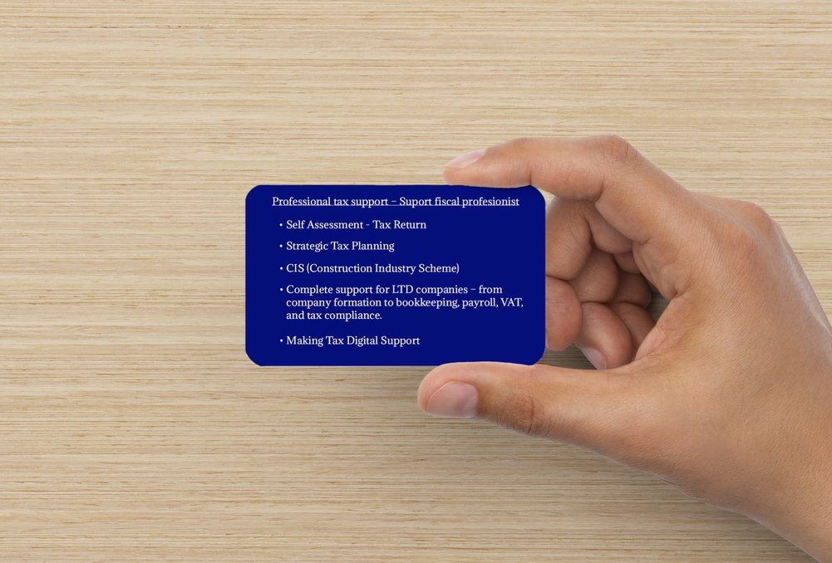

- Questionnaire graphs

To gain insight and feedback relevant to my research, I created a short questionnaire using Google Forms. The survey designed to collect participants’ opinions and experiences (CIPD, 2021).

Questionnaire: https://docs.google.com/forms/d/1Ts40eX76BtZQENSjY0r4VhuexM24BWhA7mbTcwHORVo/edit

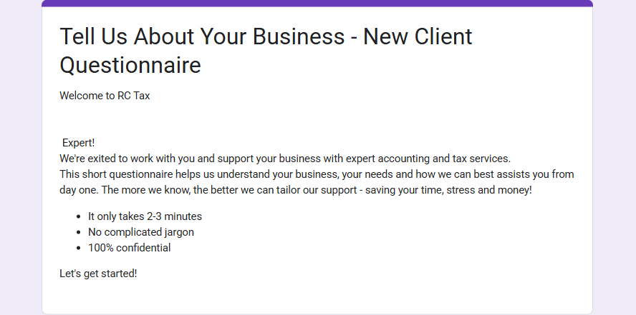
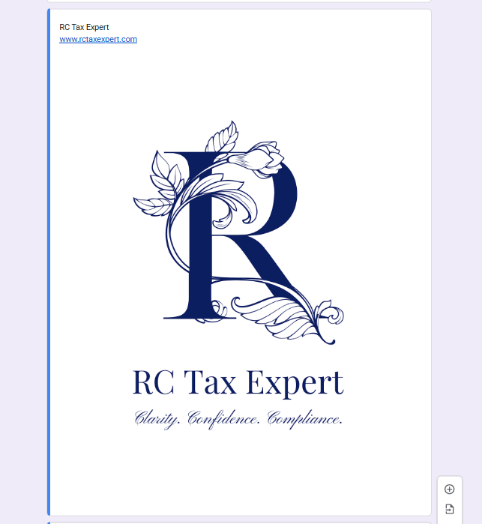
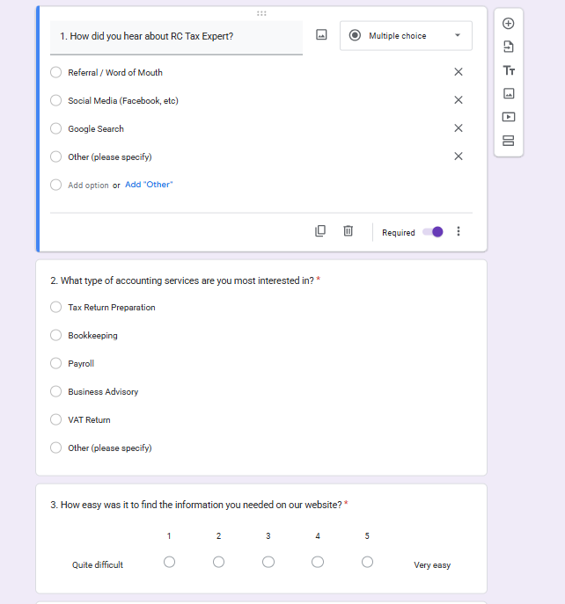

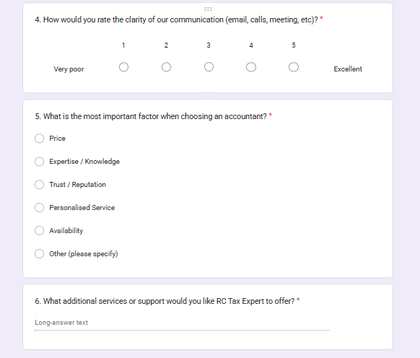

- Connecting research to strategy and materials

The insights gathered through the questionnaire played a crucial role in shaping the design and strategic direction of RC Tax Expert’s website, branding and marketing materials. For example, discovering that most clients found the service through referrals, but very few online, highlighted the need to enhance digital visibility This insight informed the SEO focused content structure and strategic use of keywords the website (Google, 2023).
Client’s prioritisation of trust and expertise over cost directly influenced the clean, professional visual identity and the inclusion of trust-building elements like testimonials and credentials. Feedback on communication and website usability let to a simplifies site layout clear calls-to-action, making it easier for visitors to book services or get in touch.

- Conclusion

The questionnaire results provided valuable insights into client needs, which guided the creation of RC Tax Expert website, logo and business cards.
Each element was designed to improve use experience, reflect professionalism and boost visibility. This research-driven approach has strengthened the brand and supports future business growth.

References

Adobe, 2023 ‘The power of Visual Identity in branding’ Available at: https://www.adobe.com/creativecloud/design/discover/brand-identity.html (Accessed on: 18 June 2025).
Chaffey, D. and Ellis-Chadwick, F., 2019 ‘Digital marketing: strategy, implementation and practice’ 7th ed. Harlow: Pearson Education
CIPD, 2021 ‘Designing Effective Employee Surveys’ Available at: https://www.cipd.org/uk/knowledge/factsheets/surveys-factsheet/ (Accessed on: 16 June 2025).
Google, 2023 ‘Search engine Optimisation (SEO) starter guide’ Available at: https://developers.google.com/search/docs/fundamentals/seo-starter-guide (Accessed on:20 June 2025).
Kotler, P., Kartajaya, H and Setiawan, I., 2021 ‘Marketing 5.0: Technology for Humanity’ Hoboken: Wiley.
Laudon, K.C. and Traver, C.G., 2022 ‘E-commerce 2022: Business, Technology and Society’17th ed. Harlow: Pearson Education.
McKee, S., 2010 ‘Creative B2B Branding: Building a Brand that Customers Trust.’ New York: Bloomberg Press.
Nielsen Norman Group, 2023. ‘UX Research Methods’ Available at: https://www.nngroup.com/articles/ux-research-methods/ (Accessed on: 18 June 2025).
Rowles, D., 2017 ‘Digital Branding: A complete Step-By-Step Guide to Strategy, Tactics and Measurement’ 2nd ed. London: Kogan Page.
Strauss, J and Frost, R., 2019 ‘E-Marketing’ 8th ed. London: Routledge.

Task 2

The Importance of Microsoft Excel in the Digital Era
How it helps my business

This 12-months cash flow forecast outlines the expected income and expenses for RC Tax Expert, a sole trader accountancy business. It categorises cost into fixed, variable and capital expenses, helping to track financial performance. With income of £31,150 and total expenses of £10,887.45, the business expects a net profit of £20, 262.55. This forecast supports effective budgeting and planning throughout the year.

In today’s digital world, where time moves fast and information comes from all directions, having the right tools to manage your business efficiently is more important than ever. One of the most useful and powerful tools I use every day is Microsoft Excel.
Whether you’re tunning a small business like mine or working with clients on their financial reports, tax return or bookkeeping, Excel helps keep things organised, clear and under control.
Here’s how I use it in my business and why I believe every modern business owner should feel comfortable with it too.

- Keeping Data organised and accessible

As an accountant, I deal with a lot of information, from income and expenses to client records, deadlines and reports. Excel gives me a structure, easy-to-navigate space to store and manage this data (Walkenbach, 2015).
For example, I use it to:
- Keep track of tax return deadlines for each client.
- Monitor who’s sent in their documents and who still needs a reminder.
- Maintain contact lists, invoice logs and fee tracking.
Using simple tools like drop-down menus, colour coding and filters, I can easily prioritise tasks, spot missing information and stay on top of everything without getting overwhelmed. This makes my work more efficient and my clients more satisfied (Harvey, 2020).

- Turning numbers into insights

Excel doesn’t just help me store information; it helps me make sense of it. With formulas, charts and PivotTables, I can analyse client data quickly and clearly (Roberts, 2022).
For example:
- I can compare a client’s income and expenses across months or years
- I can build quick visual reports to explain trends or tax liabilities
- I can ever forecast estimated payments based on current figures.

For clients who struggle with numbers, I can present their financial situation in a simple visual way, turning spreadsheet into stories they can understand.

- Saving time on repetitive tasks

One of the best things about Excel is how much time it saves me. As a sole trader, every minute counts. That’s why I use Excel to automate parts of my work that would otherwise take hours (LinkedIn Learning, 2023).
For examples:
- I have templates set up to calculate tax or VAT based on inputs
- I use functions that auto-update total or highlight anything unusual
- I prepare batch invoices using formulas and templates, saving tine each month.

Instead of doing the same manual work over and over, Excel helps me streamline processes, avoid errors and focus on offering value to my clients (Forbes, 2021).

- A tool that fits any industry and any person

While I use Excel mainly for my accounting, its beauty is that it works for everyone. Whether you’re in marketing, logistics, HR or healthcare, Excel gives you the flexibility to build exactly what you need, from scratch or from a template (Indeed.com, 2023).
That’s why I also encourage some of my clients, especially small business owners to learn the basics of Excel. Even a simple spreadsheet can help them manage cash flow, track expenses or plan ahead without needing expensing software (Microsoft Excel, 2024).

- A skill that builds trust and confidence

When clients see that I work confidently in Excel, it shows them they’re in safe hands. Being able to answer questions quickly, pull up numbers on the spot and send clean, well formatted reports builds trust.
It’s also a skill that helps me run my own business more professionally.

- Integrating with other tools

Excel plays nicely with other systems too. I often import data from accounting software or export spreadsheets to share via email. Whether I’m using Outlook to send client updates, Word to prepare letters or bookkeeping app like QuickBooks, Excel acts like a central hub for all my data (PwC Report, 2022).

For me, Excel is more than just a spreadsheet tool. It’s a daily companion in my business. It helps me stay organised, serve my clients better and make smarter decisions. In this digital era, where everything moves quickly and efficiently, Excel remains one of the most important tools in my toolbox.

References

Indeed, 2023. ‘Top Excel Skills Employers Value’. Available at: https://www.indeed.com/career-advice/resume-samples/excel-skills (Accessed on: 20 June 2025).

Forbes, 2021. ‘How Microsoft Excel is Powering Business Intelligence’. Available at: https://www.forbes.com/sites/forbestechcouncil/2021/11/18/how-microsoft-excel-is-powering-business-intelligence/ (Accessed on: 20 June 2025).

Harvey, G., 2020 ‘Data Literacy for HR: How to use people analytics for better business performance’. London: Kogan Page.

LinkedIn Learning, 2023. ‘Why Excel is still a must-have in 2023’. Available at: https://www.linkedin.com/learning (Accessed on: 20 June 2025).

Microsoft, 2024. ‘Microsoft Excel, features and benefits. ‘Available at: https://www.microsoft.com/en-us/microsoft-365/excel (Accessed on: 20 June 2025).

PwC, 2022. ‘Digital Upskilling: Building Confidence in Data Skills.’ Available at: https://www.pwc.com/gx/en/issues/upskilling.html (Accessed on:20 June 2025).

Roberts, A. 2022 ‘The role of Microsoft Excel in Small business Operations. International Journal of Business Tools’, 14 (2), pp.87-95.

Walkenbach, J., 2015. ‘Excel 2016 Bible’. Hoboken, NJ: John Wiley and Sons.

