Part One

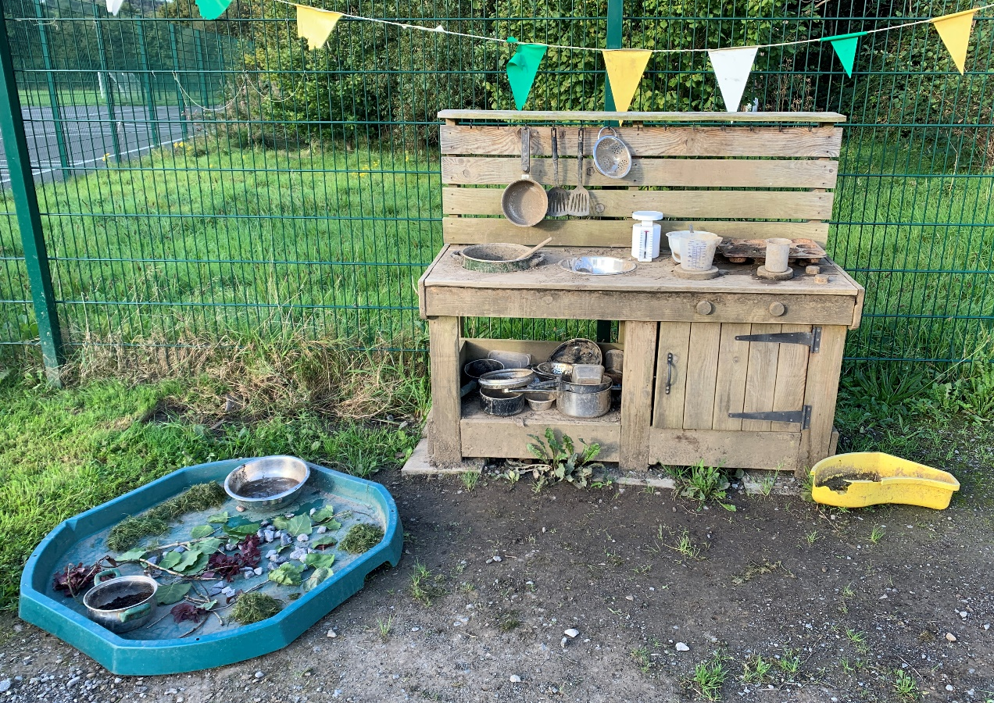

Image: Williams, 2022.

Part Two
It is generally considered today that maths and science are important in supporting children to develop and learn concepts that’s essential for everyday life. For instance: children need to develop the understanding of calculating money, telling the time and have knowledge of how to maintain a healthy lifestyle (Welsh Government, 2020).

The photograph encourages children to explore and discover because they can see the loose parts that they could be using during the activity and children have the opportunity to use their imagination and creativity to decide what are they going to be doing and creating. The photograph was based in the outdoors and the new Curriculum for Wales encourages outdoor learning. Williams (2022) highlights that the outdoor area is an important factor in the new Curriculum because it will support children’s social, emotional and physical development as they can question, connect with nature and discover and explore their surroundings. To extend, Young Wales (no date) claims that the outdoors encourages children to learn through first-hand experiences in the natural world, learn to assess their own risk and also supports the well-being of young children by supporting children to be themselves in a safe, holistic and interesting environment.

In the photograph there are opportunities for young children to develop mathematical and scientific concept. Firstly, children have opportunities to develop mathematical concept by measuring. Children will gain understanding of calculating different measurements as the weighing scale, beaker and jug that is placed on the mud kitchen supports this particular idea. For example: children have the opportunity to calculate the weight of two stones and a spoonful of compost and use a beaker or jug to measure the volume of water. KidsDo Gardening (no date) highlights that measuring loose parts in the mud kitchen benefits children’s mathematical and scientific development because they are problem solving. By problem solving, children can consider: if I have compost and add 60ml of water, what will happen to the compost? And if I add another 60ml of water, what will happen to the compost? By using weighing scales, beaker and a jug, it links to progression two of Mathematics and Numeracy (Curriculum for Wales) as young children will measure different materials by choosing the right method of calculating the measurement (Welsh Government, 2020). For instance: if a child wants to measure water, they would use a beaker or jug and if they want to know the weight of a stone, they will use a weighting scale.
To extend, young children will have the opportunity to count the different loose parts that are on offer on the messy play tray. For example: children can count the leaves, stones and sticks and work out what material has the most and what material has the least. By counting loose parts, children will develop progression step one of mathematics and numeracy (Curriculum for Wales) as children could be using mathematical language like: more than, less than and equal to (Welsh Government, 2020). Also, by considering loose parts children will have the opportunity to compare long and short sticks and heavy and light stones. By comparing, children will estimate the measurement and weight of the natural materials and develop progression step one of mathematics and numeracy (Curriculum for Wales) as children will use vocabulary like: shorter than or heavier than (Welsh Government, 2020).
One can go as far to say that when children use their imagination and creativity, children will use mathematical concept by introducing time and money in their play. For instance: the 12 cupcakes will take 10 minutes to cook in the oven and when the cakes are ready, a cake will cost 12 pence. By adding money in children’s play, it will link to progression step one of mathematics and numeracy (Curriculum for Wales) as children will understand the meaning of money and knowing that they need to exchange money for items (Pentagon, no date).

By considering scientific concept, children will have the opportunity to experiment, problem solve and explore different properties and textures by getting their hands dirty and understanding and making different potions and mixtures (Kelly, 2016 and White, no date). For instance: children can experiment with compost and water and consider: what will happen if I mix compost and water together. By experimenting they might question their learning by considering: how much water is needed to make the mixture thick, what will happen when I add more or less water to the mixture and if I add water will the mixture become thick, gloopy or sticky? By experimenting with compost and water, children can make connections by considering the cause and effect. For example: I have mixed compost and water together, and the compost is now liquid because of the water, and if I want to make the texture thick, I’ll experiment and add more compost (White, no date). By considering this, it links to progression two of science and technology (Curriculum for Wales) as children can observe and describe what happens if material is mixed together (Welsh Curriculum, 2020).
To extend, by providing an outdoor learning environment children will develop their senses. For example: children will develop their sense of smell by smelling the natural world, children will use their hearing to listen to birds sing or insects making a noise, children will use their touch by touching the loose parts and experimenting in the mud kitchen and also children will use their sight by exploring the natural environment.

By looking at the photograph, I would consider adding extra resources to the environment to support children’s discovery and exploration. For example: I would include a magnifying glass because Martin (2019) believes that it encourages children to explore the world around them and be able to see something in a different way. Also, Creative World School (2020) are convinced that a magnifying glass supports children to see something they have never seen before. I would also include baskets as this would encourage young children to explore the environment by collecting natural material and then placing them into the baskets as this could be ingrediencies that’s needed to make a cake or pie. Also, I would include recipe books as children have the opportunity to use their imagination and creativity to create different food items from the book and have ideas of what products can be made in the mud kitchen. An example of books that could be placed in the mud kitchen is ‘The Muddy Chef’ and ‘The best Mud Kitchen Books for Kids’ as it encourages children to use natural materials like compost and water to create cupcakes and lasagne (Whitehouse, no date). Moreover, I would include more open-ended materials because children will have the opportunity to discover and explore with other loose parts. For example: I could include pasta and shaving foam as children could make a range of different tasty items in the mud kitchen. Furthermore, when children are playing in the mud kitchen, they might use their imagination and creativity to create a mud kitchen café. By considering this, I would include a till and money beside the mud kitchen as children are given the opportunity to sell their creations like: cakes, pies and soup and also develop their understanding of money.
Part Three
Risk Benefit Assessment.
Location: The school’s outdoor area – mud kitchen.
Assessor: Chloe Williams.
Date: 18th of September 2022.
Review date: 20th of April 2023.
The hazard | How will young people benefit from the hazard? | The risks that could occur | Who is at risk? | Precautious in place to reduce the risk of injury | Overall risk rating: L/M/H
Broken equipment | - The children are accessing their own risk. | - The children could have a cut and/or graze. | Adults and children | - Get rid of broken equipment. For example: in the photograph there is a yellow container that is broken and has sharp edges.  - Adults to monitor the outdoor area daily. | Low
Messy play tray | - The loose parts that were collected is on the tray as it gives children different ideas of what natural materials can be used during the activity. | - The children could slip, trip and/or fall which could case cuts and/or grazes. | Adults and children | - Supervise the children.  - Adults to set boundaries and rules for the children to follow during the activity. For example: don’t run as you may fall. | Low
Sticks | - Children are using natural materials.  - A stick is an open-ended material that children could use in many different ways.  - A stick encourages children to use their imagination and creativity.  - By gathering sticks, children have the opportunity to compare long and short sticks.  - By gathering sticks, children have the opportunity to compare light and heavy sticks.  - Children could develop fine and gross motor skills.  - Sticks encourage open-ended learning for children.  - The children are engaging with the natural world. | - A stick could hurt a child. For example: a stick could go into a child’s eye.  - Children could be messing about with the sticks.  - The stick might be unsanitary.  - The sticks could have sharp edges. | The children | - Supervise the children.  - Adults to check the sticks to ensure that the material is safe to use. For example: ensure there’s no sharp edges on the sticks that could harm the children.  - Wash the sticks to ensure good hygiene.  - Adults to set boundaries and rules for the children to follow during the activity.  - After using the sticks, children must wash their hands to ensure good hygiene. | Low
Natural materials | - Children are using open-ended materials.  - By collecting natural materials, children have the opportunity to count the different loose parts.  - The children are engaging with the natural world. | - The children may eat the natural materials such as: grass, sticks, compost, leaves and stones.  - Eating natural materials can cause illnesses and chocking. | The children | - Supervise the children.  - Adults to set boundaries and rules for the children to follow during the activity.  - After touching the natural materials, children must wash their hands to ensure good hygiene. | Low.
Water | - The children would be able to see their reflection.  - The children can develop mathematical and scientifical concept. For example: measurements, and different properties. | - The children are likely to get wet.  - The children could catch a cold. | The children | - Supervise the children.  - Ensure that all children are wearing water proof clothing and wellies during the activity. | Low
Mud kitchen | - By providing a mud kitchen, children have the opportunity to express their creativity and enhance their fine motor skills.  - The mud kitchen provides children the opportunity for open-ended activities.  - A mud kitchen provides children the opportunity to problem solve and develop their communication, and imagination. | - Children could hurt themselves on the edges of the mud kitchen.  - Children may get a splinter from the wood. | Adults and children | - Adults to set boundaries and rules for the children to follow during the activity. For example: don’t run as you may hurt yourself.  - Supervise the children.  - Adults to monitor the outdoor area daily. | Low
Uneven surfaces | - The children are developing their sense of balance.  - The children are accessing their own risk. | - The children could slip, trip and/or fall which could case cuts and/or grazes. | Adults and children | - Play a wibbly wobbly game as it gives the children the opportunity to be familiar with the uneven surface.  - Ensure that the children are wearing suitable wellies.  - Adults to warn children there may be holes and dips in the ground.  - Look over the children’s medical information form to ensure that the surface is appropriate for the children’s physical needs.  - Supervise the children. | Low
Grass | - Children are using natural materials.  - Grass encourages children to use their imagination and creativity.  - Grass encourages open-ended learning because it is an open-ended material that children could use in many different ways.  - The children are engaging with the natural world. | - Children could suffer from hay fever.  - Children could be messing about with the grass.  - The pieces of grass might be unsanitary. | Children | - Look over the children’s medical information form.  - Supervise the children.  - Adults to set boundaries and rules for the children to follow during the activity.  - After touching the grass, children must wash their hands to ensure good hygiene. | Low

Part Four
Adults play a critical role in supporting and encouraging children to engage with mathematical and scientific concepts. By considering the role of an adult, they have a responsibility to create an interesting environment that support’s children to learn and encourages discovery and exploration. According to Rees and Gealy (2013) an environment is important because it supports children’s self-confidence and self-esteem and support’s children to learn through doing and hands-on experiences. Reggio Emilia’s theory claimed that the environment is the 3rd teacher as its supports children’s learning and development (Rees and Gealy, 2013). By creating an environment, Malaguzzi believed that children must have space to move freely because children will then become active learners and for adults to change the environment regularly as it encourages children to explore, supports children’s holistic development and maintain the children’s interests and progression (Learning Teaching Scotland, 1999).

To create an interesting environment, adults must include interesting resources and loose parts for children’s indoor and outdoor area. According to Rahardjo (2019) and Gull et al (2019) loose parts are materials that are open-ended and can be used in different ways and form. Moreover, loose parts are interested natural and open-ended items that can be used in different ways and to put it more simply, children are taking the lead on their learning by making decision on what they are going to be doing with the loose parts (Gull et al, 2019; Early Impact, 2022). An example of loose parts is: sticks, stones, mud, water and grass. EcoKids (2018) believes that loose parts are beneficial in supporting children’s learning because young children will engage with open-ended play as they use the natural materials in many different ways by using their natural creativity. For example: a box is interesting for a child as it can provide possibilities for children’s open-ended play. By including a box as a loose part, children can develop their imagination and creativity as they can create a bed out of the box, play hide and seek and build a house (EcoKids, 2018). Additionally, tyres are open-ended materials that can support children’s mathematical and scientific concepts as children can order the tyres from small too big and understand forces when a child rolls the tyre down a big hill. By providing an open-ended material such as tyres in an outdoor area, adults can use it for gardening, children can create a vehicle, children can climb and jump off the tyres and adults can even create a climbing frame for children to support their physical development (MA Education, 2016). Even a tarpaulin sheet can encourage children’s imagination and creativity because it can be used for a water slide, a shelter for a den and a hammock for children to sit and lay on.
Nicholson created a theory of loose parts. Play Scotland (no date) claims that Nicholson believed that an environment with loose parts supports children’s holistic development because it encourages young children to experiment by using their imagination and creativity. According to Rahardjo (2019) and Gull et al (2019) loose parts support children’s development because they will problem solve and become mathematical and scientific experts. For example: if children are given a messy play tray with different colour pom-poms as loose materials, they have an opportunity to develop the concept of maths by doing colour patterns, adding and subtracting and counting the different colour pom-poms (Lipp, 2022). By considering science, adults may include a tub full of water and loose parts like a dice, bottle, pencil, duck and car and encourage children to develop the concept of floating and stinking by children experimenting and learning through doing with the different materials that are on offer (Early Impact, 2022).
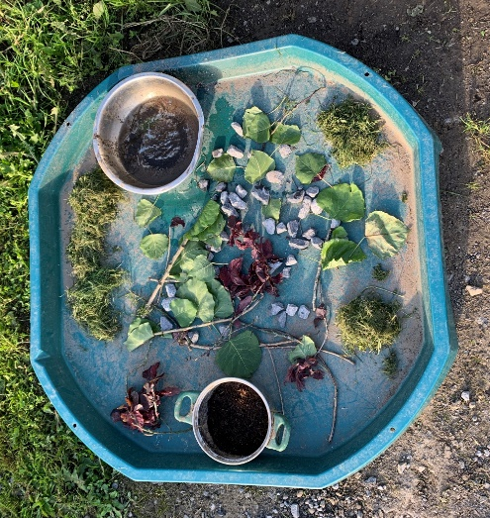

Image: Williams, 2022.

Furthermore, adults must observe and document children’s learning because it will support and encourage children to engage with mathematical and scientific concepts as the environment and activities are suitable for children’s interests and learning. Froebel pointed out that an adult’s role is an important factor in supporting and encouraging children to engage with mathematical and scientific concepts because whilst observing children, early years practitioners are aware of their learning and development (Louis, 2022). By observing children, early years practitioners will be aware of their strengths and weaknesses, the child’s interests and can consider what is the next step of learning that is needed to support the child’s holistic development. Tyrybon (2015) maintains that observing children supports adults because they gather an understanding of a child’s academic, emotional and motor development and can provide progression steps that can support a child to reach their full potential. By documenting children’s learning and development, early years practitioners might photograph their learning, take videos, keep drawings and take voice recordings.
Another example of an adult’s role in supporting and encouraging children to engage with mathematical and scientific concepts is for the adult to ask problem solving and open-ended questions to the children. An example of problem solving and open-ended questions could be: I wonder if the beaker can hold the same volume of water as the jug, why did that happen to the compost and what happens if you add 10ml of water to the compost. Asking problem solving and open-ended questions support and encourage children because it provides opportunities for young children to become creative thinkers by experimenting, discovering and exploring their own learning (Ritchie, 2019). By asking open-ended questions, this relates to sustained shared thinking because the children and adults are working together to solve a problem and having a conversation by observing what is happening and developing knowledge together by discussing what happened (Early Education, no date).
Also, adults can support and encourage children to engage with mathematical and scientific concepts by offering choice. For example: the children can explore, discover and play in the mud kitchen or look for loose parts in the forest. By offering choice, children will develop the skill of independence by taking the lead of their learning and following their interest by deciding what they want to do (Durant, 2018). When children are taking the lead on their own learning and following their interests, children are likely to enjoy the activity they have chosen which supports and encourages young children to engage with mathematical and scientific concept. In other words, if adults do not offer choice to children, they may not have interest in the activity which decreases the opportunities for children to develop mathematical and scientific concepts. With this in mind, an adult may give children the choice of staying indoors or go outside. If a child decides to go outside to play and it is raining, some early years practitioners may not respect the child’s choice and say no because they will get wet but some practitioners will encourage this as children are exploring and discovering different temperatures, weather and seasons which also support children to develop mathematical and scientific concepts (Durant, 2018).

One can go as far to say that issues might arise that prevents adults from using the outdoors for supporting mathematics and science. For example: the adults do not understand the importance of the outdoor environment and believes that the outdoor area does not support children’s development and learning of mathematics and science. Some adults may believe that children are not able to develop and learn mathematical and scientific concepts through open-ended play, exploring and discovering in the outdoors. White and Edwards (2018) suggest that young children need early years practitioners who value and enjoy the outdoor environment. For example: if an early year’s practitioner doesn’t want to get their hands dirty and not exploring, the children will not feel confident in exploring and discovering the natural environment. By considering this, early years setting must ensure that staff members are good role models and are attending courses regularly to increase their knowledge and understand why the outdoor environment is beneficial in supporting children’s learning and development. To support this, early years practitioners can take part in forest school courses and experiences because it can help them to understand the importance of outdoor play, understand how it supports children’s holistic and physical development and have ideas of activities that could be placed in the outdoors to support children to develop mathematical and scientific concept. (Rees and Gealy, 2013).
Another reason why adults avoid using the outdoors is because of staff ratios. Take for instance: 30 children in a classroom with a teacher and teaching assistant. By considering the scenario, practitioners do not have enough time for 1:1 interaction, ask open-ended questions and discover and explore with a child because they have a duty of care to safeguard and supervise all children (Citizens Information, 2022). Some may consider that the outdoor environment contains a lot of risk which could lead to practitioners avoiding the outdoors as they have anxiety and fear because they know there are not enough staff to supervise all children and have small groups to support children’s mathematical and scientific learning (Rees and Gealy, 2013).
To extend, another reason why adults may prevent using the outdoors for supporting mathematics and science is not having an outdoor area. By considering this, children are not been given the opportunity to discover and explore the natural environment, decreases the children’s learning and development and also the risk of obesity as children are unable to increase their physical development by running and walking (Maltby, 2016). Durant (2018) suggests that early year’s settings that have no outdoor area could be using the local park and woodland area because it encourages children’s discovery and exploration and Durant (2018) claims that children learn best when they are outside.
Another reason why adults may prevent using the outdoors is because they do not have enough money. By considering this, practitioners do not have money to provide resources for children to explore, discover and use their imagination and creativity. For instance: early years practitioners are unable to provide activities like learning in the mud kitchen as there are no resources, loose parts and materials available to support children to learn mathematics and scientific concepts through play. One can agree to a certain point that loose parts such as sticks, grass and stones are free items that can be found in outdoor areas and can support children’s development and learning. For example: by using sticks, grass and stones, children can make a house for a hedgehog and use the natural materials as ingrediencies for making a chocolate cake or pie.

To conclude, Bruner was convinced that early year’s practitioners can teach can concept to anybody at any age but as long as they do it with the right level (First Discoveries, 2022). For example: when children are young, they will develop the concept of math and science by measuring and observing the changes of different properties in the mud kitchen and when their older, they will develop this in more detail.

Reference List
Citizen Information. (2022). ‘Teachers duty of care’. Available at: https://www.citizensinformation.ie/en/education/primary_and_post_primary_education/teachers_and_schools/teachers_duty_of_care.html (Accessed: 28th of September).
Creative World School. (2020). ‘The Power of the Magnifying Glass’. Available at: https://creativeworldschool.com/power-magnifying-glass/ (Accessed: 25th of September).
Durrant, S. (2018). ‘The value of outdoor play’. Available at: https://www.communityplaythings.co.uk/learning-library/articles/the-value-of-outdoor-play (Accessed: 2nd of October).
Early Education. (No date). ‘Sustained shared thinking (SST)’. Available at: https://early-education.org.uk/sustained-shared-thinking-sst/ (Accessed: 1st of October).
Early Impact. (2022). ’16 Science Loose Parts Play Ideas’. Available at: https://earlyimpactlearning.com/16-science-loose-parts-play-ideas/ (Accessed: 28th of September).
EcoKids. (2018). ‘Playing with Loose Parts’. [Video]. Available at: https://www.youtube.com/watch?v=PFEg6Mlc490 (Accessed: 2nd of October).
First Discoveries. (2022). ‘Child Development Theories: Jerome Bruner’. Available at: https://www.firstdiscoverers.co.uk/jerome-bruner-child-development-theories/ (Accessed: 1st of October).
Gull, et al. (2019). ‘Definitions of Loose Parts in Early Childhood Outdoor Classrooms: A Scoping Review’. Available at: https://files.eric.ed.gov/fulltext/EJ1225658.pdf (Accessed: 28th of September).
Kelly. (2016). ‘Why mud play should be encouraged’. Available at: https://www.earlyyearscareers.com/eyc/learning-and-development/why-mud-play-should-be-encouraged/ (Accessed: 25th of September).
KidsDo Gardening. (No date). ‘Mud Kitchens for Children’. Available at: https://www.kidsdogardening.com/mud-kitchens-for-children/ (Accessed: 24th of September).
Learning Teaching Scotland. (1999). ‘The Reggio Emilia Approach to Early Years Education’. Available at: https://education.gov.scot/improvement/Documents/ELC/ELC35_ReggioEmilia/ELC35_ReggioAug06.pdf (Accessed: 30th of September).
Lipp, M. (2022). ‘Fantastic Fun and Learning’. Available at: https://www.fantasticfunandlearning.com/math-and-loose-parts-play.html (Accessed: 28th of September).
Louis, S. (2022). ‘Observing young children’. Available at: https://www.froebel.org.uk/uploads/documents/FT_Observing-young-children_Pamphlet_INTERACTIVE_REV-2.pdf (Accessed: 1st of October).
MA Education. (2016). ‘Terrific Tyres’. Available at: https://www.earlyyearseducator.co.uk/features/article/terrific-tyres (Accessed: 2nd of October).
Maltby, E. (2016). ‘Lack of outdoor space hinders children’s development’. Available at: https://www.prolandscapermagazine.com/lack-of-outdoor-space-hinders-childrens-development/#:~:text=Lack%20of%20outdoor%20space%20hinders%20children%E2%80%99s%20development.%20As,the%20box%20when%20it%20comes%20to%20outdoor%20greenery. (Accessed: 28th of September).
Martin, J. (2019). ‘What Can Kids Use Magnifying Glasses For [Hobbies + Opinions]’. Available at: https://imagniphy.com/blogs/news/what-can-kids-use-magnifying-glasses-for (Accessed: 22nd of September).
Pentagon. (No date). ‘Mud Kitchen’. Available at: https://content.pentagonplay.co.uk/article-pdfs/66/mud-kitchen-activities-and-ideas-pdf.pentagonplay.pdf (Accessed: 25th of September).
Play Scotland. (No date). ‘Loose Parts’. Available at: https://www.playscotland.org/wp-content/uploads/Play-Scotland-Loose-Parts-Leaflet.pdf#:~:text=The%20theory%20of%20loose%20parts1was%20introduced%20by%20architect,and%20discover%20new%20things%20and%20form%20new%20concepts.%E2%80%9D (Accessed: 28th of September).
Rahardjo, M. (2019). ‘How to use Loose-Parts in STEAM? Early Childhood Educators Focus Group discussion in Indonesia’. Available at: https://core.ac.uk/download/pdf/296973537.pdf (Accessed: 28th of September).
Rees, A and Gealy, A. (2013). ‘Chwarae Allan Dysgu Mas’. Y Drindod Dewi Sant.
Ritchie, E. (2019). ‘Using Open Ended Questions With Young Children’. Available at: https://www.british-school.org/using-open-ended-questions-with-young-children/ (Accessed: 1st of October).
Tyrybon, S. (2015). ‘Why Montessori Teachers Observe’ [Video]. Available at: https://www.youtube.com/watch?v=GeZUZ2p_pZU (Accessed: 1st of October).
Welsh Government. (2020). ‘Curriculum for Wales’. Available at: https://hwb.gov.wales/curriculum-for-wales/ (Accessed: 24th of September).
White, J. (No date). ‘Making a mud kitchen’. Available at: https://circleofliferediscovery.com/wp-content/uploads/2021/05/Making-a-mud-kitchen-1.pdf (Accessed: 25th of September).
White, L and White, J. (2018). ‘Making a Mud Kitchen’. Available at: https://muddyfaces.co.uk/content/files/Making_a_mud_kitchen_LowResAW.pdf (Accessed: 30th of September).
Whitehouse, P. (No date). ‘The BEST Mud Kitchen Books for Kids’. Available at: https://mothernatured.com/nature-play/mud-kitchen-books/ (Accessed: 22nd of September).
Williams, S. (2022). ‘Increased role for outdoor learning and natural environment in new school curriculum’. Available at: https://naturalresourceswales.gov.uk/about-us/news-and-events/blog/increased-role-for-outdoor-learning-and-natural-environment-in-new-school-curriculum/?lang=en#:~:text=Increased%20role%20for%20outdoor%20learning%20and%20natural%20environment,for%20educators%20...%204%20Find%20out%20more%20 (Accessed: 23rd of September).
Young Wales. (No date). ‘First steps outdoors’. Available at: https://hwb.gov.wales/api/storage/79a90e4b-0385-4cc8-be9b-2b20be3a85d0/first-steps-outdoors.pdf (Accessed: 23rd of September).

