Name: Ryan Alderson
Student Number: 2024392
Course: L4 - Introduction to Web and Database Concepts
Date: 20th April 2021

Table of Contents
Introduction 3
Requirements 4
Implementation 5
Evaluation 11
References 14
Appendices 16

Introduction
This report is going to cover topics such as:
- the contents of the website and its target audience,
- HTML and CSS validation errors I came across,
- Usability,
- Accessibility,
- Search Engine Optimisation,
- And why I used Bootstrap4 to help with responsiveness and layout

Requirements
The reason I chose to build this website was because the company that it’s for is owned by my Dad. His website needs an uplift as the current one is very old, so I chose to build a sample of what a more modern, responsive website for his company could look like. Although the employees and customers are fictitious (Star Wars characters), I used some content from his current website to describe what the company do and what services they provide. I have left this brief as I focused more on the layout and design rather than the content. The intended target audience includes any business in the UK that uses electrical appliances, as these needs to be PAT tested on an annual basis to meet health and safety laws, so that’s pretty much every workplace in the country. I know the name has ‘Wales’ in it but the audience is any business in the UK that needs electrical appliances tested. As people now tend to use smaller devices such as mobile phones and tablets to look at websites these days, this added an extra requirement of making this website responsive too.

Implementation
Home page:
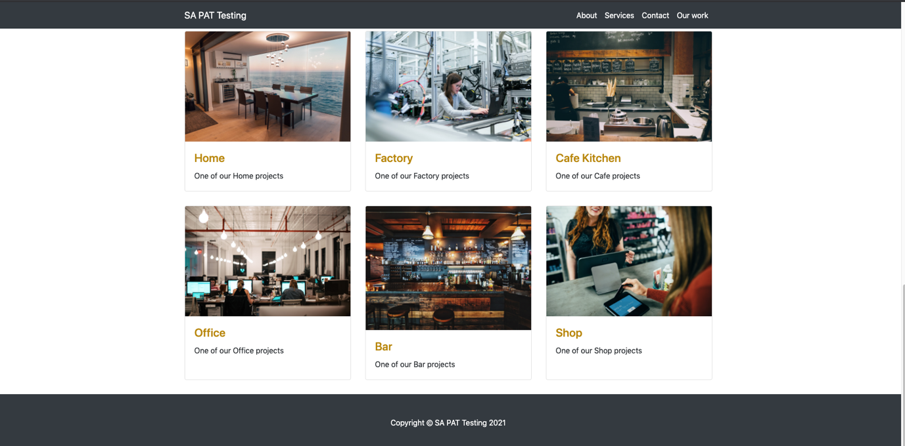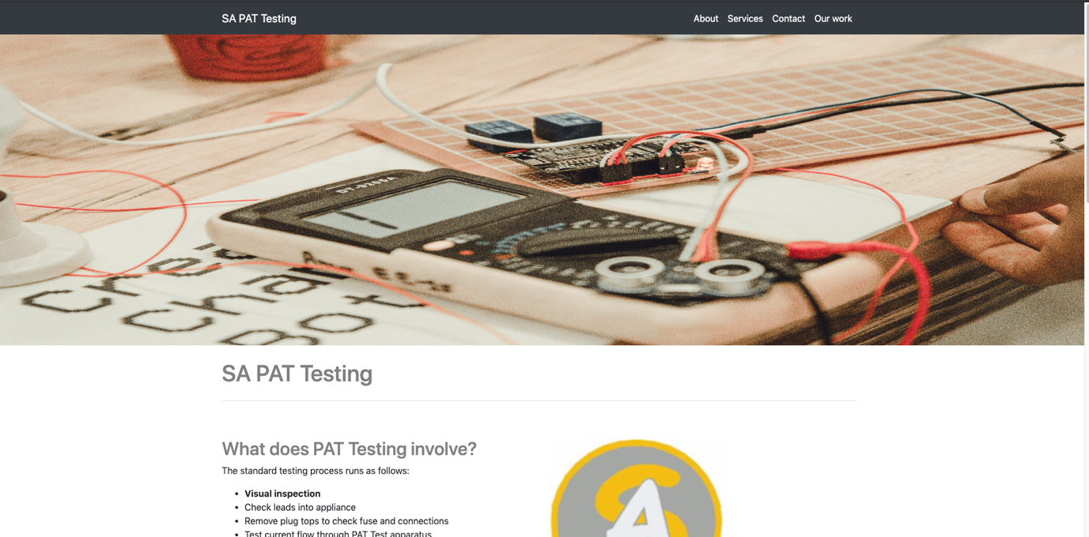
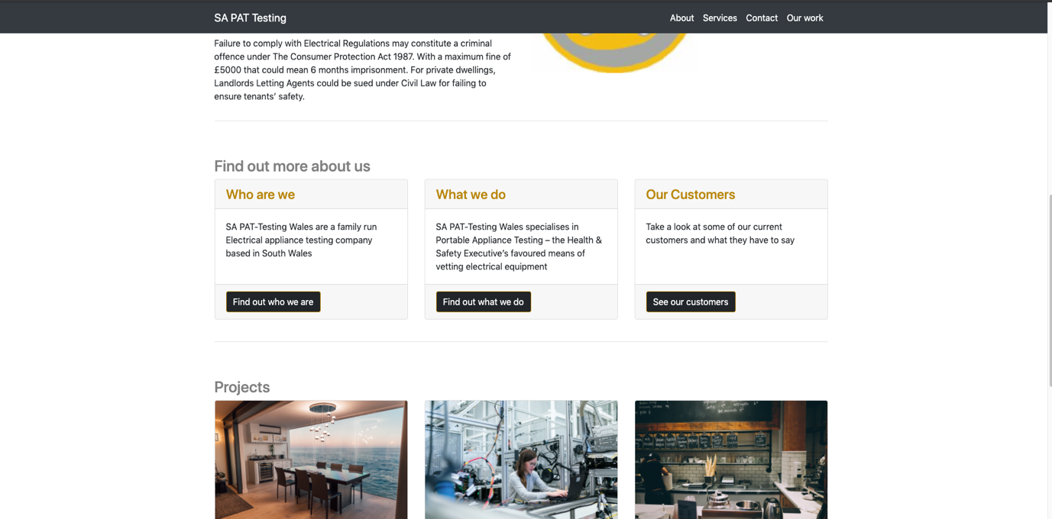
About Us Page:
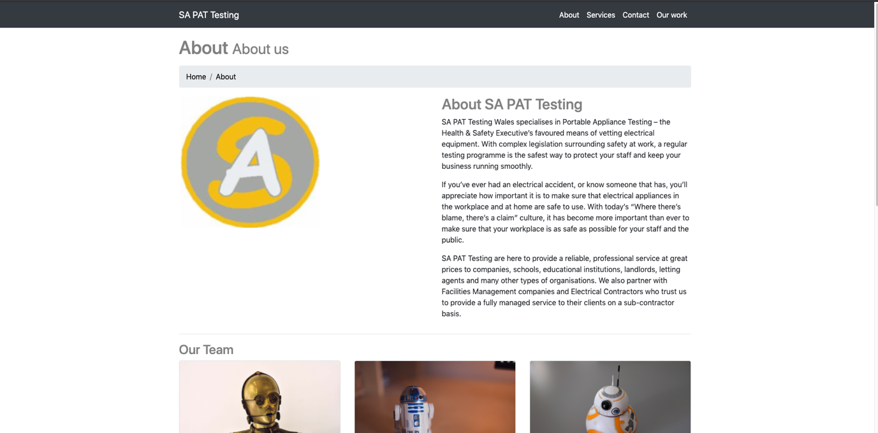
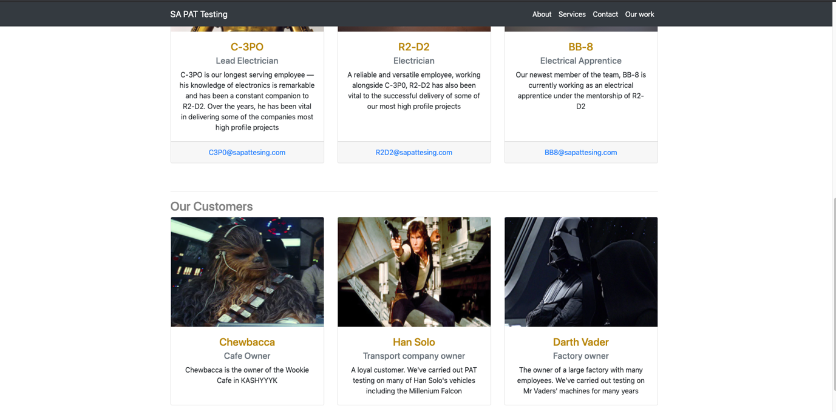
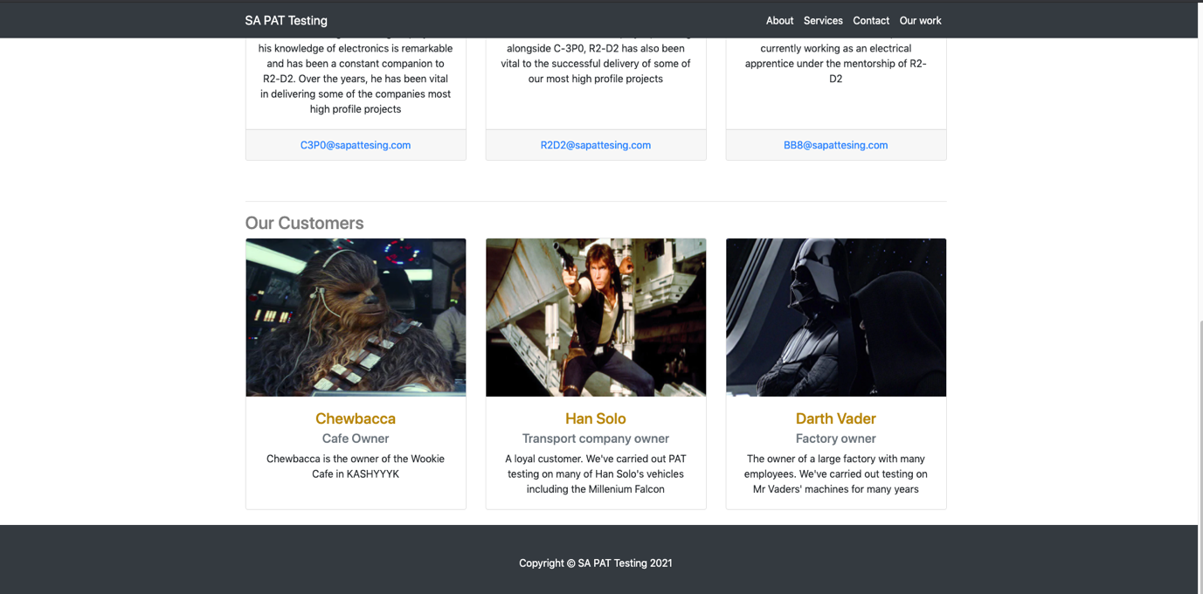

Services page:

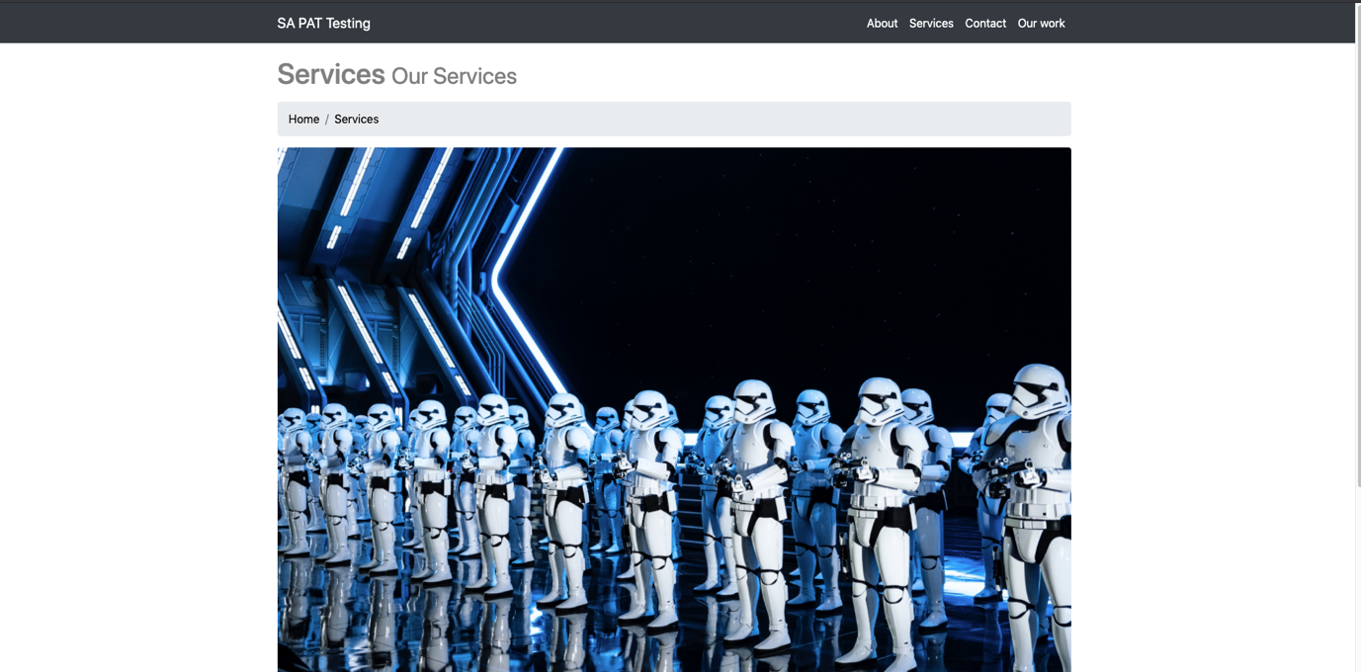
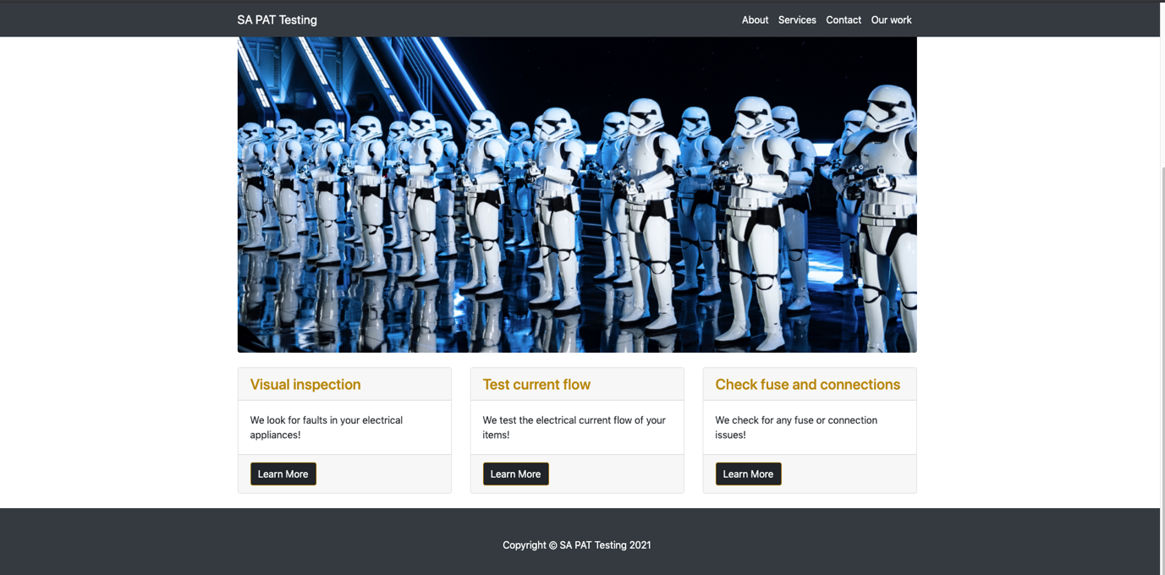

Contact page:

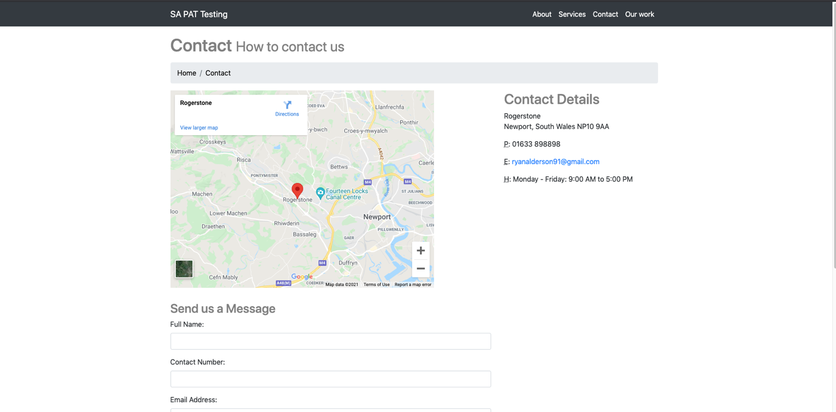
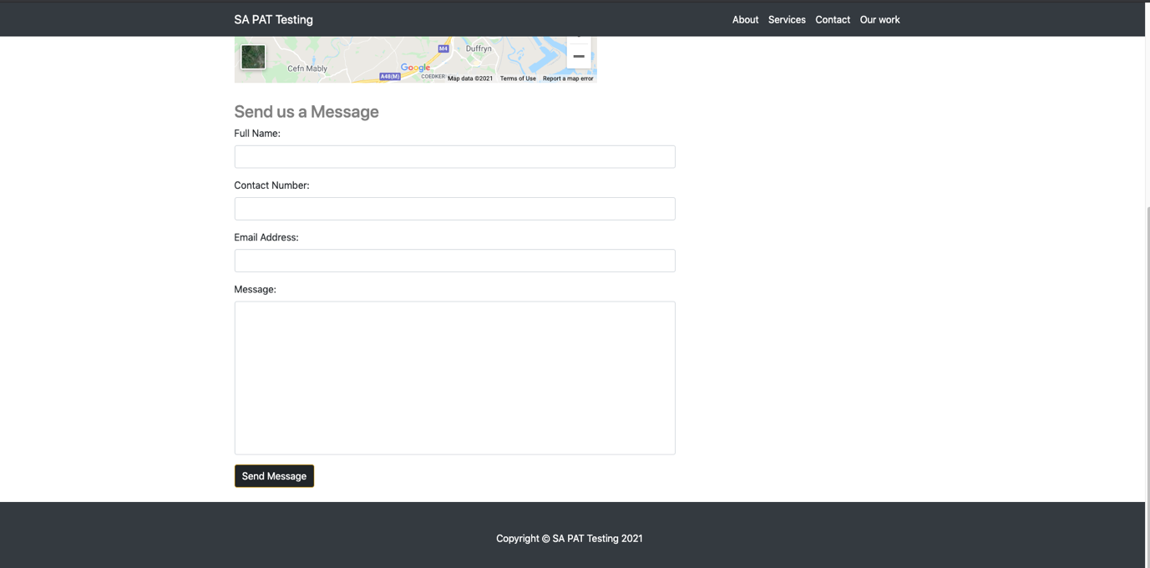

Our Work / portfolio page:

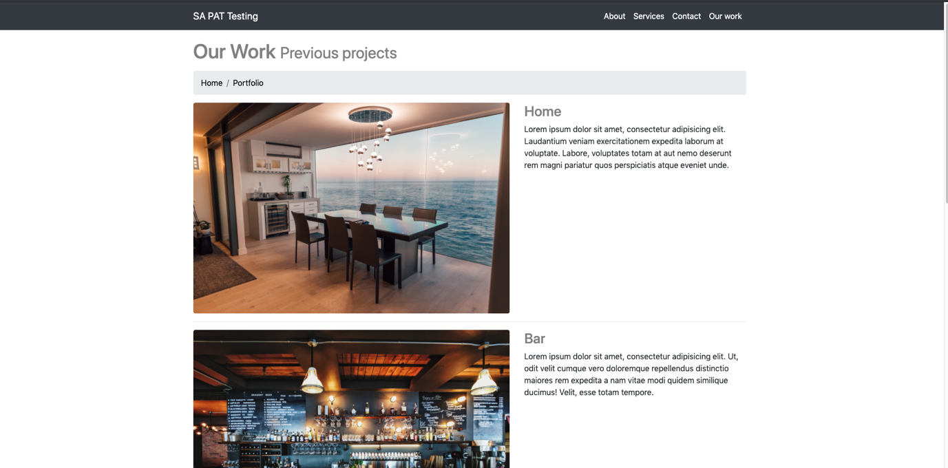
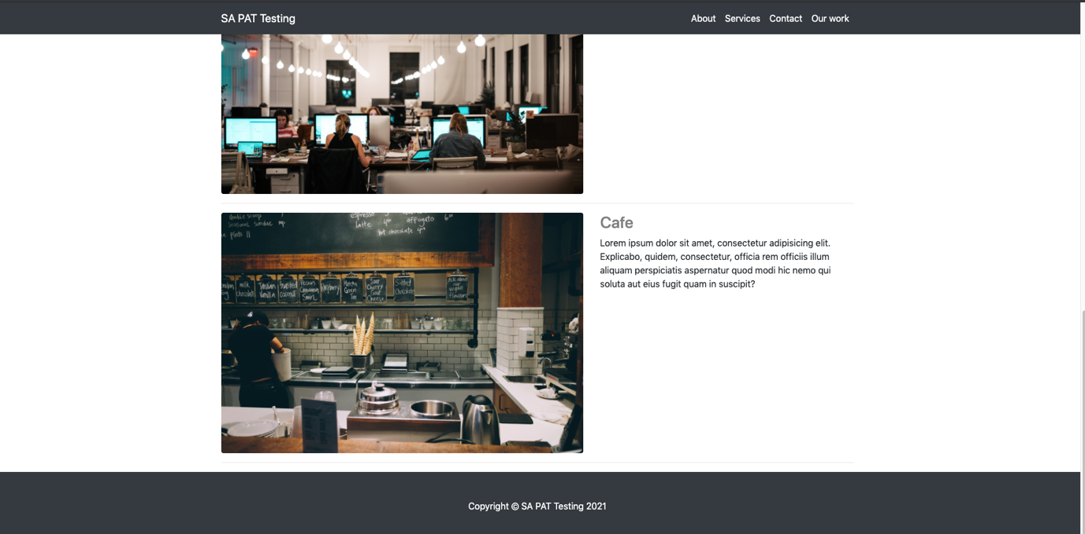

Validation of the pages:
After running the HTML and CSS through the W3 Validator, I got the following errors:
- Iframe on contact.html had duplicate inline styling which I removed
- The Electrical tester image on the index.html page had no alt tag, which I then added
- CSS file has margin and padding values set to none rather than 0 for #main-header img which I amended

Evaluation
There are main indicators to determine the quality of a website. The most important indicators that are used across the industry are usability, accessibility and search engine optimisation, also known as SEO. I’m now going to describe in detail what each term means and give an evaluation on each against my own website.

Usefulness (Usability and Utility)
The usability of a website is often explained as the ease with which a user can access information and how effectively then can achieve their goals, from a website [1]. This depends on how easy it is to navigate the website, how quickly a user can find what they’re looking for and the relevance of the content on the website. Studies have shown that users prefer sites that are easy to use and are intuitive [2]. Usability is very important because if a user doesn’t get what they want from a website, they will quickly move on to another website.
When evaluating the usability of my website, I believe that it has achieved the goal of being easy to use for the following reasons:
- It has a simple layout which is easy on the eye
- It is responsive, looks good on mobile and smaller devices, thanks to my knowledge and use of Bootstrap
- Elements have been re-used and are consistent across all pages (headings, colours, text size, buttons)
- Navigation bar which allows the user to easily navigate the website
- Names of the pages are relevant to the content of that page
- Bootstrap breadcrumbs which allow the user to see what page they are on and to easily navigate back to the home page
- Most of the content is relevant to a user who would be looking for this service (Portable Appliance Testing)
- Images included, not too text heavy for a user
To improve the usability of the site though, I could have added more relevant content rather than just ‘Lorem Ipsum’ text for the projects and added more explanation about each service the company provides. I could have also added a pricing page as this is probably one of the most important things a customer would want to know.

Search Engine Optimisation (SEO)
Search Engine Optimisation is essentially “making your website better for search engines” [3]. As search engines such as Google and Yahoo have become the primary ways to retrieve information or find websites on the internet, SEO has become more and more important. SEO involves a number of techniques to improve the ranking of your website on search engines which is key in getting users to visit your website, as many studies have actually shown that most users click on only the first page of search results [4]. I will discuss a number of these techniques in the evaluation of my own website.
In order to improve the Search Engine Optimisation of my website, I:
- Created unique and accurate page titles using the <title> tag which describes to the users and search engines exactly what the page is about, such as “SA PAT Testing Wales – Home of Wales Best Portable Appliance Testing Company”
- Used meta tags such as “description” and “author” to give the search engines information of what the page is about and who it was created by
- Used hierarchical heading tags to emphasise important text
- Created a simple navigation bar on all pages that links all pages’ together
- Content on the page is relevant to the Company so it may help when searching for keywords such as “PAT Testing” or “PAT Testing Wales” specifically
- Used the HTML image element for images on my page which helps web crawlers find images with descriptive filenames and added an “alt” attribute to all so the text can be searched if the image isn’t displayed for some reason
- Added meta name = “viewport” tag to tell the device how to adjust the content for that device and made my site responsive, so that my site will even show up in mobile device search results
I believe these on page SEO techniques that I’ve added, will certainly improve the sites search engine ranking.

Accessibility
Website accessibility is the process of designing websites that are accessible to all. This is so that people with disabilities (visual or speech for example) and even people without disabilities (people with smaller devices, people with slower internet connections, older people who find it difficult to use the internet) can still use the websites [5]. Accessibility in websites is essential in order to provide equal access and opportunity for everyone. The WCAG 2.1 sets out guidelines on this that anyone developing a website should follow. Research has found that more accessible websites attract more users and help to maintain user satisfaction [6] as you would expect.
Following the four main accessibility principles of Perceivable, Operable, Understandable, and Robust to improve the accessibility of my site, I:
- Provided text alternatives to non-text content such as images using the <alt> tag so that it can be changed into other forms such as speech or braille for example
- Made the website to be easily navigated with the navbar element and added breadcrumbs so they could see where they are, added links to other pages through buttons
- Didn’t add flashing content to the page to cause any physical reactions
- Made functionality available from a keyboard and mouse, scrolling and navigating?
- Made my content readable and easy to understand
- Re-used elements (such as headings, navbar, footer) across pages to make it consistent and predictable
- Bootstrap to make the website available on all size devices, such as mobiles and tablets
- Considered compatibility with assistive technologies such as screen readers as I work with colleagues who use them, so used semantic elements, made sure images had <alt> text, heading levels increased appropriately, added calls to action on buttons that are descriptive and action-oriented, made sure elements had sufficient colour contrasts
I then tested all of this out using the aXe Chrome plugin and corrected any major issues it highlighted.

As mentioned many times during the report, I heavily used Bootstrap in my project. The reason for this was due to my working experience using this and the fact it makes it so much easier when dealing with responsiveness and layouts. The navbar, footer and card elements I used on a few pages on the site are a prime example of this. I have added references to the sites I used to help me make the proper use of Bootstrap below [9] [10] [11] [12].

For reference:
Images [11]
Company logo image [8]

References
[1] Anonymous "Online recruiting: The effects of organizational familiarity, website usability, and website attractiveness on viewers? impressions of organizations," Computers in Human Behavior, vol. 24, (6), pp. 2992-3001, 2008. Available: https://www-sciencedirect-com.ezproxy.uwtsd.ac.uk/science/article/pii/S0747563208001027. DOI: 10.1016/j.chb.2008.05.005[AccessedApr 21, 20212021 ].
[2] M. Dishman, "Technology Review: Website Usability Testing Software--Improving User Experience and Satisfaction with Community College Websites," Community College Enterprise, vol. 21, (1), pp. 84-87, 2015. Available: https://ezproxy.uwtsd.ac.uk/login?url=https://search.ebscohost.com/login.aspx?direct=true&db=eue&AN=108397545&site=ehost-live[AccessedApr 21, 20212021 ].
[3] Anonymous (). SEO Starter Guide: The Basics | Google Search Central. Available: https://developers.google.com/search/docs/beginner/seo-starter-guide [Accessed Apr 21, 2021].
[4] Anonymous (). Estimating Google's search engine ranking function from a search engine optimization perspective - ProQuest. Available: https://www-proquest-com.ezproxy.uwtsd.ac.uk/docview/1776786007?accountid=130472 [Accessed Apr 21, 2021].
[5] (WAI), W3C Web Accessibility Initiative. (). Introduction to Web Accessibility. Available: https://www.w3.org/WAI/fundamentals/accessibility-intro/ [Accessed Apr 21, 2021].
[6] M. H. Alshira'H, "The Effects of Usability and Accessibility for E-Government Services on the End-user Satisfaction," International Journal of Interactive Mobile Technologies (iJIM), vol. 14, (13), pp. 78-90, 2020. Available: https://online-journals.org/index.php/i-jim/article/view/14659[AccessedApr 21, 20212021 ].
Images:
[7] Anonymous (). Beautiful Free Images & Pictures | Unsplash. Available: https://unsplash.com/ [Accessed Apr 26, 2021].
[8] Anonymous (). SA PAT Testing Wales | SA PAT Testing. Available: http://www.pat-testingwales.co.uk/ [Accessed Apr 26, 2021].
Bootstrap code:
[9] contributors, Mark Otto, Jacob Thornton, and Bootstrap. (). Bootstrap. Available: https://getbootstrap.com/ [Accessed Apr 26, 2021].
[10] contributors, Mark Otto, Jacob Thornton, and Bootstrap. (). Cards. Available: https://getbootstrap.com/docs/4.0/components/card/ [Accessed Apr 26, 2021].
[11] Anonymous (). Free Bootstrap Themes, Templates, Snippets, and Guides. Available: https://startbootstrap.com [Accessed Apr 26, 2021].
[12] contributors, Mark Otto, Jacob Thornton, and Bootstrap. (). Navbar. Available: https://getbootstrap.com/docs/4.0/components/navbar/ [Accessed Apr 26, 2021].

Appendices
HTML:
Index.html:
<!DOCTYPE html>
<html lang="en">

<head>

<meta charset="utf-8">
<meta name="viewport" content="width=device-width, initial-scale=1.0">
<meta name="description" content="Home page of Wales' best Portable appliance testing company">
<meta name="author" content="Ryan Alderson">

<title>SA PAT Testing Wales - Home of Wales best portable appliance testing company</title>

<link href="css/sa-pat-testing.css" rel="stylesheet">
<link rel="stylesheet" href="https://maxcdn.bootstrapcdn.com/bootstrap/4.5.2/css/bootstrap.min.css">
<script src="https://ajax.googleapis.com/ajax/libs/jquery/3.5.1/jquery.min.js"></script>
<script src="https://cdnjs.cloudflare.com/ajax/libs/popper.js/1.16.0/umd/popper.min.js"></script>
<script src="https://maxcdn.bootstrapcdn.com/bootstrap/4.5.2/js/bootstrap.min.js"></script>

</head>

<body>
<main>

<nav class="navbar navbar-expand-md navbar-dark bg-dark fixed-top">
<div class="container">
<a class="navbar-brand" href="index.html">SA PAT Testing</a>
<button class="navbar-toggler navbar-toggler-right" type="button" data-toggle="collapse" data-target="#responsive-navbar">
<span class="navbar-toggler-icon"></span>
</button>
<div class="collapse navbar-collapse" id="responsive-navbar">
<ul class="navbar-nav ml-auto">
<li class="nav-item">
<a class="nav-link" href="about.html">About</a>
</li>
<li class="nav-item">
<a class="nav-link" href="services.html">Services</a>
</li>
<li class="nav-item">
<a class="nav-link" href="contact.html">Contact</a>
</li>
<li class="nav-item">
<a class="nav-link" href="portfolio.html">Our work</a>
</li>
</ul>
</div>
</div>
</nav>

<header class="main-header">
<div id="main-header">
<img src="images/tester.jpg" alt="Electrical testing machine">
</div>
</header>

<div class="container" id="index-body">

<h1 class="my-4">SA PAT Testing</h1>
<hr>
<br>
<br>

<div class="row">
<div class="col-lg-6">
<h2>What does PAT Testing involve?</h2>
<p>The standard testing process runs as follows:</p>
<ul>
<li>
<strong>Visual inspection</strong>
</li>
<li>Check leads into appliance</li>
<li>Remove plug tops to check fuse and connections</li>
<li>Test current flow through PAT Test apparatus</li>
<li>Issue Pass or Fail</li>
</ul>
<p>Failure to comply with Electrical Regulations may constitute a criminal offence under The Consumer Protection Act 1987. With a maximum fine of £5000 that could mean 6 months imprisonment. For private dwellings, Landlords Letting Agents could be sued under Civil Law for failing to ensure tenants’ safety.</p>
</div>
<div class="col-lg-4">
<img class="img-fluid rounded" src="images/logo.png" alt="">
</div>
</div>

<hr>
<br>
<br>

<div class="row">
<div class="col-lg-4">
<h3>Find out more about us</h3>
</div>
</div>
<div class="row">
<div class="col-lg-4 mb-4">
<div class="card h-100">
<h4 class="card-header">Who are we</h4>
<div class="card-body">
<p class="card-text"> SA PAT-Testing Wales are a family run Electrical appliance testing company based in South Wales</p>
</div>
<div class="card-footer">
<a href="about.html" class="btn btn-primary page-btns">Find out who we are</a>
</div>
</div>
</div>
<div class="col-lg-4 mb-4">
<div class="card h-100">
<h4 class="card-header">What we do</h4>
<div class="card-body">
<p class="card-text">SA PAT-Testing Wales specialises in Portable Appliance Testing – the Health & Safety Executive’s favoured means of vetting electrical equipment</p>
</div>
<div class="card-footer">
<a href="services.html" class="btn btn-primary page-btns">Find out what we do</a>
</div>
</div>
</div>
<div class="col-lg-4 mb-4">
<div class="card h-100">
<h4 class="card-header">Our Customers</h4>
<div class="card-body">
<p class="card-text">Take a look at some of our current customers and what they have to say</p>
</div>
<div class="card-footer">
<a href="portfolio.html" class="btn btn-primary">See our customers</a>
</div>
</div>
</div>
</div>

<hr>
<br>
<br>

<h3>Projects</h3>

<div class="row">
<div class="col-lg-4 col-sm-6 portfolio-item">
<div class="card h-100">
<a href="portfolio.html"><img class="card-img-top" src="images/dining.jpg" alt="Dining Photo"></a>
<div class="card-body">
<h4 class="card-title">
<a href="portfolio.html">Home</a>
</h4>
<p class="card-text">One of our Home projects</p>
</div>
</div>
</div>
<div class="col-lg-4 col-sm-6 portfolio-item">
<div class="card h-100">
<a href="portfolio.html"><img class="card-img-top" src="images/factory.jpg" alt="Factory Photo"></a>
<div class="card-body">
<h4 class="card-title">
<a href="portfolio.html">Factory</a>
</h4>
<p class="card-text">One of our Factory projects</p>
</div>
</div>
</div>
<div class="col-lg-4 col-sm-6 portfolio-item">
<div class="card h-100">
<a href="portfolio.html"><img class="card-img-top" src="images/kitchen.jpg" alt="Kitchen Photo"></a>
<div class="card-body">
<h4 class="card-title">
<a href="portfolio.html">Cafe Kitchen</a>
</h4>
<p class="card-text">One of our Cafe projects</p>
</div>
</div>
</div>
<div class="col-lg-4 col-sm-6 portfolio-item">
<div class="card h-100">
<a href="portfolio.html"><img class="card-img-top" src="images/office.jpg" alt="Office Photo"></a>
<div class="card-body">
<h4 class="card-title">
<a href="portfolio.html">Office</a>
</h4>
<p class="card-text">One of our Office projects</p>
</div>
</div>
</div>
<div class="col-lg-4 col-sm-6 portfolio-item">
<div class="card h-100">
<a href="portfolio.html"><img class="card-img-top" src="images/bar.jpg" alt="Bar Photo"></a>
<div class="card-body">
<h4 class="card-title">
<a href="portfolio.html">Bar</a>
</h4>
<p class="card-text">One of our Bar projects</p>
</div>
</div>
</div>
<div class="col-lg-4 col-sm-6 portfolio-item">
<div class="card h-100">
<a href="portfolio.html"><img class="card-img-top" src="images/shop.jpg" alt="Shop Photo"></a>
<div class="card-body">
<h4 class="card-title">
<a href="portfolio.html">Shop</a>
</h4>
<p class="card-text">One of our Shop projects</p>
</div>
</div>
</div>
</div>

</div>
</main>

<footer class="py-3 bg-dark">
<div class="container">
<p class="footer">Copyright &copy; SA PAT Testing 2021</p>
</div>
</footer>

</body>

</html>

About.html:
<!DOCTYPE html>
<html lang="en">

<head>

<meta charset="utf-8">
<meta name="viewport" content="width=device-width, initial-scale=1.0">
<meta name="description" content="About us of Wales' best PAT Testing company">
<meta name="author" content="Ryan Alderson">

<title>About us</title>

<link href="css/sa-pat-testing.css" rel="stylesheet">
<link rel="stylesheet" href="https://maxcdn.bootstrapcdn.com/bootstrap/4.5.2/css/bootstrap.min.css">
<script src="https://ajax.googleapis.com/ajax/libs/jquery/3.5.1/jquery.min.js"></script>
<script src="https://cdnjs.cloudflare.com/ajax/libs/popper.js/1.16.0/umd/popper.min.js"></script>
<script src="https://maxcdn.bootstrapcdn.com/bootstrap/4.5.2/js/bootstrap.min.js"></script>

</head>

<body>
<main>

<nav class="navbar navbar-expand-md navbar-dark bg-dark fixed-top">
<div class="container">
<a class="navbar-brand" href="index.html">SA PAT Testing</a>
<button class="navbar-toggler navbar-toggler-right" type="button" data-toggle="collapse" data-target="#responsive-navbar">
<span class="navbar-toggler-icon"></span>
</button>
<div class="collapse navbar-collapse" id="responsive-navbar">
<ul class="navbar-nav ml-auto">
<li class="nav-item">
<a class="nav-link" href="about.html">About</a>
</li>
<li class="nav-item">
<a class="nav-link" href="services.html">Services</a>
</li>
<li class="nav-item">
<a class="nav-link" href="contact.html">Contact</a>
</li>
<li class="nav-item">
<a class="nav-link" href="portfolio.html">Our work</a>
</li>
</ul>
</div>
</div>
</nav>

<div class="container">

<h1 class="mt-4 mb-3">About
<small>About us</small>
</h1>

<ol class="breadcrumb">
<li class="breadcrumb-item">
<a href="index.html">Home</a>
</li>
<li class="breadcrumb-item active">About</li>
</ol>

<div class="row">
<div class="col-lg-6">
<img class="img-fluid rounded mb-4" src="images/logo.png" alt="Logo Image">
</div>
<div class="col-lg-6">
<h2>About SA PAT Testing</h2>
<p>SA PAT Testing Wales specialises in Portable Appliance Testing – the Health & Safety Executive’s favoured means of vetting electrical equipment.
With complex legislation surrounding safety at work, a regular testing programme is the safest way to protect your staff and keep your business running smoothly.</p>
<p>If you’ve ever had an electrical accident, or know someone that has, you’ll appreciate how important it is to make sure that electrical appliances in the workplace and at home are safe to use. With today’s “Where there’s blame, there’s a claim” culture, it has become more important than ever to make sure that your workplace is as safe as possible for your staff and the public.</p>
<p>SA PAT Testing are here to provide a reliable, professional service at great prices to companies, schools, educational institutions, landlords, letting agents and many other types of organisations. We also partner with Facilities Management companies and Electrical Contractors who trust us to provide a fully managed service to their clients on a sub-contractor basis.</p>
</div>
</div>

<!-- Team Members -->
<hr>
<h3>Our Team</h3>

<div class="row">
<div class="col-lg-4 mb-4">
<div class="card h-100 text-center">
<img class="card-img-top" src="images/c3po.jpg" alt="Team Member image">
<div class="card-body">
<h4 class="card-title">C-3PO</h4>
<h5 class="card-subtitle mb-2 text-muted">Lead Electrician</h5>
<p class="card-text">C-3PO is our longest serving employee — his knowledge of electronics is remarkable and has been a constant companion to R2-D2. Over the years, he has been vital in delivering some of the companies most high profile projects</p>
</div>
<div class="card-footer">
<a href="#">C3P0@sapattesing.com</a>
</div>
</div>
</div>
<div class="col-lg-4 mb-4">
<div class="card h-100 text-center">
<img class="card-img-top" src="images/R2D2.jpg" alt="Team Member Image">
<div class="card-body">
<h4 class="card-title">R2-D2</h4>
<h5 class="card-subtitle mb-2 text-muted">Electrician</h5>
<p class="card-text">A reliable and versatile employee, working alongside C-3P0, R2-D2 has also been vital to the successful delivery of some of our most high profile projects</p>
</div>
<div class="card-footer">
<a href="#">R2D2@sapattesing.com</a>
</div>
</div>
</div>
<div class="col-lg-4 mb-4">
<div class="card h-100 text-center">
<img class="card-img-top" src="images/BB8.jpg" alt="Team Member image">
<div class="card-body">
<h4 class="card-title">BB-8</h4>
<h5 class="card-subtitle mb-2 text-muted">Electrical Apprentice</h5>
<p class="card-text">Our newest member of the team, BB-8 is currently working as an electrical apprentice under the mentorship of R2-D2</p>
</div>
<div class="card-footer">
<a href="#">BB8@sapattesing.com</a>
</div>
</div>
</div>
</div>

<br>
<hr>
<!-- Our Customers -->
<h3>Our Customers</h3>
<div class="row">
<div class="col-lg-4 mb-4">
<div class="card h-100 text-center">
<img class="card-img-top customer-images" src="images/customers/chewie.jpeg" alt="Customer image">
<div class="card-body">
<h4 class="card-title">Chewbacca</h4>
<h5 class="card-subtitle mb-2 text-muted">Cafe Owner</h5>
<p class="card-text">Chewbacca is the owner of the Wookie Cafe in KASHYYYK </p>
</div>
</div>
</div>
<div class="col-lg-4 mb-4">
<div class="card h-100 text-center">
<img class="card-img-top customer-images" src="images/customers/han-solo.jpeg" alt="Customer image">
<div class="card-body">
<h4 class="card-title">Han Solo</h4>
<h5 class="card-subtitle mb-2 text-muted">Transport company owner</h5>
<p class="card-text">A loyal customer. We've carried out PAT testing on many of Han Solo's vehicles including the Millenium Falcon</p>
</div>
</div>
</div>
<div class="col-lg-4 mb-4">
<div class="card h-100 text-center">
<img class="card-img-top customer-images" src="images/customers/sith.jpeg" alt="Customer image">
<div class="card-body">
<h4 class="card-title">Darth Vader</h4>
<h5 class="card-subtitle mb-2 text-muted">Factory owner</h5>
<p class="card-text">The owner of a large factory with many employees. We've carried out testing on Mr Vaders' machines for many years</p>
</div>
</div>
</div>
</div>

</div>
</main>

<footer class="py-3 bg-dark">
<div class="container">
<p class="footer">Copyright &copy; SA PAT Testing 2021</p>
</div>
</footer>

</body>

</html>

Services.html:
<!DOCTYPE html>
<html lang="en">

<head>

<meta charset="utf-8">
<meta name="viewport" content="width=device-width, initial-scale=1.0">
<meta name="description" content="Services page of Wales' best PAT Testing company">
<meta name="author" content="Ryan Alderson">

<title>Modern Business - Start Bootstrap Template</title>

<link href="css/sa-pat-testing.css" rel="stylesheet">
<link rel="stylesheet" href="https://maxcdn.bootstrapcdn.com/bootstrap/4.5.2/css/bootstrap.min.css">
<script src="https://ajax.googleapis.com/ajax/libs/jquery/3.5.1/jquery.min.js"></script>
<script src="https://cdnjs.cloudflare.com/ajax/libs/popper.js/1.16.0/umd/popper.min.js"></script>
<script src="https://maxcdn.bootstrapcdn.com/bootstrap/4.5.2/js/bootstrap.min.js"></script>

</head>

<body>
<main>

<nav class="navbar navbar-expand-md navbar-dark bg-dark fixed-top">
<div class="container">
<a class="navbar-brand" href="index.html">SA PAT Testing</a>
<button class="navbar-toggler navbar-toggler-right" type="button" data-toggle="collapse" data-target="#responsive-navbar">
<span class="navbar-toggler-icon"></span>
</button>
<div class="collapse navbar-collapse" id="responsive-navbar">
<ul class="navbar-nav ml-auto">
<li class="nav-item">
<a class="nav-link" href="about.html">About</a>
</li>
<li class="nav-item">
<a class="nav-link" href="services.html">Services</a>
</li>
<li class="nav-item">
<a class="nav-link" href="contact.html">Contact</a>
</li>
<li class="nav-item">
<a class="nav-link" href="portfolio.html">Our work</a>
</li>
</ul>
</div>
</div>
</nav>

<div class="container">

<h1 class="mt-4 mb-3">Services
<small>Our Services</small>
</h1>

<ol class="breadcrumb">
<li class="breadcrumb-item">
<a href="index.html">Home</a>
</li>
<li class="breadcrumb-item active">Services</li>
</ol>

<img class="img-fluid rounded mb-4" src="images/stormtroopers.jpg" alt="Services image">

<div class="row">
<div class="col-lg-4 mb-4">
<div class="card h-100">
<h4 class="card-header">Visual inspection</h4>
<div class="card-body">
<p class="card-text">We look for faults in your electrical appliances!</p>
</div>
<div class="card-footer">
<a href="https://www.hse.gov.uk/electricity/faq-portable-appliance-testing.htm" class="btn btn-primary">Learn More</a>
</div>
</div>
</div>
<div class="col-lg-4 mb-4">
<div class="card h-100">
<h4 class="card-header">Test current flow</h4>
<div class="card-body">
<p class="card-text">We test the electrical current flow of your items!</p>
</div>
<div class="card-footer">
<a href="https://www.hse.gov.uk/electricity/faq-portable-appliance-testing.htm" class="btn btn-primary">Learn More</a>
</div>
</div>
</div>
<div class="col-lg-4 mb-4">
<div class="card h-100">
<h4 class="card-header">Check fuse and connections</h4>
<div class="card-body">
<p class="card-text">We check for any fuse or connection issues!</p>
</div>
<div class="card-footer">
<a href="https://www.hse.gov.uk/electricity/faq-portable-appliance-testing.htm" class="btn btn-primary">Learn More</a>
</div>
</div>
</div>
</div>

</div>
</main>

<footer class="py-3 bg-dark">
<div class="container">
<p class="footer">Copyright &copy; SA PAT Testing 2021</p>
</div>
</footer>

</body>

</html>

Portfolio.html:
<!DOCTYPE html>
<html lang="en">

<head>

<meta charset="utf-8">
<meta name="viewport" content="width=device-width, initial-scale=1.0>
<meta name="description" content="Portfolio page of Wales' best PAT Testing company">
<meta name="author" content="Ryan Alderson">

<title>Modern Business - Start Bootstrap Template</title>

<link href="css/sa-pat-testing.css" rel="stylesheet">
<link rel="stylesheet" href="https://maxcdn.bootstrapcdn.com/bootstrap/4.5.2/css/bootstrap.min.css">
<script src="https://ajax.googleapis.com/ajax/libs/jquery/3.5.1/jquery.min.js"></script>
<script src="https://cdnjs.cloudflare.com/ajax/libs/popper.js/1.16.0/umd/popper.min.js"></script>
<script src="https://maxcdn.bootstrapcdn.com/bootstrap/4.5.2/js/bootstrap.min.js"></script>

</head>

<body>
<main>

<nav class="navbar navbar-expand-md navbar-dark bg-dark fixed-top">
<div class="container">
<a class="navbar-brand" href="index.html">SA PAT Testing</a>
<button class="navbar-toggler navbar-toggler-right" type="button" data-toggle="collapse" data-target="#responsive-navbar">
<span class="navbar-toggler-icon"></span>
</button>
<div class="collapse navbar-collapse" id="responsive-navbar">
<ul class="navbar-nav ml-auto">
<li class="nav-item">
<a class="nav-link" href="about.html">About</a>
</li>
<li class="nav-item">
<a class="nav-link" href="services.html">Services</a>
</li>
<li class="nav-item">
<a class="nav-link" href="contact.html">Contact</a>
</li>
<li class="nav-item">
<a class="nav-link" href="portfolio.html">Our work</a>
</li>
</ul>
</div>
</div>
</nav>

<div class="container">

<h1 class="mt-4 mb-3">Our Work
<small>Previous projects</small>
</h1>

<ol class="breadcrumb">
<li class="breadcrumb-item">
<a href="index.html">Home</a>
</li>
<li class="breadcrumb-item active">Portfolio</li>
</ol>

<div class="row">
<div class="col-md-7">
<a>
<img class="img-fluid rounded mb-3 mb-md-0" src="images/dining.jpg" alt="">
</a>
</div>
<div class="col-md-5">
<h3>Home</h3>
<p>A beautiful home project</p>
</div>
</div>

<hr>

<div class="row">
<div class="col-md-7">
<a>
<img class="img-fluid rounded mb-3 mb-md-0" src="images/bar.jpg" alt="">
</a>
</div>
<div class="col-md-5">
<h3>Bar</h3>
<p>A fantastic Bar project</p>
</div>
</div>

<hr>

<div class="row">
<div class="col-md-7">
<a>
<img class="img-fluid rounded mb-3 mb-md-0" src="images/office.jpg" alt="">
</a>
</div>
<div class="col-md-5">
<h3>Office</h3>
<p>A large office project</p>
</div>
</div>

<hr>
<div class="row">

<div class="col-md-7">
<a>
<img class="img-fluid rounded mb-3 mb-md-0" src="images/kitchen.jpg" alt="">
</a>
</div>
<div class="col-md-5">
<h3>Cafe</h3>
<p>A small cafe project</p>
</div>
</div>

<hr>

</div>
</main>

<footer class="py-3 bg-dark">
<div class="container">
<p class="footer">Copyright &copy; SA PAT Testing 2021</p>
</div>
</footer>

</body>

</html>

Contact.html:
<!DOCTYPE html>
<html lang="en">

<head>

<meta charset="utf-8">
<meta name="viewport" content="width=device-width, initial-scale=1.0">
<meta name="description" content="Contact page of Wales' best PAT Testing company">
<meta name="author" content="Ryan Alderson">

<title>Contact Page</title>

<link href="css/sa-pat-testing.css" rel="stylesheet">
<link rel="stylesheet" href="https://maxcdn.bootstrapcdn.com/bootstrap/4.5.2/css/bootstrap.min.css">
<script src="https://ajax.googleapis.com/ajax/libs/jquery/3.5.1/jquery.min.js"></script>
<script src="https://cdnjs.cloudflare.com/ajax/libs/popper.js/1.16.0/umd/popper.min.js"></script>
<script src="https://maxcdn.bootstrapcdn.com/bootstrap/4.5.2/js/bootstrap.min.js"></script>

</head>

<body>
<main>

<nav class="navbar navbar-expand-md navbar-dark bg-dark fixed-top">
<div class="container">
<a class="navbar-brand" href="index.html">SA PAT Testing</a>
<button class="navbar-toggler navbar-toggler-right" type="button" data-toggle="collapse" data-target="#responsive-navbar">
<span class="navbar-toggler-icon"></span>
</button>
<div class="collapse navbar-collapse" id="responsive-navbar">
<ul class="navbar-nav ml-auto">
<li class="nav-item">
<a class="nav-link" href="about.html">About</a>
</li>
<li class="nav-item">
<a class="nav-link" href="services.html">Services</a>
</li>
<li class="nav-item">
<a class="nav-link" href="contact.html">Contact</a>
</li>
<li class="nav-item">
<a class="nav-link" href="portfolio.html">Our work</a>
</li>
</ul>
</div>
</div>
</nav>

<div class="container">

<h1 class="mt-4 mb-3">Contact
<small>How to contact us</small>
</h1>

<ol class="breadcrumb">
<li class="breadcrumb-item">
<a href="index.html">Home</a>
</li>
<li class="breadcrumb-item active">Contact</li>
</ol>

<div class="row">
<div class="col-lg-8 mb-4">
<iframe title="SA PAT testing location" src="https://www.google.com/maps/embed?pb=!1m18!1m12!1m3!1d39654.379029243086!2d-3.0913747532036666!3d51.59758308178293!2m3!1f0!2f0!3f0!3m2!1i1024!2i768!4f13.1!3m3!1m2!1s0x4871e100bdc47ba3%3A0x84d62b6f29506cfa!2sRogerstone!5e0!3m2!1sen!2suk!4v1618237315228!5m2!1sen!2suk" width="600" height="450" style="border:0;" allowfullscreen="" loading="lazy"></iframe>
</div>
<div class="col-lg-4 mb-4">
<h2>Contact Details</h2>
<p>
Rogerstone
<br>Newport, South Wales NP10 9AA
<br>
</p>
<p>
<abbr title="Phone">P</abbr>: 01633 898898
</p>
<p>
<abbr title="Email">E</abbr>:
<a href="mailto:ryanalderson91@gmail.com">ryanalderson91@gmail.com
</a>
</p>
<p>
<abbr title="Hours">H</abbr>: Monday - Friday: 9:00 AM to 5:00 PM
</p>
</div>
</div>

<div class="row">
<div class="col-lg-8 mb-4">
<h3>Send us a Message</h3>
<form name="sentMessage" id="contactForm" novalidate>
<div class="control-group form-group">
<div class="controls">
<label>Full Name:</label>
<input type="text" class="form-control" id="name" required data-validation-required-message="Please enter your name.">
<p class="help-block"></p>
</div>
</div>
<div class="control-group form-group">
<div class="controls">
<label>Contact Number:</label>
<input type="tel" class="form-control" id="phone" required data-validation-required-message="Please enter your phone number.">
</div>
</div>
<div class="control-group form-group">
<div class="controls">
<label>Email Address:</label>
<input type="email" class="form-control" id="email" required data-validation-required-message="Please enter your email address.">
</div>
</div>
<div class="control-group form-group">
<div class="controls">
<label>Message:</label>
<textarea rows="10" cols="100" class="form-control" id="message" required data-validation-required-message="Please enter your message" maxlength="999" style="resize:none"></textarea>
</div>
</div>
<div id="success"></div>
<button type="submit" class="btn btn-primary" id="sendMessageButton">Send Message</button>
</form>
</div>

</div>

</div>
</main>

<footer class="py-3 bg-dark">
<div class="container">
<p class="footer">Copyright &copy; SA PAT Testing 2021</p>
</div>
</footer>
</body>

</html>

Sa-pat-testing.css:
body {
padding-top: 50px;
}

.portfolio-item {
margin-bottom: 30px;
}

#main-header{
position: relative;
}

#main-header img{
width: 100%;
margin: 0;
padding: 0;
height: 550px;
image-rendering: auto;
image-rendering: crisp-edges;
image-rendering: pixelated;
}

h1, h2, h3 {
color: gray;
}

h4, h5 {
color: darkgoldenrod;
}

.card-title a {
color: darkgoldenrod;
}

.customer-images {
height: 250px;
}

/* Override bootstrap button colour */
.btn-primary, .btn-primary:hover, .btn-primary:active, .btn-primary:visited {
background-color:#212529 !important;
border-color: darkgoldenrod;
}

#sendMessageButton {
border-color: darkgoldenrod;
}

/* Change navbar text color to same as company name */
#responsive-navbar ul li a {
color: #fff;
}

/* Override Breadcrumb colours for accessibility */
.breadcrumb .breadcrumb-item a {
color: black;
}

.breadcrumb .breadcrumb-item.active {
color: black
}

.footer {
text-align: center;
color: white;
}

References
[1] Anonymous "Online recruiting: The effects of organizational familiarity, website usability, and website attractiveness on viewers? impressions of organizations," Computers in Human Behavior, vol. 24, (6), pp. 2992-3001, 2008. Available: https://www-sciencedirect-com.ezproxy.uwtsd.ac.uk/science/article/pii/S0747563208001027. DOI: 10.1016/j.chb.2008.05.005[AccessedApr 21, 20212021 ].
[2] M. Dishman, "Technology Review: Website Usability Testing Software--Improving User Experience and Satisfaction with Community College Websites," Community College Enterprise, vol. 21, (1), pp. 84-87, 2015. Available: https://ezproxy.uwtsd.ac.uk/login?url=https://search.ebscohost.com/login.aspx?direct=true&db=eue&AN=108397545&site=ehost-live[AccessedApr 21, 20212021 ].
[3] Anonymous (). SEO Starter Guide: The Basics | Google Search Central. Available: https://developers.google.com/search/docs/beginner/seo-starter-guide [Accessed Apr 21, 2021].
[4] Anonymous (). Estimating Google's search engine ranking function from a search engine optimization perspective - ProQuest. Available: https://www-proquest-com.ezproxy.uwtsd.ac.uk/docview/1776786007?accountid=130472 [Accessed Apr 21, 2021].
[5] (WAI), W3C Web Accessibility Initiative. (). Introduction to Web Accessibility. Available: https://www.w3.org/WAI/fundamentals/accessibility-intro/ [Accessed Apr 21, 2021].
[6] M. H. Alshira'H, "The Effects of Usability and Accessibility for E-Government Services on the End-user Satisfaction," International Journal of Interactive Mobile Technologies (iJIM), vol. 14, (13), pp. 78-90, 2020. Available: https://online-journals.org/index.php/i-jim/article/view/14659[AccessedApr 21, 20212021 ].
[11] Anonymous (). Beautiful Free Images & Pictures | Unsplash. Available: https://unsplash.com/ [Accessed Apr 26, 2021].

