BSC Health and Wellbeing and Social Care
BMHP6021
Chloe Harries
Joanne Davies
Component 1 – Written Report
Friday 31st November 2023.
Carrie Jelfs – 1912214 Uwtsd


Contents

Introduction……………………………………………………………………………. 2
Wellbeing defined………………………………………………………………..…… 3
Welling theories……………………………………………………………….……… 4
The importance of wellbeing………………………………………………..………. 6
Sustainable development…………………………………………………………… 6
Why sustainable development is important……………………………….………. 7
Health………………………………………………………………………….……… 8
Why health is important……………………………………………………..………. 9
Sustainable development goals………………………………………...………….. 9
The importance of sustainable development goals in the UK………………….. 10
SDG 1 – No Poverty…………………………………………………………..…….. 11
Strategies for Achieving SDG’ 1…………………………………………..……….. 11
Free School Meals and Their Importance………………………………………… 12
Food Banks…………………………………………………………………….…….. 12
Strategies to Address Poverty in the UK……………………………………….…. 13
Limitations – financial Constraints………………………………………………….. 14
SDG 3 – Good health and wellbeing……………………………………………….. 15
Conclusion……………………………………………………………………………..16
References …………………………………………………………………………….17.

- Introduction
The importance of introducing this report is to illustrate, analysis and highlight an overview of the concepts and current situations of the health and wellbeing in the United health care sector in the UK. This report will brief Amanda Pritchard (CEO) the chief executive of the national health service England (NHS) who is head of statistics and current affairs. According to David Puncheon, the director of the sustainable development unit, the NHS public funding faces financial burden and says there are ways to cut costs with staff riding bikes to work and saving the environment cash. This potentially benefits the physical, mental well-being of everyone (NHS England, 2017).
History: A unifying framework for peace and prosperity for people and the planet, both now and in the future, is to achieve the success by the 2030 Agenda for Sustainable Development, which the United Nations accepted, by all Member States in 2015. The 17 Sustainable Development Goals (SDGs), which are an urgent call to action for all nations—developed and developing—in a global partnership, are at the centre of it. They understand that combating poverty and other forms of deprivation requires policies that enhance health and education, lessen inequality, promote economic growth, combat climate change, and fight to protect our oceans and forests.
The purpose of this consultation is to discuss the impact of the implementation of two sustainable development goals, (Gov.UK, (No Date). This report will highlight issues and barriers within the ideas in achieving success to protect and sustain a balance of economic and environmental factors, (Gov.UK, No Date). SDG’S within the NHS, creates ideas for future success in an individual’s health and well-being. Impacting better outcomes for the environment is done by promoting logical development ideas which are encouraged by the United Nations for improving health in the UK, (NHS England, 2022).
According to the world health organisation all 191 UN members nations have committed to working towards the 17 goals and 169 targets of the sustainable development goals (SDG’s) by the year 2030 (2030 Agenda). SDG’s 3? health goals are to “ensure healthy lives and promote well-being for all at all ages,” and it is supported by 13 objectives that span a variant of WHO initiatives. (WHO, 2023).
The current factors affecting health and wellbeing in the health and social care sector: socioeconomic, physical, environmental, and behaviour elements fall under this category: physical health and well-being, social health and well-being and psychological health and well-being are the three elements of health and well-being that can be impacted by any of these variables, (WHO, 2023). 8.9% of the Department of health and social cares overall budget in 2021/22 was committed for mental health and well-being services. (GOV.UK).

- Wellbeing defined.
Wellbeing, often described as the state of being comfortable, healthy, and happy, is a fundamental aspect of human life, WHO (2023). It encompasses physical, mental, and emotional health, and it plays a crucial role in our overall quality of life, WHO (2023). Wellbeing is important for several reasons, as it significantly impacts our individual lives and society, (WHO, 2023).
Office for national statistics – the ONS reports the personal wellbeing of individual in the UK. The reports measure and compare the statistics of the wellbeing of individuals and on average, assessments of personal well-being have declined in the year ending March 2023 on all metrics, (ONS, 2023).
Below are these statistics showing how satisfied, worthwhile, happy and anxious people felt in their current lives.
2.1 Review of wellbeing measures
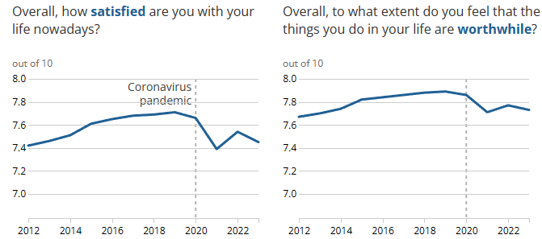
(ONS, 2023)
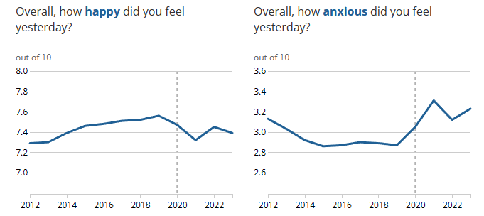
(ONS, 2023)
The findings deliberately demonstrate the significant impact that COVID-19 has had on people's mental health and wellness, particularly during the lockdown period (). A person is more likely to function successfully if they are in good physical and mental health (WHO, 2023). According to the data, many people felt valuable in 2020, the year that COVID reached its height. This might be attributed to helping those in need when they needed it most (WHO, 2023).
  - Wellbeing Theories
Wellbeing subjective theory: recent decades, the field of "subjective wellbeing" philosopher researching has grown rapidly, leading to significant new discussions in moral philosophy, happiness economics, and personality and social psychology. Fabian, 2022, here the author shows a correlation between personality and economic growth. For a more in-depth understanding of this perspective see reference.
Objective wellbeing: Objective well-being indicators are often used in research, policy development, and social assessments to understand the overall health and prosperity of individuals and communities in Britian. While subjective well-being remains crucial for understanding individuals' experiences and perceptions, combining both subjective and objective measures provides a more comprehensive understanding of overall mental health and well-being, (GRMF), (Wigfield & Turner, 2013).
Below is a visual image of a what consists of a one’s positive wellbeing. Psychological wellbeing and Freud’s famous human psyche hierarchy of needs theory, relates to people feeling good about themselves. This can be determined by feelings of the achievement of success with a mature personality (Cherry, 2022).

Psychological wellbeing model

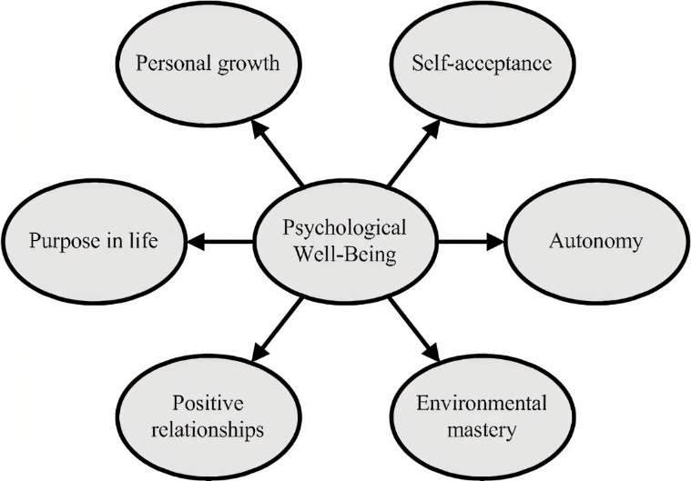

(Positive Psychology, 2017).
2.3 The Importance of Wellbeing
“Wellbeing" is a wide term. According to the UK Government. This is specifically said to be related to the following areas: personal dignity which includes showing respect for the person, protection from abuse and neglect control over one's daily life (GOV. UK, 2020).
This includes the provision of care and support, which will be discussed in the health section of this report, and how it is offered; the physical, mental, and emotional well-being involvement in employment, education, training, or leisure; social and economic well-being; suitability of a person's living arrangement (what is considered living in poverty) and the person's contribution to society and how we learn from our mistakes and managing stress levels, (GOV. UK, 2020).
Ideas are put in place (SDG’s) to preserve and protect the planet and wellbeing future, (Kaltenborn et al, 2019). Mental Health Foundation (2015) makes a point that negative impact can induce depression and anxiety and Philosophers have made significant headway in recent decades in addressing the "very crucial topic of what, ultimately, makes life good for anyone.
Ben Bradley, a philosopher in this field, has produced helpful, focused insight, understandable knowledgeable, and open-minded literature centred on the significance of wellbeing and the way in which this is a narrative theory that is crucial to so many people's lives today, (Bradley, 2015).
One of the most essential ideas in moral philosophy is the notion of well-being. Moral philosophers are concerned the importance of the fundamental components of a good standard of living. A society’s shared moral standards among its members constitutes its positive morality, (Griffin, 1986).
- Sustainable Development
Sustainable development is an approach that balances the present's needs with the potential for future generations to meet their own needs (SDC, No Date). Sustainable development is the idea that the planet can last longer as well as life expectancy for humans (UNDP, 2023).
With the publication of the Bruntland Commission Report (Our Common Future) in 1987, the phrase "sustainable development" has gained importance for governments, organizations, and people, (Filiz Bozkurt & Ahu Ergen, 2015).
The UK is committed to achieving the Sustainable Development Goals by embedding them in each government departments, planned activities such as saving energy and storing heat, through a departmental planning process (GOV. UK, 2015).


(Pixabay, 2023).
4.1 Why Sustainable development is Important.
Suitability is important to the environment and most importantly the public health sector UN, 2023). It is opportunity to reduce poverty, hunger and mental health, (GOV.UK, 2023). Everyone is impacted by the way this is approached. People's lives are affected in very real ways by the decisions that our society makes. For instance, ill-planned towns lower the standard of living for their residents. There could be a food scarcity in the UK if we continue to rely on imports instead of cultivating our own food, (Gov.UK, 2023).
In the book Politics, poverty and belief, Frank Field explains his time spent analysing poverty in Britian. The world of cash, he talked about the activism which his foundation of work with Child Poverty Action Group, passed legislation for the national minimum living wage in YEAR (Field, 2023). This shows a huge dedication to his work speaking out as a social reformer, against poverty in Britian.
The United Nations supports over 4,800 projects to reduce poverty, promote governance, and preserve the environment, primarily funded by country contributions, under the Millennium Development Goals: Sustainable Development Goal 1. No poverty, UN (No Date).
Sustainable development and the global environmental issues are measured by sustainable indicators, environmental assessments, management, policy and approaches to reducing poverty. Rogers et al, discusses the impact of infrastructure development, economics, consumption, market failures, governance, disaster management, international financial institutions which all play a role in civil society, Rogers et al (2007). The importance of this and how it relates to society and individuals will be discuss below.
- Health
Health encompasses complete physical, mental, and social well-being, a fundamental human right regardless of race, religion, or social condition. It is essential for peace and security, requiring cooperation between individuals and states (WHO, 2023).
Public Health England (Health Profile) - this report compares health in various countries, and presents information in charts, discusses key points. This covers COVID-19, mortality, life expectancy, child, adult, risk factors, wider determinants and health protection issues (Public Health England, 2021).
Global threats - Public Health Impact: The primary and most immediate impact of COVID-19 was on public health. The virus spread rapidly, leading to a surge in infections and placing an enormous burden on healthcare systems. Hospitals faced challenges in handling the influx of COVID-19 patients, and there were concerns about the capacity to provide adequate medical care and in worse cases, homelessness for many individuals and, loneliness which was one of the biggest root causes of decline in mental health, (NHS, 2023).
Crisis in mental health: Context Professionals in the fields of education, health, and other fields have expressed growing concerns about the possibility that children's and adolescents' mental health and wellbeing in the UK may be declining, although few nationally representative researchers have investigated this theory. The study looked at trends in the mental health and wellbeing of people in the UK and national health surveys from 2000 to 2014 who were between the ages of 4 and 2, (Pitchforth, Viner and Hardgreaves, 2016).

5.1. Why Health is Important
PHE Strategy 2020-25 - the strategy by public health England also known now as the UK Health Security outlines priorities for the next five years to protect and help people live longer in good health (promoting life expectancy). A job, a safe home, and a supportive network are crucial for good health (Public Health England, 2019).
The Security of health in charge of the department of health – Spead costs to charitable organisations. The Government has little to do with this, merely passes money to the NHS and the NHS passes money where needs-based CCG Health NHS
Malnutrition: Current issues within the health Care sector are rising. Chronic understaffed is at its peak with unclear boundaries of who is in charge – Changes in 2014 (NHS 5 year forward view) this resulted to patients having more control over their care needs and receive support and care provided for people in their homes, increased support for the elderly, evolving approach (Improved health care) 44 SCP 5 in ENGLAND.
Government Funding the Government provide funding within the NHS which is a budget created by government taxes. National insurance contributions (NIC) and general taxation account for a considerable amount of the public funding for this (). Patient fees for services like medications or even dental care, account for a minor fraction of funding in comparison to mental health and well-being. This is to provide care and support for vulnerable individuals who lack the fund for health care in the UK (GOV.UK, 2023).
6. Sustainable Development Goals
The United Nations approved the Sustainable Development Goals (SDGs), sometimes referred to as the Global Goals, in 2015 as a global call to action to end poverty, safeguard the environment, and guarantee that by 2030 all people live in peace and prosperity, (UNDP, 2023).

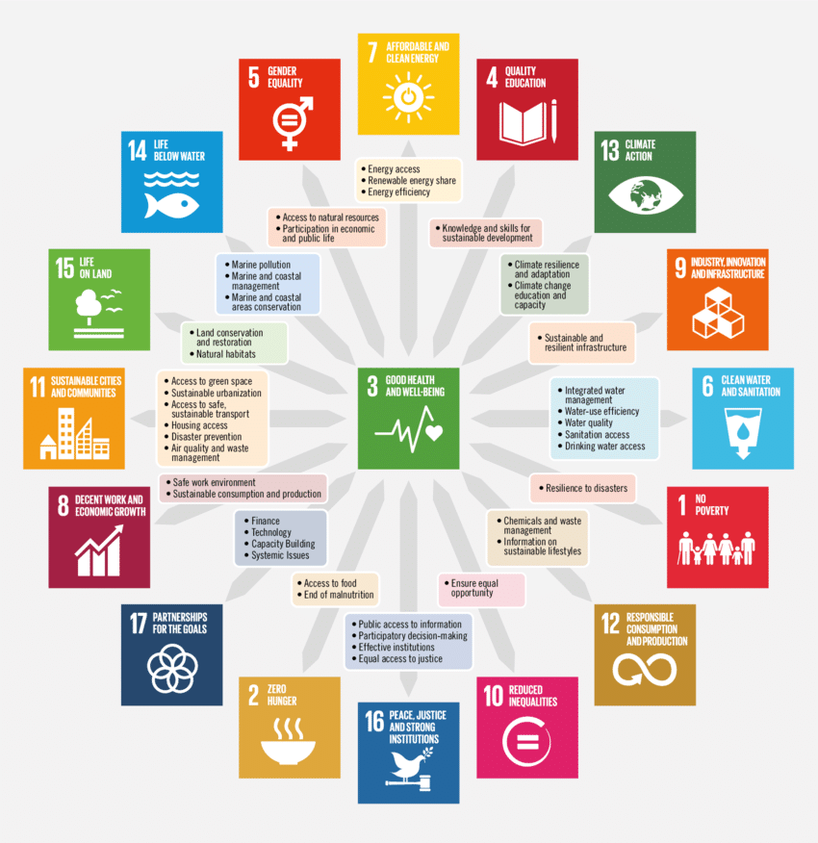
(Romanelli, 2023).

This is an approach to growth and progress that seeks to balance economic, social, and environmental considerations to meet the needs of the present without compromising the ability of future generations to meet their own needs. It is a framework for addressing the interconnected challenges of economic development, social inclusion, and environmental sustainability (United Nations, 2023).
6.1. The Importance of Sustainable Development Goals in the UK
Sustainable Development Goals (SDGs) are important in the UK, as they provide a framework for addressing global challenges in a holistic and interconnected manner. Here are several reasons why SDGs are crucial in the context of the UK. These include:

- Global Interconnectedness

- International Commitment

- Environmental Sustainability

- Social Equality and Inclusion

- Economic Prosperity

- Good Governance and Institutions

- Public Awareness and Engagement, (UNDP, 2023).

- SDG 1 - No Poverty
One of the biggest problems facing humanity continues to be the eradication of poverty in all its manifestations. Despite a more than half-century decline in the number of individuals living in extreme poverty, far too many continue to struggle to meet even the most necessities (UNDP, 2023),
Aim: By the year 2030 to show a decline in poverty across the UK.
7.1. Strategies for Achieving SDG’ 1
Pro-poor Policies: Implement policies that specifically target and benefit the poor. This includes targeted social welfare programs, subsidies for essential services, and measures to improve income distribution.

Education and Skills Development: Invest in education and skills development to empower individuals to break the cycle of poverty. Access to quality education can open opportunities for better employment and economic advancement.
Education and Skills Development:
Universal Healthcare:

Universal Healthcare: Ensure access to affordable and quality healthcare for all. Health shocks can push people into poverty, and having access to healthcare services can mitigate this risk.
By implementing these key points and strategies, countries can make significant progress towards achieving SDG 1 and ultimately ending poverty in all its forms, (UNDP, 2023).
7.2. Free School Meals and Their Importance:
Free school meals are critical in the UK for several reasons which are detailed below:
- Nutritional Support: They provide nutritional support to students, contributing to their physical and cognitive development.

- Addressing Food Insecurity: For families experiencing financial hardship, free school meals ensure that children have access to regular, nutritious meals, addressing food insecurity.

- Educational Outcomes: Proper nutrition is linked to better concentration, learning outcomes, and overall educational achievement. Students who have access to nutritious meals may perform better academically.

- Equity and Inclusion: Free school meals contribute to creating a more equitable education system by ensuring that all students, regardless of their economic background, have equal access to essential resources.

- Reducing Stigma: Universal access to free school meals helps eliminate any stigma associated with receiving assistance, as all students are eligible, reducing social and economic disparities among students, (UK Parliament, 2023).

  - Food Banks
Fighting food poverty in Britian: Food banks play a role in addressing immediate food needs for individuals and families facing financial difficulties. However, they are not a long-term solution to poverty. Sustainable solutions, such as social protection programs, employment opportunities, and education, are essential to address the root causes of poverty, (Gov. UK, 2023).

More than ever food banks are being used as a lifeline. Volunteers and support workers across the nation are pulling together to help those in desperate need of food and essentials which are required to sustain their wellbeing, and health of course.

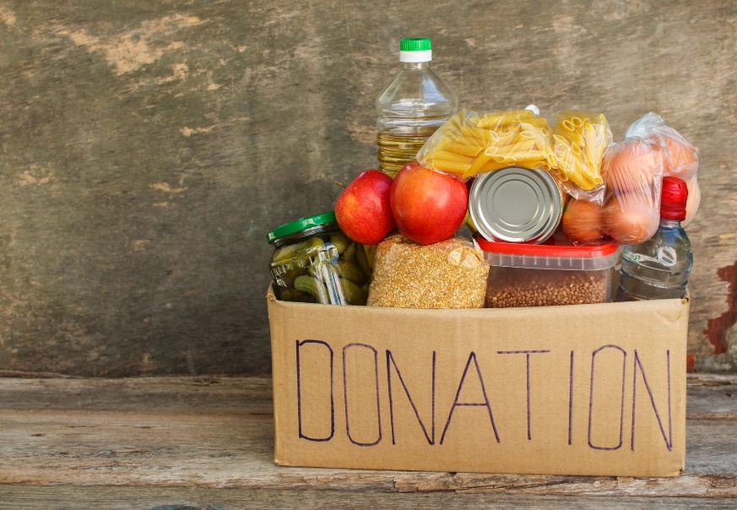 (Bing.com, 2020).

As time goes on it seems that change in society is causing a decline in meeting the needs of citizens. A healthy and caring state provision by politicians is needed more than ever to assist basic needs of those suffering, funding wars, needs to change (VICE 2015). The date on this YouTube video shows that this critical issue has not just happened over night but continues to escalate in the rising of poverty.
While food banks provide crucial support, they should ideally be part of a broader strategy aimed at reducing poverty rates and improving overall well-being. Long-term solutions involve addressing systemic issues that contribute to poverty, such as income inequality, lack of access to education and healthcare, and insufficient social safety nets, (BBC News, 2019).
7.4. Strategies to Address Poverty in the UK
Comprehensive Social Protection and Programmes: this is to Implement and expand social protection programs that provide financial support to vulnerable populations, including cash transfer programs and social insurance.
Education and skills Development: invest in education and skills development programs to empower individuals to break the cycle of poverty.

Employment Opportunities: promote inclusive economic growth that creates job opportunities and supports entrepreneurship.

Affordable Health Care: ensure access to affordable and quality healthcare to prevent health-related expenses from pushing individuals into poverty.

Gender Inclusive Opportunities: develop policies that promote gender equality and address the unique challenges faced by women in poverty.

Community Development: invest in community development initiatives that address local challenges and empower communities to become more self-sufficient.

Affordable Housing: implement policies to ensure access to affordable housing, recognizing its importance in poverty alleviation.

Environmental Sustainability: integrate strategies that promote environmental sustainability, recognizing the impact of environmental factors on poverty.
It is important to understand poverty and what it will take to reduce poverty in 2023. A holistic and sustainable mindset to grasp the experience of living in poverty will help to achieve the visual. By addressing both immediate needs and long-term systemic issues, allows the analysis of the trend of all aspects of poverty especially, from the DWP. Collaboration between government, civil society, and international organizations is often key to the success of such strategies and making key judgements on progress made so far, (Jospeh Rowntree Foundation, 2023).
Addressing poverty and implementing strategies to achieve Sustainable Development Goal 1 (No Poverty) can face various limitations. The UK is not a 3rd world nation so why are people witnessing a serious household decline in significant poverty since World War 2, (Economy whisperer, 2023). Below are some common limitations to the success of poverty reduction efforts in the UK.
  - Limitations

Insufficient funding (Gov.UK and the NHS), Many poverty reduction initiatives require significant financial resources. Limited budgets and government cuts may constrain the scale and effectiveness of programs.

The links between health and the benefit system can have significant implications for individuals, communities, and the overall welfare of a society. The effectiveness of these links depends on various factors, and it is often a complex and dynamic relationship, (Gov. UK, 2023). Here are some aspects to consider:

Impact on Health Outcomes:

- Positive Impact: a well-designed benefit system can contribute to better health outcomes by providing financial support for individuals and families, improving access to healthcare, and reducing stress associated with economic insecurity.

- Negative Impact: on the other hand, an inadequate or poorly structured benefit system may contribute to health disparities, as individuals facing financial difficulties may struggle to afford essential healthcare services and meet basic needs, (Public Health England, 2023).

Recommendations: UNICEF aims to continue to measure and track child poverty on a regular basis. Give child poverty top priority in national development plans and strategies. Extend child-sensitive social protection initiatives, both in the short- and long-term plans of the government COVID-19 reaction. Spend money on high-quality social services and lastly, preserve social expenditures, (UNCEIF, 2023).

- SDG 3 – Good health and wellbeing
Sustainable Development Goal 3 (SDG 3) is one of the 17 goals established by the United Nations as part of the 2030 Agenda for Sustainable Development. SDG 3 is focused on “ensuring healthy lives and promoting well-being for all at all ages” ()
Below are some general considerations on how countries, including the UK, typically approach SDG 3 implementation:
8.1. Strategies to achieve SDG 3

National Strategies: countries develop national strategies and action plans to align with the SDGs. In the UK, efforts are likely made to integrate SDG 3 targets into national health policies and programs.

Healthcare Access: SDG 3 includes targets related to universal health coverage. In the UK, the National Health Service (NHS) plays a crucial role in providing healthcare services to the population, contributing to progress toward the goal.

Data Collecting and Monitoring: regular data collection and monitoring are essential to assess progress. The UK government, through various agencies, likely collects data on health indicators to track progress and identify areas that require attention.

International Collaboration: many SDGs, including SDG 3, involve global challenges. Countries collaborate internationally to address issues such as infectious diseases, maternal and child health, and access to essential medicines.

Public Health Initiatives: countries often implement public health initiatives to address specific health challenges. In the UK, this might involve campaigns on issues like mental health, healthy living, and disease prevention, (Public Health England, 2023).

So, is SDG 3 working. It is important to note that progress can vary across different targets within SDG 3, and challenges may persist. According to the United Nations report, with any comprehensive global goals the success requires ongoing commitment, resources, and collaborative efforts from governments, organizations, and civil society, (United Nation, 2023).
For the most current and specific information on SDG 3 implementation in the UK, it is recommend checking official reports from the UK government, relevant to health agencies, or international organizations that track SDG progress. Additionally, news sources and updates from public health organizations may provide insights into recent initiatives and challenges related to health and well-being in the UK.
Recommendations: data collection on monitoring the health and wellbeing continues to be of importance. Recommending health education awareness, good hygiene and clean drinking water, the continued partnership of global health governance is just some of the recommendations that emphasizes the importance of a comprehensive and integrated approach to health, addressing various health determinants and ensuring that health services are accessible, equitable, and sustainable, strengthening partnership for innovation cooperation, (WHO, 2023).

Conclusion
Overall, the aims of sustainable development goals for promoting health and wellbeing, reflects a commitment to creating a more equitable and just world by tackling the root causes of poverty (rising cost of living) and promoting sustainable development that leaves no one behind promoting an affordable way to live and access healthcare such as primary care, home care and hospital care that benefits all individuals. This should align with the broader vision of the 2030 Agenda for Sustainable Development to achieve a world of prosperity, peace, and well-being for everyone.

References

Bing (2020) How to donate to food banks. Available at: food banks images - Search Images (bing.com). (Accessed 30th November 2020).

Bradley, B. (2015) Well-Being. Policy.

Cherry, K. (2022) Sigmund Freud’s Life, Theories, and Influence. Available at: www.veryweelmind.com. (Accessed 10th November 2023).

Field, F (2023) Politics, Poverty and Belief. Bloomsbury Continuum.
Fabian, M. (2022). A theory of subjective well-being. Oxford University Press.

Gov. UK (No Date) State of the Environment: people and the Environment. Available at: https://www.Environment Agency - GOV.UK (www.gov.uk) (Accessed 27th September 2023).

Gov.UK (No Date) Implementing the Sustainable Development Goals. Available at: https://www.Implementing the Sustainable Development Goals - GOV.UK (www.gov.uk) (Accessed 27th September 2023).

GOV, UK (2021) Research and analysis Health Profile for England. Available at: www.Health Profile for England: 2021 - GOV.UK (www.gov.uk). (Accessed 6th November 2023).
GOV, UK (2020) Guidance Wellbeing. Available at: www.Wellbeing. (Accessed 7th November 2023).

GOV (2015) Corporate report Implementing the sustainable development goals Available at: https://www.gov.uk/government/publications/implementing-the-sustainable-development-goals/implementing-the-sustainable-development-goals--2. (Accessed 6th November 2023).

Groarke, J. M., Berry, E., Graham-Wisener, L., McKenna-Plumley, P. E., McGlinchey, E., & Armour, C. (2020). Loneliness in the UK during the COVID-19 pandemic: Cross-sectional results from the COVID-19 Psychological Wellbeing Study. PloS One, 15(9), e0239698–e0239698. https://doi.org/10.1371/journal.pone.0239698.

Pixabay (2023) Sustainable Development Images. Available at: www.blackandsilversolarpanels-freestockphoto(prexels.com). (Accessed 6th November 2023).

Griffin, J. (1986) WELL-BEING its meaning, measurement and moral importance. Clarendon Press.

NHS England (2017) The Sustainable development unit for the NHS England & Public Health England. Available at: https://www.NHS England » The Sustainable Development Unit for NHS England and Public Health England (Accessed 27th of September 2023).

Kaltenbirn, M., Krajewski, M., Kuhn, H. (2019) Sustainable Development Goals and Human Rights. Springer. 1 ed.

Mental Health Foundation (2015) What is well-being, how can we measure it and how can we support people to improve it. Available at: www.mentalhealth.org.uk (Accessed 09th October 2023).

Pixabay (2023) Sustainable Development Images. Available at: www.blackandsilversolarpanels-freestockphoto(prexels.com. (Accessed 6th November 2023).

Pitchforth, J. M., Viner, R. M., & Hargreaves, D. S. (2016). Trends in mental health and wellbeing among children and young people in the UK: a repeated cross-sectional study, 2000–14. The Lancet, 388, S93–S93. https://doi.org/10.1016/S0140-6736(16)32329-7.

Positive Psychology (2017) What is Eudaimonia? The Concept of Eudaimonia Well-Being and Happiness. Available at: www.positivepsycholgy.org. (Accessed 7th November 2023).

Public Health England (2021) Health Profile for England 2021. Available at: https://wwwhealthprofileforengland2021(phe.org.uk. (Accessed 7th November 2023).

Public Health England (2019) Protecting and improving the nation’s health PHE Strategy 2020-25. Available a:t www.phestrategy2020-25(publishing.service.gov.uk. (Accessed 7th November 2023).

Rogers, P., Jalal, F K., Boyd A. (2007) An Introduction to Sustainable Development. Routledge.

United Nations Development Programme (2023) What are the Sustainable Development Goals. Available at: Sustainable Development Goals | United Nations Development Programme (undp.org). (Accessed 24th October).

United Nations (No Date) Poverty eradication. Available at: www.povertyeradicationdepartementofeconomicandsocialaffairs(un.org).(Accessed 7th November 2023).

UNDP (2023) What are Sustainable Development Goals. Available at: https://www.undp.org/sustaible-development-goals. (Accessed 7th November 2023).

UNDP (2023) What are the Sustainable Development Goals? Available at: Goal 1: No poverty | Sustainable Development Goals | United Nations Development Programme (undp.org). (Accessed 16th November 2023).

UNICEF (2023) UNICEF for every child UNICEF data: monitoring the situation of children and women. Available at: SDG Goal 1: No Poverty - UNICEF DATA. (Accessed 29th November 2023).
Romanelli, C. (2023) Research Gate. Available at :Sustainable Development Goals and targets: deconstructing environmental... | Download Scientific Diagram (researchgate.net) (Accessed 17th October 2023).
Sustainable Development Commission (NO DATE) What is sustainable Development. Available at: www.Whatissustainabledevelopment–sustainabledevelopmentcommission(sd-commission.org.uk. (Accessed 6th November 2023).

WHO (2023) Promoting Well-being. Available at: https://www.Promotingwell-being(whoint). (Accessed 7th November 2023).

WHO (2023) The Global Health Observatory Explore a world of health data. Available at: https://www.healthandwellbeing(whoint). (Accessed 7th November 2023).

World Health Organisation (2022) Mental Health Factsheet. Available at: www.who.int. (Accessed 24th October 2023).

World Health Organisation (2023) The Global Health Observatory. Available at www.who.int (Accessed 9th October 2023).

WHO (2023) WHO remains firmly committed to the principles set out in the preamble to the Constitution. Available at: https://www.constituionoftheworldhealthorganization(int). (Accessed 6th November 2023).

WHO (2023) WHO and Echo discuss the way forward in strengthening their partnership and innovative ways of cooperation. Available at: WHO and ECHO discuss the way forward in strengthening their partnership and innovative ways of cooperation. (Accessed 29th November 2023).

Wigfield, A., & Turner, R. (2013). The Development of the Good Relations Measurement Framework in Britain: A Template for Experiential Social Measurement. Social Indicators Research, 114(2), 655–686. https://doi.org/10.1007/s11205-012-0167-9.

