
Applied Leadership and Management in the Workplace
Module Assignment Submission

Student Name: | KIM BOUKERAS
Student Number: | 2226794
Module No: | BMSK4009
Module Title: | Learning in the Digital Era

Statement of Confirmation of Authenticity
By the act of making this submission, the student declares that this is the work of the student named above. The work has not, in whole or in part, been knowingly presented elsewhere for assessment, or where assessment has been built on a previous assessment, this has been identified. Where materials have been used from other sources it has been properly acknowledged. If this statement is untrue, the student acknowledges that an assessment offence has been committed.
Attention is drawn to the plagiarism and unfair practice policies of both the University and of ILM.
Section 1: Explain how I can prepare for studying in Higher Education
1.1 Explain aspects such as: time management, academic writing, referencing, criticality, reflection and other skills needed (1000 words)
1.2 Create a mind map (500 words max) that shows the skills identified, and how they interconnect to create transferable skills study, life, and workplace
1.3 Create a Personal Development Plan showing identified skills and plan for improvement, tabular format (500 words max.)
1.4 References

  - Explain aspects such as: time management, academic writing, referencing, criticality, reflection and other skills needed (1000 words)

- Time management
My time management is very important as it’s a massive part of my everyday life. The way I manage time is planning my days as I am remarkably busy with my personal life. I have 6 children from 24 to 7 years old. I work 3 days a week and I am currently studying at university full time. I have three dependants at home, but all have activities and after school clubs in the week and at weekends. I must be very organised to keep up with my scheduled life.
- Academic writing
Academic writing is descriptive and more. The basic purpose of it is to provide facts and information. The key skills for academic writing are writing clearly and consistently and using the correct punctuation grammar and spelling.
- Criticality
Academic writing doesn’t just describe things it also does criticality and reflection. Based on the units in the tutorial programe I have learned that academic writing uses checks to make sure that information is reliable and is not false news or misleading information. So, I have learned about the CRAAP test
  - Currency: Is the information up to date? Has anything changed recently?
  - Relevancy: does it fit in with the rest of the information? Does it add anything to what we are doing?
  - Authority: Does the author know what they are talking about. Are they recognised experts?
  - Accuracy: Can the information be verified and proven correct?
  - Purpose: Is the information objective? Is it fact or just opinion? Is the information biased? Is the writer trying to sell you something?
- Reflection
I’ve learned about learning styles and according to the Honey and Mumford (1986) I am a reflective and visual learner (Bolton, 2010). This means that I learn best when shown how to do things and, I think about things before doing them. For me forward planning is an everyday part of my life, and I always think before acting on any scenario to decide whether I’m doing the right thing and decide whether it’s right or wrong.
I have also seen the Kolb (1984) model which mentions reflection and shows how thinking and doing are important ways of learning.
The Kolb Reflective Learning Cycle has four stages of learning. I start with having the actual experience of a job or task, observation of how it’s done and then thinking about
the task, then I would think about how to do it better before putting the task together again.

- Other skills I will need

There are so many I will pick out a few especially relevant to me as a future leader or person running my own business, basically skills helpimg me be a good boss.
Things that are new to me:
Paraphrasing: saying things in your own words. This is made harder because I think I have some dyslexia. I got the questions right that were asked in the teaching unit.
Synthesis: bringing things together from different resources.
Avoiding plagiarism: avoiding copying off authors. Paraphrasing helps. And referencing is important to show where information has come from.
Referencing: I need to get used to the rules of the APAv7 system

Things where I have transferable skills:
These are skills that can be used in different settings. My skills are problem solving, critical thinking, good leader skills and a very motivated person. I understand peoples needs and wellbeing in and out of work. My skills need to be transferred to a new environment, of further and higher education (Coles, 2004)
Physical fitness/ mental health and wellbeing: I walk a lot in work as I’m on my feet for 9 hours a day so that keeps me very active and fit. I also go to the gym, and this helps with my mental health.
Culture and identity: Culture is to treat people with respect and understand the needs and differences. Identity is to know who you are and who others are of a different background.
Team working, giving advice etc: Teamwork is important. It solves problems. Without it the business will not thrive and succeed. Teamwork is also essential for personal life as well as academically and put to everyday life. Giving advice such as feedback, you can look back where you’ve gone wrong and put plans in place to achieve your goals.

1.2 Create a mind map (500 words max) that shows the skills identified, and how they interconnect to create transferable skills study, life, and workplace

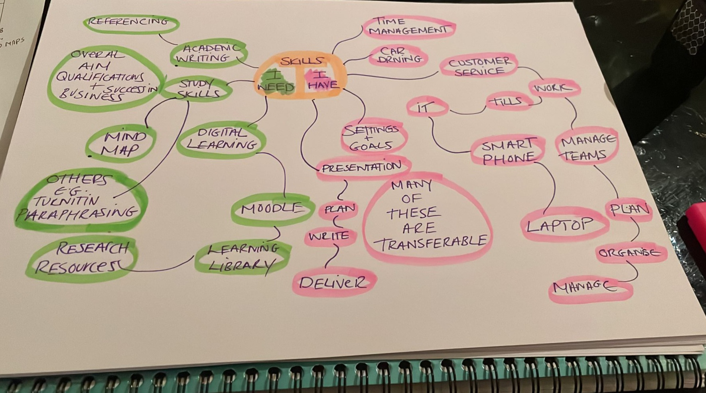

Mind maps were made popular by Buzan (1995).
Instead of thinking in a straight line, they encourage you to think in all directions. This is called radial thinking, and it helps you to see the “big picture” of any issue. You start with a central issue, and work from that.
My starting point was SKILLS, and I divided them into skills I have and skills I need. The skills I have are on the right of the diagram, and they spread out and all link together. On the left-hand side, these are skills I need, to improve and here I’m focusing on skills to improve academic learning and writing for future studies and digital learning.
An example of a lengthy branch with many off shoots, there is CUSTOMER SERVICE. Which is part of my work, and it needs me to manage teams for which I plan, organise and then manage.
On the “skills I need” side of the diagram, an example is the DIGITAL LEARNING route, which leads on to several other skills, such as Moodle, Learning Library and research resources, all of which are new to me.
Many of the skills on the right are transferable to the left and can be used in new scenarios. And the skills on the left help with skills on the right as well. For example, learning to be a digital learner takes a lot of time at first before we get used to the new systems, but in the long run it saves time, for example, it is very much quicker to use a online library rather than visit a actual library to search for books.

1.3 Personal Development Plan showing identified skills and plan for improvement, tabular format (500 words max.)
What do I want to learn? | What do I have to do? | What support and resources will I need? | How will I measure success? | Target Date for Review
I want in 1 years’ time to learn more IT SKILLS for me to improve with academic studies. | I must take time out for self-directed studies for me to achieve my knowledge in using the computer and broaden my understanding. | Laptop, money more lessons and support from tutors and peers. | I will measure success by my peers and supported family. | 1 year
I want to gain further knowledge in study skills as it will help in my future studies and career.  Digital learning is another skill that I would like to gain more knowledge of to help with further studies. | I will need to take time out for self-directed studies to broaden my understanding | I will need a laptop and support from tutors and peers. | Again, I would need feedback from tutors, peers and my grades. | 1 year
Paraphrasing is another skill that I would need to gain more knowledge to help with further studies. | I would need to take time out for self-directed studies to gain further knowledge. | I need a laptop and support from tutors and peers. | I would measure success from tutors and peers, also from my grades. | 1 year

1.4 References

Bolton, G., 2010, Reflective Practice, Sage
Buzan, T., and Buzan, B., 1995,The Mindmap Book, BBC Books
Honey, P. and Mumford, A. 1986, Using our learning styles, Peter Honey.
Kolb, D.A., 1984, Experiential Learning, Prentice-Hall
Coles, A. (ed.) 2004, Teaching in Post-Compulsory Education, David Fulton

